Identify reporting/analytics stories: Show SQL, query plan and output in a doc

3. As a *Fan*, I want to view standings (leaderboard) so that easily know each team’s ranking *# 3 Sub-tasks  
# 1. Need to create a totals view that records wins AND losses  
# e.g. Totals VIEW attributes -> seasonid, teamid, wins, loses, win%, conference, division, home, road  
# 2. Need to create a standings view that summarizes each team based ON totals view  
# 3. Need to rank teams in standings  
  
# Sub-task 1 - Create Totals View*

**EXPLAIN EXTENDED**(  
 **SELECT DISTINCT** t1.**idgame**,  
 t1.**season_idseason**,  
 t1.**home_team_id**,  
 t1.**away_team_id**,  
 **CASE  
 WHEN** t1.team_points > t2.team_points  
 **THEN** t1.**idteam  
 WHEN** t1.team_points < t2.team_points  
 **THEN** t2.**idteam  
 END AS** win_team_id,  
 **CASE  
 WHEN** t1.team_points < t2.team_points  
 **THEN** t1.**idteam  
 WHEN** t1.team_points > t2.team_points  
 **THEN** t2.**idteam  
 END AS** loss_team_id  
  
 **FROM** (  
 **SELECT idgame**,  
 **team_name**,  
 **idteam**,  
 **home_team_id**,  
 **away_team_id**,  
 **season_idseason**,  
 *SUM*(**pts**) **AS** team_points  
 **FROM** game g  
 **JOIN** box_score b  
 **ON** g.**idgame** = b.**game_idgame  
 JOIN** team t

**ON** b.**team_idteam** = t.**idteam  
 GROUP BY** 1, 2  
 **ORDER BY** 1 **ASC** ) **as** t1  
 **INNER JOIN** (  
 **SELECT idgame**,  
 **team_name**,  
 **idteam**,  
 **home_team_id**,  
 **away_team_id**,  
 **season_idseason**,  
 *SUM*(**pts**) **AS** team_points  
 **FROM** game g  
 **JOIN** box_score b  
 **ON** g.**idgame** = b.**game_idgame  
 JOIN** team t  
 **ON** b.**team_idteam** = t.**idteam  
  
 GROUP BY** 1, 2  
 **ORDER BY** 1 **ASC** ) **as** t2  
 **ON** t1.**idgame** = t2.**idgame  
 WHERE** t1.**team_name** <> t2.**team_name  
 HAVING** win_team_id **IS NOT NULL  
 AND** loss_team_id **IS NOT NULL**);

*query-plan1.png*

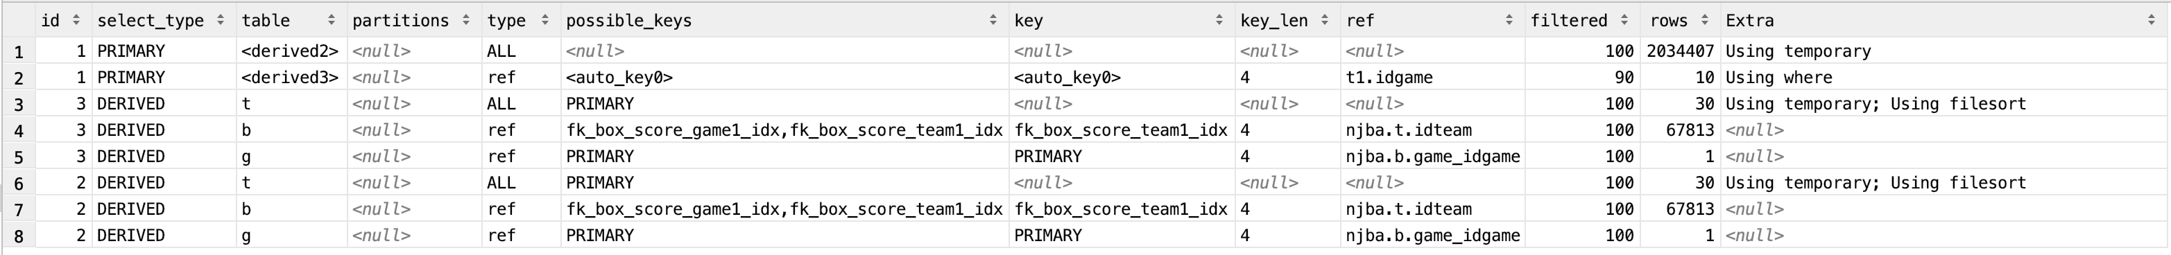

*# Sub-task 2 - Create standings View*

**EXPLAIN EXTENDED**(  
 **SELECT season_idseason**,  
 **loss_team_id**,  
 *COUNT*(**loss_team_id**) **AS** loss  
 **FROM** totals  
 **WHERE** (**home_team_id** = **loss_team_id  
 OR away_team_id** = **loss_team_id**)  
 **GROUP BY** 1, 2  
 **ORDER BY** 1, 2  
);

*query-plan2.png*

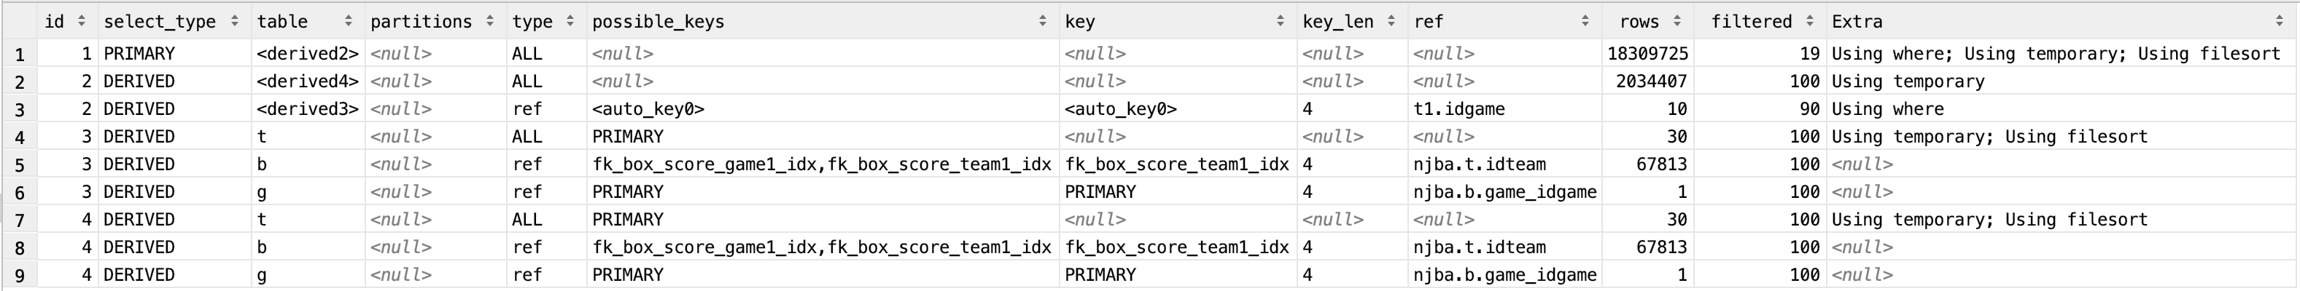

**EXPLAIN EXTENDED**(  
 **SELECT season_idseason**,  
 **win_team_id**,  
 *COUNT*(**win_team_id**) **AS** win  
 **FROM** totals  
 **WHERE** (**home_team_id** = **win_team_id  
 OR away_team_id** = **win_team_id**)  
 **GROUP BY** 1, 2  
 **ORDER BY** 1, 2  
);

*query-plan3.png*

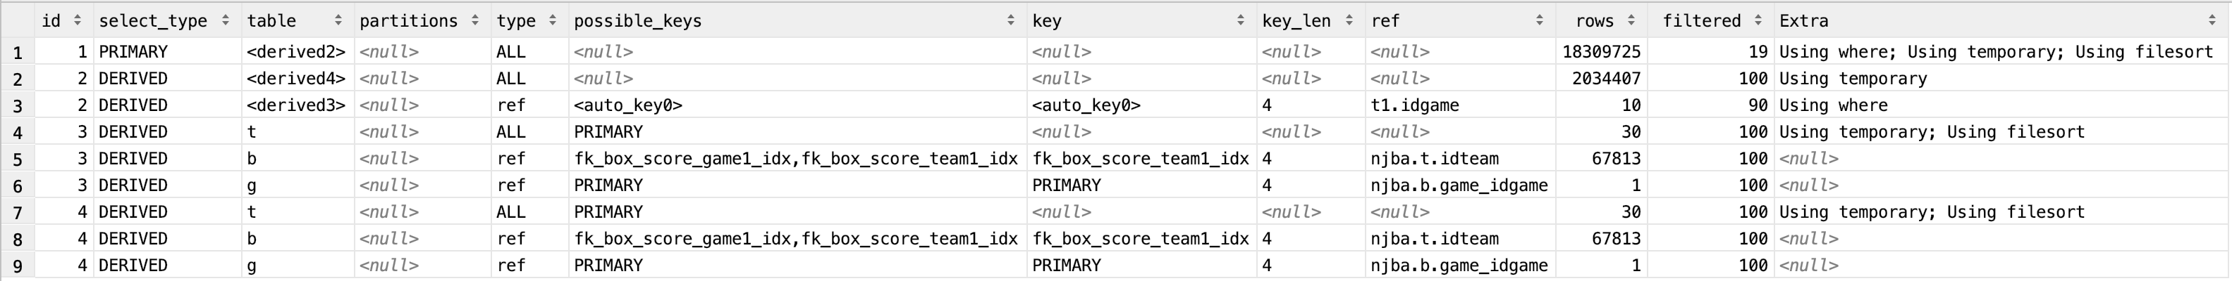

**EXPLAIN EXTENDED**(  
 **SELECT season_idseason**,  
 **idteam**,  
 *SUM*(game_win) **AS** wins,  
 *SUM*(game_loss) **AS** loses,  
 *ROUND*((*SUM*(game_win)/*SUM*(game_win + game_loss)) * 100, 1)  
 **AS** win_pct,  
 *CONCAT*(*CAST*(*SUM*(conf_win) **AS CHAR**(2)), **' - '**,  
 *CAST*(*SUM*(cONf_loss) **AS CHAR**(2)) ) **AS** conf_record,  
 *CONCAT*(*CAST*(*SUM*(div_win) **AS CHAR**(2)), **' - '**,  
 *CAST*(*SUM*(div_loss) **AS CHAR**(2)) ) **AS** div_record,  
 *CONCAT*(*CAST*(*SUM*(home_win) **AS CHAR**(2)), **' - '**,  
 *CAST*(*SUM*(home_loss) **AS CHAR**(2)) ) **AS** home_record,  
 *CONCAT*(*CAST*(*SUM*(away_win) **AS CHAR**(2)), **' - '**,  
 *CAST*(*SUM*(away_loss) **AS CHAR**(2)) ) **AS** away_record  
 **FROM** (  
 **SELECT season_idseason**,  
 **idteam**,  
 **conference**,  
 **division**,  
 s.**win_team_id**,  
 s.**loss_team_id**,  
 **CASE WHEN** s.**win_team_id** = t.**idteam**

**THEN** 1  
 **ELSE** 0

**END AS** game_win,  
 **CASE WHEN** s.**loss_team_id** = t.**idteam**

**THEN** 1  
 **ELSE** 0

**END AS** game_loss,  
 *-- Conference Record* **CASE WHEN** (s.**win_team_id** = t.**idteam**) **AND  
 conference** = (  
 **SELECT** t.**conference  
 FROM** team t  
 **WHERE** s.**loss_team_id** = t.**idteam** )  
 **THEN** 1  
 **ELSE** 0

**END AS** conf_win,  
 **CASE WHEN** (s.**loss_team_id** = t.**idteam**) **AND  
 conference** = (  
 **SELECT** t.**conference  
 FROM** team t  
 **WHERE** s.**win_team_id** = t.**idteam** )  
 **THEN** 1  
 **ELSE** 0 **END AS** conf_loss,  
 *-- Division Record* **CASE WHEN** (s.**win_team_id** = t.**idteam**) **AND  
 division** = (  
 **SELECT** t.**division  
 FROM** team t  
 **WHERE** s.**loss_team_id** = t.**idteam** )  
 **THEN** 1  
 **ELSE** 0 **END AS** div_win,  
 **CASE WHEN** (s.**loss_team_id** = t.**idteam**) **AND  
 division** = (  
 **SELECT** t.**division  
 FROM** team t  
 **WHERE** s.**win_team_id** = t.**idteam** )  
 **THEN** 1  
 **ELSE** 0 **END AS** div_loss,  
 *-- Home Record* **CASE WHEN** (s.**win_team_id** = t.**idteam**) **AND home_team_id** = **win_team_id  
 THEN** 1  
 **ELSE** 0 **END AS** home_win,  
 **CASE WHEN** (s.**loss_team_id** = t.**idteam**) **AND home_team_id** = **loss_team_id  
 THEN** 1  
 **ELSE** 0 **END AS** home_loss,  
 *-- Away Record* **CASE WHEN** (s.**win_team_id** = t.**idteam**) **AND away_team_id** = **win_team_id  
 THEN** 1  
 **ELSE** 0 **END AS** away_win,  
 **CASE WHEN** (s.**loss_team_id** = t.**idteam**) **AND away_team_id** = **loss_team_id  
 THEN** 1  
 **ELSE** 0 **END AS** away_loss  
 **FROM** totals s  
 **JOIN** team t  
 ) **AS** standings  
 **GROUP BY idteam**);

*query-plan4.png*

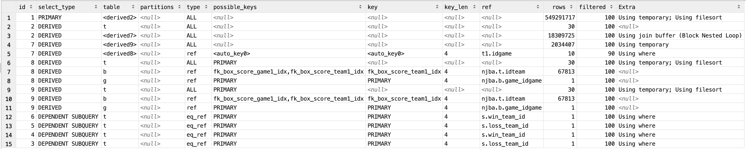

*# Sub-task 3 - Rank the standings***EXPLAIN EXTENDED**(  
 **SELECT** s.**season_idseason**,  
 t.**team_name**,  
 s.**win_pct**,  
 *@curRank* := @curRank + 1 **AS** ranks  
 **FROM** standings s  
 **JOIN** team t **ON** s.**idteam** = t.**idteam**,  
 (**SELECT** @curRank := 0) r  
*-- WHERE s.idseason = 2 # Uncomment to specify which season to show ranking for* **ORDER BY win_pct DESC**);

*query-plan5.png*

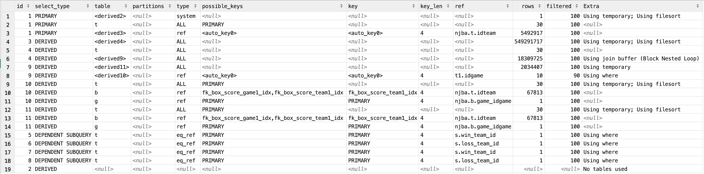

8. As a *Fan*, I want to view player stats so that I can see a player‘s averages over various time periods (e.g. month-to-month stats, season averages, etc.)

*# 2 Sub-tasks  
# 1. Need to create a totals view that records number of games played by a team in a given period  
# e.g. games_played VIEW attributes -> date, teamid, played_game  
# 2. Need to create a standings view that summarizes each team based ON totals view  
  
-- Traditional Stats  
#___________________________________________________________________________________#  
# Stat | Name | Formula #  
#_________|___________________________________|_____________________________________#  
# gp | Games Played | #  
# min | Minutes Played | #  
# pts | Points | #  
# fgm | Field Goals Made | #  
# fga | Field Goals Attempted | #  
# fg_pct | Field Goal Percentage | (FGM / FGA) * 100 #  
# fg3 | 3 Point Field Goals Made | #  
# fg3a | 3 Point Field Goals Attempted | #  
# fg3_pct | 3 Point Field Goals Percentage | (FG3 / FG3A) * 100 #  
# ft | Free Throws Made | #  
# fta | Free Throws Attempted | #  
# ft_pct | Free Throw Percentage | (FT / FTA) * 100 #  
# orb | Offensive Rebounds | #  
# drb | Defensive Rebounds | #  
# trb | Total Rebounds | #  
# ast | Assists | #  
# fouls | Fouls | #  
# blk | Blocks | #  
# tov | Turnovers | #  
#_________|___________________________________|_____________________________________#  
  
  
-- Player Averages***EXPLAIN EXTENDED**(  
 **SELECT** t.**team_name**,  
 p.**full_name**,  
 *AVG*(**mins**) **AS** mins,  
 *AVG*(**fgm**) **AS** fgm,  
 *AVG*(**fga**) **AS** fga,  
 **CASE  
 WHEN  
 fga** <> 0  
 **THEN** *ROUND*((*AVG*(**fgm**) / *AVG*(**fga**)) * 100, 1)  
 **ELSE** 0  
 **END AS** fg_pct,  
 *AVG*(**fg3**) **AS** fg3,  
 *AVG*(**fg3a**) **AS** fg3a,  
 **CASE  
 WHEN  
 fg3a** <> 0  
 **THEN** *ROUND*((*AVG*(**fg3**) / *AVG*(**fg3a**)) * 100, 1)  
 **ELSE** 0  
 **END AS** fg3_pct,  
 *AVG*(**ft**) **AS** ft,  
 *AVG*(**fta**) **AS** fta,  
 **CASE  
 WHEN  
 fta** <> 0  
 **THEN** *ROUND*((*AVG*(**ft**) / *AVG*(**fta**)) * 100, 1)  
 **ELSE** 0  
 **END AS** ft_pct,  
 *AVG*(**orb**) **AS** orb,  
 *AVG*(**drb**) **AS** drb,  
 *AVG*(**trb**) **AS** trb,  
 *AVG*(**ASt**) **AS** assists,  
 *AVG*(**blk**) **AS** blocks,  
 *AVG*(**tov**) **AS** turnovers,  
 *AVG*(**fouls**) **AS** fouls,  
 *AVG*(**pts**) **AS** points  
 **FROM** game g  
 **JOIN** box_score b  
 **ON** g.**idgame** = b.**game_idgame  
 JOIN** player p  
 **ON** b.**player_idplayer** = p.**idplayer  
 JOIN** team t  
 **ON** b.**team_idteam** = t.**idteam****WHERE** g.**date BETWEEN** *start_date*() **AND** *end_date*()  
 **GROUP BY** 1, 2  
 **ORDER BY** 1, 2 **ASC**);  
  
*query-plan6.png*



*-- Player Sum (Raw Scores)***EXPLAIN EXTENDED**(  
 **SELECT** t.**team_name**,  
 p.**full_name**,  
 *SUM*(**mins**) **AS** mins,  
 *SUM*(**fgm**) **AS** fgm,  
 *SUM*(**fga**) **AS** fga,  
 **CASE  
 WHEN  
 fga** <> 0  
 **THEN** *ROUND*((*SUM*(**fgm**) / *SUM*(**fga**)) * 100, 1)  
 **ELSE** 0  
 **END AS** fg_pct,  
 *SUM*(**fg3**) **AS** fg3,  
 *SUM*(**fg3a**) **AS** fg3a,  
 **CASE  
 WHEN  
 fg3a** <> 0  
 **THEN** *ROUND*((*SUM*(**fg3**) / *SUM*(**fg3a**)) * 100, 1)  
 **ELSE** 0  
 **END AS** fg3_pct,  
 *SUM*(**ft**) **AS** ft,  
 *SUM*(**fta**) **AS** fta,  
 **CASE  
 WHEN  
 fta** <> 0  
 **THEN** *ROUND*((*SUM*(**ft**) / *SUM*(**fta**)) * 100, 1)  
 **ELSE** 0  
 **END AS** ft_pct,  
 *SUM*(**orb**) **AS** orb,  
 *SUM*(**drb**) **AS** drb,  
 *SUM*(**trb**) **AS** trb,  
 *SUM*(**ASt**) **AS** assists,  
 *SUM*(**blk**) **AS** blocks,  
 *SUM*(**tov**) **AS** turnovers,  
 *SUM*(**fouls**) **AS** fouls,  
 *SUM*(**pts**) **AS** points  
 **FROM** game g  
 **JOIN** box_score b  
 **ON** g.**idgame** = b.**game_idgame  
 JOIN** player p  
 **ON** b.**player_idplayer** = p.**idplayer  
 JOIN** team t  
 **ON** b.**team_idteam** = t.**idteam  
 JOIN** games_played gp  
 **ON** t.**team_name** = gp.**team_name  
 WHERE** g.**date BETWEEN** *start_date*() **AND** *end_date*()  
 **GROUP BY** 1, 2  
 **ORDER BY** 1, 2 **ASC**);

*query-plan7.png*

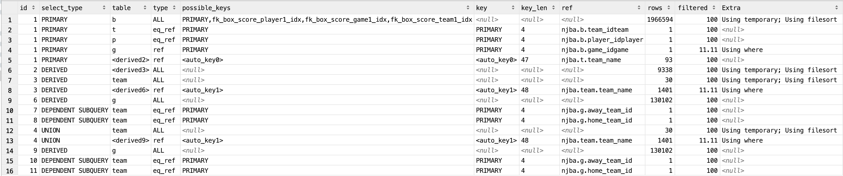

*-- Games Played Totals***EXPLAIN EXTENDED**(  
 **SELECT team_name**, *sum*(games_played) games_played  
 **FROM** (  
 **SELECT** *count*(*\**) **AS** games_played, **team_name  
 FROM schedule** s  
 **JOIN** team  
 **ON team_name** = **home  
 WHERE date BETWEEN** *start_date*() **AND** *end_date*()  
 **GROUP BY team_name  
  
 UNION ALL  
  
 SELECT** *count*(*\**) **AS** games_played, **team_name  
 FROM schedule** s  
 **JOIN** team **ON team_name** = **away  
 WHERE date BETWEEN** *start_date*() **AND** *end_date*()  
 **GROUP BY team_name** ) **AS** game_total  
 **GROUP BY team_name**);

*query-plan8.png*

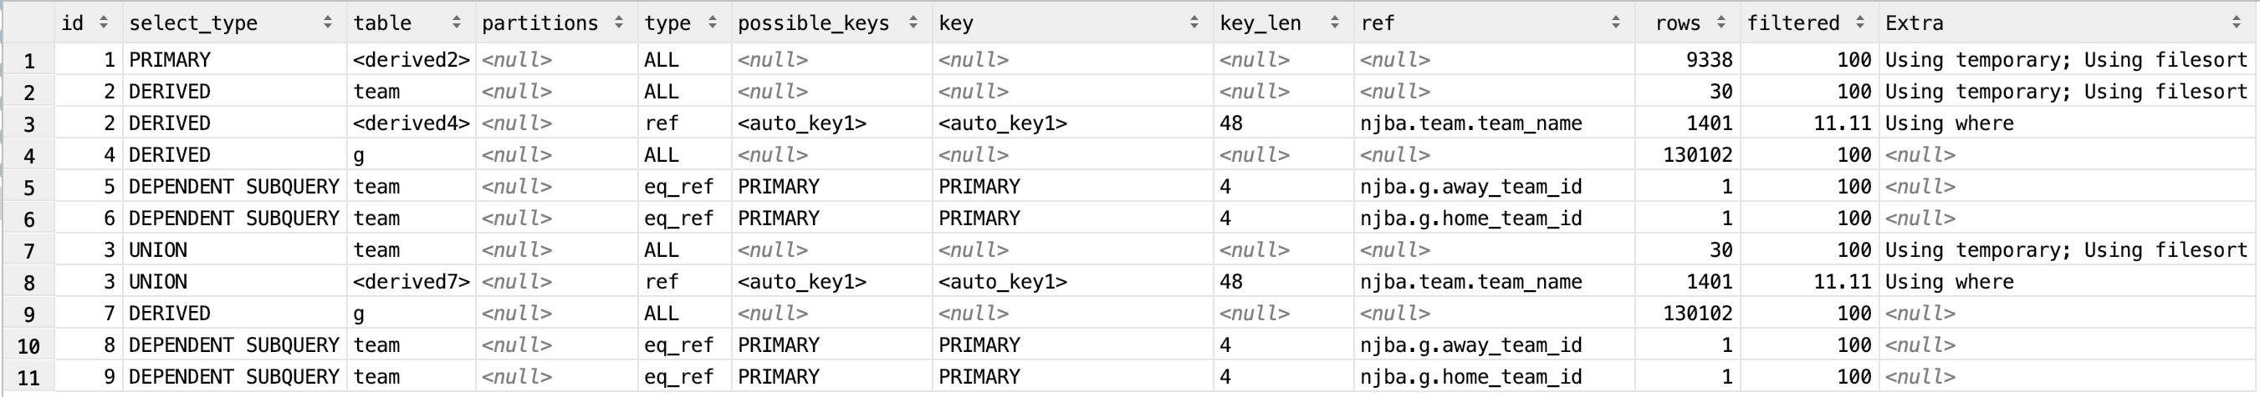

9. As a *Fan*, I want to view team stats so that I can see a team’s averages over various time periods (e.g. month-to-month stats, season averages, etc.) *-- Traditional Stats  
#___________________________________________________________________________________#  
# Stat | Name | Formula #  
#_________|___________________________________|_____________________________________#  
# gp | Games Played | #  
# min | Minutes Played | #  
# pts | Points | #  
# fgm | Field Goals Made | #  
# fga | Field Goals Attempted | #  
# fg_pct | Field Goal Percentage | (FGM / FGA) * 100 #  
# fg3 | 3 Point Field Goals Made | #  
# fg3a | 3 Point Field Goals Attempted | #  
# fg3_pct | 3 Point Field Goals Percentage | (FG3 / FG3A) * 100 #  
# ft | Free Throws Made | #  
# fta | Free Throws Attempted | #  
# ft_pct | Free Throw Percentage | (FT / FTA) * 100 #  
# orb | Offensive Rebounds | #  
# drb | Defensive Rebounds | #  
# trb | Total Rebounds | #  
# ast | Assists | #  
# fouls | Fouls | #  
# blk | Blocks | #  
# tov | Turnovers | #  
#_________|___________________________________|_____________________________________#*

*-- Team Averages***EXPLAIN EXTENDED**(  
 **SELECT** t.**team_name**,  
 *ROUND*(*SUM*(**mins** / gp.**games_played**), 0) **AS** mins,  
 *ROUND*(*SUM*(**fgm**) / gp.**games_played**, 0) **AS** team_fgm,  
 *ROUND*(*SUM*(**fga**) / gp.**games_played**, 0) **AS** team_fga,  
 *ROUND*((*ROUND*(*SUM*(**fgm**) / gp.**games_played**, 0) /  
 *ROUND*(*SUM*(**fga**) / gp.**games_played**, 0)) * 100, 1) **AS** team_fg_pct,  
 *ROUND*(*SUM*(**fg3**) / gp.**games_played**, 0) **AS** team_fg3,  
 *ROUND*(*SUM*(**fg3a**) / gp.**games_played**, 0) **AS** team_fg3a,  
 *ROUND*((*ROUND*(*SUM*(**fg3**) / gp.**games_played**, 0) /  
 *ROUND*(*SUM*(**fg3a**) / gp.**games_played**, 0)) * 100, 1) **AS** team_fg3_pct,  
 *ROUND*(*SUM*(**ft**) / gp.**games_played**, 0) **AS** team_ft,  
 *ROUND*(*SUM*(**fta**) / gp.**games_played**, 0) **AS** team_fta,  
 *ROUND*((*ROUND*(*SUM*(**ft**) / gp.**games_played**, 0) /  
 *ROUND*(*SUM*(**fta**) / gp.**games_played**, 0)) * 100, 1) **AS** team_ft_pct,  
 *ROUND*(*SUM*(**orb**) / gp.**games_played**, 0) **AS** team_orb,  
 *ROUND*(*SUM*(**drb**) / gp.**games_played**, 0) **AS** team_drb,  
 *ROUND*(*SUM*(**trb**) / gp.**games_played**, 0) **AS** team_trb,  
 *ROUND*(*SUM*(**ast**) / gp.**games_played**, 0) **AS** team_assists,  
 *ROUND*(*SUM*(**blk**) / gp.**games_played**, 0) **AS** team_blocks,  
 *ROUND*(*SUM*(**tov**) / gp.**games_played**, 0) **AS** team_turnovers,  
 *ROUND*(*SUM*(**fouls**) / gp.**games_played**, 0) **AS** team_fouls,  
 *ROUND*(*SUM*(**pts**) / gp.**games_played**, 0) **AS** team_points  
 **FROM** game g  
 **JOIN** box_score b  
 **ON idgame** = **game_idgame  
 JOIN** team t  
 **ON team_idteam** = **idteam  
 JOIN** games_played gp  
 **ON** t.**team_name** = gp.**team_name  
 WHERE** g.**date BETWEEN** *start_date*() **AND** *end_date*()  
 **GROUP BY** 1  
 **ORDER BY** 1 **ASC**);

*query-plan9.png*

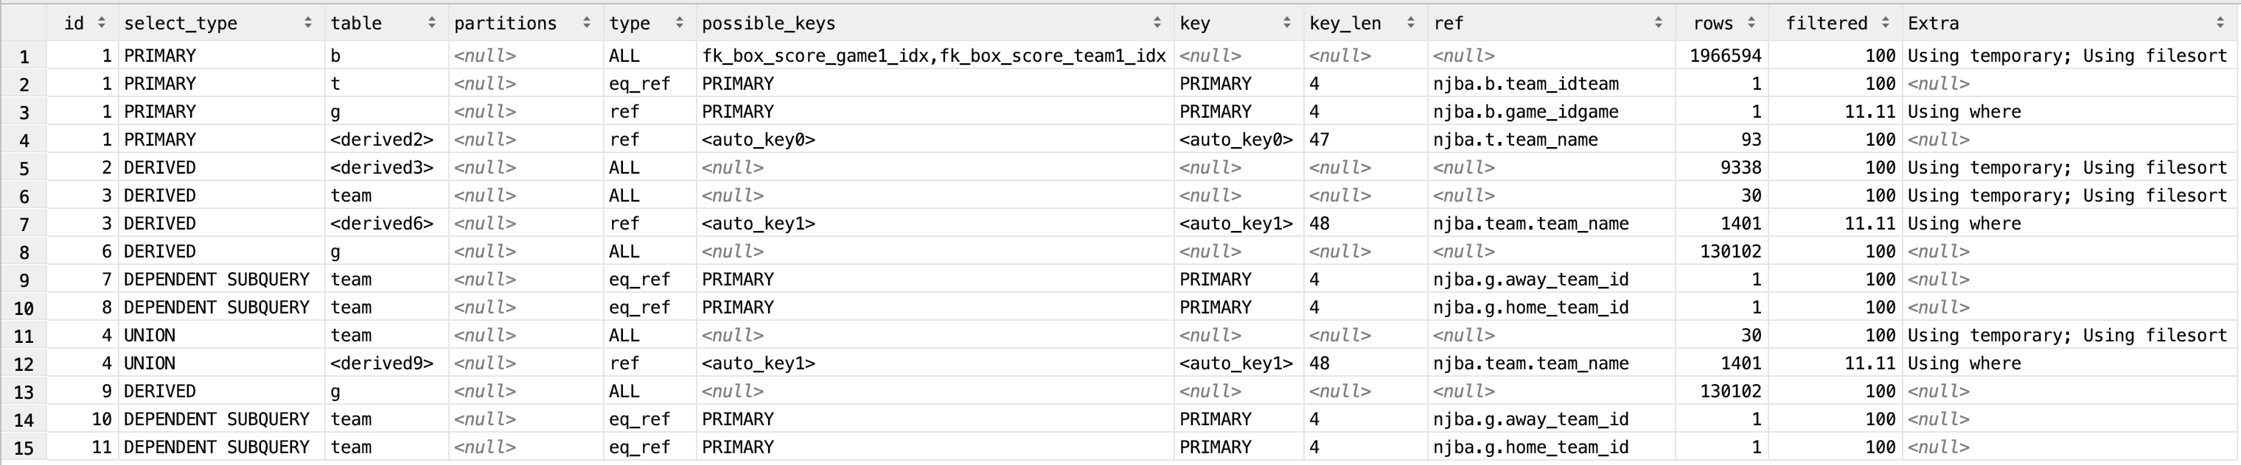

*-- Team Totals (Raw Scores)***EXPLAIN EXTENDED**(  
 **SELECT** t.**team_name**,  
 *ROUND*(*SUM*(**mins**), 0) **AS** mins,  
 *SUM*(**fgm**) **AS** team_fgm,  
 *SUM*(**fga**) **AS** team_fga,  
 *ROUND*((*SUM*(**fgm**) / *SUM*(**fga**)) * 100, 1) **AS** team_fg_pct,  
 *SUM*(**fg3**) **AS** team_fg3,  
 *SUM*(**fg3a**) **AS** team_fg3a,  
 *ROUND*((*SUM*(**fg3**) / *SUM*(**fg3a**)) * 100, 1) **AS** team_fg3_pct,  
 *SUM*(**ft**) **AS** team_ft,  
 *SUM*(**fta**) **AS** team_fta,  
 *ROUND*((*SUM*(**ft**) / *SUM*(**fta**)) * 100, 1) **AS** team_ft_pct,  
 *SUM*(**orb**) **AS** team_orb,  
 *SUM*(**drb**) **AS** team_drb,  
 *SUM*(**trb**) **AS** team_trb,  
 *SUM*(**ASt**) **AS** team_assists,  
 *SUM*(**blk**) **AS** team_blocks,  
 *SUM*(**tov**) **AS** team_turnovers,  
 *SUM*(**fouls**) **AS** team_fouls,  
 *SUM*(**pts**) **AS** team_points  
 **FROM** game g  
 **JOIN** box_score b  
 **ON idgame** = **game_idgame  
 JOIN** team t  
 **ON team_idteam** = **idteam  
 JOIN** games_played gp  
 **ON** t.**team_name** = gp.**team_name  
 WHERE** g.**date BETWEEN** *start_date*() **AND** *end_date*()  
 **GROUP BY** 1  
 **ORDER BY** 1 **ASC**);

*query-plan10.png*

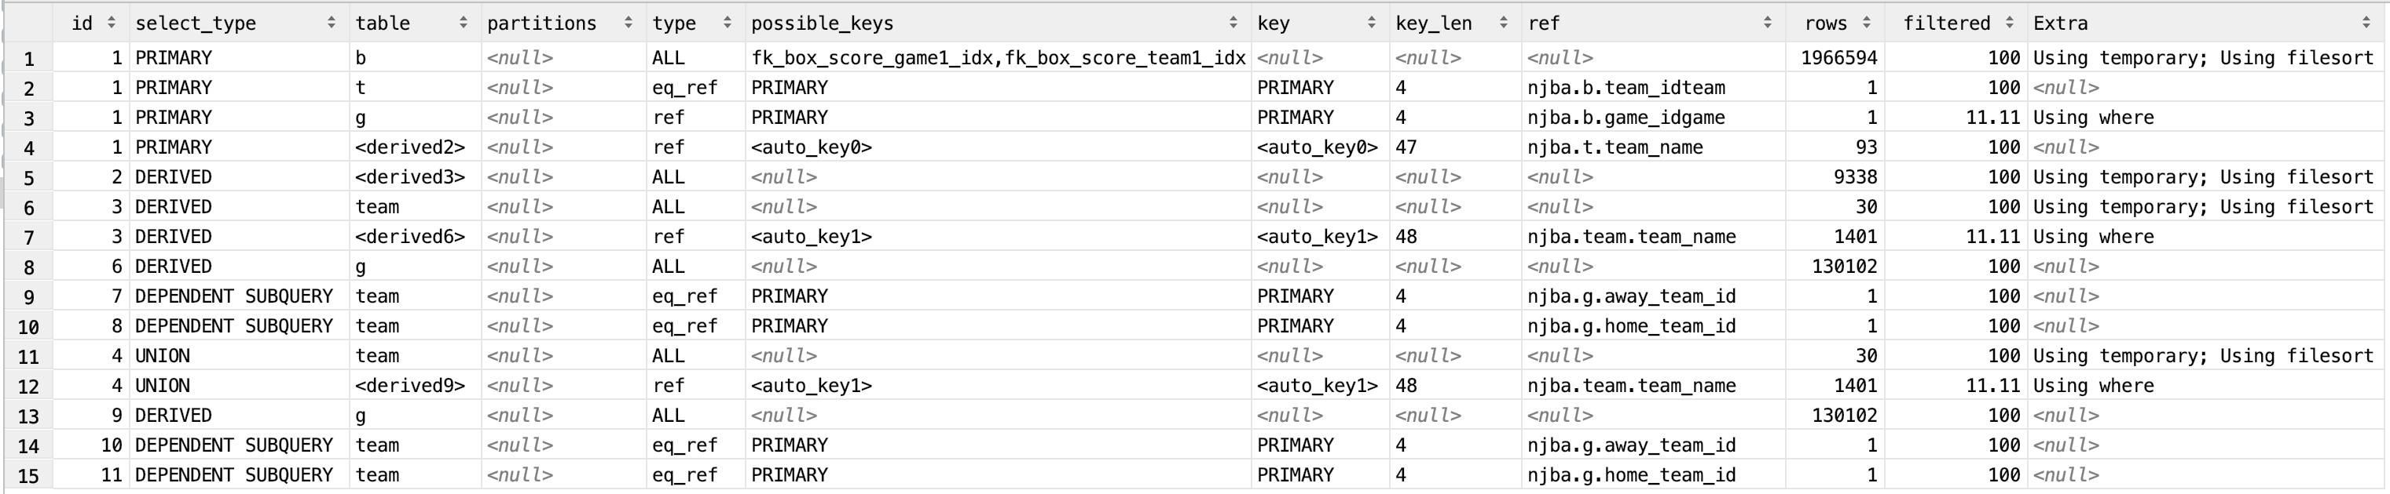  
  
18. As a *Fan*, I want to view a ‘Top Player Stats’ leaderboard so that I can see which player is the top ranked player in each statistical category**EXPLAIN EXTENDED**(  
 **SELECT team_name**,  
 **full_name**,  
 *ROUND*(**fgm**, 0) **AS** fgm,  
 *ROUND*(**fga**, 0) **AS** fga,  
 **fg_pct**,  
 *ROUND*(**fg3**, 0) **AS** fg3,  
 *ROUND*(**fg3a**, 0) **AS** fg3a,  
 **fg3_pct**,  
 *ROUND*(**ft**, 0) **AS** ft,  
 *ROUND*(**fta**, 0) **AS** fta,  
 **ft_pct**,  
 *ROUND*(**orb**, 0) **AS** orb,  
 *ROUND*(**drb**, 0) **AS** drb,  
 *ROUND*(**trb**, 0) **AS** trb,  
 *ROUND*(**assists**, 0) **AS** ast,  
 *ROUND*(**blocks**, 0) **AS** blk,  
 *ROUND*(**turnovers**, 0) **AS** tov,  
 *ROUND*(**fouls**, 0) **AS** fouls,  
 *ROUND*(**points**, 0) **AS** pts,  
 @curRank := @curRank + 1 **AS** ranks  
 **FROM** player_avg p,  
 (**SELECT** @curRank := 0) r  
 *-- Stat Filter* **ORDER BY** pts **DESC**);

*query-plan11.png*  
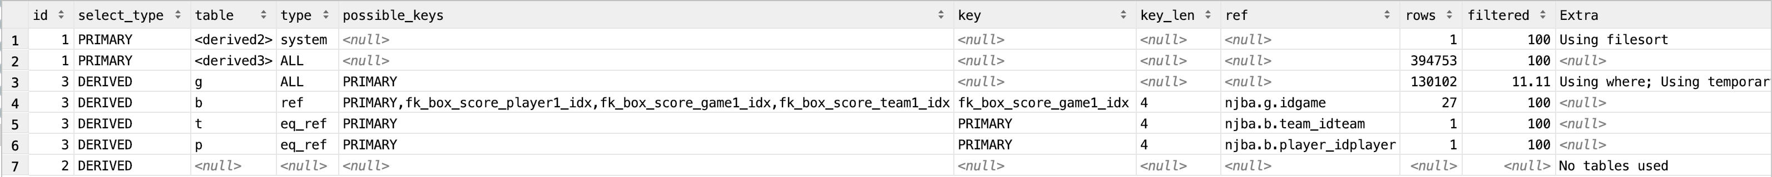

19. As a *Fan*, I want to view a ‘Top Team Stats’ leaderboard so that I can see which team is the top ranked team in each statistical category  
**EXPLAIN EXTENDED**(  
 **SELECT team_name**,  
 *ROUND*(**team_fgm**, 0) **AS** team_fgm,  
 *ROUND*(**team_fga**, 0) **AS** team_fga,  
 **team_fg_pct**,  
 *ROUND*(**team_fg3**, 0) **AS** team_fg3,  
 *ROUND*(**team_fg3a**, 0) **AS** team_fg3a,  
 **team_fg3_pct**,  
 *ROUND*(**team_ft**, 0) **AS** team_ft,  
 *ROUND*(**team_fta**, 0) **AS** team_fta,  
 **team_ft_pct**,  
 *ROUND*(**team_orb**, 0) **AS** team_orb,  
 *ROUND*(**team_drb**, 0) **AS** team_drb,  
 *ROUND*(**team_trb**, 0) **AS** team_trb,  
 *ROUND*(**team_assists**, 0) **AS** team_ast,  
 *ROUND*(**team_blocks**, 0) **AS** team_blk,  
 *ROUND*(**team_turnovers**, 0) **AS** team_tov,  
 *ROUND*(**team_fouls**, 0) **AS** team_fouls,  
 *ROUND*(**team_points**, 0) **AS** team_pts,  
 @curRank := @curRank + 1 **AS** ranks  
 **FROM** team_avg t,  
 (**SELECT** @curRank := 0) r  
 *-- Stat Filter* **ORDER BY** team_pts **DESC**);  
  
*query-plan12.png*

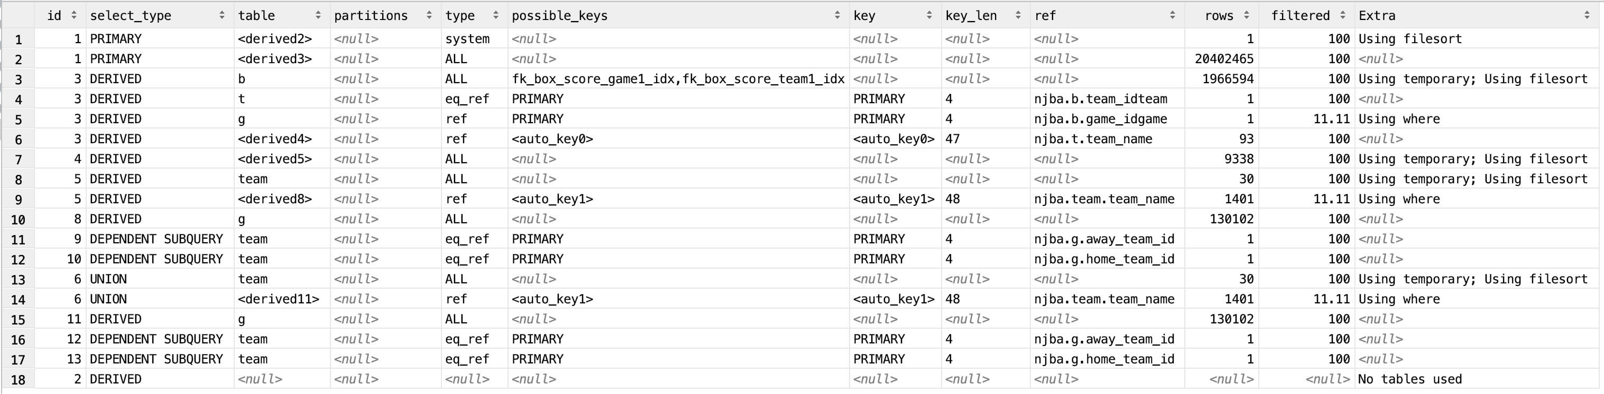

*-- Note: There are no user stories for displaying the Store data. Store is out of the scope of MVP.  
  
-- =====================================================  
-- Additional Reporting/Analytics  
-- =====================================================  
  
-- Advanced Stats  
#_________________________________________________________________________________________________#  
# Stat | Name | Formula #  
#_________|___________________________________|___________________________________________________#  
# efg_pct | Effective Field Goal Percentage | (FG + 0.5 * 3P) / FGA #  
# tsa | True Shooting Attempts | FGA + 0.475 * FTA #  
# ts_pct | True Shooting Percentage | PTS / (2 * TSA) -> PTS / (2 * (FGA + 0.475 * FTA))#  
# ftr | Free Throw Rate | FT / FGA #  
# tov_pct | Turnover Percentage | 100 * TOV / (FGA + 0.44 * FTA + TOV) #  
# gmsc | Game Score | PTS + 0.4 * FG - 0.7 * FGA - 0.4*(FTA - FT) + #  
# | | 0.7 * ORB + 0.3 * DRB + STL + 0.7 * AST + 0.7 * #  
# | | BLK - 0.4 * Fouls - TOV #  
#_________|___________________________________|___________________________________________________#***EXPLAIN EXTENDED**(  
 **SELECT** t.**team_name**,  
 p.**full_name**,  
 *ROUND*((*SUM*(**fgm** + **fg3**) + 0.5 * **fg3**) / *SUM*(**fga** + **fg3a**) * 100, 1) **AS** efg_pct,  
 *ROUND*(*SUM*(**fga** + **fg3a**) + 0.475 * **fta**, 1) **AS** tsa,  
 *ROUND*(**points** / (2 * (*SUM*(**fga** + **fg3a**) + 0.475 * **fta**)) * 100, 1) **AS** ts_pct,  
 *ROUND*((**ft** / *SUM*(**fga** + **fg3a**) * 100), 1) **AS** ftr,  
 *ROUND*(100 * **turnovers** / (*SUM*(**fga** + **fg3a**) + 0.44 * **fta** + **turnovers**), 1) **AS** tov_pct,  
 *ROUND*((**points** + 0.4 * *SUM*(**fga** + **fg3a**) - 0.7 * **fga** -  
 0.4 * (**fta** - **ft**) + 0.7 * **orb** + 0.3 * **drb** + 0.7 *  
 **assists** + 0.7 * **blocks** - 0.4 * **Fouls** - **turnovers**), 1) **AS** gmsc  
*# (100 * ((SUM(fga + fg3a) + 0.44 * fta + turnovers) * (TmMP / 5)) / (min * (TmFGA + 0.44 * Tm FTA + Tm TOV))) AS usage* **FROM** player_raw pr  
 **JOIN** player p  
 **ON** pr.**full_name** = p.**full_name  
 JOIN** team t  
 **ON** pr.**team_name** = t.**team_name  
 JOIN** games_played gp  
 **ON** t.**team_name** = gp.**team_name  
 GROUP BY** 1, 2  
 **ORDER BY** 1, 2 **ASC**);