Joshua Frazier

July 3, 2022

Module 7 : MySQL Installation & Setup

Sequence:

1. Output of MySQL installed with terminal:(steps in the outline with new MacOS system did it automatically. These were the two screenshots for the installation.)

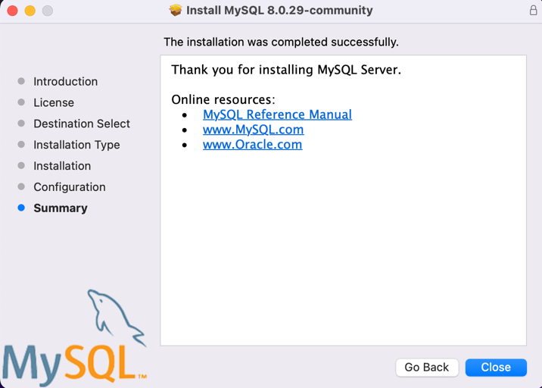

1. Start the database through the terminal: This process was outdated due to the MacOS system and its use of default zshell. Without instructions, I did a deeper research to understand the difference of bash and zshell and to update the system to go behind and change default to bash. Layout may be a little different than use to due to outdated or updated guide book.

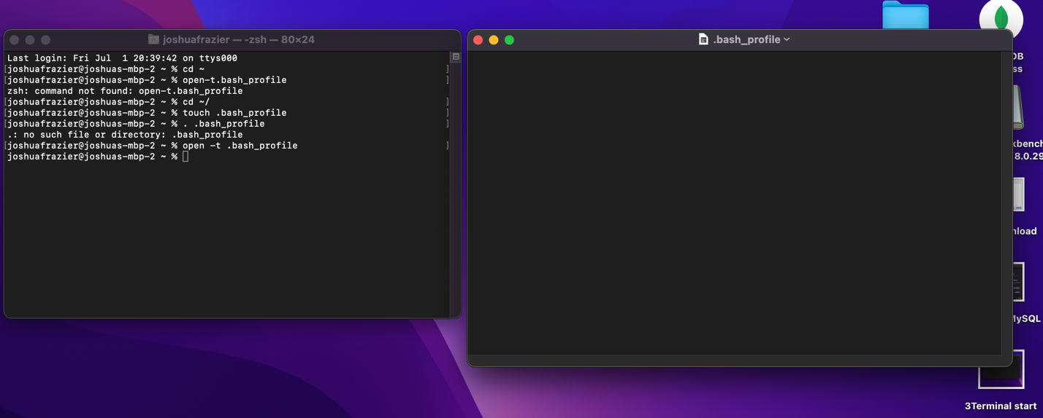

Saved path-

MySQL was able to fun after -u root -p command and bash version 5 update:

1. Create command from provided example and output:

Database was added to the before and after output to show it was created.