Generation of single cell tracks from Ca²⁺ microscopy data

The following is our pipeline for transforming raw Ca²⁺ imaging data into single cell tracks.

Preprocessing
- Create the following folders in your experiment folder:
  - image_data (for preprocessed TIFs)
  - raw nd2s (for raw nd2 files off the microscope)
  - tracking (for exported csv files from TrackMate)
  - transposed (for simplified csv files)
- Open Fiji and crop images to exclude time points prior to stimulation addition (if cells moved significantly after stimulation addition).
  - Image Duplicate alter frame range
  - Save duplicates as TIF and organize into a new folder

Segmentation & Tracking (one sample at a time)
- Load one TIF image into Fiji
- Load “trackingv2.ijm” to run StarDist segmentation.

name = getInfo("image.title")
print(name);
selectWindow(name);
run("Split Channels");
selectWindow("C3-"+name);
run("Command From Macro", "command=[de.csbdresden.stardist.StarDist2D], args=['input':'C3-"+name+"', 'modelChoice':'Versatile (fluorescent nuclei)', 'normalizeInput':'true', 'percentileBottom':'1.0', 'percentileTop':'99.8', 'probThresh':'0.49999999999999994', 'nmsThresh':'0.4', 'outputType':'Label Image', 'nTiles':'1', 'excludeBoundary':'1', 'roiPosition':'Stack', 'verbose':'false', 'showCsbdeepProgress':'true', 'showProbAndDist':'false'], process=[false]");
run("Merge Channels...", "c1=[C3-"+name+"] c2=[C1-"+name+"] c4=[Label Image] c7=[C2-"+name+"]");
run("TrackMate");

Before StarDist
Channel 1 = FITC (Fluo-4 AM)
Channel 2 = TRITC (pHELD-AF594)
Channel 3 = Cy5 (B220-AF647) segmentation formed using this channel

After StarDist
Channel 1 = Cy5
Channel 2 = FITC
Channel 4 (3) = labeled imaged
Channel 7 (4) = TRITC

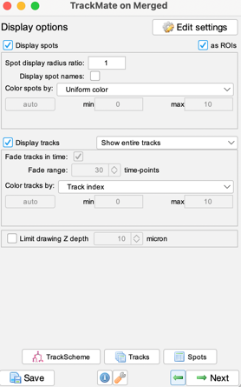
- Follow TrackMate console using the following settings:
- Detector: label image detector
- Segment in channel 3
  - Check simplify contours
- Set thresholding to Auto
- Tracker: simple LAP tracker
  - Linking and closing max distance: 6.0 uM (approximately the size of your naïve B cells)
  - Gap-closing max frame: 2 (how many frames can a cell go undetected before it is thrown out of the analysis)
- Export Spots file and save as csv in your “tracking” folder

