Consistencia interna de la escala completa de VG

Reliability analysis

Call: alpha(x = VG_F)

raw_alpha std.alpha G6(smc) average_r S/N ase mean sd median_r

0.92 0.92 0.94 0.48 12 0.0054 1.5 0.64 0.48

95% confidence boundaries

lower alpha upper

Feldt 0.91 0.92 0.93

Duhachek 0.91 0.92 0.93

Reliability if an item is dropped:

raw_alpha std.alpha G6(smc) average_r S/N alpha se var.r med.r

VG_1 0.92 0.92 0.93 0.50 12 0.0055 0.016 0.52

VG_3 0.91 0.92 0.93 0.48 11 0.0060 0.016 0.48

VG_4 0.91 0.92 0.93 0.48 11 0.0059 0.016 0.48

VG_5 0.91 0.92 0.93 0.47 11 0.0061 0.016 0.47

VG_6 0.91 0.92 0.93 0.48 11 0.0059 0.017 0.47

VG_7 0.91 0.91 0.93 0.47 11 0.0061 0.014 0.47

VG_8 0.91 0.92 0.93 0.48 11 0.0059 0.016 0.48

VG_9 0.91 0.92 0.93 0.48 11 0.0060 0.015 0.47

VG_10 0.91 0.91 0.92 0.47 11 0.0061 0.013 0.47

VG_11 0.91 0.92 0.93 0.48 11 0.0061 0.016 0.47

VG_13 0.92 0.92 0.93 0.49 11 0.0058 0.016 0.50

VG_2_I 0.92 0.93 0.93 0.51 12 0.0055 0.012 0.52

VG_12_I 0.92 0.92 0.93 0.50 12 0.0056 0.014 0.52

Item statistics

n raw.r std.r r.cor r.drop mean sd

VG_1 410 0.63 0.62 0.57 0.54 1.6 1.00

VG_3 410 0.77 0.77 0.76 0.72 1.4 0.84

VG_4 410 0.74 0.74 0.71 0.68 1.4 0.87

VG_5 410 0.79 0.79 0.77 0.75 1.4 0.88

VG_6 410 0.76 0.74 0.72 0.69 1.7 1.11

VG_7 410 0.80 0.81 0.80 0.76 1.4 0.87

VG_8 410 0.74 0.72 0.70 0.68 1.6 1.08

VG_9 410 0.77 0.79 0.78 0.73 1.3 0.74

VG_10 410 0.82 0.83 0.83 0.78 1.3 0.76

VG_11 410 0.78 0.76 0.75 0.73 1.5 0.96

VG_13 410 0.73 0.70 0.68 0.66 1.7 1.15

VG_2_I 410 0.50 0.55 0.50 0.45 1.6 0.56

VG_12_I 410 0.54 0.59 0.55 0.49 1.6 0.57

Non missing response frequency for each item

1 2 3 4 5 miss

VG_1 0.71 0.14 0.04 0.11 0.00 0

VG_3 0.74 0.16 0.03 0.07 0.00 0

VG_4 0.76 0.14 0.03 0.07 0.00 0

VG_5 0.76 0.14 0.02 0.08 0.00 0

VG_6 0.66 0.15 0.04 0.14 0.00 0

VG_7 0.76 0.14 0.03 0.07 0.00 0

VG_8 0.68 0.14 0.05 0.12 0.01 0

VG_9 0.79 0.13 0.03 0.04 0.00 0

VG_10 0.78 0.14 0.03 0.05 0.00 0

VG_11 0.73 0.15 0.02 0.09 0.01 0

VG_13 0.68 0.14 0.04 0.12 0.03 0

VG_2_I 0.40 0.55 0.04 0.00 0.00 0

Measures of reliability

reliability(keys = VG_F)

omega_h alpha omega.tot Uni tau cong max.split min.split mean.r med.r n.items CFI

All_items 0.58 0.92 0.94 0.92 0.94 0.98 0.96 0.85 0.48 0.48 13 0.86

ECV Beta EVR

All_items 0.83 0.65 5.92

── **Tests for the suitability of the data for factor analysis** ─────────────────────────────────────

**Bartlett's test of sphericity**

**✔** The **Bartlett's test of sphericity** was **significant** at an alpha level of .05.

These data are probably suitable for factor analysis.

𝜒²(78) = 3236.2, *p* < .001

**Kaiser-Meyer-Olkin criterion (KMO)**

**✔** The overall KMO value for your data is **marvellous** with **0.916**.

These data are probably suitable for factor analysis.

── **Number of factors suggested by the different factor retention criteria** ────────────────────────

◌ Comparison data: **4**

◌ Empirical Kaiser criterion: **1**

◌ Hull method with CAF: **1**

◌ Hull method with CFI: **NA**

◌ Hull method with RMSEA: **NA**

◌ Kaiser-Guttman criterion with PCA: **2**

◌ Kaiser-Guttman criterion with SMC: **1**

◌ Kaiser-Guttman criterion with EFA: **1**

◌ Parallel analysis with PCA: **1**

◌ Parallel analysis with SMC: **5**

◌ Parallel analysis with EFA: **4**

◌ Sequential 𝜒² model tests: **7**

◌ Lower bound of RMSEA 90% confidence interval: **5**

◌ Akaike Information Criterion: **7**

**ANALISIS FACTORIAL CONFIRMATORIO**

summary(VG_A, fit.measures = TRUE)

lavaan 0.6-19 ended normally after 46 iterations

Estimator ML

Optimization method NLMINB

Number of model parameters 29

Number of observations 410

Model Test User Model:

Test statistic 510.982

Degrees of freedom 62

P-value (Chi-square) 0.000

Model Test Baseline Model:

Test statistic 3285.617

Degrees of freedom 78

P-value 0.000

User Model versus Baseline Model:

Comparative Fit Index (CFI) 0.860

Tucker-Lewis Index (TLI) 0.824

Loglikelihood and Information Criteria:

Loglikelihood user model (H0) -5348.066

Loglikelihood unrestricted model (H1) -5092.575

Akaike (AIC) 10754.132

Bayesian (BIC) 10870.601

Sample-size adjusted Bayesian (SABIC) 10778.578

Root Mean Square Error of Approximation:

RMSEA 0.133

90 Percent confidence interval - lower 0.122

90 Percent confidence interval - upper 0.144

P-value H_0: RMSEA <= 0.050 0.000

P-value H_0: RMSEA >= 0.080 1.000

Standardized Root Mean Square Residual:

SRMR 0.065

Parameter Estimates:

Standard errors Standard

Information Expected

Information saturated (h1) model Structured

Latent Variables:

Estimate Std.Err z-value P(>|z|)

D1 =~

VG_1 1.000

VG_2_I 0.461 0.060 7.722 0.000

VG_3 1.195 0.108 11.111 0.000

VG_6 1.423 0.135 10.535 0.000

VG_7 1.338 0.116 11.578 0.000

D2 =~

VG_4 1.000

VG_5 1.086 0.072 15.017 0.000

VG_8 1.201 0.089 13.573 0.000

VG_10 1.057 0.062 16.927 0.000

VG_11 1.138 0.079 14.390 0.000

D3 =~

VG_9 1.000

VG_12_I 0.455 0.047 9.630 0.000

VG_13 1.282 0.093 13.853 0.000

Covariances:

Estimate Std.Err z-value P(>|z|)

D1 ~~

D2 0.337 0.039 8.543 0.000

D3 0.317 0.036 8.866 0.000

D2 ~~

D3 0.374 0.035 10.709 0.000

Variances:

Estimate Std.Err z-value P(>|z|)

.VG_1 0.708 0.051 13.902 0.000

.VG_2_I 0.252 0.018 14.075 0.000

.VG_3 0.291 0.023 12.682 0.000

.VG_6 0.622 0.047 13.294 0.000

.VG_7 0.234 0.020 11.507 0.000

.VG_4 0.380 0.028 13.529 0.000

.VG_5 0.326 0.025 13.200 0.000

.VG_8 0.612 0.045 13.618 0.000

.VG_10 0.151 0.013 11.744 0.000

.VG_11 0.434 0.032 13.414 0.000

.VG_9 0.223 0.020 11.320 0.000

.VG_12_I 0.257 0.018 14.276 0.000

.VG_13 0.795 0.059 13.550 0.000

D1 0.295 0.051 5.770 0.000

D2 0.382 0.047 8.119 0.000

D3 0.318 0.036 8.713 0.000

Gráfico modelo

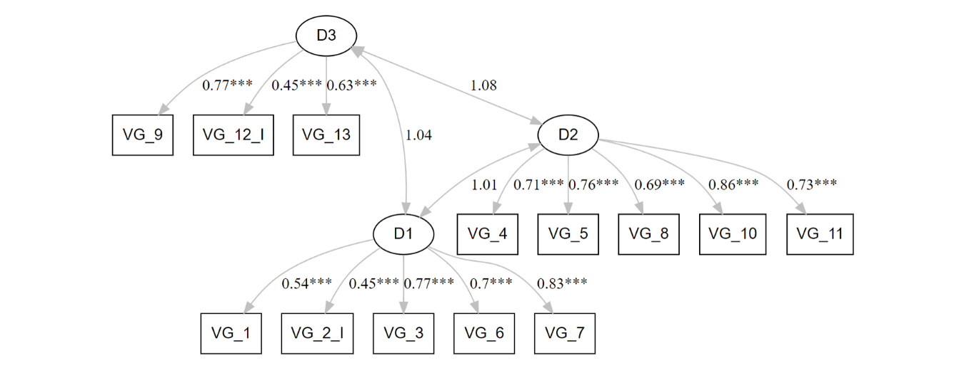

**DIMENSION 1 DE VG**

alpha(D1_VG)

Reliability analysis

Call: alpha(x = D1_VG)

raw_alpha std.alpha G6(smc) average_r S/N ase mean sd median_r

0.79 0.79 0.77 0.44 3.9 0.015 1.5 0.66 0.4

95% confidence boundaries

lower alpha upper

Feldt 0.75 0.79 0.82

Duhachek 0.76 0.79 0.82

Reliability if an item is dropped:

raw_alpha std.alpha G6(smc) average_r S/N alpha se var.r med.r

VG_1 0.77 0.78 0.74 0.47 3.5 0.016 0.0186 0.45

VG_3 0.71 0.72 0.67 0.39 2.5 0.021 0.0104 0.37

VG_6 0.73 0.74 0.70 0.41 2.8 0.020 0.0181 0.37

VG_7 0.72 0.73 0.68 0.40 2.7 0.021 0.0083 0.39

VG_2_I 0.79 0.80 0.77 0.51 4.1 0.017 0.0103 0.50

Item statistics

n raw.r std.r r.cor r.drop mean sd

VG_1 410 0.71 0.69 0.56 0.50 1.6 1.00

VG_3 410 0.81 0.82 0.78 0.69 1.4 0.84

VG_6 410 0.81 0.78 0.70 0.63 1.7 1.11

VG_7 410 0.80 0.79 0.75 0.66 1.4 0.87

VG_2_I 410 0.55 0.63 0.46 0.42 1.6 0.56

Non missing response frequency for each item

1 2 3 4 5 miss

VG_1 0.71 0.14 0.04 0.11 0 0

VG_3 0.74 0.16 0.03 0.07 0 0

VG_6 0.66 0.15 0.04 0.14 0 0

VG_7 0.76 0.14 0.03 0.07 0 0

VG_2_I 0.40 0.55 0.04 0.00 0 0

> reliability(D1_VG)

keys not specified, all items will be scored

Measures of reliability

reliability(keys = D1_VG)

omega_h alpha omega.tot Uni tau cong max.split min.split mean.r med.r n.items CFI ECV Beta EVR

All_items 0.68 0.79 0.83 0.93 0.94 1 0.83 0.68 0.44 0.4 5 0.98 0.88 0.6 3.68

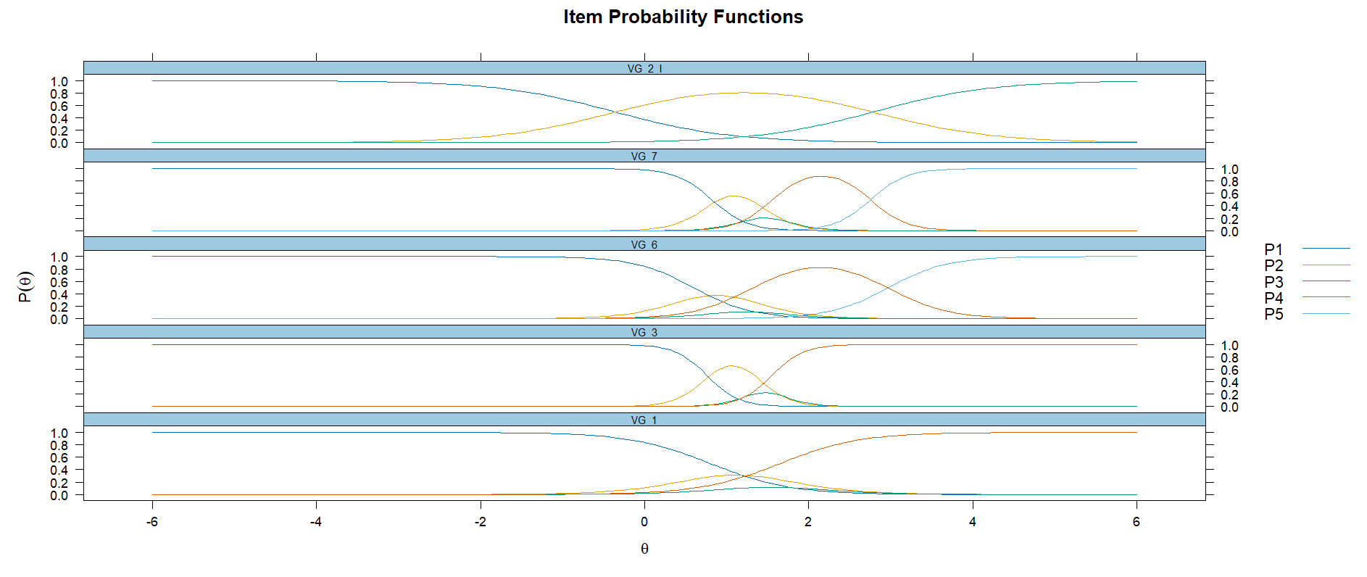

Dimensión 2 VG

alpha(D2_VG)

Reliability analysis

Call: alpha(x = D2_VG)

raw_alpha std.alpha G6(smc) average_r S/N ase mean sd median_r

0.86 0.87 0.84 0.57 6.6 0.011 1.5 0.74 0.57

95% confidence boundaries

lower alpha upper

Feldt 0.84 0.86 0.88

Duhachek 0.84 0.86 0.88

Reliability if an item is dropped:

raw_alpha std.alpha G6(smc) average_r S/N alpha se var.r med.r

VG_4 0.84 0.85 0.81 0.58 5.6 0.013 0.0028 0.58

VG_5 0.83 0.83 0.79 0.56 5.0 0.014 0.0033 0.56

VG_8 0.85 0.85 0.82 0.60 5.9 0.012 0.0019 0.59

VG_10 0.82 0.83 0.79 0.54 4.8 0.014 0.0023 0.55

VG_11 0.82 0.83 0.79 0.56 5.0 0.014 0.0037 0.56

Item statistics

n raw.r std.r r.cor r.drop mean sd

VG_4 410 0.78 0.78 0.70 0.65 1.4 0.87

VG_5 410 0.82 0.82 0.77 0.71 1.4 0.88

VG_8 410 0.79 0.77 0.68 0.63 1.6 1.08

VG_10 410 0.83 0.84 0.80 0.74 1.3 0.76

VG_11 410 0.83 0.83 0.77 0.71 1.5 0.96

Non missing response frequency for each item

1 2 3 4 5 miss

VG_4 0.76 0.14 0.03 0.07 0.00 0

VG_5 0.76 0.14 0.02 0.08 0.00 0

VG_8 0.68 0.14 0.05 0.12 0.01 0

VG_10 0.78 0.14 0.03 0.05 0.00 0

VG_11 0.73 0.15 0.02 0.09 0.01 0

> reliability(D2_VG)

keys not specified, all items will be scored

Measures of reliability

reliability(keys = D2_VG)

omega_h alpha omega.tot Uni tau cong max.split min.split mean.r

All_items 0.81 0.87 0.88 0.99 0.99 1 0.86 0.81 0.57

med.r n.items CFI ECV Beta EVR

All_items 0.57 5 0.99 0.94 0.8 5.86

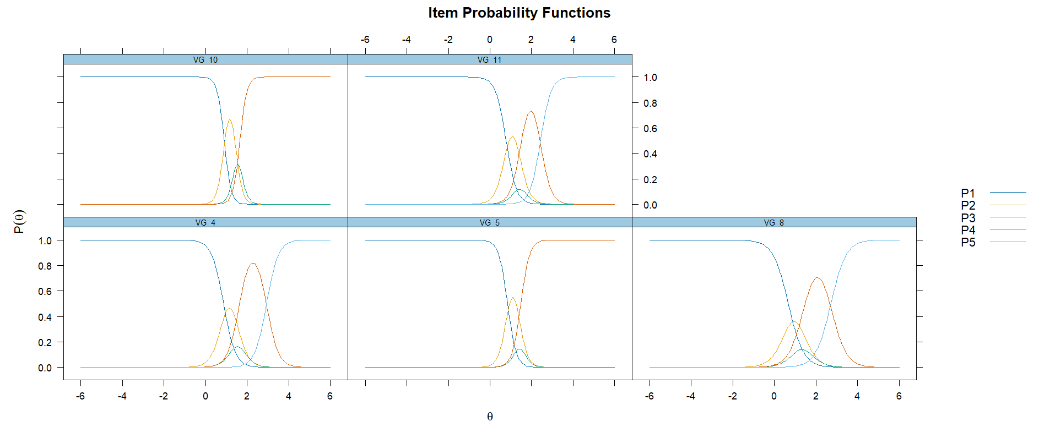

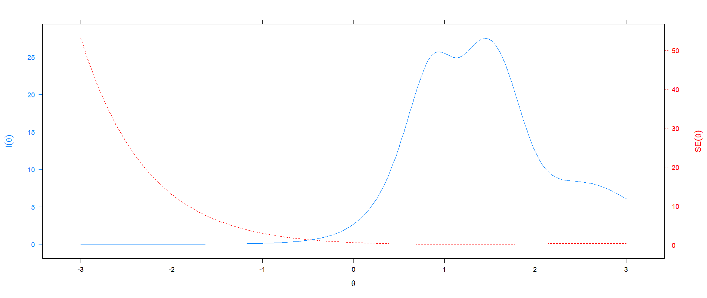

**Dimensión 3**

eliability analysis

Call: alpha(x = D3_VG)

raw_alpha std.alpha G6(smc) average_r S/N ase mean sd median_r

0.61 0.65 0.56 0.38 1.9 0.03 1.5 0.64 0.39

95% confidence boundaries

lower alpha upper

Feldt 0.54 0.61 0.67

Duhachek 0.55 0.61 0.67

Reliability if an item is dropped:

raw_alpha std.alpha G6(smc) average_r S/N alpha se var.r med.r

VG_9 0.39 0.47 0.31 0.31 0.88 0.047 NA 0.31

VG_12_I 0.58 0.62 0.45 0.45 1.65 0.037 NA 0.45

VG_13 0.55 0.56 0.39 0.39 1.28 0.043 NA 0.39

Item statistics

n raw.r std.r r.cor r.drop mean sd

VG_9 410 0.77 0.80 0.65 0.52 1.3 0.74

VG_12_I 410 0.63 0.74 0.50 0.39 1.6 0.57

VG_13 410 0.86 0.76 0.57 0.46 1.7 1.15

Non missing response frequency for each item

1 2 3 4 5 miss

VG_9 0.79 0.13 0.03 0.04 0.00 0

VG_12_I 0.47 0.50 0.04 0.00 0.00 0

VG_13 0.68 0.14 0.04 0.12 0.03 0

> reliability(D3_VG)

keys not specified, all items will be scored

Omega_h for 1 factor is not meaningful, just omega_t

Measures of reliability

reliability(keys = D3_VG)

omega_h alpha omega.tot Uni tau cong max.split min.split mean.r med.r n.items CFI ECV Beta EVR

All_items 0.66 0.65 0.66 0.98 0.98 1 0.64 0.53 0.38 0.39 3 1 0.4 0.59 2.52

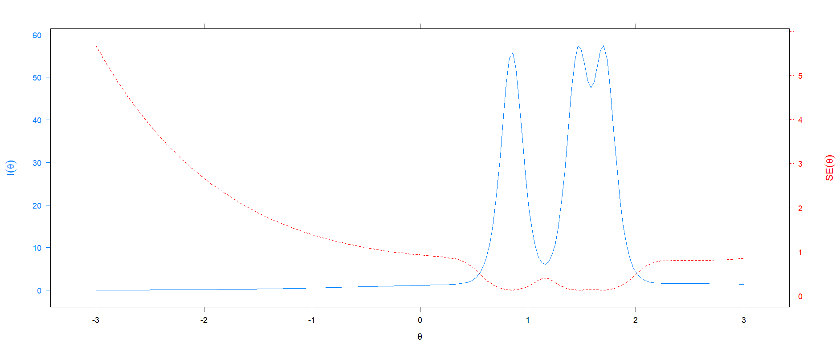

VIOLENCIA OBSTRETICA

Reliability analysis

Call: alpha(x = VO_IT, check.keys = TRUE)

raw_alpha std.alpha G6(smc) average_r S/N ase mean sd median_r

0.9 0.9 0.92 0.34 8.9 0.0082 1.7 0.83 0.36

95% confidence boundaries

lower alpha upper

Feldt 0.88 0.9 0.92

Duhachek 0.89 0.9 0.92

Reliability if an item is dropped:

raw_alpha std.alpha G6(smc) average_r S/N alpha se var.r med.r

VO_1 0.89 0.89 0.91 0.34 8.2 0.0089 0.020 0.35

VO_2 0.90 0.89 0.91 0.34 8.4 0.0086 0.022 0.36

VO_3 0.89 0.89 0.91 0.34 8.2 0.0089 0.020 0.35

VO_4 0.89 0.89 0.91 0.33 8.0 0.0092 0.018 0.35

VO_5 0.89 0.89 0.91 0.34 8.1 0.0091 0.019 0.35

VO_6 0.90 0.89 0.91 0.35 8.5 0.0085 0.022 0.36

VO_7 0.89 0.89 0.91 0.34 8.3 0.0089 0.019 0.35

VO_8- 0.90 0.90 0.92 0.37 9.5 0.0083 0.016 0.37

VO_9 0.89 0.89 0.91 0.34 8.3 0.0088 0.019 0.36

VO_10 0.90 0.90 0.92 0.35 8.5 0.0084 0.022 0.36

VO_11 0.90 0.90 0.92 0.35 8.8 0.0082 0.021 0.36

VO_12 0.89 0.89 0.91 0.34 8.2 0.0088 0.021 0.36

VO_13 0.89 0.89 0.91 0.33 7.9 0.0092 0.019 0.35

VO_14 0.90 0.90 0.92 0.36 9.1 0.0082 0.019 0.36

VO_15 0.90 0.90 0.91 0.35 8.6 0.0084 0.022 0.36

VO_16 0.90 0.89 0.91 0.35 8.4 0.0086 0.022 0.36

VO_17 0.89 0.89 0.91 0.34 8.3 0.0088 0.020 0.36

Item statistics

n raw.r std.r r.cor r.drop mean sd

VO_1 276 0.69 0.69 0.67 0.63 1.7 1.30

VO_2 276 0.62 0.62 0.59 0.55 1.7 1.29

VO_3 276 0.70 0.70 0.68 0.65 1.8 1.35

VO_4 276 0.77 0.76 0.76 0.73 1.8 1.42

VO_5 275 0.74 0.73 0.72 0.69 1.9 1.47

VO_6 276 0.56 0.59 0.55 0.50 1.4 1.04

VO_7 276 0.70 0.67 0.66 0.64 2.0 1.55

VO_8- 276 0.24 0.31 0.24 0.21 1.2 0.41

VO_9 276 0.69 0.65 0.64 0.62 2.1 1.63

VO_10 276 0.61 0.58 0.54 0.52 2.4 1.79

VO_11 276 0.51 0.51 0.46 0.42 1.8 1.45

VO_12 276 0.69 0.70 0.68 0.63 1.6 1.26

VO_13 276 0.77 0.77 0.77 0.73 1.7 1.36

VO_14 276 0.39 0.42 0.38 0.33 1.3 0.93

VO_15 276 0.55 0.55 0.51 0.47 1.8 1.43

VO_16 276 0.61 0.61 0.57 0.55 1.7 1.32

VO_17 276 0.66 0.67 0.65 0.61 1.6 1.15

Non missing response frequency for each item

1 2 3 4 5 miss

VO_1 0.70 0.13 0.04 0.03 0.10 0

VO_2 0.71 0.14 0.03 0.01 0.11 0

VO_3 0.68 0.13 0.04 0.04 0.11 0

VO_4 0.66 0.14 0.02 0.04 0.13 0

VO_5 0.63 0.15 0.03 0.05 0.15 0

VO_6 0.78 0.14 0.01 0.01 0.06 0

VO_7 0.64 0.13 0.03 0.03 0.18 0

VO_8 0.00 0.00 0.01 0.14 0.85 0

VO_9 0.59 0.13 0.03 0.04 0.21 0

VO_10 0.57 0.09 0.02 0.02 0.29 0

VO_11 0.71 0.11 0.02 0.02 0.15 0

VO_12 0.72 0.13 0.04 0.01 0.10 0

VO_13 0.69 0.14 0.02 0.02 0.12 0

VO_14 0.82 0.12 0.01 0.00 0.05 0

VO_15 0.71 0.12 0.01 0.01 0.14 0

VO_16 0.70 0.14 0.01 0.05 0.10 0

VO_17 0.73 0.13 0.04 0.03 0.07 0

ANALISIS CONFIRMATORIO

summary(V0_A, fit.measures = TRUE)

lavaan 0.6-19 ended normally after 29 iterations

Estimator ML

Optimization method NLMINB

Number of model parameters 34

Used Total

Number of observations 275 276

Model Test User Model:

Test statistic 546.512

Degrees of freedom 119

P-value (Chi-square) 0.000

Model Test Baseline Model:

Test statistic 2137.456

Degrees of freedom 136

P-value 0.000

User Model versus Baseline Model:

Comparative Fit Index (CFI) 0.786

Tucker-Lewis Index (TLI) 0.756

Loglikelihood and Information Criteria:

Loglikelihood user model (H0) -6881.165

Loglikelihood unrestricted model (H1) -6607.910

Akaike (AIC) 13830.331

Bayesian (BIC) 13953.301

Sample-size adjusted Bayesian (SABIC) 13845.494

Root Mean Square Error of Approximation:

RMSEA 0.114

90 Percent confidence interval - lower 0.105

90 Percent confidence interval - upper 0.124

P-value H_0: RMSEA <= 0.050 0.000

P-value H_0: RMSEA >= 0.080 1.000

Standardized Root Mean Square Residual:

SRMR 0.073

Parameter Estimates:

Standard errors Standard

Information Expected

Information saturated (h1) model Structured

Latent Variables:

Estimate Std.Err z-value P(>|z|)

VO =~

VO_1 1.000

VO_2 0.828 0.093 8.926 0.000

VO_3 1.044 0.097 10.718 0.000

VO_4 1.263 0.104 12.167 0.000

VO_5 1.232 0.107 11.537 0.000

VO_6 0.601 0.074 8.085 0.000

VO_7 1.165 0.112 10.408 0.000

VO_8 -0.096 0.029 -3.342 0.001

VO_9 1.180 0.118 10.040 0.000

VO_10 1.050 0.128 8.227 0.000

VO_11 0.663 0.103 6.450 0.000

VO_12 0.945 0.091 10.370 0.000

VO_13 1.172 0.099 11.826 0.000

VO_14 0.305 0.065 4.656 0.000

VO_15 0.759 0.102 7.466 0.000

VO_16 0.829 0.094 8.777 0.000

VO_17 0.838 0.083 10.128 0.000

Variances:

Estimate Std.Err z-value P(>|z|)

.VO_1 0.880 0.081 10.818 0.000

.VO_2 1.125 0.100 11.240 0.000

.VO_3 0.937 0.087 10.797 0.000

.VO_4 0.737 0.074 9.993 0.000

.VO_5 0.937 0.090 10.429 0.000

.VO_6 0.794 0.070 11.363 0.000

.VO_7 1.311 0.120 10.900 0.000

.VO_8 0.159 0.014 11.680 0.000

.VO_9 1.541 0.140 11.005 0.000

.VO_10 2.306 0.203 11.345 0.000

.VO_11 1.745 0.151 11.525 0.000

.VO_12 0.875 0.080 10.911 0.000

.VO_13 0.747 0.073 10.252 0.000

.VO_14 0.785 0.067 11.632 0.000

.VO_15 1.576 0.138 11.435 0.000

.VO_16 1.188 0.105 11.265 0.000

.VO_17 0.752 0.069 10.981 0.000

VO 0.800 0.126 6.348 0.000

