Template of International Journal of Electrical, Energy and Power System Engineering (16 pt)

First Author^{1*}, Second Author² (10 pt)
¹First Author Affiliation, Country, e-mail
²Second Author Affiliation, Country, e-mail
*Corresponding author, e-mail

Abstract— Abstract example. The abstract is written in English. Use 10 pt Abadi MT, 0.5cm left and right indentation. The maximum length is 200 words, and make sure the grammars are correct. Please use a spelling checker in order to ensure the correct spelling. The abstract cannot contain equations, figures, tables, or references.

Keywords: Keyword 1, Keyword 2, Keyword 3, Keyword 4, Keyword 5. (italic 10 pt)
This work is licensed under a CC BY-SA. Copyright ©2024 by Author. Published by Universitas Riau.

INTRODUCTION (11 pt)
The title of each section is written in 11pt Arial. Introductions consist of the background or problem and the significance of the research. It also should clearly state the purpose of the research, gap analysis, and hypothesis (if any). When describing gap analysis, please provide references for other related previous works and clearly state the position of the research to other literature.
METHOD (11 pt)
All figures and tables should be centered and numbered consecutively. Use the “Figure. 1,” to cite the figure in the text and Table. 1 to cite the table in the text. Such as the power system components can be divided into five primary levels or subsystems, as shown in Figure 1 below:

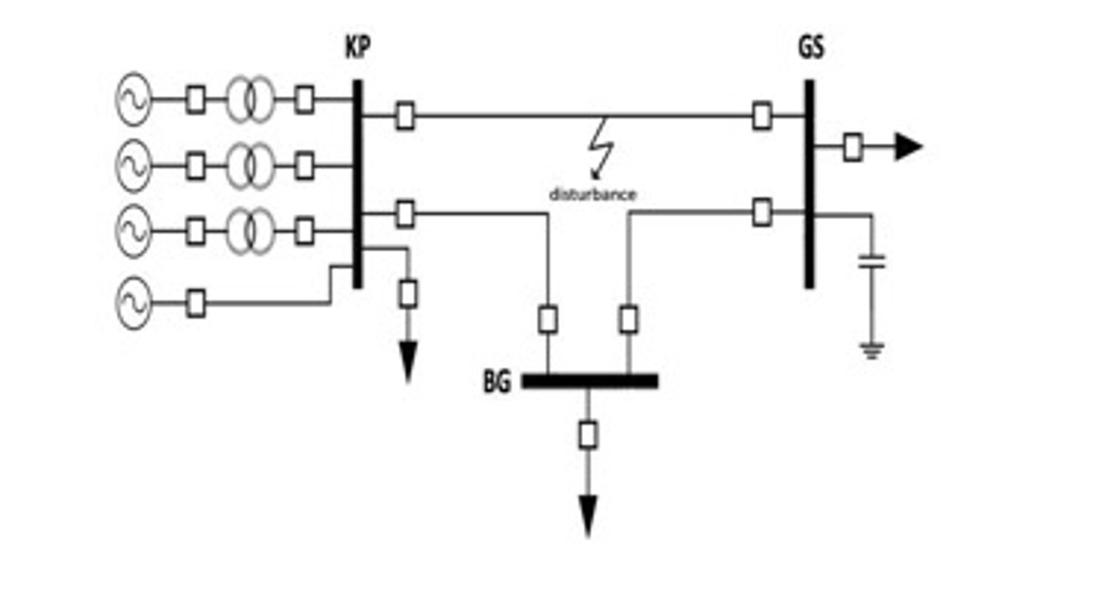
Figure 1. Electrical power system

Table 1. Example on How to Present Your Second Table
Column Title | Column A (t) | Column B (t)
First row | 1 | 2
Second row | 3 | 4
Next row | 5 | 6

Number equations consecutively with equation numbers in parentheses flush with the right margin (1). Be sure that the symbols in your equation have been defined before the equation appears or immediately following.
Y = 10 x² - 6 (1)
- Second-Order Heading (11 pt)
This section contains the methodology or theory used to solve problems from articles published in International Journal of Electrical, Energy and Power System Engineering. The section addresses connections between findings and basic concepts or hypotheses made earlier. Authors should also express whether any arguments were needed relating to other works from other researchers. Write implications caused by the work related to theoretical or applications. Write results in a logical sequence.
- Second-Order Heading (11 pt)
This section contains the methodology or theory used to solve problems from articles published in International Journal of Electrical, Energy and Power System Engineering. The section addresses connections between findings and basic concepts or hypotheses made earlier. Authors should also express whether any arguments were needed relating to other works from other researchers. Write implications caused by the work related to theoretical or applications. Write results in a logical sequence.
RESULT AND DISCUSSION (11 pt)
This section contains the results and discussion of articles published in the International Journal of Electrical, Energy and Power System Engineering . The conclusion should be linked to the title and objectives of the study. Do not make statements not adequately supported by your findings. Do not use bulleted points; use paragraphed sentences instead
CONCLUSION (11 pt) (11 pt)
This section contains conclusions from articles published in the International Journal of Electrical, Energy and Power System Engineering. Papers accepted for publication are strictly limited to 6-12 pages in a one-column format following this template.
ACKNOWLEDGMENT (11 pt)
Financial support should be stated in acknowledgment. The preferred spelling of the word “acknowledgment” in America is without an “e” after the “g”. Avoid the stilted expression “one of us (R. B. G.) thanks ...”. Instead, try “R. B. G. thanks...”. Put sponsor acknowledgments in the unnumbered footnote on the first page.
REFERENCES (11 pt)
References are important to the reader; therefore, each citation must be complete and correct. Please use citation software such as Endnote and Mendeley. List only one reference per reference number. If a reference is available from two sources, each should be listed as a separate reference. Give all authors' names; do not use et al. Use IEEE reference style.
DVD
- I. Holm, Narrator, and J. Fullerton-Smith, Producer, How to Build a Human [DVD]. London: BBC; 2002.

Sound Recording
- D. Fisher, Writer, and T. Baker, Presenter, Doctor Who and the Creature From the Pit [Sound recording]. Bath, UK: BBC Audiobooks, 2009.

Video Recording
- C. Rogers, Writer and Director, Grrls in IT [Videorecording]. Bendigo, Vic. : Video Education Australasia, 1999.

YouTube/Vimeo Video
- NRK. "Medieval helpdesk with English subtitles," YouTube, Feb. 26, 2007 [Video file]. Available: http://www.youtube.com/watch?v=pQHX-SjgQvQ. [Accessed: Jan. 28, 2014].

Chapter or Article in Edited Book
- A. Rezi and M. Allam, "Techniques in array processing by means of transformations, " in Control and Dynamic Systems, Vol. 69, Multidemsional Systems, C. T. Leondes, Ed. San Diego: Academic Press, 1995, pp. 133-180.

Book: Single Author
- W.-K. Chen, Linear Networks and Systems. Belmont, CA: Wadsworth, 1993, pp. 123-135
Book: Two or More Authors
- U. J. Gelinas, Jr., S. G. Sutton, and J. Fedorowicz, Business Processes and Information Technology. Cincinnati: South-Western/Thomson Learning, 2004.

Book: Organisation as Author
- World Bank, Information and Communication Technologies: A World Bank group strategy. Washington, DC: World Bank, 2002.

Book: Government Agency as Author
- Australia. Attorney-Generals Department., Digital Agenda Review, 4 Vols. Canberra: Attorney- General's Department, 2003.

Book: No Author
- The Oxford Dictionary of Computing, 5th ed. Oxford: Oxford University Press, 2003.

Book: Editor
- D. Sarunyagate, Ed., Lasers. New York: McGraw-Hill, 1996.

Book: Different Editions
- K. Schwalbe, Information Technology Project Management, 3rd ed. Boston: Course Technology, 2004.

Scientific/Technical Report
- K. E. Elliott and C.M. Greene, "A local adaptive protocol," Argonne National Laboratory, Argonne, France, Tech. Rep. 916-1010-BB, 1997.

Conference Paper in Print
- L. Liu and H. Miao, "A specification based approach to testing polymorphic attributes," in Formal Methods and Software Engineering: Proc. of the 6th Int. Conf. on Formal Engineering Methods, ICFEM 2004, Seattle, WA, USA, November 8-12, 2004, J. Davies, W. Schulte, M. Barnett, Eds. Berlin: Springer, 2004. pp. 306-19.

BIOGRAPHIES OF AUTHORS (11 pt)
FIRST A. AUTHOR (M’76–SM’81–F’87) and all authors may include biographies. Biographies are often not included in conference-related papers. This author became a Member (M) of IEEE in 1976, a Senior Member (SM) in 1981, and a Fellow (F) in 1987. The first paragraph may contain a place and/or date of birth (list place, then date). Next, the author’s educational background is listed. The degrees should be listed with type of degree in what field, which institution, city, state, and country, and year the degree was earned. The author’s major field of study should be lower-cased.
Photo

Photo

SECOND B. AUTHOR was born in Greenwich Village, New York, NY, USA in 1977. He received the B.S. and M.S. degrees in aerospace engineering from the University of Virginia, Charlottesville, in 2001 and the Ph.D. degree in mechanical engineering from Drexel University, Philadelphia, PA, in 2008. From 2001 to 2004, he was a Research Assistant with the Princeton Plasma Physics Laboratory.

Photo

THIRD C. AUTHOR, JR. (M’87) received the B.S. degree in mechanical engineering from National Chung Cheng University, Chiayi, Taiwan, in 2004 and the M.S. degree in mechanical engineering from National Tsing Hua University, Hsinchu, Taiwan, in 2006. He is currently pursuing the Ph.D. degree in mechanical engineering at Texas A&M University, College Station, TX, USA. From 2008 to 2009, he was a Research Assistant with the Institute of Physics, Academia Sinica, Tapei, Taiwan.

