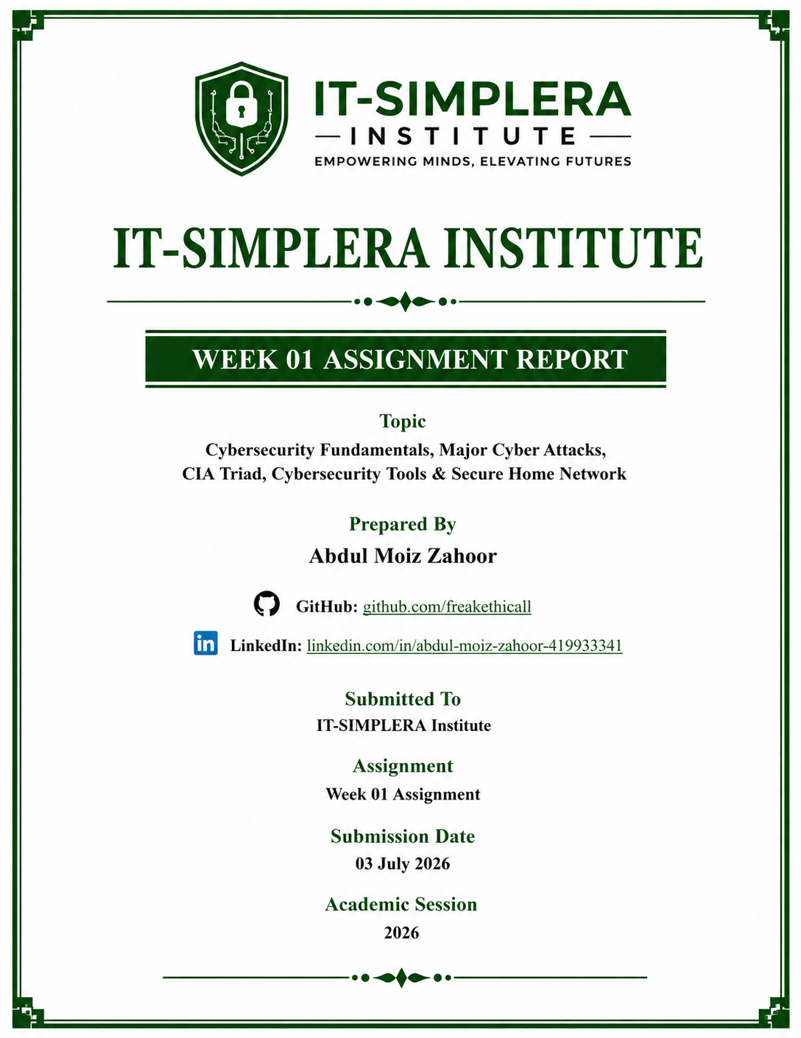

IT-SIMPLERA INSTITUTE

CYBER SECURITY ANALYST INTERNSHIP PROGRAM
WEEK 01 ASSIGNMENT REPORT
Prepared By:
Abdul Moiz Zahoor
Submitted To:
IT-SIMPLERA Cyber Security Team
Submission Date:
03 July 2026

Executive Summary:
This report presents a comprehensive study of fundamental cybersecurity concepts completed as part of the IT-SIMPLERA Cyber Security Analyst Internship Program – Week 1 Assignment. The primary objective of this report is to develop a strong understanding of modern cybersecurity threats, security principles, defensive technologies, and the responsibilities of cybersecurity professionals in protecting digital assets.
The report begins with an analysis of five significant real-world cyberattacks, including WannaCry, SolarWinds, Equifax, Colonial Pipeline, and Yahoo, highlighting their causes, impacts, and key lessons learned. It further explains the CIA Triad (Confidentiality, Integrity, and Availability), which serves as the foundation of information security and guides organizations in protecting sensitive data and maintaining secure systems.
In addition, the report introduces three widely used cybersecurity tools—Nmap, Wireshark, and Metasploit—describing their features, advantages, and practical applications in network security, vulnerability assessment, traffic analysis, and penetration testing. The assignment also includes the design of a secure home network, emphasizing essential security measures such as firewalls, secure Wi-Fi configuration, antivirus protection, and network segmentation.
Finally, the report discusses the key roles and responsibilities of a cybersecurity analyst, including security monitoring, incident response, vulnerability management, risk assessment, and compliance. Overall, this assignment provides valuable theoretical knowledge and practical insight into modern cybersecurity practices while strengthening technical research, analytical thinking, and professional documentation skills.

Introduction
Cybersecurity is the practice of protecting computer systems, networks, applications, and digital information from cyber threats, unauthorized access, data breaches, and malicious attacks. As businesses, governments, educational institutions, and individuals increasingly depend on digital technologies, the importance of maintaining strong cybersecurity has become greater than ever. Cybercriminals continuously develop new attack techniques such as ransomware, phishing, malware, supply chain attacks, and data breaches, making cybersecurity an essential component of modern information technology.
Organizations rely on the CIA Triad—Confidentiality, Integrity, and Availability—to ensure that sensitive information remains protected, accurate, and accessible only to authorized users. Achieving these objectives requires a combination of technical controls, security policies, employee awareness, and continuous monitoring to defend against evolving cyber threats.
This report examines several major cyberattacks that have significantly impacted organizations around the world and analyzes their effects using the CIA Triad framework. It also explores widely used cybersecurity tools such as Nmap, Wireshark, and Metasploit, which assist security professionals in network analysis, vulnerability assessment, and penetration testing. Furthermore, the report presents the concept of a secure home network and discusses the daily responsibilities of a cybersecurity analyst in identifying, preventing, and responding to cyber incidents.
Through this assignment, valuable knowledge has been gained regarding cybersecurity fundamentals, industry best practices, and defensive security strategies. The research conducted provides a strong foundation for future learning, professional certifications, and a successful career in cybersecurity.

Task 1: Five Real-World Cyberattacks
Attack | Year | Organization | Type | Impact
WannaCry | 2017 | NHS & Others | Ransomware | Global disruption | Lessons: Apply patches, backups, MFA, monitoring.
SolarWinds | 2020 | SolarWinds | Supply Chain | Espionage | Lessons: Apply patches, backups, MFA, monitoring.
Equifax | 2017 | Equifax | Data Breach | 147M records | Lessons: Apply patches, backups, MFA, monitoring.
Colonial Pipeline | 2021 | Colonial Pipeline | Ransomware | Fuel shortage | Lessons: Apply patches, backups, MFA, monitoring.
Yahoo | 2016 | Yahoo | Data Breach | 3B accounts | Lessons: Apply patches, backups, MFA, monitoring.
 |  |  |  | | Lessons: Apply patches, backups, MFA, monitoring.

WannaCry Ransomware Attack (2017)
The WannaCry ransomware attack, which occurred in May 2017, is considered one of the most devastating cyberattacks in history. The malware exploited the EternalBlue vulnerability in the Microsoft Windows Server Message Block (SMBv1) protocol, allowing it to spread rapidly across networks without requiring user interaction. Once a system was infected, the ransomware encrypted files and demanded payment in Bitcoin in exchange for the decryption key. More than 300,000 computers across over 150 countries were affected, including hospitals, businesses, universities, and government organizations. The United Kingdom's National Health Service (NHS) suffered severe disruptions, leading to cancelled medical appointments and delayed healthcare services. This incident highlighted the critical importance of timely security patch management, regular offline backups, endpoint protection, and continuous vulnerability assessment to prevent large-scale ransomware attacks.

SolarWinds Supply Chain Attack (2020)
The SolarWinds cyberattack, discovered in December 2020, was one of the most sophisticated supply chain attacks ever recorded. Attackers successfully compromised the software development environment of SolarWinds and inserted malicious code into legitimate updates of the Orion network management platform. When customers downloaded these trusted updates, the malware was silently installed, giving attackers unauthorized access to thousands of networks worldwide. Numerous government agencies, technology companies, and private organizations were affected, making the attack a significant national security concern. The incident demonstrated the growing risks associated with software supply chain attacks and emphasized the need for secure software development practices, code integrity verification, Zero Trust Architecture, continuous monitoring, and advanced threat detection solutions.

Equifax Data Breach (2017)
The Equifax data breach occurred in 2017 after attackers exploited a known vulnerability in the Apache Struts web application framework that had not been patched by the organization. As a result, cybercriminals gained unauthorized access to highly sensitive personal information, including names, addresses, Social Security numbers, driver's license numbers, dates of birth, and financial records of approximately 147 million individuals. The breach caused significant financial losses, legal consequences, and reputational damage to the company. It also highlighted the importance of vulnerability management, regular software updates, secure system configuration, continuous security monitoring, and effective incident response planning. Organizations worldwide continue to study this incident as an example of the consequences of poor patch management.

Colonial Pipeline Ransomware Attack (2021)
In May 2021, Colonial Pipeline, one of the largest fuel pipeline operators in the United States, became the victim of a ransomware attack carried out by the DarkSide ransomware group. Attackers gained access to the company's network through compromised VPN credentials that were not protected with Multi-Factor Authentication (MFA). Although the operational technology systems were not directly compromised, the organization temporarily shut down pipeline operations to contain the attack, causing fuel shortages and economic disruption across several U.S. states. This incident emphasized the importance of implementing Multi-Factor Authentication, network segmentation, continuous security monitoring, strong password policies, and a well-defined incident response plan to minimize operational disruptions during cyber incidents.

Yahoo Data Breach (2016)
The Yahoo data breach is recognized as one of the largest data breaches in history, affecting approximately three billion user accounts. Attackers obtained unauthorized access to user information, including names, email addresses, phone numbers, dates of birth, hashed passwords, and security questions. The breach remained undisclosed for several years before being publicly reported, leading to significant reputational damage and a reduction in Yahoo's acquisition value during its sale. The incident demonstrated the importance of implementing strong authentication mechanisms, encryption of sensitive information, continuous security monitoring, timely breach disclosure, and proactive threat detection. It also reinforced the need for organizations to regularly review their security controls and incident response procedures to protect customer information.

Task 2: CIA Triad
The CIA Triad is one of the most fundamental security models in cybersecurity. It provides the foundation for designing, implementing, and evaluating information security policies and controls. The three core principles—Confidentiality, Integrity, and Availability—work together to ensure that information systems remain secure, reliable, and accessible to authorized users. Organizations use the CIA Triad to assess risks, develop security strategies, and protect critical information from cyber threats.

1. Confidentiality
Confidentiality ensures that sensitive information is accessible only to authorized individuals or systems. It protects personal, financial, and organizational data from unauthorized access, disclosure, or theft. Organizations achieve confidentiality by implementing security measures such as strong authentication, role-based access control (RBAC), encryption, multi-factor authentication (MFA), and data classification. Maintaining confidentiality is essential for protecting user privacy, intellectual property, and business-critical information.

2. Integrity
Integrity ensures that information remains accurate, complete, and unaltered throughout its lifecycle. It prevents unauthorized modifications, deletion, or corruption of data, ensuring that users can trust the information they access. Security mechanisms such as hashing algorithms, digital signatures, file integrity monitoring, version control, and audit logs help maintain data integrity. Preserving integrity is crucial for financial systems, healthcare records, government databases, and other environments where data accuracy is essential.

3. Availability
Availability ensures that systems, applications, and information are accessible to authorized users whenever they are needed. Cyberattacks such as ransomware and Distributed Denial-of-Service (DDoS) attacks can disrupt availability by preventing users from accessing critical services. Organizations maintain availability through regular backups, disaster recovery planning, redundant systems, failover mechanisms, load balancing, continuous monitoring, and timely system maintenance. High availability is essential for businesses that depend on uninterrupted access to their digital services.

Attack | Affected Principle | Reason
WannaCry | Availability | Systems encrypted
SolarWinds | Confidentiality & Integrity | Unauthorized access
Equifax | Confidentiality | Sensitive data stolen
Colonial Pipeline | Availability | Operations disrupted
Yahoo | Confidentiality | Account data exposed

Task 3: Cybersecurity Tools
Tool | Purpose | Advantages | Real-world Use
Nmap | Network discovery, host identification, and port scanning | Fast and flexible | Security auditing
Wireshark | Packet analysis | Deep protocol inspection | Network troubleshooting
Metasploit | Exploit framework | Large exploit database | Authorized penetration testing

Nmap (Network Mapper)
Nmap is a powerful open-source network scanning and security auditing tool used by cybersecurity professionals to discover devices connected to a network and identify open ports, running services, and operating systems. It helps security analysts detect exposed systems, identify misconfigurations, and evaluate the security posture of a network. Nmap supports various scanning techniques, including TCP, UDP, SYN, and version detection scans, making it an essential tool for vulnerability assessments, network inventory, and penetration testing.

Wireshark
Wireshark is a widely used network protocol analyzer that captures and examines network traffic in real time. It enables cybersecurity professionals to inspect individual data packets, analyze communication between devices, troubleshoot network issues, detect suspicious activities, and investigate malware-related traffic. Wireshark supports hundreds of network protocols and is commonly used for network troubleshooting, digital forensics, incident response, and security analysis.

Metasploit Framework
Metasploit is an advanced penetration testing framework that helps security professionals identify, validate, and demonstrate security vulnerabilities in a controlled and authorized environment. It provides a comprehensive collection of exploits, payloads, auxiliary modules, and post-exploitation tools that simulate real-world cyberattacks. Metasploit is widely used during penetration tests to assess system security, verify vulnerabilities, evaluate defensive measures, and generate detailed security assessment reports while helping organizations strengthen their overall cybersecurity posture
.

Task 4: Secure Home Network Diagram
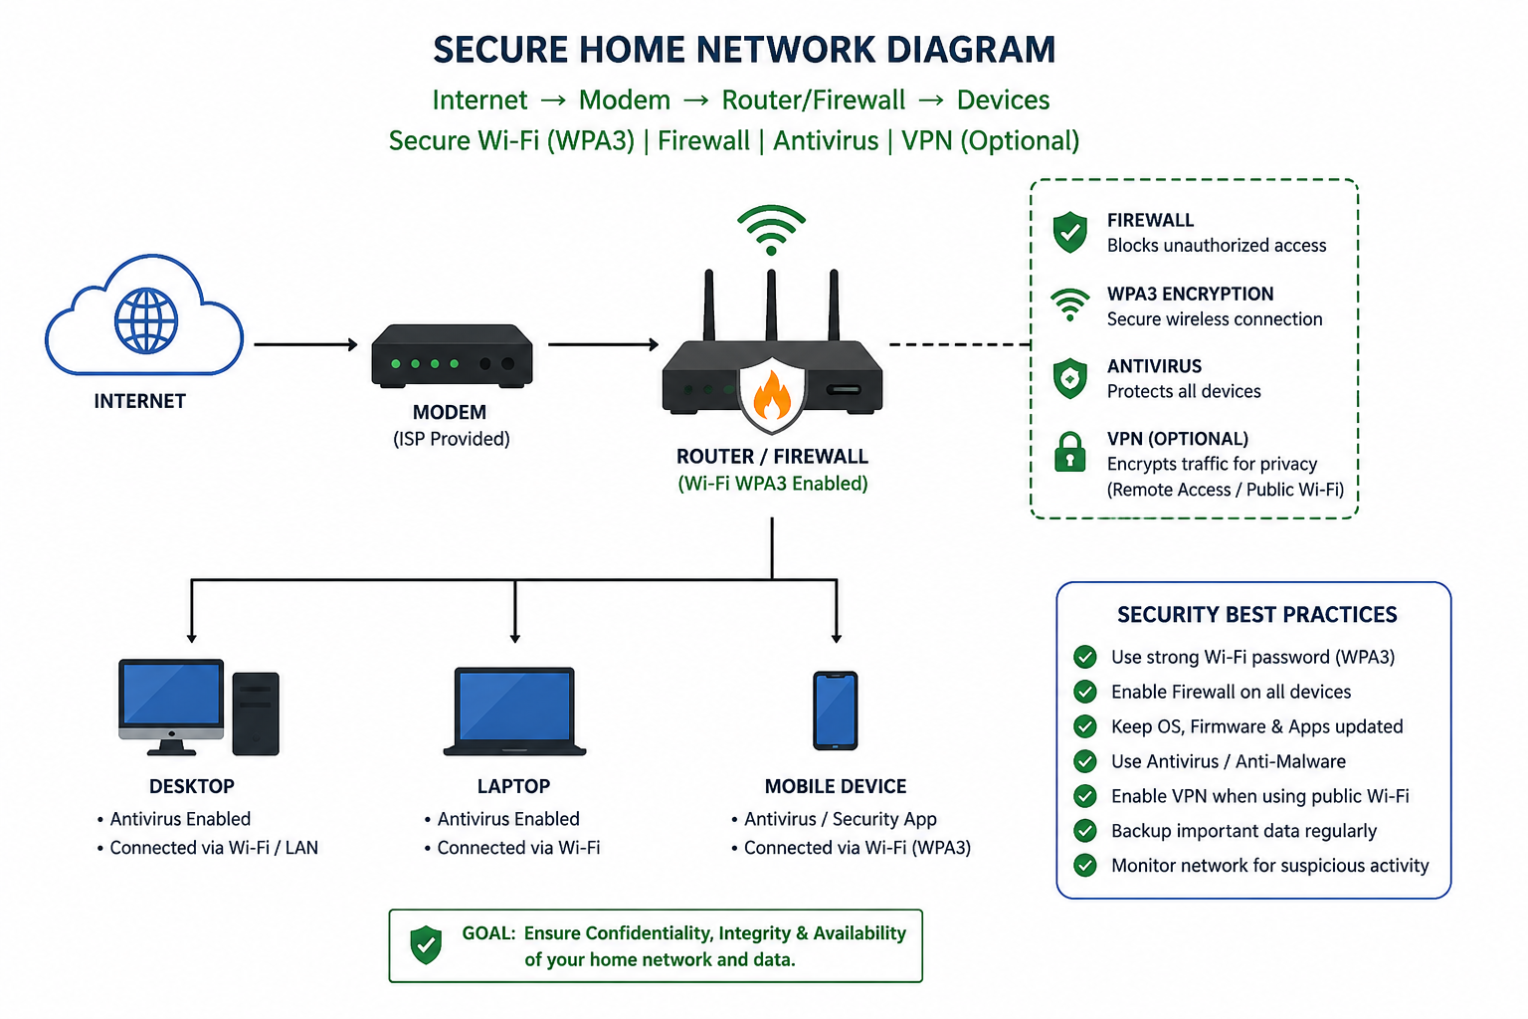

Task 5: Responsibilities of a Cybersecurity Analyst
A Cybersecurity Analyst plays a vital role in protecting an organization's digital infrastructure, sensitive information, and network resources from cyber threats. Their primary responsibility is to continuously monitor systems and networks for suspicious activities using security monitoring tools such as Security Information and Event Management (SIEM) platforms. They investigate security alerts, analyze system and network logs, and identify potential vulnerabilities before attackers can exploit them.
Cybersecurity analysts conduct regular vulnerability assessments and security audits to evaluate the organization's security posture. They work closely with IT teams to apply security patches, configure firewalls, implement access controls, and strengthen endpoint security. During a security incident, they perform incident response activities by containing threats, investigating the root cause, recovering affected systems, and documenting the incident for future reference.
In addition to technical responsibilities, cybersecurity analysts prepare detailed security reports, maintain documentation, support compliance with security standards and regulations, and assist management in making informed security decisions. They also educate employees about cybersecurity best practices, phishing awareness, password security, and safe internet usage to reduce the risk of human-related security incidents.
Furthermore, cybersecurity analysts stay updated with the latest cyber threats, attack techniques, and emerging technologies through continuous learning, threat intelligence, security research, and professional certifications. Their proactive approach helps organizations improve their overall security posture, reduce cyber risks, and ensure the confidentiality, integrity, and availability (CIA Triad) of critical information systems.

Conclusion
This assignment provided a comprehensive understanding of fundamental cybersecurity concepts, including the analysis of major real-world cyberattacks, the CIA Triad, essential cybersecurity tools, and secure network design principles. By studying incidents such as WannaCry, SolarWinds, Equifax, Colonial Pipeline, and Yahoo, it became evident how cyber threats can significantly impact organizations, compromise sensitive information, and disrupt critical services. The assignment also highlighted the importance of implementing strong security measures such as regular system updates, vulnerability management, multi-factor authentication, network segmentation, encryption, and continuous monitoring.
Furthermore, exploring tools such as Nmap, Wireshark, and Metasploit provided valuable insight into how cybersecurity professionals identify vulnerabilities, analyze network traffic, and perform authorized security assessments. Understanding the daily responsibilities of a cybersecurity analyst emphasized the importance of proactive threat detection, incident response, risk assessment, and security awareness in protecting organizational assets. Overall, this assignment strengthened both theoretical knowledge and practical understanding of cybersecurity, providing a solid foundation for future learning, professional certifications, and a career in cybersecurity.

References
- National Institute of Standards and Technology. (2024). Cybersecurity Framework (CSF) 2.0. Retrieved from https://www.nist.gov/cyberframework
- Cybersecurity and Infrastructure Security Agency. (2024). Cybersecurity Best Practices. Retrieved from https://www.cisa.gov
- OWASP Foundation. (2024). OWASP Top 10: Web Application Security Risks. Retrieved from https://owasp.org/www-project-top-ten/
- Microsoft. (2024). Microsoft Security Documentation. Retrieved from https://learn.microsoft.com/security/
- Cisco Systems. (2024). Cisco Learning Network. Retrieved from https://learningnetwork.cisco.com
- MITRE Corporation. (2024). MITRE ATT&CK Framework. Retrieved from https://attack.mitre.org
- SANS Institute. (2024). SANS Reading Room. Retrieved from https://www.sans.org/white-papers/

