**A**

**Summer Internship Report**

**On**

**"Blood Bank Project"**

(CE446 – Summer Internship - I)

**Prepared by**

Amar Gokani(19CE031)

**Under the Supervision of**

Assistant Prof. Dhaval Bhoi

**Submitted to**

Charotar University of Science & Technology (CHARUSAT)

for the Partial Fulfillment of the Requirements for the

Degree of Bachelor of Technology (B.Tech.)

for Semester 5

**Submitted at**



**Accredited with Grade A by NAAC**

**Accredited with Grade A by KCG**



**U & P U. PATEL DEPARTMENT OF COMPUTER ENGINEERING**

**Chandubhai S. Patel Institute of Technology (CSPIT)**

**Faculty of Technology & Engineering (FTE), CHARUSAT**

**At: Changa, Dist: Anand, Pin: 388421.**

**July 2021**



**Accredited with Grade A by NAAC**

**Accredited with Grade A by KCG**

**CERTIFICATE**

This is to certify that the report entitled “**Blood Bank Project**” is a bonafied work carried out by **Amar Gokani (19CE031)** under the guidance and supervision of **Assistant Prof. Dhaval Bhoi** / **Prof. Amit Thakkar** for the subject **Summer Internship – II (CE446)** of 7th Semester of Bachelor of Technology in **Computer Engineering** at Chandubhai S. Patel Institute of Technology (CSPIT), Faculty of Technology & Engineering (FTE) – CHARUSAT, Gujarat.

To the best of my knowledge and belief, this work embodies the work of candidate himself, has duly been completed, and fulfills the requirement of the ordinance relating to the B.Tech. Degree of the University and is up to the standard in respect of content, presentation and language for being referred by the examiner(s).

|  |  |
| --- | --- |
| Under the supervision of,  Assistant Prof. Dhaval Bhoi  Assistant Professor  U & P U. Patel Dept. of Computer Engineering  CSPIT, FTE, CHARUSAT, Changa, Gujarat |  |
| Dr. Ritesh Patel  Head - U & P U. Patel Department of Computer Engineering,  CSPIT, FTE, CHARUSAT, Changa, Gujarat. | |

**Chandubhai S. Patel Institute of Technology (CSPIT)**

**Faculty of Technology & Engineering (FTE), CHARUSAT**

At: Changa, Ta. Petlad, Dist. Anand, Pin: 388421. Gujarat.

**Acknowledgement**

With the help and guidance of the professors this project could see the light of the day. Our heartiest thanks to Prof. Dhaval Bhoi for providing us with the guidance and encouragement to develop this project, which thus helped us in shaping our abilities towards a constructive goal.

We owe special debt of gratitude to Dr. Ritesh Patel and Prof. Amit Thakkar for their constant support and guidance throughout the course of our work. Their sincerity, thoroughness and perseverance to have been a constant source of inspiration for us.

We also thank all the staff of the blood bank who took time out of their busy schedule to explain all the different modules and all the working of the blood bank so that we could develop the project and lead it to a better path.

We also would like to thank all our colleagues who have helped us solve doubts and issue that we have faced throughout the project and are grateful to all the people who were part of the project.

**Abstract**

The project describes the blood bank management system. This report will help you know in deep the actual work that has been done as a team work. The main objective of the application is to digitalize the documentation. They need to maintain thousands of records. also searching should be an option, so that the results our found. Main objective is to create a system which helps the staff complete their work faster in a simple way by using computer and the olden ways of paper.

Table of Contents

Acknowledgement……………………………………………………………………i

Abstract……………………………………………………………………………….ii

Chapter 1 Introduction………………………………………………………….........1

1.1 Purpose of Internship .....1

1.2 Overview of Project .1

1.3 Objective 1

1.4 Scope 1

1.5 Roles and Responsibilities 2

1.6 Internship plan (Week wise)…………………………………………………….3

Chapter 2 System Analysis…………………………………………………………..4

2.1 Study of existing system & its limitations 4

2.2 Requirement of new system 4

2.2.1 Functional Requirements.…………………………………………………………4

2.2.2 Non-functional Requirements……………………………………………..............5

2.3 Hardware Requirements 6

2.4 Software Requirements 6

Chapter 3 Development Environment……………………………………….............7

Chapter 4 System Design……………………………………………………………..8

4.1 ER Diagram …………………………………8

Chapter 5 Implementation Screenshots……………………………………………..9

Chapter 6 Test Cases………………………………………………………….............15

Chapter 7 Limitations and Future Work…………………………………………….16

7.1 Limitations……………………………………………………………………...16

7.2 Future Work…………………………………………………………………….16

Chapter 8 Conclusion………………………………………………………………….17

References……………………………………………………………………...……….18

**List of Figures**

Fig 4.1 ER Diagram 8

Fig 5.1 Implementation Screenshot 1 9

Fig 5.2 Implementation Screenshot 2 10

Fig 5.3 Implementation Screenshot 3 11

Fig 5.4 Implementation Screenshot 4 12

**Fig 5.5 Implementation Screenshot 5………………………………………………….13**

**Fig 5.6 Implementation Screenshot 6………………………………………………….13**

**Fig 5.7 Implementation Screenshot 7………………………………………………….14**

**List of Tables**

Table 1.1 Roles and Responsibilities 2

Table 1.2 Internship Plan (Week wise) 3

Table 6.1 Test Cases 15

**CHAPTER 1: INTRODUCTION**

* 1. **PURPOSE OF INTERNSHIP**

Blood Bank Management Software is designed & suitable for several Blood Bank either operating as individual organization or part of Hospital. It covers all Blood banking process from Donor recruitment, donor management, mobile sessions, component preparation, screening covering all tests, blood stock inventory maintenance, patient registration, cross matching, patient issues etc.

* 1. **OVERVIEW OF PROJECT**

The project consists of several modules that form the complete project which is to be used in the blood bank. It starts with the simple login and registration and then has all the required modules for the blood bank to be functional.

* 1. **OBJECTIVE**

The main objective of this specification is to support the automated tracking of blood products administration of a blood transfusion and subsequent updates to care records.

To allow the probable recipients to make search and match the volunteer donors, and make request for the blood.

* 1. **SCOPE**

The scope of the specification includes the following scenarios:

* Donor registration
* Blood bag entries
* Blood group identification
* Blood component separation
  1. **ROLES AND RESPONSIBILITIES**

**(Table 1.1 – Roles and Responsibilities)**

|  |  |
| --- | --- |
| **Name** | **Responsibilities** |
| Dhruv Joshi | Project Lead Developer, Full Stack Developer |
| Karan Hansalia | Full Stack Developer |
| Harshad Mangalia | Full Stack Developer |
| Krupa Chotai | Full Stack Developer |
| Amar Gokani | Full Stack Developer |
| Bhakti Pipaliya | Full Stack Developer |

* 1. **INTERNSHIP PLAN (WEEK WISE)**

(Table 1.2 – Internship Plan)

|  |  |  |
| --- | --- | --- |
| **AMAR GOKANI** | | |
| **Date** | **Description of work** | **Hrs** |
| 03-06-2021 | Meeting with faculty | 1:30 |
| 04-06-2021 | GUI , work distribution, general discussion | 1 |
| 05-06-2021 | GUI understanding | 2 |
| 06-06-2021 | Overview for PHP ,HTML, CSS | 3 |
| 07-06-2021 | Overview for html/php, learn Javascipt | 2 |
| 08-06-2021 | Study for table and their attributes | 2 |
| 09-06-2021 | study table, bootstrap video | 3 |
| 10-06-2021 | study of sample code | 1.3 |
| 11-06-2021 | meeting for doubt in sample code and codding standard video among students | 1 |
| 12-06-2021 | meeting with faculty | 1 |
| 13-06-2021 | Designing GUI | 2.5 |
| 14-06-2021 | GUI discussion meeting | 1 |
| 15-06-2021 | Changes In GUI | 1 |
| 16-06-2021 | GUI verification  database analysis | 2 |
| 17-06-2021 | Tutorials on php | 2 |
| 18-06-2021 | GUI verification meeting | 0.5 |
| 19-06-2021 | Database analysis | 2 |
| 20-06-2021 | create database and tables | 1.5 |
| 21-06-2021 | Learning about mysql | 3 |
| 22-06-2021 | Database connectivity with GUI | 4 |
| 23-06-2021 |  |  |
| 24-06-2021 |  |  |
| 25-06-2021 | Changes as per the discussion | 1.5 |

**CHAPTER 2: SYSTEM ANALYSIS**

* 1. **STUDY OF EXISTING SYSTEM & ITS LIMITATIONS**
* The operation of the blood bank still now is maintained in the manual system.

The operation is tedious, time consuming and space consuming.

* It creates room for errors as the data is entered manually by the persons.
* It includes the risk of the documents being lost over years and maintenance of the records is difficult.
* The data recorded during testing or while acquiring the details of different aspects of blood bank management system is not so accurate and precise.
* Maintaining the stock of blood and the daily transactions without computerization also poses a challenge.
  1. **REQUIREMENTS OF A NEW SYSTEM**
     1. **Functional Requirements**
* Login

The system provides security features through username-password matching where only authorized user can access the system with different authorization level.

* Admin

Input: Username, Password

Output: - Invalid or Update Blood Details, logout

* Donor Profile Registration

This allows healthy public to register as volunteer donor.

Input: Donor/ Recipient Id, Name, Date of Birth, Sex, Blood Group, Address, Contact Number, Email Address, Diseases (if any), Aadhar Card No.

Output: - Successfully Registered

* Blood Bag Entry

Input: Blood bag details

Output: Successfully entered.

* Blood group Identification

Input: Blood details

Output: Blood Group of the donor

* Blood Component Sepration
  + 1. **Non-functional Requirements**
* **Availability**

The system should be available at all times, meaning the user can access it using application. In case of a of a hardware failure or database corruption, a replacement page will be shown. Also in case of a hardware failure or database corruption, backups of the database should be retrieved from the application data folder and saved by the administrator. It means 24 x 7 availability.

* **Security**

The system use SSL (secured socket layer) in all transactions that include any confidential customer information.

The system must automatically log out all customers after a period of inactivity.

* **Performance**

The system is interactive and the delays involved are less. When connecting to the server the delay is based editing on the distance of the 2 systems and the configuration between them so there is high probability that there will be or not a successful connection in less than 20 seconds for sake of good communication.

* **Reliability**

As the system provide the right tools for problem solving it is made in such a way that the system is reliable in its operations and for securing the sensitive details.

* 1. **HARDWARE REQUIREMENTS**

For the project to run, the minimum hardware requirements are

* + Intel Pentium
  + 512MB RAM
  + Stable Internet
  1. **SOFTWARE REQUIREMENTS**
* Any browser (Preferably Chrome)

**CHAPTER 3: DEVELOPMENT ENVIRONMENT**

The whole project has been developed using HTML, CSS, PHP and JS and the tools used for collaboration work are GitHub and Microsoft Teams.

**CHAPTER 4: SYSTEM DESIGN**

* 1. **ER DIAGRAM**

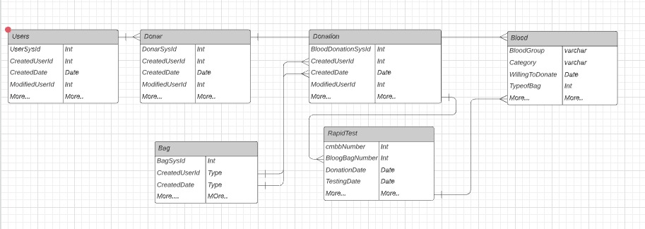

**(Figure 4.1 – Entity Relationship Diagram)**

This Diagram describes the interrelated things of interest in this domain

**CHAPTER 5: IMPLMENTATION SCREENSHOTS**

**Add New User**

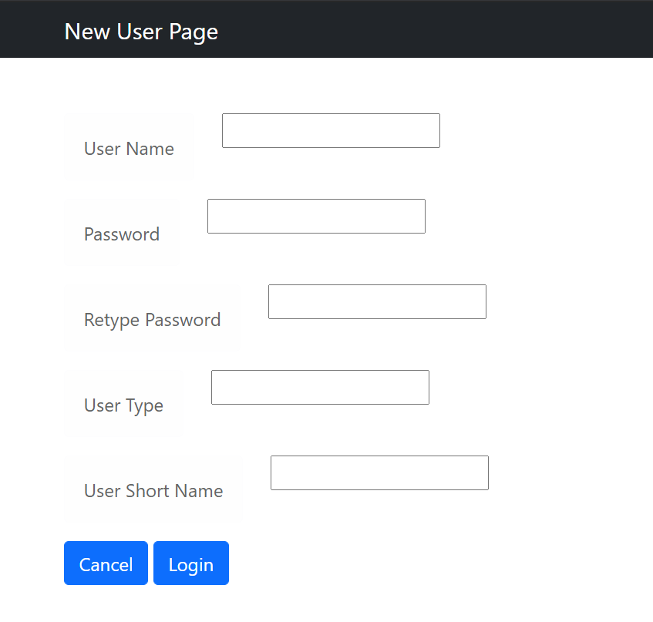

**(Figure 5.1 – Implementation Screenshot 1)**

**New login Page**

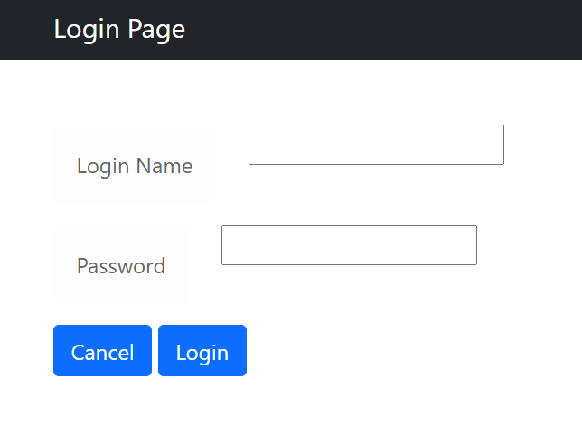

**(Figure 5.2 – Implementation Screenshot 2)**

**Add New Donor Page**

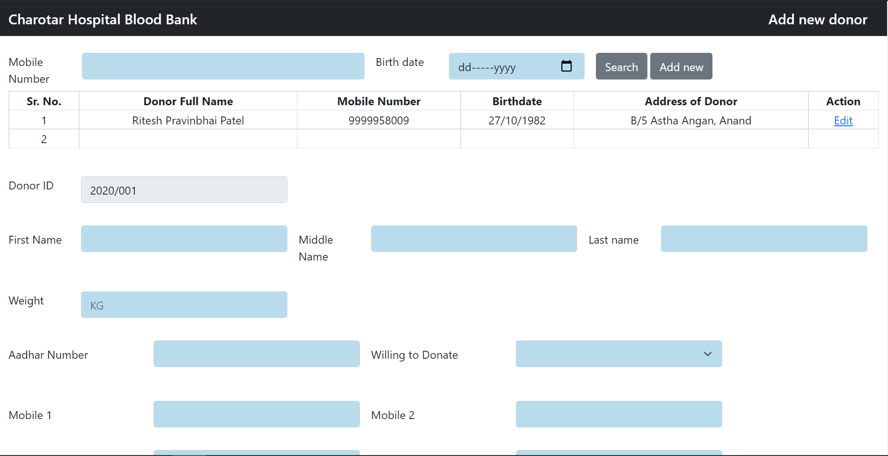

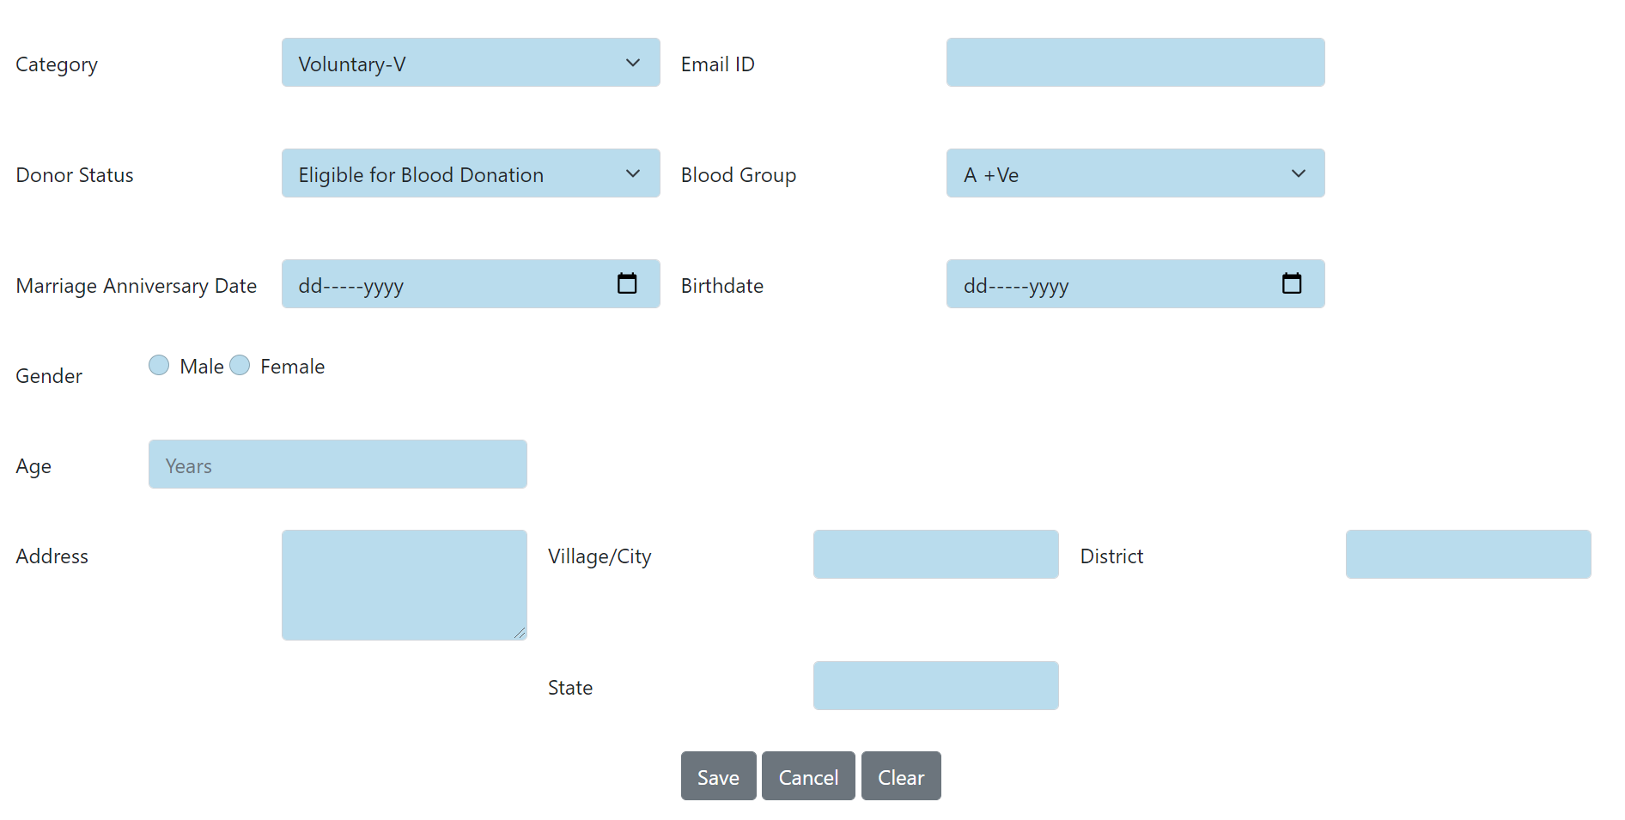

**(Figure 5.3 – Implementation Screenshot 3)**

**Blood Donation Information page**

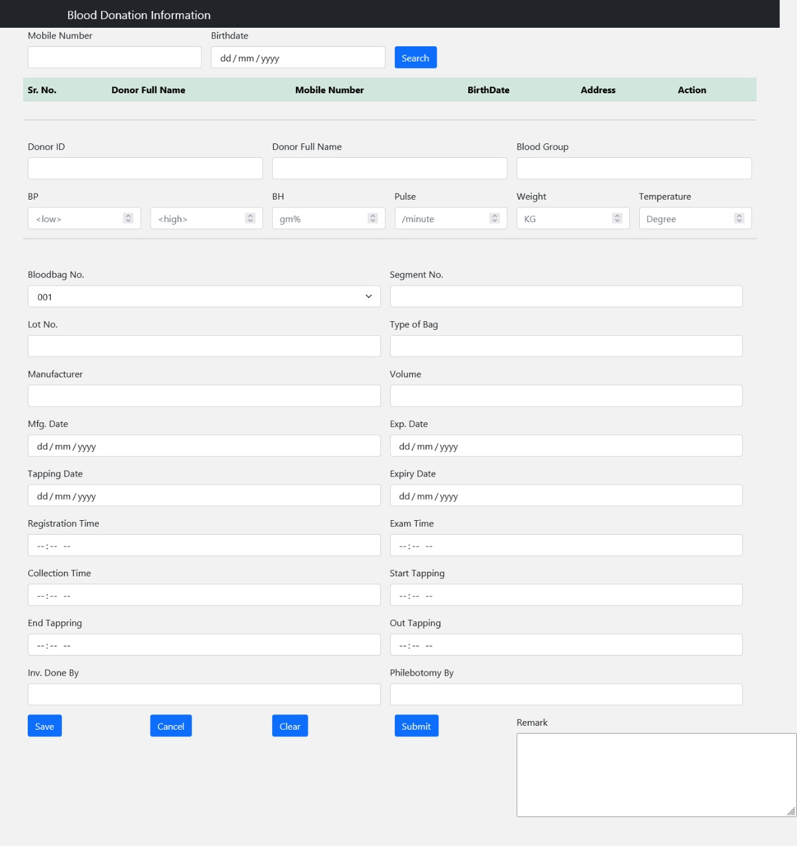

**(Figure 5.4 – Implementation Screenshot 4)**

**Blood bag Entry Page**

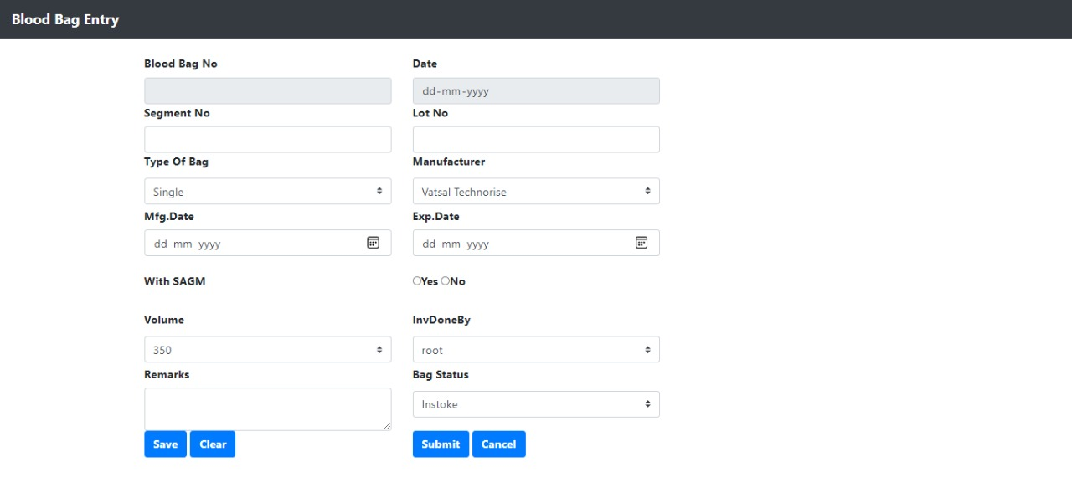

**(Figure 5.5 – Implementation Screenshot 5)**

**Component Separation Page**

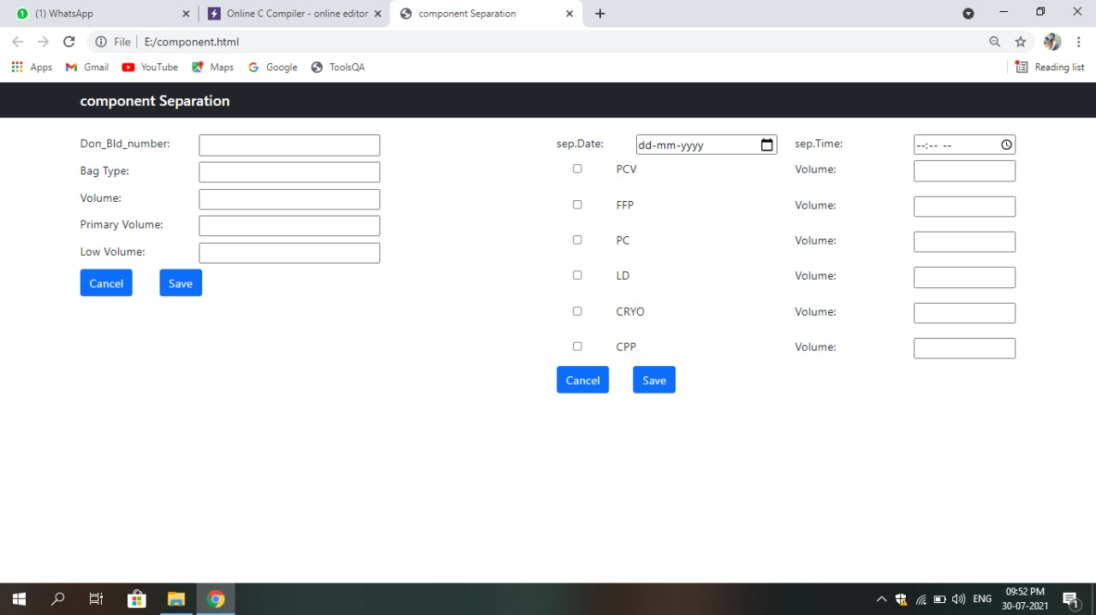

**(Figure 5.6 – Implementation Screenshot 6)**

**Rapid Test Page**

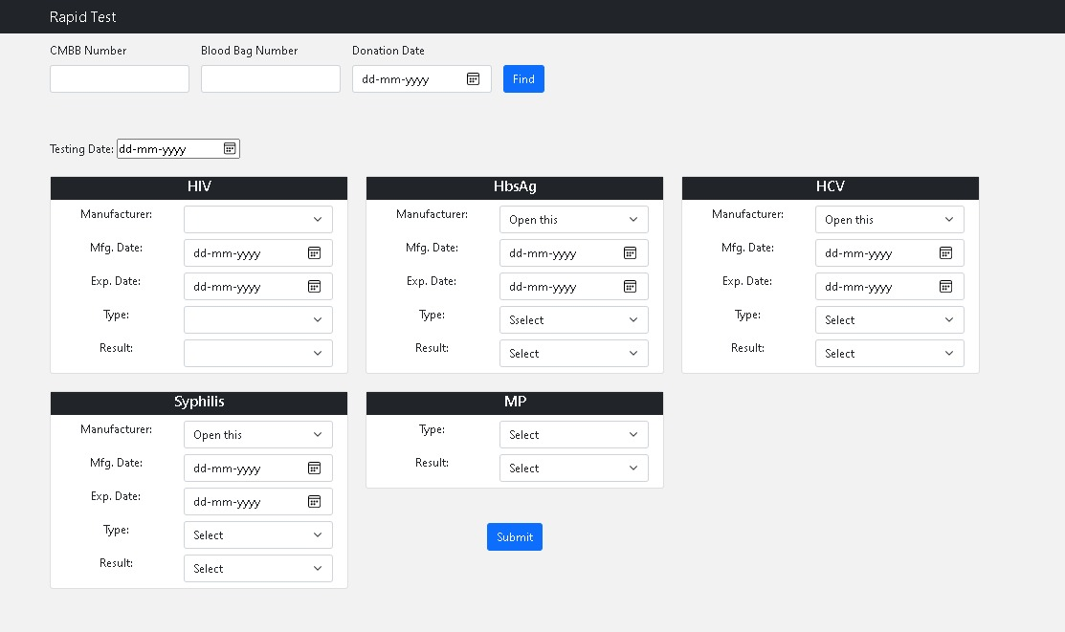

**(Figure 5.7 – Implementation Screenshot 7)**

|  |  |  |  |  |  |  |  |
| --- | --- | --- | --- | --- | --- | --- | --- |
| **Test case scenarios** | **Test case Name** | **Pre-condition** | **Testing Steps** | **Testing Data** | **Expected Result** | **Post Condition** | **Status(Pass/Fail)** |
| Create Login | Registering staff/admin | NA | 1. Enter Username 2. Enter Password 3. Retype Password 4. Enter user type 5. Enter user short name 6. Submit | User registered | Registered Successfully | Show Login page | Pass |
| Login | Logging in as staff or admin | User should be registered | 1. Enter Username 2. Enter Password 3. Click on Login | <valid username>  <invalid password> | Logged in successfully | Show dashboard | Pass |
| Add New Donor | Adding new user | Logged in as staff/admin | 1. Search by mobile number if already added.(if No) 2. Enter necessary details 3. Save | Donor details | Donor added successfully | Show dashboard | Pass |
| BloodBag Entry | Adding blood bag details |  | 1. Enter necessary details 2. Save | Bag details | Bag added successfully | TBD | Pass |
| Donor details | Editing donor details |  | 1. Enter mobile number 2. Enter birthdate 3. Search | Editing donor details failed | Edited successfully | TBD | Fail |
| BloodDonation Information | Blood donation Entry |  | 1. Enter necessary details 2. save | Donation entry successful | Added Successfully | Donation page | pass |
| Rapid test | Searching rapid test details | Blood bag no., blood donation no in database | 1. Enter necessary details 2. search | Reflected in 1 card for now | Details reflected | Same page | pass |

**CHAPTER 6: TEST CASES**

**(Table 6.1 – Test Cases)**

**CHAPTER 7: LIMITATIONS AND FUTURE WORK**

* 1. **LIMITATIONS**

The web pages are not synched yet making some of the functionalities not testable. It also lacks a solid database as of now because some of the fields are obscure and the general flow is inconceivable.

* 1. **FUTURE WORK**

For future, main focus will be given upon discerning the flow from entering a new donor till storing the donated blood bag by visiting the Charusat Hospital and understanding it in person. Creating a solid database structure and merging the pages excluded in the first flow.

**CHAPTER 8: CONCLUSION**

The basic GUI and most of the web pages are completed and are working under generic database, First flow that is from registering new user to adding donor is completed as well. Amalgamation of website and concurrent database is remaining.

**REFERENCES**

1. <https://www.w3schools.com/php/>
2. <https://www.tutorialspoint.com/android/android_php_mysql.htm>
3. <https://www.w3schools.com/html/>
4. <https://getbootstrap.com/docs/5.0/forms/form-control/>
5. <https://www.youtube.com/channel/UC29ju8bIPH5as8OGnQzwJyA>