NGETEH

Technical Documentation

Version 1.00

Revision History

Date | Version | Description | Author
24-16-2016 | 1.00 | Draft | Hanis Basira

Table of Contents

1. Introduction 5
1.1 Purpose of this document 5
1.2 Intended Audience 5
1.3 Scope 5
1.4 Definitions and acronyms 5
1.4.1 Definitions 5
1.4.2 Acronyms and abbreviations 5
2. General overview 6
2.1 Technologies used 6
2.2 General functioning 6
3. Technical requirement 7
3.1 Client requirement 7
3.2 Server Requirement 7
3.3 Laragon 7
4. NGETEH folder structure 8
5. Architecture 9
5.1 High Level Architecture 9
5.2 NGETEH Class Diagram 10
6. User Interface 12
6.1 Login Module 12
6.2 Language Settings Module 13
6.3 Employees Module 13
6.4 Suppliers Module 15
6.5 Customers Module 16
6.6 Products Module 18
6.7 Sales Module 20
6.8 Receivings Module 21
6.9 Reports Module 23
6.9.1 Sales Report 23
6.9.2 Receivings Report 24
7. References 25
Introduction

Purpose of this document

The purpose of this document is to give technical information about NGETEH project design and implementation.

Intended Audience

The intended audiences are:
- Supervisor to analyze the design and implementation of NGETEH project.
- NGETEH project team members.
- Future developers to extend or use some ideas of NGETEH project.

Scope

This document will describe the design and some technical issues of NGETEH project. Further documents should contact Jezrin Technologies Sdn Bhd.

Definitions and acronyms

Definitions

Keyword | Definitions

Acronyms and abbreviations

Acronym or  abbreviation | Definitions
MVC | Model-View-Controller
IDE | Isolated Development Environment
POS | Point of Sale
URL | Uniform Resource Locator
PHP

General overview

Technologies used

NGETEH is a web based application created using PHP framework Laravel 5.2. For this project, Laragon software bundle with Laravel 5.2 are installed on the Window operating system. Laragon is extremely fast and powerful IDE with all services needed such as Mysql, Memcached, Apache and a lot more to create a web application on the fly. It is also portable and very flexible means any project in Laragon folder are able to be move around to any disk and it still works.

General functioning

There are nine module in NGETEH web application functionality which are Login Module, Language Settings Module, Employees Module, Customers Module, Suppliers Module, Products Module, Sales Module, Receivings Module and Reports Module for sales and receiving.

The following are the major system functionalities:
- Login and logout authentication of employee in NGETEH web application.
- Edit language settings.
- Create a new employee.
- Edit and delete an existing employee.
- Create a new customer.
- Edit and delete an existing customer.
- Create a new supplier.
- Edit and delete an existing supplier.
- Create and delete a new product.
- Edit an existing product.
- Store and update an inventory for a particular product.
- Record a sales transactions when customer buy a particular product.
- Record a receiving purchase transaction when a supplier deliver a particular product.
- Display a record for each of customer sales transactions.
- Display a record for each of receiving purchase transactions.

Technical requirement

Client requirement

NGETEH web application which can be run on any operating systems via a web browser. It has been tested with Chrome and Mozilla Firefox and no problem has been found.

Server Requirement

Laragon software bundle with Laravel open-source PHP web framework need to be install in order to run NGETEH web application. The following technologies are use in NGETEH web application.

- Mysql 10.1.9
- Apache 2.4.17
- PHP Server 5.6.16

Laragon

Laragon 1.0.8 is a fast, powerful and isolated development environment which is portable and very flexible design for Window operating system to run a PHP framework Laravel. It is a web development environment which does not affect Window operating system. It need to be install as a software, start it up, program any required web application using a PHP framework Laravel and when finished just exit the service.

Software and services that is bundle with Laragon include Mysql 10.1.9, Apache 2.4.17, PHP Server 5.6.16, Memcached 1.4.5, Redis 2.8.17, Mail Catcher and Mail Sender. Tools which can be used with Laragon are WinSCP, Putty, SSH and any text editor.

Laravel is a free, open-source PHP framework intended for the development of web applications following the Model-View-Controller (MVC) architectural pattern. Some of the features of Laravel are a modular packaging system with a dedicated dependency manager, different ways for accessing relational databases, utilities that aid in application deployment and maintenance,

NGETEH folder structure

There are three main folder that represent the MVC architecture in the project which are:
- App
- Database
- Resources

All the necessary display file for NGETEH web application is located in Resources folder. In this Resources folder, blade template from Laravel is used to design the display for web application. The database source file for migration in Laravel is located in the Database folder which responsible to create and delete any tables for the required database in NGETEH. The most important files are located in App folder. App folder consists of files structure for a model. App/Http folder consist controller and also routes source file for NGETEH project. The main programming is done inside the App folder structure. Figure 1 shows the folder for NGETEH project implementation.

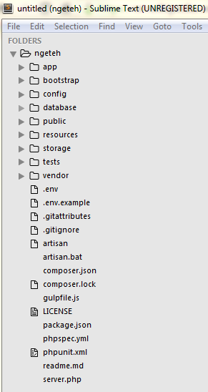
Figure 1: Folder structure of NGETEH.

Architecture

Architectural design consisted of high level architecture and detail design including sequence diagrams and class diagrams.

High Level Architecture

Project design follow the traditional MVC design pattern. Controllers are used to handle user requests and retrieve data by leveraging a models approach. Models are used to interact with database and retrieve an objects information in the NGETEH project. Meanwhile, Views used to render a pages to the user who used this web application. Routes source files need to be define in order to interconnect all of these controllers, models and views as shown in Figure 2 below.

All processes are passed from view to controller via routes to retrieve the url link for the web application. Any data needed to be pass to the controller is retrieve from model interaction with the Mysql database. Figure 2 shows the MVC concept for NGETEH project implementation.

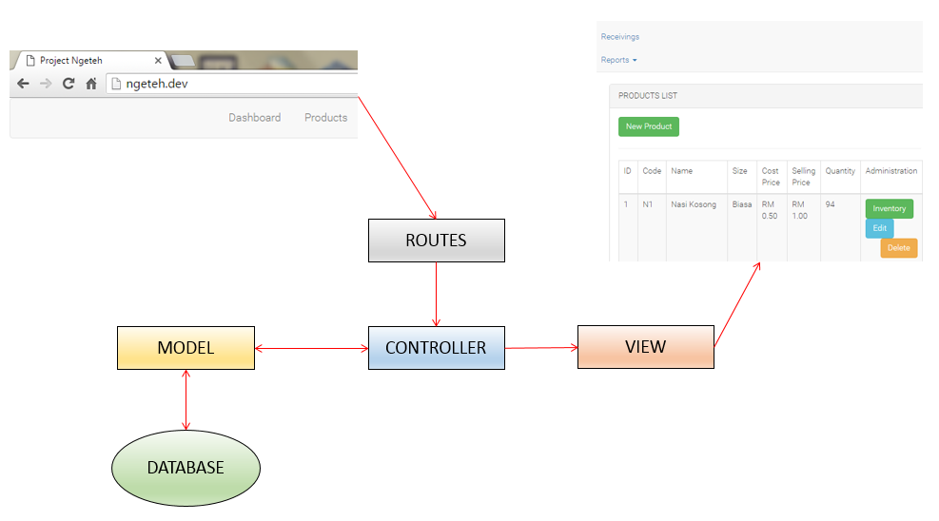

Figure 2: MVC concept in NGETEH.

NGETEH Class Diagram

The class diagram is briefly explained in this section. All users of the system have an administrator right to create, edit and delete any new product, customer, supplier and employee. They also have the right to change a language setting, record a sale transaction, record a receiving purchase transaction and also to view a report for sales and receiving’s transactions.

User, Product, Customer, Supplier and Employee information are stored in its respective table which are ‘users, ‘products’, ‘customers’, ‘suppliers’ and ‘employees’. Table ‘inventories’ are linked with foreign key to ‘products’ table using a field product_id and also linked with foreign key to ‘users’ table using a field user_id.

‘sale_temps’ is a table created to store a temporary sale product during a sale transaction to the customer. Once a sale has been completed, the sale transaction is recorded into the ‘sale_products’ table. This table has a foreign key link to ‘products’ table and ‘sale’ table.

Meanwhile ‘receiving_temps’ is a table created to store a temporary receiving product during a receiving purchase transaction by the employee. If receiving transaction is completed, the product receive will be recorded into the ‘receiving_products’ table. This table has a foreign key link to ‘products’ table and ‘receivings’ table. The related class diagram is shown in Figure 3 below.

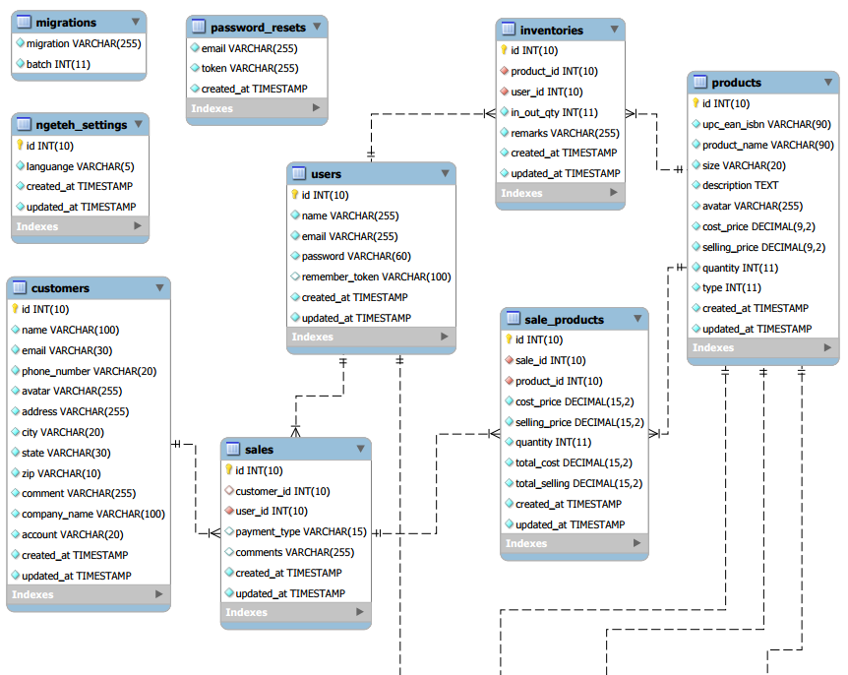
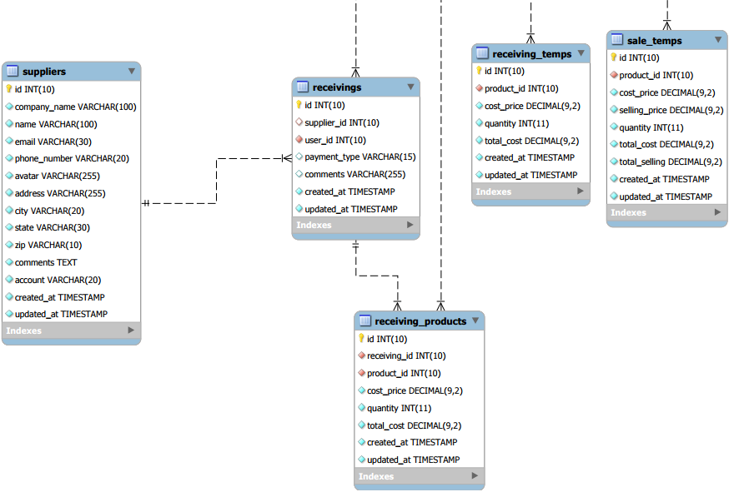
Figure 2: Simplified NGETEH Class Diagram

User Interface

User interface consisted of the NGETEH web application interface displayed to the user who will use to create, edit and delete an information in a specific module and also to display record a sale and receiving transaction.

Login Module

Login module is required as a form to validate a user identity who will use NGETEH web application by comparing user data for authentication and authorization from the database. To use this web application, user need to login using their email address and password before proceeding to click the ‘Login’ button as shown in Figure 4 below.

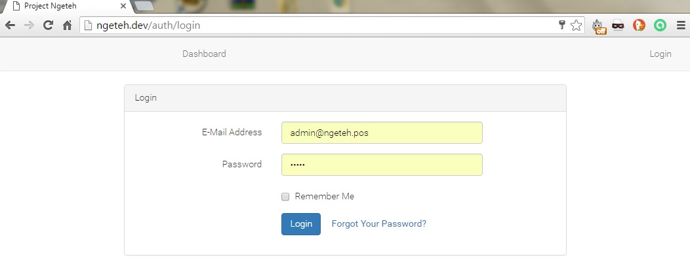
Figure 4: Login Module

Figure 5 below shown a link for user to logout from the web applications. After user logged in to the NGETEH web application, user will be automatically transfer to dashboard page. From the drop down menu of user name on right top of the page, user are able to logout from the web application by clicking the ‘Logout’ link.

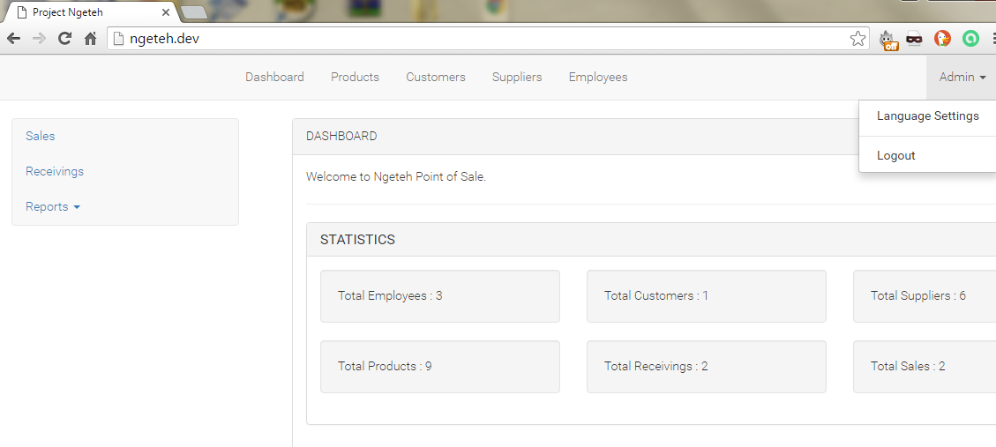
Figure 5: Logout Link

Language Setting Module

Language settings module give a user an option to choose between two available languages which are English or Malay. Figure 6 below show the option to change the language setting.

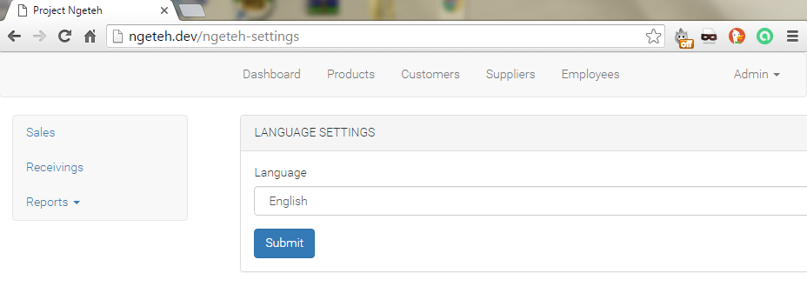

Figure 6: Language Settings Module

Employees Module

All existing users are listed in the Employees module as shown in Figure 7. User are able to create a new employee by clicking a ‘New Employee’ button and fill-up the detail as shown in Figure 8. The information to be fill are Name, Email, Password and Confirm Password.

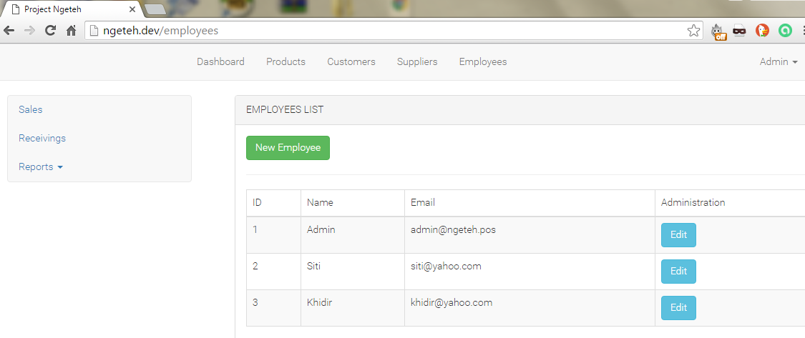

Figure 7: Employees Module

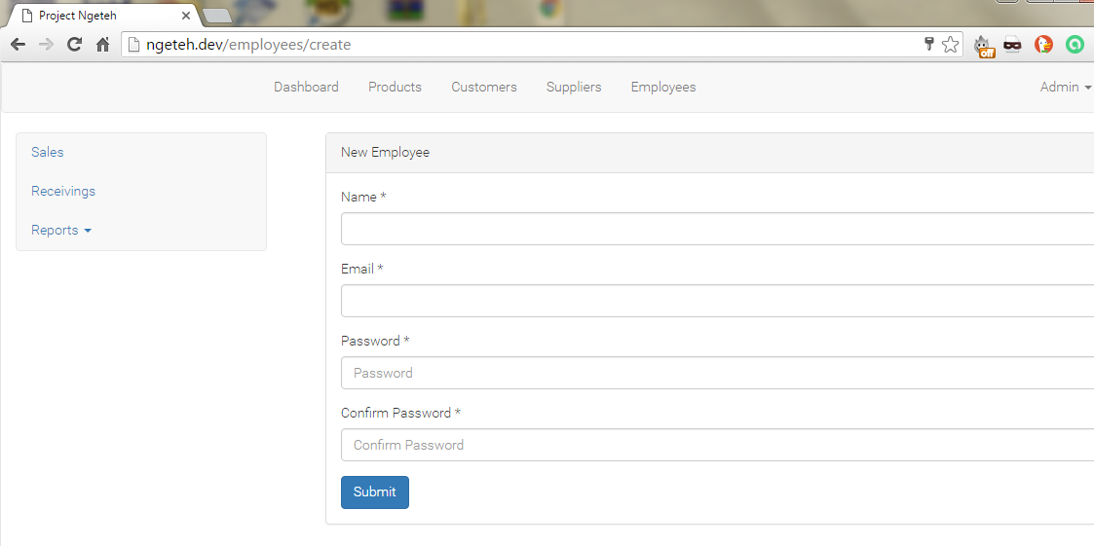

Figure 8: Create a New Employee

Figure 9 shown that user also able to edit any employee information by clicking an ‘Edit’ button. To delete any employee, user just need to click the ‘Delete’ button for that particular employee name in the Employee module list.

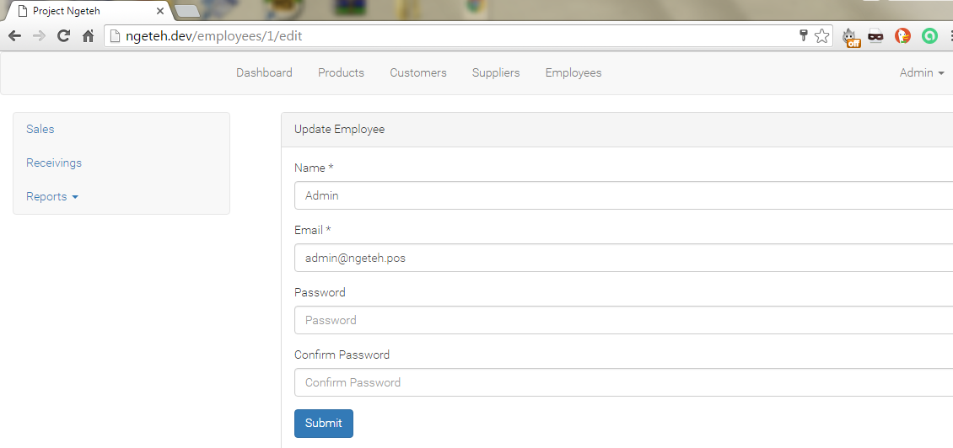

Figure 9: Edit an Existing Employee

Suppliers Module

Existing suppliers are listed in the Suppliers module as shown in Figure 10. User are able to create a new supplier by clicking a ‘New Supplier’ button and fill-up the detail as shown in Figure 11. The information to be fill are Name, Manager Name, Email, Phone Number, Address, City, State, Zip, Comments and Account Number.

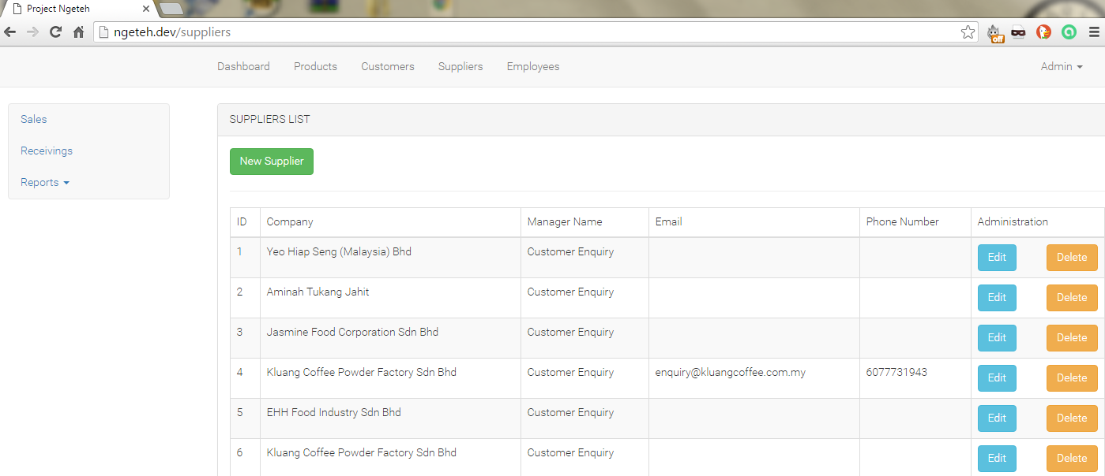

Figure 10: Suppliers Module

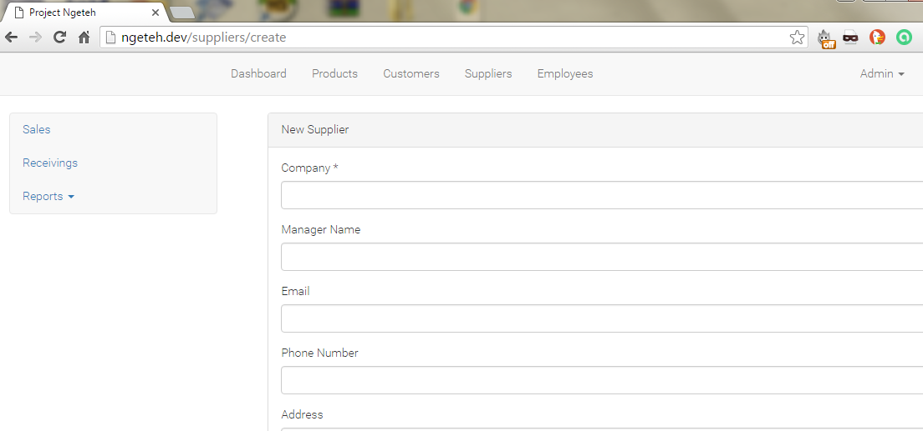

Figure 11: Create a New Supplier

Figure 12 shown that user also able to edit any supplier information by clicking an ‘Edit’ button. To delete any supplier, user just need to click the ‘Delete’ button for that particular supplier name in the Supplier module list.

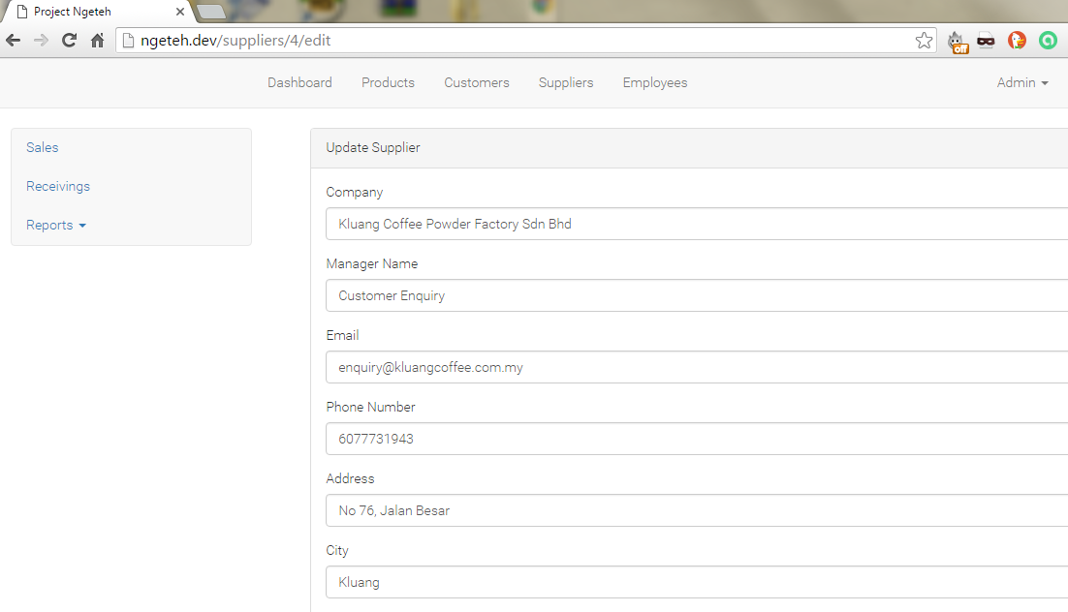

Figure 12: Edit an Existing Supplier

Customers Module

Existing customers are listed in the Customers module as shown in Figure 13. User are able to create a new customer by clicking a ‘New Customer’ button and fill-up the detail as shown in Figure 14. The information to be fill are Name, Phone Number, Address, City, State, Zip, Company Name and Account Number.

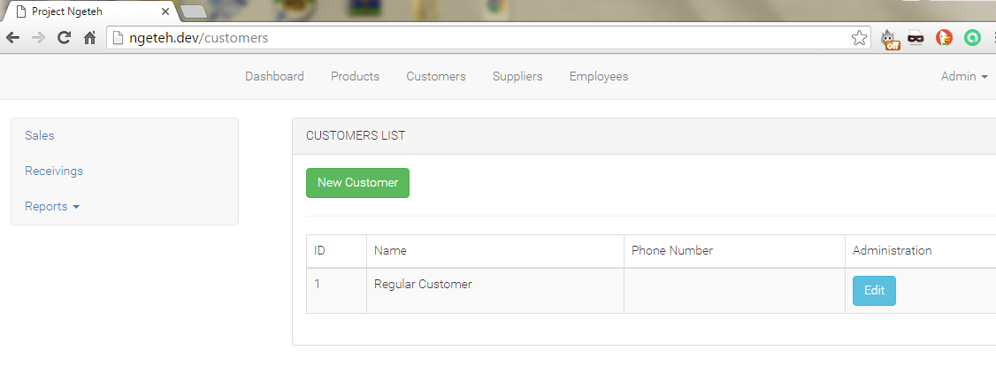

Figure 13: Customers Module

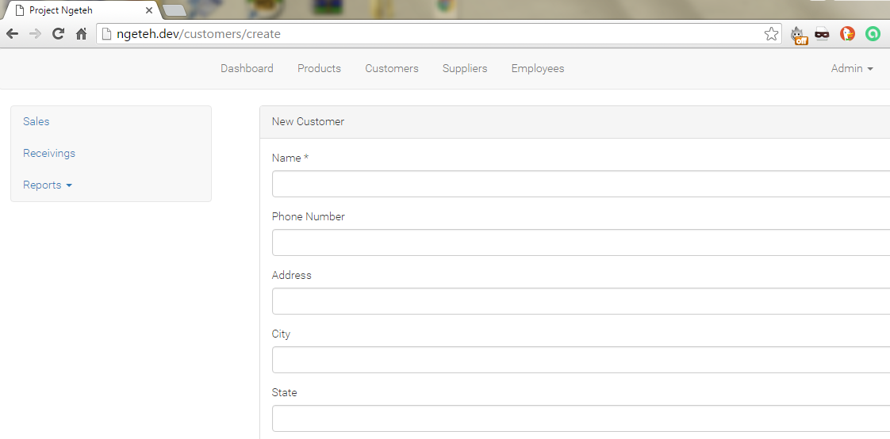

Figure 14: Create a New Customer

Figure 15 shown that user also able to edit any customer information by clicking an ‘Edit’ button. To delete any customer, user just need to click the ‘Delete’ button for that particular customer name in the Customer module list.

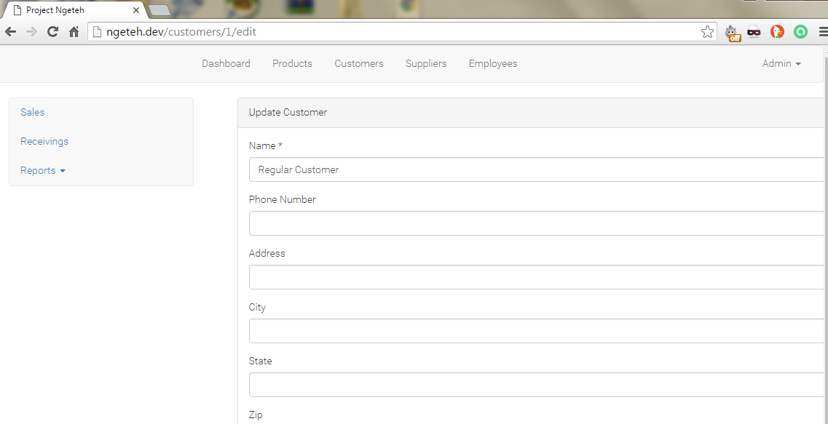

Figure 15: Edit an Existing Customer

Product Module

In this module, existing product is listed in the module interface page as shown in Figure 16. User are able to create a new product by clicking a ‘New Product’ button as shown in Figure 17. User also able to edit any product information by clicking an ‘Edit’ button. Figure 18 show the information to be fill which are Code, Name, Size, Description, Picture, Cost Price, Selling Price and Quantity.

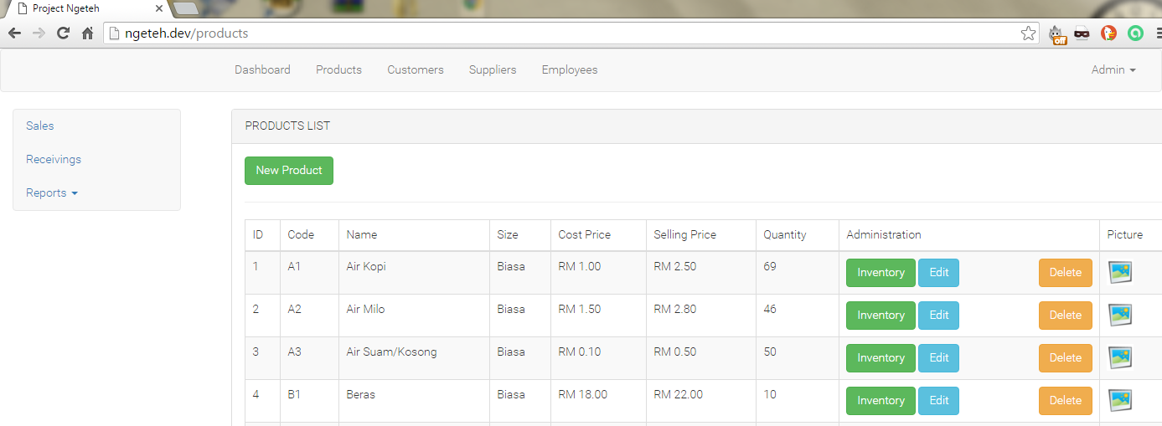

Figure 16: Product Module

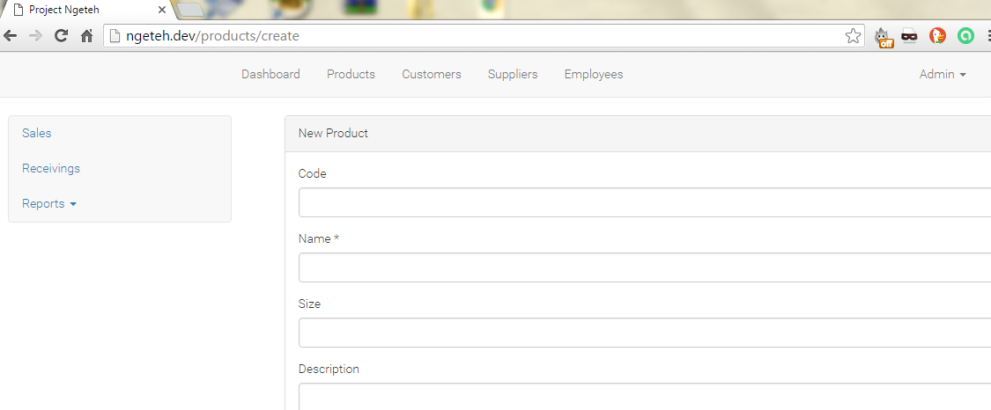

Figure 17: Create a New Product

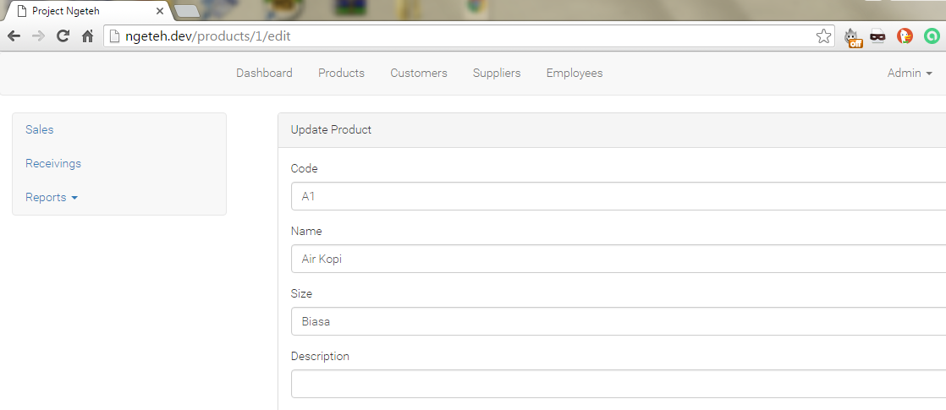

Figure 18: Edit an Existing Product

To update the inventory for a particular existing product, user may do so by clicking an ’Inventory’ button as shown in Figure 19. To delete any new product, user just need to click the ‘Delete’ button for that product.

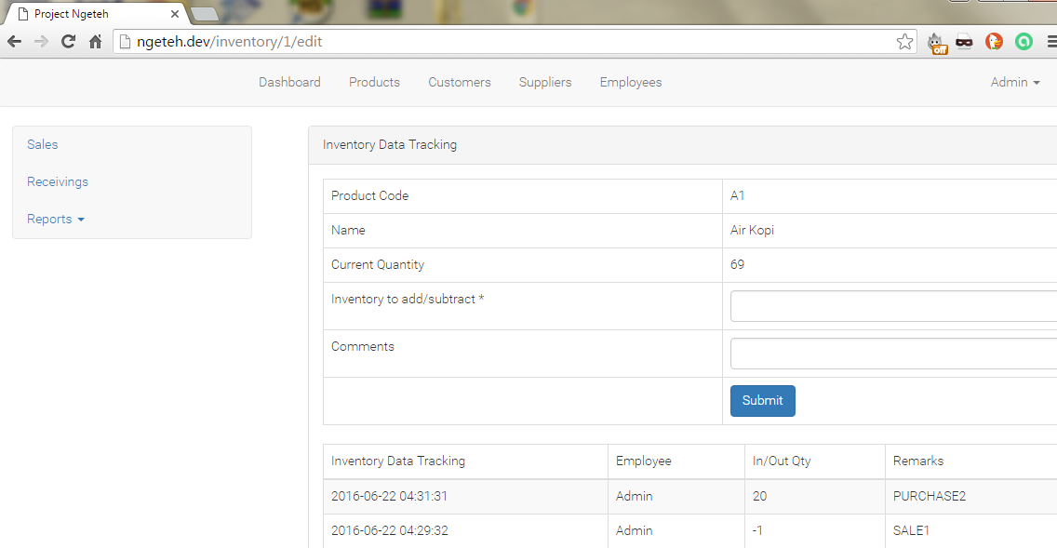

Figure 19: Update Inventory for Existing Product

Sales Module

Sales module located on the side menu give user the way to record a sale transaction for any product bought by a customer. User able to search a product by using the product name in the ‘Search Product’ field. If there is no product added in the transaction, user cannot finish the sale transaction because there is no ‘Complete Sale’ button as shown in Figure 20 below.

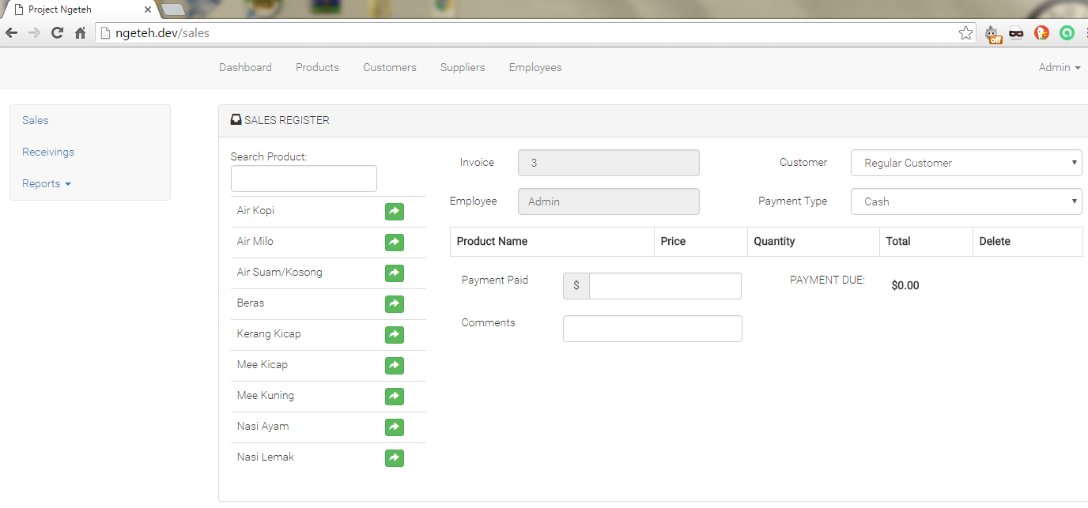

Figure 20: Sales Module

If there is any product added in the sale module, ‘Complete Sale’ button will be automatically appear in the page and user able to finish the sale transaction by clicking the button. In order to complete the sale transaction, Customer field and Payment Type field should be fill-in by user from the drop down menu and the Product Name also should be added in the transaction. The Invoice field and Employee field is automatically filled-in by the web application system as shown in Figure 21.

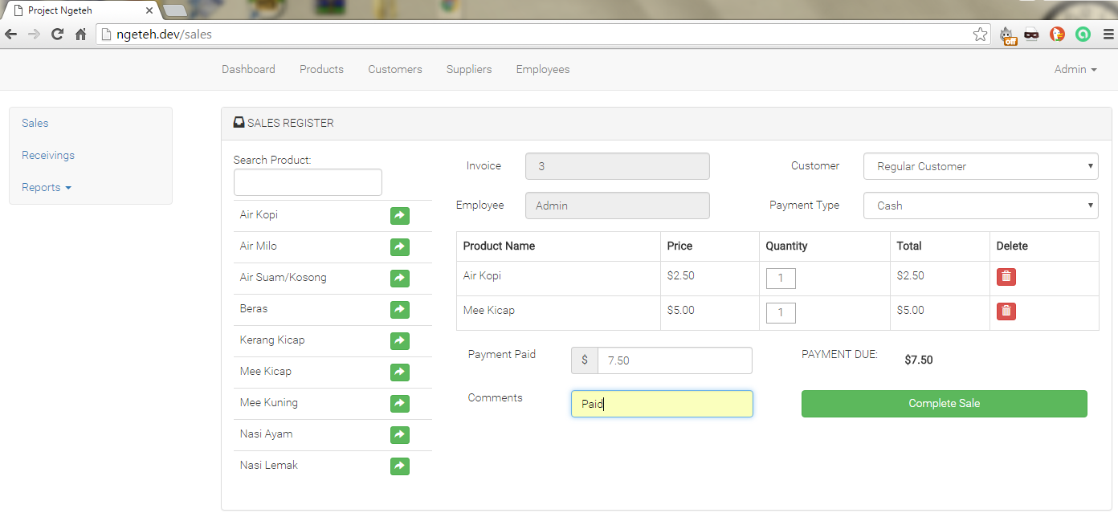
Figure 21: Sales Transaction
Once sale transaction is completed, user will be directed to the completed sale page receipt consisting of the current transaction product bought by customer. As shown in Figure 22, user have an option to print the receipt by clicking the ‘Print’ button or to make a new sale by clicking a ‘New Sale’ button.

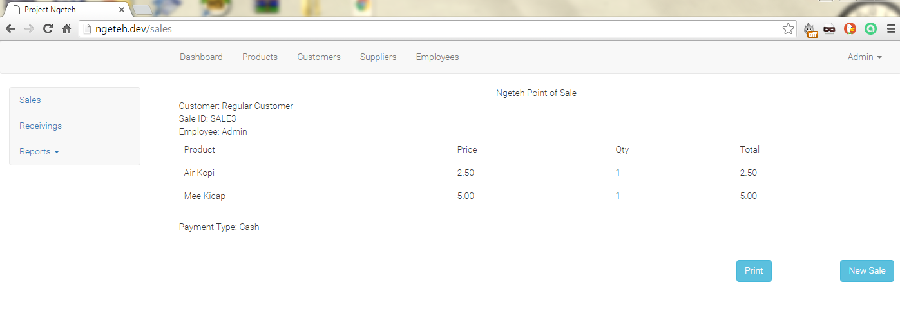

Figure 22: Completed Sales Transaction

Receivings Module

Receivings module located on the side menu give user the way to record a receiving transaction for any product purchase. User able to search a product by using the product name in the ‘Search Product’ field. If there is no product added in the transaction, user cannot finish the receiving transaction because there is no ‘Finish Received’ button as shown in Figure 23 below.

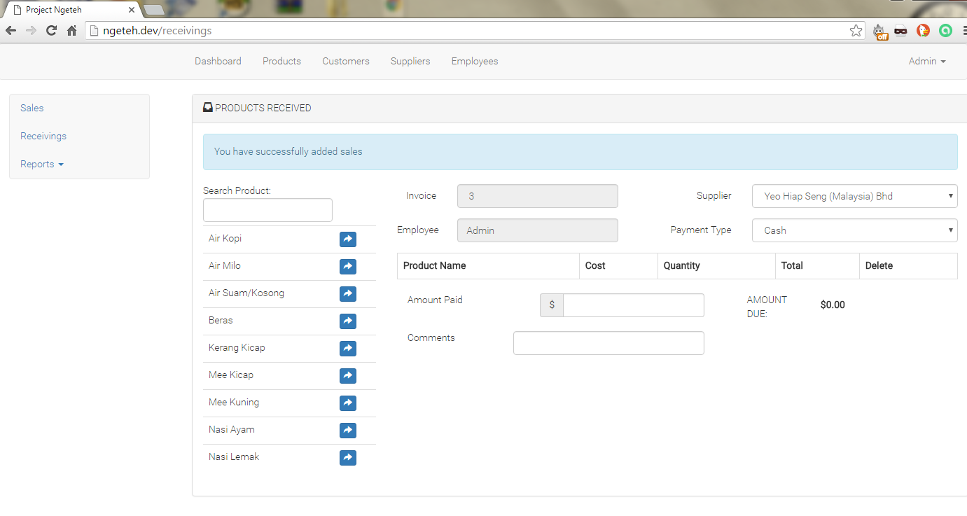

Figure 23: Receivings Module

If there is product added in the receivings module, ‘Finish Received’ button will be automatically appear in the page and user able to finish the receiving transaction by clicking the button. In order to complete the receiving transaction, Supplier field and Payment Type field should be fill-in by user from the drop down menu and the Product Name also should be added in the transaction. The Invoice field and Employee field is automatically filled-in by the web application system as shown in Figure 24.

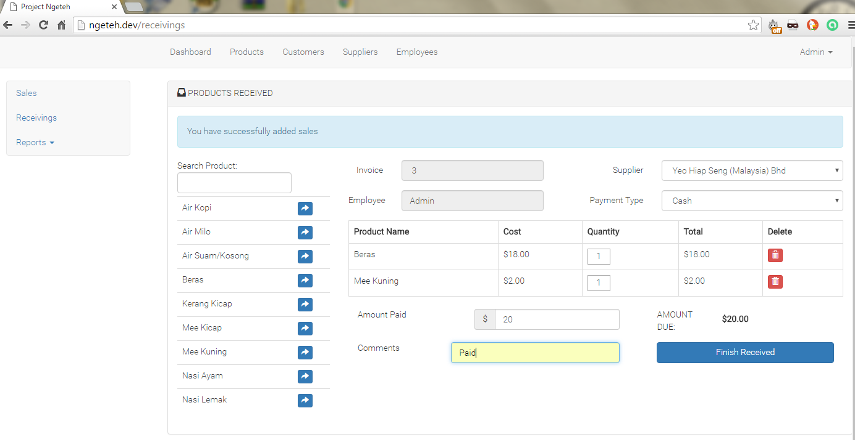

Figure 24: Receivings Transaction

Once receiving transaction is completed, user will be directed to the completed receiving page receipt consisting of the current transaction purchase by employee. As shown in Figure 25, user have an option to print the receipt by clicking the ‘Print’ button or to make a new receiving by clicking a ‘New Received’ button.

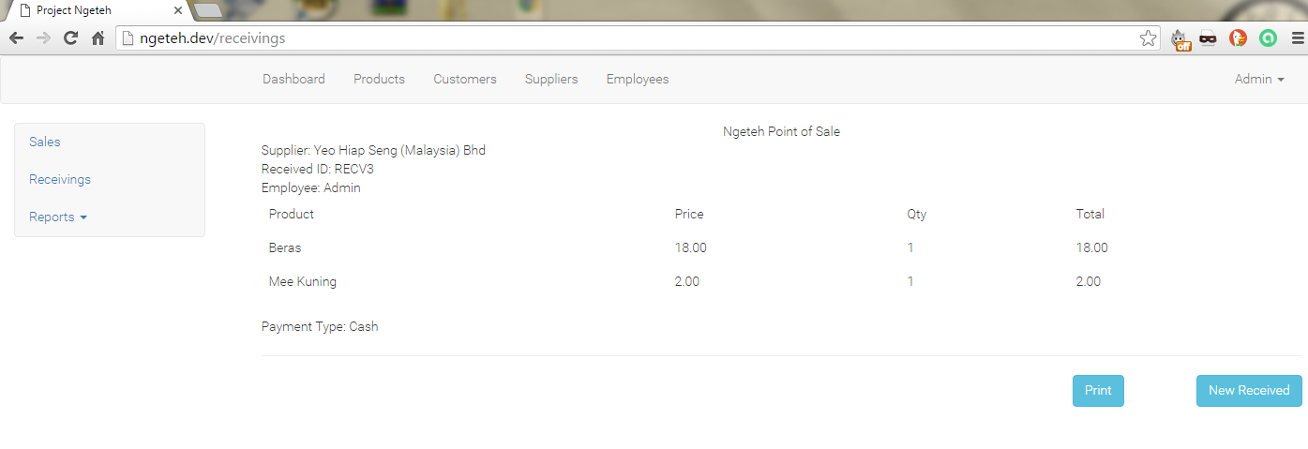

Figure 25: Completed Receivings Transaction

Reports Module

Sales Report

Every sales transaction is recorded in the database and can be view in the Reports Module. There are two types of report which are Sales Report and Receiving Report. Figure 26 show the sales report which display the summary of total sold and total profit for every sale transactions.

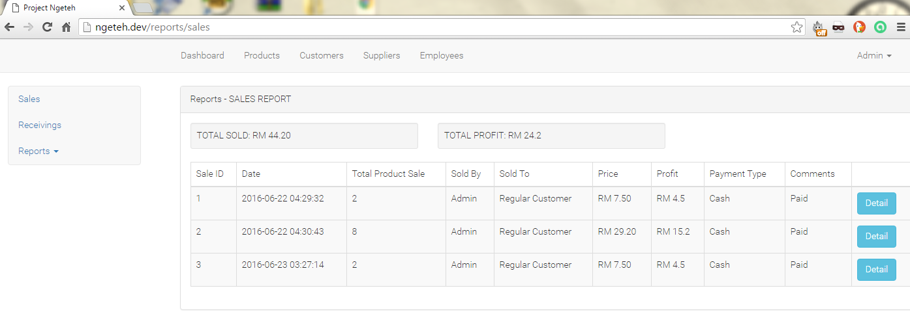

Figure 26: Sales Report

If the employee want to view the details of sale transaction, they may do so by clicking the detail button as shown in Figure 27. Information such as Product Name, Quantity Sale, Price and Price will be displayed.

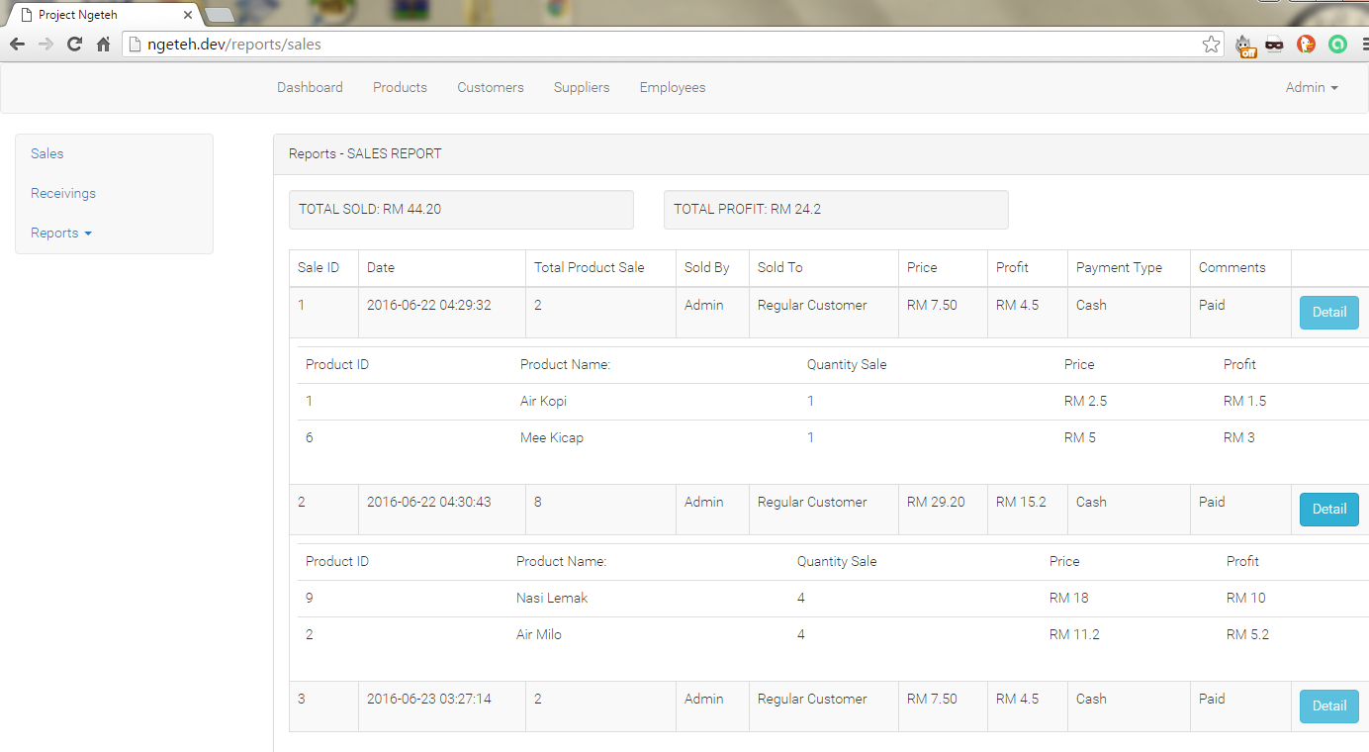
Figure 27: Details Sales Report

Receivings Report

Every sales transaction is recorded in the database and can be view in the Reports Module. There are two types of report which are Sales Report and Receiving Report. Figure 26 show the sales report which display the summary of total sold and total profit for every sale transactions.

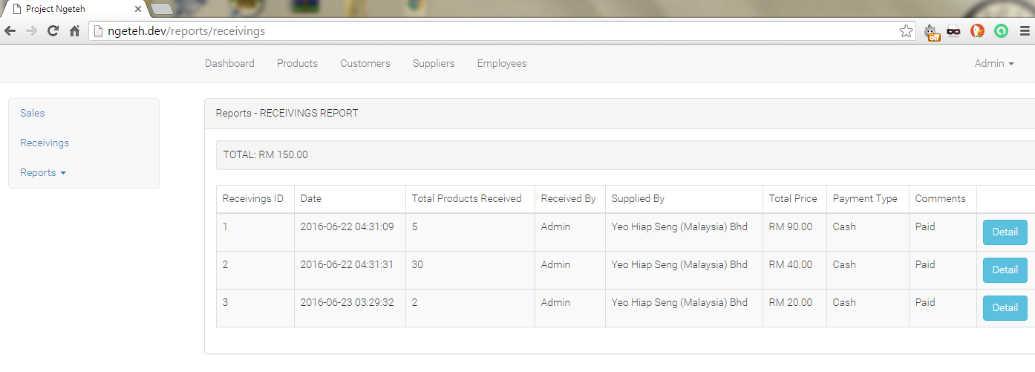

Figure 28: Receivings Report

If the employee want to view the details of sale transaction, they may do so by clicking the detail button as shown in Figure 27. Information such as Product Name, Quantity Sale, Price and Price will be displayed.

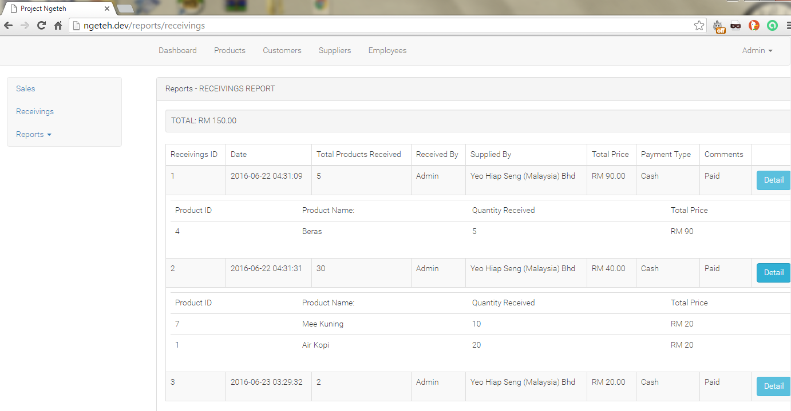

Figure 29: Details Receiving Report

References

- https://laravel.com/docs/5.2
- https://laracasts.com/series/laravel-5-from-scratch/
- https://selftaughtcoders.com/from-idea-to-launch/lesson-17/laravel-5-mvc-application-in-10-minutes/
- https://selftaughtcoders.com/from-idea-to-launch/lesson-15/managing-database-with-laravel-5-migrations/1/
- https://scotch.io/tutorials/create-a-laravel-and-angular-single-page-comment-application
- https://github.com/tutacare/tutapos
- https://www.google.com/url?sa=t&rct=j&q=&esrc=s&source=web&cd=4&cad=rja&uact=8&ved=0ahUKEwiBsqSkj8DNAhVKp48KHc7GCY0QFgg1MAM&url=https%3A%2F%2Fwww.fer.unizg.hr%2F_download%2Frepository%2FPATH_Technical_Documentation.doc&usg=AFQjCNGoF1QYcbwR-CnLt1gbItUx5klQmg

