TECHNICAL PROJECT REPORT
Submitted for Review 1

INTELLIGENT MEASUREMENT UNCERTAINTY
AND CALIBRATION ANALYZER (IMUCA)
An Integrated Platform for Automated Uncertainty Evaluation,
Calibration Assessment and Measurement-Quality Decision Support

Course: Measurements and Instrumentation
Project Review 1 • Design and Proof-of-Concept Stage
Field | Details
Team members | _______________________________________________
Register numbers | _______________________________________________
Department / Branch | _______________________________________________
Institution | _______________________________________________
Guide / Supervisor | _______________________________________________
Academic year | _______________________________________________
Date of submission | _______________________________________________

Scope note: all numerical results in this report are derived from a synthetic dataset created for
proof-of-concept demonstration. No laboratory measurements have been performed at this stage.

TABLE OF CONTENTS
If the list below appears empty, select it in Word and press F9, or right-click and choose Update Field.

1. ABSTRACT

Measurement underpins every engineering decision, yet a bare reading carries no information about how far it can be trusted. An instrument that displays 5.02 V tells the user nothing about whether the true value lies within one millivolt or one hundred millivolts of that figure. Accuracy describes closeness to the true value; precision describes closeness between repeated readings. An instrument can be highly precise and still badly inaccurate, which is why both properties must be quantified separately. Measurement uncertainty closes this gap by defining the interval within which the true value is expected to lie at a stated level of confidence. Calibration links an instrument to a reference standard and quantifies the systematic component of its error. Both are mandatory in accredited testing, and both are still commonly handled outside the measurement system itself, using spreadsheets, calculator work and manually assembled certificates.
This report presents the design and proof-of-concept analysis of the Intelligent Measurement Uncertainty and Calibration Analyzer (IMUCA), a software platform that integrates the full measurement-analysis chain into a single automated workflow. IMUCA accepts a measurement dataset from an instrument, sensor or data file and then performs validation, preprocessing, descriptive statistics, error analysis, Type A and Type B uncertainty evaluation, uncertainty budget construction, combined and expanded uncertainty computation, calibration analysis against a reference standard, drift and trend detection, and rule-based decision generation. The pipeline ends with a dashboard and an automatically generated measurement report.
Type A uncertainty is evaluated from the statistical dispersion of repeated readings. Type B uncertainty is evaluated from display resolution, manufacturer specifications, reference-standard certificates and environmental effects, with each source converted to a standard uncertainty through its assumed probability distribution. The two categories are combined by root sum of squares and expanded by a coverage factor to give a stated confidence interval.
A synthetic dataset was created for Review 1 so that the method could be demonstrated end to end without claiming experimental results. For a 5.000 V reference point with ten repeated readings from the device under test, the analysis returns a mean of 5.021 V, a sample standard deviation of 9.944 mV, a Type A standard uncertainty of 3.145 mV, a combined standard uncertainty of 5.274 mV and an expanded uncertainty of 10.5 mV at a coverage factor of k = 2. The measurement is therefore reported as (5.021 ± 0.011) V. The uncertainty budget identifies repeatability as the dominant contributor at 35.6 % of the total variance, followed closely by the instrument specification at 30.2 % and display resolution at 30.0 %. A ten-point calibration sweep recovers a zero offset of +6.7 mV and a gain error of +0.303 %, and flags the 0.5 V point as failing an illustrative ±1 % tolerance while the upper eight points pass. A ten-session drift study returns a trend of 1.10 mV per session with a projected tolerance breach at session 28.
The intelligent layer is implemented as a transparent, auditable rule set rather than a trained model, because a first prototype must produce decisions that an examiner can reproduce by hand. Machine-learning anomaly detection and predictive calibration scheduling are identified as later extensions rather than completed work. Hardware integration and experimental validation are planned for the next phase. Target applications include electronics and electrical test laboratories, sensor calibration, industrial instrumentation, manufacturing quality control and automotive test.
Keywords: measurement uncertainty; Type A and Type B evaluation; uncertainty budget; instrument calibration; error analysis; drift detection; rule-based decision support; automated measurement reporting.

2. INTRODUCTION

2.1 Why measurement matters
Engineering is a quantitative discipline, and every quantitative claim rests on a measurement. A power supply is specified at 5 V because someone measured it. A strain gauge reports 220 microstrain because a bridge circuit was measured and converted. A batch of resistors is accepted or scrapped because a tester measured them against a limit. If the measurement is wrong, every decision built on it is wrong, and the cost of that error scales with how far downstream it travels.
A measurement system converts a physical quantity into a readable output through a sensing element, a signal-conditioning stage, and a display or data-acquisition stage. Each stage adds its own imperfection. The sensor has a finite sensitivity and a temperature coefficient. The amplifier has offset and gain error. The analogue-to-digital converter quantises the signal. The display truncates the result. None of these imperfections vanish because the instrument is expensive; they simply become smaller and better documented.

2.2 Core metrological terms
The following definitions follow the International Vocabulary of Metrology and are used consistently throughout this report.
Term | Definition and engineering meaning
Accuracy | Closeness between a measured value and the true value. A voltmeter reading 5.10 V on a true 5.00 V source is inaccurate by 0.10 V. Accuracy is qualitative; the quantitative statement is the error or the uncertainty.
Precision | Closeness between repeated readings under the same conditions. A meter reading 5.10, 5.10, 5.10 V on a true 5.00 V source is precise but inaccurate. Precision does not correct a systematic offset.
Resolution | Smallest input change producing a detectable change in the reading. A 3½-digit meter on the 20 V range resolves 0.01 V, so it can never distinguish 5.002 V from 5.004 V.
Repeatability | Closeness of repeated readings by the same operator, instrument and conditions over a short time. Quantified by the sample standard deviation of the repeat set.
Reproducibility | Closeness of readings when conditions change: different operator, instrument, laboratory or day. Always equal to or worse than repeatability.
Measurement error | Difference between the measured and the reference value: a signed number knowable only when a reference exists. Split into systematic error, which is correctable, and random error, which is not.
Measurement uncertainty | A non-negative parameter characterising the dispersion of values attributable to the measurand. An interval, not a single number, and it exists even with no reference available.
Calibration | The operation establishing the relation between values indicated by an instrument and those realised by a reference standard, with the associated uncertainties.
Traceability | The property whereby a result can be related to a stated reference through a documented, unbroken chain of calibrations, each contributing its own uncertainty.
Table 2.1 – Metrological terms used in this report

2.3 Why a bare reading is incomplete
Consider the statement produced by almost every laboratory instrument:
Measured value = 5.02 V
This is an incomplete engineering statement. It asserts a value without stating how well that value is known. It does not say whether it came from one reading or from fifty. It does not say whether the meter was calibrated last month or three years ago. It does not say whether the display resolution allows the second decimal place to be believed. A second engineer cannot use this number to decide whether a 5.00 V ± 0.5 % specification has been met, because the claim contains no dispersion information.
The complete statement takes the form:
Measured value = 5.02 ± U V, where U = k · u_{c}
The added term U is the expanded uncertainty. It defines an interval around the reported value within which the true value is expected to lie at a stated level of confidence, typically about 95 % when the coverage factor k is 2. Three points follow from this and are worth stating explicitly for a viva.
- U is not an error. It is not a correction. It does not tell you which way the reading is wrong. It tells you how wide the plausible band is.
- U is not the manufacturer’s accuracy specification on its own. The specification is one input to U, alongside repeatability, resolution, reference-standard uncertainty and environmental effects.
- Without U, a conformity decision is not defensible. If the tolerance is ±0.05 V and the error is +0.021 V, the result looks acceptable, but only until U is compared against the remaining margin.
This report treats the production of that complete statement, automatically and repeatably, as the central engineering task.

3. PROBLEM STATEMENT

Conventional measurement systems are designed to produce readings. Uncertainty evaluation, calibration assessment, error analysis and the interpretation of those results generally take place afterwards, in separate manual procedures carried out by an engineer with a spreadsheet, a calculator and a copy of the relevant guide. The instrument and the analysis are therefore decoupled.
This separation produces a set of recurring practical problems.
Problem | How it appears in practice
Manual calculation burden | A ten-point calibration with five repeats per point and a five-line uncertainty budget requires several hundred arithmetic operations. Doing this for twenty instruments per quarter consumes significant engineer time.
Transcription and formula errors | Values are copied from an instrument display into a notebook and then into a spreadsheet. A misplaced divisor of √3 instead of √6, or a standard deviation computed with n instead of n − 1, changes the reported uncertainty without producing any visible symptom.
Disconnected analysis | Statistics live in one spreadsheet tab, the uncertainty budget in another, the calibration table in a third and the conclusion in an email. Nothing forces the four to stay consistent when a value is updated.
Difficult interpretation | A budget that reports uᴄ = 5.274 mV does not, by itself, tell a technician what to do next. Converting the number into an action requires experience that a junior engineer may not yet have.
Poor visibility of dominant error sources | Because contributions are usually listed rather than ranked, effort is often spent reducing a source that contributes 3 % of the variance while the source contributing 36 % is left untouched.
Difficulty detecting drift | Drift is a slow trend across calibration events. It is invisible in any single calibration record and only appears when historical results are plotted together, which rarely happens automatically.
No automated recommendation | Calibration intervals are typically fixed by policy rather than by observed instrument behaviour, so a stable instrument is recalibrated unnecessarily while a drifting one is left in service.
Table 3.1 – Practical consequences of separating measurement from measurement analysis

The problem addressed by this project can therefore be stated as follows.
Measurement data acquired from an instrument is not automatically converted into a complete, traceable and interpretable statement of measurement quality. The statistical, uncertainty, calibration and trend analyses that produce that statement exist as separate manual procedures, which makes the process slow, error-prone, inconsistent between engineers, and difficult to audit. A system is required that ingests measurement data and produces, without manual intervention, a quantified uncertainty statement, a calibration assessment, a drift indication and an explicit measurement-quality decision.
IMUCA addresses this by placing all of these functions in one ordered pipeline, so that a dataset entering the system produces a decision leaving it, with every intermediate quantity recorded and reproducible.

4. EXISTING SYSTEM AND CURRENT PRACTICE

Current practice is not deficient in method. The methods are mature, standardised and well documented. What is fragmented is the workflow that connects them. The following approaches are in routine use.

Manual uncertainty calculation
An engineer lists the uncertainty sources, assigns a distribution to each, divides by the appropriate divisor, squares, sums and takes the root. This is exactly correct when done carefully, and it is the reference against which any software must be validated. It is also slow and does not scale.

Spreadsheet analysis
Spreadsheets are the most common tool for uncertainty budgets and calibration tables. They are flexible and universally available. Their weaknesses are well known: formulas are hidden inside cells, version control is informal, a dragged formula can silently break a reference, and there is no built-in concept of a distribution, a divisor or a coverage factor, so the metrology is encoded by convention rather than enforced by the tool.

Instrument-specific calibration procedures
Many calibrators and automated test systems include a calibration routine for the instrument they are paired with. These are effective within their scope. They are typically tied to a specific instrument family and do not generally produce a full uncertainty budget across arbitrary user-defined sources.

Statistical software and manufacturer documentation
General statistical packages compute means, standard deviations and regressions accurately but have no metrological semantics. Manufacturer specifications and calibration certificates supply essential Type B inputs, but they are documents to be read and transcribed, not data structures that flow into a calculation.
It would be inaccurate to claim that commercial instruments and metrology software lack these capabilities. Dedicated commercial calibration-management and uncertainty software exists and is widely used in accredited laboratories. The limitation being addressed here is narrower and more specific: in a typical teaching laboratory, small test facility or product-development bench, the stages below are usually performed in separate tools by separate manual steps, and no single lightweight, transparent workflow connects raw data to an interpretable decision.
Table 4.1 – Comparison of conventional workflow with the proposed IMUCA workflow
Feature | Conventional approach | IMUCA (proposed)
Data processing | Manual entry or copy-paste; no automatic validation of range, type or missing values. | Automated import from CSV or instrument stream, with rule-based validation and outlier flagging before any statistic is computed.
Error analysis | Computed per point by hand; systematic and random components rarely separated. | Absolute, relative and percentage error per point; offset and gain error separated by regression.
Type A uncertainty | Standard deviation from a spreadsheet function; the divisor √n is sometimes omitted. | Computed as s/√n with the n − 1 denominator enforced and degrees of freedom retained.
Type B uncertainty | Read from datasheets and entered manually; distribution and divisor chosen ad hoc. | Source library with an explicit distribution and divisor per entry, so every assumption is recorded.
Uncertainty budget | Built manually; contributions listed but rarely ranked. | Generated automatically, each source ranked by percentage contribution to the combined variance.
Calibration analysis | Separate procedure and document; conformity judged point by point. | Integrated: curve, offset, gain error, residuals and pass or fail computed in the same run as the uncertainty.
Drift detection | Manual comparison of historical certificates; often not performed. | Regression on stored error history with a significance test and a projected tolerance breach.
Decision support | Left to judgement; not recorded reproducibly. | Explicit rule set producing a named status, with the triggering rule logged alongside the result.
Reporting | Manually assembled; formatting repeated per instrument. | Generated from the computed values, so the document cannot disagree with the calculation.

The right-hand column describes the designed behaviour of IMUCA. For Review 1 this behaviour has been specified, formulated mathematically and demonstrated numerically on a synthetic dataset; the software that automates it is under development.

5. RESEARCH GAP AND CONTRIBUTION

The gap targeted by this project is one of integration rather than of method. Each of the following stages is individually well established, with mature standards and textbook treatments behind it:
Raw data → Statistics → Uncertainty → Calibration → Interpretation
What is thinly supported at the scale of a teaching laboratory or small test bench is the connective tissue: an open, inspectable workflow in which the output of each stage becomes the input of the next without manual transcription, and in which the final numerical result is converted into a stated engineering decision rather than left as a number for someone else to interpret.
Three specific observations define the gap.
- Numerical completeness does not imply interpretability. A correct combined uncertainty of 5.274 mV is only useful once it is compared against an allowable uncertainty and turned into an action. The comparison step is where most manual workflows stop.
- Uncertainty and calibration are usually analysed separately, although they share the same input data and constrain each other. A conformity decision that uses the calibration error but ignores the expanded uncertainty is incomplete, because the error and its uncertainty must be assessed together against the tolerance.
- Drift is structurally invisible to single-event analysis. Detecting it requires the system to retain history and to run a trend test, which a per-calibration spreadsheet cannot do by design.
The contribution claimed here is deliberately modest and specific: a unified, transparent analysis workflow that spans these stages for a general measurement dataset, and that terminates in an explicit, rule-traceable measurement-quality decision. This project does not claim to be the first or only system to compute uncertainty, to perform calibration analysis, or to detect drift. Established software and accredited laboratory procedures already do all three. The contribution is the integration of these stages into a single lightweight pipeline whose every intermediate step is exposed and verifiable by hand, which makes it suitable both as an engineering tool and as a teaching instrument.

6. AIM AND OBJECTIVES

6.1 Aim
To develop an intelligent measurement-analysis platform capable of quantifying measurement uncertainty, evaluating calibration performance, detecting potential measurement anomalies or drift, and generating an interpretable measurement-quality decision.

6.2 Objectives
The aim is decomposed into twelve objectives. Each is written so that its completion can be verified against a concrete artefact rather than a subjective judgement.
# | Objective | Verification criterion
1 | Acquire or import measurement datasets from a CSV file, and later from a live instrument interface. | A dataset with reference, DUT and repeat columns loads without manual editing.
2 | Validate and preprocess the data: type checking, range checking, missing-value handling and outlier flagging. | Injected invalid rows are flagged and excluded, with a reason recorded for each.
3 | Compute descriptive statistics: mean, sample standard deviation, variance, range and standard error. | Software output matches hand calculation to at least four significant figures.
4 | Quantify measurement error in absolute, relative and percentage form for every calibration point. | Error table generated for all ten points of the reference dataset.
5 | Calculate Type A standard uncertainty from repeated observations, retaining degrees of freedom. | uₐ = s/√n reproduced for the demonstration set as 3.145 mV.
6 | Estimate Type B standard uncertainty from resolution, instrument specification, reference certificate and environmental effects. | Each source carries an explicit half-width, distribution and divisor in the output.
7 | Construct a complete uncertainty budget ranking sources by contribution to the combined variance. | Budget table sums to 100 % and identifies the dominant source automatically.
8 | Calculate combined standard uncertainty and expanded uncertainty at a stated coverage factor. | uᴄ = 5.274 mV and U = 10.5 mV at k = 2 reproduced for the demonstration set.
9 | Perform calibration analysis against a reference standard: curve fitting, offset, gain error and residual analysis. | Fitted offset of +6.7 mV and gain error of +0.303 % recovered from the synthetic dataset.
10 | Detect trends and drift from stored measurement history using regression with a significance test. | Drift slope of 1.10 mV per session detected with p < 0.001 on the synthetic history.
11 | Generate a measurement-quality decision from a transparent rule set, recording the triggering rule. | Each of the five statuses is produced by at least one test case.
12 | Generate visualisations and an automated measurement report from the computed values. | Six figures and one report document produced without manual editing.
Table 6.1 – Project objectives and their verification criteria

7. COMPLETE SYSTEM ARCHITECTURE

IMUCA is organised as a strictly ordered pipeline of six layers. Data flows in one direction, and each block consumes only the output of the block above it. This ordering is not cosmetic. It enforces the metrological requirement that data must be validated before it is averaged, that a standard deviation must exist before a Type A uncertainty can be formed, and that an uncertainty must be known before a conformity decision is issued.
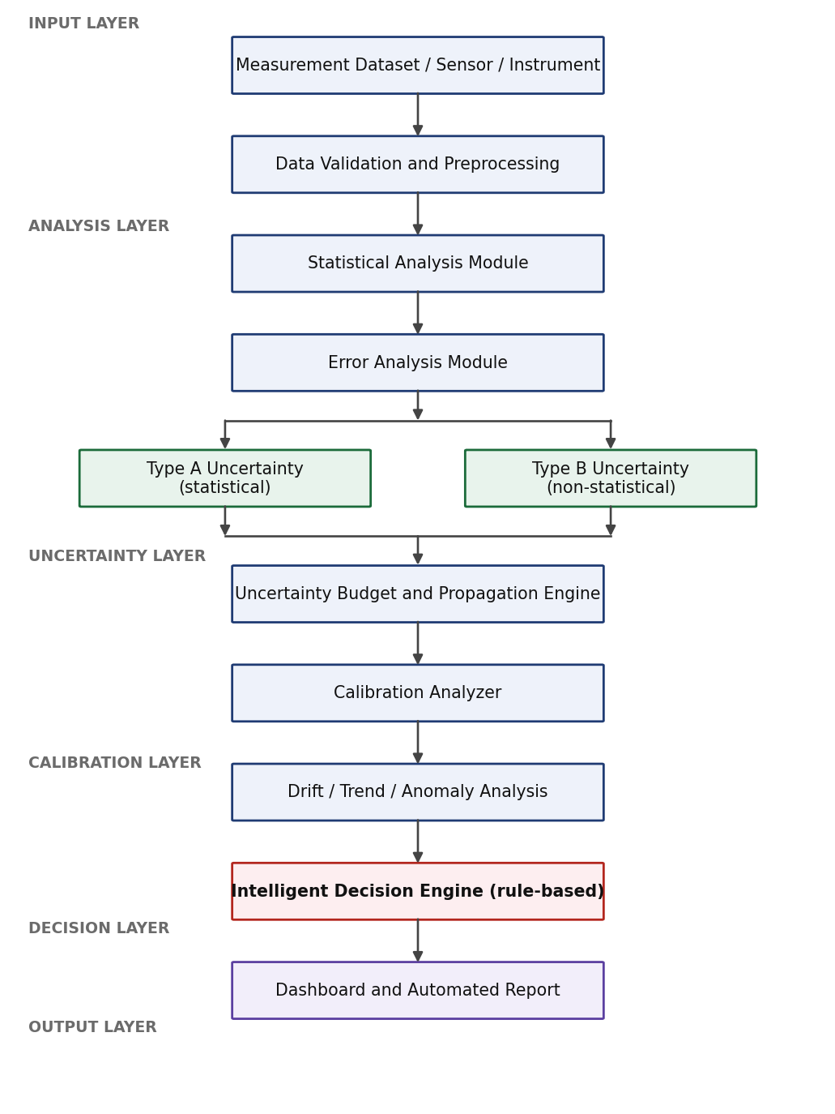
Figure 7.1 – Overall IMUCA system architecture

7.1 Block-by-block description
Block | Function and engineering motivation
1. Measurement dataset,  sensor or instrument | The entry point. Currently a CSV file of reference values, DUT indications and repeats; in the hardware phase, a serial or USB stream from a multimeter or DAQ. The block sits behind a single loader interface so that the analysis chain does not change when the source changes.
2. Data validation and  preprocessing | Nothing downstream is meaningful if the input is corrupt. Checks types, verifies values against the instrument range, detects missing entries and screens for outliers. Outliers are flagged, never deleted: a genuine outlier may indicate a loose connection or an intermittent fault, and discarding it destroys evidence. Also applies unit normalisation and records any correction it has applied.
3. Statistical analysis | Computes mean, sample standard deviation, variance, range, standard error and degrees of freedom for each repeat set. The n − 1 denominator is used throughout, because the repeat set is a sample drawn from the population of readings the instrument could produce, not the population itself.
4. Error analysis | Produces absolute, relative and percentage error against the reference. Across a sweep it also separates systematic error into a constant offset and a proportional gain error by regression. The separation matters because the two have different causes and different remedies: offset points to an input bias or zero error, gain to a reference or divider ratio problem.
5 and 6. Type A and  Type B uncertainty | The pipeline splits here because the two categories are evaluated by fundamentally different means. Type A is evaluated statistically from the repeat set. Type B is evaluated by any other method: display resolution, manufacturer specification, reference certificate, temperature coefficient. The distinction concerns the method of evaluation, not the nature of the effect, and both produce a standard uncertainty in the same units.
7. Uncertainty budget and  propagation engine | Collects every standard uncertainty, applies a sensitivity coefficient where the measurand is not the directly measured quantity, and combines by root sum of squares. Computes each source’s percentage share of the combined variance and ranks them, so the largest contributor is identified without comparing squares by eye. Effective degrees of freedom follow from Welch-Satterthwaite, which allows the coverage factor to be justified rather than assumed.
8. Calibration analyzer | Fits the DUT indication against the reference across the sweep, extracts offset and gain error, computes residuals and evaluates conformity of every point. The residual plot is the diagnostic output: random residuals mean the linear model is adequate; structured residuals reveal a nonlinearity or quantisation effect that a two-parameter correction will not remove.
9. Drift, trend and  anomaly analysis | Operates on stored history rather than a single event. Regresses calibration error against session index or elapsed time, tests whether the slope differs significantly from zero, and projects when the error will reach the tolerance limit. This projection is what converts a fixed calibration interval into a condition-based one.
10. Intelligent decision  engine | Applies an ordered rule set to the computed quantities and emits a named status. Described in full in Section 16. This is the point at which numbers become an engineering instruction.
11. Dashboard and  automated report | Renders results as figures and tables and generates the measurement report. Because the report is built from the same computed objects that produced the decision, the document cannot drift out of step with the calculation.

8. DETAILED PROCESS FLOWCHART

The following flowchart expands the architecture into the executable sequence, including the decision points at which the flow can branch.
START
|
+------------v------------+
| Load dataset (CSV/stream)|
+------------+------------+
|
+------------v------------+
| Validate dataset |
+------------+------------+
|
/-------------\ +--------------------+
< Values valid ? >---- NO ----->| Flag invalid rows |
\-------------/ | Log reason |
| YES <-------- | Request correction |
+------------v------------+ +--------------------+
| Preprocess data |
+------------+------------+
|
+------------v------------+
| Mean, SD, variance, |
| range, standard error |
+------------+------------+
|
+------------v------------+
| Measurement error |
| E, E_rel, E% |
+------------+------------+
|
+----------------+----------------+
| |
+-----v------------+ +---------v----------+
| Type A | | Identify Type B |
| u_A = s/sqrt(n) | | sources |
+-----+------------+ +---------+----------+
| |
| +---------v----------+
| | Type B |
| | u_B = a / divisor |
| +---------+----------+
+----------------+----------------+
|
+------------v------------+
| Uncertainty budget | ranked by contribution
+------------+------------+
|
+------------v------------+
| u_c = RSS of u_i |
+------------+------------+
|
+------------v------------+
| U = k * u_c |
+------------+------------+
|
+------------v------------+
| Compare DUT with |
| reference; calibration |
| error, offset, gain |
+------------+------------+
|
+------------v------------+
| Residual and trend |
| analysis |
+------------+------------+
|
+------------v------------+
| Check tolerance |
+------------+------------+
|
+------------v------------+
| DECISION ENGINE R1-R5 |
+------------+------------+
|
+-------------------+-------------------+
| | |
+----v-------+ +--------v---------+ +------v--------+
| ACCEPTABLE | | ATTENTION | | CALIBRATION |
| | | REQUIRED | | REQUIRED |
+----+-------+ +--------+---------+ +------+--------+
+-------------------+-------------------+
|
+------------v------------+
| Dashboard -> Report |
+------------+------------+
|
END
Figure 8.1 – Detailed IMUCA process flowchart

8.1 Explanation of the decision points
Three branch points control the behaviour of the pipeline, and each exists for a specific engineering reason.
Decision point | Test applied | Reason it exists
Are values valid? | Type is numeric; value lies within the instrument range; no missing entries; value passes an outlier screen such as a modified z-score or an interquartile-range test. | A single non-numeric entry or an out-of-range value will silently corrupt a mean and inflate a standard deviation. Catching it before any statistic is computed prevents an invalid uncertainty from propagating all the way to a conformity decision.
Tolerance check | Is the absolute calibration error within the stated tolerance, and does the error plus the expanded uncertainty remain within it? | Comparing only the error against the tolerance ignores how well the error itself is known. A result sitting just inside the limit with a large uncertainty is not the same as one sitting well inside it with a small uncertainty.
Status branch | Ordered evaluation of rules R1 to R5 on the computed uncertainty, error, drift slope and repeatability. | The pipeline must terminate in exactly one status so that the output is unambiguous. Ordering the rules by severity guarantees that the most serious condition determines the headline status while every triggered rule is still logged.
Table 8.1 – Decision points in the IMUCA pipeline

9. MATHEMATICAL FOUNDATION

Every quantity computed by IMUCA is defined below. These equations are the specification of the software; the implementation is validated by reproducing them by hand, as described in Section 21.

9.1 Descriptive statistics
For n repeated observations x₁, x₂, …, xₙ of the same measurand under repeatability conditions, the arithmetic mean is the best estimate of the measured quantity:
x̄ = (1/n) Σ_{i=1}^{n} x_{i} (9.1)
The dispersion of the individual readings is described by the sample standard deviation. The n − 1 denominator is used because the mean has been estimated from the same data, which removes one degree of freedom:
s = √[ Σ_{i=1}^{n} (x_{i} − x̄)² / (n − 1) ] (9.2)
The standard deviation of the mean, also called the standard error, describes how well the mean itself is known and is smaller than s by a factor of √n:
s(x̄) = s / √n (9.3)

9.2 Type A uncertainty
Type A evaluation obtains the standard uncertainty from the statistical analysis of the observations. When the reported result is the mean of n readings, the Type A standard uncertainty is the standard error:
u_{A} = s(x̄) = s / √n, with ν_{A} = n − 1 degrees of freedom (9.4)
Taking more readings reduces u_A, but only as 1/√n. Reducing it by a factor of two requires four times as many readings, which is why beyond about ten to twenty repeats the effort is usually better spent on the Type B sources.

9.3 Type B uncertainty
Type B evaluation converts a stated limit into a standard uncertainty using an assumed probability distribution. If a source is known to lie within ±a of its stated value, the standard uncertainty is the half-width divided by a divisor that depends on the distribution:
u_{B} = a / d (9.5)
Distribution | Divisor d | When it is the appropriate assumption | Typical source
Rectangular (uniform) | √3 ≈ 1.732 | The value is equally likely to be anywhere within ±a, with no reason to prefer the centre. The default choice when only a limit is known. | Display resolution, manufacturer accuracy specification, quantisation
Triangular | √6 ≈ 2.449 | Values near the centre are more likely than values near the limits, but the limits are still hard. | Sum of two independent rectangular effects
Normal, k = 2 | 2 | The source is quoted as an expanded uncertainty at approximately 95 % confidence. | Reference standard calibration certificate
Normal, k = 3 | 3 | The source is quoted at approximately 99.7 % confidence. | Some manufacturer confidence statements
U-shaped (arcsine) | √2 ≈ 1.414 | The value spends most of its time near the extremes rather than the centre. | Thermostatically cycled ambient temperature, mismatch effects
Table 9.1 – Distributions, divisors and the conditions under which each applies

Choosing the divisor is the single most common source of error in a manual budget. IMUCA stores the distribution as an attribute of each source, so the divisor is applied by the software and the assumption is visible in the output rather than hidden in an engineer’s head.

9.4 Sensitivity coefficients and propagation
When the measurand y is not measured directly but computed from input quantities x₁ … xₙ through a model y = f(x₁, …, xₙ), each input uncertainty must be scaled by the rate at which y changes with that input. This scaling factor is the sensitivity coefficient:
c_{i} = ∂f / ∂x_{i} (9.6)
For a resistance measured as R = V/I, the sensitivity to voltage is c_V = 1/I and the sensitivity to current is c_I = −V/I². A one-millivolt voltage uncertainty therefore matters far more at 1 mA than at 1 A. In the direct voltage measurement demonstrated in this report all sensitivity coefficients equal one, because the measurand is the indicated quantity itself, but the engine retains the general form so that derived quantities such as resistance, power and sensor-scaled physical values can be handled later.

9.5 Combined and expanded uncertainty
Assuming the sources are uncorrelated, the combined standard uncertainty is the root sum of squares of the scaled contributions. Summing squares rather than magnitudes reflects the fact that independent errors are unlikely to reach their extremes simultaneously and in the same direction:
u_{c}(y) = √[ Σ_{i=1}^{n} (c_{i} u_{i})² ] (9.7)
The percentage contribution of each source to the combined variance is used to rank the budget:
h_{i} = (c_{i} u_{i})² / u_{c}² × 100 % (9.8)
The combined standard uncertainty corresponds to roughly a 68 % level of confidence, which is too low for a conformity statement. It is therefore multiplied by a coverage factor to give the expanded uncertainty:
U = k · u_{c} (9.9)
The value k = 2 is used by convention and gives approximately 95 % confidence when the combined distribution is approximately normal and the effective degrees of freedom are large. The effective degrees of freedom are obtained from the Welch-Satterthwaite formula, which weights each contribution by its own reliability:
ν_{eff} = u_{c}⁴ / Σ_{i} ( u_{i}⁴ / ν_{i} ) (9.10)
If ν_eff is small, k = 2 is not justified and the coverage factor must be taken from the Student t distribution at the required confidence level. IMUCA computes ν_eff so that this choice is defensible rather than assumed.

9.6 Calibration quantities
For a device under test indicating X_DUT against a reference value X_REF, the calibration error is:
E = X_{DUT} − X_{REF} (9.11)
Expressed relative to the reference value:
E% = [ (X_{DUT} − X_{REF}) / X_{REF} ] × 100 % (9.12)
Across a multi-point sweep, the systematic behaviour is separated by fitting a straight line to the indication against the reference:
X_{DUT} = m · X_{REF} + c (9.13)
Here c is the zero offset and (m − 1) × 100 % is the gain error. The residual at each point is what remains after this two-parameter correction:
r_{i} = X_{DUT,i} − (m · X_{REF,i} + c) (9.14)
A structured residual pattern indicates that a linear correction is insufficient. A random residual pattern indicates that offset and gain fully describe the systematic behaviour and that what remains is noise and quantisation.

9.7 Drift and conformity
Drift is estimated as the slope of the calibration error against time or session index:
b = Σ (t_{j} − t̄)(E_{j} − Ē) / Σ (t_{j} − t̄)² (9.15)
The slope is tested for significance using t = b / s(b) before it is reported, so that ordinary scatter is not mistaken for drift. Finally, a conformity decision that accounts for the uncertainty of the result uses a guard band: the result is accepted only if the measured error together with its expanded uncertainty remains inside the tolerance T:
| E | + U ≤ T (9.16)
This is a conservative decision rule. It guarantees that the true error lies inside the tolerance at the stated confidence level, at the cost of rejecting some results that are in fact conforming.

10. DATASET DESIGN

SYNTHETIC / DUMMY DATASET FOR PROOF-OF-CONCEPT DEMONSTRATION
The dataset below was generated numerically. It is not experimental laboratory data, no instrument was connected, and no measurement was performed. Its purpose is to exercise the analysis chain with values whose true properties are known in advance, so that the correctness of every computed quantity can be checked against the values that were deliberately injected.

10.1 Measurement scenario
The scenario is the calibration of a DC voltage measurement. A device under test, modelled as a 3½-digit digital multimeter on its 20 V range, is compared against a reference voltage source across ten points from 0.5 V to 5.0 V in 0.5 V steps.
Parameter | Value | Note
Measured quantity | DC voltage | Direct measurement, so all sensitivity coefficients equal 1
Reference range | 0.5 V to 5.0 V in 0.5 V steps | 10 calibration points
DUT display resolution | 0.01 V (10 mV) | 3½-digit meter on the 20 V range
DUT specification (illustrative) | ±0.1 % of reading | Assumed for the demonstration; a real value would be taken from the datasheet
Reference standard uncertainty | U = 0.002 V at k = 2 | As would appear on a calibration certificate
Ambient temperature variation | ±3 °C about the calibration temperature | Combined with a 0.005 %/°C coefficient
Tolerance (illustrative) | ±1.0 % of reading | Example acceptance requirement, not a universal standard
Repeats | 3 repeats at four points, 10 repeats at 5.000 V | Supports Type A evaluation
Table 10.1 – Measurement scenario parameters for the synthetic dataset

10.2 Injected error model
The DUT indication was generated from the reference value using a deliberate error model, so that the analysis has known answers to recover:
X_{DUT} = Q[ (1 + g) X_{REF} + c₀ + ε + δ(t) ] (10.1)
Term | Injected value | What it represents | Which IMUCA output should recover it
c₀ | +8 mV | Zero offset error | Intercept of the calibration fit
g | +0.25 % | Gain error | Slope of the calibration fit minus one
ε | ± a few mV | Random noise | Sample standard deviation of the repeat sets
δ(t) | ≈ +1 mV per session | Slow drift across sessions | Slope of the drift regression
Q[·] | 10 mV steps | Display quantisation | Structured pattern in the residual plot
Table 10.2 – Injected error components and the IMUCA output expected to recover each

This construction is what makes the synthetic dataset useful rather than decorative. Because the injected values are known, the demonstration in Sections 11 to 14 is simultaneously a functional test: if the recovered offset, gain error and drift slope do not agree with the injected values, the analysis is wrong.

10.3 The dataset
Ref  (V) | DUT  (V) | Rpt 1  (V) | Rpt 2  (V) | Rpt 3  (V) | Error  (mV) | Error  (%) | Status  (±1 %)
0.500 | 0.51 | 0.51 | 0.50 | 0.51 | +10 | +2.000 | FAIL
1.000 | 1.01 | – | – | – | +10 | +1.000 | MARGINAL
1.500 | 1.51 | – | – | – | +10 | +0.667 | PASS
2.000 | 2.01 | 2.01 | 2.02 | 2.01 | +10 | +0.500 | PASS
2.500 | 2.51 | – | – | – | +10 | +0.400 | PASS
3.000 | 3.02 | – | – | – | +20 | +0.667 | PASS
3.500 | 3.52 | 3.52 | 3.51 | 3.52 | +20 | +0.571 | PASS
4.000 | 4.02 | – | – | – | +20 | +0.500 | PASS
4.500 | 4.52 | – | – | – | +20 | +0.444 | PASS
5.000 | 5.02 | 5.02 | 5.01 | 5.03 | +20 | +0.400 | PASS
Table 10.3 – Synthetic calibration dataset (dummy data, proof-of-concept only)

An additional set of ten repeated readings at the 5.000 V point supports the Type A evaluation in Section 11: 5.02, 5.01, 5.03, 5.02, 5.04, 5.01, 5.02, 5.03, 5.02 and 5.01 V. A ten-session history of the mean error at that point supports the drift analysis in Section 14.
Two features of this dataset deserve comment before the analysis begins. First, all DUT values are multiples of 10 mV because the modelled instrument cannot display anything finer; this is realistic and it is the reason the residual plot in Section 15 shows structure rather than random scatter. Second, the percentage error is largest at the smallest reference value even though the absolute error is smallest there, which is the expected behaviour of a fixed offset expressed as a fraction of reading and is exactly why the 0.5 V point fails.

11. PROOF-OF-CONCEPT NUMERICAL DEMONSTRATION

ILLUSTRATIVE PROOF-OF-CONCEPT RESULT – SYNTHETIC DATA, NOT EXPERIMENTAL
This section works the complete IMUCA calculation by hand for a single calibration point, so that every number produced by the software has a manually verifiable counterpart. This hand calculation is also Level 1 of the validation strategy described in Section 21.

11.1 Input
CALIBRATION POINT : 5.000 V (DC voltage)
REFERENCE STANDARD : 5.000 V, certificate U = 0.002 V at k = 2
DUT : 3.5-digit DMM, 20 V range, resolution 0.01 V
DUT SPECIFICATION : +/- 0.1 % of reading (illustrative assumption)
AMBIENT VARIATION : +/- 3 degC, tempco 0.005 %/degC (illustrative)
TOLERANCE : +/- 1.0 % of reading (illustrative requirement)

REPEATED DUT READINGS (n = 10), volts:
5.02 5.01 5.03 5.02 5.04
5.01 5.02 5.03 5.02 5.01

11.2 Steps 1 to 3 – Mean, standard deviation and Type A uncertainty
Σx_{i} = 50.21 V → x̄ = 50.21 / 10 = 5.021 V
The squared deviations from the mean, in units of 10⁻⁶ V², are 1, 121, 81, 1, 361, 121, 1, 81, 1 and 121, giving:
Σ(x_{i} − x̄)² = 8.90 × 10⁻⁴ V² → s² = 8.90 × 10⁻⁴ / 9 = 9.8889 × 10⁻⁵ V²
s = 9.944 × 10⁻³ V = 9.944 mV
u_{A} = s / √n = 9.944 / √10 = 9.944 / 3.1623 = 3.145 mV, ν_{A} = 9 (11.1)
Note that u_A is roughly one third of s: averaging ten readings does not remove the scatter, it reduces the uncertainty of the average by √10.

11.3 Step 4 – Type B standard uncertainties
- B1 Display resolution. The meter displays in 10 mV steps, so a reading of 5.02 V could correspond to any true indication between 5.015 V and 5.025 V. The half-width is half the resolution, and a rectangular distribution is correct because no value inside that window is more likely than any other: a₁ = 0.01/2 = 5.000 mV, so u₁ = 5.000/√3 = 2.887 mV.
- B2 DUT specification. The assumed ±0.1 % of reading is a limit the manufacturer guarantees, with no distribution stated, so rectangular is again used: a₂ = 0.001 × 5.021 = 5.021 mV, so u₂ = 5.021/√3 = 2.899 mV.
- B3 Reference standard. The certificate states an expanded uncertainty at k = 2, so it is converted back by dividing by the same coverage factor: u₃ = 2.000/2 = 1.000 mV.
- B4 Ambient temperature. A coefficient of 0.005 % of reading per degree Celsius over ±3 °C: a₄ = 0.00005 × 5.021 × 3 = 0.753 mV, so u₄ = 0.753/√3 = 0.435 mV.
u_{B} = √(2.887² + 2.899² + 1.000² + 0.435²) = √17.928 = 4.234 mV (11.2)

11.4 Steps 5 and 6 – Combined and expanded uncertainty
u_{c} = √(u_{A}² + u_{B}²) = √(3.145² + 4.234²) = √27.818 = 5.274 mV (11.3)
The effective degrees of freedom are computed from equation 9.10. Only the Type A term has finite degrees of freedom, since the Type B sources are taken as reliably known:
ν_{eff} = u_{c}⁴ / (u_{A}⁴ / ν_{A}) = 773.7 / (97.83 / 9) = 71.2
At 71 effective degrees of freedom the two-sided Student t value for 95 % confidence is 1.99, so k = 2 is justified rather than merely assumed:
U = k · u_{c} = 2 × 5.274 = 10.55 mV (11.4)
Following normal metrological practice the expanded uncertainty is rounded upward to two significant figures, and the reported value is rounded to the same decimal place:
V = (5.021 ± 0.011) V, k = 2, approximately 95 % confidence

11.5 Step 7 – Error and conformity
E = 5.021 − 5.000 = +0.021 V = +21 mV, E% = +0.42 %, T = ±1.0 % of 5.000 V = ±50 mV
The simple conformity test compares the error alone against the tolerance: 21 mV ≤ 50 mV, so the point passes. The guard-banded test of equation 9.16 also accounts for how well the error itself is known:
| E | + U = 21.0 + 10.5 = 31.5 mV ≤ 50 mV → PASS
A margin of 18.5 mV remains. The point conforms under both decision rules, which is the strongest form of the statement that can be made from this data. Had the error been 42 mV instead of 21 mV, the simple test would still have passed while the guard-banded test would have failed, and IMUCA would have reported the result as marginal rather than acceptable. This is precisely the distinction that a reading without an uncertainty cannot make.

12. UNCERTAINTY BUDGET DEMONSTRATION

The uncertainty budget assembles every contribution into one table and ranks them. It is the most useful single output of the analysis, because it converts a scalar result into a statement about where the uncertainty comes from and therefore where engineering effort should be directed.
Source | Type | Value  (mV) | Distribution | Divisor | uᵢ  (mV) | cᵢ | cᵢuᵢ  (mV) | νᵢ | Contribution  (%)
Repeatability | A | 9.944 | Normal | √10 | 3.145 | 1 | 3.145 | 9 | 35.6
Display resolution | B | 5.000 | Rectangular | √3 | 2.887 | 1 | 2.887 | ∞ | 30.0
DUT specification | B | 5.021 | Rectangular | √3 | 2.899 | 1 | 2.899 | ∞ | 30.2
Reference standard | B | 2.000 | Normal (k = 2) | 2 | 1.000 | 1 | 1.000 | ∞ | 3.6
Ambient temperature | B | 0.753 | Rectangular | √3 | 0.435 | 1 | 0.435 | ∞ | 0.7
Combined standard uncertainty uᴄ |  |  | RSS of above |  | 5.274 |  |  | 71 | 100.0
Expanded uncertainty U (k = 2) |  |  | Normal |  | 10.55
Table 12.1 – Illustrative uncertainty budget for the 5.000 V calibration point

All sensitivity coefficients equal one because the measurand is the indicated voltage itself. The percentage contributions are variance shares, computed from equation 9.8, and they sum to 100 %.

12.1 Identifying the dominant contributor
Repeatability is the largest single contributor at 35.6 % of the combined variance, with the DUT specification at 30.2 % and display resolution at 30.0 % close behind. The reference standard contributes 3.6 % and ambient temperature 0.7 %.
IMUCA identifies the dominant source automatically by sorting the squared contributions in descending order after the budget is built, then writes the top entry into the report as a named field. This is a trivial operation in software and a tedious one by hand, which is exactly the kind of step that gets skipped in a manual workflow. The engineering value of the ranking lies in what it rules out.
- Buying a more accurate reference standard would be close to useless here. Removing its 1.000 mV contribution entirely would reduce uᴄ from 5.274 mV to 5.179 mV, an improvement of under 2 %.
- Controlling the laboratory temperature more tightly would change essentially nothing, since that source contributes 0.7 % of the variance.
- Taking more readings attacks the largest term, but with diminishing returns: increasing n from 10 to 40 would halve u_A to 1.572 mV and reduce uᴄ to 4.517 mV, an improvement of 14 % for four times the measurement effort.
- Replacing the 3½-digit meter with a 4½-digit instrument would attack two terms at once. It would cut the resolution contribution by a factor of ten and, in practice, tighten repeatability as well, since much of the observed scatter is quantisation appearing as noise.
The last point is the actionable conclusion, and it is not obvious from the combined uncertainty alone. Three sources of comparable size mean there is no single easy fix; the instrument itself is the limiting element.
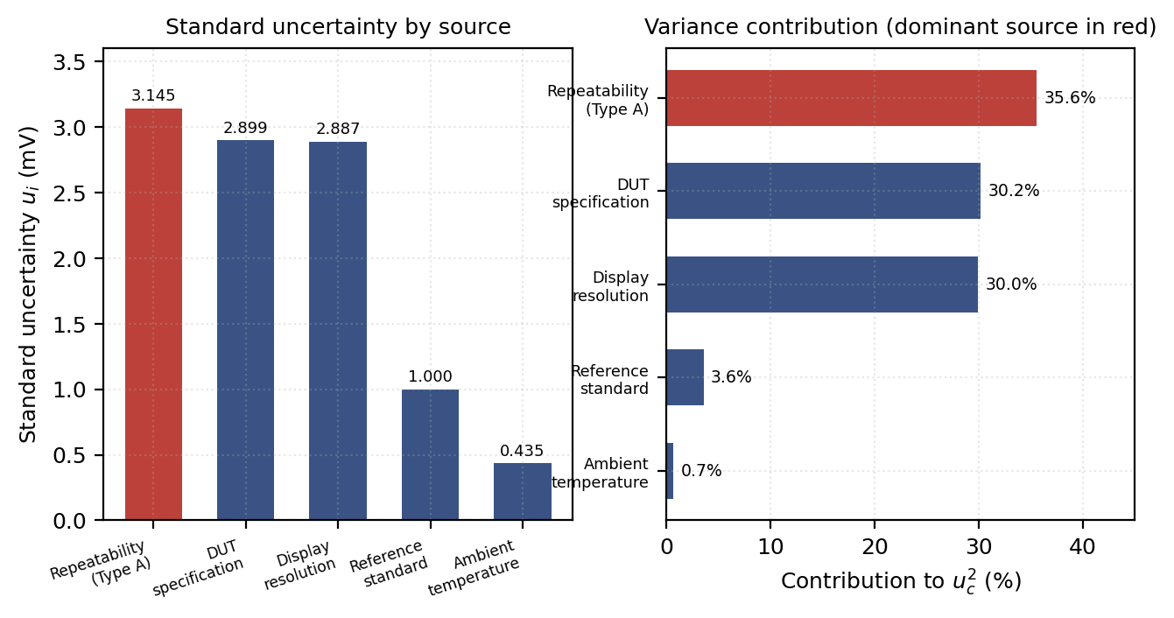
Figure 12.1 – Uncertainty contributions by source (illustrative proof-of-concept result). Left: standard uncertainty of each source. Right: percentage contribution to the combined variance, with the dominant source shown in red.

13. CALIBRATION DEMONSTRATION

ILLUSTRATIVE PROOF-OF-CONCEPT RESULT – SYNTHETIC DATA, NOT EXPERIMENTAL
The single-point analysis of Section 11 establishes the uncertainty at one value. A calibration requires the instrument to be characterised across its working range, because offset and gain errors behave differently and are only separable from a multi-point sweep.

13.1 Point-by-point conformity
The tolerance used here is ±1.0 % of reading. This is an example acceptance requirement chosen to make the demonstration concrete. It is not a universal standard, and a real specification would come from the application, the customer requirement or the governing test standard. A three-band decision rule is applied: a point passes if the magnitude of its relative error is below 80 % of the tolerance, is marginal between 80 % and 100 %, and fails above 100 %.
Point | Reference  (V) | DUT  (V) | Absolute error  (mV) | Relative error  (×10⁻³) | Percentage  error (%) | Status
1 | 0.500 | 0.51 | +10 | +20.00 | +2.000 | FAIL
2 | 1.000 | 1.01 | +10 | +10.00 | +1.000 | MARGINAL
3 | 1.500 | 1.51 | +10 | +6.67 | +0.667 | PASS
4 | 2.000 | 2.01 | +10 | +5.00 | +0.500 | PASS
5 | 2.500 | 2.51 | +10 | +4.00 | +0.400 | PASS
6 | 3.000 | 3.02 | +20 | +6.67 | +0.667 | PASS
7 | 3.500 | 3.52 | +20 | +5.71 | +0.571 | PASS
8 | 4.000 | 4.02 | +20 | +5.00 | +0.500 | PASS
9 | 4.500 | 4.52 | +20 | +4.44 | +0.444 | PASS
10 | 5.000 | 5.02 | +20 | +4.00 | +0.400 | PASS
Table 13.1 – Calibration results against an illustrative ±1 % of reading tolerance

Eight of ten points pass, one is marginal and one fails. The overall calibration verdict is therefore a failure against the stated requirement, even though the instrument performs well across most of its range. This is a realistic and instructive outcome: a single non-conforming point invalidates a blanket statement of conformity, and it forces a specific engineering conversation about whether the 0.5 V point is actually needed for the intended application.

13.2 Separating offset from gain error
Fitting equation 9.13 to the ten points by least squares gives:
X_{DUT} = 1.003030 · X_{REF} + 0.006667, R² = 0.999997
Quantity | Recovered value | Injected value | Interpretation
Zero offset c | +6.67 mV | +8 mV | A constant additive error present at all readings, consistent with an input bias or zero error.
Gain error (m − 1) | +0.303 % | +0.25 % | A proportional error that grows with the reading, consistent with a reference or divider ratio error.
Coefficient of determination R² | 0.999997 | – | The linear model explains almost all of the variation, so a two-parameter correction is appropriate.
Largest residual | 4.24 mV | – | Below half the display resolution of 10 mV, confirming that quantisation limits what remains.
Table 13.2 – Recovered systematic error parameters compared with the injected values

The recovered values are close to the injected ones but not identical. The difference is not an analysis error; it is a direct consequence of the 10 mV display quantisation, which prevents the fit from resolving an 8 mV offset and a 0.25 % gain error separately when both produce sub-resolution effects at low readings. Reporting this honestly is more useful than tuning the dataset to give an exact match, because a real calibration of a 3½-digit meter behaves the same way. It also demonstrates a genuine limitation that the validation strategy in Section 21 must account for.
The practical consequence is that applying a correction of X_corrected = (X_DUT − 0.006667) / 1.003030 would bring every point well inside the tolerance, including the 0.5 V point, whose error would fall from +10 mV to under 2 mV. IMUCA can therefore report not only that the instrument fails, but that it fails in a way that a documented correction would fix.

14. DRIFT AND TREND ANALYSIS

Drift is a slow change in an instrument’s systematic error over time. It cannot be detected from a single calibration, no matter how carefully that calibration is performed, because one measurement of the error contains no information about how the error is changing. Detecting it requires stored history and a trend test, and this is the clearest case where an integrated system does something a per-event spreadsheet structurally cannot.

14.1 Within-run trend
IMUCA first checks whether the ten repeated readings taken within a single session show a trend, which would indicate thermal settling or a loose contact rather than random scatter. Regressing the readings against their sequence number gives a slope of −0.303 mV per reading with a standard error of 1.156 mV per reading, hence t = −0.26 and p = 0.80.
The slope is not significantly different from zero, so the repeat set is treated as independent observations from a stable process and the Type A evaluation of Section 11 is valid. This check matters: if a within-run trend had been present, averaging the readings would have produced a mean that describes no particular moment in time, and the standard deviation would have been inflated by the trend rather than describing genuine repeatability.

14.2 Between-session drift
The mean error at the 5.000 V point was recorded across ten measurement sessions in the synthetic history:
Session | 1 | 2 | 3 | 4 | 5 | 6 | 7 | 8 | 9 | 10
Mean error (mV) | +21 | +22 | +21 | +24 | +25 | +26 | +26 | +28 | +29 | +31
Table 14.1 – Synthetic calibration history at the 5.000 V point

Applying equation 9.15 to this history gives:
b = +1.10 mV per session, s(b) = 0.085 mV, R² = 0.954, p = 1.3 × 10⁻⁶
The slope is highly significant, so the trend is real and not scatter. Against an illustrative drift threshold of 0.5 mV per session, the observed slope of 1.10 mV per session triggers rule R3 and the status POSSIBLE DRIFT.
Extrapolating the fitted line to the +50 mV tolerance limit gives a projected breach at session 28, which is eighteen sessions beyond the last recorded one. This projection is the output that converts a fixed calibration interval into a condition-based one: instead of recalibrating on a fixed schedule, the instrument can be scheduled for recalibration before the projected breach, with a margin chosen from the confidence interval of the slope.
The projection carries an obvious assumption that must be stated whenever it is reported: it presumes the drift continues linearly. Real instrument drift is often nonlinear, can reverse after a temperature excursion, and can step discontinuously after mechanical shock. The projection is therefore a planning aid, not a prediction, and IMUCA reports it alongside the R² and the p value so the reader can judge how much weight it deserves.
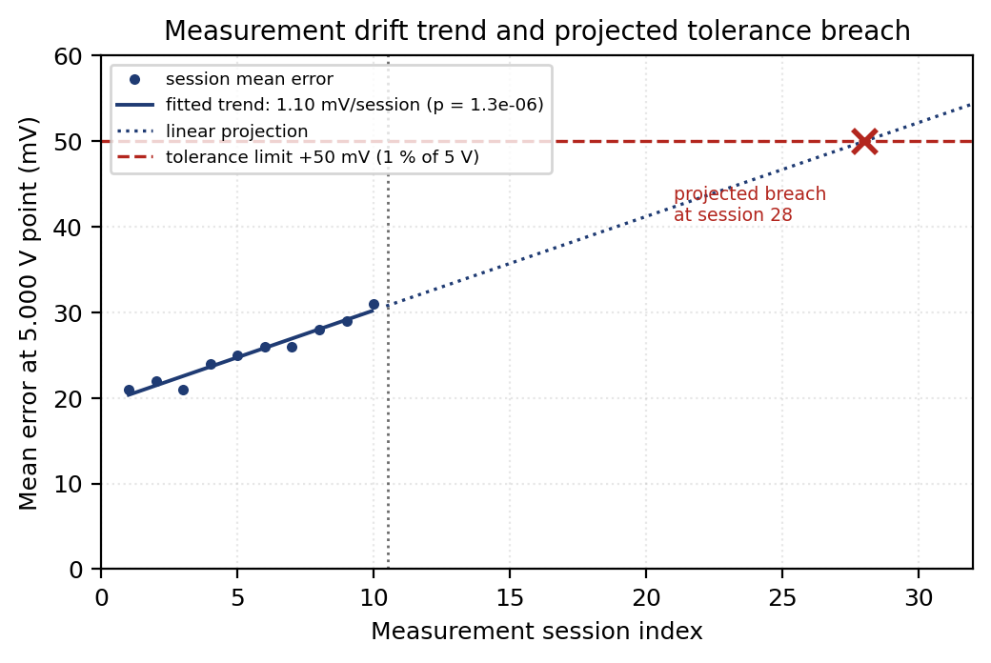
Figure 14.1 – Measurement drift trend and projected tolerance breach (illustrative proof-of-concept result)

15. GRAPHS AND VISUALISATION

Six figures form the visual output of the analysis. All were generated from the synthetic dataset of Section 10 using the computations of Sections 11 to 14, and all are illustrative proof-of-concept results.

15.1 Reference versus DUT calibration curve
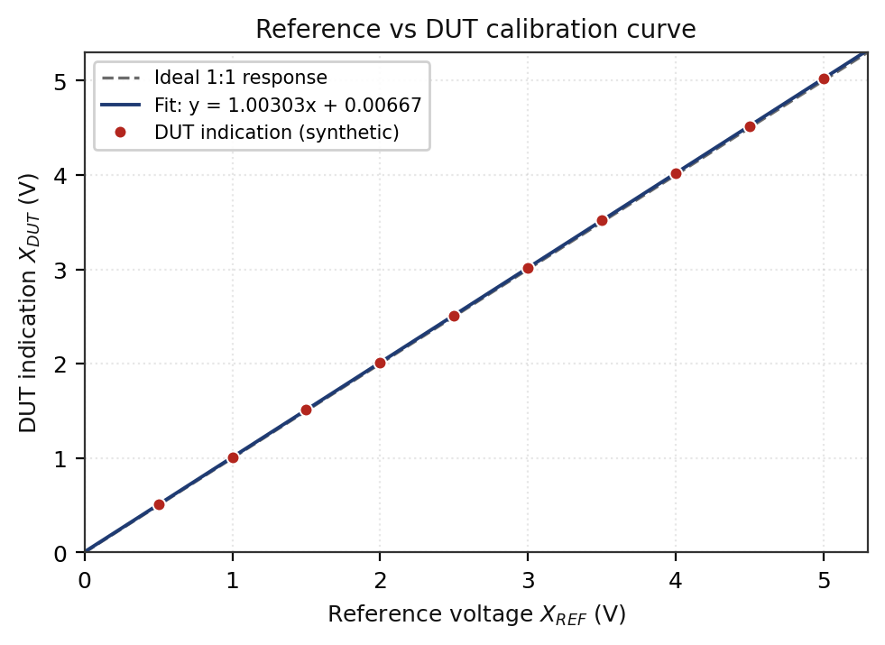
Figure 15.1 – Reference vs DUT calibration curve (illustrative proof-of-concept result)
Axes: reference voltage X_REF (horizontal) against DUT indication X_DUT (vertical), both 0 to 5.3 V. The plot shows the ten calibration points, the ideal 1:1 response as a dashed line and the least-squares fit. Conclusion: the response is highly linear and the fitted line sits consistently above the ideal line, which is the visual signature of a combined positive offset and positive gain error. On this scale the deviation is barely visible, which is exactly why the error and residual plots are needed: a calibration curve alone will not reveal a 10 mV problem on a 5 V axis.

15.2 Measurement error versus reference value
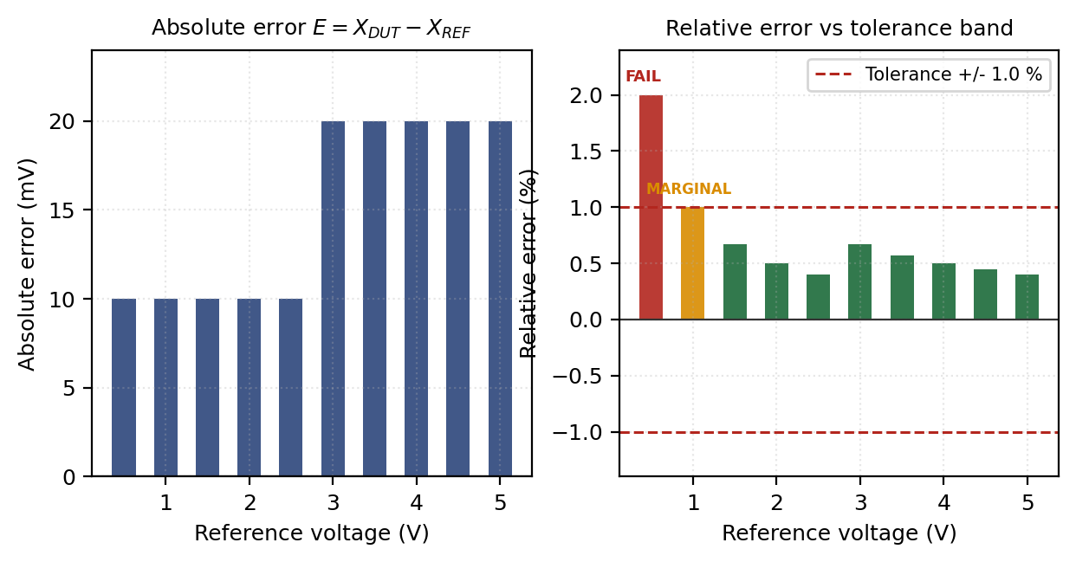
Figure 15.2 – Absolute and relative error against reference value (illustrative proof-of-concept result)
Axes: reference voltage from 0.5 to 5.0 V on both panels; absolute error in mV on the left, relative error in per cent with the ±1 % tolerance band on the right, colour-coded by conformity status. Conclusion: the two panels tell opposite stories and both are true. Absolute error grows with the reading, stepping from +10 mV to +20 mV, which is the gain error made visible. Relative error falls from 2.0 % to 0.4 %, because the fixed offset becomes a smaller fraction of a larger number. A tolerance expressed as a percentage of reading is therefore hardest to meet at the bottom of the range, which is where this instrument fails.

15.3 Residual error plot
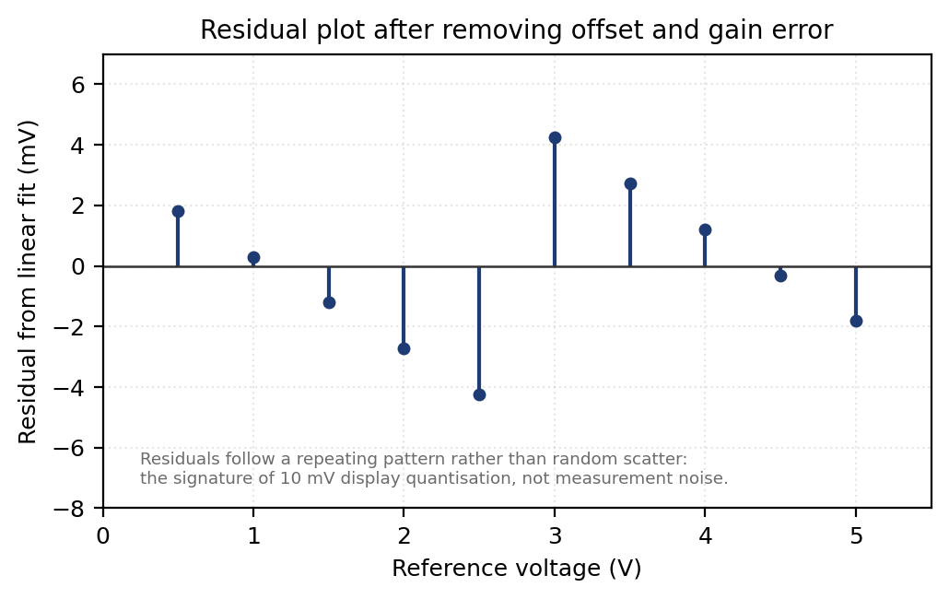
Figure 15.3 – Residuals after removing offset and gain error (illustrative proof-of-concept result)
Axes: reference voltage from 0 to 5.5 V against the residual from the linear fit, −8 to +7 mV. Conclusion: the residuals are not random. They descend steadily to −4.24 mV at 2.5 V, jump to +4.24 mV at 3.0 V, then descend again. This sawtooth is the signature of 10 mV display quantisation rather than measurement noise, and its amplitude never exceeds half the display resolution. Offset and gain therefore fully describe the systematic behaviour of this instrument, and further curve fitting would be fitting the quantiser rather than the meter.

15.4 Repeated measurement distribution
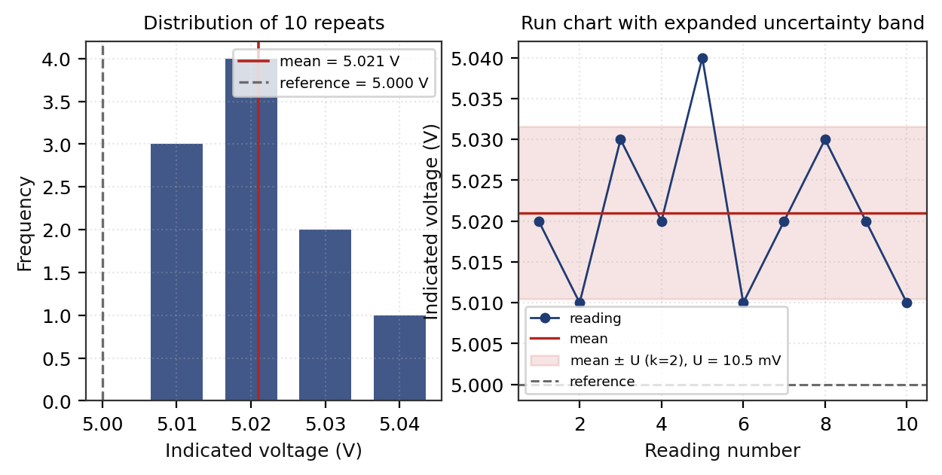
Figure 15.4 – Distribution and run chart of the ten repeated readings (illustrative proof-of-concept result)
Axes: left panel, indicated voltage against frequency of occurrence; right panel, reading number 1 to 10 against indicated voltage, with the mean and the ±U band shown. Conclusion: the distribution is centred at 5.02 V and roughly symmetric, with the 5.04 V reading as the only value more than two standard deviations from the mean. The run chart shows no systematic movement, confirming the within-run trend test of Section 14.1. The reference value of 5.000 V lies outside the ±U band, which is the visual statement that the observed error is real and not explainable by the measurement uncertainty alone.

15.5 Uncertainty contribution chart and drift trend
The remaining two figures appear in the sections they support. The uncertainty contribution chart is Figure 12.1: its horizontal axis lists the uncertainty sources and its vertical axis shows the standard uncertainty in millivolts on the left panel and the percentage contribution to the combined variance on the right. The conclusion drawn from it is that three sources of comparable magnitude dominate, so no single change produces a large improvement, and the instrument itself is the limiting element. The drift trend is Figure 14.1: session index against mean error at the 5.000 V point in millivolts, showing a significant upward drift of 1.10 mV per session and a projected tolerance breach at session 28.

16. INTELLIGENT DECISION ENGINE

The decision engine is where IMUCA earns the word intelligent, and it is worth being precise about what is being claimed. The engine is a transparent, ordered rule set operating on the quantities computed by the preceding blocks. It is not a trained model, it does not learn, and no machine-learning component has been implemented at this stage.

16.1 Rule set
RULE R1 - UNCERTAINTY CHECK
IF U > U_allowable
THEN status := "HIGH UNCERTAINTY"
action := "Result not fit for the stated purpose;"
"reduce dominant contributor before use"

RULE R2 - CONFORMITY CHECK
IF |E| > T OR (|E| + U) > T
THEN status := "CALIBRATION REQUIRED"
action := "Adjust, correct or withdraw the instrument"

RULE R3 - DRIFT CHECK
IF |b| > b_threshold AND p_value < 0.05
THEN status := "POSSIBLE DRIFT"
action := "Shorten calibration interval;"
"schedule before projected breach"

RULE R4 - REPEATABILITY CHECK
IF s > s_allowable
THEN status := "REPEATABILITY CONCERN"
action := "Investigate connections, thermal settling, noise"

RULE R5 - DEFAULT
IF none of R1 to R4 fired
THEN status := "MEASUREMENT ACCEPTABLE"
action := "Release result; retain for drift history"
Figure 16.1 – IMUCA decision rule set

16.2 Decision tree
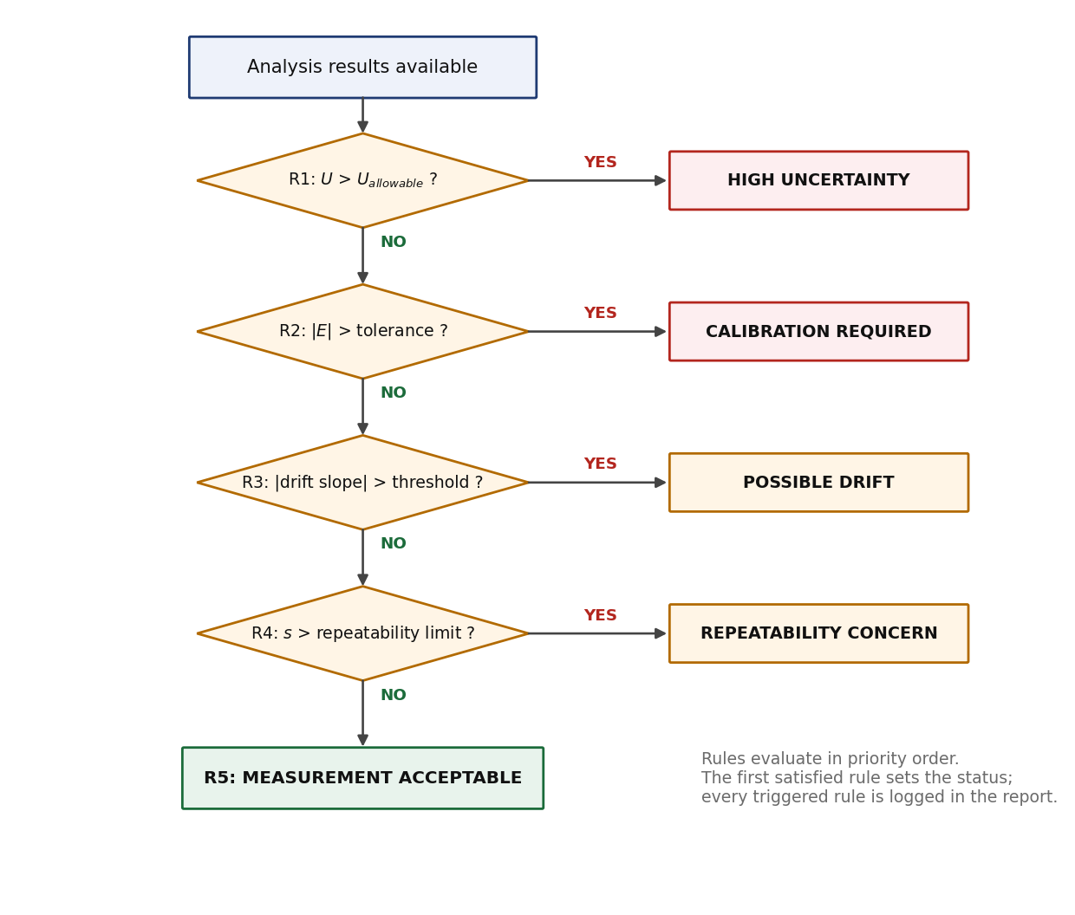
Figure 16.2 – Decision-tree structure of the IMUCA rule engine
Rules are evaluated in the order R1 to R5 and the first rule that fires sets the headline status, but evaluation does not stop there: every triggered rule is recorded in the report. This ordering encodes severity. A result whose uncertainty is too large cannot support any conformity statement at all, so R1 precedes R2. A non-conforming instrument requires action regardless of its drift behaviour, so R2 precedes R3.

16.3 Applying the rules to the demonstration data
Rule | Condition | Computed value | Limit | Fired?
R1 | U > U_allowable | U = 10.55 mV | 25 mV (illustrative) | No
R2 | |E| + U > T | 31.5 mV | 50 mV | No
R3 | |b| > b_threshold | 1.10 mV/session, p = 1.3×10⁻⁶ | 0.5 mV/session | YES
R4 | s > s_allowable | s = 9.944 mV | 15 mV (illustrative) | No
R5 | default | – | – | Not reached
Table 16.1 – Rule evaluation for the demonstration dataset

For the single-session analysis, in which no history is available, R1 to R4 all fail to fire and the status is MEASUREMENT ACCEPTABLE. Once the ten-session history of Section 14 is included, R3 fires and the status becomes POSSIBLE DRIFT. Both outcomes are shown in Section 17 to demonstrate that the engine produces different decisions from different evidence rather than always returning the same answer.

16.4 Why transparent rules for the first prototype
A rule-based engine is the correct choice at this stage for five reasons, and being able to defend this choice matters more in a viva than claiming a machine-learning component.
- Verifiability. Every decision can be reproduced by hand from the printed intermediate values. An examiner can check the entire chain with a calculator, which is not possible with a trained model.
- No training data exists. A supervised anomaly detector needs a labelled history of normal and abnormal instrument behaviour. This project has ten synthetic sessions. Training a model on that would produce a component that appears sophisticated and means nothing.
- Metrological alignment. The thresholds are not arbitrary hyperparameters; they are the tolerance, the allowable uncertainty and the drift limit, all of which come from the application requirement or the governing standard. The rules therefore encode existing engineering practice rather than replacing it.
- Auditability. In accredited testing, a conformity statement must be traceable to a documented decision rule. A rule engine satisfies this by construction; a model whose reasoning cannot be inspected does not.
- It establishes the baseline. Any future machine-learning extension must be shown to outperform this rule set. Without the baseline there is nothing to measure the extension against.
The planned extension is described in Section 24. In outline, once sufficient real calibration history has been collected, unsupervised anomaly detection could flag reading patterns that satisfy every threshold yet differ from the instrument’s established behaviour, and time-series models could replace the linear drift extrapolation with a forecast that accounts for nonlinearity. Neither is claimed as completed work.

17. SAMPLE FINAL SYSTEM OUTPUT

The following report mock-up is populated entirely with values computed in Sections 11 to 14 from the synthetic dataset. No number in it has been chosen for appearance.
===========================================================================
I M U C A M E A S U R E M E N T A N A L Y S I S
A N A L Y S I S R E P O R T
===========================================================================
Report ID : IMUCA-DEMO-001 Data source : synthetic dataset
Parameter : DC Voltage Analysis : single session
DUT : 3.5-digit DMM, 20 V range, resolution 0.01 V
Reference : 5.000 V standard, U = 0.002 V (k = 2)
---------------------------------------------------------------------------
MEASUREMENT RESULT
Reference value ................ 5.000 V
Number of observations n ....... 10
Measured mean .................. 5.021 V
Sample standard deviation ...... 9.944 mV
Measurement error .............. +0.021 V
Percentage error ............... +0.42 %
---------------------------------------------------------------------------
UNCERTAINTY EVALUATION
Type A uncertainty u_A ........ 3.145 mV (nu = 9)
Type B uncertainty u_B ........ 4.234 mV
Combined uncertainty u_c ...... 5.274 mV
Effective degrees of freedom ... 71
Coverage factor k .............. 2 (95 % confidence)
Expanded uncertainty U ........ 10.55 mV

REPORTED VALUE ................. (5.021 +/- 0.011) V, k = 2
---------------------------------------------------------------------------
UNCERTAINTY BUDGET (ranked by variance contribution)
1. Repeatability ............... 3.145 mV .......... 35.6 % <== DOMINANT
2. DUT specification ........... 2.899 mV .......... 30.2 %
3. Display resolution .......... 2.887 mV .......... 30.0 %
4. Reference standard .......... 1.000 mV ........... 3.6 %
5. Ambient temperature ......... 0.435 mV ........... 0.7 %
---------------------------------------------------------------------------
CALIBRATION ASSESSMENT
Tolerance ...................... +/- 1.00 % of reading (+/- 50 mV)
Simple conformity |E| <= T .... 21.0 mV <= 50 mV .... PASS
Guard-banded |E| + U <= T ..... 31.5 mV <= 50 mV .... PASS
Remaining margin ............... 18.5 mV
Sweep result (10 points) ....... 8 PASS / 1 MARGINAL / 1 FAIL
Zero offset .................... +6.67 mV
Gain error ..................... +0.303 %
Linearity R^2 .................. 0.999997
---------------------------------------------------------------------------
TREND ANALYSIS
Within-run trend ............... -0.303 mV/reading, p = 0.80
Within-run verdict ............. NO SIGNIFICANT TREND
---------------------------------------------------------------------------
DECISION ENGINE
R1 High uncertainty ............ not triggered
R2 Calibration required ........ not triggered
R3 Possible drift .............. not evaluated (no history)
R4 Repeatability concern ....... not triggered
R5 Default ..................... TRIGGERED

MEASUREMENT QUALITY ............ ACCEPTABLE
CALIBRATION STATUS ............. PASS (at this point)
DOMINANT UNCERTAINTY SOURCE .... REPEATABILITY (35.6 %)
DRIFT STATUS ................... NOT ASSESSED

FINAL RECOMMENDATION ........... MEASUREMENT ACCEPTABLE. Release result
and retain for drift history. Note that
the 0.5 V point of the full sweep is
non-conforming; restrict use to the
range above 1.5 V or apply the
documented offset and gain correction.
===========================================================================
Figure 17.1 – IMUCA report output, single-session analysis (illustrative proof-of-concept result)
When the ten-session history of Section 14 is supplied, the same dataset produces a different decision. Only the affected panel is reproduced below.
---------------------------------------------------------------------------
TREND ANALYSIS (history: 10 sessions)
Drift slope .................... +1.10 mV/session
Standard error of slope ........ 0.085 mV/session
R^2 ............................ 0.954
Significance p ................. 1.3e-06
Drift threshold ................ 0.50 mV/session
Projected tolerance breach ..... session 28 (18 sessions ahead)
---------------------------------------------------------------------------
DECISION ENGINE
R3 Possible drift .............. TRIGGERED

MEASUREMENT QUALITY ............ ATTENTION REQUIRED
DRIFT STATUS ................... SIGNIFICANT UPWARD DRIFT DETECTED

FINAL RECOMMENDATION ........... Shorten the calibration interval.
Schedule recalibration before session
24 to retain margin against the
projected breach at session 28.
===========================================================================
Figure 17.2 – IMUCA report output with calibration history supplied (illustrative proof-of-concept result)
The two outputs use the same measurement data and the same rule set. The only difference is the evidence available to the engine. This is the clearest demonstration that the decision layer responds to what it is given rather than producing a fixed answer.

18. END-TO-END DEMONSTRATION WORKFLOW

The complete execution sequence, from the user supplying a file to the report being written, comprises sixteen steps grouped into four stages.
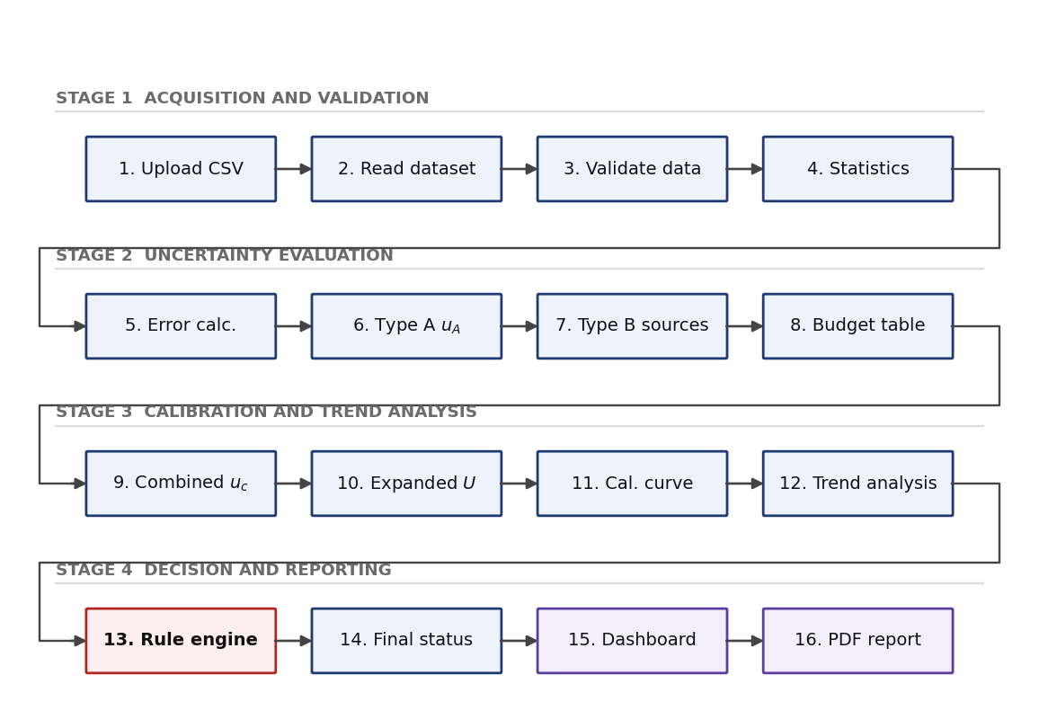
Figure 18.1 – IMUCA end-to-end demonstration workflow
Each step consumes only the output of the one before it: validation produces the clean dataset that statistics operates on, statistics produces the standard deviation that Type A evaluation needs, the budget produces the combined uncertainty that the conformity test needs, and the rule engine produces the status that the report states. Steps 1 to 14 were executed manually for this report to produce every number in Sections 11 to 14. Steps 15 and 16 exist as the generated figures and this document. Automating the sequence so that it runs unattended from a single file upload is the principal software task in progress.

19. ALGORITHMS

The following pseudocode specifies each computational block. It is written to be readable rather than syntactically complete, and each algorithm corresponds directly to the equations of Section 9.

Algorithm 1 – Measurement analysis (top level)
INPUT : dataset D, Type B source list B, limits L
OUTPUT : analysis result R, status S

1. D_valid <- VALIDATE(D) // Algorithm 1a
2. IF D_valid is empty THEN return "NO VALID DATA"
3. stats <- DESCRIPTIVE_STATISTICS(D_valid)
4. errors <- ERROR_ANALYSIS(stats.mean, D_valid.reference)
5. u_A <- TYPE_A(D_valid.repeats) // Algorithm 2
6. u_B[] <- TYPE_B(B, stats.mean) // Algorithm 3
7. budget, u_c, U <- COMBINE(u_A, u_B[], k) // Algorithm 4
8. cal <- CALIBRATION(D_valid) // Algorithm 5
9. drift <- DRIFT(history) // Algorithm 6
10. S <- DECIDE(U, errors, drift, stats.s, L) // Algorithm 7
11. RETURN assemble(stats, errors, budget, cal, drift, S)
ALGORITHM 1a - VALIDATE
FOR each row r IN D:
IF r is not numeric THEN flag "NON-NUMERIC"; skip
IF r outside instrument range THEN flag "OUT OF RANGE"; skip
IF r is missing THEN flag "MISSING"; skip
compute median and MAD of remaining rows
FOR each remaining row r:
z <- 0.6745 * (r - median) / MAD
IF |z| > 3.5 THEN flag "OUTLIER" // flag only, do not delete
RETURN rows that were not skipped

Algorithm 2 – Type A uncertainty
INPUT : array x[1..n] of repeated readings
OUTPUT : u_A, s, nu

1. IF n < 2 THEN return "TYPE A NOT EVALUABLE"
2. mean <- SUM(x) / n
3. ss <- SUM( (x[i] - mean)^2 )
4. s <- SQRT( ss / (n - 1) ) // sample SD, n-1 denominator
5. u_A <- s / SQRT(n)
6. nu <- n - 1
7. RETURN u_A, s, nu

Algorithm 3 – Type B uncertainty
INPUT : source list B, each with (name, halfwidth a, distribution)
OUTPUT : array of standard uncertainties u_B[]

1. FOR each source b IN B:
2. SWITCH b.distribution:
3. CASE "rectangular" : d <- SQRT(3)
4. CASE "triangular" : d <- SQRT(6)
5. CASE "normal_k2" : d <- 2
6. CASE "normal_k3" : d <- 3
7. CASE "u_shaped" : d <- SQRT(2)
8. DEFAULT : RAISE "distribution not specified"
9. IF b.is_percent_of_reading THEN a <- b.percent * reading / 100
10. u_B[b] <- a / d
11. record (b.name, a, b.distribution, d, u_B[b])
12. RETURN u_B[]

Algorithm 4 – Combined and expanded uncertainty
INPUT : u_A with nu_A, array u_B[] with sensitivity c[], target confidence
OUTPUT : budget table, u_c, nu_eff, k, U

1. u_all <- [u_A] concatenated with u_B[]
2. terms <- [ (c[i] * u_all[i])^2 for all i ]
3. u_c <- SQRT( SUM(terms) )
4. FOR each i: contribution[i] <- terms[i] / u_c^2 * 100
5. budget <- SORT sources BY contribution DESC
6. dominant <- budget[1]
7. nu_eff <- u_c^4 / SUM( u_all[i]^4 / nu[i] ) // infinite nu -> term = 0
8. IF nu_eff >= 30 THEN k <- 2
9. ELSE k <- STUDENT_T(confidence, nu_eff)
10. U <- k * u_c
11. U <- ROUND_UP(U, 2 significant figures)
12. RETURN budget, u_c, nu_eff, k, U, dominant

Algorithm 5 – Calibration analysis
INPUT : reference[], dut[], tolerance T (percent of reading)
OUTPUT : error table, offset, gain error, residuals, per-point status

1. FOR each point i:
2. E[i] <- dut[i] - reference[i]
3. Epct[i] <- E[i] / reference[i] * 100
4. IF |Epct[i]| > T THEN status[i] <- "FAIL"
5. ELSE IF |Epct[i]| >= 0.8*T THEN status[i] <- "MARGINAL"
6. ELSE status[i] <- "PASS"
7. (m, c) <- LEAST_SQUARES_FIT(reference, dut)
8. offset <- c
9. gain_error <- (m - 1) * 100
10. FOR each i: residual[i] <- dut[i] - (m * reference[i] + c)
11. IF MAX(|residual|) > resolution/2 THEN note "NONLINEARITY PRESENT"
12. overall <- "FAIL" IF any status = "FAIL" ELSE ...
13. RETURN error table, offset, gain_error, residual[], status[], overall

Algorithm 6 – Drift detection
INPUT : history of (session index t[], mean error E[]), threshold b_lim,
tolerance T
OUTPUT : slope b, significance p, drift status, projected breach

1. IF LENGTH(history) < 3 THEN return "INSUFFICIENT HISTORY"
2. b <- SUM( (t[j]-mean_t) * (E[j]-mean_E) ) / SUM( (t[j]-mean_t)^2 )
3. a <- mean_E - b * mean_t
4. s_resid <- SQRT( SUM( (E[j] - (a + b*t[j]))^2 ) / (N - 2) )
5. s_b <- s_resid / SQRT( SUM( (t[j]-mean_t)^2 ) )
6. t_stat <- b / s_b ; p <- 2 * (1 - T_CDF(|t_stat|, N-2))
7. IF |b| > b_lim AND p < 0.05 THEN drift <- "POSSIBLE DRIFT"
8. ELSE drift <- "NO SIGNIFICANT DRIFT"
9. IF drift = "POSSIBLE DRIFT" AND b != 0:
10. t_breach <- (T - a) / b
11. RETURN b, s_b, p, drift, t_breach

Algorithm 7 – Intelligent decision engine
INPUT : U, E, T, b, p_drift, s, limits L = {U_allow, b_lim, s_allow}
OUTPUT : headline status, fired rule list, recommended action

1. fired <- empty list
2. IF U > L.U_allow:
3. append("R1", "HIGH UNCERTAINTY", U, L.U_allow)
4. IF |E| > T OR (|E| + U) > T:
5. append("R2", "CALIBRATION REQUIRED", |E|+U, T)
6. IF history exists AND |b| > L.b_lim AND p_drift < 0.05:
7. append("R3", "POSSIBLE DRIFT", b, L.b_lim)
8. IF s > L.s_allow:
9. append("R4", "REPEATABILITY CONCERN", s, L.s_allow)
10. IF fired is empty:
11. append("R5", "MEASUREMENT ACCEPTABLE", -, -)
12. headline <- fired[1].status // first by severity order
13. action <- ACTION_MAP[ headline ]
14. RETURN headline, fired, action // all fired rules are reported

20. SOFTWARE IMPLEMENTATION

The prototype is being built in Python. The choice is driven by the availability of validated numerical libraries, the readability of the resulting code for an engineering audience, and the ability to move from a script to an interactive dashboard without changing language.
Component | Role in IMUCA | Why it was chosen
Python 3 | Host language for the pipeline | Readable enough that the implementation can be checked against the equations of Section 9 by inspection
pandas | Import, tabular handling, validation, history storage | Native CSV handling, easy grouping for repeat sets, and a natural table structure for calibration records
NumPy | Vectorised arithmetic for statistics and uncertainty combination | Array operations remove the loop-level errors that dominate manual and spreadsheet work
SciPy | Least-squares fitting, Student t values, significance testing | scipy.stats.linregress returns the slope, its standard error, R² and the p value in one call, exactly what Algorithm 6 needs
Matplotlib | Static figures for the report | Precise control over axes and annotation, and output suitable for print
Plotly | Interactive dashboard figures | Hover values and zoom let a user inspect a calibration point without regenerating the figure
Streamlit | Dashboard and user interface | Turns the analysis script into a browser interface with file upload and parameter entry, with no separate front-end work
Table 20.1 – Proposed software stack

20.1 Layered software architecture
+------------------------------------------------------------+
| CSV file / Sensor stream / Instrument (future) |
+------------------------------+-----------------------------+
v
+------------------------------------------------------------+
| PYTHON PROCESSING LAYER (pandas, NumPy) |
| loader.py validator.py statistics.py errors.py |
+------------------------------+-----------------------------+
v
+------------------------------------------------------------+
| UNCERTAINTY ENGINE (NumPy, SciPy) |
| type_a.py type_b.py budget.py coverage.py |
+------------------------------+-----------------------------+
v
+------------------------------------------------------------+
| CALIBRATION ENGINE (SciPy) |
| fit.py residuals.py conformity.py drift.py |
+------------------------------+-----------------------------+
v
+------------------------------------------------------------+
| DECISION ENGINE (pure Python, no dependencies) |
| rules.py limits.py actions.py |
+------------------------------+-----------------------------+
v
+------------------------------------------------------------+
| PRESENTATION (Streamlit, Plotly, Matplotlib) |
| dashboard.py figures.py report.py |
+------------------------------------------------------------+
Figure 20.1 – Layered software architecture of the IMUCA prototype
The decision engine is deliberately written in plain Python with no numerical dependencies. It receives scalars and limits and returns a status, which means it can be unit-tested exhaustively against hand-computed cases and audited by a reader who does not know NumPy.
MATLAB with Simulink is a reasonable alternative, particularly if the project later extends into modelling the sensor and signal-conditioning chain itself rather than analysing its output. Simulink would allow the error model of equation 10.1 to be built as a signal-flow model with injected noise and drift, and the Statistics and Machine Learning Toolbox covers the same fitting and testing functions. Python was preferred here because the deliverable is a data-analysis pipeline with a user interface rather than a dynamic system simulation, and because the resulting tool can be distributed without a licence.

21. HARDWARE INTEGRATION (FUTURE PHASE)

NOT IMPLEMENTED. No hardware has been connected and no experimental measurement has been performed.
The analysis pipeline was designed with a single abstracted data-source interface so that replacing a CSV loader with an instrument driver requires no change to any downstream block. The planned hardware phase is described below so that the design decisions taken now can be judged against it.
Element | Intended role | Interface | Design consideration
Digital multimeter (DUT) | Instrument under calibration | USB or RS-232, SCPI command set | Reading rate limits how many repeats are practical; integration time affects observed repeatability
Programmable DC power supply | Generates the stimulus at each calibration point | USB or GPIB | Its own stability contributes a Type B term unless the reference measures the actual applied value
Reference instrument | Provides the traceable reference value | USB or RS-232 | Must have an in-date calibration certificate; its stated uncertainty enters the budget directly
Voltage and current sensors | Extends the system beyond direct DMM measurement | Analogue output to DAQ | Sensor sensitivity introduces a sensitivity coefficient that is no longer unity
DAQ module | Multi-channel simultaneous acquisition | USB | ADC resolution and input noise replace display resolution as the quantisation term
Microcontroller | Low-cost acquisition and environmental logging | Serial over USB | On-board ADC is typically 10 or 12 bit, so quantisation will dominate the budget unless external conversion is used
Temperature and humidity sensor | Records the environmental conditions during measurement | I²C to the microcontroller | Converts the assumed ±3 °C term of Section 11 into a measured value
Table 21.1 – Planned hardware elements and their design implications

One design point is worth recording now. The last row changes the character of the analysis. In the present demonstration the ambient temperature contribution is an assumption entered by the user. With a logged temperature it becomes a measured quantity, and the uncertainty budget stops relying on an estimate for that term. Where a Type B source can be converted into a Type A one by measuring it, the resulting budget is stronger, and identifying such opportunities is a legitimate output of the budget ranking itself.

22. REVIEW 1 PROGRESS

This section states plainly what has been done, what is under way and what has not been started. The distinction is maintained throughout the report and is repeated here in consolidated form.

22.1 Completed
Problem identification and scoping, with the consequences documented in Table 3.1. Background study of the applicable metrological framework: the Guide to the Expression of Uncertainty in Measurement, the International Vocabulary of Metrology, and the national metrology institute guidance listed in the references. Requirement analysis expressed as twelve objectives with stated verification criteria. The complete system architecture, with all eleven blocks specified and their inputs and outputs defined. The full uncertainty methodology covering Type A and Type B evaluation, distributions and divisors, sensitivity coefficients, combination, coverage factor selection and effective degrees of freedom. The calibration methodology covering sweep design, offset and gain separation by regression, residual diagnostics and both simple and guard-banded conformity rules. Sixteen numbered equations forming the software specification. A synthetic dataset with a documented injected error model. A complete numerical proof of concept worked by hand from raw readings to a reported value with uncertainty, a conformity decision and a drift assessment. Five decision rules with their evaluation order, justification and a worked evaluation. Seven pseudocode listings. Six figures with the engineering conclusion stated for each. Two report mock-ups populated entirely with computed values.

22.2 In progress
Software implementation of the pipeline in Python: the uncertainty and calibration mathematics has been coded and used to produce the figures in this report, while the validation, history storage and reporting modules are incomplete. The Streamlit dashboard layout has been specified but not built. Acquisition of an experimental dataset is pending laboratory access and confirmation of a reference instrument with a current calibration certificate.

22.3 Future
Hardware integration with a digital multimeter, programmable supply, reference instrument and data-acquisition module. Real-time acquisition and continuous monitoring. Machine-learning anomaly detection, once sufficient real calibration history exists to train and test on. Experimental validation against a reference instrument, which is Level 3 of Section 23. Automated calibration scheduling driven by the drift projection.

22.4 Progress summary
Component | Status | Evidence in this report
Problem definition | Completed | Section 3, Table 3.1
Literature and standards background | Completed | Section 2, references
Requirement analysis | Completed | Table 6.1, twelve objectives with verification criteria
System architecture | Completed | Figure 7.1 and the block descriptions in Section 7.1
Uncertainty model | Completed | Equations 9.1 to 9.10, Table 9.1
Calibration model | Completed | Equations 9.11 to 9.16, worked in Section 13
Synthetic dataset | Completed | Tables 10.1 to 10.3 with a documented injected error model
Numerical demonstration | Completed | Section 11, hand-worked from raw data to (5.021 ± 0.011) V
Uncertainty budget | Completed | Table 12.1, dominant source identified at 35.6 %
Calibration analysis | Completed | Table 13.1 and 13.2, offset and gain error recovered
Drift analysis | Completed | Section 14, slope 1.10 mV/session with p = 1.3×10⁻⁶
Decision logic | Completed | Section 16, five rules with a worked evaluation
Algorithms | Completed | Section 19, seven pseudocode listings
Visualisation | Completed | Six figures generated from the synthetic dataset
Software prototype | In progress | Analysis code used to produce the figures; modules incomplete
Dashboard | In progress | Layout specified in Section 20, not yet built
Experimental dataset | Not started | Planned, pending laboratory access
Hardware integration | Future | Design implications recorded in Table 21.1
Machine learning | Future | Scope and prerequisites stated in Sections 16.4 and 24
Table 22.1 – Review 1 progress summary

23. VALIDATION STRATEGY

Validation proceeds in three levels of increasing difficulty and increasing evidential value. Level 1 is complete. Level 2 is partially complete. Level 3 has not been started.

23.1 Level 1 – Mathematical validation
Every quantity computed by the software is compared against the same quantity computed by hand from the same input. Section 11 is that comparison written out in full: the mean, standard deviation, Type A uncertainty, each Type B term, the combined and expanded uncertainty, the error and the conformity decision were all obtained manually and agree with the software output to the number of digits reported.
The acceptance criterion is agreement to at least four significant figures. This level catches the failure modes that dominate manual and spreadsheet work: a standard deviation computed with n instead of n − 1, a missing √n in the Type A step, a wrong divisor for a distribution, and magnitudes summed instead of squares. Level 1 is complete for the demonstration dataset.

23.2 Level 2 – Synthetic dataset validation
The second level tests whether the analysis recovers defects that were deliberately injected. Because the injected values are known, this is a genuine pass or fail test rather than a demonstration.
Injected defect | Injected value | Expected detection | Result at Review 1
Zero offset | +8 mV | Non-zero intercept of the calibration fit | Detected: +6.67 mV recovered, limited by 10 mV quantisation
Gain error | +0.25 % | Fit slope differs from unity | Detected: +0.303 % recovered
Random noise | A few mV | Non-zero sample standard deviation | Detected: s = 9.944 mV at the 5 V point
Drift | ≈ +1 mV per session | Significant regression slope on history | Detected: +1.10 mV per session, p = 1.3×10⁻⁶
Outliers | Not yet injected | Flagged by the modified z-score screen of Algorithm 1a | Not yet tested
Missing and invalid values | Not yet injected | Rejected by the validation block with a logged reason | Not yet tested
Nonlinearity | Not yet injected | Structured residual pattern exceeding the quantisation envelope | Not yet tested
Table 23.1 – Level 2 validation status

Four of the seven defect classes have been injected and correctly recovered. The remaining three require the validation module to be completed. A note on the first row is important for honesty: the recovered offset of +6.67 mV does not equal the injected +8 mV, and the reason is the display quantisation described in Section 13.2 rather than an analysis fault. The acceptance criterion for this defect class therefore has to be stated in terms of the resolution, not as exact recovery.

23.3 Level 3 – Experimental validation
The third level uses real measurements. A device under test is measured against a reference instrument holding a current calibration certificate, across the same ten-point sweep, with repeats at each point and logged ambient conditions. The IMUCA output is then compared against a manually prepared uncertainty budget produced independently by a second person.
Three acceptance criteria apply. First, the reported expanded uncertainty must agree with the independently prepared budget within the rounding tolerance of the reported figures. Second, the conformity decision must match the decision an experienced engineer reaches from the same data. Third, where the reference instrument itself has a documented history, the drift slope reported by IMUCA must be consistent with that record. This level has not been started and is scheduled for the phase following hardware integration.
One limitation of Level 3 deserves stating in advance. Experimental validation confirms that the system produces the right answer for the instruments tested; it does not confirm that the Type B source list is complete. A missing influence quantity produces an uncertainty that is too small and is not detectable from the data alone, since the omitted term leaves no trace in the readings. Guarding against this requires review of the source list against the applicable guidance rather than any statistical test, and that review is part of the Level 3 procedure rather than a software function.

24. EXPECTED RESULTS

The measurable outputs of the completed system are listed below. Deliberately, no performance percentages are quoted for anything that has not been measured. Claiming a detection accuracy or a time saving at this stage would be an invented number.
Output | Form it takes | Acceptance criterion
Descriptive statistics | Mean, sample SD, variance, range, standard error, degrees of freedom | Agreement with hand calculation to four significant figures
Uncertainty components | u_A and every u_B with half-width, distribution and divisor recorded | Each entry traceable to a source document or a measured dispersion
Uncertainty budget | Ranked table with percentage contributions summing to 100 % | Dominant source correctly identified against manual ranking
Combined and expanded uncertainty | u_c, ν_eff, justified k, U rounded upward | Reproduces the manual result; k justified by ν_eff, not assumed
Calibration error estimation | Absolute, relative and percentage error for every point | Matches hand calculation
Calibration curve | Fitted line with offset, gain error and R² | Recovers injected parameters within the resolution limit
Residual analysis | Residual plot, flagged when structure exceeds the quantisation envelope | Distinguishes quantisation structure from nonlinearity
Error trend and drift | Slope, standard error, R², p value and projected breach | Detects injected drift; reports no drift when none is present
Automated conformity decision | PASS, MARGINAL or FAIL per point under both simple and guard-banded rules | Agrees with manual application of the stated tolerance
Intelligent recommendation | Headline status, fired-rule list, recommended action | Every status reachable by a test case; decision reproducible by hand
Automated report | Generated document containing all of the above | Report values identical to the computed objects, no manual transcription
Table 24.1 – Expected measurable outputs and their acceptance criteria

25. LIMITATIONS

The limitations below are properties of the present state of the project and of the method itself. Stating them is part of making the work defensible.
- Synthetic data is not experimental data. The dataset contains exactly the defects that were injected and nothing else. Real instruments produce effects no model anticipates: thermal transients, contact resistance, mains pickup, self-heating and range-switching discontinuities. Perfect performance on synthetic data demonstrates that the mathematics is correct, not that the system is fit for laboratory use.
- Results depend entirely on input data quality. IMUCA can flag values that are non-numeric, out of range or statistically unusual. It cannot detect a systematically wrong reading that is plausible: a meter left on the wrong range, a reference source that has itself drifted, or a thermocouple in the wrong medium will all produce clean data leading to a confidently wrong conclusion.
- Distribution assumptions materially change the answer. The same ±5 mV limit gives 2.887 mV under a rectangular assumption and 2.041 mV under a triangular one, a difference of over 40 %. The software applies the divisor correctly, but it cannot verify that the assumed distribution is the right one. That judgement remains with the engineer, which is why IMUCA records the assumption in the output rather than hiding it.
- The budget is only as complete as its source list. An omitted influence quantity produces an uncertainty that is too small, and no statistical test on the data can reveal the omission because the missing term leaves no trace in the readings.
- Reference standard quality bounds everything. The reported uncertainty can never be smaller than the contribution from the reference. A reference with an expired certificate invalidates the traceability chain regardless of how carefully the rest of the analysis is performed.
- Rule-based intelligence has limited adaptability. The engine detects only the conditions it was programmed to detect. It will not notice a failure mode nobody anticipated, and its thresholds must be set by a knowledgeable user. This is the deliberate trade for transparency and auditability.
- Machine learning requires data that does not yet exist. Meaningful anomaly detection needs a substantial history of calibration records covering both normal and abnormal behaviour. Ten synthetic sessions cannot train or test such a model, and presenting one trained on them would be misleading.
- Linear drift extrapolation is a planning aid, not a prediction. Real drift can be nonlinear, can reverse, and can step discontinuously. The projected breach in Section 14 is valid only while the linear assumption holds.

26. FUTURE SCOPE

Extension | What it adds | Prerequisite
Real-time acquisition | Continuous monitoring with uncertainty on a rolling window instead of a fixed batch | Instrument interface and streaming data handling
IoT integration | Distributed sensors reporting to a central analyser, with environmental logging per measurement | Networked nodes and a time-synchronised data model
Automated calibration scheduling | Intervals set by observed drift rather than fixed policy, with alerts before a projected breach | Reliable drift history and a validated projection method
Predictive maintenance | Degradation identified from changes in repeatability and drift before a tolerance failure | Long-term history across a fleet of instruments
ML anomaly detection | Detects reading patterns that satisfy every threshold yet differ from established behaviour | Labelled history of normal and abnormal calibration events
Time-series drift forecasting | Replaces linear extrapolation with a model handling nonlinearity and seasonality | Sufficient history length per instrument
Digital twin of the measurement chain | Simulates the sensor and conditioning path, so budget sensitivity can be explored before hardware is built | Validated component models
Cloud measurement history | Central retention of calibration records with version control and audit trail | Data model, access control, retention policy
Multi-instrument and multi-parameter support | Extends beyond DC voltage to current, resistance, temperature, pressure and derived quantities | Sensitivity coefficient handling for non-unity models
Automated calibration certificates | Documents in the format required by the applicable accreditation standard | Template compliance review and validated report generation
Table 26.1 – Planned extensions and their prerequisites

27. APPLICATIONS

Domain | How IMUCA would be used
Electronics laboratories | Routine verification of bench multimeters, oscilloscopes and supplies against a laboratory reference, with an uncertainty statement on every verification
Electrical testing | Voltage, current and resistance measurements needing a defensible conformity statement against a specification
Sensor calibration | Temperature, pressure, load and displacement sensors, where the sensitivity coefficient is not unity and propagation through the transfer function matters
Industrial instrumentation | Periodic verification of process transmitters, with drift tracking setting calibration intervals by condition rather than calendar
Manufacturing and quality control | Measurement system evaluation on production test equipment, where uncertainty consumes part of the product tolerance
Automotive testing | Verification of test-bench instrumentation for emissions, electrical and durability testing, where traceability is a regulatory requirement
Research laboratories | Reporting experimental results with a defensible uncertainty statement, a condition of publication in most measurement journals
IoT instrumentation | Quantifying the uncertainty of low-cost distributed sensors, where quantisation and specification terms typically dominate
Engineering education | Teaching uncertainty evaluation with every intermediate quantity visible, so students see the effect of each assumption
Table 27.1 – Application domains

28. PROJECT ROADMAP

Phase | Activity | Duration | Status | Deliverable
1 | Literature and requirement analysis | 3 weeks | Completed | Objectives with verification criteria
2 | Mathematical uncertainty engine | 3 weeks | Completed | Equations 9.1 to 9.10, validated by hand
3 | Calibration engine formulation | 2 weeks | Completed | Equations 9.11 to 9.16 and Algorithm 5
4 | Synthetic dataset and proof of concept | 3 weeks | Completed | Sections 10 to 15 of this report
5 | Dashboard development | 4 weeks | In progress | Streamlit interface with file upload
6 | Experimental data acquisition | 3 weeks | Not started | Real ten-point sweep with repeats
7 | Hardware integration | 4 weeks | Future | DMM and reference instrument under software control
8 | Intelligent analysis extension | 3 weeks | Future | Anomaly detection evaluated against the rule baseline
9 | Validation | 3 weeks | Level 1 complete | Three-level validation record
10 | Deployment and documentation | 2 weeks | Future | Final report and user documentation
Table 28.1 – Project phases

PHASE W1 W3 W5 W7 W9 W11 W13 W15 W17 W19 W21 W23 W25 W27 W29
| | | | | | | | | | | | | | |
P1 Literature & requirements [########]
P2 Uncertainty engine [########]
P3 Calibration engine [#####]
P4 Synthetic data & proof of concept [########] <-- REVIEW 1
P5 Dashboard development [===========]
P6 Experimental data acquisition [........]
P7 Hardware integration [...........]
P8 Intelligent analysis extension [........]
P9 Validation [..........]
P10 Deployment & documentation [.....]

KEY [####] completed [====] in progress [....] planned
Figure 28.1 – Project timeline. Review 1 falls at the end of Phase 4.

29. REVIEW 1 VIVA PREPARATION

The following questions and answers cover the material a Measurements and Instrumentation examiner is most likely to probe. All numerical values quoted come from the demonstration in Sections 11 to 14.
Q1. What is measurement uncertainty?
A non-negative parameter characterising the dispersion of values that could reasonably be attributed to the measurand. It defines an interval around the reported value within which the true value is expected to lie at a stated confidence level. It is a property of the measurement, not a mistake in it, and it exists even when the measurement is performed perfectly.
Q2. What is the difference between error and uncertainty?
Error is a single signed number, the difference between the measured and the reference value, knowable only when a reference exists. Uncertainty is an interval describing how well the value is known, and it exists whether or not a reference exists. Error can be corrected; uncertainty can only be reduced. In our demonstration the error is +21 mV and the expanded uncertainty is 10.5 mV: two different statements about the same measurement.
Q3. What is the difference between accuracy and precision?
Accuracy is closeness to the true value; precision is closeness between repeated readings. A meter reading 5.10, 5.10, 5.10 V on a true 5.00 V source is highly precise and clearly inaccurate. Precision is quantified by the standard deviation of repeats, accuracy by the error against a reference.
Q4. What is Type A uncertainty?
A component evaluated by statistical analysis of a series of observations. Here it is the standard deviation of ten repeats divided by √10, giving u_A = 9.944/√10 = 3.145 mV with nine degrees of freedom.
Q5. What is Type B uncertainty?
A component evaluated by any means other than statistics: display resolution, manufacturer specifications, calibration certificates, published data or engineering judgement. Each stated limit is divided by a divisor set by the assumed distribution. Our four Type B terms combine to 4.234 mV.
Q6. Why are both needed?
They capture different things. Type A captures what the instrument does when you repeat the measurement. Type B captures what it cannot tell you at all: a perfectly stable meter with 10 mV resolution gives ten identical readings, so u_A is zero, yet the true value is still unknown to within ±5 mV. Using Type A alone would report zero uncertainty for a clearly uncertain measurement.
Q7. Is the Type A and Type B distinction about random and systematic error?
No, and this is a common confusion. The distinction concerns the method of evaluation, not the nature of the effect. A systematic effect can be evaluated statistically and a random one from a specification. Once expressed as standard uncertainties, both are treated identically in the combination.
Q8. What is calibration?
The operation establishing the relation between the values indicated by an instrument and those realised by a reference standard, together with the associated uncertainties. Calibration determines the relationship; it does not necessarily adjust the instrument. Adjustment is a separate operation that may follow.
Q9. What is a reference standard, and what is the DUT?
The reference standard is a measurement standard of higher metrological quality than the device under test, with a documented, traceable calibration; its own uncertainty enters the budget directly, contributing 1.000 mV or 3.6 % of the variance here. The DUT is the device being calibrated, in our case a 3½-digit multimeter on its 20 V range.
Q10. Why use expanded rather than combined standard uncertainty?
Because the combined standard uncertainty corresponds to only about 68 % confidence, which is too weak for a conformity statement. Multiplying by a coverage factor produces an interval at a stated higher confidence level, typically 95 %, which is what a customer or accreditation body requires.
Q11. Why is k ≈ 2 used?
For a normal distribution, ±2 standard deviations contains about 95.45 %. The value is exact only when the effective degrees of freedom are large. We compute ν_eff by Welch-Satterthwaite and obtain 71, at which the Student t value for 95 % is 1.99, so k = 2 is justified rather than assumed. Had ν_eff been 5, we would have needed k = 2.57.
Q12. What makes this project intelligent?
The decision layer. The system does not stop at producing numbers; it evaluates them against stated limits, emits a named engineering status with a recommended action, and records which rule produced it. For Review 1 the intelligence is a transparent ordered rule set, not a trained model. We are deliberately not claiming machine learning, because none has been implemented.
Q13. Why did you not use machine learning?
Three reasons. No training data: a supervised anomaly detector needs a labelled history of normal and abnormal behaviour, and we have ten synthetic sessions. Verifiability: every rule-based decision can be reproduced with a calculator, which a trained model does not allow. Baseline: any future model must be shown to beat the rule set, so the rule set has to exist first.
Q14. Why use synthetic data?
Because the injected defects are known in advance, which turns the demonstration into a functional test. We injected an 8 mV offset, a 0.25 % gain error and about 1 mV per session of drift, and the analysis recovered 6.67 mV, 0.303 % and 1.10 mV per session. Real data would not let us verify the analysis, because we would not know the right answer. Synthetic data is a starting point, not a substitute for experiment.
Q15. Why does the recovered offset not match the injected value exactly?
Because the modelled instrument quantises to 10 mV steps. An 8 mV offset cannot be resolved exactly by a display moving in 10 mV increments, so the least-squares fit distributes some of it into the gain term. This is realistic for a 3½-digit meter, and the residual plot shows the quantisation signature directly.
Q16. How will you validate the system?
In three levels. Level 1 compares software output against hand calculation and is complete for the demonstration dataset. Level 2 injects known defects and checks they are recovered; four of seven defect classes are done. Level 3 uses real measurements against a calibrated reference and an independently prepared budget, and has not been started.
Q17. What happens if the uncertainty exceeds the tolerance?
Rule R1 fires and the status becomes HIGH UNCERTAINTY. The result is reported as not fit for the stated purpose, because an uncertainty comparable to the tolerance cannot distinguish a conforming part from a non-conforming one. The system also names the dominant contributor so the user knows what to reduce first.
Q18. How will drift be detected?
By regressing the stored calibration error against session index and testing whether the slope differs significantly from zero. On our synthetic history the slope is 1.10 mV per session with p = 1.3×10⁻⁶, exceeding the 0.5 mV per session threshold, so rule R3 fires. Extrapolating to the +50 mV limit projects a breach at session 28.
Q19. Why not simply use Excel?
Excel can perform every one of these calculations, and for a single budget it is adequate. What it does not do is keep the stages consistent when data changes, enforce the semantics of a distribution and a divisor, retain history for drift detection, rank contributions automatically, or produce a decision with a logged rule. Those are the specific gaps addressed here. We are not claiming Excel is incapable, only that the workflow around it is manual and error-prone.
Q20. What is the role of the guard band?
It accounts for the uncertainty of the result in the conformity decision. Our test requires |E| + U ≤ T, giving 31.5 mV against a 50 mV limit with 18.5 mV of margin. Had the error been 42 mV, the simple test would have passed while the guard-banded test would have failed.
Q21. What is a sensitivity coefficient?
The partial derivative of the measurand with respect to an input quantity, which scales that input’s uncertainty into the output units. For R = V/I the sensitivity to voltage is 1/I. In our direct voltage demonstration all coefficients equal one, but the engine retains the general form so derived quantities can be handled.
Q22. What hardware will eventually be used?
A digital multimeter as the DUT, a programmable DC supply as the stimulus, a reference instrument with a current calibration certificate, a DAQ module or microcontroller for acquisition, and a temperature and humidity sensor to log ambient conditions, communicating over USB or serial using a SCPI command set. None of this has been connected yet.
Q23. What is the expected final output?
A measurement report containing the value with its expanded uncertainty and coverage factor, a ranked uncertainty budget identifying the dominant source, a calibration assessment with per-point conformity status, offset and gain error, a drift status with a projected tolerance breach where applicable, and an explicit measurement-quality decision with the rule that produced it. Section 17 shows the mock-up populated with computed values.

30. REFERENCES

Sources are limited to primary standards documents, national metrology institute guidance, established textbooks and peer-reviewed software papers. No source has been invented, and no digital object identifier or author list has been supplied where it could not be confirmed.
[1] JCGM 100:2008, Evaluation of Measurement Data – Guide to the Expression of Uncertainty in Measurement (GUM 1995 with minor corrections). Joint Committee for Guides in Metrology, Bureau International des Poids et Mesures, 2008.
[2] JCGM 200:2012, International Vocabulary of Metrology – Basic and General Concepts and Associated Terms (VIM), 3rd ed. Joint Committee for Guides in Metrology, BIPM, 2012.
[3] JCGM 101:2008, Evaluation of Measurement Data – Supplement 1 to the GUM: Propagation of Distributions using a Monte Carlo Method. Joint Committee for Guides in Metrology, BIPM, 2008.
[4] JCGM 106:2012, Evaluation of Measurement Data – The Role of Measurement Uncertainty in Conformity Assessment. Joint Committee for Guides in Metrology, BIPM, 2012.
[5] B. N. Taylor and C. E. Kuyatt, Guidelines for Evaluating and Expressing the Uncertainty of NIST Measurement Results, NIST Technical Note 1297, 1994 edition. National Institute of Standards and Technology, Gaithersburg, MD.
[6] NIST/SEMATECH e-Handbook of Statistical Methods, National Institute of Standards and Technology. Available: https://www.itl.nist.gov/div898/handbook/
[7] ISO/IEC 17025:2017, General Requirements for the Competence of Testing and Calibration Laboratories. International Organization for Standardization, Geneva, 2017.
[8] ILAC-G8:09/2019, Guidelines on Decision Rules and Statements of Conformity. International Laboratory Accreditation Cooperation, 2019.
[9] EA-4/02 M: 2013, Evaluation of the Uncertainty of Measurement in Calibration. European Accreditation, 2013.
[10] S. Bell, A Beginner’s Guide to Uncertainty of Measurement, Measurement Good Practice Guide No. 11 (Issue 2). National Physical Laboratory, Teddington, UK.
[11] IEC 60359:2001, Electrical and Electronic Measurement Equipment – Expression of Performance. International Electrotechnical Commission, Geneva, 2001.
[12] A. S. Morris and R. Langari, Measurement and Instrumentation: Theory and Application, 2nd ed. Academic Press / Elsevier, 2015.
[13] E. O. Doebelin and D. N. Manik, Measurement Systems: Application and Design, 6th ed. McGraw-Hill, 2011.
[14] J. G. Webster and H. Eren (Eds.), Measurement, Instrumentation, and Sensors Handbook, 2nd ed. CRC Press, Boca Raton, FL, 2014.
[15] R. H. Dieck, Measurement Uncertainty: Methods and Applications, 4th ed. ISA – The Instrumentation, Systems and Automation Society, Research Triangle Park, NC, 2007.
[16] IEEE Std 1451.0-2007, IEEE Standard for a Smart Transducer Interface for Sensors and Actuators – Common Functions, Communication Protocols, and Transducer Electronic Data Sheet (TEDS) Formats. IEEE, 2007.
[17] C. R. Harris et al., “Array programming with NumPy,” Nature, vol. 585, pp. 357–362, 2020.
[18] P. Virtanen et al., “SciPy 1.0: fundamental algorithms for scientific computing in Python,” Nature Methods, vol. 17, pp. 261–272, 2020.
[19] J. D. Hunter, “Matplotlib: A 2D graphics environment,” Computing in Science & Engineering, vol. 9, no. 3, pp. 90–95, 2007.

A structured survey of peer-reviewed instrumentation and metrology literature, including papers from IEEE Transactions on Instrumentation and Measurement and the journal Measurement, is in progress and will be presented at the next review. It has not been included here because listing papers that have not been read would misrepresent the work completed.

