Meeting Minute

18th March 2015

Attendees

김선웅, 김형락, 성다혜, 송형석, 안윤근, 오지강, 우승연, 이학진

Scribe

Sung Da Hae

Agenda

Old Business

* Finalizing SRS and Analysis Model
  + Checking if gathering SRS and AM(analysis modeling) is finished
  + Total review about SRS and AM
  + Checking if unreviewed function exists
* Fixing daily meeting date and time

New Business

* Plans about Sprint
  + Assigning member to sprint schedule
  + Reviewing scrum and project schedule
* Presentation preparation
  + Fixing if rehearsal is needed (if it is needed, when it will be started)

Old Business

* **Finalizing SRS and Analysis Model**  
  index is needed at the last time  
  format is needed to be fixed (HYU(e)mini, 장평, 복붙, 줄간격, 기타등등)  
  swimlane diagram has to be changed to activity diagram
* **Fixing daily meeting date and time**  
  the weekday 10PM at kakao-talk group chatting

New Business

* **Plans about Sprint**  
  Sprint extends 4 sprints and keep the number of master.  
  Worry about implement for 5/3-5/30 so, these time is running as floating using.  
  Assign number of member to each activities of scrum.  
  Design for each functionalities and UI wireframing need to be closed cooperation.  
  Server and DB Design/Create need to be closed cooperation (Server admin lets DB Design/Create team know SSH password and somethings need to)  
  Scrum master helps each sprint but not attend everything.  
  PM doesn’t attend implement that week.  
    
  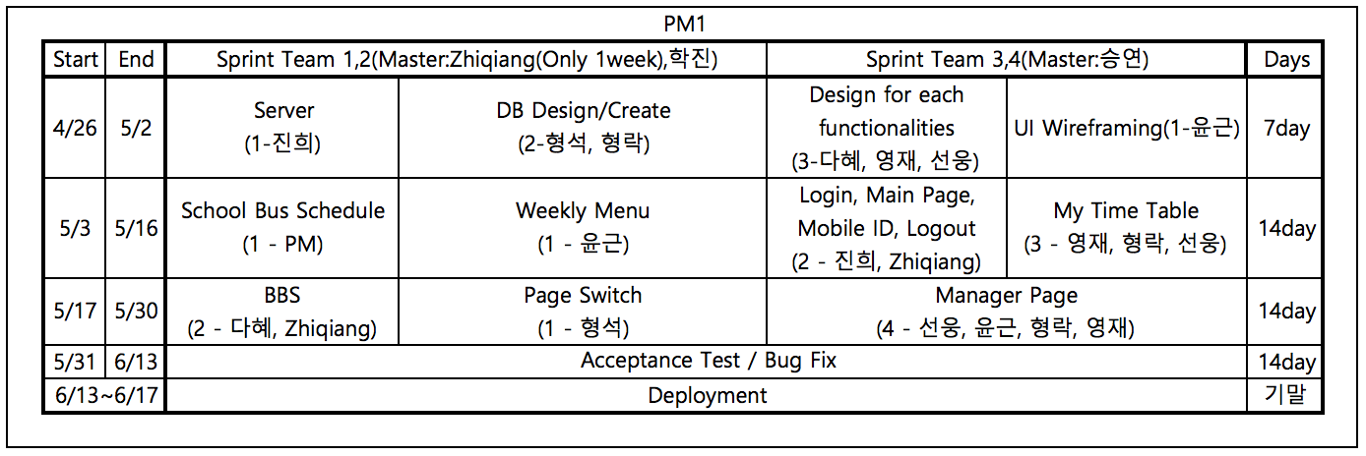
* **Presentation preparation**  
  rehearsal- Friday 1:00PM~

Next Meeting

* **Date - Time:** Friday 1:00PM (after or before rehearsal)
* **Place:** 제 3공학관 305호

Next Meeting Agenda Items