1. Device/sensor/parameter to test: Power consumption
2. General objective: Measure the consumption of the device during a shorter cycle
3. Constraints or specific conditions: The consumption is to be measured on a cycle where the device gets out of idle mode to measure and send data
4. Input(s): /
5. Output(s): mA, mW
6. Test procedure: measure the voltage drop on a resistance put in series on the power line with an oscilloscope // use the power measuring device
7. Results **and** interpretation: excepted result 104uA in idle and 130 mA when sending data
8. Actions post-test: implement a sleep mode on the arduino
9. Results post-actions: better idle consumption
10. Device/sensor/parameter to test: Time on air
11. General objective: Measure the time it takes for data sent by the device to reach the gateway
12. Constraints or specific conditions:
13. Input(s): 8 bytes payload
14. Output(s): ms
15. Test procedure: Calculated value on https://loratools.nl/#/airtime
16. Results **and** interpretation: **991.23 ms**
17. Actions post-test:
18. Results post-actions:

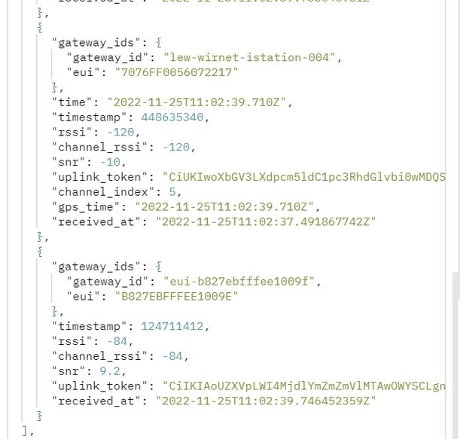

1. Device/sensor/parameter to test: RSSI
2. General objective: Measure the strength of the received signal at the gateway
3. Constraints or specific conditions: measured inside the lab at a given distance of about 10m
4. Input(s): 8 bytes payload
5. Output(s):
6. Test procedure: Send data to the gateway with the device at a given distance of 10 meters from the gateway, all inside a building (noisy environment, 1F04). Read the value in the payload in TTN.
7. Results **and** interpretation:
8. Actions post-test:
9. Results post-actions:
10. Device/sensor/parameter to test: SNR
11. General objective: Measure the signal to noise ratio
12. Constraints or specific conditions: The SNR is measured inside the lab at a given distance of about 10m
13. Input(s): 8 bytes payload
14. Output(s):
15. Test procedure: Send data to the gateway with the device at a given distance of 10 meters from the gateway, all inside a building (noisy environment, 1F04). Read the value in the payload in TTN.
16. Results **and** interpretation:
17. Actions post-test:
18. Results post-actions:
19. Device/sensor/parameter to test: Loadcell HX 711
20. General objective: Validate the calibration of the loadcell
21. Constraints or specific conditions:
22. Input(s): known weight
23. Output(s): /
24. Test procedure: Set 0 weight on the loadcell, measure the weight, set the known weight on the loadcell, measure.
25. Results **and** interpretation:
26. Actions post-test:
27. Results post-actions: