**CSE 212 – Programming with Data Structures**

**W01 Prove – Response Document**

|  |  |
| --- | --- |
| **Name:** | Freddy Haun |
| **Date:** | September 17th 2024 |
| **Teacher:** | Brother Zachariah Alvey |

*It is a violation of BYU-Idaho Honor Code to post or share this document with others or to post it online. Storage into a personal and private repository (e.g. private GitHub repository, unshared Google Drive folder) is acceptable.*

**Question 1: For the rotate right problem, provide a description of how you solved the problem.**

First, I defined a variable called start that could take the count of the data list, subtract the amount, and subtract 1 more to give the starting point of the data in the list. Then a loop would run that would put the shifted data into a new list called shiftright. If the start variable equaled the data count, then it would go back to zero. After making the new list, I deleted everything from the data list. Then I ran another loop that would put the data from the shiftright list into the data list.

**Question 2: For the rotate right problem, draw a picture of how you solved the problem.**

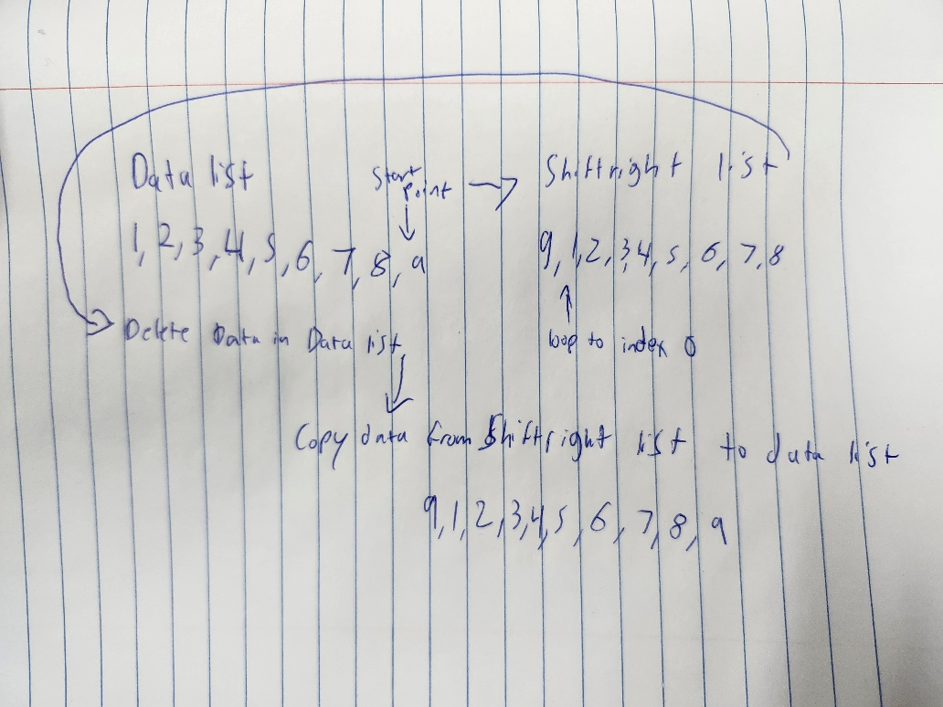

Remember: You need to commit all the changes to the prove-01-<username> repository along with this document. Then submit a link to the repository in I-Learn.