**How to set up Grafana displays for Puck Monitoring**

Verify database services are running:

systemctl status influxdb

systemctl status prometheus

To verify services which write to databases are running:

systemctl status puck_monitoring_service

systemctl status prometheus-node-exporter

Grafana setup:

Download the following files from the following github project and save to a directory of your choice:

wget https://raw.githubusercontent.com/fred-woolf-vk/puck_monitoring/master/Gateworks-6200-Node-Exporter-Server-Metrics-test-gw-board2.json

wget https://raw.githubusercontent.com/fred-woolf-vk/puck_monitoring/master/gw-modem-stats_test_Board1.2-withDataSource_01.28,21.json

Download and install Grafana from:

https://grafana.com

After Grafana is installed, open a browser window and navigate to this url: localhost:3000

(3000 is the port which Grafana uses to retrieve and display data)

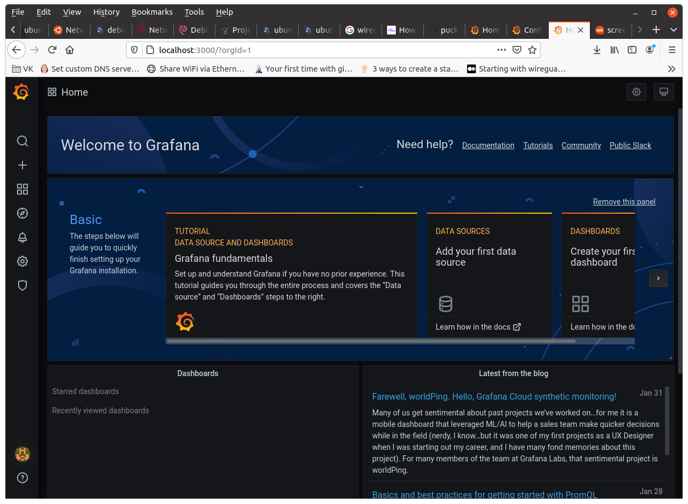The “Welcome to Grafana” page will display.

In the left pane, click on the Settings Gear→Data Sources

The Data Sources page is displayed:

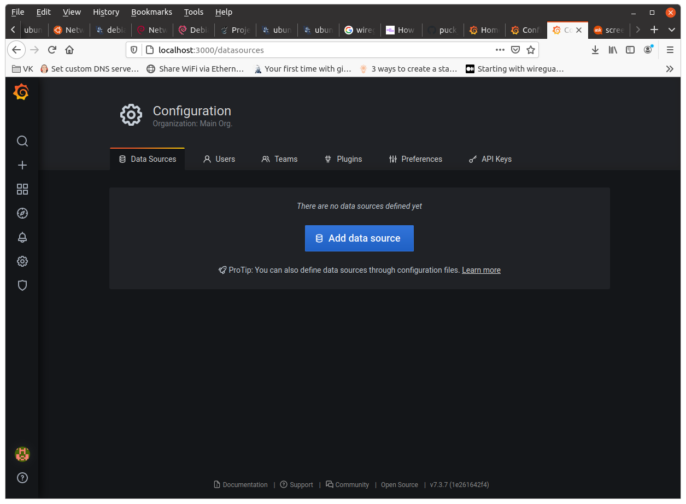

Click on “Add data source” to display the “Add data source” page:

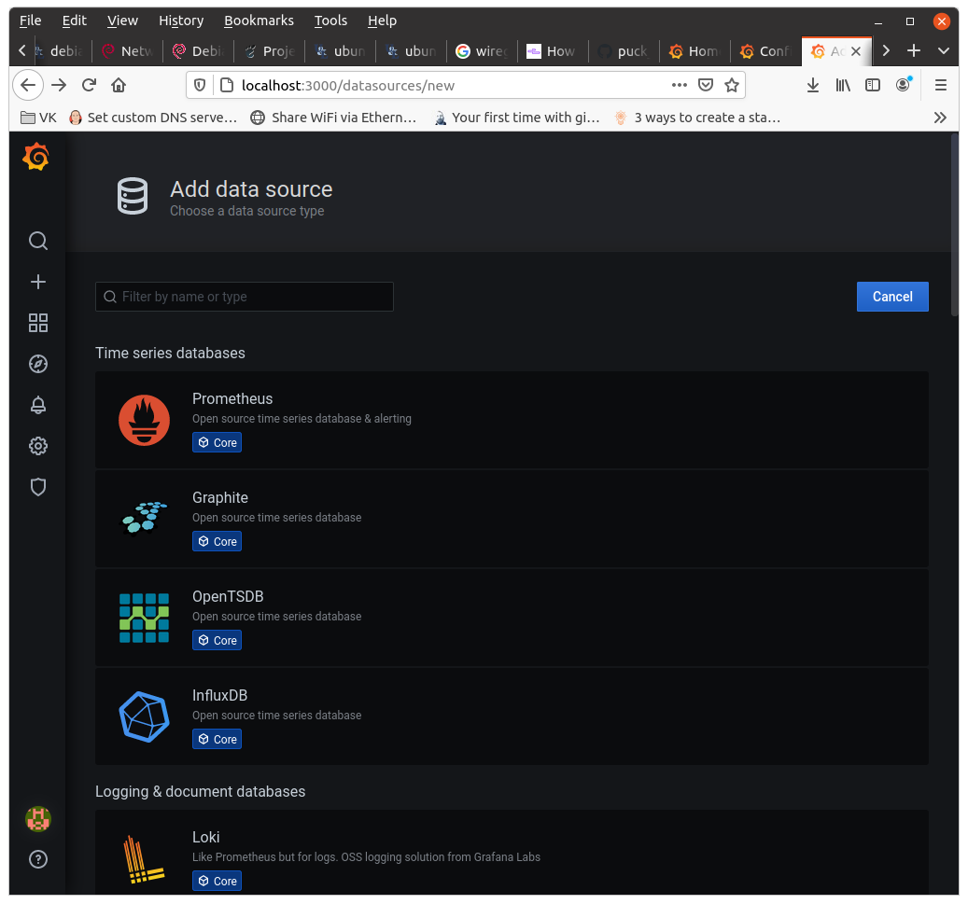

Choose “Prometheus” database.

The Prometheus configuration page is displayed

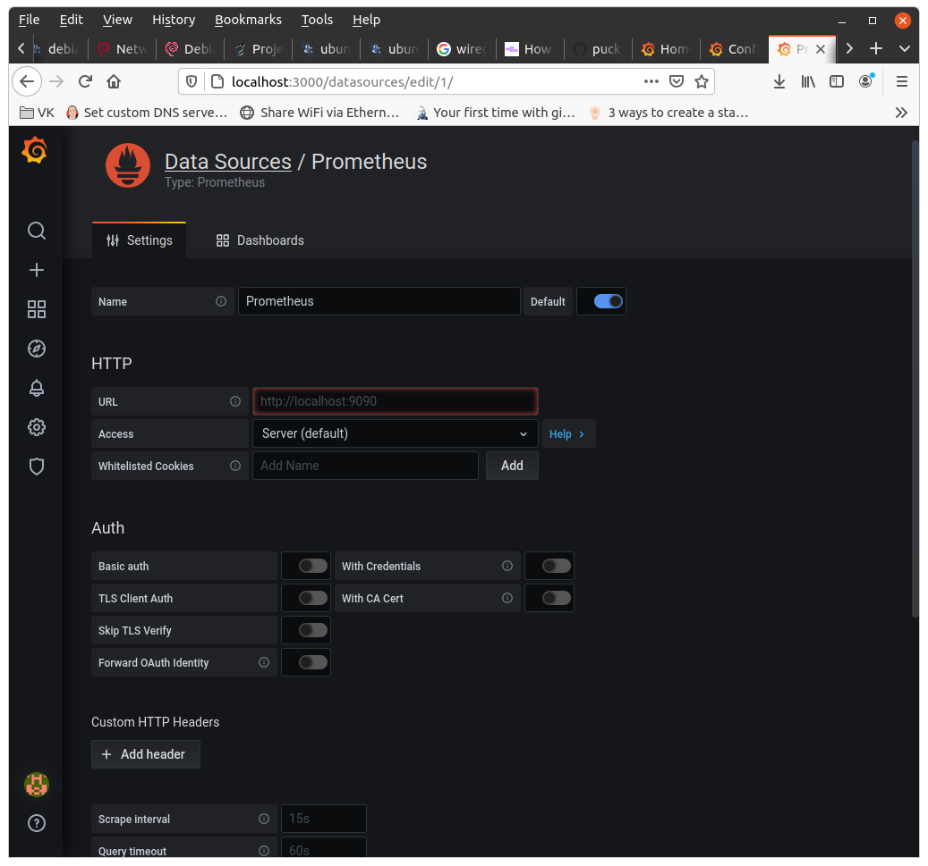

On this page, most items will be left as default. Fill out the following items:

Name:

Set the name to: Prometheus

URL:

input <ip addr of gw board>:9090, i.e., 10.0.0.8:9090

Then click “Save & Test” at the bottom of the page. Verify that a green banner comes up and displays a checkmark with “Data source is working”. If it doesn’t display the banner, check the ip address of the board and that the services are running as described at the top of this document.

Click the back button once to navigate to the “Add data source” page

Click on “Add Data Source”. Then click on “InfluxDB”. The InfluxDB configuration page is displayed:

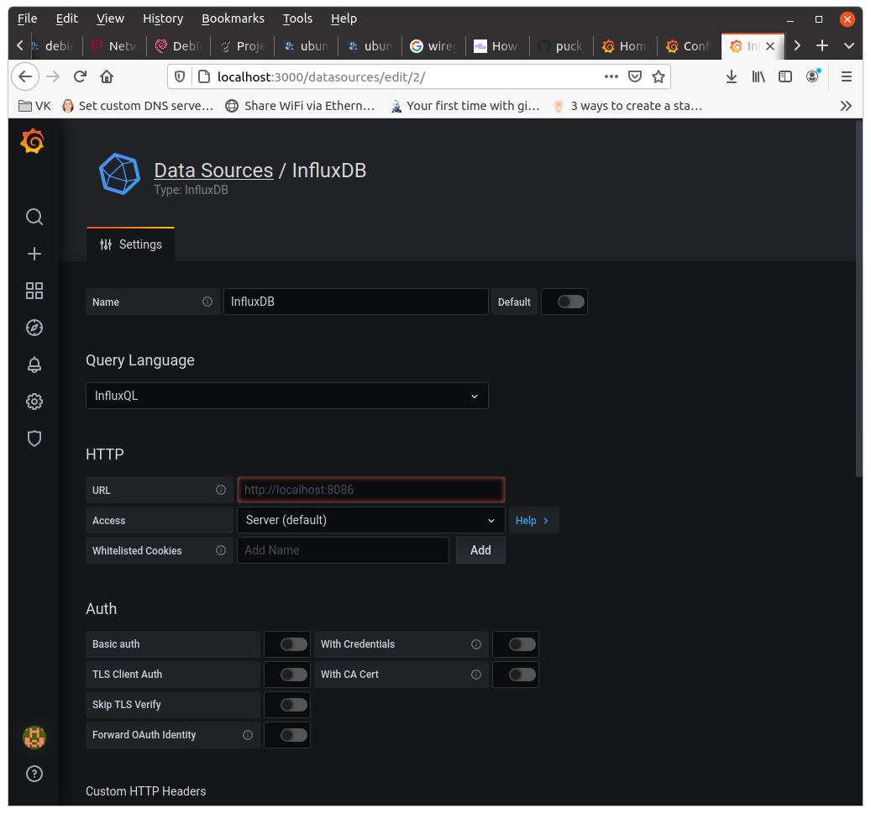

On this page, most items will be left as default. Fill out the following items:

Name:

Set the name to: InfluxDB

URL:

input <ip addr of gw board>:9090, i.e., 10.0.0.8:8086

Under InfluxDB Details → Database, input:

GW_Collections_DB2

Then click “Save & Test” at the bottom of the page. Verify that a green banner comes up and displays a checkmark with “Data source is working”. If it doesn’t display the banner, check the ip address of the board and that the services are running as described at the top of this document.

Click the back button 2 times to return to the Welcome To Grafana page.

On this page, click the “+” in the left pane and then select “Import” from the drop-down menu.

On the import page, select “Upload JSON file”. The file you will upload is the file saved earlier: “Gateworks-6200-Node-Exporter-Server-Metrics-test-gw-board2.json”. After selecting the file, if there is an existing UID, click Change uid” and remove the alphanumeric uid code, leaving the field blank.

Click “Import” or “Import(Overwrite)” as applicable and the Grafana display should come up.

Note the two drop-down boxes: “node” and “PromDataServer”. For the “PromDataSource” drop-down, select “Prometheus”.

In the “node” drop-down, type “localhost:9100” and then click somewhere in the blank area of the screen but outside of this drop-down box.

Go to the time setting at the top right and select today’s date. Then click the refresh button just to the right and in the refresh rate drop-down set the refresh rate to 30 seconds.

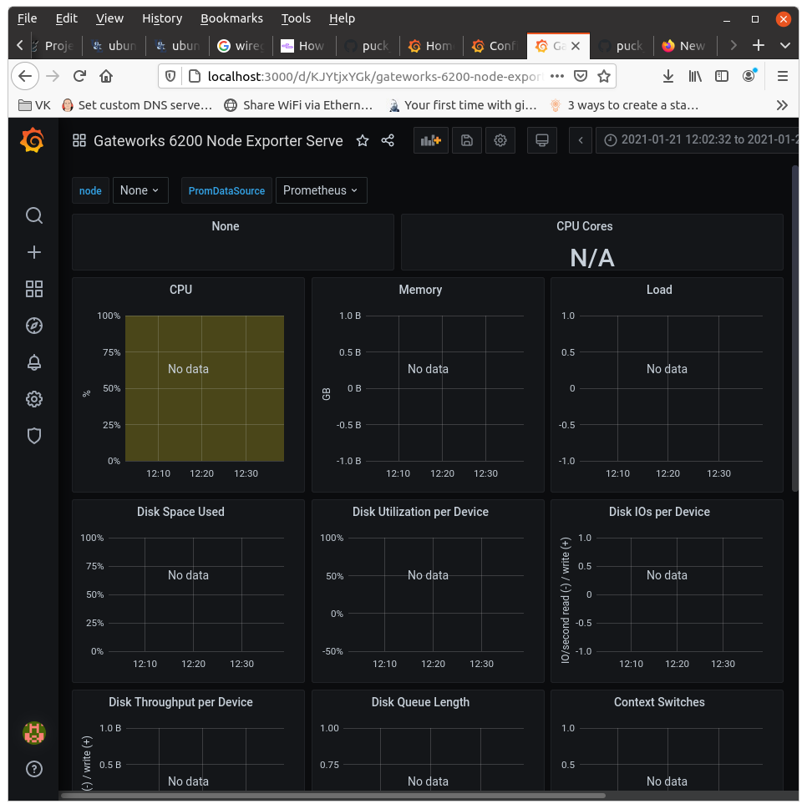At this point the data should begin to populate the charts.

To add the puck monitoring charts, open a new browser window and type: localhost:3000. The Welcome to Grafana page is displayed.

As done for the Prometheus data display, the same steps will be followed to bring up the Puck Monitoring display.

Click on the “+” in the left pane and in the drop-down select “Import”. Upload the other JSON file saved earlier (gw-modem-stats_test_Board1.2-withDataSource_01.28,21.json).

After selecting the file, if there is an existing UID, click Change uid” and remove the alphanumeric uid code, leaving the field blank. Click “Import”.

The puck monitoring page should display. At the top left, change the “InfluxDataSource” dropdown to “InfluxDB” and click outside of the drop-down.

Set the time to today’s date. Click the refresh button and set a continual refresh rate of 30 seconds.

The charts should begin to show the data.