SYSTEMS INTEGRATION AND ARCHITECTURE 1
OPENDOOR
An Integrated Job Matching Platform with Accommodation-Based Filtering and Post-Hire Accommodation Verification for Persons with Disabilities

Project Information
Field | Details
Project Title | OpenDoor: An Integrated Job Matching Platform with Accommodation-Based Filtering and Post-Hire Accommodation Verification for Persons with Disabilities
Selected UN SDG | SDG 8 – Decent Work and Economic Growth (Target 8.5)
Course | Systems Integration and Architecture 1
Section | [Enter section]
Instructor | [Enter instructor name]
Group Name / Number | [Enter group name or number]
Submission Date | [Month Day, Year]

Group Members
Name | Student Number | Primary Role / Responsibility
[Name] | [Student No.] | Project lead and integration architect – API gateway, service contracts, CI/CD
[Name] | [Student No.] | Core Service developer – Laravel API, MySQL schema, matching and trust score
[Name] | [Student No.] | Integration developer – Accessibility Insights mashup and SOAP Business Registry
[Name] | [Student No.] | Frontend developer – React SPA, accessibility (WCAG 2.1 AA)
[Name] | [Student No.] | QA and DevOps – Postman/Newman, JMeter, cloud deployment, documentation

Note: the role split above is a suggested division of the five integration workstreams. Adjust it to match the actual group.

Document Control
Field | Information
Application Platform | Web (responsive single-page application usable on desktop and on 360 px phone screens)
Repository | [Insert repository link, e.g., https://github.com/<org>/opendoor]
Deployment / Access URL | Frontend: [https://opendoor.vercel.app] · API Gateway: [https://opendoor-gateway.up.railway.app/api]
Version | 1.0
Date | [Insert date]

Executive Summary
Persons with disabilities (PWDs) remain largely excluded from the Philippine workforce: of about 1.9 million working-age Filipinos with a disability, only around 353,000 were in the labor force in January 2022 (Rappler, 2023). Republic Act No. 7277 already requires reasonable accommodation, yet the information a PWD job seeker needs to act on that right is scattered across systems that do not exchange data. Accommodation details are buried in free-text postings on separate job boards, employer legitimacy is checked by hand against DTI and SEC registry websites, the accessibility of a workplace's surroundings is looked up separately on maps, and no system records whether advertised accommodations were actually delivered after hire.
OpenDoor integrates these sources into one web application aligned with SDG 8, Target 8.5 (full and productive employment and decent work for all, including persons with disabilities). Candidates record their accommodation needs once and see job postings ranked by how many needs each one meets ("Meets 4 of 5 of your needs"). Employers post jobs with structured accommodation fields and move applicants through a server-enforced status workflow. After hire, candidates rate each advertised accommodation, producing an anonymous accommodation trust score that is published only after three responses.
The final architecture uses an API Gateway (Node.js/Express) as the single entry point for a React single-page application. Behind the gateway, the Core Service (Laravel 11, Sanctum, MySQL 8) owns users, profiles, postings, matching, applications, feedback and moderation. An Accessibility Insights Service (Node.js) is a mashup that combines the posting's address and accommodations from the Core Service with three external REST APIs – OpenStreetMap Nominatim (geocoding), the Overpass API (wheelchair-tagged places nearby) and the PSGC API (official Philippine location codes) – into a normalized "Workplace Accessibility Snapshot". A Business Registry Service exposes a WSDL-described SOAP 1.1 interface that simulates a legacy DTI/SEC registry; the Core Service calls it with XML and WS-Security credentials during employer verification and maps the XML result to JSON.
All services are deployed to the cloud: the React app on Vercel and the gateway, services and MySQL on Railway, with only the gateway exposed publicly and the other services on a private network. GitHub Actions runs linting, unit and feature tests, React builds and a Newman (Postman) API test run on every pull request, and the Vercel and Railway GitHub integrations deploy the main branch. Quality is verified through a Postman collection with assertions on status codes, identifiers, business values and application error codes, and through an Apache JMeter load test of the matching endpoint. The outcome is a deployed, accessible platform in which integration – not a single database – lets PWDs find jobs that fit their needs and lets the community hold employers to their accommodation promises.
[Update the final paragraph with the measured results (test pass rate, JMeter P95 and error rate, SUS score) once testing is complete.]

1. Project Overview

1.1 Background and Problem
Philippine law recognizes that the employment of PWDs depends on workplace accommodation. Republic Act No. 7277 (Magna Carta for Disabled Persons) defines reasonable accommodation as accessible facilities, modified work schedules, acquired or modified equipment, adjusted training materials and policies, and auxiliary aids and services, and Republic Act No. 10524 reserves at least 1% of government positions for PWDs. In practice, studies report low quota compliance, limited employer awareness, and a lack of accommodation facilities and assistive technology. The 2016 National Disability Prevalence Survey found that 78% of PWDs were unemployed or in the informal sector (SDDirect, 2023).
Several channels already exist. DOLE's PhilJobNet and the PESO Employment Information System keep a national job-seeker registry, and PWD-focused platforms such as PWD-E and Access Careers match candidates on skills, location, disability type, work mode and shift. The problem is that these sources are not integrated with the information that actually decides whether a PWD can take a job:
- Accommodations are written as free text inside postings on separate boards, so they cannot be filtered or matched, and the same profile must be re-entered on every board.
- Employer legitimacy is verified manually by visiting DTI BNRS or SEC registry websites; nothing links a job posting to registry data.
- Whether a workplace's surroundings are accessible (ramps, accessible transport stops, accessible toilets and parking) has to be checked separately on map services.
- No system closes the loop after hire: there is no record of whether the accommodations an employer advertised were delivered, so a candidate often learns of a mismatch only at the interview or after starting work.
Integration is needed because the value comes from combining these sources: structured accommodation data from employers and candidates, registry data about the employer, open geographic data about the location, and post-hire feedback from previous hires. OpenDoor brings them together behind a single gateway so that each decision a PWD makes is informed by all of them.

1.2 SDG Alignment
OpenDoor is aligned with SDG 8 – Decent Work and Economic Growth, specifically Target 8.5: by 2030, achieve full and productive employment and decent work for all women and men, including for young people and persons with disabilities, and equal pay for work of equal value. The connection is direct:
- Access to employment. Accommodation-based matching lets PWDs find openings they can actually take, reducing the number of applications that fail because of an unmet accommodation (Target 8.5, "persons with disabilities").
- Decent work. The post-hire trust score makes delivered accommodations – a component of decent, non-discriminatory working conditions under RA 7277 – visible and measurable for each employer.
- Inclusive economic participation. Verified employers and transparent accommodation records encourage employers to hire inclusively and help close the gap between the PWD and general labor force participation rates.
The project also supports SDG 10 (Reduced Inequalities), Target 10.2, by promoting the economic inclusion of all irrespective of disability. Matching on accommodation needs rather than diagnosis avoids collecting unnecessary health information, in line with the Data Privacy Act of 2012 (RA 10173).

1.3 Project Objectives
General objective: to design, integrate, deploy and evaluate OpenDoor, a service-based web application that enables PWDs to find jobs based on their accommodation needs and holds employers accountable for the accommodations they advertise. Specific objectives:
- Objective 1 – Integrated application. Implement the React client, API Gateway and Core Service so that candidates, employers and administrators complete the full hiring transaction – profile with accommodation needs, "Matches my needs" search, application, server-enforced status workflow (Pending → Reviewed → Hired/Rejected, Withdrawn) and per-accommodation post-hire feedback with a trust score shown after three responses – entirely through REST/JSON endpoints.
- Objective 2 – Service-to-service, external and legacy integration. Integrate (a) an Accessibility Insights mashup service that combines Core Service data with the Nominatim, Overpass and PSGC REST APIs, and (b) a WSDL/SOAP 1.1 Business Registry service used for employer verification, with documented contracts, timeouts and graceful degradation.
- Objective 3 – Security. Secure every request with Sanctum bearer tokens, role middleware and Laravel Policies; secure service-to-service calls with service keys and WS-Security credentials; and keep all secrets out of the repository.
- Objective 4 – Quality assurance. Verify the APIs and integrations with an automated Postman/Newman collection (functional, negative and integration cases) and measure performance of the matching endpoint with Apache JMeter (response time, P95, throughput, error rate).
- Objective 5 – Cloud deployment and DevOps. Deploy all components to Vercel and Railway with a private service network, and automate linting, testing, building and deployment with GitHub Actions.
- Objective 6 – Accessibility and usability. Evaluate the client against WCAG 2.1 Level AA (Lighthouse, axe, NVDA) and through the System Usability Scale with at least five PWD and three employer participants (target mean SUS ≥ 68).

1.4 Scope and Limitations
Included in scope:
- Public area, Candidate, Employer and Admin portals in one React application (13 functional modules, M1–M13, as defined in the OpenDoor Modules and Features Specification).
- API Gateway with routing, CORS, rate limiting, request IDs, timeouts and a uniform error envelope.
- Core Service (Laravel 11 + MySQL 8): authentication and roles, candidate and company profiles, job postings with structured accommodations, search/filter/matching, application workflow, feedback and trust score, dashboards, in-app notifications, moderation, master data.
- Accessibility Insights Service: Workplace Accessibility Snapshot (mashup) and PSGC location lookup with caching.
- Business Registry Service: SOAP 1.1 operation VerifyBusinessRegistration with a published WSDL, used in employer verification.
- Postman collection, JMeter test plan, GitHub Actions workflow, and cloud deployment.
Excluded / limitations:
- The Business Registry Service is a simulated legacy system seeded with sample registrations; it does not connect to the real DTI BNRS or SEC databases, which offer no public SOAP or REST API. An administrator always makes the final verification decision.
- Accessibility Snapshot data depends on OpenStreetMap volunteers tagging places with wheelchair=yes; coverage in some Philippine areas is incomplete, so the snapshot is informational only and never used for ranking.
- Public Nominatim and Overpass instances have usage limits (Nominatim: at most one request per second, identifying User-Agent required), so results are cached and requests are throttled.
- Email notifications, saved jobs and display settings are "Could have" features and may be delivered only if time allows. No mobile app, payments, or video interviews are included.
- Free-tier/hobby cloud plans may sleep when idle and are not sized for production traffic.

1.5 Intended Users / Stakeholders
Stakeholder | Type | Role in the System
PWD Job Seeker (Candidate) | Primary user | Registers with data privacy consent; records accommodation needs; browses in "Matches my needs" mode; views the Accessibility Snapshot and trust score; applies, withdraws or confirms hire; rates each accommodation 30 days after hire; reports misleading postings.
Employer / HR Officer | Primary user | Registers a company with its DTI/SEC registration number; posts jobs with structured accommodations and interview format; reviews applicants and records decisions; views its trust score and per-accommodation breakdown.
Platform Administrator | Administrator | Runs registry checks and verifies employers; approves or removes postings; reviews reports and flagged feedback; suspends accounts; maintains categories and accommodation types; monitors the dashboard.
Business Registry Service (simulated DTI/SEC) | Legacy system (SOAP) | Returns registration status and registered business name for a registration number.
OpenStreetMap Nominatim and Overpass API | External systems (REST) | Geocode job addresses; return wheelchair-accessible places near the workplace.
PSGC API | External system (REST) | Provides official Philippine region, province and city/municipality codes for consistent locations.
PESO / PDAO offices, PWD organizations | Secondary stakeholders | Refer job seekers, help recruit research and usability-test participants, and may use the platform to support placements.

2. AS-IS Analysis

2.1 Current Process / Existing Systems
Today a PWD looking for work moves between several unconnected systems and manual steps:
- The job seeker searches general job boards (PhilJobNet, JobStreet) and PWD-focused boards (PWD-E, Access Careers) one by one, creating and re-entering a profile on each. None of them stores accommodation needs as structured data.
- Employers post openings as free text. Accommodation details, if present, are buried in the description, so the job seeker cannot filter by them and must ask the employer through social media, email or phone.
- To judge the commute and surroundings (accessible entrance, nearby accessible transport stops, toilets, parking), the job seeker looks up the address separately on an online map.
- PESO/PDAO officers record PWD registrants on paper forms or spreadsheets and, when they endorse employers, check legitimacy manually on the DTI BNRS or SEC registry websites.
- After hire, nothing records whether the promised accommodations were delivered. Experiences spread only by word of mouth, so the next applicant has no reliable evidence.

2.2 AS-IS Diagram
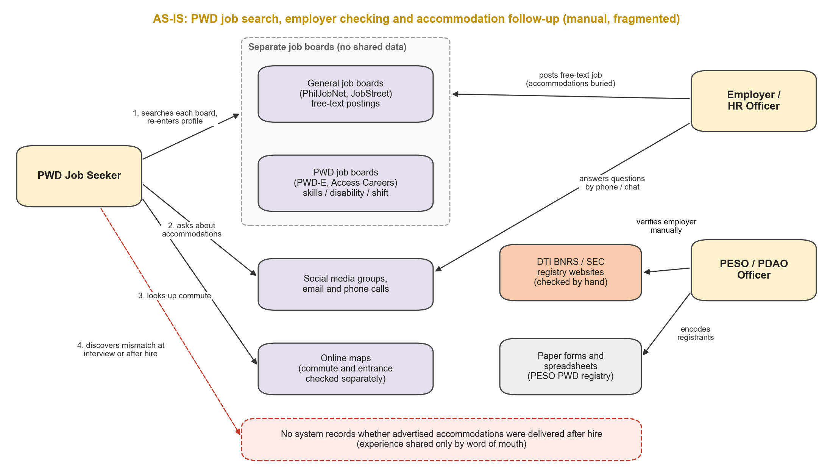
Figure 1. AS-IS process: actors, unconnected systems, manual data stores and information flows

2.3 Identified Integration Problems
- Unstructured, siloed accommodation data. Accommodations exist only as free text on separate boards with no shared vocabulary or data exchange, so they cannot be matched against a candidate's needs and profiles must be re-entered (duplicate data entry, no single source of truth).
- No link to authoritative business registry data. Employer verification depends on a person manually searching registry websites; the result is not stored with the employer record or reflected on postings.
- Location accessibility lives in a separate system. Geographic and accessibility data (OpenStreetMap) is never combined with job postings, so every job seeker repeats the same manual lookup and locations are written inconsistently (no standard PSGC codes).
- No post-hire feedback loop. No system captures delivered-versus-advertised accommodations, so there is no data to build employer accountability or to warn future applicants.

3. TO-BE Solution and Architecture

3.1 Proposed Application
OpenDoor is a responsive web application (React single-page application) with one public area and three role-based portals – Candidate, Employer and Admin – served through one API Gateway. After login, the client reads the user's role and opens the matching portal. The main business transaction it supports is accommodation-aware hiring with post-hire verification:
- Onboard – a candidate registers with consent and selects accommodation needs from a shared list; an employer registers a company and is verified by an administrator against the Business Registry Service (SOAP).
- Post and match – the employer posts a job with structured accommodations; after approval, the Core Service ranks open postings by the number of the candidate's needs they meet.
- Inform – the job details page combines the posting, the employer's trust score and a Workplace Accessibility Snapshot built by the Insights Service from Nominatim, Overpass and PSGC data.
- Apply and decide – the candidate applies (optionally requesting an interview accommodation); the employer moves the application through the server-enforced workflow.
- Verify after hire – 30 days after hire, the candidate rates each advertised accommodation; the Core Service recomputes the employer's trust score and publishes it after three responses.

3.2 Final Architecture
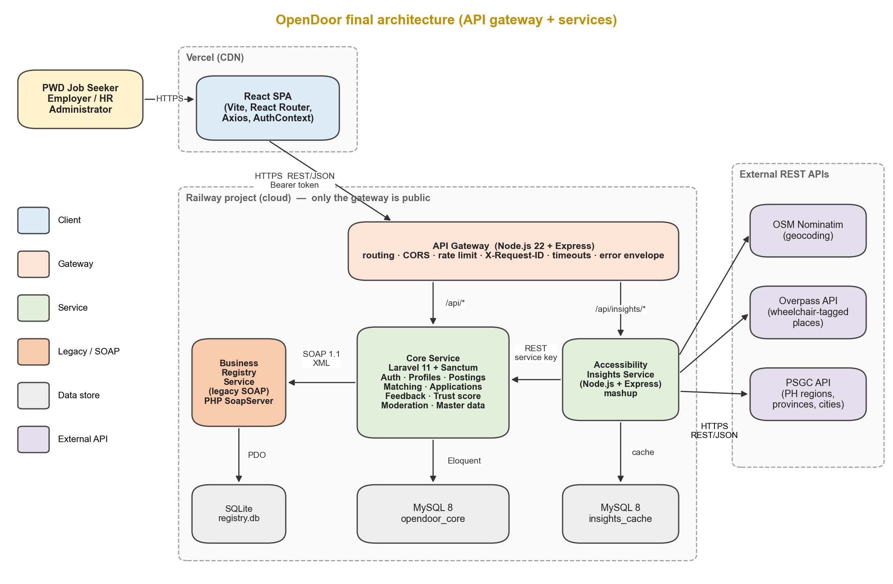
Figure 2. OpenDoor final architecture: client, gateway, services, databases, external REST APIs and legacy SOAP component
The React client (Vercel) sends every request over HTTPS to the API Gateway, the only public component on Railway. The gateway routes /api/insights/* to the Accessibility Insights Service and all other /api/* paths to the Core Service. The Core Service owns the opendoor_core MySQL database and calls the Business Registry Service over SOAP/XML. The Insights Service calls the Core Service's internal REST endpoints for posting data, calls the three external REST APIs, and stores normalized results in its own insights_cache database. Each service owns its data; no service reads another service's database.

3.3 Architectural Decisions
Decision | Choice | Rationale
Architecture style | API Gateway + a small number of services (service-based architecture), not a single monolith and not fine-grained microservices | Integration concerns (external APIs, legacy SOAP) are isolated in their own services so that their failures and rate limits cannot break core hiring features. The hiring domain (users, postings, applications, feedback) stays in one Core Service because it is strongly transactional – for example, feedback must check the application status and update the trust score atomically. This keeps the system realistic for a student team.
Single entry point | API Gateway (Node.js 22 + Express + http-proxy-middleware) | One public URL for the client; central CORS, rate limiting, request IDs, timeouts and error format; the internal services stay on a private network. Express is lightweight and well suited to proxying.
Core Service | Laravel 11, Sanctum, Eloquent, MySQL 8 | Already the team's IPT stack. Sanctum issues API tokens for an SPA on a different domain; Policies, Form Requests and backed enums give clean authorization, validation and the status state machine.
Service boundaries | Core (hiring domain) · Insights (geographic mashup) · Business Registry (legacy) | Boundaries follow data ownership and failure isolation: each service owns one data store and one integration concern.
Synchronous protocol | REST/JSON over HTTPS for client, gateway and service-to-service calls | Simple, widely supported, easy to test with Postman and JMeter.
Legacy protocol | SOAP 1.1 with WSDL and WS-Security UsernameToken | Represents how government and enterprise registries commonly expose services; demonstrates XML contracts, schema-typed messages and SOAP faults. Implemented with PHP's built-in SoapServer/SoapClient.
External data | Nominatim, Overpass API, PSGC API | Free, open, no paid keys; directly relevant to PWDs (wheelchair tagging) and to Philippine location data. Responses are cached to respect usage policies.
Resilience | Per-call timeouts, caching, partial (degraded) responses | The snapshot is optional information; hiring must keep working if an external API or the registry is down.
Deployment | Vercel (client) + Railway (gateway, services, MySQL) with private networking | Railway runs Docker services and managed MySQL in one project and supports internal hostnames (*.railway.internal); Vercel is optimized for static SPAs.

3.4 Component / Service Inventory
Component / Service | Responsibility | Technology | Port / URL | Depends On
React SPA (Client) | Public area and Candidate, Employer and Admin portals; accessible UI; calls the gateway only | React 18, Vite, React Router, Axios, AuthContext | Vercel: [https://opendoor.vercel.app] (dev :5173) | API Gateway
API Gateway | Single entry point; routing; CORS; rate limiting; X-Request-ID; timeouts; uniform error envelope; health check | Node.js 22, Express, http-proxy-middleware, express-rate-limit | Public: [https://opendoor-gateway.up.railway.app] (dev :8080) | Core Service, Insights Service
Core Service | Auth and roles, profiles, postings, matching, applications and status workflow, feedback and trust score, dashboards, notifications, moderation, master data | PHP 8.3, Laravel 11, Sanctum, Eloquent | core-api.railway.internal:8001 (dev :8001) | MySQL opendoor_core, Business Registry Service
Accessibility Insights Service | Workplace Accessibility Snapshot mashup; PSGC location lookup; caching and throttling | Node.js 22, Express, Axios, mysql2 | insights.railway.internal:8002 (dev :8002) | Core Service (internal API), Nominatim, Overpass, PSGC, MySQL insights_cache
Business Registry Service (legacy) | SOAP 1.1 VerifyBusinessRegistration; WSDL; simulated DTI/SEC records | PHP 8.3 SoapServer, SQLite | registry.railway.internal:8003/soap, WSDL at /soap?wsdl (dev :8003) | registry.db
MySQL – opendoor_core | Users, profiles, employers, postings, accommodations, applications, feedback, notifications, reports | MySQL 8 (Railway managed) | mysql.railway.internal:3306 | –
MySQL – insights_cache | Geocoding results, Overpass results, PSGC lists, with expiry | MySQL 8 (same server, separate schema and user) | mysql.railway.internal:3306 | –
Nominatim (external) | Geocoding of job addresses | REST/JSON | https://nominatim.openstreetmap.org | –
Overpass API (external) | Query OSM elements tagged wheelchair=yes near a point | REST (Overpass QL) / JSON | https://overpass-api.de/api/interpreter | –
PSGC API (external) | Philippine regions, provinces, cities/municipalities | REST/JSON | https://psgc.gitlab.io/api | –

4. API and Data Exchange Design

4.1 REST API Endpoints
All client requests use the gateway base URL {GATEWAY}/api. JSON is used for all REST bodies; lists are paginated (?page=, 12 items per page). Protected endpoints require Authorization: Bearer <token>. The main endpoints are listed below; the complete reference is in Appendix A.
Service | Method | Endpoint | Purpose | Request / Response
Gateway | GET | /api/health | Gateway and downstream health | → {status, services:{core, insights}}
Core | POST | /api/register | Create candidate or employer account with consent | {name,email,password,role,consent:true} → 201 {user, token}
Core | POST | /api/login | Log in; returns token and role | {email,password} → 200 {token, user:{id,name,role}}
Core | POST | /api/logout | Revoke current token | → 204
Core | GET, PUT | /api/candidate/profile | View or update own profile | {headline,skills[],experience,location_psgc,...} → profile
Core | PUT | /api/candidate/accommodations | Replace list of accommodation needs | {accommodation_ids:[1,4,9]} → 200 needs[]
Core | GET | /api/job-postings | Search, filter and match postings | ?q=&category=&accommodations[]=&match=1&sort=&page= → {data:[posting+match], meta}
Core | GET | /api/job-postings/{id} | Posting details with match result and trust score | → posting (Section 4.2)
Core | POST | /api/job-postings | Create posting (draft or submit) | {title,description,category_id,...,accommodations:[{id,note}]} → 201
Core | PUT, DELETE | /api/job-postings/{id} | Update or soft-delete own posting | → 200 / 204
Core | POST | /api/job-postings/{id}/applications | Apply | {cover_note, interview_request} → 201 application
Core | GET | /api/applications | Own applications (candidate) or applicants (employer) | ?status= → {data:[application]}
Core | PATCH | /api/applications/{id}/status | Change status (server-enforced transitions) | {status:'reviewed'|'hired'|'rejected'|'withdrawn'} → 200
Core | GET | /api/applications/{id}/feedback-form | Accommodations to rate | → {items:[{accommodation_id,name}]}
Core | POST | /api/applications/{id}/feedback | Submit per-accommodation feedback | {items:[{accommodation_id,rating}],comments} → 201
Core | GET | /api/employers/{id}/trust-score | Score, count and breakdown | → {published, score, based_on, breakdown[]}
Core | PATCH | /api/admin/employers/{id}/verify | Run registry check, approve or reject | {action:'check'|'approve'|'reject', reason} → 200 {registry, verified_at}
Core | GET, POST, PUT, DELETE | /api/admin/categories, /api/admin/accommodations | Manage master data | → category / accommodation
Core (internal) | GET | /internal/job-postings/{id}/summary | Posting data for the Insights Service (not routed by gateway) | X-Service-Key → {address, psgc_code, accommodations, trust_score}
Insights | GET | /api/insights/job-postings/{id} | Workplace Accessibility Snapshot (mashup) | → snapshot (Section 4.5)
Insights | GET | /api/insights/locations/{level} | Normalized PSGC lists (regions, provinces, cities) | ?parent= → [{code,name,level}]
Registry (SOAP) | POST | /soap (SOAPAction: VerifyBusinessRegistration) | Legacy registry lookup (internal only) | SOAP envelope → SOAP response / Fault (Section 4.3)

4.2 JSON Representation
Search with matching – GET /api/job-postings?match=1&q=encoder&page=1 (candidate token). The match object is computed by the Core Service from the candidate's needs; it appears only for logged-in candidates.
{
"data": [
{
"id": 42,
"title": "Data Encoder",
"employer": { "id": 7, "company_name": "Bright Path BPO Inc.", "verified": true },
"category": { "id": 3, "name": "Administrative" },
"location": { "psgc_code": "137404000", "label": "Quezon City, NCR" },
"employment_type": "full_time",
"work_setup": "hybrid",
"interview_format": "online",
"closes_at": "2026-11-30",
"accommodations": [
{ "id": 1, "name": "Wheelchair-accessible entrance", "group": "physical_access",
"note": "Ramp at main entrance; restroom on 2nd floor via elevator" },
{ "id": 9, "name": "Flexible hours", "group": "work_arrangement", "note": null }
],
"match": { "met": 4, "total": 5, "missing": [ { "id": 6, "name": "Sign language interpreter" } ] },
"trust_score": { "published": true, "score": 86, "based_on": 5 }
}
],
"meta": { "current_page": 1, "per_page": 12, "total": 12, "match_mode": true }
}

Important fields: match.met/match.total drive the "Meets 4 of 5 of your needs" badge and missing names the unmet accommodation; trust_score.published is false (and score null) until three feedback responses exist; location.psgc_code is the normalized PSGC code used by the Insights Service.
Apply – POST /api/job-postings/42/applications
Request: { "cover_note": "I have 3 years of encoding experience.",
"interview_request": "Please provide a captioned online interview." }

Response 201:
{ "id": 318, "job_posting_id": 42, "status": "pending",
"created_at": "2026-10-02T09:15:04+08:00" }

Submit feedback – POST /api/applications/318/feedback (only when status is hired and at least 30 days after hired_at; one per application). Ratings map to Delivered = 1, Partially = 0.5, Not delivered = 0.
Request: { "items": [ { "accommodation_id": 1, "rating": "delivered" },
{ "accommodation_id": 9, "rating": "partial" } ],
"comments": "Ramp is available; schedule changes need two weeks' notice." }

Response 201: { "id": 77, "application_id": 318, "items_rated": 2 }

Error envelope – every service returns errors in one format, so the client can show a message and the team can trace the request across services with request_id. Validation errors (422) keep Laravel's errors object so the React forms can show messages beside each field.
HTTP/1.1 409 Conflict
{ "error": { "code": "ALREADY_APPLIED",
"message": "You have already applied to this posting.",
"request_id": "c7f1e2a4-5b0d-4f7e-9c41-0d8a1f2b3c4d" } }

HTTP/1.1 422 Unprocessable Content
{ "message": "The given data was invalid.",
"error": { "code": "VALIDATION_FAILED", "request_id": "..." },
"errors": { "accommodations.0.id": [ "The selected accommodation is invalid." ] } }

4.3 XML / SOAP / Legacy Interoperability
Scenario. Employers register with a DTI (sole proprietorship) or SEC (corporation/partnership) registration number. In the AS-IS process this is checked by hand on registry websites. OpenDoor models the registry as a legacy system that exposes only a SOAP 1.1 interface described by a WSDL. Because the real DTI BNRS and SEC systems offer no public machine interface, the Business Registry Service is a simulation seeded with sample records; the contract, transport, security header and faults are implemented as a real SOAP integration.
Contract (WSDL excerpt) – published at /soap?wsdl, target namespace urn:opendoor:registry:v1, document/literal style, one operation:
<definitions name="BusinessRegistry" targetNamespace="urn:opendoor:registry:v1"
xmlns="http://schemas.xmlsoap.org/wsdl/" xmlns:tns="urn:opendoor:registry:v1"
xmlns:soap="http://schemas.xmlsoap.org/wsdl/soap/" xmlns:xsd="http://www.w3.org/2001/XMLSchema">
<types>
<xsd:schema targetNamespace="urn:opendoor:registry:v1" elementFormDefault="qualified">
<xsd:element name="VerifyBusinessRegistrationRequest">
<xsd:complexType><xsd:sequence>
<xsd:element name="RegistrationNumber" type="xsd:string"/>
<xsd:element name="RegistryType"> <!-- DTI | SEC -->
<xsd:simpleType><xsd:restriction base="xsd:string">
<xsd:enumeration value="DTI"/><xsd:enumeration value="SEC"/>
</xsd:restriction></xsd:simpleType>
</xsd:element>
<xsd:element name="BusinessName" type="xsd:string"/>
</xsd:sequence></xsd:complexType>
</xsd:element>
<xsd:element name="VerifyBusinessRegistrationResponse">
<xsd:complexType><xsd:sequence>
<xsd:element name="Found" type="xsd:boolean"/>
<xsd:element name="Status" type="xsd:string"/> <!-- ACTIVE | EXPIRED | CANCELLED | NOT_FOUND -->
<xsd:element name="RegisteredName" type="xsd:string" minOccurs="0"/>
<xsd:element name="DateRegistered" type="xsd:date" minOccurs="0"/>
<xsd:element name="NameMatchScore" type="xsd:decimal"/>
<xsd:element name="CheckedAt" type="xsd:dateTime"/>
</xsd:sequence></xsd:complexType>
</xsd:element>
</xsd:schema>
</types>
<!-- message, portType, binding (soap:binding style="document"), service elided; see Appendix B -->
</definitions>

Representative request (sent by the Core Service with PHP SoapClient):
POST /soap HTTP/1.1
Host: registry.railway.internal:8003
Content-Type: text/xml; charset=utf-8
SOAPAction: "urn:opendoor:registry:v1#VerifyBusinessRegistration"

<soapenv:Envelope xmlns:soapenv="http://schemas.xmlsoap.org/soap/envelope/"
xmlns:reg="urn:opendoor:registry:v1"
xmlns:wsse="http://docs.oasis-open.org/wss/2004/01/oasis-200401-wss-wssecurity-secext-1.0.xsd">
<soapenv:Header>
<wsse:Security>
<wsse:UsernameToken>
<wsse:Username>opendoor-core</wsse:Username>
<wsse:Password>${REGISTRY_SOAP_PASSWORD}</wsse:Password>
</wsse:UsernameToken>
</wsse:Security>
</soapenv:Header>
<soapenv:Body>
<reg:VerifyBusinessRegistrationRequest>
<reg:RegistrationNumber>CS201912345</reg:RegistrationNumber>
<reg:RegistryType>SEC</reg:RegistryType>
<reg:BusinessName>Bright Path BPO Inc.</reg:BusinessName>
</reg:VerifyBusinessRegistrationRequest>
</soapenv:Body>
</soapenv:Envelope>

Representative response and fault:
<soapenv:Envelope xmlns:soapenv="http://schemas.xmlsoap.org/soap/envelope/" xmlns:reg="urn:opendoor:registry:v1">
<soapenv:Body>
<reg:VerifyBusinessRegistrationResponse>
<reg:Found>true</reg:Found>
<reg:Status>ACTIVE</reg:Status>
<reg:RegisteredName>BRIGHT PATH BPO INC.</reg:RegisteredName>
<reg:DateRegistered>2019-03-14</reg:DateRegistered>
<reg:NameMatchScore>0.96</reg:NameMatchScore>
<reg:CheckedAt>2026-10-02T10:02:11+08:00</reg:CheckedAt>
</reg:VerifyBusinessRegistrationResponse>
</soapenv:Body>
</soapenv:Envelope>

<!-- Fault example: missing/invalid credentials -->
<soapenv:Fault>
<faultcode>soapenv:Client.Authentication</faultcode>
<faultstring>Invalid WS-Security credentials</faultstring>
</soapenv:Fault>

How the contract is used. The Core Service sends the employer's business_reg_no, registry_type and company_name. The response is mapped to JSON and stored in a registry_checks record (status, registered name, match score, checked time). NameMatchScore is a normalized similarity (0–1) between the submitted and registered names. The administrator sees the result and decides; a NOT_FOUND, EXPIRED or CANCELLED status or a score below 0.80 is highlighted. Client faults (bad input, bad credentials) become HTTP 422/502 with codes REGISTRY_INVALID_REQUEST/REGISTRY_AUTH_FAILED; server faults or a 5-second timeout become HTTP 502 REGISTRY_UNAVAILABLE, and the employer stays in the manual review queue.

4.4 External REST API
Provider | Purpose | Authentication | Data Used | Failure / Fallback Handling
OpenStreetMap Nominatim (/search) | Geocode a job posting's address to latitude/longitude | None; identifying User-Agent and contact email required by usage policy | lat, lon, display_name, importance | Max 1 request/second (throttled queue); results cached 30 days; on error or timeout (5 s) fall back to the PSGC city centroid stored in cache, mark source degraded
Overpass API (/api/interpreter) | Find OSM elements tagged wheelchair=yes|limited within 500 m (transit stops, toilets, parking, entrances) | None (fair-use limits) | elements[].tags (amenity, public_transport, highway, wheelchair, name), lat, lon | Cached 24 h; on 429/504 or timeout (8 s) return the last cached result with stale:true, or omit the nearby section and mark source unavailable
PSGC API (psgc.gitlab.io/api) | Official Philippine regions, provinces, cities/municipalities for location pickers and normalization | None | code, name, regionCode, provinceCode, isCity | Lists cached 7 days (data rarely changes); a seeded copy of the NCR and major cities list is used if the API is unreachable

4.5 Mashup / Data Transformation
The Workplace Accessibility Snapshot (GET /api/insights/job-postings/{id}) combines four sources into one result shown on the job details page:
- Extract – Core Service. The Insights Service calls GET /internal/job-postings/{id}/summary (service key) to obtain the posting's street address, PSGC code, advertised accommodations (grouped) and the employer's published trust score.
- Extract – PSGC. The PSGC code is resolved to a standard City, Province, Region label so that free-text locations such as "QC", "Quezon City" and "Q.C." become one value.
- Extract – Nominatim. The normalized address is geocoded to coordinates (cached).
- Extract – Overpass. An Overpass QL query returns OSM elements within 500 m that carry a wheelchair tag.
- Transform. OSM tags are mapped to four PWD-relevant categories (Accessible transit stops, Accessible toilets, Accessible parking, Other accessible places); distances are computed with the haversine formula; duplicates are removed; limited is reported separately from yes; the nearest three items per category are kept.
- Combine. The result merges the employer's own claims (advertised physical-access accommodations), the community verification (trust score and per-accommodation breakdown) and the independent map data, plus a sources object that tells the client which parts are live, cached or unavailable.
{
"job_posting_id": 42,
"location": { "psgc_code": "137404000", "label": "Quezon City, Metro Manila, NCR",
"lat": 14.6507, "lon": 121.0494, "precision": "street" },
"employer_claims": { "physical_access": [ "Wheelchair-accessible entrance", "Elevator or ground-floor workspace" ] },
"community_verification": { "trust_score": 86, "based_on": 5,
"breakdown": [ { "accommodation": "Wheelchair-accessible entrance", "delivered": 5, "of": 5 } ] },
"nearby_accessible": {
"radius_m": 500,
"transit_stops": [ { "name": "Quezon Ave. MRT Station", "wheelchair": "yes", "distance_m": 220 } ],
"toilets": [ { "name": null, "wheelchair": "yes", "distance_m": 140 } ],
"parking": [],
"other": [ { "name": "Example Mall", "wheelchair": "limited", "distance_m": 410 } ]
},
"sources": { "core": "ok", "psgc": "cached", "nominatim": "ok", "overpass": "ok" },
"disclaimer": "Map data from OpenStreetMap contributors (ODbL); coverage may be incomplete.",
"generated_at": "2026-10-02T10:05:40+08:00"
}

A second transformation happens inside the Core Service: the matching engine joins candidate_accommodation and job_posting_accommodation (Eloquent withCount) to compute match.met, orders full matches first and then partial matches by count, and applies keyword, category and extra accommodation filters on top. The trust score transformation converts ratings to values (Delivered = 1, Partially = 0.5, Not delivered = 0) and computes Σ item ratings ÷ number of rated items × 100%.

5. Integration Flow

5.1 Core Transaction Sequence
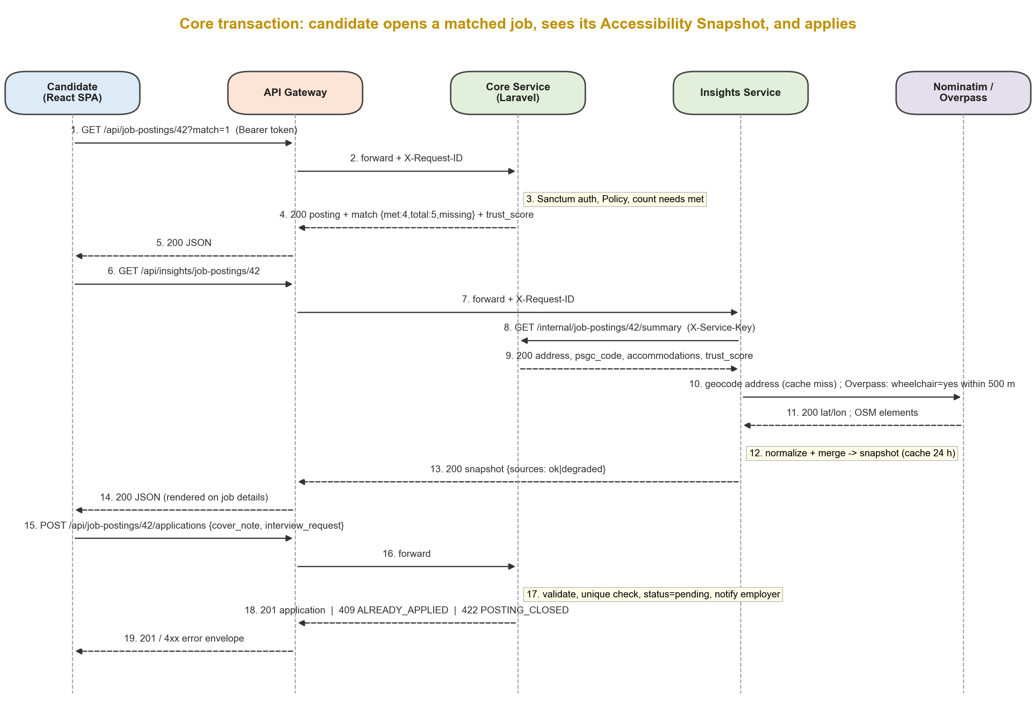
Figure 3. Sequence – a candidate opens a matched job, receives the Accessibility Snapshot and applies
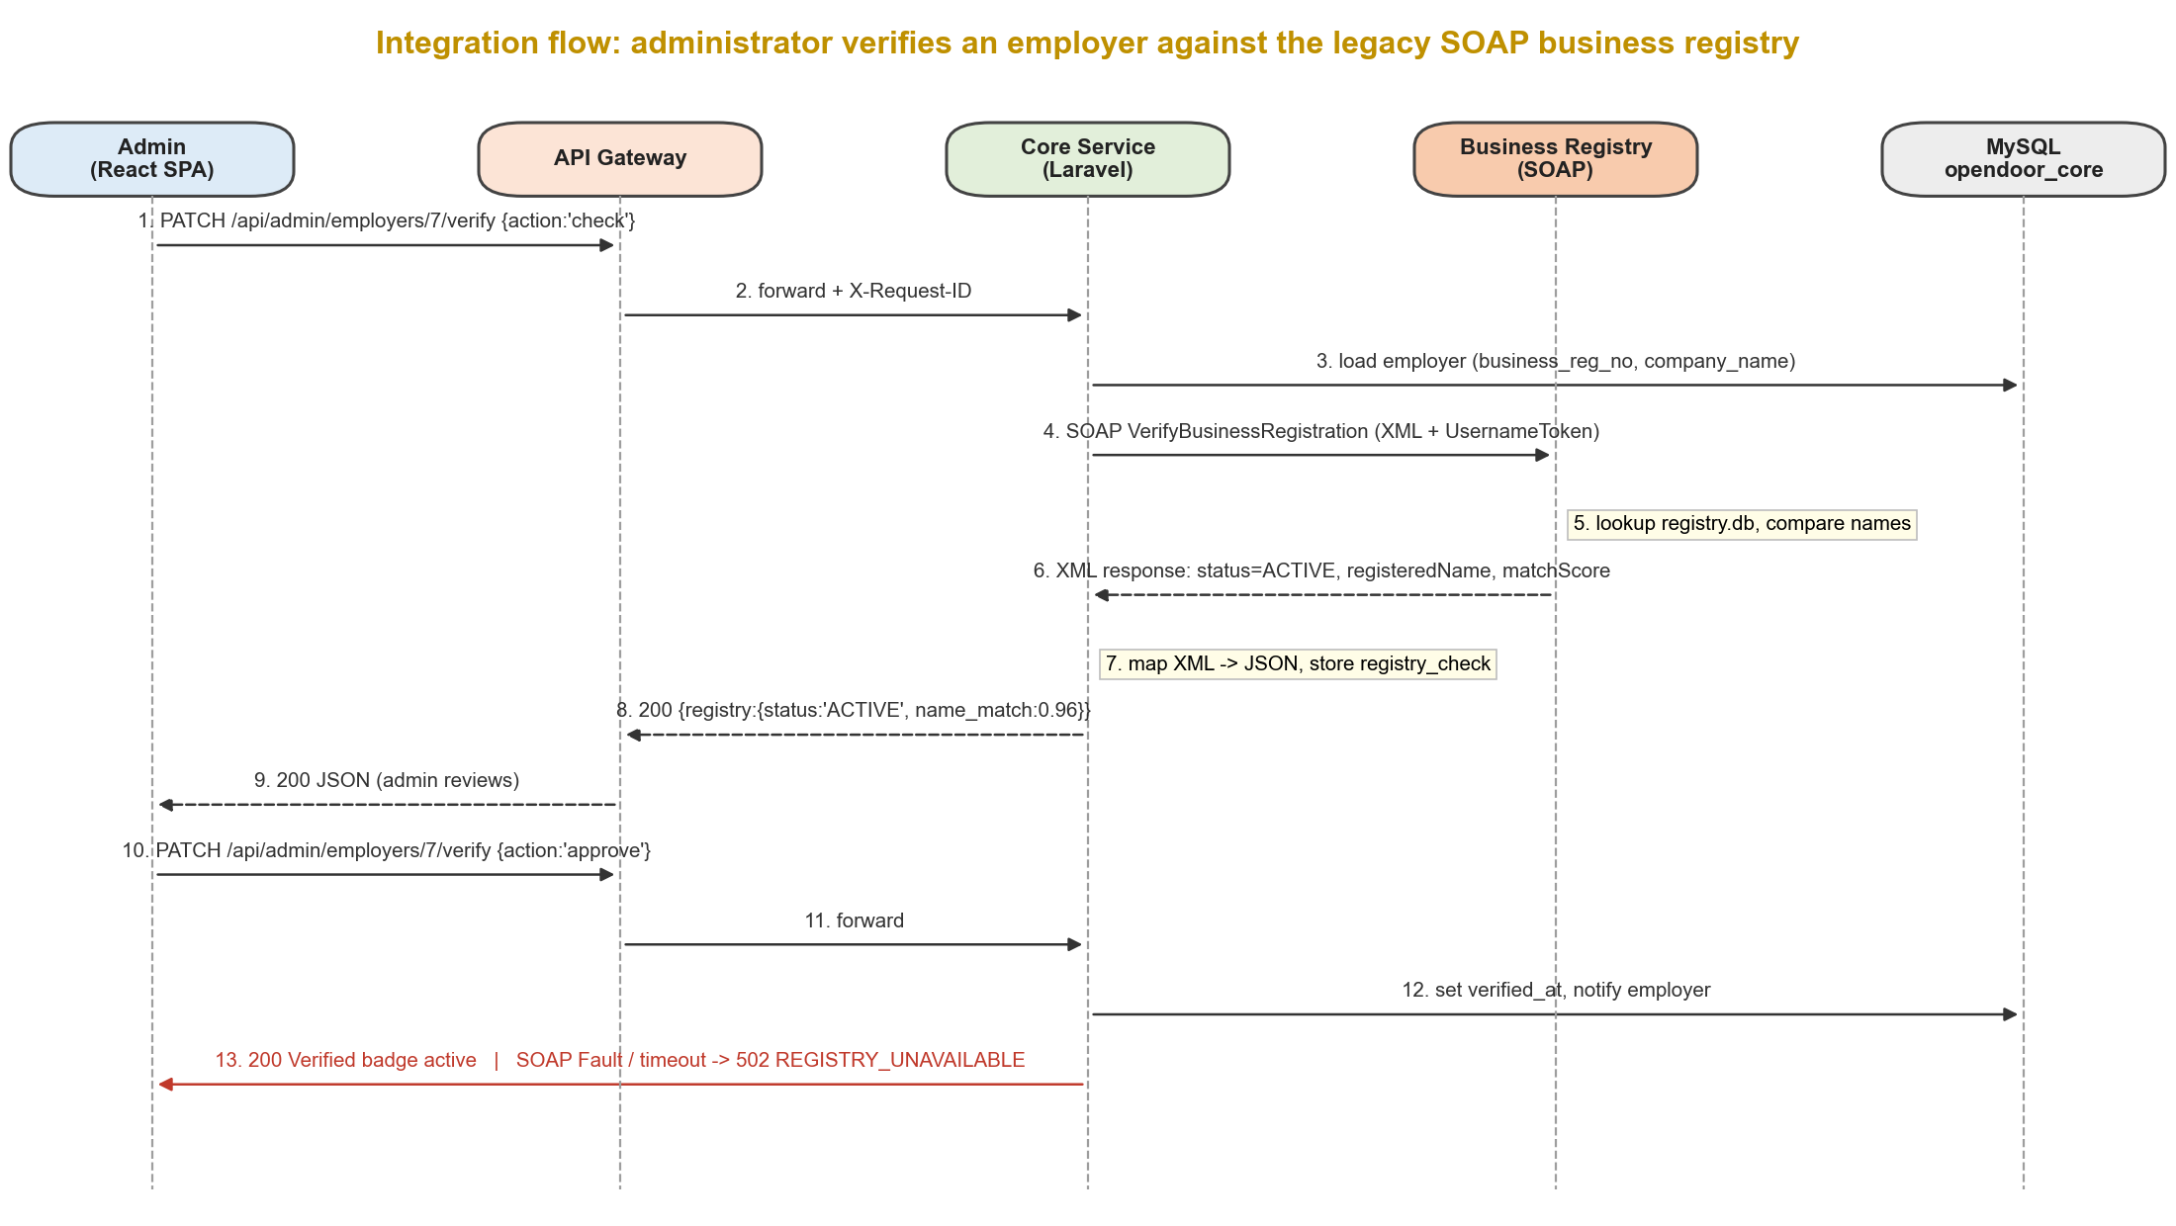
Figure 4. Sequence – an administrator verifies an employer through the legacy SOAP Business Registry

5.2 Service-to-Service Integrations
Source | Destination | Trigger / Endpoint | Data Exchanged | Expected Result
React SPA | API Gateway | Any /api/* call (HTTPS) | JSON body, Bearer token | Request routed with X-Request-ID; uniform error format on failure
API Gateway | Core Service | /api/* (except insights) via http://core-api.railway.internal:8001 | Original request + X-Request-ID, X-Forwarded-For | Core response passed back unchanged; 504 UPSTREAM_TIMEOUT after 10 s
API Gateway | Insights Service | /api/insights/* via http://insights.railway.internal:8002 | Original request + X-Request-ID | Snapshot or location list; 504 after 15 s
Insights Service | Core Service | GET /internal/job-postings/{id}/summary with X-Service-Key | Address, PSGC code, accommodations, trust score | 200 summary; 404 if posting is not open/approved (snapshot not built)
Core Service | Business Registry (legacy) | SOAP VerifyBusinessRegistration on PATCH /api/admin/employers/{id}/verify (action=check) | Registration number, registry type, business name; WS-Security UsernameToken | Registry status and name-match score stored in registry_checks
Insights Service | Nominatim (external) | GET /search?q=&countrycodes=ph&format=jsonv2&limit=1 | Normalized address → lat/lon | Coordinates cached 30 days
Insights Service | Overpass (external) | POST /api/interpreter (Overpass QL, around:500) | Coordinates → OSM elements with wheelchair tag | Nearby accessible places cached 24 h
Insights Service | PSGC API (external) | GET /regions, /regions/{code}/provinces, /provinces/{code}/cities-municipalities | PSGC codes and names | Normalized location lists cached 7 days
Core Service | Core Service (event) | Application status change, feedback saved/hidden (observer) | Application, feedback items | Notification created; employer trust score and feedback count recalculated

5.3 Error Handling and Status Propagation
Every service returns the error envelope shown in Section 4.2. The gateway creates an X-Request-ID (UUID) if the client did not send one, forwards it to every downstream call, and logs it, so one request can be traced through all services. Downstream status codes are propagated unchanged to the client; the gateway only generates its own errors when a dependency cannot be reached.
HTTP | Application Error Code | Raised by | When / Behavior
400 | BAD_REQUEST | Gateway, services | Malformed JSON or query parameters
401 | UNAUTHENTICATED | Core | Missing, invalid or revoked Sanctum token; the client logs the user out
403 | FORBIDDEN / ACCOUNT_SUSPENDED | Core | Wrong role or Policy denies (e.g., editing another employer's posting); suspended account
404 | NOT_FOUND | Core, Insights | Unknown ID, or a posting that is not open and approved
409 | ALREADY_APPLIED / FEEDBACK_EXISTS | Core | Duplicate application or second feedback for the same application
422 | VALIDATION_FAILED | Core | Form Request validation fails; field errors returned in errors
422 | INVALID_STATUS_TRANSITION | Core | Transition not allowed by the ApplicationStatus enum (e.g., Rejected → Hired, Pending → Hired)
422 | POSTING_CLOSED / FEEDBACK_NOT_OPEN | Core | Applying to a closed posting; feedback before 30 days after hire
429 | RATE_LIMITED | Gateway, Core | Over 120 requests/min per IP at the gateway, or over 5 login attempts/min; Retry-After header sent
502 | REGISTRY_UNAVAILABLE / REGISTRY_AUTH_FAILED | Core | SOAP fault or connection failure; employer remains in the manual review queue
502 | UPSTREAM_ERROR | Gateway | Downstream service refused the connection or returned an invalid response
503 | SERVICE_UNAVAILABLE | Gateway | Health check shows the target service down (e.g., sleeping free-tier instance)
504 | UPSTREAM_TIMEOUT | Gateway | Core > 10 s, Insights > 15 s

Graceful degradation. External and legacy integrations never block the core hiring transaction. The Insights Service uses per-source timeouts (Nominatim 5 s, Overpass 8 s, Core 3 s), returns HTTP 200 with whatever parts it could build, and reports each source as ok, cached, stale or unavailable; the client hides empty sections and shows "Nearby accessibility information is temporarily unavailable." If the Insights Service itself is down, the job details page still renders the posting, match result and trust score from the Core Service. If the Business Registry is down, administrators can still verify manually and the check can be retried. Retries are limited to one retry with back-off for idempotent GET calls; POST/PATCH calls are never retried automatically.

6. Security Design

6.1 Authentication
- Users log in with email and password through POST /api/login. Passwords are hashed with bcrypt. The Core Service issues a Laravel Sanctum personal access token, which the React client sends as Authorization: Bearer <token> on each request through the gateway. Logout revokes the token on the server. Suspended accounts cannot log in and their tokens are revoked.
- Administrators are never self-registered; they are created by the seeder or by another administrator.
- Gateway → services: the gateway forwards the bearer token unchanged; the Core Service validates it (the gateway does not trust or decode it).
- Insights → Core (service-to-service): internal endpoints under /internal/* are not routed by the gateway and require an X-Service-Key header whose value is a shared secret held only by the two services; requests without it receive 401.
- Core → Business Registry (legacy): a WS-Security UsernameToken in the SOAP header identifies the Core Service; the registry rejects missing or wrong credentials with a SOAP fault.

6.2 Authorization
Authorization is enforced on the server in three layers: (1) auth:sanctum middleware requires a valid token; (2) a role middleware restricts route groups to candidate, employer or admin; and (3) Laravel Policies (JobPostingPolicy, ApplicationPolicy, CandidateProfilePolicy, FeedbackPolicy) check ownership of the specific record – for example, an employer can update only its own postings and can see a candidate's accommodation needs only through an application to its own posting, and only the hired candidate can submit feedback. API Resources control which fields each role receives (feedback authors are never exposed to employers). The React ProtectedRoute component only improves navigation; the server is the real protection. The full permission matrix is reproduced in Appendix A.
OAuth 2.0 is not used in this version: all users authenticate directly with OpenDoor, and the external APIs used require no delegated access. A delegated-authorization scenario (e.g., "Sign in with Google" or letting a candidate import a résumé from a third-party service) is listed as a future improvement.

6.3 Secret and Credential Management
- All secrets are environment variables: APP_KEY, DB_*, SERVICE_KEY_INSIGHTS, REGISTRY_SOAP_USER/PASSWORD, NOMINATIM_CONTACT_EMAIL, CORS_ALLOWED_ORIGIN, VITE_API_URL.
- Each component has a committed .env.example with placeholder values only; real .env files are listed in .gitignore and are never committed.
- Production values are stored in Railway service variables and Vercel environment variables; CI values in GitHub Actions encrypted secrets. The production APP_KEY is generated fresh and differs from development.
- Demo and test accounts (one per role) are created by seeders with passwords read from environment variables; they are shared with the evaluators through the submission notes, not written in the repository or this document.
- Secrets are never logged: the gateway redacts Authorization and X-Service-Key headers in logs, and APP_DEBUG=false in production.

6.4 Security Considerations
- Input validation: Laravel Form Requests validate every create/update (required fields, Rule::exists for accommodation and category IDs, Rule::enum for statuses, max lengths, PDF-only size-limited résumé uploads); Eloquent parameter binding prevents SQL injection; the SOAP request is validated against the WSDL schema; React escapes output by default.
- Transport/HTTPS: Vercel and Railway public endpoints use HTTPS only; internal calls stay on Railway's private network and are not exposed to the internet.
- Least privilege / access controls: only the gateway is public; each service has its own database user limited to its own schema; role middleware and Policies enforce per-record ownership; CORS allows only the deployed frontend origin.
- Abuse protection: gateway rate limiting (120 requests/min per IP) and login rate limiting (5 attempts/min).
- Data privacy (RA 10173): explicit consent is recorded (consented_at) before accommodation data is stored; disability type is optional, hidden by default and never used for matching; candidates' needs are shown to an employer only after the candidate applies; trust scores are aggregated and shown only after three responses so individual employees cannot be identified.
- Project-specific risks: fake employers (mitigated by registry check and Verified badge), retaliation for negative feedback (anonymity and three-response threshold), false accommodation claims (report-a-posting and moderation), and dependence on third-party APIs (caching, timeouts, degraded mode).

7. Testing and Quality Assurance

7.1 Functional and Integration Test Plan
Test ID | Scenario | Type | Expected Result | Actual Result | Status
T01 | Register candidate with consent, then log in | Functional | 201 then 200 with token and role=candidate | [Actual] | [PASS/FAIL]
T02 | Employer creates a posting with 3 accommodations and notes | Functional | 201; posting status=pending_approval, 3 accommodations stored | [Actual] | [PASS/FAIL]
T03 | Candidate with 5 needs searches with match=1 | Functional | 200; postings ordered by match.met desc; missing lists unmet needs | [Actual] | [PASS/FAIL]
T04 | Candidate applies to an open posting | Functional | 201 status=pending; employer receives notification | [Actual] | [PASS/FAIL]
T05 | Candidate applies to the same posting twice | Negative | 409 ALREADY_APPLIED | [Actual] | [PASS/FAIL]
T06 | Employer changes pending directly to hired | Negative | 422 INVALID_STATUS_TRANSITION | [Actual] | [PASS/FAIL]
T07 | GET /api/job-postings/999999 (invalid ID) | Negative | 404 NOT_FOUND with request_id | [Actual] | [PASS/FAIL]
T08 | Employer A updates Employer B's posting | Negative (security) | 403 FORBIDDEN | [Actual] | [PASS/FAIL]
T09 | Request without token to /api/applications | Negative (security) | 401 UNAUTHENTICATED | [Actual] | [PASS/FAIL]
T10 | Hired candidate submits feedback after 30 days; 3rd response for employer | Functional | 201; trust score published with based_on=3 and correct value | [Actual] | [PASS/FAIL]
T11 | Feedback before 30 days after hire | Negative | 422 FEEDBACK_NOT_OPEN | [Actual] | [PASS/FAIL]
T12 | Get Accessibility Snapshot (Gateway → Insights → Core → Nominatim/Overpass/PSGC) | Integration | 200; location.lat/lon present; sources.core=ok | [Actual] | [PASS/FAIL]
T13 | Snapshot with Overpass unreachable (invalid URL in test env) | Integration (degradation) | 200; sources.overpass=unavailable; other sections present | [Actual] | [PASS/FAIL]
T14 | Admin registry check for a seeded ACTIVE SEC number | Integration (SOAP) | 200; registry.status=ACTIVE; name_match ≥ 0.80; check stored | [Actual] | [PASS/FAIL]
T15 | Registry check with an unknown number / wrong SOAP password | Integration (negative) | 200 status=NOT_FOUND / 502 REGISTRY_AUTH_FAILED | [Actual] | [PASS/FAIL]
T16 | Insights calls /internal/... without X-Service-Key | Integration (security) | 401 | [Actual] | [PASS/FAIL]

7.2 Postman / API Test Evidence
The repository contains tests/postman/OpenDoor.postman_collection.json and environments local.postman_environment.json and production.postman_environment.json (variables: baseUrl, candidateEmail, employerEmail, adminEmail, passwords from secrets). The collection is organized in folders that run in order: 01 Auth, 02 Master Data, 03 Employer & Postings, 04 Candidate & Matching, 05 Applications & Status, 06 Feedback & Trust Score, 07 Insights Mashup, 08 Admin & SOAP Registry, 09 Negative & Security Cases. Login requests save tokens to collection variables; create requests save IDs (jobPostingId, applicationId) for later requests.
Assertions written in each request's Tests tab check:
- Status codes – e.g., pm.response.to.have.status(201) for create, 409/422/403/401/404 for negative cases.
- Identifiers – returned id is a number and equals the saved applicationId; job_posting_id matches the request.
- Business values – status equals pending after apply; match.met <= match.total; results sorted by match.met descending; trust_score.published is false with fewer than three responses and true with based_on >= 3.
- Application errors – error.code equals the expected code (ALREADY_APPLIED, INVALID_STATUS_TRANSITION, …) and error.request_id exists.
- Schema and timing – key responses validated against JSON schemas with pm.response.to.have.jsonSchema; response time under 1,000 ms for non-mashup endpoints.
The collection runs headless in CI with newman run tests/postman/OpenDoor.postman_collection.json -e <env> --reporters cli,htmlextra. [Insert the Newman summary: total requests, assertions, failures, and a screenshot of the HTML report.]

7.3 Load / Stress Testing
Item | Details
Target component | API Gateway → Core Service: GET /api/job-postings?match=1&page=1 (candidate token; matching query with withCount), plus GET /api/job-postings/{id} as a secondary sampler
Tool | Apache JMeter 5.6 (test plan tests/jmeter/opendoor-matching.jmx), run in CLI mode: jmeter -n -t opendoor-matching.jmx -l results.jtl -e -o report/
Workload | Thread Group: 50 users, ramp-up 60 s, 10 loops each (500 search requests + 500 detail requests); CSV Data Set with 50 seeded candidate tokens; database seeded with 500 postings and 20 accommodation types. A stress step repeats with 100 and 200 users.
Metrics | Average and median response time, 95th percentile (P95), throughput (requests/s), error rate (%); targets: P95 < 1,500 ms and error rate < 1% at 50 users
Observed result | [Record average, P95, throughput and error rate for 50 / 100 / 200 users from the JMeter HTML dashboard.]
Interpretation | [Explain whether targets were met, where the limit is (e.g., the user count at which P95 or errors rise), and limitations: hobby-tier instances, shared MySQL, test run from one client machine, results not representative of production scale.]

7.4 Defects and Corrections
[Record the real integration defects found during development and testing. Use the table below; examples of the kind of defects to watch for are listed so the team can recognize them, but only defects that actually occurred should be submitted.]
ID | Defect | Cause | Correction | Verified by
D01 | [Defect] | [Cause] | [Correction] | [Test ID]
D02 | [Defect] | [Cause] | [Correction] | [Test ID]
D03 | [Defect] | [Cause] | [Correction] | [Test ID]

Typical integration defects to check for: CORS preflight blocked between Vercel and the gateway; gateway stripping the Authorization header; Nominatim requests rejected without a User-Agent; SOAP namespace mismatch between WSDL and SoapClient; time-zone differences in the 30-day feedback rule; trust score not recalculated when feedback is hidden.

8. Deployment and DevOps

8.1 Deployment Architecture
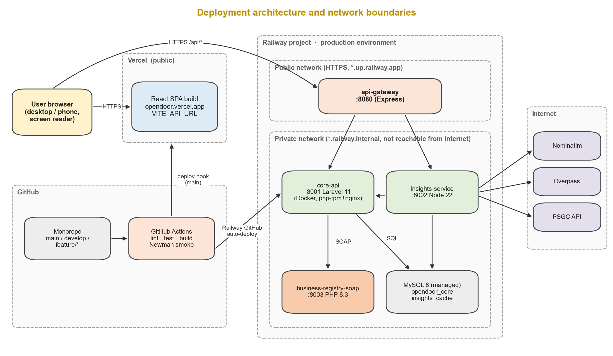
Figure 5. Deployment architecture: Vercel and Railway, public and private network boundaries, CI/CD path

8.2 Cloud Deployment
Component | Provider / Platform | URL / Host | Configuration
React SPA | Vercel (Hobby) | [https://opendoor.vercel.app] | Root frontend/; build npm run build; output dist/; VITE_API_URL = gateway URL; SPA rewrite to index.html
API Gateway | Railway service (Nixpacks/Node 22) | [https://opendoor-gateway.up.railway.app] (public domain) | CORE_URL, INSIGHTS_URL (internal hostnames), CORS_ALLOWED_ORIGIN, rate-limit settings; health check /api/health
Core Service | Railway service (Dockerfile: php-fpm + nginx) | core-api.railway.internal:8001 (no public domain) | APP_ENV=production, APP_DEBUG=false, DB_*, REGISTRY_WSDL_URL, SERVICE_KEY_INSIGHTS; release command php artisan migrate --force
Insights Service | Railway service (Node 22) | insights.railway.internal:8002 (no public domain) | CORE_INTERNAL_URL, SERVICE_KEY_INSIGHTS, NOMINATIM_CONTACT_EMAIL, CACHE_DB_*, timeouts
Business Registry (SOAP) | Railway service (Dockerfile: PHP 8.3 + SoapServer) | registry.railway.internal:8003 (no public domain) | REGISTRY_SOAP_USER/PASSWORD; SQLite file seeded at build
MySQL 8 | Railway managed database | mysql.railway.internal:3306 | Schemas opendoor_core and insights_cache with separate users; daily backups (Railway)

Limitations. The Railway Hobby plan (about US$5/month after the trial credit) and Vercel Hobby are not sized for production load; services may cold-start, so the team opens the application a few minutes before the demonstration. Demo accounts for every role and enough feedback to show a published trust score are seeded. Both URLs are documented in the README and submitted before the defense.

8.3 Git and Repository Workflow
OpenDoor uses one GitHub monorepo so that contracts, services and tests change together:
opendoor/
├─ frontend/ React SPA (Vite)
├─ gateway/ Node.js Express API Gateway
├─ services/
│ ├─ core-api/ Laravel 11 Core Service
│ ├─ insights-service/ Node.js mashup service
│ └─ business-registry-soap/ PHP SoapServer + WSDL + seed data
├─ tests/
│ ├─ postman/ collection + environments
│ └─ jmeter/ .jmx test plans + CSV data
├─ docs/ architecture diagrams, API reference, this document
├─ .github/workflows/ci.yml CI/CD pipeline
└─ README.md setup, URLs, demo accounts (no secrets)

- Branches: main (deployed, protected), develop (integration), and short-lived feature/<module>-<desc> branches (e.g., feature/M5-matching, feature/soap-registry), plus fix/<desc>.
- Commits: Conventional Commits (feat(core): add match ranking, fix(gateway): forward Authorization header, test(postman): add T06).
- Pull requests: every change goes through a PR into develop with at least one reviewer and a green CI run; develop is merged into main for releases, tagged v1.0, v1.1, ….
- Issues: GitHub Issues/Projects board with one issue per module feature (F1.1 … F13.5) and per integration task, linked to PRs.

8.4 CI/CD Workflow
GitHub Actions workflow .github/workflows/ci.yml:
Stage | Trigger | Steps
Validate & test | Pull request to develop or main; push to develop | Path-filtered jobs run in parallel: frontend – npm ci, ESLint, npm run build, axe accessibility check on the built pages; gateway and insights-service – npm ci, lint, unit tests (Jest, with external APIs mocked); core-api – composer install, Laravel Pint, php artisan test against a MySQL service container (policies, status transitions, trust score); business-registry-soap – php -l, WSDL validated with xmllint, SOAP smoke test.
Integration test | Same as above, after the jobs pass | docker compose up of gateway, core, insights (external APIs replaced by a mock server), registry and MySQL; seed data; run Newman with the ci environment; upload the HTML report as an artifact.
Deploy | Push/merge to main | Vercel and Railway GitHub integrations build and deploy the changed components automatically; Laravel migrations run as the Railway release command.
Post-deploy smoke test | After deploy on main | Newman runs the smoke folder (health, login, search, snapshot) against the production gateway; failure marks the run red and the team rolls back with Railway/Vercel "redeploy previous".

8.5 Environment and Startup Instructions
Full instructions are in the repository README. Summary for local development (no real secret values shown):
# 1. Clone and copy environment files
git clone <repository-url> opendoor && cd opendoor
cp services/core-api/.env.example services/core-api/.env # repeat for each component

# 2. Start everything with Docker (MySQL, core, insights, registry, gateway)
docker compose up -d --build
docker compose exec core-api php artisan key:generate
docker compose exec core-api php artisan migrate --seed

# 3. Start the React client
cd frontend && npm ci && npm run dev # http://localhost:5173 (VITE_API_URL=http://localhost:8080/api)

# 4. Run tests
docker compose exec core-api php artisan test
npx newman run tests/postman/OpenDoor.postman_collection.json -e tests/postman/local.postman_environment.json

9. Application Screens and Demonstration

9.1 Key Application Screens
[Insert the screenshots from the existing UI into the boxes below. Keep or remove screens to match the final build; each caption already states the related business function.]
[Insert screenshot: Public – Browse jobs (/jobs)]

Screen: Public – Browse jobs (/jobs)
Guests search by keyword and filter by category and accommodation; job cards show accommodation icons and the employer's Verified badge (M5).
[Insert screenshot: Candidate – Profile and accommodation needs (/candidate/profile)]

Screen: Candidate – Profile and accommodation needs (/candidate/profile)
The candidate records accommodation needs once from the shared, grouped list; disability type is optional and private (M2).
[Insert screenshot: Candidate – Find jobs in "Matches my needs" mode (/candidate/jobs)]

Screen: Candidate – Find jobs in "Matches my needs" mode (/candidate/jobs)
Postings ranked by needs met, with "Meets 4 of 5 of your needs" and the missing accommodation named – the output of the matching integration (M5).
[Insert screenshot: Candidate – Job details with Accessibility Snapshot (/candidate/jobs/:id)]

Screen: Candidate – Job details with Accessibility Snapshot (/candidate/jobs/:id)
One page combines the posting, trust score and nearby accessible places from the Insights mashup (Core + Nominatim + Overpass + PSGC); Apply with interview accommodation request (M4, M6, M7).
[Insert screenshot: Candidate – My applications and feedback form]

Screen: Candidate – My applications and feedback form
Status tracking, withdraw or confirm hire, and per-accommodation post-hire rating (M6, M7).
[Insert screenshot: Employer – Create/edit posting (/employer/jobs/new)]

Screen: Employer – Create/edit posting (/employer/jobs/new)
Structured accommodations with notes, interview format, PSGC location picker (M4).
[Insert screenshot: Employer – Applicants and trust score]

Screen: Employer – Applicants and trust score
Review applicants, mark Hired/Rejected; see the aggregated trust score and per-accommodation breakdown (M6, M7).
[Insert screenshot: Admin – Employer verification with registry check (/admin/employers)]

Screen: Admin – Employer verification with registry check (/admin/employers)
Result of the SOAP Business Registry check shown beside the employer's submitted details before approval (M3, M10).
[Insert screenshot: Admin – Dashboard and analytics (/admin/dashboard)]

Screen: Admin – Dashboard and analytics (/admin/dashboard)
Users by role, pending queues, applications and hires per month, most-needed accommodations (M8).

9.2 End-to-End Demonstration Scenario
- User action in client application: the demo candidate (needs: wheelchair-accessible entrance, accessible restroom, flexible hours, screen-reader-compatible tools, sign language interpreter) logs in, opens Find jobs and clicks the top-ranked "Data Encoder" posting showing "Meets 4 of 5 of your needs".
- Gateway/integration request: the SPA sends GET /api/job-postings/42?match=1 and GET /api/insights/job-postings/42 to the API Gateway, which adds an X-Request-ID and routes them to the Core and Insights services.
- Service-to-service interaction: the Core Service authenticates the token, computes the match and returns the trust score; the Insights Service calls the Core Service's internal summary endpoint with its service key.
- External/legacy API interaction: the Insights Service resolves the PSGC code, geocodes the address with Nominatim and queries Overpass for wheelchair-tagged places within 500 m. (Separately, the admin demo shows the Core Service calling the SOAP Business Registry to verify the posting's employer.)
- Transformation/mashup: OSM tags are mapped to accessible transit, toilets and parking with distances, and merged with the employer's advertised accommodations and the community trust score into the Workplace Accessibility Snapshot.
- Final result shown to user: the job details page shows the match badge, the unmet accommodation, the Verified badge, "86% – based on 5 hires", and the nearest accessible MRT stop; the candidate applies with an interview accommodation request and sees the application as Pending, while the employer receives a notification.

10. Evaluation of the Final Solution

10.1 Achievement of Objectives
Objective | Success Measure | Result / Evidence
1 – Integrated application | All Must-have modules work end to end through the gateway; T01–T11 pass | [Achieved / Partly achieved – evidence]
2 – Service, external and legacy integration | Snapshot built from 4 sources; SOAP registry check stored; degradation works (T12–T16) | [Evidence]
3 – Security | Security tests T08, T09, T16 pass; no secrets in repository (secret scan) | [Evidence]
4 – Quality assurance | Newman run with 0 failed assertions; JMeter P95 < 1,500 ms and error rate < 1% at 50 users | [Evidence]
5 – Cloud deployment and DevOps | Public URLs working; CI green on main; automatic deploy and smoke test | [Evidence]
6 – Accessibility and usability | No critical axe/Lighthouse issues; NVDA walkthrough; mean SUS ≥ 68 (n ≥ 5 PWD, 3 employers) | [Evidence]

10.2 Technical Limitations
- Simulated legacy integration: the Business Registry is a SOAP simulation with seeded data, not the real DTI/SEC systems; real integration would require an agreement with those agencies.
- Open data coverage: accessibility data near workplaces depends on OpenStreetMap tagging, which is incomplete in many Philippine areas; absence of data does not mean a place is inaccessible.
- Provider restrictions: public Nominatim and Overpass instances are rate-limited and intended for light use; heavier use would need self-hosted instances or a commercial provider.
- Scale: hobby-tier hosting, a single MySQL instance shared by two schemas, and synchronous calls limit throughput; no message queue or horizontal scaling is used.
- Security scope: no multi-factor authentication or OAuth 2.0; service keys are static shared secrets rather than mutual TLS or signed tokens.
- Trust score validity: the score depends on honest self-reported feedback and needs enough hires per employer to be meaningful.
- [Add any feature that was not completed or was simplified in the final build.]

10.3 Recommended Improvements
- Asynchronous events (message queue): publish application.status_changed and feedback.saved events (e.g., RabbitMQ or Redis Streams) so notifications, email and trust-score recalculation run outside the request – improves response time and resilience.
- OAuth 2.0 / OpenID Connect sign-in (e.g., Google) and optional multi-factor authentication – easier and safer login for users who rely on assistive technology to type passwords.
- Official data partnerships: integrate with PhilJobNet/PESO or DTI/SEC if APIs become available, replacing the simulated registry and avoiding duplicate registration.
- Signed service tokens or mutual TLS between services instead of static keys.
- Observability: centralized logs and tracing (OpenTelemetry) keyed by X-Request-ID, and uptime alerts.
- Contributing back to OpenStreetMap: let hired PWDs suggest accessibility tags for their workplace area to improve the open data that the mashup relies on.

10.4 Lessons Learned
[Summarize the team's actual lessons. Suggested prompts: architectural – where service boundaries helped or added overhead; integration – handling external rate limits, SOAP namespaces and XML-to-JSON mapping; testing – value of Postman assertions in CI and what JMeter revealed; teamwork – how API contracts written first let frontend and backend work in parallel; deployment – private networking, environment variables and cold starts.]

11. Team Contribution
Member | Primary Responsibilities | Key Deliverables / Commits | Approx. Contribution
[Name] | Project lead; API Gateway; service contracts; CI/CD | [gateway/, .github/workflows/ci.yml, PR links] | [%]
[Name] | Core Service (Laravel), database schema, matching, trust score | [services/core-api/, PR links] | [%]
[Name] | Accessibility Insights mashup; SOAP Business Registry | [services/insights-service/, services/business-registry-soap/] | [%]
[Name] | React SPA, accessibility (WCAG 2.1 AA) | [frontend/, PR links] | [%]
[Name] | Postman/Newman, JMeter, deployment, documentation | [tests/, docs/, deployment notes] | [%]

[Add a short statement explaining how the team verified contributions (e.g., GitHub commit and PR history, issue assignments, weekly stand-up notes) and how overlapping responsibilities (e.g., shared API contracts between frontend and Core Service) were resolved.]

12. References
Access Careers. (n.d.). Access Careers. Retrieved September 28, 2026, from http://careers.axlearning.org/
Apache Software Foundation. (n.d.). Apache JMeter user's manual. https://jmeter.apache.org/usermanual/
Department of Labor and Employment. (n.d.). PhilJobNet and PESO Employment Information System. Retrieved September 28, 2026, from https://philjobnet.gov.ph/
Express.js. (n.d.). Express 4.x API reference. https://expressjs.com/
GitHub. (n.d.). GitHub Actions documentation. https://docs.github.com/actions
Laravel. (n.d.). Laravel 11.x documentation: Sanctum, Authorization, Validation. https://laravel.com/docs/11.x
National Privacy Commission. (2016). Implementing rules and regulations of Republic Act No. 10173, known as the Data Privacy Act of 2012. https://privacy.gov.ph/implementing-rules-regulations-data-privacy-act-2012/
OASIS. (2006). Web Services Security UsernameToken Profile 1.1. https://docs.oasis-open.org/wss/v1.1/
OpenStreetMap Foundation. (n.d.). Nominatim usage policy. https://operations.osmfoundation.org/policies/nominatim/
OpenStreetMap Wiki. (n.d.). Overpass API; Key:wheelchair. https://wiki.openstreetmap.org/wiki/Overpass_API
PHP Group. (n.d.). SOAP extension (SoapServer, SoapClient). https://www.php.net/manual/en/book.soap.php
Postman. (n.d.). Writing tests and running collections with Newman. https://learning.postman.com/docs/
PSGC API. (n.d.). Philippine Standard Geographic Code API. https://psgc.gitlab.io/api/
PWD-E. (n.d.). PWD-E: Future begins today. Retrieved September 28, 2026, from https://pwd-e.com/home/
Railway. (n.d.). Private networking. https://docs.railway.com/
Rappler. (2023). Still a long road ahead: PWDs struggle to join Philippine workforce. https://www.rappler.com/newsbreak/in-depth/persons-with-disability-struggle-philippine-workforce/
Republic Act No. 7277. (1992). Magna Carta for Disabled Persons. Official Gazette of the Republic of the Philippines.
Republic Act No. 10173. (2012). Data Privacy Act of 2012. Official Gazette of the Republic of the Philippines.
Republic Act No. 10524. (2013). An Act expanding the positions reserved for persons with disability, amending Republic Act No. 7277. Official Gazette of the Republic of the Philippines.
Respicio & Co. (n.d.). PWD right to reasonable accommodation in the workplace (Philippines). https://www.lawyer-philippines.com/
SDDirect. (2023). Disability inclusion in the Philippines (Disability Inclusion Helpdesk Report No. 61). https://sddirect.org.uk/
United Nations. (n.d.). Goal 8: Promote sustained, inclusive and sustainable economic growth, full and productive employment and decent work for all. https://sdgs.un.org/goals/goal8
Vercel. (n.d.). Vite on Vercel. https://vercel.com/docs
W3C. (2007). SOAP Version 1.2 and Web Services Description Language (WSDL) 1.1 notes. https://www.w3.org/TR/wsdl
W3C. (2018). Web Content Accessibility Guidelines (WCAG) 2.1. https://www.w3.org/TR/WCAG21/

Appendices

Appendix A - API endpoint reference / OpenAPI or equivalent
Base URL: {GATEWAY}/api. Access: P = public, C = candidate, E = employer, A = administrator, S = internal service key. [Attach or link the generated OpenAPI file, e.g., docs/openapi.yaml.]
Module | Method | Endpoint | Access | Purpose
M1 Auth | POST | /register, /login, /logout | P / any | Account, token, logout
M1 Auth | GET, PUT | /me, /me/password | any | Current user; change password
M2 Profile | GET, PUT | /candidate/profile | C | Own profile
M2 Profile | PUT | /candidate/accommodations | C | Replace needs
M2 Profile | POST | /candidate/resume | C | Upload PDF résumé
M3 Company | GET, PUT | /employer/company | E | Own company profile
M3 Company | GET | /employers/{id} | P | Public employer page
M3 Company | PATCH | /admin/employers/{id}/verify | A | check (SOAP) / approve / reject
M4 Postings | GET | /employer/job-postings | E | Own postings
M4 Postings | POST | /job-postings | E | Create
M4 Postings | PUT, DELETE | /job-postings/{id} | E (owner) | Update / soft-delete
M4 Postings | PATCH | /job-postings/{id}/status | E (owner) | Close / reopen
M4 Postings | PATCH | /admin/job-postings/{id}/approve | A | Approve / reject
M5 Search | GET | /job-postings?q=&category=&accommodations[]=&match=1&sort=&page= | P (match: C) | Search, filter, match
M5 Search | GET | /job-postings/{id} | P | Details (+ match for C)
M5/M11 | GET | /categories, /accommodations | P | Filter options
M6 Applications | POST | /job-postings/{id}/applications | C | Apply
M6 Applications | GET | /applications, /applications/{id} | C (own) / E (own postings) | List / details
M6 Applications | PATCH | /applications/{id}/status | C / E | Status transition
M7 Feedback | GET | /applications/{id}/feedback-form | C (hired) | Items to rate
M7 Feedback | POST | /applications/{id}/feedback | C (hired, 30 days) | Submit
M7 Feedback | GET | /employers/{id}/trust-score | P | Score and breakdown
M8 Dashboards | GET | /candidate/dashboard, /employer/dashboard, /admin/dashboard | C / E / A | Summaries
M9 Notifications | GET, PATCH | /notifications, /notifications/{id}/read, /notifications/read-all | C / E | List, mark read
M10 Moderation | GET, PATCH | /admin/users, /admin/users/{id}/suspend | A | Users
M10 Moderation | POST | /job-postings/{id}/reports | C | Report posting
M10 Moderation | GET, PATCH | /admin/reports, /admin/reports/{id} | A | Review reports
M10 Moderation | PATCH | /admin/feedback/{id}/hide | A | Hide feedback
M11 Master data | POST, PUT, DELETE | /admin/categories/{id}, /admin/accommodations/{id} | A | Manage lists
M12 Saved jobs | GET, POST, DELETE | /candidate/saved-jobs, /candidate/saved-jobs/{jobId} | C | Bookmarks
Insights | GET | /insights/job-postings/{id} | P | Accessibility Snapshot
Insights | GET | /insights/locations/{regions|provinces|cities}?parent= | P | PSGC lists
Internal | GET | /internal/job-postings/{id}/summary (Core, not public) | S | Data for mashup
Gateway | GET | /health | P | Health of gateway and services

Role permission summary (C = create, R = read, U = update, D = delete; enforced by Laravel Policies):
Data | Guest | Candidate | Employer | Admin
User account | C (register) | R, U own | R, U own | C admins, R all, U (suspend)
Candidate profile and needs | – | C, R, U own | R (own applicants only) | R
Company profile | R (public) | R (public) | C, R, U own | R, U (verify)
Job posting | R (open) | R (open) | C, R, U, D own | R all, U (approve), D
Application | – | C, R own, U (withdraw, confirm hire) | R, U status (own postings) | R
Accommodation feedback | – | C, R own (once, after hire) | – (score only) | R, U (hide)
Trust score | R (3+ responses) | R (3+ responses) | R own | R all
Categories and accommodation types | R | R | R | C, R, U, D

Appendix B - Representative JSON/XML/SOAP samples
JSON samples: Sections 4.2 and 4.5. SOAP request, response and fault: Section 4.3. Additional samples:
WSDL – message, portType, binding and service elements (completes the excerpt in Section 4.3):
<message name="VerifyBusinessRegistrationInput">
<part name="parameters" element="tns:VerifyBusinessRegistrationRequest"/>
</message>
<message name="VerifyBusinessRegistrationOutput">
<part name="parameters" element="tns:VerifyBusinessRegistrationResponse"/>
</message>
<portType name="BusinessRegistryPortType">
<operation name="VerifyBusinessRegistration">
<input message="tns:VerifyBusinessRegistrationInput"/>
<output message="tns:VerifyBusinessRegistrationOutput"/>
</operation>
</portType>
<binding name="BusinessRegistryBinding" type="tns:BusinessRegistryPortType">
<soap:binding style="document" transport="http://schemas.xmlsoap.org/soap/http"/>
<operation name="VerifyBusinessRegistration">
<soap:operation soapAction="urn:opendoor:registry:v1#VerifyBusinessRegistration"/>
<input><soap:body use="literal"/></input>
<output><soap:body use="literal"/></output>
</operation>
</binding>
<service name="BusinessRegistryService">
<port name="BusinessRegistryPort" binding="tns:BusinessRegistryBinding">
<soap:address location="http://registry.railway.internal:8003/soap"/>
</port>
</service>

Overpass QL query sent by the Insights Service (coordinates from Nominatim):
[out:json][timeout:8];
(
node(around:500,14.6507,121.0494)["wheelchair"~"yes|limited"];
way(around:500,14.6507,121.0494)["wheelchair"~"yes|limited"];
);
out center tags 50;

Internal summary returned by the Core Service to the Insights Service:
GET /internal/job-postings/42/summary X-Service-Key: ${SERVICE_KEY_INSIGHTS}
200 { "id": 42, "address": "123 Quezon Ave., Brgy. Paligsahan", "psgc_code": "137404000",
"accommodations": [ { "id": 1, "name": "Wheelchair-accessible entrance", "group": "physical_access" } ],
"trust_score": { "published": true, "score": 86, "based_on": 5,
"breakdown": [ { "accommodation_id": 1, "delivered": 5, "of": 5 } ] } }

Appendix C - Postman collection and environment reference
Item | Reference
Collection | tests/postman/OpenDoor.postman_collection.json – folders 01 Auth … 09 Negative & Security Cases (Section 7.2)
Environments | local, ci, production – variables baseUrl, role emails; passwords supplied from secrets / Newman --env-var
Chained variables | candidateToken, employerToken, adminToken, jobPostingId, applicationId, employerId
CI command | newman run ... -e tests/postman/ci.postman_environment.json --reporters cli,htmlextra --reporter-htmlextra-export newman-report.html
Evidence | [Insert screenshot of the Postman runner / Newman HTML report and the assertion totals.]

Appendix D - JMeter/load-test configuration and results
Element | Configuration
Test plan | tests/jmeter/opendoor-matching.jmx
User Defined Variables | host = gateway host, protocol = https, pageSize = 12
CSV Data Set Config | tokens.csv – 50 seeded candidate tokens (generated by a seeder in a test environment, never production users)
Thread Groups | Load: 50 threads, 60 s ramp-up, 10 loops · Stress: 100 and 200 threads, 60 s ramp-up, 5 loops
Samplers | HTTP Request GET /api/job-postings?match=1&page=${__Random(1,10)}; HTTP Request GET /api/job-postings/${postingId}
Header Manager | Authorization: Bearer ${token}, Accept: application/json
Assertions | Response Assertion: code 200; JSON Assertion: $.meta.match_mode == true; Duration Assertion: 3,000 ms
Listeners | Summary Report, Aggregate Report; HTML dashboard generated with -e -o report/
Results | [Insert the Aggregate Report table and the response-time-over-time chart for each run.]

Appendix E - Repository structure / deployment notes
Repository structure: Section 8.3. Additional deployment notes:
- docker-compose.yml defines mysql, core-api, insights-service, business-registry-soap, gateway and a mock-external server for CI so tests never depend on public Nominatim/Overpass.
- Railway: one project, five services plus MySQL; only gateway has a public domain; services reference each other with ${{service.RAILWAY_PRIVATE_DOMAIN}} variables.
- Laravel production: php artisan config:cache route:cache, migrate --force on release, queue driver sync (no worker needed in v1.0).
- Seeders: categories (about 10 industries), RA 7277-based accommodation types, one administrator, demo candidate/employer accounts, sample feedback that publishes a trust score, and sample DTI/SEC records in registry.db.
- Before the defense: open the frontend and call /api/health a few minutes early to wake sleeping services.

Appendix F - Additional screenshots or diagrams
Core Service data model (MySQL opendoor_core). Accommodations are stored once in a lookup table and linked to postings, candidate needs and feedback through pivot tables, so the same vocabulary drives filtering, matching and per-accommodation ratings.
Table | Key Fields | Notes
users | id, name, email, password, role, is_active, consented_at, timestamps | Shared auth table (Sanctum); unique email; suspension; consent
candidate_profiles | id, user_id, headline, skills, experience, location_psgc, disability_type (nullable), show_disability, resume_path | 1:1 with candidate users; disability type optional and hidden
employers | id, user_id, company_name, business_reg_no, registry_type, industry, address, location_psgc, verified_at, trust_score, feedback_count | Trust score null until 3 responses
registry_checks | id, employer_id, status, registered_name, name_match_score, checked_at, raw_response (XML) | Result of SOAP verification calls
categories / accommodations | id, name / id, name, group, description, is_retired | Admin-managed lists
job_postings | id, employer_id, category_id, title, description, address, location_psgc, employment_type, work_setup, interview_format, status, closes_at, is_approved, deleted_at | Soft deletes; full-text index on title and description
job_posting_accommodation | job_posting_id, accommodation_id, note | Pivot: accommodations provided
candidate_accommodation | candidate_profile_id, accommodation_id | Pivot: accommodations needed
applications | id, job_posting_id, candidate_profile_id, status, cover_note, interview_request, hired_at, hire_confirmed_by | Unique (job_posting_id, candidate_profile_id)
feedback / feedback_items | id, application_id, comments, is_hidden / id, feedback_id, accommodation_id, rating | One feedback per application; one rating per advertised accommodation
notifications, reports, saved_jobs | Laravel notifications; id, reporter_id, job_posting_id, reason, status; candidate_profile_id, job_posting_id | In-app notices; moderation; bookmarks

[Insert the ERD image and any additional screenshots here.]

