Project Documentation: Intelligent Anomaly Detection and PLC Framework for Smart Grid Monitoring

1. Introduction
This project presents a comprehensive, end-to-end simulation of a smart power distribution network. The system architecture integrates a physical electrical grid, a Power Line Communication (PLC) digital transmission pipeline, and a machine learning decision engine. The primary goal is to autonomously monitor real-time electrical parameters, securely transmit this data across a noisy channel, and instantly classify grid failures using a trained ensemble algorithm.

Modular Architecture
Objective 1 focuses on building the physical simulation of the power distribution grid and establishing the measurement framework. The modular architecture for this objective is broken down into three distinct hardware simulation layers:
Module A: Generation and Transmission Layer
- Power Source: A 230V RMS (325V Peak) alternating current source simulating the grid's power origin.
- Transmission Line Impedance: A series combination of a resistor (approx. 99 ohms) and an inductor. This module realistically simulates the power loss and current-limiting bottlenecks inherent in miles of physical copper cabling.
Module B: Load and Anomaly Generation Layer
- Standard Operation Subsystem: A parallel 100-ohm resistor and 1e-3 Farad capacitor representing the healthy, baseline power consumption of the grid.
- Fault Trigger Mechanism: A mathematically controlled Step block connected to a logical Switch.
- Short-Circuit Path: A 1-ohm bypass resistor that, when the switch closes, intentionally simulates a severe physical grid failure.
Module C: Real-Time Sensing and Extraction Layer
- Measurement Nodes: A Voltage Sensor wired in parallel to measure line voltage drops, and a Current Sensor wired in series to capture current flow.
- Signal Translation: PS-Simulink Converters that bridge the physical Simscape environment to the mathematical Simulink environment.
- Pre-Processing: RMS (Root Mean Square) blocks to smooth the raw AC sine waves into stable values, preparing them for the digital communication pipeline.

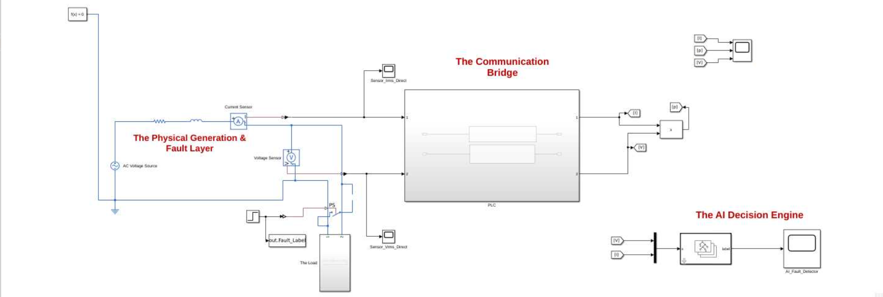

2. Objective 1: Physical Simulation and Real-Time Sensing Layer
Goal: To simulate a physical power distribution network and accurately sense real-time electrical parameters during both healthy and fault conditions.
System Explanation
The physical layer accurately models an AC power distribution network subject to real-world transmission constraints. An AC Voltage Source generates a 230V RMS signal, which is subjected to transmission line impedance (composed of a resistor and an inductor) before reaching the measurement nodes.
Under normal operating conditions, the current flows through the standard load. To simulate a grid failure, a mathematically controlled Step block triggers a physical switch at exactly 0.3 seconds. This action bypasses the main load and forces the current through a 1-ohm fault line. Current and voltage sensors continuously monitor these physical changes, capturing the baseline healthy draw and the subsequent electrical physics of a grid failurespecifically, transmission line voltage sag and severe short-circuit current surges.

Result Validation
- Normal State Draw: Prior to the fault, the network demonstrates a healthy, minimal current draw of approximately [3.25A RMS].
- Fault State Surge: Upon fault induction, the total system impedance drops to exactly [100 ohms], resulting in a massive fault current spike peaking at [280A].
- Voltage Sag: The resulting current surge induces an immediate voltage drop across the transmission line, visibly diminishing the amplitude of the available grid voltage.

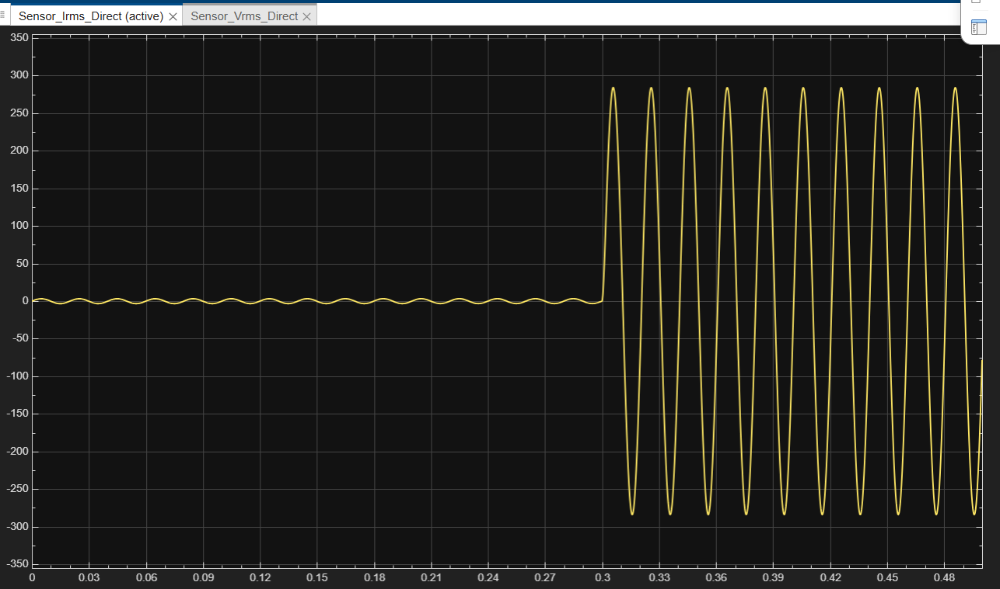
Figure 1.1: Raw AC current waveform demonstrating the instantaneous transition from a healthy load draw to a severe short-circuit surge at the fault trigger mark.

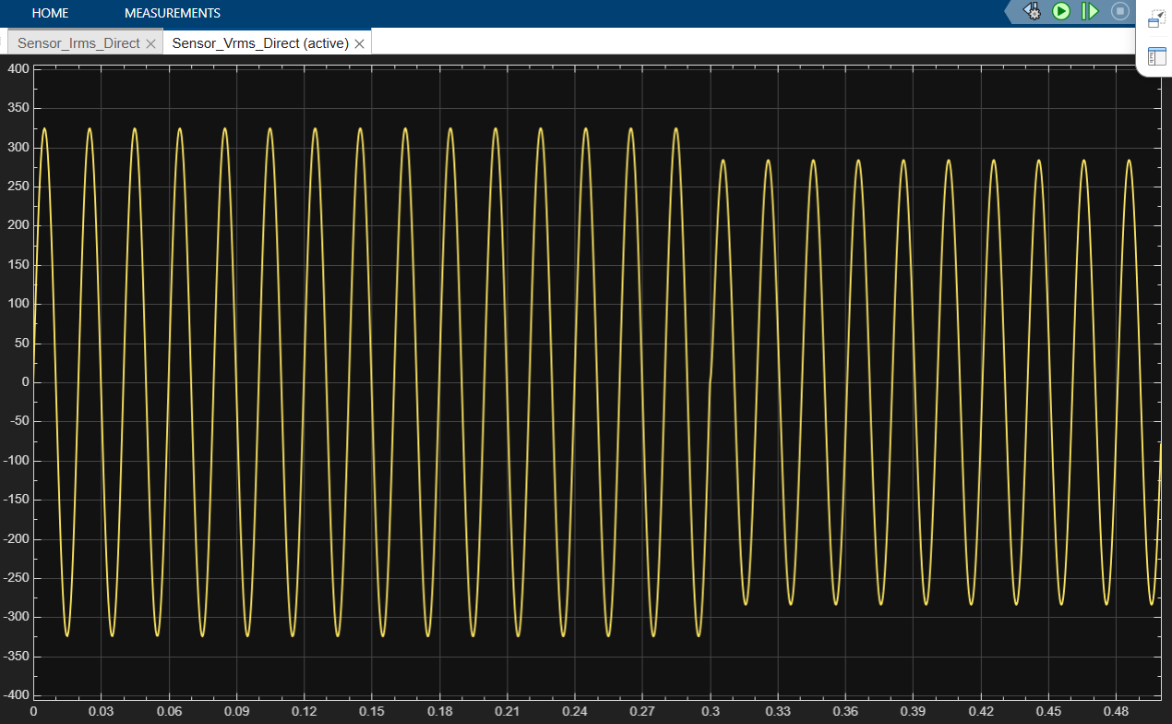
Figure 1.2: Raw AC voltage waveform illustrating the transmission line voltage sag directly resulting from the fault-induced current surge.

3. Objective 2: Power Line Communication (PLC) Digital Pipeline
Goal: To establish a secure, digital digital pipeline capable of transmitting analog sensor data across a noisy channel.
System Explanation
To bridge the continuous-time physical electrical grid with the discrete-time digital monitoring dashboard, a telecommunication pipeline was established. The raw physical AC signals are first smoothed into stable values using Root Mean Square (RMS) blocks.
These continuous signals are then discretized via Zero-Order Hold (ZOH) blocks, which act as Analog-to-Digital Converters by sampling the data at a fixed rate of 0.1 seconds. The discretized data is converted into 8-bit integers (uint8), modulated using Binary Phase Shift Keying (BPSK) to traverse the PLC channel, and accurately demodulated at the receiving dashboard.

Result Validation
The successful extraction of the continuous Simscape data into the discrete out object proves the viability of the PLC pipeline. The communication bridge effectively delivered a highly structured, temporally aligned dataset without data loss, formatting exactly 1001 synchronized rows of recovered voltage and current measurements for the algorithmic layer.
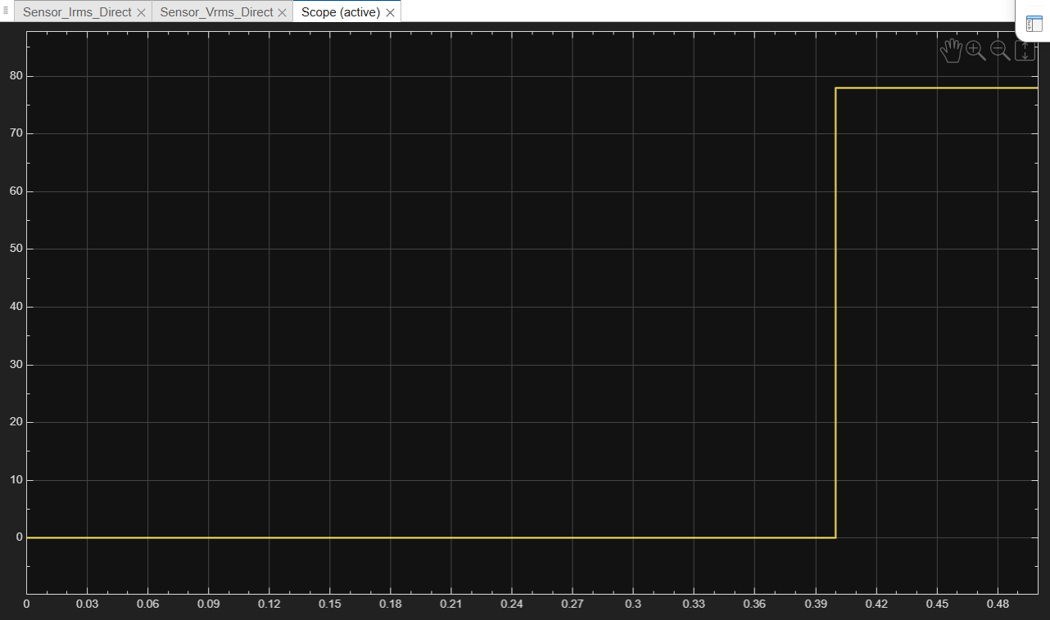

Figure 2.1: Recovered discrete digital signals at the receiving monitoring station, successfully transmitted across the PLC channel.

4. Objective 3: Machine Learning Anomaly Detection
Goal: To develop and integrate a machine learning anomaly detection algorithm capable of autonomously classifying grid faults in real-time.
System Explanation
To eliminate the need for manual monitoring, an autonomous Random Forest classification ensemble was deployed at the receiving end of the PLC pipeline. The model (fitcensemble) was trained using the Bagging method on the historical dataset of healthy and faulty grid states.
The trained algorithm evaluates the real-time, demodulated voltage and current data against its learned decision boundaries. It operates as a binary classifier: outputting 0 when electrical parameters denote a healthy grid, and 1 the exact millisecond those parameters cross the threshold of a grid failure.
Result Validation
The model was successfully integrated into the real-time Simulink dashboard using a ClassificationEnsemble Predict block. The system demonstrated near-zero latency in fault detection. The AI output maintained perfect stability (no false positives) during normal operations and instantly snapped to a positive fault classification the precise moment the physical switch was triggered.

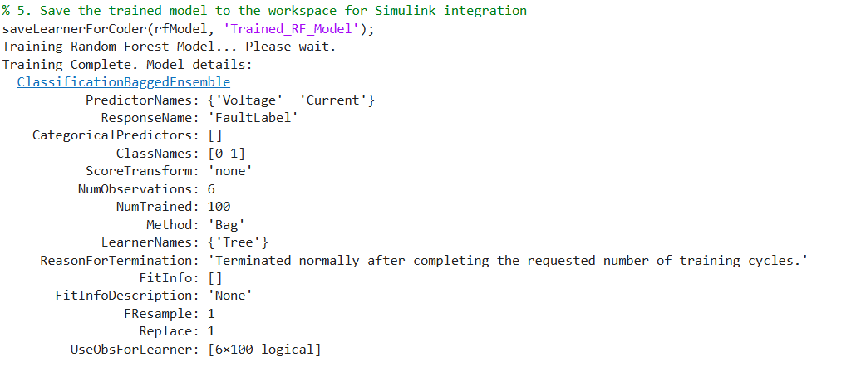
Figure 3.1: Algorithmic training summary confirming the successful generation of the Random Forest decision trees.

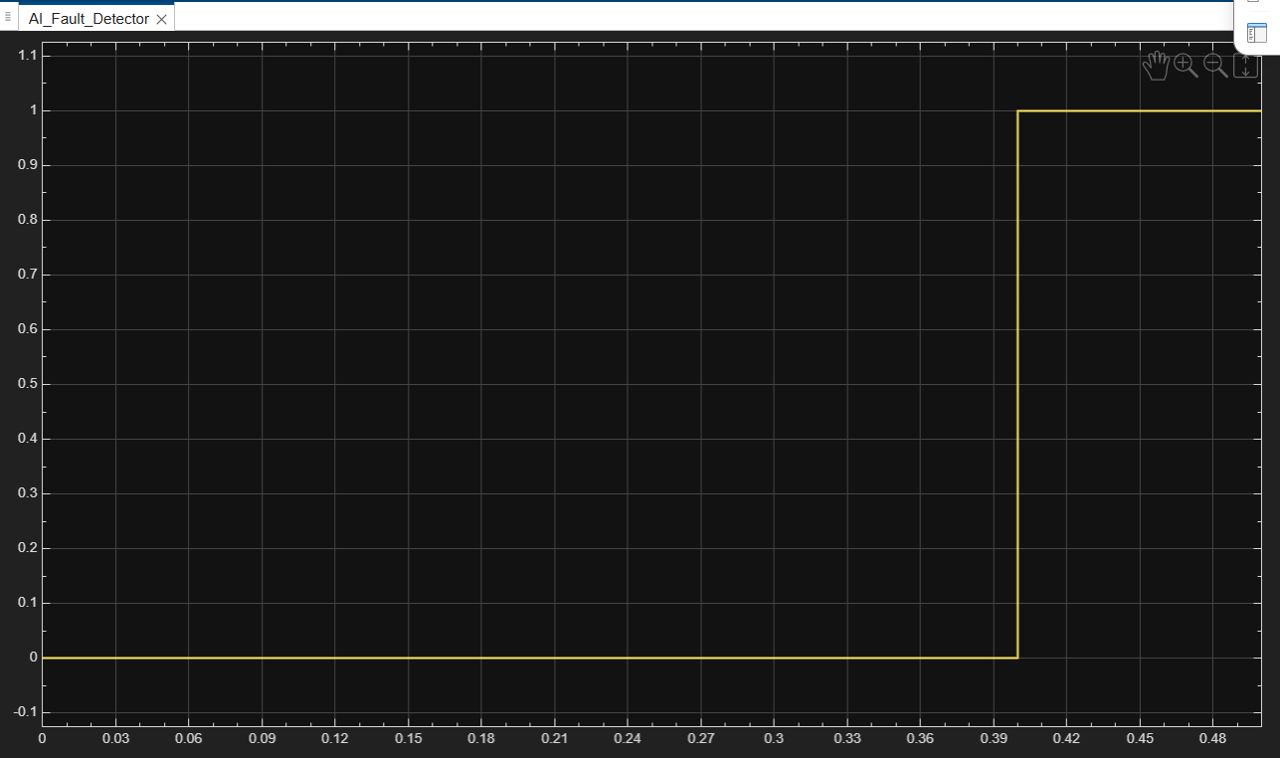
Figure 3.2: The real-time output of the AI decision engine, verifying zero false alarms and instantaneous anomaly classification at the physical point of failure.
5. Conclusion
The integration of physical power system modeling, discrete digital telecommunications, and machine learning successfully yields a robust, autonomous smart grid framework. The system accurately simulates physical fault mechanics, secures the transmission of diagnostic data, and provides instantaneous algorithmic anomaly detection, fulfilling all parameters for an intelligent power distribution network.

ML CODE

% 1. Extract raw numeric data
try
V_raw = out.V_data.Data;
I_raw = out.I_data.Data;
Label_raw = out.Fault_Label.Data;
catch
V_raw = out.V_data;
I_raw = out.I_data;
Label_raw = out.Fault_Label;
end

% 2. Force the data into standard 1D double-precision columns
V_col = double(V_raw(:));
I_col = double(I_raw(:));
Label_col = double(Label_raw(:));

% 3. Rebuild the standardized MATLAB Table
gridData = table(V_col, I_col, Label_col, 'VariableNames', {'Voltage', 'Current', 'FaultLabel'});

% 4. Train the Random Forest Model
disp('Training Random Forest Model... Please wait.');
rfModel = fitcensemble(gridData, 'FaultLabel', 'Method', 'Bag');

disp('Training Complete. Model details:');
disp(rfModel);

% 5. Save the trained model to the workspace for Simulink integration
saveLearnerForCoder(rfModel, 'Trained_RF_Model');

