# Introduction:

New York City's demographics show that it is a large and ethnically diverse metropolis. It is the largest city in the United States with a long history of international immigration. New York City was home to nearly 8.5 million people in 2014, accounting for over 40% of the population of New York State and a slightly lower percentage of the New York metropolitan area, home to approximately 23.6 million. Over the last decade, the city has been growing faster than the region. The New York region continues to be by far the leading metropolitan gateway for legal immigrants admitted into the United States. New York City has also been a major point of entry for immigrants; the term "melting pot" was coined to describe densely populated immigrant neighborhoods on the Lower East Side. As many as 800 languages are spoken in New York, making it the most linguistically diverse city in the world. English remains the most widely spoken language, although there are areas in the outer boroughs in which up to 25% of people speak English as an alternate language, and/or have limited or no English language fluency. English is least spoken in neighborhoods such as Flushing, Sunset Park, and Corona. With its diverse culture, comes diverse food items. There are many restaurants in New York City, each belonging to different categories like Chinese, Indian, and French, etc.

# Problem: To find the answers to the following questions:

1. List and visualize all major parts of New York City that have great Chinese restaurants.
2. What is the best location in New York City for Chinese Cuisine?
3. Which areas have potential Chinese Restaurant Market?
4. Which areas lack Chinese Restaurants?
5. Which is the best place to stay if you prefer Chinese Cuisine?

# Data Section:

For this project we need the following data:

1. New York City data that contains list Boroughs, Neighbourhoods along with their latitude and longitude.
   * Data source: <https://cocl.us/new_york_dataset>
   * Description: This data set contains the required information. And we will use this data set to explore various neighborhoods of New York City
2. Chinese restaurants in each neighborhood of New York City.
   * Data source: Foursquare API
   * Description: By using this API we will get all the venues in each neighborhood. We can filter these venues to get only Chinese restaurants.
3. 3. GeoSpace data
   * Data source: <https://data.cityofnewyork.us/City-Government/Borough-Boundaries/tqmj-j8zm>
   * Description: By using this geospace data we will get the New York Borough boundaries that will help us visualize the choropleth map.

# Methodology section

1. We begin by collecting the New York city data from the following link "[https://cocl.us/new_york_dataset"](https://cocl.us/new_york_dataset%22)
2. We will find all venues for each neighbourhood using Foursquare API

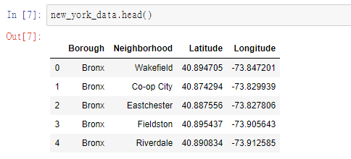 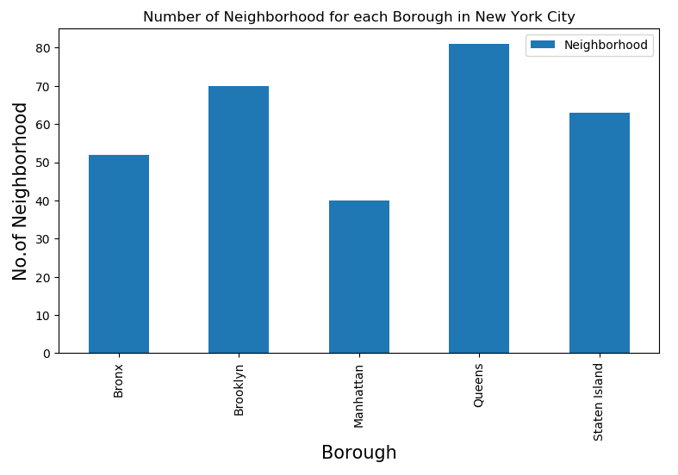

1. We will then filter out all venues with Chinese restaurant for further analysis. 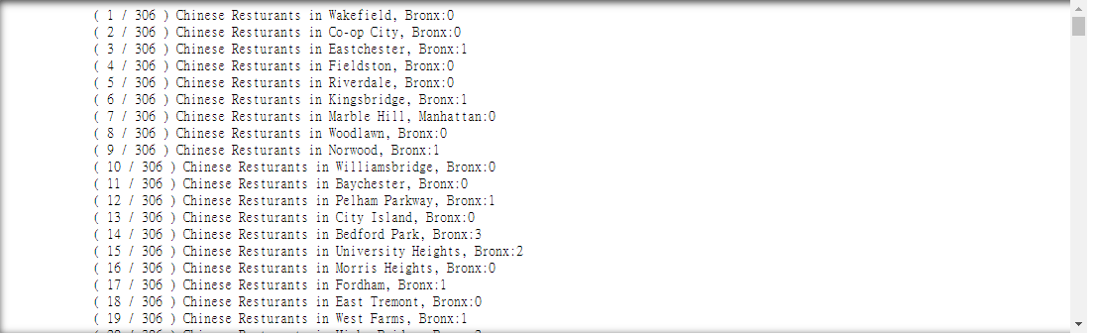
2. Next using Foursquare API, we will find the Ratings, Tips, and Number of Likes for all the Indian Restaurants. 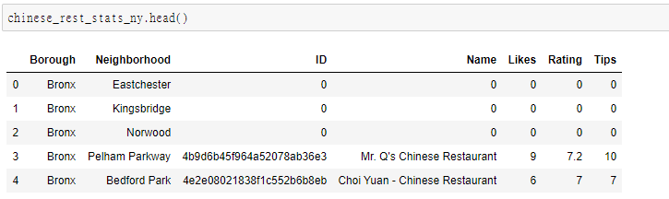
3. We will then sort Neighbourhoods and Borough the data keeping Ratings as the constraint.

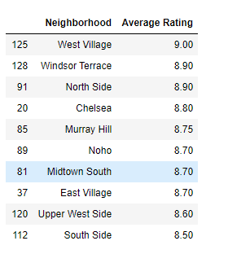 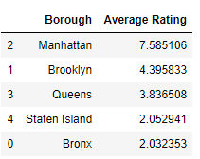

1. Next we will consider all the neighbourhoods with average rating greater or equal 9.0 to visualize on map.

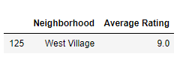

1. Finally, we will visualize the Neighbourhoods and Borough based on average Rating using python’s Folium library.

Neighbourhoods based on average rating:

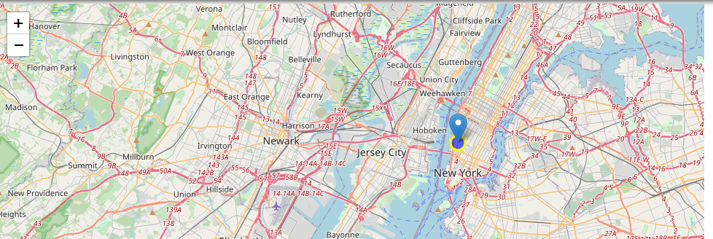

# Results section

So now we can answer the questions asked above in the Questions section:

Answers:

1. The following location in New York City has great Chinese restaurants.



#### West Village(Manhattan), Windsor Terrace(Brooklyn), North Side(Brooklyn) are some of the best neighborhoods for Chinese cuisine.

#### Manhattan have potential Chinese Restaurant Market.

#### Bronx ranks last in average rating of Chinese Restaurants.

#### Manhattan is the best place to stay if you prefer Chinese Cuisine.

# Discussion section

This kind of exercise could apply to other cuisine as this helps someone who just move to New York or want to open a new restaurant in New York.

# Conclusion section

There is always room for improvement and hence the above solution I have provided can also be improved for best results depending upon the data we have.