## Breakdown of the tasks assigned to each team member

**Correy Wilkinson:** As the principal architect, Correy leads the project and shapes the core structure of our website. He also undertakes the crucial task of server-side PHP coding.

**Lei Luo:** manage user and form validation using JavaScript and populating our database with Chinese and Japanese food recipe information.

Christy Guan: oversees the visual appeal of our platform, also assists in the augmentation of our recipe database.

**Etieno Josiah & Emmah Gichia:** responsible for curating and uploading African food recipes into our MySQL database.

## Traditional Recipes Inspiration Web Application

Welcome to Traditional Recipes Inspiration, a unique culinary platform dedicated to Chinese, Japanese, and African cuisines. Here's a succinct outline of our web page structure:

**Main structure:**

**Homepage:** Features user authentication and personalized greeting. An integrated search tool allows for keyword-based recipe discovery. The navigation bar offers direct access to Chinese, African, and Japanese recipe sections.

**Signup Page**: Emphasizes user information validation and includes a newsletter subscription option.

**Sign-in Page:** Ensures secure access by verifying credentials. Successful login redirects to a personalized homepage.

**Category Pages:** Showcases a variety of food categories, each equipped with attractive images, brief cooking instructions, and a link to full recipes.

**Recipe View Page:** Details individual recipes with images, ingredients, and step-by-step directions, meticulously compiled in our database.

**Search Page:** Displays recipes matching user-inputted keywords from titles, ingredients, or cooking instructions.

**Wireframe**

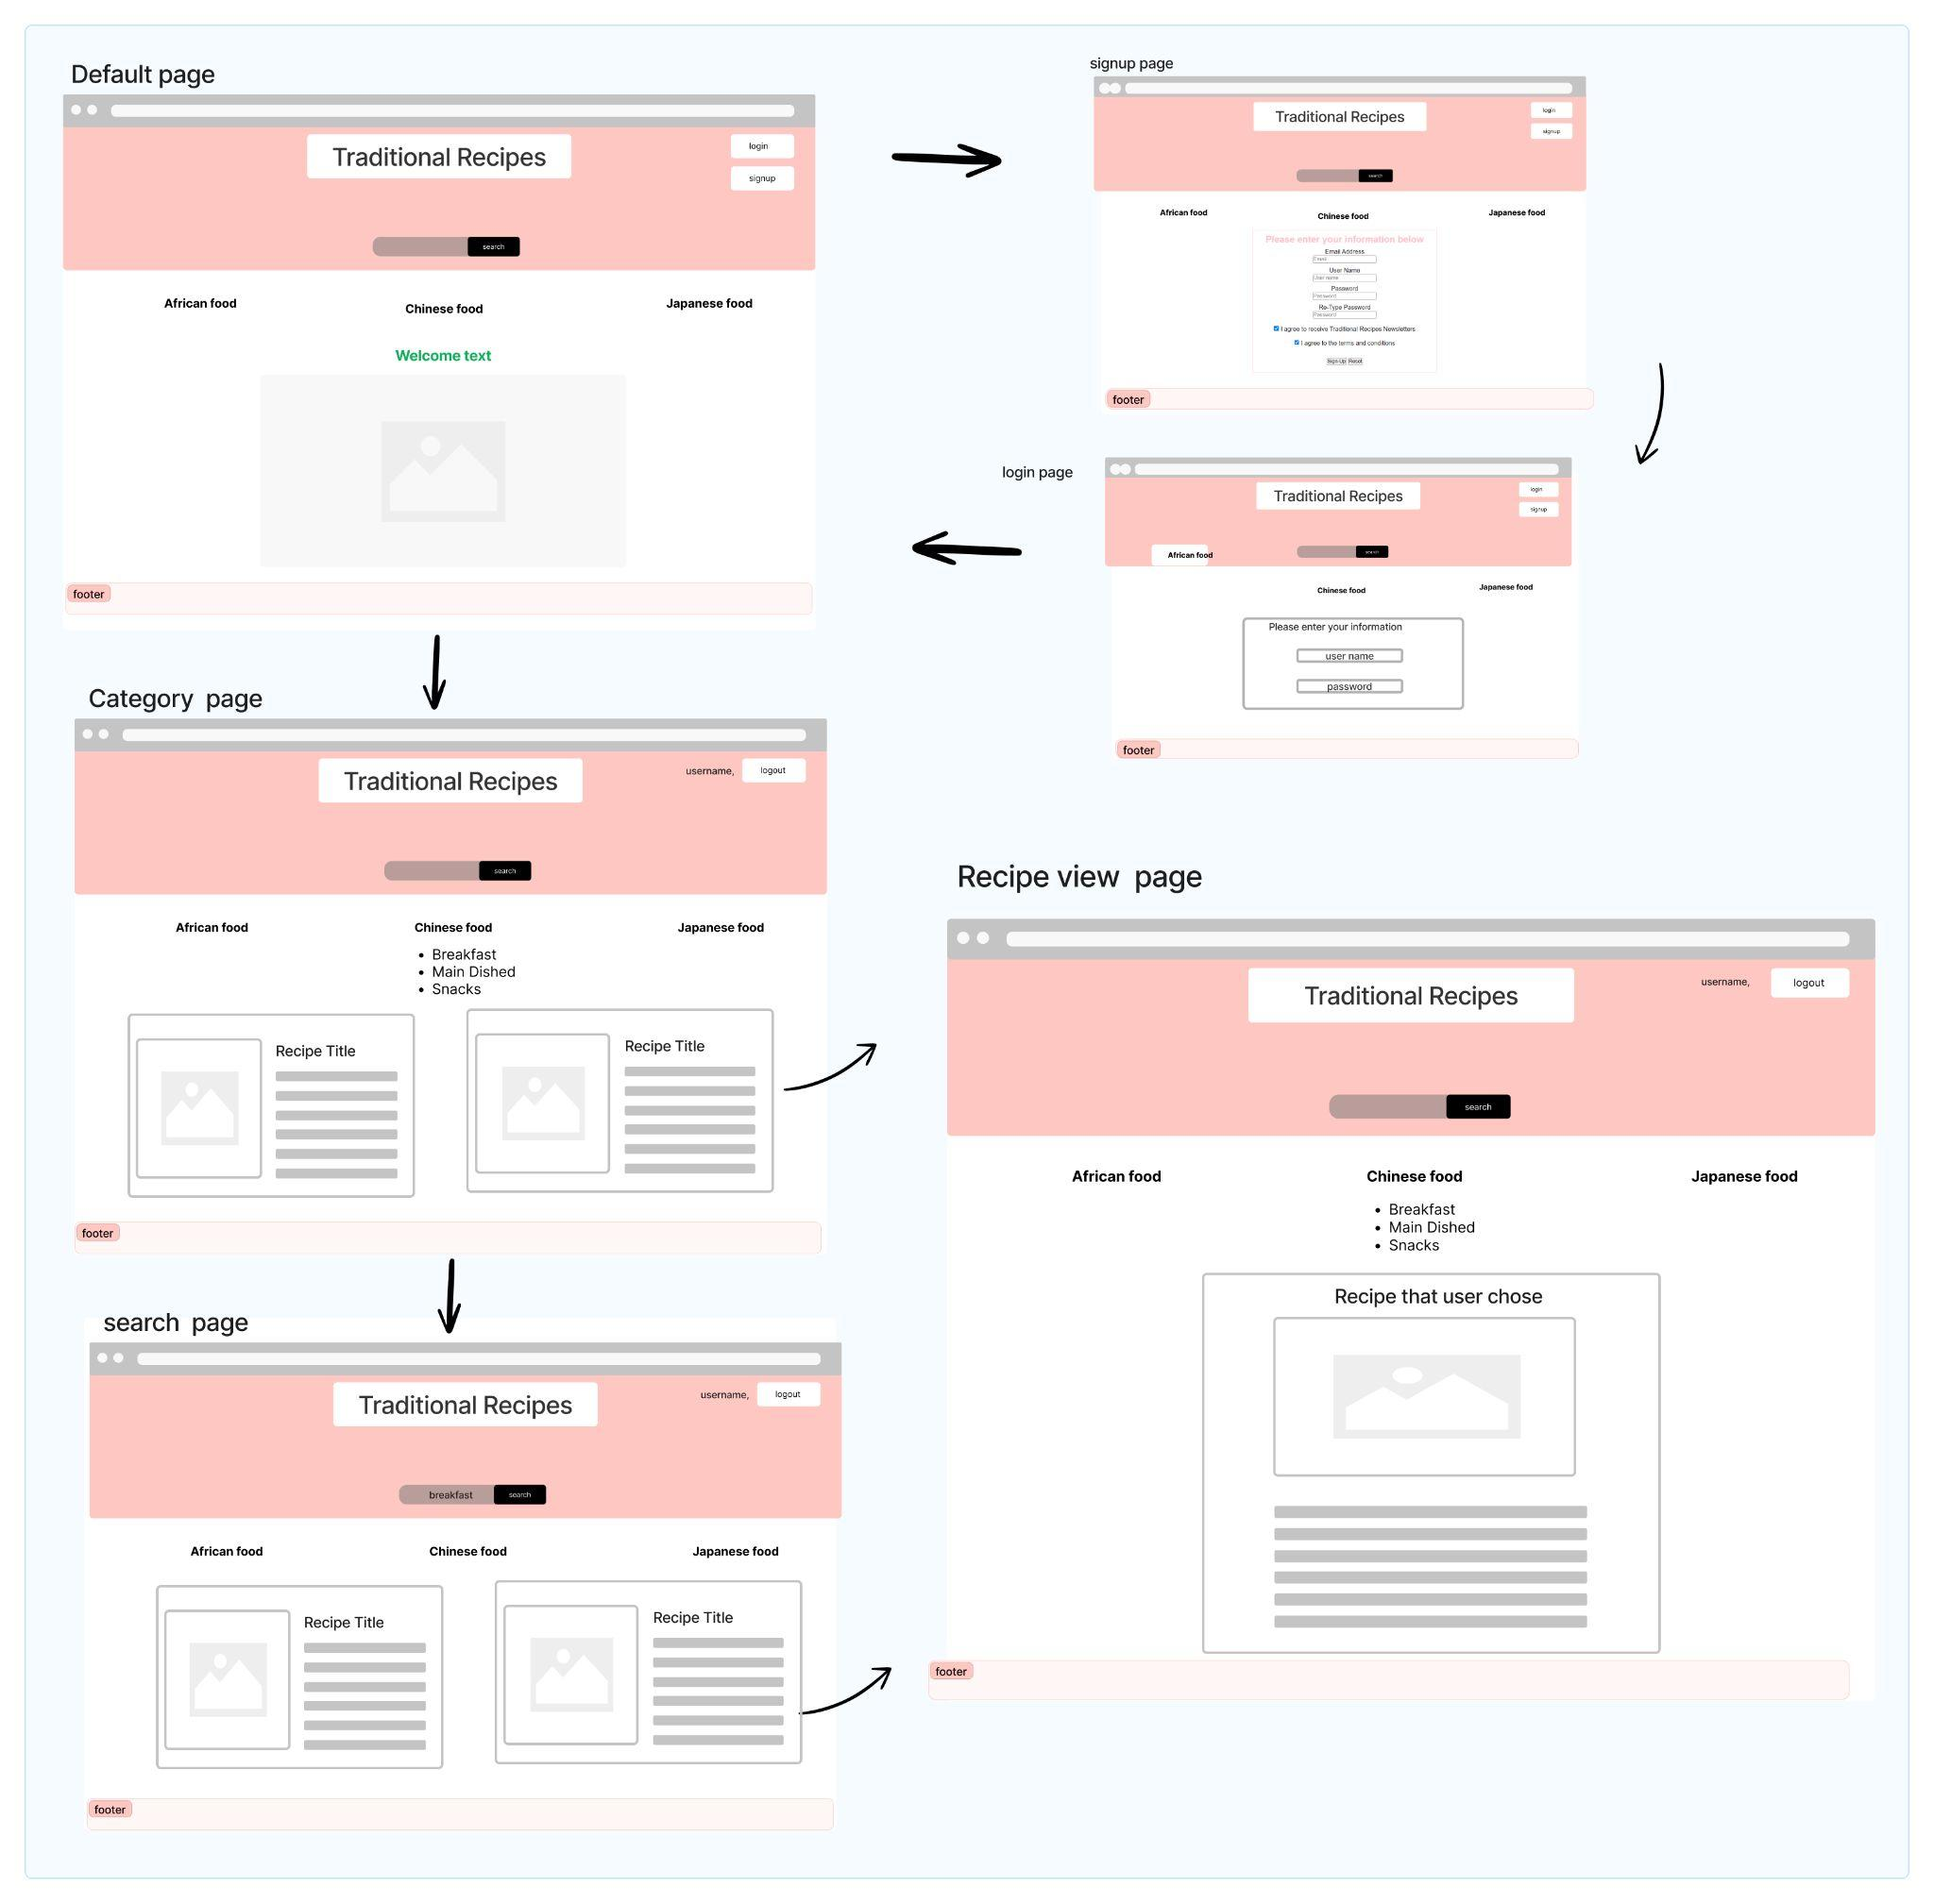

**Our Application Features:**

**Client-side Design (HTML/CSS):**

Traditional Recipes Inspiration leverages semantic HTML and an external CSS file for consistent and appealing design. Its responsive layout guarantees a fluent user experience on multiple devices.

**Client-side Scripting (JavaScript):**

We utilize JavaScript for robust form validation, user-friendly error messaging, efficient DOM manipulation, and dynamic style/layout alterations based on specific events.

**Secure User Sign-up/Login:**

Our secure user sign-up and login processes validate and protect user credentials

**Efficient Search Feature:**

Our effective search function allows users to easily navigate our extensive recipe database, making culinary exploration a breeze.

**Database description:**

It consists of two core tables: recipes and users.

The recipes table is the heart of the application, storing all the vital information related to a recipe. This includes the preparation and cook time, number of servings, associated image, ingredients list, cooking directions, and categorical data such as the dish's title and its subcategory (for example, whether it's a breakfast, main dishes or snacks recipe).

The users table stores information about the users of the application. Each user has a unique identifier, first and last name, email address, and login credentials (username and password).