Bahman Bahmani et al. introduced k-means||, which is a faster version of k-means++.
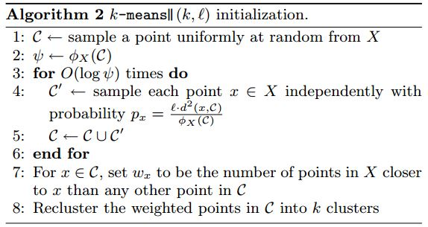
This algorithm is taken from page 4 of their paper, Bahmani, B., Moseley, B., Vattani, A., Kumar, R., & Vassilvitskii, S. (2012). Scalable k-means++. Proceedings of the VLDB Endowment, 5(7), 622-633.
Unfortunately I don't understand those fancy Greek letters, so I need some help to understand how this works. As far as I understand this algorithm is an improved version of k-means++, and it uses oversampling, to reduce the number of iterations: k-means++ has to iterate kk times, where kk is the number of desired clusters.
I got a very good explanation through a concrete example of how k-means++ works, so I will use the same example again.
Example
I have the following dataset:
(7,1), (3,4), (1,5), (5,8), (1,3), (7,8), (8,2), (5,9), (8,0)
k=3k=3 (number of desired clusters)
ℓ=2ℓ=2 (oversampling factor)
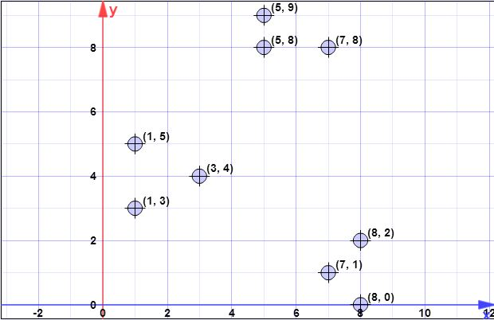
I started to calculate it, but I'm not sure if I got it right, and have no idea about Steps 2, 4, or 5.
- Step 1: C←C← sample a point uniformly at random from XX
Let's say the first centroid is (8,0)(8,0) (same as in k-means++)
- Step 2: ψ←ϕX(C)ψ←ϕX(C)
no idea
- Step 3:
  - d2(x,C)=[2,41,74,73,58,65,4,90]d2(x,C)=[2,41,74,73,58,65,4,90]
We calculate the squared distances to the closest center to each point. In this case we have only one center so far, (8,0)(8,0).
  - ℓ⋅d2(x,C)=[4,81,148,146,116,130,8,180]ℓ⋅d2(x,C)=[4,81,148,146,116,130,8,180]
(Because ℓ=2ℓ=2 in this case.)
  - cumulative ℓ⋅d2(x,C)=[4,85,233,379,495,625,633,813]cumulative ℓ⋅d2(x,C)=[4,85,233,379,495,625,633,813]
Pick ℓ=2ℓ=2 random numbers in the interval [0,813)[0,813). Say you pick 246.90246.90 and 659.42659.42. They fall in the ranges [379,495)[379,495) and [633,813)[633,813) which correspond to the 4th and 8th items respectively.
  - Repeat it O(logψ)O(log⁡ψ) times, but what is ψψ (calculated in Step 2) in this case?
- Step 4: For x∈Cx∈C, set wxwx to be the number of points in XX closer to xx than any other point in CC.
- Step 5: Recluster the weighted points in CC into kk clusters.
Any help in general or in this particular example would be great.

+100
data points: (7,1),(3,4),(1,5),(5,8),(1,3),(7,8),(8,2),(5,9),(8,0)
l = 2 // oversampling factor
k = 3 // no. of desired clusters
Step 1:
Suppose the first centroid is CC is {c1}={(8,0)}{c1}={(8,0)}. X={x1,x2,x3,x4,x5,x6,x7,x8}={(7,1),(3,4),(1,5),(5,8),(1,3),(7,8),(8,2),(5,9)}X={x1,x2,x3,x4,x5,x6,x7,x8}={(7,1),(3,4),(1,5),(5,8),(1,3),(7,8),(8,2),(5,9)}
Step 2:
ϕX(C)ϕX(C) is the sum of all smallest 2-norm distances (euclidean distance) from all points from the set XX to all points from CC. In other words, for each point in XX find the distance to the closest point in CC, in the end compute the sum of all those minimal distances, one for each point in XX.
Denote with d2C(xi)dC2(xi) as the distance from xixi to the closest point in CC. We then have ψ=∑ni=1d2C(xi)ψ=∑i=1ndC2(xi).
At step 2, CC contains a single element (see step 1), and XX is the set of all elements. Thus in this step the d2C(xi)dC2(xi) is simply the distance between the point in CC and xixi. Thus ϕ=∑ni=1||xi−c||2ϕ=∑i=1n||xi−c||2.
ψ=∑ni=1d2(xi,c1)=1.41+6.4+8.6+8.54+7.61+8.06+2+9.4=52.128ψ=∑i=1nd2(xi,c1)=1.41+6.4+8.6+8.54+7.61+8.06+2+9.4=52.128log(ψ)=log(52.128)=3.95=4(rounded)log(ψ)=log(52.128)=3.95=4(rounded)
Note however that in step 3, the general formula is applied since CC will contain more than one point.
Step 3:
The for loop is executed for log(ψ)log(ψ) previously computed.
The drawings are not like you understood. The drawings are independent, which means you will execute a draw for each point in XX. So, for each point in XX, denoted as xixi, compute a probability from px=ld2(x,C)/ϕX(C)px=ld2(x,C)/ϕX(C). Here you have ll a factor given as parameter, d2(x,C)d2(x,C) is the distance to the closest center, and ϕX(C)ϕX(C) is explained at step 2.
The algorithm is simply:
- iterate in XX to find all xixi
- for each xixi compute pxipxi
- generate an uniform number in [0,1][0,1], if is smaller than pxipxi select it to form C′C′
- after you done all draws include selected points from C′C′ into CC
Note that at each step 3 executed in iteration (line 3 of the original algorithm) you expect to select llpoints from XX (this is easily shown writing directly the formula for expectation).
for(int i=0; i<4; i++) {

// compute d2 for each x_i
int[] psi = new int[X.size()];
for(int i=0; i<X.size(); i++) {
double min = Double.POSITIVE_INFINITY;
for(int j=0; j<C.size(); j++) {
if(min>d2(x[i],c[j])) min = norm2(x[i],c[j]);
}
psi[i]=min;
}

// compute psi
double phi_c = 0;
for(int i=0; i<X.size(); i++) phi_c += psi[i];

// do the drawings
for(int i=0; i<X.size(); i++) {
double p_x = l*psi[i]/phi;
if(p_x >= Random.nextDouble()) {
C.add(x[i]);
X.remove(x[i]);
}
}
}
// in the end we have C with all centroid candidates
return C;
Step 4:
A simple algorithm for that is to create a vector ww of size equals to the number of elements in CC, and initialize all its values with 00. Now iterate in XX (elements not selected in as centroids), and for each xi∈Xxi∈X, find the index jj of the closest centroid (element from CC) and increment w[j]w[j] with 11. In the end you will have the vector ww computed properly.
double[] w = new double[C.size()]; // by default all are zero
for(int i=0; i<X.size(); i++) {
double min = norm2(X[i], C[0]);
double index = 0;
for(int j=1; j<C.size(); j++) {
if(min>norm2(X[i],C[j])) {
min = norm2(X[i],C[j]);
index = j;
}
}
// we found the minimum index, so we increment corresp. weight
w[index]++;
}
Step 5:
Considering the weights ww computed at the previous step, you follow kmeans++ algorithm to select only kk points as starting centroids. Thus, you will execute kk for loops, at each loop selecting a single element, drawn randomly with probability for each element being p(i)=w(i)/∑mj=1wjp(i)=w(i)/∑j=1mwj. At each step you select one element, and remove it from candidates, also removing its corresponding weight.
for(int k=0; k<K; k++) {
// select one centroid from candidates, randomly,
// weighted by w
// see kmeans++ and you first idea (which is wrong for step 3)
...
}
All the previous steps continues, as in the case of kmeans++, with the normal flow of the clustering algorithm
I hope is clearer now.
[Later, later edit]
I found also a presentation made by authors, where you can not clearly that at each iteration multiple points might be selected. The presentation is here.
[Later edit @pera's issue]
It is obvious that log(ψ)log(ψ) depends on data and the issue you raised would be a real problem if the algorithm would be executed on a single host/machine/computer. However you have to note that this variant of kmeans clustering is dedicated to large problems, and for running on distributed systems. Even more, the authors, in the following paragraphs above the algorithm description state the following:
Notice that the size of CC is significantly smaller than the input size; the reclustering can therefore be done quickly. For instance, in MapReduce, since the number of centers is small they can all be assigned to a single machine and any provable approximation algorithm (such as k-means++) can be used to cluster the points to obtain k centers. A MapReduce implementation of Algorithm 2 is discussed in Section 3.5. While our algorithm is very simple and lends itself to a natural parallel implementation (in log(ψ)log(ψ) rounds ), the challenging part is to show that it has provable guarantees.
Another thing to note is the following note on the same page which states:
In practice, our experimental results in Section 5 show that only a few rounds are enough to reach a good solution.
Which means you could run the algorithm not for log(ψ)log(ψ) times, but for a given constant time.

