Copywright
Copyright © 2016-2021 Federico Bonelli and Raffaella Rovida

Le Grand Jeu is licensed under a Creative Commons Attribution-NonCommercial 4.0 International License. You can find the necessary files for laser-cutting your own game set on GitHub (https://github.com/freddbomba/legrandjeu).

TO CONTACT US:
Stichting Trasformatorio
Marcus Straat 52/4a
1091TK
Amsterdam
www.legrandjeu.net | @legrandjeu11 #legrandjeu

ACKNOWLEDGEMENTS


This work has been carried out within the framework of the EUROfusion consortium and has received funding from the Euratom research and training programme 2014-2018 and 2019-2020 under grant agreement No 633053.

Introduction

Le Grand Jeu does not have a moralistic message to deliver, does not impose any alignment to the players and does not provide clear victory rules.
Like in real life!

About the game
Le Grand Jeu is the name of a game designed in May-July 2016 by an expert group in a 4 days workshop, held in Milan 10-14 July 2016. The group gathered by Federico included artists, engineers, design experts and activists. The idea was to design a situation where some narratives about the future of our society could be told, crafted and discussed in a positive way together by a group of people.
Some games were from the beginning tools to spread ideas and have people adopt them and use them while reflecting over those issues. Is tha case of many games. LGJ is though to mirror some new concepts that can be quite technical and difficult to explain otherwise: stock and flow, blockchains, radical transparency, consensus, governance, entropy, finite resources, renewable energy and grids for example.
This special edition of LeGrandJeu was commissioned by the EUROfusion Communication Department to open the EUROfusion Expo in 2021 and to provide the scientists responsible for communication in the different European countries, with an engaging tool, to talk about the complex implications of fusion energy research in an engaging way.
This book contains an introduction to the game and to 6 scenarios specifically designed together with EUROFUSION team to enjoy playing the future of humanity starting from an energy perspective.
LGJ-EUROFusion scenarios were co-designed by Raffa and Fredd in a week-sprint, carried out in January 2020, just before the pandemic lockdown together with a group of nuclear physicists of the Danish Technological University involved into the EUROFusion project.
Three rapid iterations brought us to the development of this series of scenarios, that treat different sources of energy, like fossil, fission, renewable and, when becomes available, fusion. We thought of hinting in them different set-ups for the land and governance and spent time and effort to balance the existing elements for their economic impact.
The rest is to the master and to the players to find out by doing.

The authors would like to thank all the players that helped us refine these scenarios and will help in the future to shape reality of a better world.

1. Game Elements

THE PLAYERS
That's you.
Pick a color choosing the plastiline you like best.
And then there is a Game Master. It can be one of you. The game master ensures that the game flows and plays the world and everything is "on the table" and is not a player. He is knowledgeable and impartial. More about mastering comes in the Game Mastering (section 4).

THE PHYSICAL WORLD
LGJ is a turn based game. Turns stand for time, and allow to know what comes before and what comes after.
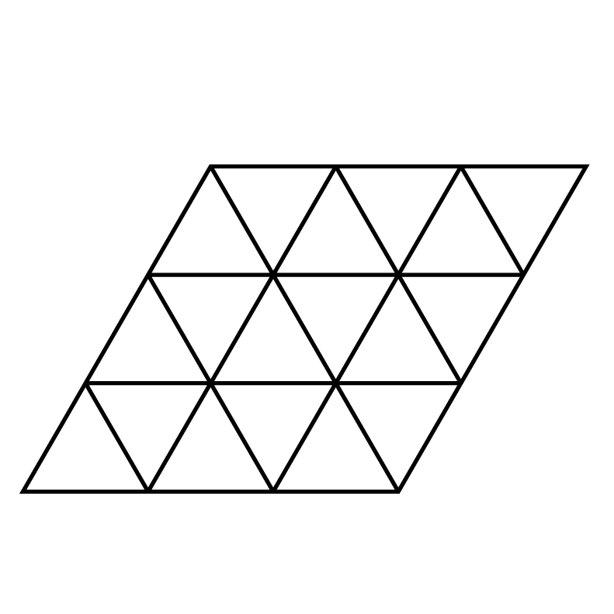 | THE BOARD
 | The Boards consists in two similar pieces of diamond shaped transparent plastic. In your kit you will find two of them.
 | They are transparent so you can use them to cover maps you have drawn yourself or a real map or anything else.
 | The Grid is the mesh of triangles drawn on the board
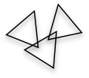 | THE LAND
 | You find transparent triangles to be used to represent the land that you control in the game.
 | to decide how many units of lands they have the players throw in the beginning 1d4+1
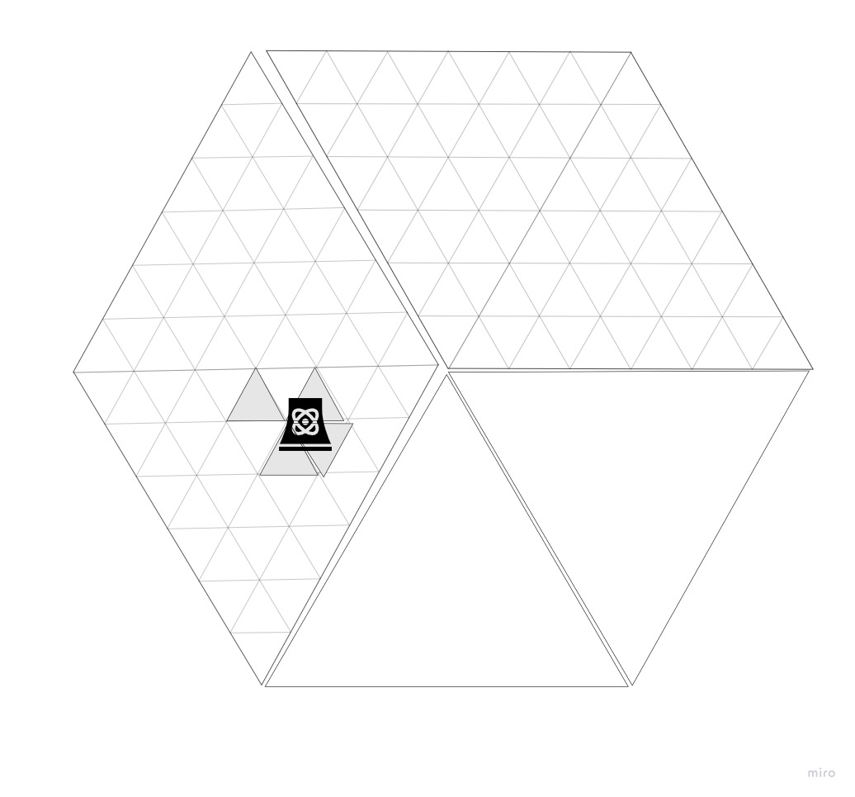 | You can place The Land on The Board, so the terrain is “on” the grid or off The Board, if you put it outside you mean you have no services (electricity, sewerage, running water, etc.) and and you have to provide to all by yourself.  What you see here is an arrangement between the many possible, were the no-grid is represented as two adiacent triangles with no grid drawn.  The Player can put the land were they want taking in account that for all our scenarios the total amount of land is finite. Therefore the master says that there cannot be more than a total of more than N units of land off the grid

THE FORTUNE
Fortune comes (and goes) in many ways.

We prefer to use D&D style dices because we find them fun to use…
 | The Wheel
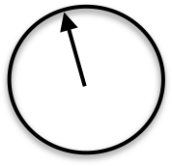 | allows your master to map distribution laws or directions of winds. It is specified in the scenarios.  To operate it keep it on the palm of your hand and tick the arrow...
 | The Dices
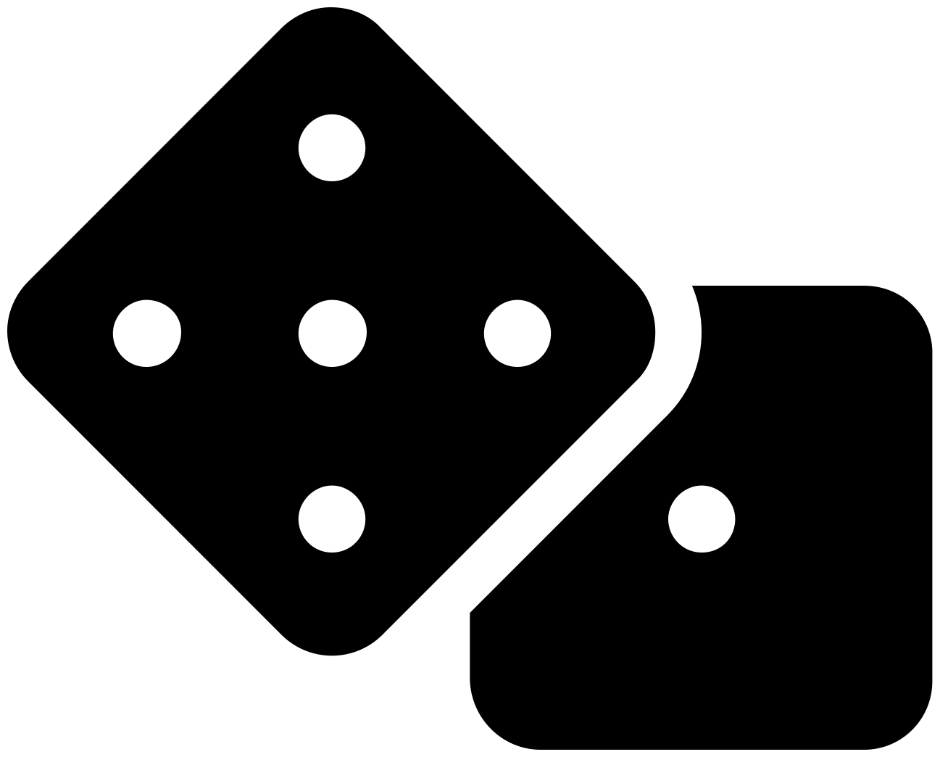 | Dices are for deciding the outcome of an action, an event where all cases have the same chance to happen, or to measure its outcome. For example determining a yield connected to our turn activities.  Is up to the master to tell you which dices to use and how many.  PS: in the box you will find a set of D&D dices, because we like them...

THE FUNCTIONAL WORLD

 | The Elements
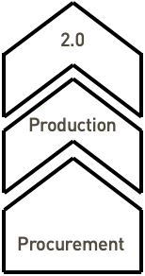 | You find in the box two types of pieces that are to be used to design the Elements of your activity. Elements are to be organised on 3 levels: procurement, production, 2.0.  Elements can be combined in lines of production, individually or cooperatively or under any other form of agreement you can come up with.  The Elements are to be written upon with a whiteboard marker, you will find some in the box
 | The Shadow
 | Greys and Whites: the currency of the game  They are translating wide concepts like:  White: money, cryptocurrency, resources, knowledge, energy etc.;  Grey: pollution, loss of biodiversity, bad karma, depletion of resources, entropy, CO2 etc.
Is good for the master to be aware that to avoid color bias, you can invert the colours.
They are beans anyway, their colour is not exactly the way they might give scandal...
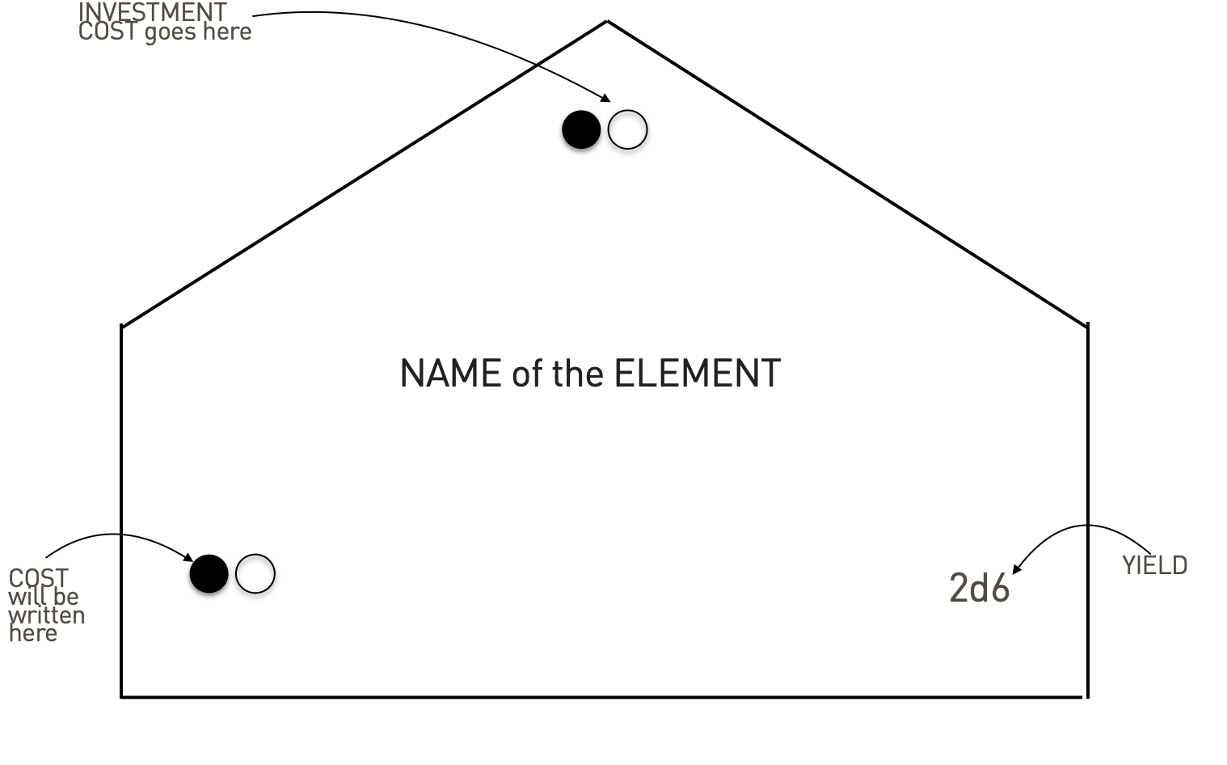 | This is how the procurement element becomes something: On the left in both greys and whites its cost; on the right the yield it can give when operates (in this case 2d6, meaning two 6 sided dices). The top values are the investment cost, both in greys and in whites

THE REST OF THE STUFF
You will see in the box: there are markers, this book, sticky notes to write all kind of deals between you, small extra things to play with… AND some colour plastiline that you should already have used...

If you play as Game Master feel free to customise the kit to your taste and needs for each scenario you want to play or design.

2. TO PLAY A GAME
Le Grand Jeu is a future-thinking game that allows to set a situation where different conditions are simulated and concepts emerge from doing, players are peers and all languages intermix
…. and a story emerge

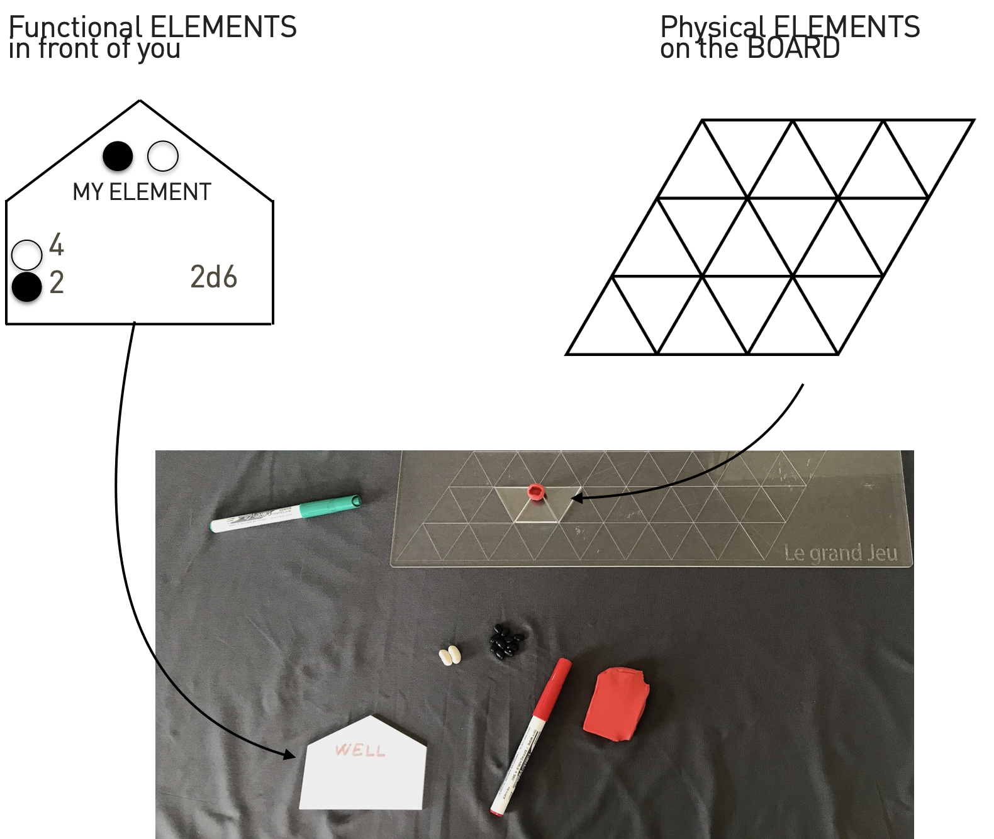
image-20211110184126044

We ask the players as well to put on their land a piece of plastiline with their color, to recognise them, and then to mimic the thing they will build adding and moulding more details as the game progress.
To set up the game now your GM refer to the instructions of the scenario you chose to play
Once you have set up the table accordingly you can just start, because all the rules can be introduced wile playing the first round

2.1. PREPARATION OF A SIMPLE GAME

- decide who is the master (can be done with a dice throw, the highest score becomes "the Master")
- set up the game board
- let every player throw 2d6 for white and 1d6 for the grey they have at game beginning
- for each player throw 1d4 for the land they already have
RULES
- Wins who, at the end of the game has more whites after they have been balanced with the greys
- If the table has more than 50 greys we all die
- If a player die the global grey pot gets 20 greys and every player gets 5
EACH ROUND
At their turn the players: Pay dues if any, they can be according to the scenario taxes, energy, money or else but are always accounted with the white coin; decide between one of the following
- Invest/Build/Entrepreneurship action
- Find/Research/Invent
- Call an assembly to decide upon a law proposal

2.2. How to be GM for a simple game

- You want people to have fun and everyone to speek
- You play the world both in the scenario (the small game) and outside (the big game), you use dices to take decisions, and have access to the larger store of beans
- You take care of the rounds and the accounts and to translate what the player decides to do in the language of the game
- You are the Master of Chaos, have fun

DECISIONS
- 10 faced dices are for percentages. Can be used to determine the success of an action.
  - es: player says "I am going to set up a workshop for electric bikes and solar energy"; Then throws 10 faced dices, and obtain a throw of 6, that on a scoresheet 1 to 10 is a reasonable success.
  - Master reasons: "This exists in our word, and you have empty space to build it, so you can do it. It will cost X white to establish, and account the generation of Y greys for the environmental cost of your decision. To operate it will need an investment of x and will produce 1d4 of yield and y greys of impacts on the environment".
  - Accordingly to the master judgement a success of 100% (or a failure with a throw of 1 or 2) can be prised or punished
- 20 faces dices are mostly used for inventions. Player says:" I want to invent a technology to have bike batteries that recharge 3 times faster". The master opens a short discussion with open questions like: "what would you think the advantage would be economically or environmentally". The master as well decides if the invention is to be allowed (for example contradicts a principle of Thermodynamics). Then considering everything gives a success level on the 20 faces dice, for example 3/20 means only 18,19,20 pass the round with a success.
To research on something the player has to spend money and generates gray, so is to decide as well how much and if the grey effects the player's own account or the world one, as if is, as an example, CO2 in the atmosphere.
- d4, d6, d8, d12 maps usually the variability of yields, so use them wisely in measuring the yield of activity to map as well the risk. You can decide as well to model losses if you need but the less time you need to account for the economy of a turn the more time you leave to the game to develop.
- The use of the Weal is introduced later on in this guide, as a general rule you should play the weal to introduce chaos. Players can throw a round of Weal and pick a card. Is used as well if you need to decide about directions (for example of the wind) in a particular moment.

2.3. PLAY THE BASIC SCENARIO
The basic scenario we usually propose to learn to play the game is something along these lines:
You and a group of friends have decided to go to live in a beautiful village in the middle of the mountains. You would like to live happy and in harmony with nature. The place is populated by overall friendly people and has some basic grid facilities, but you can as well decide to put yourself off the grid. Internet, water, electricity is available on the grid for 2 white of local tax to be payed at each round.
We call it the "happy valley" scenario and usually brings out a lot of surprises.
The game master has to keep track about the happiness of the "non playing participants" to the life of the valley and treat the players a bit as newcomers...
Another suggestion is to give focus not only to economy but to society. In this scenario a GM might give (or take) greys as well for actions that change the karma of players and of the valley atmosphere and not only related to economical advantage and/or production of goods.
The weal of fortune can be used at the end of each round to add chaos to the strategies. Try to divide it in 20% chance of getting a LGJ card, another 30% of getting a local event and the rest divided equally between "invent" and a choice between "elections" and "business as usual".
REMEMBER, THE GM HAS TO HAVE FUN AS WELL.
If you find yourself loosing the "fun element" try to make a short pause or give the mastering task to someone else, throw dices to pick your future choices or even better take a LGJ card yourself...

3. THE EUROFUSION SCENARIOS
Between 2019 an 2021

3.1. KEY LEARNINGS
1. Understand the Planet carrying capacity
1.1 Atmosphere capacity | 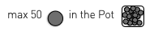
1.2. Land capacity (wastes & radioactive wastes) | 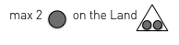
2. Understand the energetic needs, consumption and lifestyle
2.1. Cost of activities | 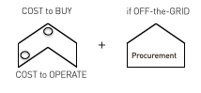
2.2. Procurement if off-the-grid
3. Understand the energetic sources features (production and distribution)
3.1. Fossil: energy production, env impacts, grid, events (raw material procurement) | 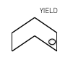
3.2. RES: energy production, env impacts, grid, events (variability) | 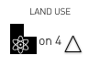
3.3. Fission: energy production, env impacts, grid, events (leaks and accidents)
3.4. Fusion: energy production, env impacts, grid, events (spinoff) | 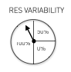

3.2. Basic Rules for the scenario
The element
Existing elements | 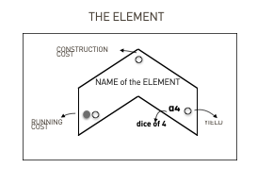
Setup | 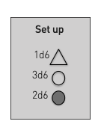
Actions
Survive | 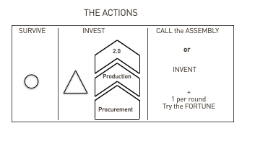
Death ? | 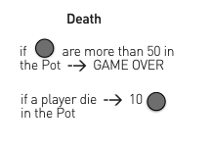
Invest | To determine the success of an investment proposed by a player let him throw 1d10 and decide accordingly about success or failure of their investment attempt
Call the Assembly | Is up to the master to act as a good facilitator of an assembly. Be sure to formulate the proposals of the assembly in the language of the game and let people discuss and vote
Invent | In this scenario inventions and research are tied to a degree of "plausibility". The master does not allow to defy the laws of thermodynamics :)  We encourage anyway never to give zero chance to an invention attempt, as strange as it might seam. Use dices/investment in research wisely to pilot the efforts of the players into making a good story. Chose for story and fun first. Ask to other players if your decisions are welcomed. In doubt, throw dices yourself...
Welfare Rule | 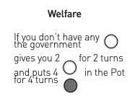

3.3. Inspiration
A shop | 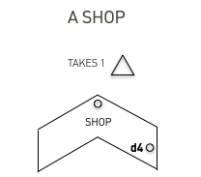
An Hospital | 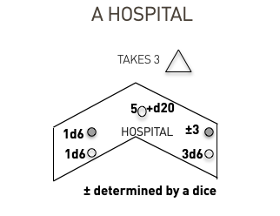
An Art Festival | 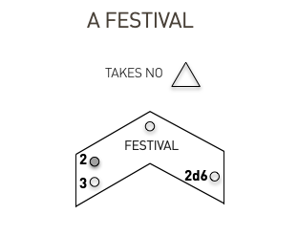
Special Rules
To be off the grid... | 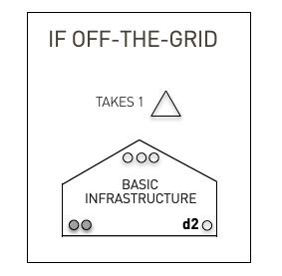
Spreading of fire and putting it down | 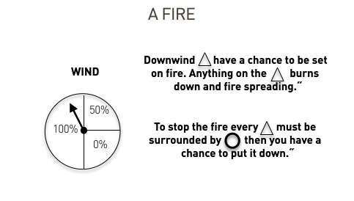
Open Source your research
Costs less? Or is a faster paced innovation model? | 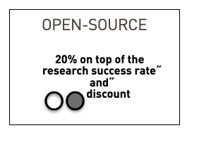
Freelance!
To be a worker can be a good strategy. But how to make more money? You can debate this with your table, this is just the usual suggestion. | 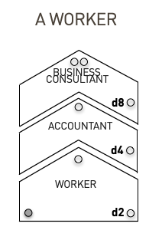
A Research Center?
 | 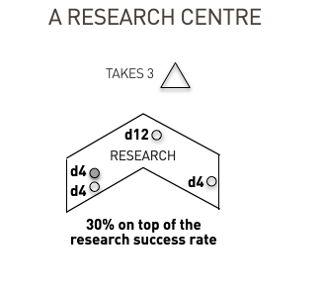
To do some criminal activity?
 | 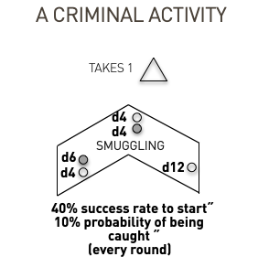

3.4. Scenario 1: Addiction
Set up the game table as such:

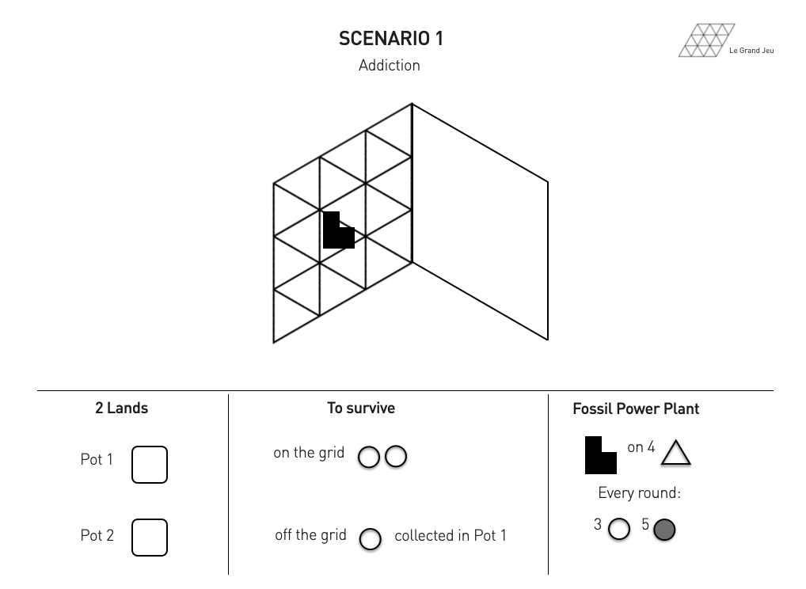

3.5. Scenario 2: Fossil vs Renewable
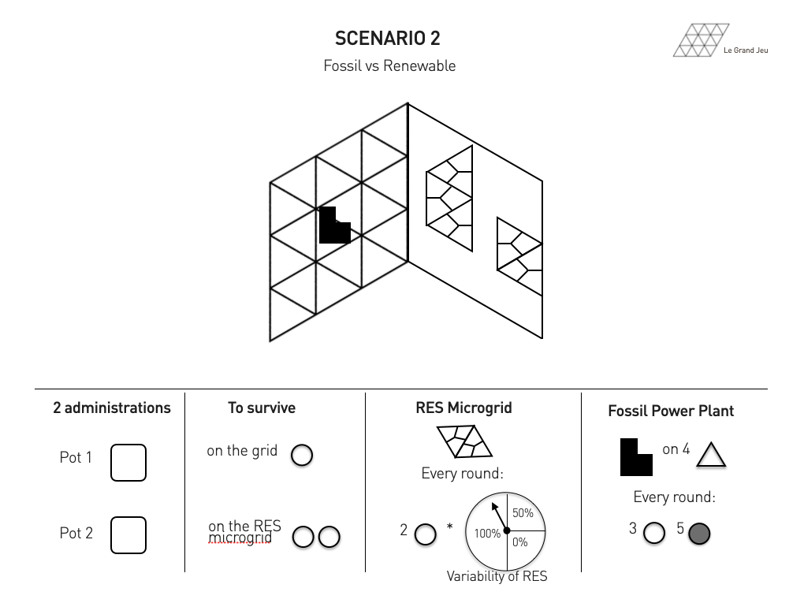

3.6 Scenario 3: The Nuclear Scenario
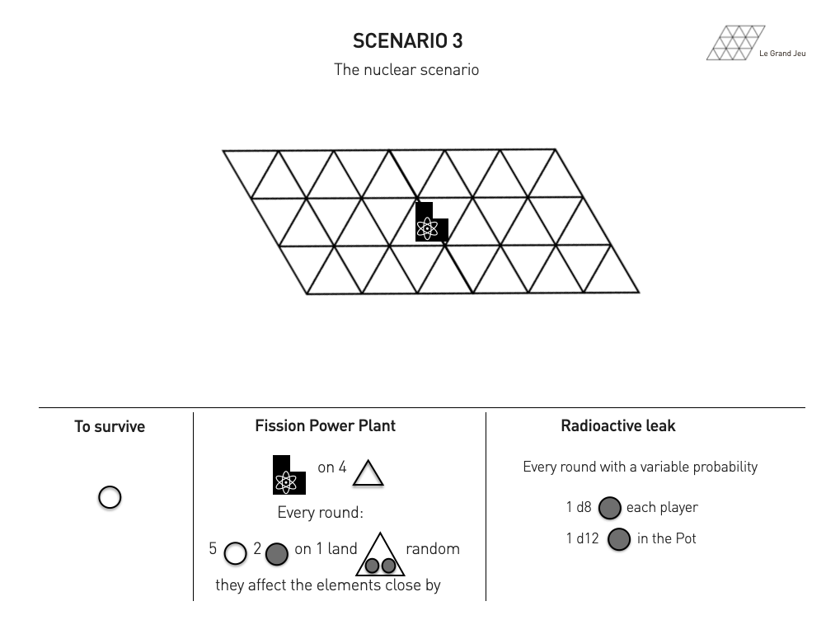

3.7. Emergence of Fusion

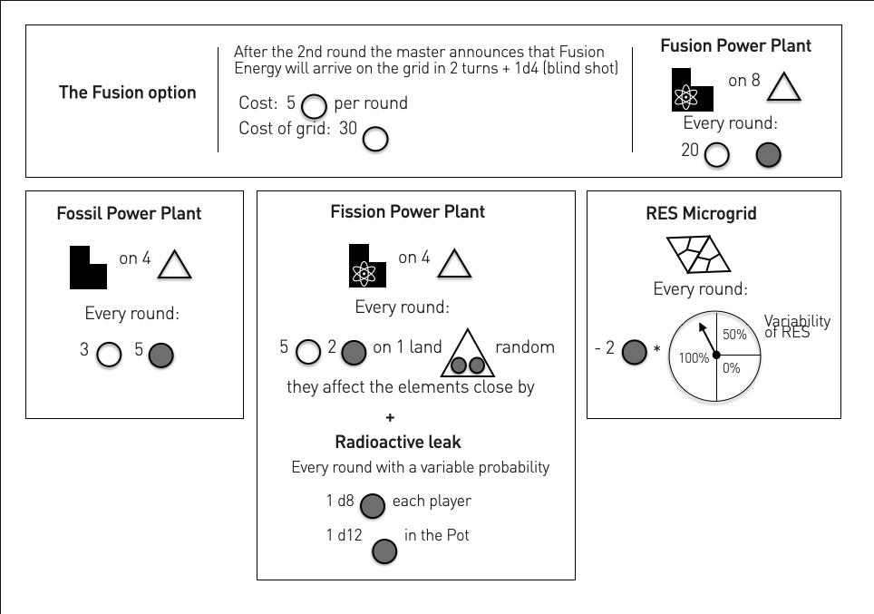

3.8 Scenario 4: The Hybrid Grid
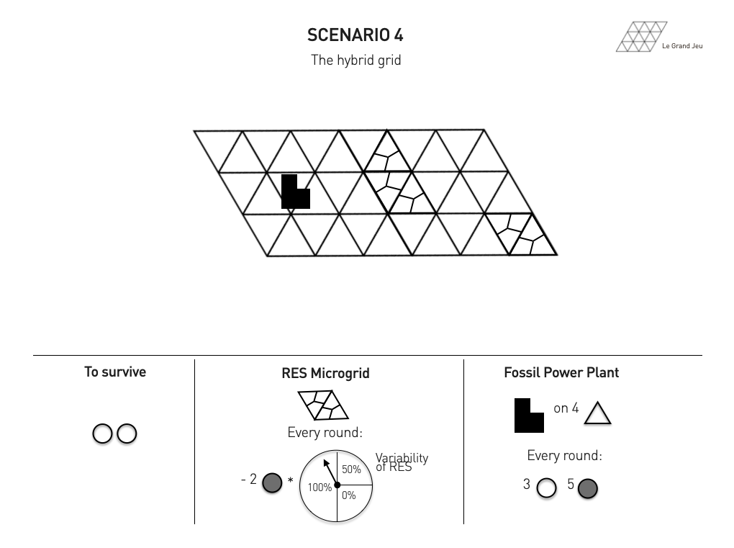

3.9. Scenario 5: The Hybrid nuclear grid
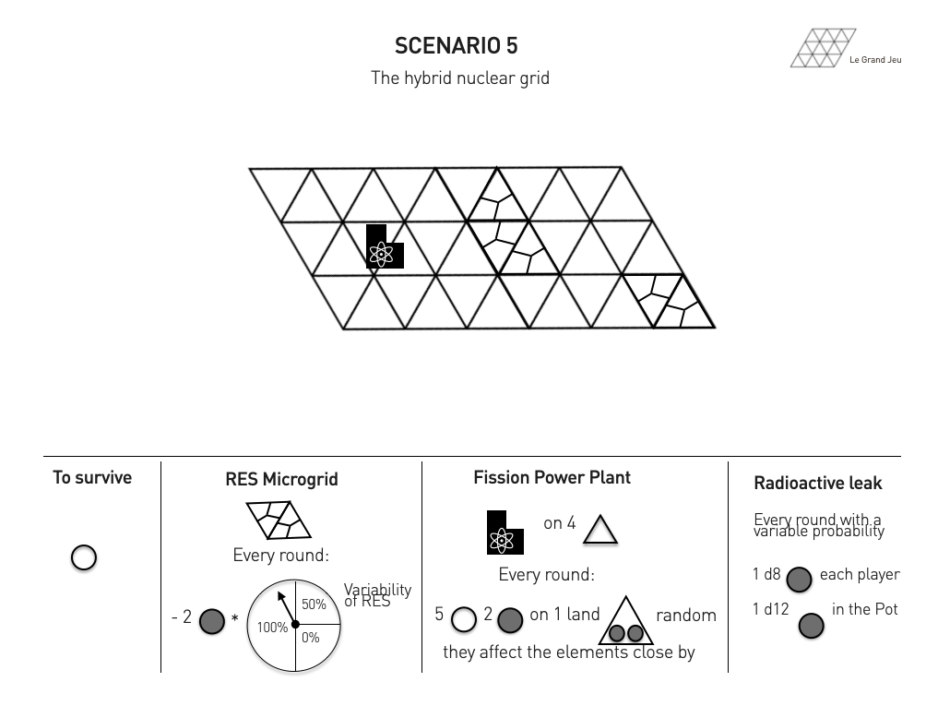

3.10. Scenario 6: The Two Islands
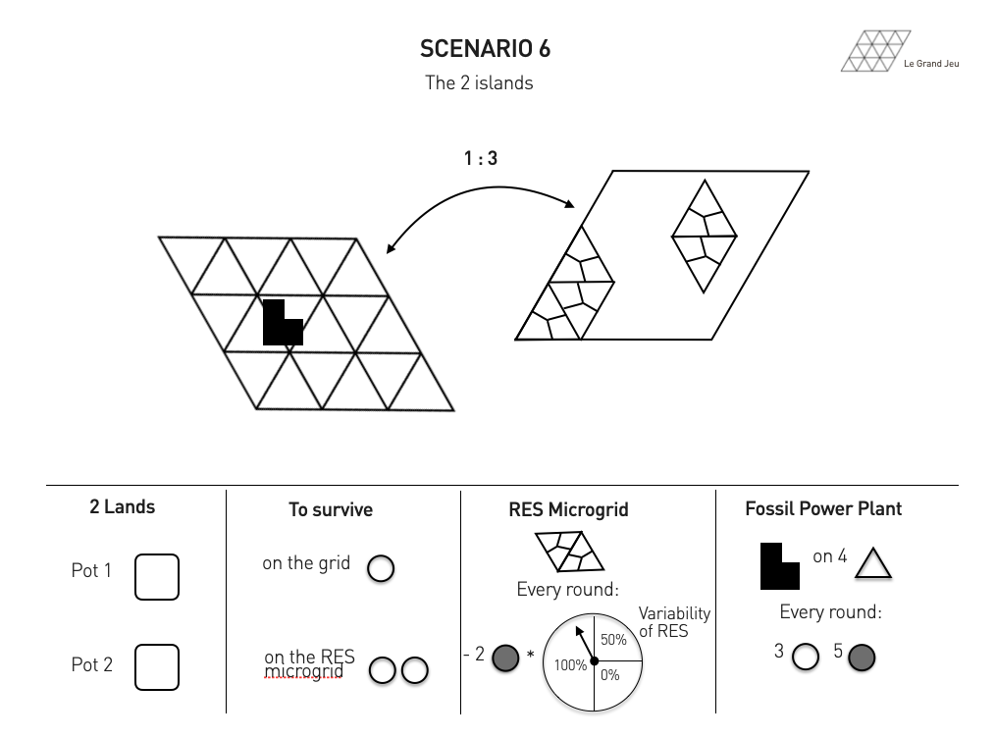

3.11. Events all around you and in between

3.11.1. Events in general

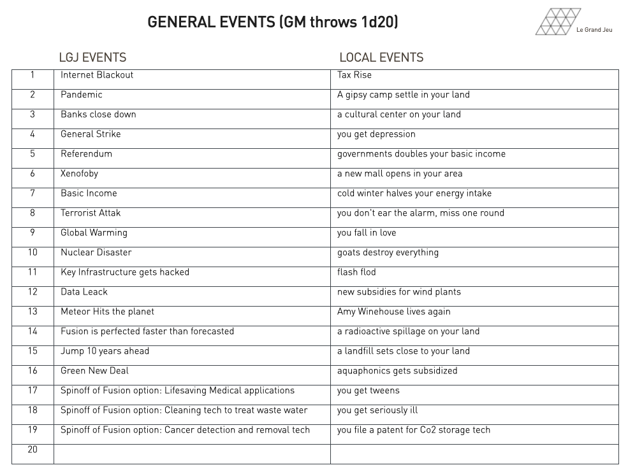

3.11.2. Events suggested for scenario 1
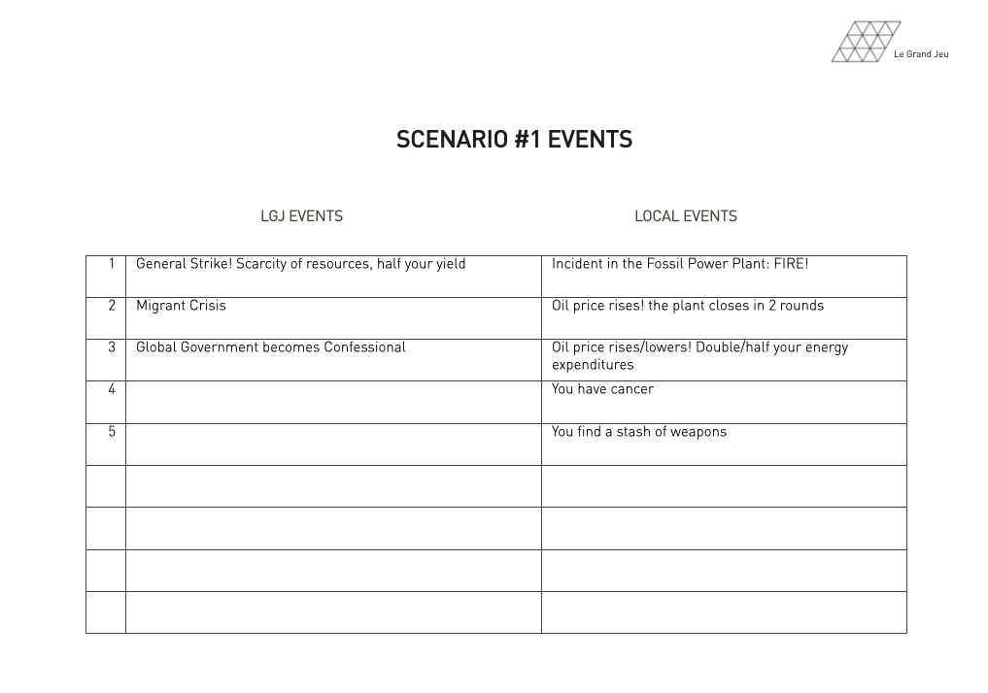

3.11.3. Events suggested for scenario 2

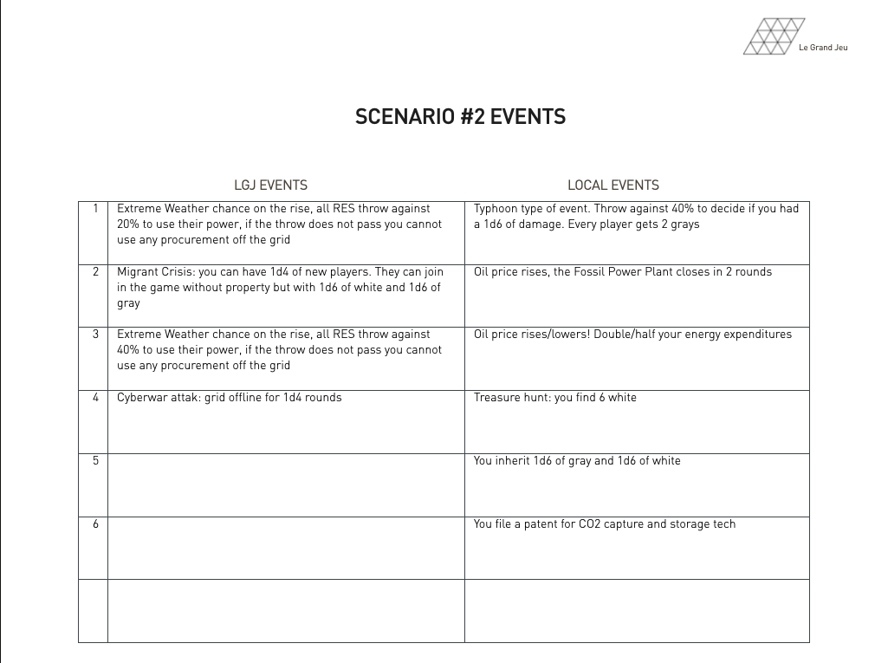

3.11.4 Events suggested for scenario 3
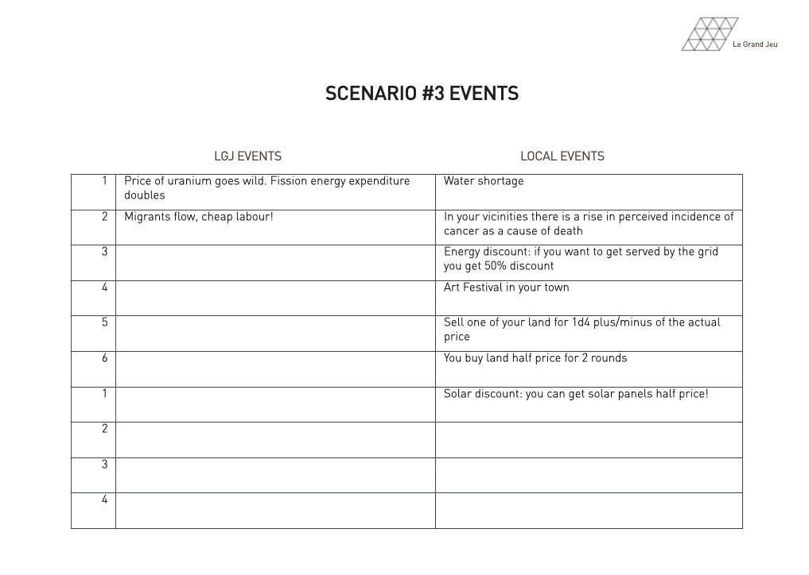

3.11.5. Events suggested for scenario 4
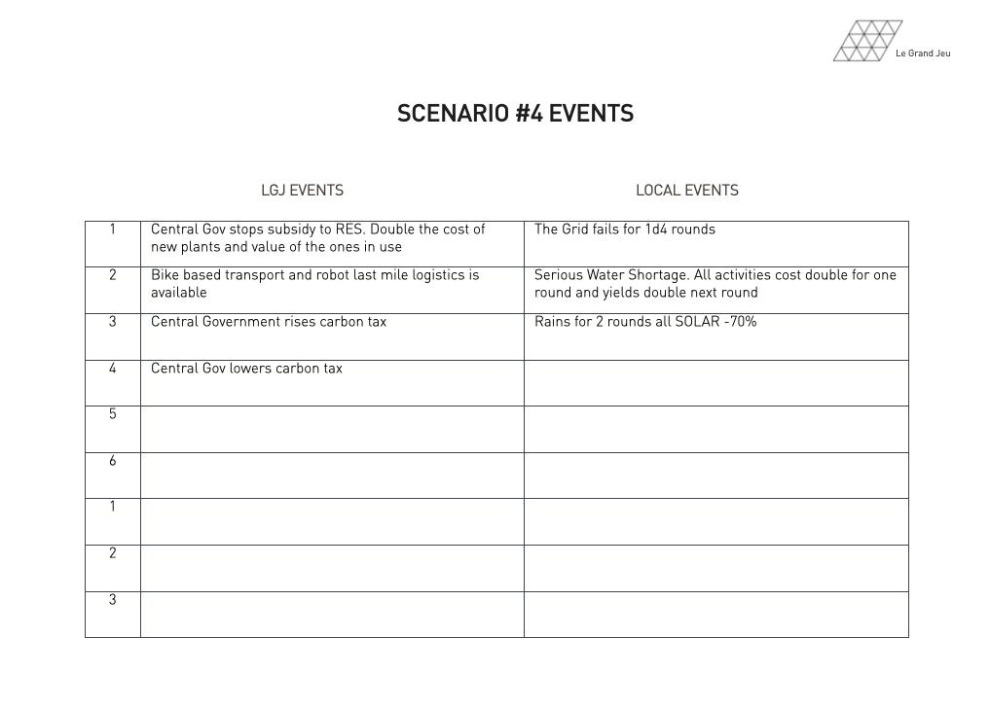

3.11.6. Events suggested for scenario 5
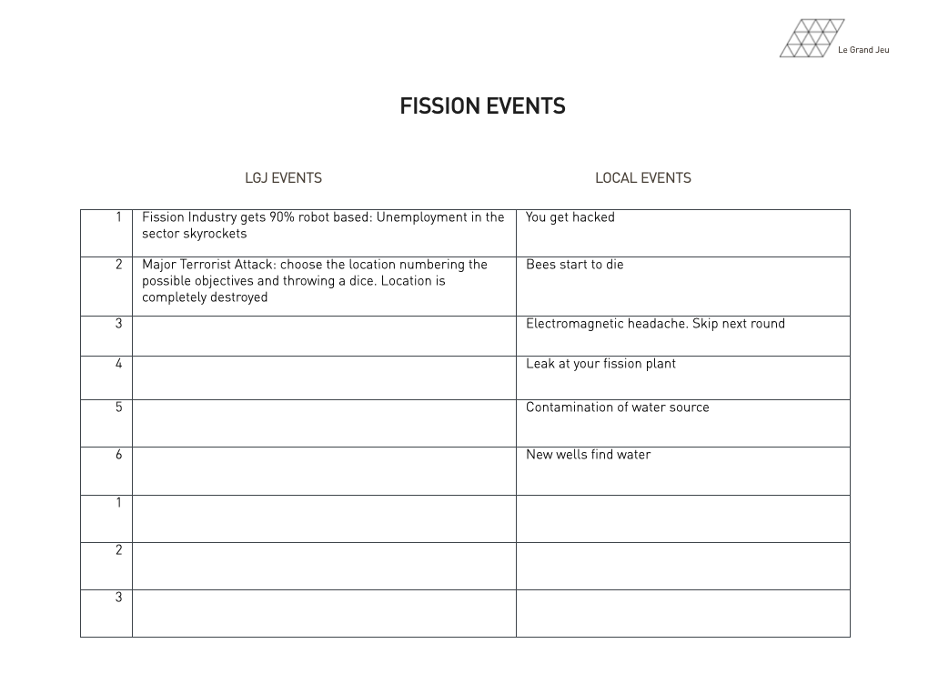

3.11.7. Events suggested for scenario 6
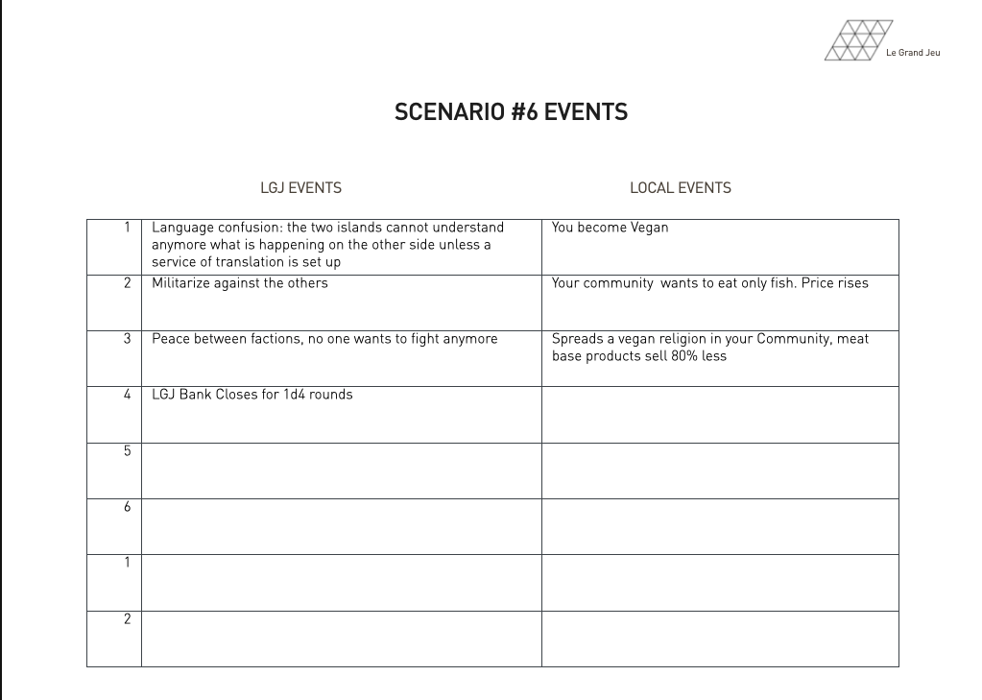

3.12. Scenario for FUSECom Master Training: Addiction+Grid
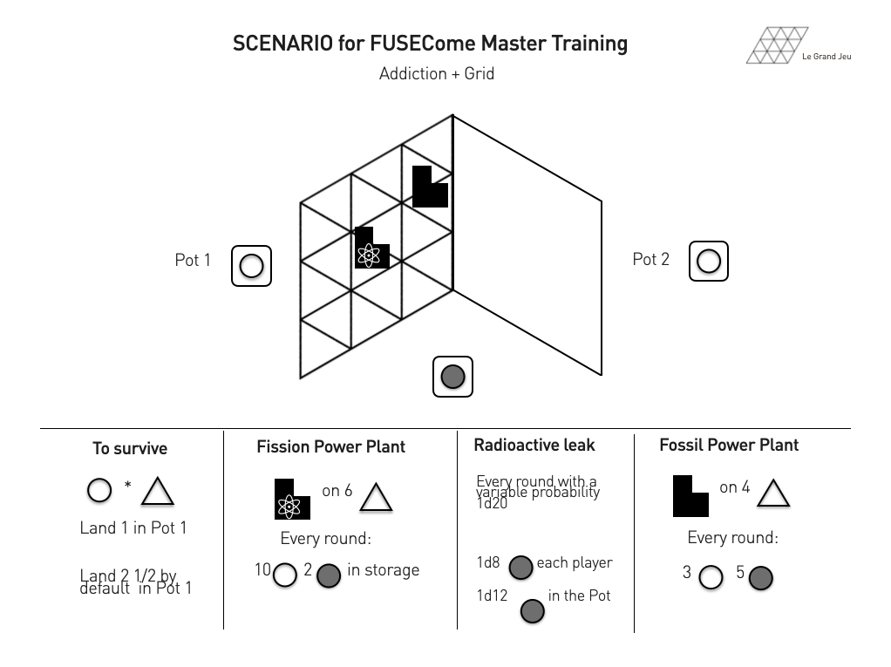

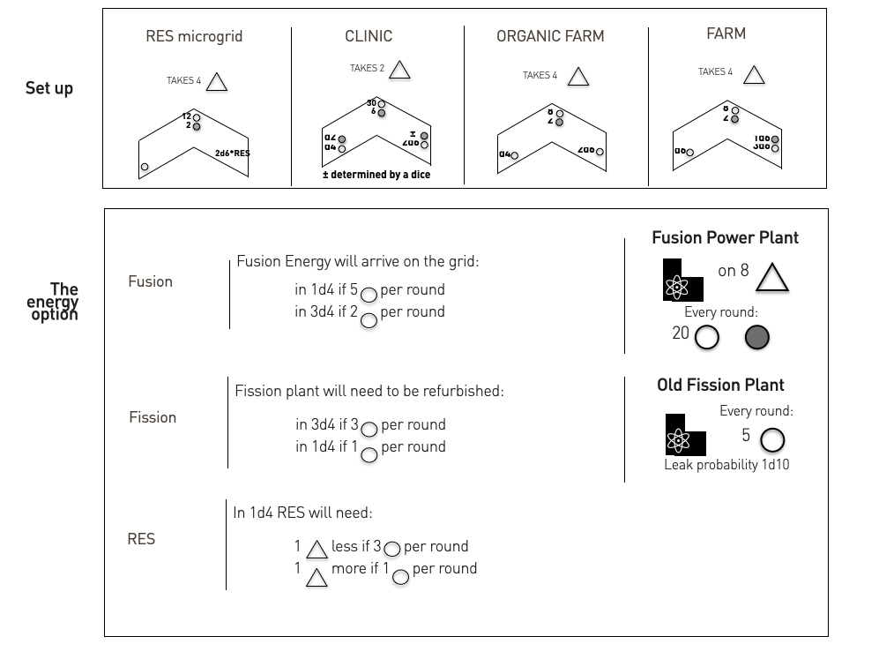

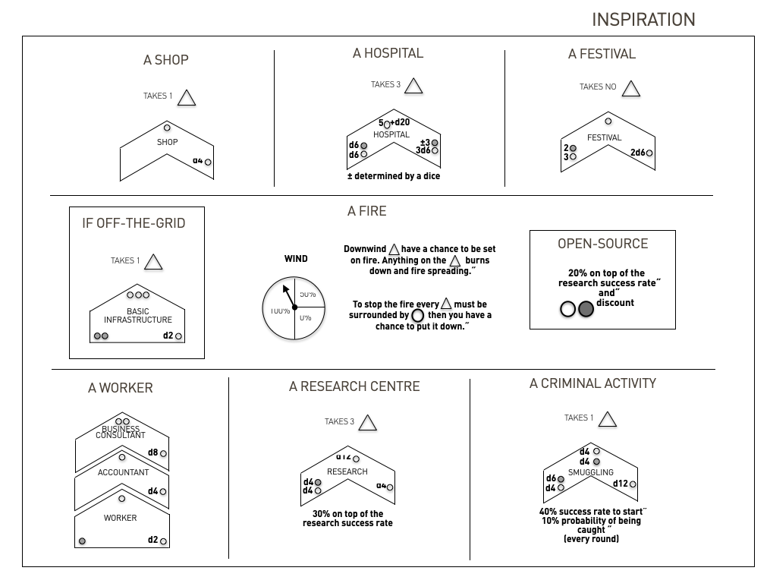

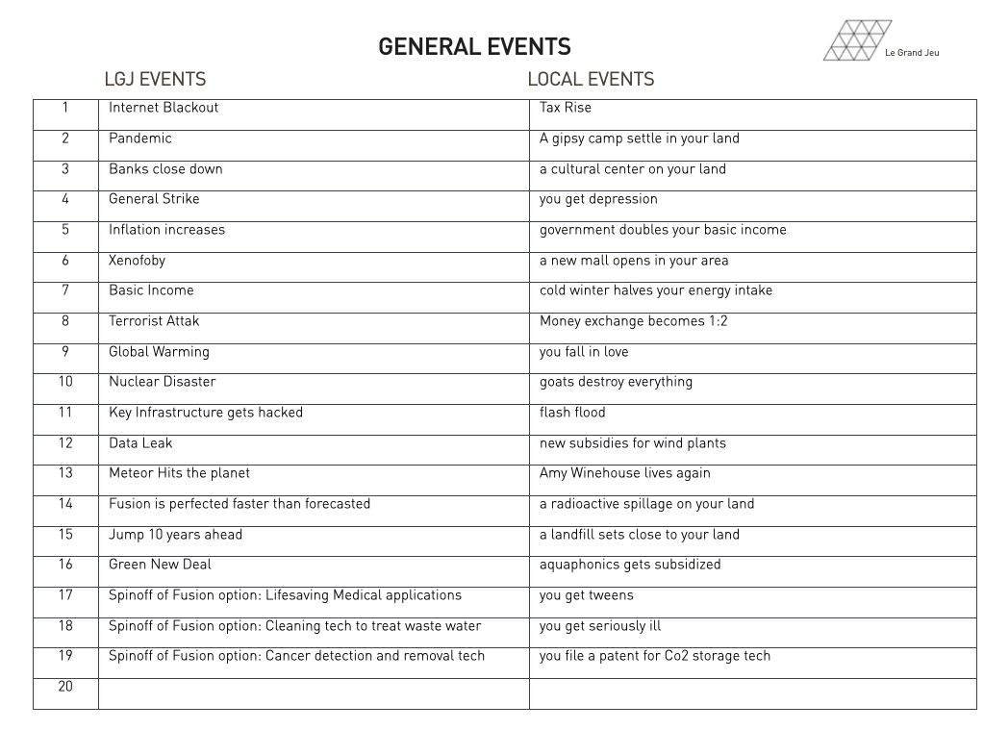

4. Mastering and Documenting Games
Mastering Focus and Documentation
- STRESS LEVEL. Balance feeling challenged (learning) and empowered (understanding)
- CREATIVITY LEVEL. Balance creativity/openness and constrains/structure
- ENGAGEMENT LEVEL. Balance participation and game tempo

4.1. Game Assessment

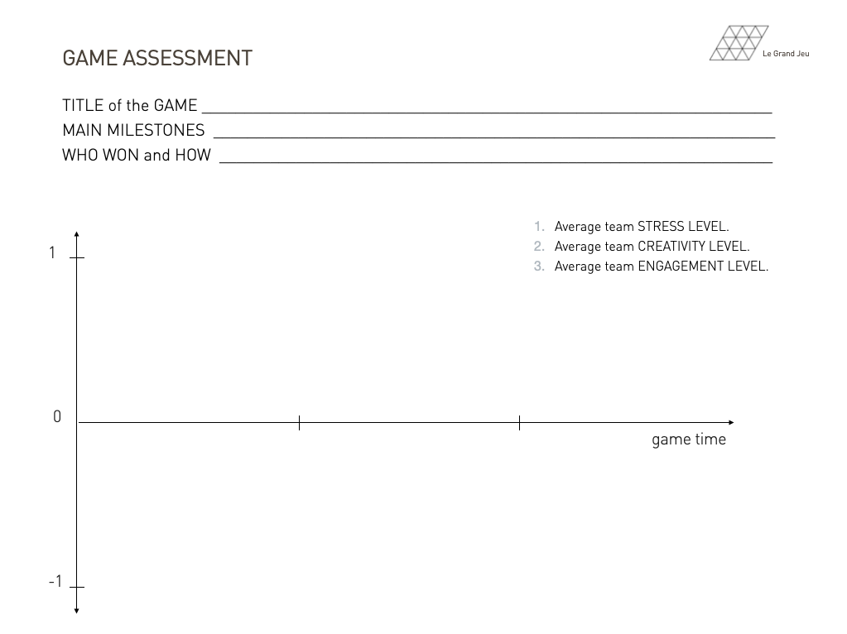

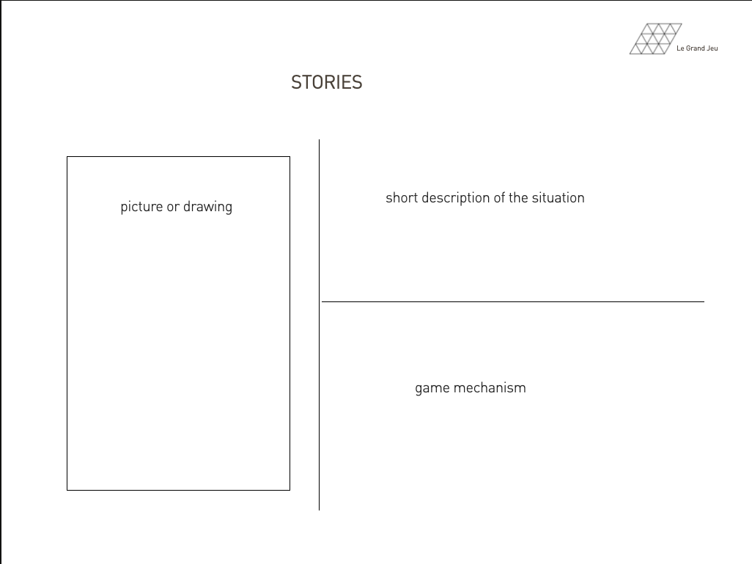

5. Conclusions

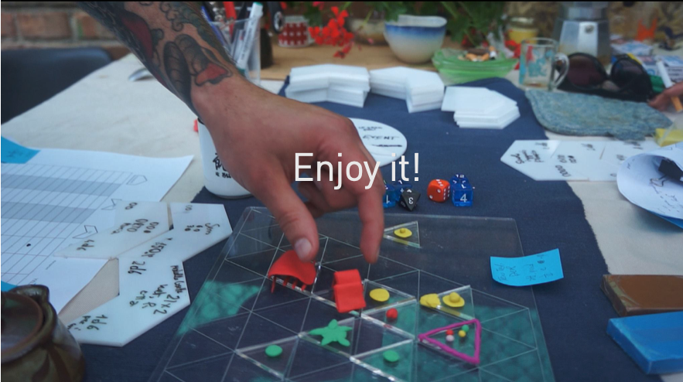

ABOUT THE AUTHORS
Federico "fredd" Bonelli
Fredd is passionate about creative research, a term without boundaries. He is interested in developing talent mentoring and consulting. Sometimes it involves walking in the woods blindfolded.
His repertoire of experiences have led him to several EU funded research projects, a one-of-kind experimental projects. As an artist he has covered many roles in many projects in the years for independent cinema, theatre and performance, visual and digital arts.
Since 2012 he is running a laboratory for sustainable off the grid performance research named trasformatorio (www.trasformatorio.net). Trasformatorio is a neologism for Art Laboratory and Transformations. The methodological insight learned from the lab enriched the methodology “trasformatorio”.
He has a degree in philosophy
fredd@trasformatorio.net

Raffaella "raffa" Rovida
Raffa is a researcher passionate about trans-disciplinary research and environmental issues.
She led the Research unit of the Copenhagen Institute of Interaction Design (www.ciid.dk) for 5 years where she successfully delivered H2020 projects on digital dialogue in cultural spaces, ethics in technology, STEAM and practice-based learning and prototyped a participatory installation for the EUROfusion Expo.She is partner of a consultancy company (www.team.it) active in the European project field where she has been working for 10 years as a researcher and project manager, dealing with urban regeneration projects, simulations of complex systems (System Dynamics), Circular Economy and Life Cycle Assessment.
She has a degree in Civil Engineering from the University of Genoa (Italy) and a PhD in Sustainability and Regional Planning from the University of Brescia.
rr@raffaellarovida.eu

CREDITS
- Co-Design sessions:
  - Dpt. Physics, Technical University of Denmark (DTU), February 2020;
  - Remote sessions between Panama and Amsterdam, September-October 2021
- Box Design: Daniela Iafrate
- Test Players: Mohamed Belhorma, Cristina Vignone, Simona Tarantino, Heidi Estibaliz Gutierrez Espinoza, Søren Bang Korsholm, Alexander Simon Thrysøe,

THANKS TO: DTU.DK, WEMAKE.CC

© 2016-2021 Federico Bonelli – Raffaella Rovida
This work is licensed under
Creative Commons Attribution-NonCommercial-ShareAlike 4.0 International License.

www.legrandjeu.net | twitter @legrandjeu11

