Iterations

Iteration 1: Imagine you are a Golf club owner and you were setting up a tournament. Normally this would be done on paper. This is risky because the paper is so easily damaged and lost. The aim of my first iteration is to be able to load up a tournament template and fill in the players first and last name. Then you enter the score for each hole which is then used to calculate the finally score which then can be ranked. Initially the template is an excel file which is loaded. Eventually I will make the score sheet part of the program and not a separate file. This means that everyone one that is part of the tournament will be able to access the score sheet which will be constantly updated. So far there is two templates one for a 9-hole game and one for a 18-hole game. I would also like it to automatically load the players in the tournament into the score sheet instead of manually having to enter them. The templates are stored on the Github Repository so are easily accessed by a user and come as part of the application.

Things to sort out: You can’t create a tournament and add a photo but because you can’t add a photo you can’t create the Tournament meaning it exits with a “'Newtonsoft.Json.Linq.JObject' to type 'Newtonsoft.Json.Linq.JValue'”. To solve this problem I need to work out how to add a file in the initialization of that object . Another problem is that you can’t add players either. Considering these are both action required events that gives a hint at the problem.

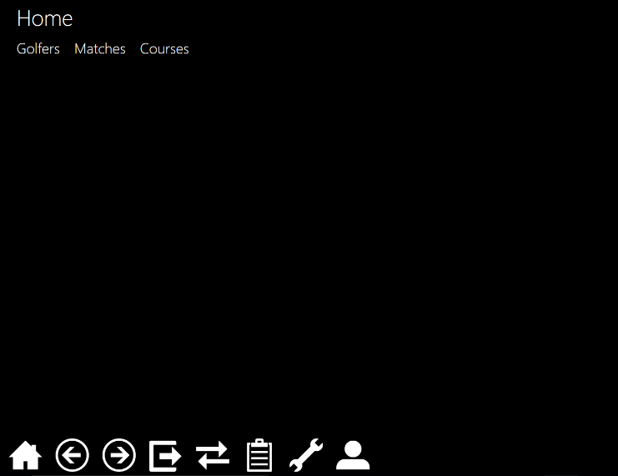Write up:

Step by step guide of how it works:

This is the main menu

It consists of 3 options. This is different to what was first purposed but when it comes to the application it can be changed. The main aim is ease of use. To create a match you just click on matches. This leads you to the next photo. So far there is two options on matches to complete this iteration. You can either create a new match/ tournament or you can see the existing one.

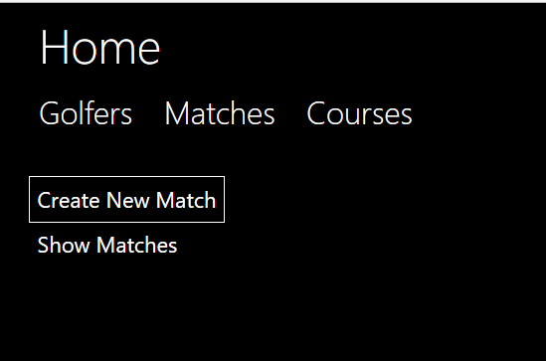

Once show matches is clicked there is a list of matches that have been created in this example there is on Stowe 1st team but many more can be created each match has further detail which has the course name, date of match and match title. Each match also has actions. They’re 2 actions one is add golfers. This is so that you can add your team as a manager to the match.

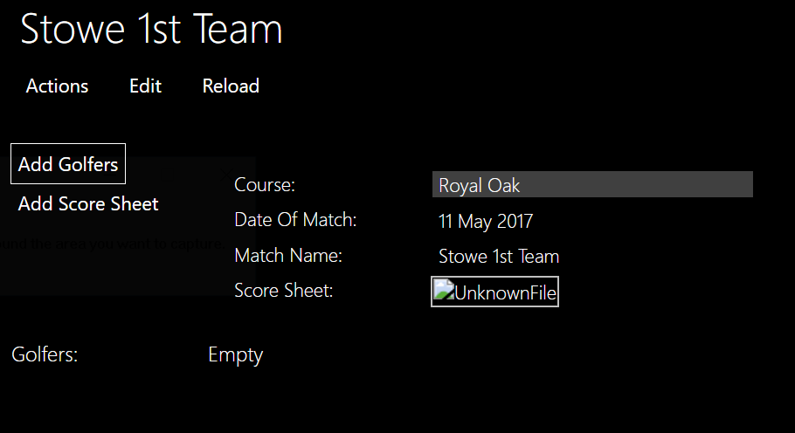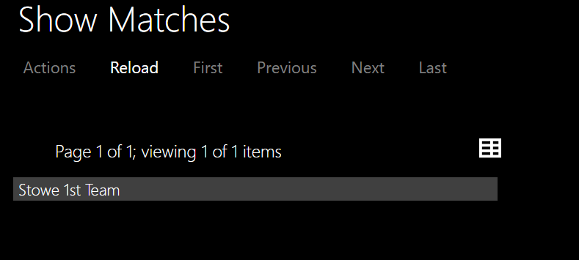

If you chose to add golfer you can split your screen giving half the screen at main options and the other half were u left off this means that you can drag and drop a golfer from the list of golfers that can be edited at any point. This is shown below.

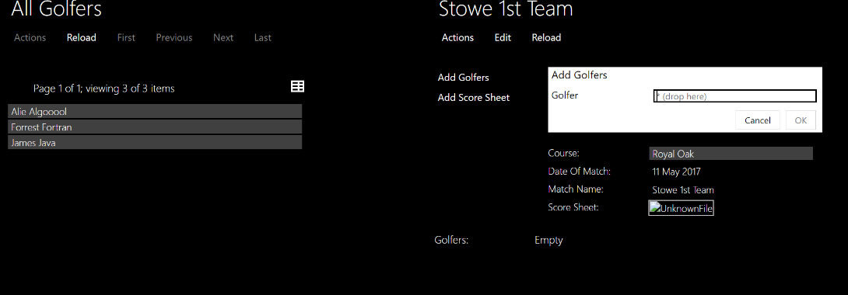So far you can add as many golfers as you want.

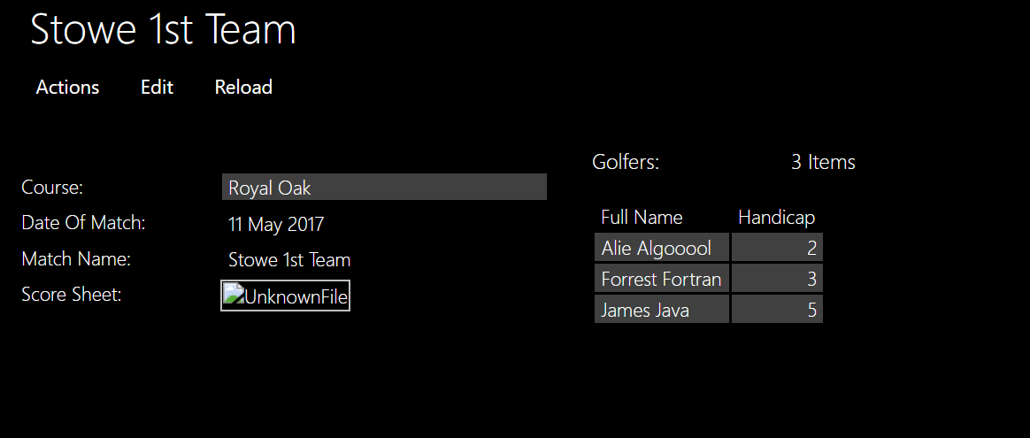

The other action was add score sheet this is done by using a file attachment.

When you click on the file attachment a pop up of a spread sheet comes up which can be edited. In a future iteration the score sheet will be a part of the application rather than a file attachment this means the golfers will be automatically added and so would the number of holes. Also each hole will have its own characteristics meaning that it will have a hardness rating.

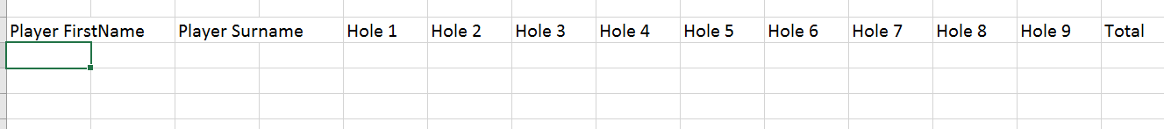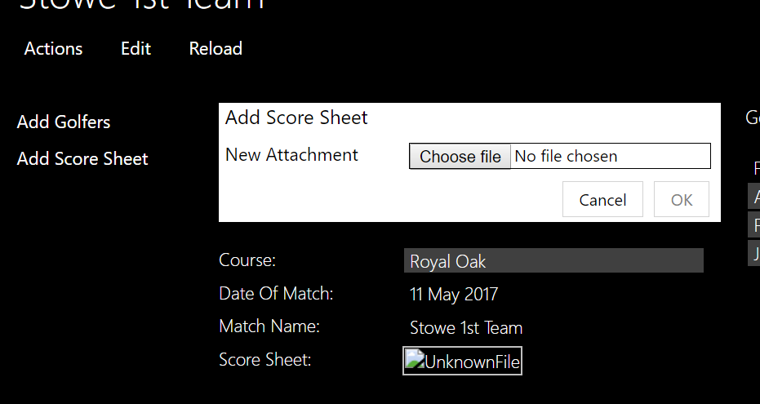

A finished match template looks like :

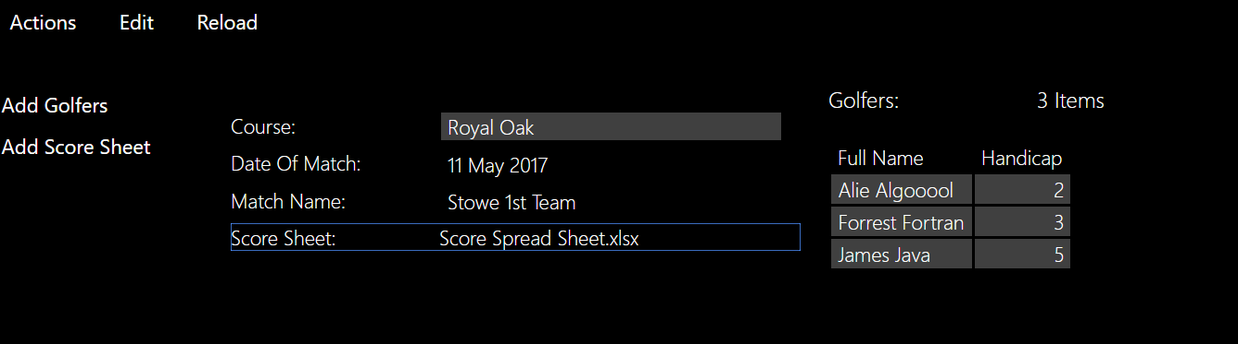

If you want to know more about the course you can just click on it and another page will pop up with all the detail about that course. This will be used with the scoresheet in further iterations.

This is great for families wanting to come watch cause they can find out where the club is. In future the location will be more advanced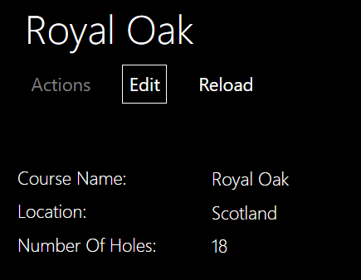 with maybe a map showing the location.

Secondly creating a new match is really simple and easy on choosing that option this page pops up:

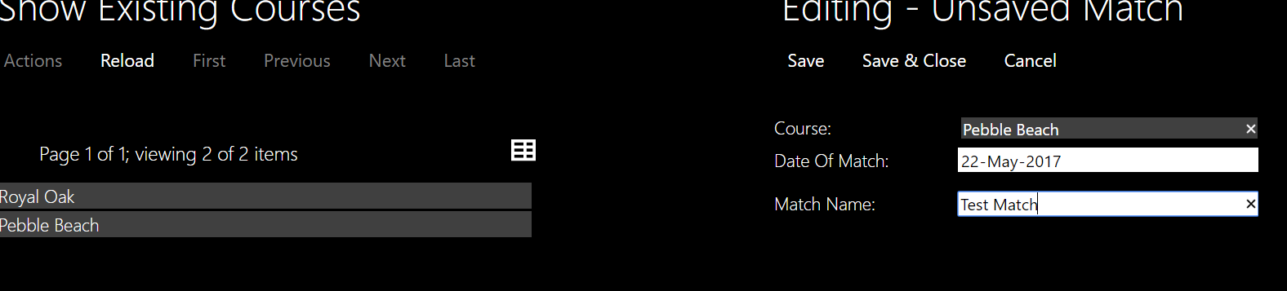

Once again to add a new course you need to go split screen and drag and drop. The Date is really cool and you just click the day on a calendar that comes up. Once you press save that match will now be on the list for anyone to see and can be edited, golfers can be added and a score sheet can be added.

Iteration 2:

Aim: To create a collection of holes with each course meaning that each course has a certain amount of holes and each hole has a distance, hardness and par. This will become very useful for scoring and will make an important addition to the scoring.