Record Section

Your working at a golf club and you have been tasked with finding golfers available for a high level golf match. These golfers would need to have a handicap below 5 and not currently be in a match or tournament.

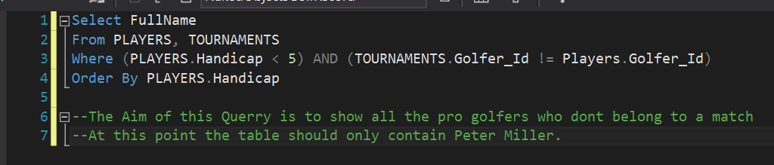

The Table should only show The Full name but instead I was met by:



To try and debug this error I attempted to reduce the query to a simple test:

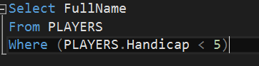

But this was met by the same error.

Querry NO.2

As a Club manager or tournament organizer sometimes little events are thrown for example a putting contest on the practice green or a father son event. The query below finds the people who are most likely to express an intrest in this event and loads there email supplying easy access to contact them.

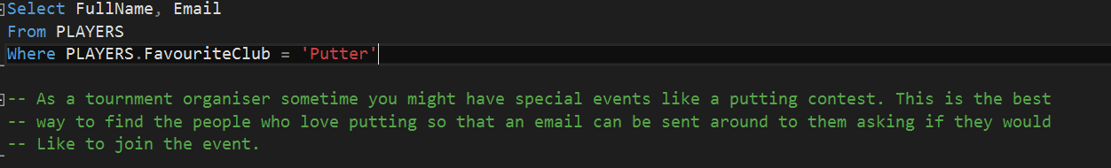

The output should look like:

|  |  |
| --- | --- |
| GolferNAme | GolferEmail |
| GolferName2 | GolferEmail2 |
| GolferName3 | GolferEmail3 |
| GolferName4 | GolferEmail4 |
| GolferName5 | GolferEmail5 |

Unfortunately I still have the System out of memory email which I can’t seem to get rid of.

Query NO.3

Since Golf is a sport that evolves around data and imformation. It is important to have an efficient way of receiving the history of each player with their scores on each hole.

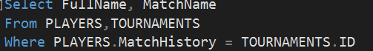

This will not work since Match History is a collection within Players and can’t be accessed in this format