# Testing

Since my project is a multi-user application which runs on one device currently I will be using Microsoft Edge and Google Chrome to simulate two different users on two different devices.

## Test 1 : Creating a New Account.

Creating a new account is a really simple process which involves two steps. The first step is logging in using the auth0. This can be done using a Facebook, Google or Auth0 account. This was mention in the Authorization section of the Technical Solution. The screen shot below shows the interface that meets the user after they have just login to Auth0.

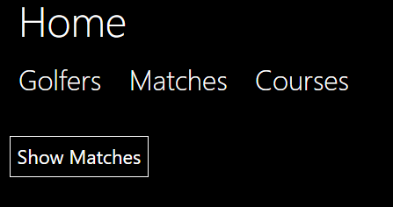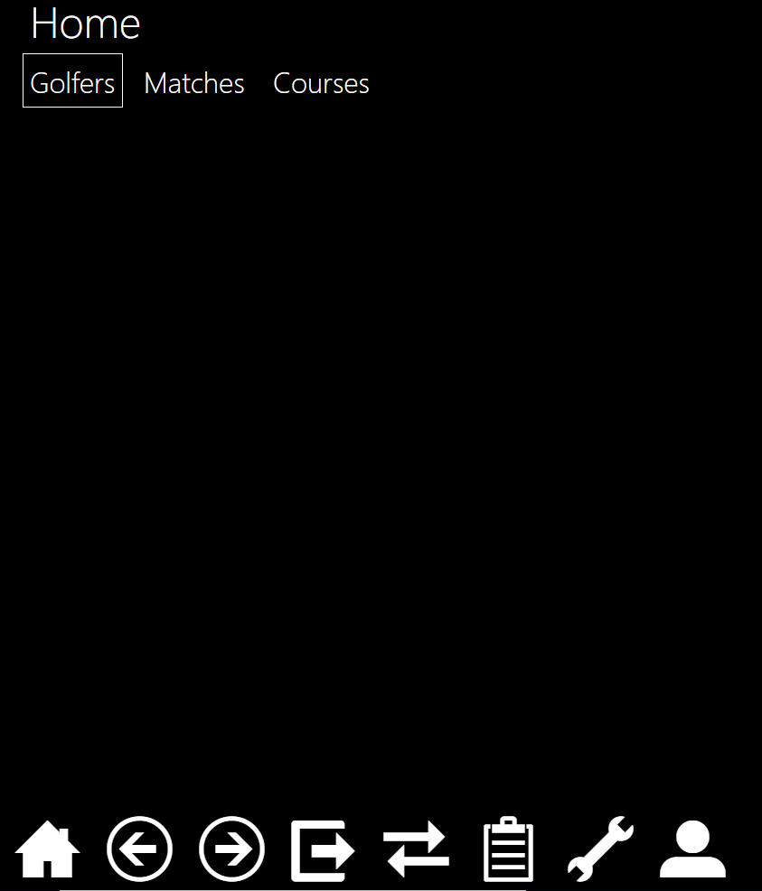As a new account the user hasn’t currently created a golfer, this means that certain aspects of the application should not be accessible. An example of this is that the user shouldn’t be capable of creating a match. The new user shouldn’t be able to create a group join a group of send a message to a golfer. All of this methods have been hidden using authorization. As each of these methods and actions are on separate objects I have only shown the screen shot for not being able to create a new match.

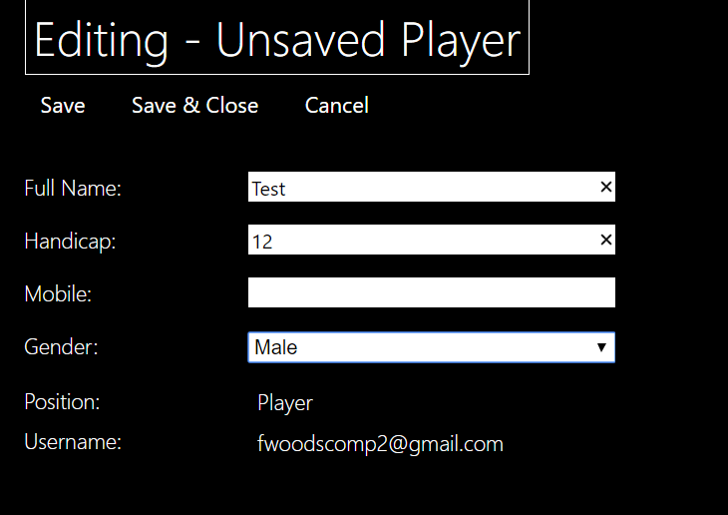

To create a Golfer the new user must press “Golfers” and then press me upon pressing “Me” they are met with this screen shot. The “Position” and “Username” is not editable this so that only a systems manager can create a club manager or change their position. The username is used to identify a golfer and is taken from your login with Auth0 therefore it can’t be changed.

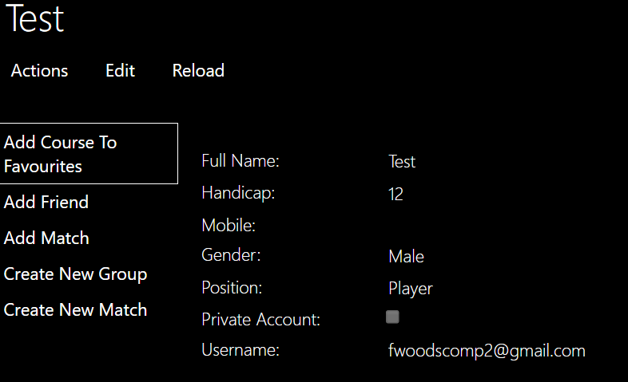The new user then fills in all the details but has left mobile blank as it is an optional parameter. From this moment he can create a new match join groups add friends as seen in the expanded actions. The new user than decides to edit their self and add their phone number but they want their account to be private meaning that no-one can see their mobile. To do this they press edit and tick the box labelled private account.

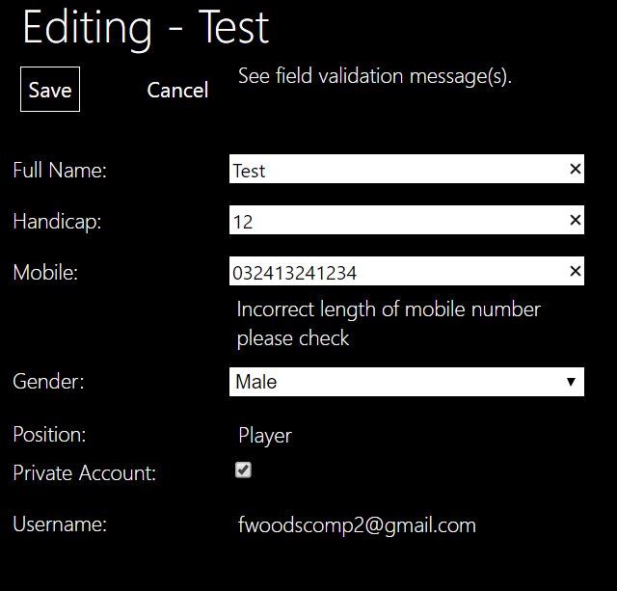

When the user enters their phone number they make a mistake but due to one a validation complementary method added to Mobile the user is warned and can’t save the changes until the mobile is the correct length.

To show the private account is working another user logins and looks at the new user’s profile. The two screen shots below show the new user’s profile once with private account ticked and the other when the account is not private.

