|  |  |  |
| --- | --- | --- |
| **Date** | **Number of Hours** | **Description of work done** |
| October 4, 2025 | 1 | **Reviewed submission feedback.** Developed and added the detailed Core Application Modules (3.2) and the specific Data Analysis Plan (3.4). Updated the Project Timeline (4.0). Final review and formatting of the expanded proposal document for length and coherence. |
| October 5, 2025 | 3 | **Project Scaffolding & Core UI Structure**. Set up the initial React Native project structure using Expo. Created the foundational file and folder architecture (e.g., /screens, /components, /assets). Developed the core application shell, including a basic navigation stack and the main "Browse" screen layout. This implements the high-level structure visible in the provided Fooditude mockup. |
| October 6, 2025 | 2 | **Developed Reusable Food Item Card Component.**Created a reusable React component (FoodCard.js) to display each food listing. The component was styled to match the mockup, including placeholders for the image, title, description, tags (Vegan, Gluten Free), location, quantity, and expiry status. This component will be used to render all items in the list. Repo Check-in: Committed and pushed the FoodCard component with the message "feat: create reusable FoodCard component with mock data". |
| October 7, 2025 | 3 | **Implemented Static Data Model & Main Browse Screen.**Defined a structured JavaScript object model for a food listing, including all fields from the mockup (title, description, dietary tags, location, quantity, expiry). Populated a mock data array with the four listings from the provided image (Fresh Organic Vegetables, Homemade Sourdough Bread, etc.). Integrated this data with the FoodCard component on the main Browse screen to create a static but fully rendered list of items. Repo Check-in: Committed and pushed the updated Browse screen and data model with the message "feat: implement static data model and render food list on Browse screen". |
| October 8, 2025 | 2 | **Added Search & Filter UI Components**. Implemented the user interface for the search and filter functionality. Added the "Search food items..." input bar and the "All Categories" / "All Dietary" filter buttons to the top of the Browse screen, as shown in the mockup. The functionality is currently visual-only (non-functional) but establishes the complete user interface. Repo Check-in: Committed and pushed the search and filter UI with the message "ui: add search input and filter buttons to Browse screen". |
| October 9, 2025 | 2 | **Analyzed Feedback & Initiated Repository Setup.** Reviewed the instructor's feedback on the first report. The key action points were: 1) Increase tangible, code-related work, and 2) Establish a properly named and registered Git repository. Initialized the repository with a README.md project description. |
| October 12, 2025 | 1 | **Final Review, Documentation, and Report Preparation**. Conducted a final review of the codebase for the past two weeks. Updated the README.md file in the repository with setup instructions and a summary of the current progress. Zipped the project report and all related documentation as per the instructor's previous feedback to ensure a clean submission. |

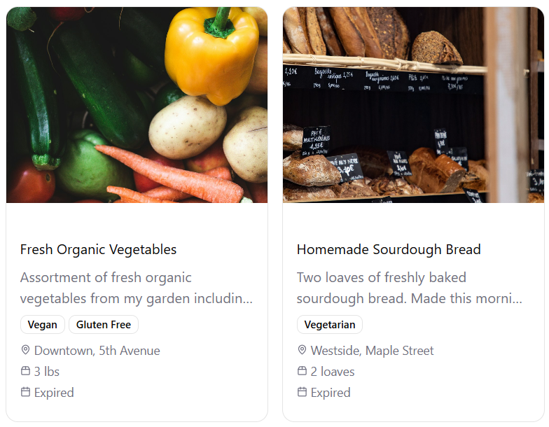

This progress report details work completed between October 4 and October 12, 2025, on a React Native application, totaling 14 hours.

The work began with planning and reviewing feedback, then moved into active development. Key accomplishments include:

* Setting up the initial project structure with Expo.
* Developing the core application shell and navigation.
* Creating a reusable FoodCard component to display food listings.
* Implementing a static data model and populating the main Browse screen with mock data.
* Adding the user interface for search and filter components.

Version control, with regular commits to a repository. The period concluded with a review of feedback, repository setup, and preparation of the final report for submission.