1 Power-On Self-Test (POST):

Explore the role and functions of the POST in the computer boot process.

Analyze the interaction between the POST and system hardware.

The Power-On Self-Test (POST) is a critical initial step in the computer boot process, conducted by firmware BIOS (Basic Input Output System) or UEFI(Unified Extensible Firmware Interface) to ensure that essential hardware components such as the CPU, memory, and input/output systems are operational before loading the operating system. Upon powering on, POST executes tests to check the hardware's integrity. If device failures are detected, POST signal errors via audible beeps or error codes are displayed on the monitor. This helps with troubleshooting eventual errors with the device.

2 Boot Sequence Post-POST:

Detail the sequence of events after a successful POST, highlighting the role of BIOS or UEFI.

Upon successful completion of the Power-On Self-Test (POST), the BIOS or UEFI proceed to the next stages of the computer's boot process. The BIOS or UEFI begins by searching for a bootable device, such as a hard drive, SSD, USB drive, or network source. Once a bootable device is identified, the BIOS or UEFI reads the boot sector, which contains essential code to initiate the loading of the operating system. This sequence effectively bridges the gap between hardware initialization and software execution, allowing the operating system to take over and manage the computer's operations.

3 Bootloaders:

Investigate different bootloaders, their functionalities, and their unique features.

Discuss the considerations for choosing a particular bootloader and the potential benefits.

Consider the process and challenges involved in manually implementing a bootloader.

Bootloaders, critical in the system boot process, come in various forms, each tailored to specific requirements. Popular bootloaders include GRUB (GNU GRand Unified Bootloader), LILO (Linux Loader), and the Windows Boot Manager. GRUB supports multiple operating systems, offering a configurable menu that simplifies system management. Windows Boot Manager is used for booting Windows and offers recovery tools and troubleshooting options.

Choosing a bootloader involves considering the operating system, hardware compatibility, and specific features like dual-boot capabilities and custom boot configurations. The benefits of an appropriate choice include enhanced boot flexibility, improved security features, and better system recovery options.

Manually implementing a bootloader requires understanding low-level programming and system architecture. Some challenges include ensuring compatibility with hardware and the BIOS/UEFI, handling disk partitions correctly, and error checking. This process demands thorough testing to avoid system boot failures.

1. **Memory Layout in the Boot Process:**
   * + 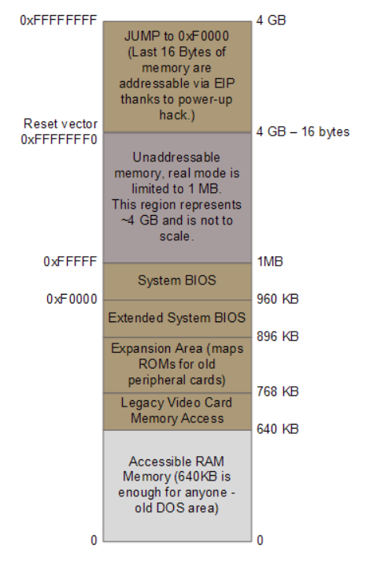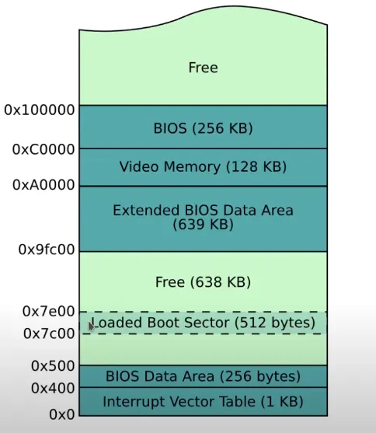

* Between 0x7c00 and 0x7e00 is the 512 byte slot for the loaded boot sector

|  |  |  |  |  |  |
| --- | --- | --- | --- | --- | --- |
| Real mode address space (the first MiB) | | | | | |
| start | end | size | description | type | |
| 0x00000000 | 0x000003FF | 1 KiB | Real Mode IVT (Interrupt Vector Table) | unusable in real mode | 640 KiB RAM  Low memory |
| 0x00000400 | 0x000004FF | 256 bytes | BDA (BIOS data area) |
| 0x00000500 | 0x00007BFF | 29.75 KiB | Conventional memory | usable memory |
| 0x00007C00 | 0x00007DFF | 512 bytes | Your OS BootSector |
| 0x00007E00 | 0x0007FFFF | 480.5 KiB | Conventional memory |
| 0x00080000 | 0x0009FFFF | 128 KiB | EBDA (Extended BIOS Data Area) | partially used by the EBDA |
| 0x000A0000 | 0x000BFFFF | 128 KiB | Video display memory | hardware mapped | 384 KiB System/Reserved  Upper Memory |
| 0x000C0000 | 0x000C7FFF | 32 KiB (typically) | Video BIOS | ROM and hardware mapped / Shadow RAM |
| 0x000C8000 | 0x000EFFFF | 160 KiB (typically) | BIOS Expansions |
| 0x000F0000 | 0x000FFFFF | 64 KiB | Motherboard BIOS |

https://wiki.osdev.org/Memory_Map_(x86)

1. **Boot Process in Modern Operating Systems:**
   * Compare the boot processes of different modern operating systems (such as Windows, Linux, macOS).
   * Reflect on how changes in hardware and software technologies have influenced these boot processes.
   * important sources:
     + https://www.freecodecamp.org/news/an-introduction-to-operating-systems/

## Boot Process in Windows and linux:

The boot process in windows and Linux traditionally started with bios, however, today, bios is effectively no longer supported, and modern hardware now mainly only support UEFI [Legacy BIOS Boot Support Removed in Lenovo 2020 products](https://support.lenovo.com/us/en/solutions/ht510878-legacy-bios-boot-support-removed-in-lenovo-2020-products) the BIOS/UEFI is stored on a chip on the motherboard, provides a more homogeneous interface of the hardware for the operating system to use. It also runs the POST, as described earlier, checking the various hardware and peripherals. If no faults happen, it moves on to loading the MRB, the first 512 bytes sector of the prioritized disk/partition. it executes the code found in the MRB, due to the size limitations, the kernel is not located here, not even the code to find and load the kernel will always fit here. Instead, it will execute code for the boot loader, potentially only the first stage.

### Boot Process in Linux:

In the case of linux the boot loader is called GRUB, short for “GRand Unified Bootloader”. If you have muliple linux kernels installed it will let you pick one, and then it will load that kernel, establish the file system, and load the programs of progressivly higher run levels.

### Boot Process in windows:

The boot loader of the windows operating systems after and including windows vista is BOOTMGR, or the windows boot manager. It runs winload.exe that in turn loads the kernel. https://en.wikipedia.org/wiki/Windows_Boot_Manager

The evolution of technology has significantly impacted the boot process, some examples are: The transition from BIOS to UEFI has enabled a lot of advantages:

-ability to boot from disks over 2TB

-network connectivity, multiple languages, and gui are supported in the pre-OS state.

-support for C and even a python interpreter

- the adoption of Solid State Drives (SSDs) over traditional Hard Disk Drives (HDDs) allow significantly faster boot up times, as reading speeds(and less importantly writing speeds) are significantly faster.

**6. Virtual Machines and Booting:**

* + What is the main difference in the boot process for virtual machines compared to physical machines?
    - ~~Discuss the boot process in virtual machines compared to physical machines.~~
  + What is the role of a hypervisor in the context of virtualization?
    - ~~Analyze how virtualization affects the boot process, including the role of hypervisors.~~
  + Explore the challenges and advantages of booting in a virtualized environment. answer:

Like we have mentioned before, this is the boot process for physical machines:

1. **BIOS**: The process begins with the BIOS, which identifies and configures hardware.

2. **MBR**: The Master Boot Record is checked for the boot loader.

3. **Boot Loader**: Loads the kernel into memory.

4. **Kernel**: The core program of the operating system takes over, initiating further boot tasks, according to the OS.

5. **Init**: The system completes boot-related tasks and starts a login shell.

Here is the process for virtual machines(QEMU):

1. **Start QEMU**: QEMU initiates the virtualization process.

2. **Load Kernel**: The kernel image is loaded into memory from the host.

3. **Start init**: Init is executed from the VM’s root disk. There is no BIOS, no MBR, and no bootloader. Because it can allready rely on the host OS for theese services, it just initiates QEMU, loads the kernel into memory, with the help of the host, and it can then initialise.

It is common to automatically log in on virtual machines, rather than using a login screen like that of a host system.

- hypervisors is a type of software, firmware or hardware that manages virtual machines. In the context of virtualization, a hypervisor plays a crucial role in managing VMs. It abstracts physical hardware resources and allocates them to VMs. There are various types of hypervisors: - native hypervisors that run directly on hardware, enhancing efficiency and resource utilization. - hosted hypervisors that run as a process on the host OS. - hypervisors that are part of the host kernel like [KVM](https://en.wikipedia.org/wiki/Kernel-based_Virtual_Machine)

### Challenges

* **Efficiency**: Virtualized environments introduce overhead due to the emulation layer.
* **Resource Management**: Overly dynamic allocation of resources is has its own set of problems, and when one subsystem is statically allocated resources, or a range of resources. it limits what is available for the other sub systems.
* **Compatibility**: Ensuring compatibility between host and guest operating systems can be challenging, and certain drivers and programs won’t run on virtual machines.

### Advantages

* **Resource Consolidation**: Multiple VMs can run on a single physical machine, potentially optimizing resource utilization, if dynamic allocation is possible, and the subsystems have volatile needs.
* **Isolation**: VMs provide isolation between different operating systems, enhancing security.
* **Flexibility**: Virtualized environments offer flexibility in scaling resources and deploying new instances. Especially the environments specialized for this like docker and Kubernetes. [paywall bypass](https://freedium.cfd/https://josephcardillo.medium.com/the-linux-boot-process-simplified-f8c5e0907bbf)