**THE INSTITUTE OF FINANCE MANAGEMENT**

**(IFM)**



**FACULTY OF COMPUTING, INFORMATION SYSTEMS AND MATHEMATICS**

**BACHELOR’S IN COMPUTER SCIENCE**

**INDIVIDUAL ASSIGNMENT**

**OBJECT ORIENTED PROGRAMMING**

**PROJECT NAME: TOUR WEB APPLICATION**

**IMC/BCS/2010619**

**FRED MAKARANGA**

Tour web application

It is a light web application that gives simple, and critical details about some common regions of Tanzania; such as current population, description on specific region.

Two users’ guest and admin are involved. The guest will navigate to read information on different parts of the web site, while the admin is responsible to for adding users (admin) and information to the web.

UML.

Relationship between classes.

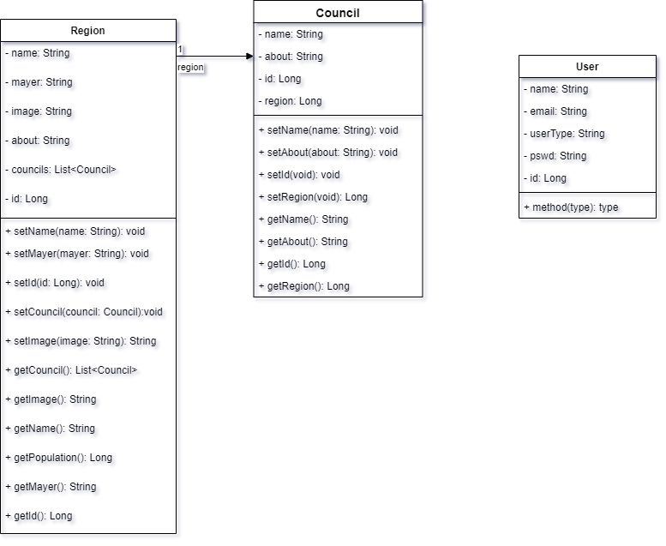

Class object oriented relations.

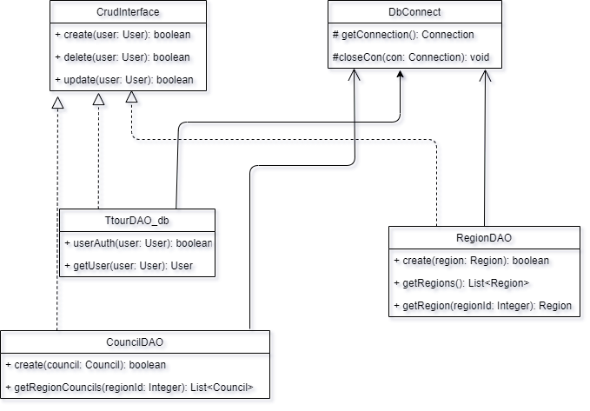

Use cases:

Admin use case.

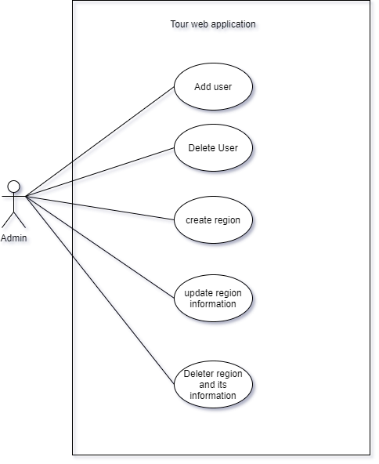

Screen shots representing different pages:

1. The front page

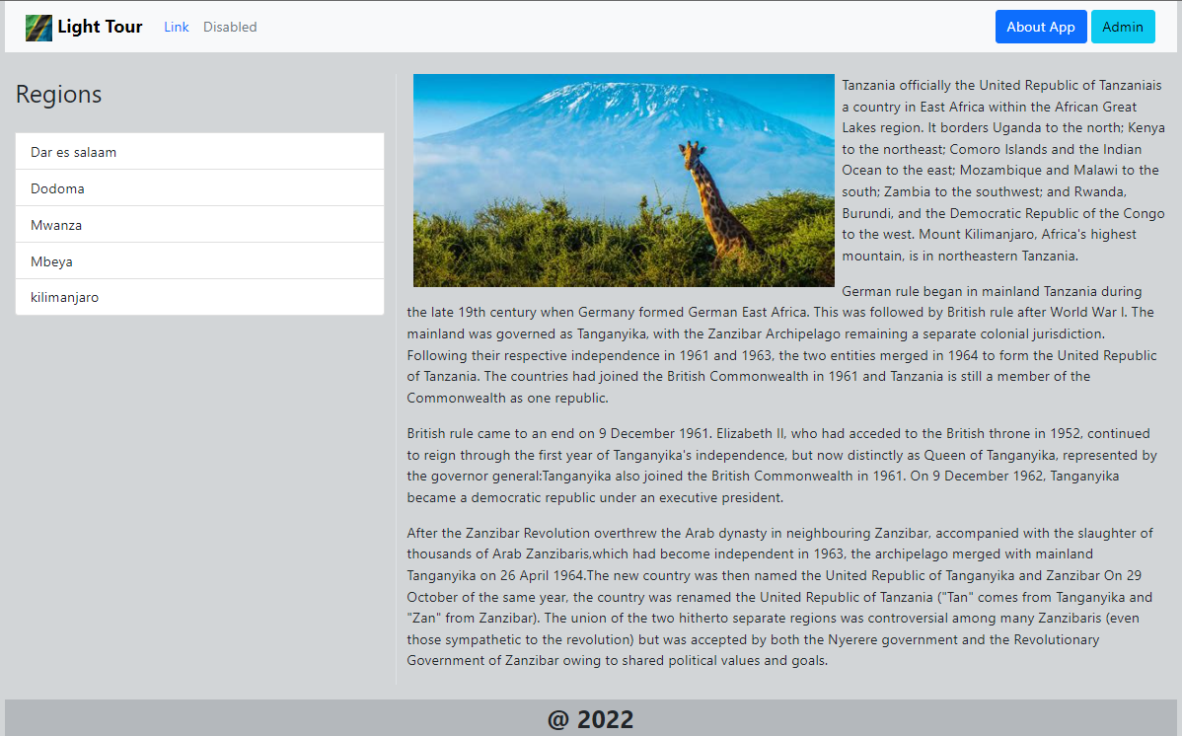

1. One of the region selected

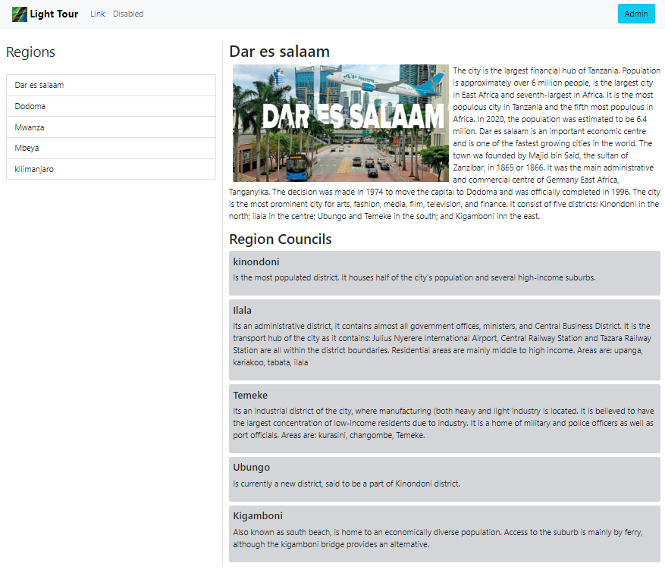

1. Admin page after logging in

