A.freddy chris

(01/10/2020)

**Internship Training Document**

* What is internet?

The Internet is the global system of interconnected computer networks that uses the Internet protocol suite (TCP/IP) to communicate between networks and devices.

* How Does the internet works?

my Computer information-1 information-1 Another Computer

internet

It's important to realize that the Internet is a global network of **physical cables**, which can include copper telephone wires, TV cables, and fiber optic cables. Even wireless connections like Wi-Fi and 3G/4G rely on these physical cables to access the Internet.

When you visit a website, your computer sends a request over these wires to a Server. A server is where websites are stored, and it works a lot like your computer's hard drive. Once the request arrives, the server retrieves the website and sends the correct data back to your computer. This all happens in just a few seconds

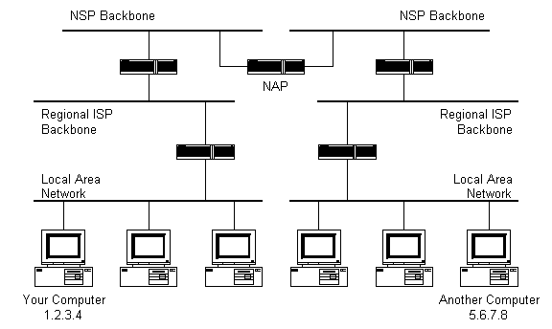

1. Local Area Network

LAN is a collection of devices connected together in one physical location, such as a building, office, or home.

1. ISP

Internet Service Provider used fiber-optics, satellite, copper wire, and other forms to provide Internet access to its customers.

1. NAP

Network Access Point is a set of operating system components that provide a platform for protected access to private networks.

1. NSP

This includes [fiber optic](https://techterms.com/definition/fiber_optic_cable) lines between hubs or "Internet exchanges" that route Internet traffic around the world. These communication lines offer extremely high [bandwidth](https://techterms.com/definition/bandwidth) of hundreds or even thousands of [gigabits per second](https://techterms.com/definition/gbps). The global network created by multiple NSPs enables data to flow seamlessly between computer systems around the world.

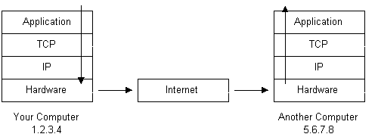

Intranet

Intranet is the system in which multiple PCs are connected to each other. PCs in intranet are not available to the world outside the intranet. Usually each organization has its own Intranet network and members/employees of that organization can access the computers in their intranet.

# (02/10/2020)

What is the browser?

A browser is a software program that is used to explore, retrieve, and display the information available on the World Wide Web. This information may be in the form of pictures, web pages, videos, and other files that all are connected via hyperlinks and categorized with the help of URLs (Uniform Resource Identifiers). For example, you are viewing this page by using a browser.

A browser is a client program as it runs on a user computer or mobile device and contacts the webserver for the information requested by the user. The web server sends the data back to the browser that displays the results on internet supported devices. On behalf of the users, the browser sends requests to web servers all over the internet by using [HTTP](https://www.javatpoint.com/http-full-form) (Hypertext Transfer Protocol). A browser requires a smartphone, computer, or tablet and internet to work.

How does browser work?

When a user enters a web address or URL in the search bar like Google.com, the request is passed to a **domain name servers** (DNS). All of these requests are routed via several routers and switches.

The domain name servers hold a list of system names and their corresponding IP addresses. Thus, when you type something in the browser search bar, it gets converted into a number that determines the computers to which the search results are to be displayed.

The browser acts as a part of the client-server model. A browser is a client program that sends the request to the server in response to the user search queries by using Hypertext Transfer Protocol or [HTTP](https://www.javatpoint.com/http-tutorial). When the server receives the request, it collects information about the requested document and forwards the information back to the browser. Thereafter, the browser translates and displays the information on the user device.

**(03/10/2020)**

What is DNS?

DNS stands for **Domain Name Server.**

When we access a website, we are using this service to locate the server where the domain’s website is located. When browsing the web, we usually type in a domain name like www.google.com into our browser. This is better than trying to remember an IP address linked to a Google server.

[www.google.com](http://www.google.com) -> 172.217.12.46

**Step 1: Information Request**

You put the domain name (www.get.tech) in your web browser and it will run a DNS query to find the answer as to where the website is located. The DNS resolver is like your middleman.

**Step 2: Root Name Servers**

The DNS resolver asks the root name server for the IP address. They don’t have the answer to your query, but they know where to find it. The response from root name servers is the address of the TLD (Top-Level Domain) Name Servers.

In the case of www.get.tech, it’s .TECH name servers.

**Step 3: TLD (Top-Level Domain) Name Servers**

The DNS resolver now asks the TLD Name Server for the IP address of the domain name. The TLD Name Server responds with the address of the Authoritative Name Server of the domain name.

The .TECH name server will provide the address for get.tech’s authoritative name servers.

**Step 4: Authoritative DNS Servers**

IP address of the server where the website is hosted, is represented by an Address Record, commonly referred to as ‘A’ record. More information on types of Zone records can be found here.

**Step 5: The Record Retrieval**

The recursive server gets the ‘A’ record for the website from the authoritative name servers and stores it on its local cache. If somebody else is looking for the same website, the information will be already there, and it won’t have to go through the entire process.

**Step 6: Website Access**

The recursive server sends the A record to your computer. The PC saves this record, reads the IP and passes the information to your browser; which then makes the connection to the web server, and you can see the [www.get.tech](http://www.get.tech/?utm_source=mediumblog) website.

Even though it seems like a long and complicated process, it takes only a few seconds, at times only microseconds, for the entire DNS process to take place.

With this system, users looking to visit your website only need to know your domain name. The IP address for the individual server on which your site is housed is irrelevant to them. If any updates are made in the website or domain name, the DNS to point to the IP address of your new server is also updated. Your visitors still visit your site by using only your domain name; even though your IP address changed. This kind of flexibility is what makes the internet the so powerful.

**(04/10/2020)**

**What is a domain name?**

A domain name is your website name. A domain name is the address where Internet users can access your website. A domain name is used for finding and identifying computers on the Internet. Computers use IP addresses, which are a series of number. However, it is difficult for humans to remember strings of numbers. Because of this, domain names were developed and used to identify entities on the Internet rather than using IP addresses.  
  
A domain name can be any combination of letters and numbers, and it can be used in combination of the various domain name extensions, such as .com, .net and more.  
  
The domain name must be registered before you can use it. Every domain name is unique. No two websites can have the same domain name. If someone types in www.yourdomain.com, it will go to your website and no one else's.