# Question 1

Transport Layer: TCP

Application Layer: SMTP

Email: [johnsmith@hotrides.com](mailto:johnsmith@hotrides.com)

Subject: “Check my new ride!!!”

Color: Blue silver



Password: “bestThief”

# Question 2

Snippet from “email_data_modeling.py”

from typing import List, Optional  
  
  
class User:  
 def __init__(  
 self, user_id: int, first_name: str, last_name: str, email_address: str  
 ):  
 self._user_id = user_id  
 self._first_name = first_name  
 self._last_name = last_name  
 self._email_address = email_address  
  
  
class Attachment:  
 def __init__(self, item_id: int, path: str):  
 self._item_id = item_id  
 self._path = path  
  
  
class Email:  
 def __init__(  
 self, from_: User, to: List[User], date_time_: str  
 , subject: Optional[str] = None  
 , message: Optional[str] = None  
 , attachment: List[Optional[Attachment]] = None  
 ):  
 self._from = from_  
 self._to = to  
 self._date_time_ = date_time_  
 self._subject = subject  
 self._message = message  
 self._attachment = attachment

# Question 3

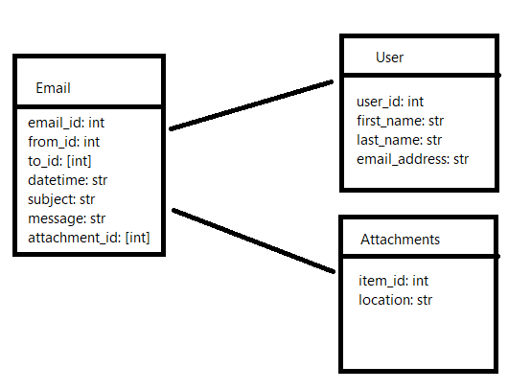

Users table has following column:

1. user_id: assigned to each user
2. first_name
3. last_name
4. email_address

Attachments table has the following column:

1. item_id: assigned to each item attachment
2. location: path to where the item is stored.

Email has the following column:

1. email_id: assigned to each email
2. from_id: the user_id of the sender, user_id is used to fetch information from Users Table
3. to_id: an array of user_id of the receivers, which is used to fetch information from User Table
4. datetime: string representation of when the email is sent
5. subject: string representing the subject of the email
6. message: string representing the message of the email
7. attachment_id: an array of item_id, which is used to fetch information from Attachment Table

# Question 4

Snippet from “email_parsing.py”

from typing import Optional  
  
import yaml  
  
  
def find_sender_email(string: Optional[str] = None, file_location: Optional[str] = None) -> (str, str):  
 if not string and not file_location:  
 return None  
  
 from_field = "From" # Sender  
  
 data = yaml.safe_load(string) if string else None  
 if not data:  
 with open(fr"{file_location}") as f:  
 data = yaml.safe_load(f)  
  
 sender_data = data[from_field].split(" ")  
 sender_email = sender_data[-1]  
 if sender_email[0] == "<":  
 sender_email = sender_email[1:-1]  
 return " ".join(sender_data[:-1]), sender_email

# Question 5

Snippet from “test_email_parsing.py”

import unittest  
  
from email_parsing import find_sender_email  
  
RAW_STRING = "Received: from x.y.test by example.netvia TCP with ESMTP id ABC12345" \  
 "for <mary@example.net>; 21 Nov 1997 10:05:43 -0600\n" \  
 "Received: from machine.example by x.y.test; 21 Nov 1997 10:01:22 -0600\n" \  
 "From: John Doe <jdoe@machine.example>\n" \  
 "To: Mary Smith <mary@example.net>\n" \  
 "Subject: Saying Hello\n" \  
 "Date: Fri, 21 Nov 1997 09:55:06 -0600\n" \  
 "Message-ID: <1234@local.machine.example>\n"  
  
RAW_STRING_NO_BRACKET = "From: John Doe jdoe@machine.example\n" \  
 "To: Mary Smith <mary@example.net>\n"  
  
RAW_STRING_NO_NAME = "From: jdoe@machine.example\n" \  
 "To: Mary Smith <mary@example.net>\n"  
  
RAW_STRING_MANY_NAME = "From: John Tim Apple Doe jdoe@machine.example\n" \  
 "To: Mary Smith <mary@example.net>\n"  
  
  
class TestEmailParser(unittest.TestCase):  
 def setUp(self):  
 self.email_original = RAW_STRING  
 self.email_no_bracket = RAW_STRING_NO_BRACKET  
 self.email_no_name = RAW_STRING_NO_NAME  
 self.email_many_name = RAW_STRING_MANY_NAME  
  
 def test_original(self):  
 self.assertEqual(find_sender_email(self.email_original), ('John Doe', 'jdoe@machine.example'))  
  
 def test_no_bracket(self):  
 self.assertEqual(find_sender_email(self.email_no_bracket), ('John Doe', 'jdoe@machine.example'))  
  
 def test_no_name(self):  
 self.assertEqual(find_sender_email(self.email_no_name), ('', 'jdoe@machine.example'))  
  
 def test_many_name(self):  
 self.assertEqual(find_sender_email(self.email_many_name), ('John Tim Apple Doe', 'jdoe@machine.example'))  
  
  
if __name__ == "__main__":  
 unittest.main()

# Question 6

The user interacts with the web interface to read email intercepted in the database. When the user enters the interface, the user will be given a list of all the emails sorted by date and time the email was sent. There will be options to allow the user to sort the email based on the database criteria such as “from” and “if there are attachments”. For filtering, each column will have a drop-down menu to filter the desired object. A search bar will be included to help with the filtering. A header in the search bar before the string input by the user will help narrow down the column the user wishes to search.