Freddy Gaffey
Scaffold

Table of Contents
Section 1 - Identifying and Defining (20 Marks) 2
1.1 — Client Scenario (3 Marks) 2
1.2 — Environmental Specification (3 Marks) 2
1.3 — List of Objectives (3 Marks) 3
1.4 — Performance Criteria (3 Marks) 4
1.5 — IPO (Input-Process-Output) (3 Marks) 4
1.6 — Gantt Chart (5 Marks) 5
Milestone 1: This should be completed by term 1, week 3. 5
Section 2 - Research and Planning (10 Marks) 6
2.1 — Research (5 Marks) 6
2.2 — Data Flow Diagram (DFD) (10 Marks) 7
2.3 — Storyboard (5 Marks) 9
2.4 — Pseudocode (10 Marks) 10
Milestone 2: This should be completed by term 1, week 6. 10

Section 1 - Identifying and Defining (20 Marks)

1.1 — Client Scenario (3 Marks) ☑️
Define a clear scenario based on the client’s needs, including the application’s purpose, target audience, and primary goals. Detail the client's requirements and provide a narrative that encapsulates the problem that the application aims to solve. Explain the overall vision and the expected impact of the application.

Purpose: The need is to make a service that automates the process of logging their hours as a learner driver as well as the hardware of the automated plate flipping.

Target Audience: Learner drivers and their fully licensed drivers, so therefore meet the accessibility requirements of having a driver's license.

Primary goals: The primary goal is to make a app/website that integrates with physical L plates, logs hours, and provides you with data analytics.

The story: Currently learner drivers often break the law by not filling their log books correctly out of laziness. Because the process takes 3 minutes to fill in but they are under pressure skip it, especially when parents are running late. You might even forget (intentionally or not) to put the L plates on. This is bad because it results in less qualified and capable drivers on the road. My MDP will solve this by making this whole process more efficient with my the app and compatible hardware. The process of logging a drive should take very minimal time to complete; therefor, the logbook will always be filled in. The client's workflow should be to open their phone and press start, maybe indicate who the supervising driver is and then at the end, press stop or it will automatically stop when out of Bluetooth range.

System environment:
This project will exist over multiple platforms and networks that will mean that it is more complicated then I would like. There is 2 esp’s one is simply a Bluetooth slave to the master. The master will have a GPS and an accelerometer on board the gps will run constant interpolation to figure out what the odometer is to keep that in sync as well as broadcasting a website this website will allow the user to start a trip and end one as well as some other features. Once the trip is logged it will be saved to a SD card on bord. The master esp 32 will broadcast a Wi-Fi network if I can't connect to a saved home Wi-Fi network. If it can connect to the home wifi network, it will and it will send it to the server. Once the user is redirected back to the pwa the redirect request will contain the essential data from the trip so it can update the pwa dashboard.

Objectives/features:
The objectives and features for my solution
- Log trips GPS and accelerometer data
- In the GUI, have a way to view trip analytics, such as a map that colour represents speed
- Due to mixed content blocking witch is where a https website can't make a request to an http site, this is what is being served by the esp32 so therefore I need two websites one that controls the hardware and the L plate and also one that is the main PWA. This integration should be as seamless as possible.
- The ability to track the day and night hours is probably displayed by 3 pi chats, one for each and one for the total
- The whole system can work offline, except for uploading, which requires internet
- An AI chat bot that has RAG for understanding road rules
- RBA that allow parent to approve drives once completed
- The app will be optimised around the speed to start a drive therefore, the app start with a BRB (big red button) this is a UI design term that make the app more efficient to use, that allow the user to got to a new page that allow them to start a drive or view drives

1.2 — Environmental Specification (3 Marks)
Outline the technical environment in which the application will operate. This includes hardware, software, network specifications, and other relevant environmental factors. Describe the operating systems, development tools, servers, and other infrastructure components necessary for the application.

Hardware
Property | Value
OS Name | Microsoft Windows 11 Home or Ubuntu (dual boot)
Version | 10.0.26200 Build 26200
OS Manufacturer | Microsoft Corporation
System Name | [REDACTED]
System Manufacturer | HP
System Model | HP Envy x360 2-in-1 Laptop 14-fc0xxx
System Type | x64-based PC
System SKU | [REDACTED]
Processor | Intel Core Ultra 7 155U, 2100 Mhz, 12 Cores, 14 Logical Processors
BIOS Version/Date | Insyde F.05, 6/11/2024
SMBIOS Version | 3.6
Embedded Controller Version | 99.27
BIOS Mode | UEFI
BaseBoard Manufacturer | HP
BaseBoard Product | 8C65
BaseBoard Version | 99.27
Platform Role | Mobile
Secure Boot State | On
PCR7 Configuration | Elevation Required to View
Windows Directory | C:\windows
System Directory | C:\windows\system32
Boot Device | \Device\HarddiskVolume1
Locale | United States
Hardware Abstraction Layer | Version = 10.0.26100.1
User Name | [REDACTED]
Time Zone | AUS Eastern Daylight Time
Installed Physical Memory (RAM) | 16.0 GB
Total Physical Memory | 15.5 GB
Available Physical Memory | 857 MB
Total Virtual Memory | 39.7 GB
Available Virtual Memory | 3.02 GB
Page File Space | 24.2 GB
Page File | C:\pagefile.sys
Kernel DMA Protection | On
Virtualization-based Security | Running
VBS Required Security Properties | Base Virtualization Support
VBS Available Security Properties | Base Virtualization Support, Secure Boot, DMA Protection, UEFI Code Readonly, SMM Security Mitigations 1.0, Mode Based Execution Control, APIC Virtualization
VBS Services Configured | Hypervisor enforced Code Integrity
VBS Services Running | Hypervisor enforced Code Integrity
App Control for Business Policy | Enforced
App Control for Business User Mode Policy | Off
Automatic Device Encryption Support | Elevation Required to View
Hypervisor | Detected (Hyper-V features hidden)

Software ☑️
Image | Platform | Specification
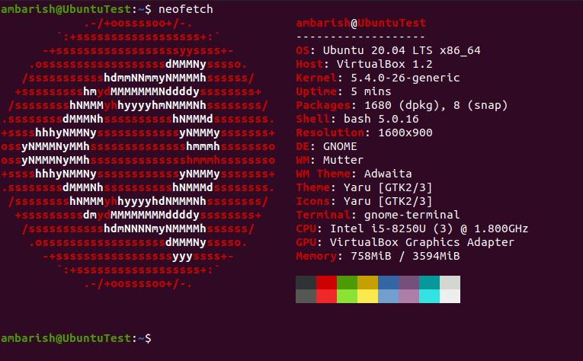 | Ubuntu 20.04 LTS (Linux Server) | Linux Kernel 5.4+  widely compatible
 | Google chrome | Any currently supported version
 | Mozilla Firefox | Any currently supported version
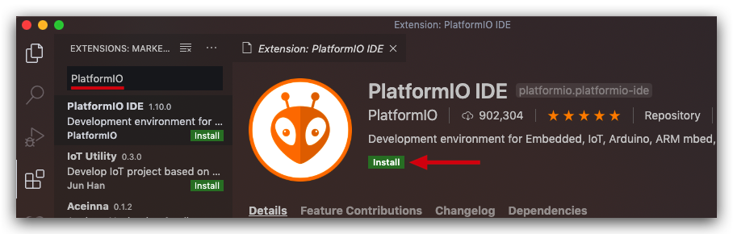 | Platform IO | https://github.com/platformio/platformio-vscode-ide/releases/tag/v3.3.4
 | Draw IO | The latest >=
 | ngrok | This lets me serve my website as https for testing
 | Apple | iPhone and mac on a browser
 | android | Phone and iPad
 | Live server | Any new ish version that are all basically the same

Network

Image | Part | Specification
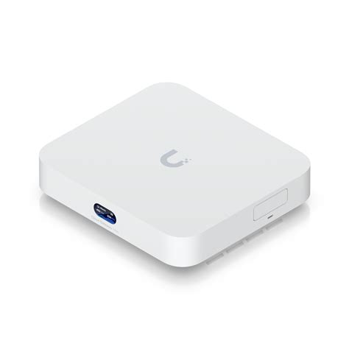 | gateway | Compact 2.5G Cloud Gateway with 30+ UniFi device / 300+ client support, 2.3 Gbps IPS routing, and selectable NVR storage.
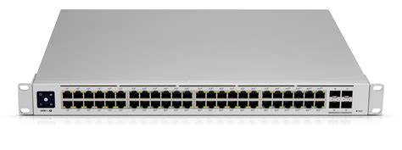 | Switch | Ubiquiti UniFi USW-PRO-48-POE Managed 48 Port POE Gigabit Switch
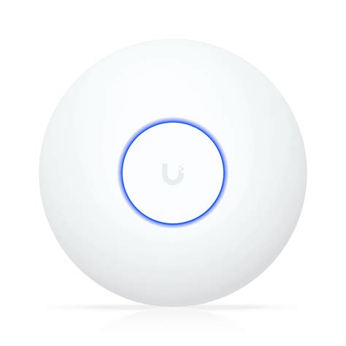 | Access point | U7 Lite Compact, ceiling-mounted WiFi 7 AP with 4 spatial streams and 2.5 GbE uplink.
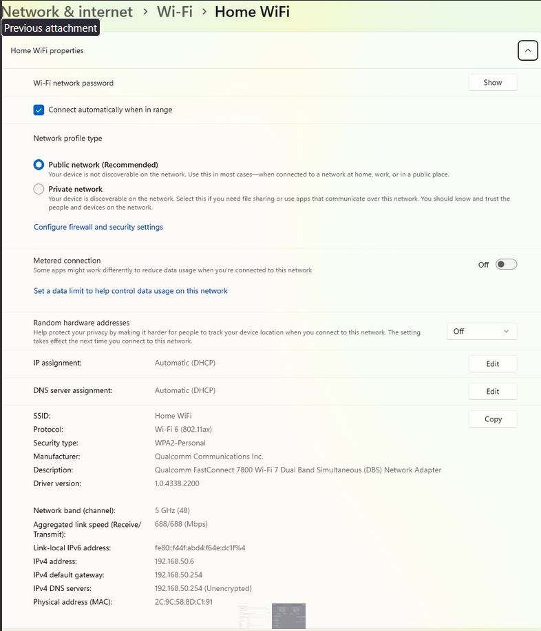 | Wi-Fi  config
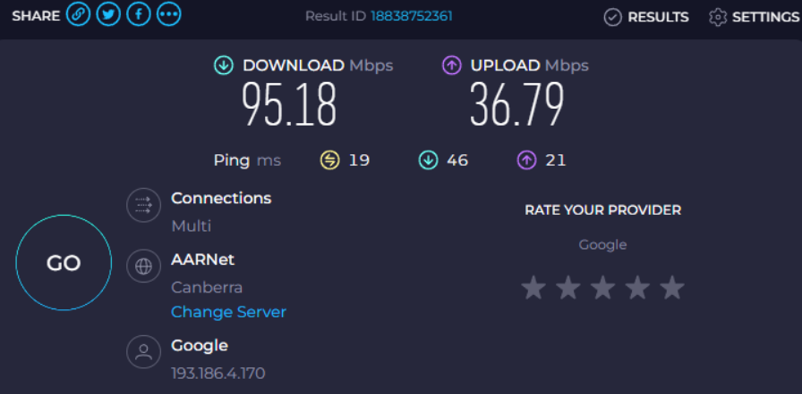 | Speed

1.3 — List of Objectives (3 Marks)
Enumerate the specific objectives that the application aims to achieve. These should be clear, measurable goals that directly address the client’s needs. The objectives could include functionality, user engagement, performance targets, and other relevant criteria.

Essential Features
Feature | Priority 1-10 | Description
- Login | 10 | Provide the user the ability to use pre-saved credentials to access protected areas of the system
1.1 - Login window | 10 | Provide users with a screen which allows them to authenticate with the program.  If a user tries to access a restricted location, redirect them to the login
1.2 - Username | 10 | User can create a unique username  Must provide username at login  If not found prompt user to sign-up
1.3- password | 10 | User uses a password which to authenticate their account  Password must be 8 characters and contain numbers and symbols
2 – Data logs from the plate | 10 | This data is saved from onboard sensors and then transmit up to the cloud database
2.1 – Accelerometer data | 5 | This data will be saved at a rate that will be determined later and then sent up to the cloud. The purpose of this data is so that it is help provide analytics the user about driving style on things like braking or acceleration.
2.2 – GPS data | 10 | This is absolutely essential because this data is the way that the odometer is determined and also the trip distance.
2.3 – speed data (extrapolated from GPS in backend) | 6 | This is data that tracks the speed in the vehicle also provides analytics on if you were speeding* this is a potential feature that might not be technically feasible to get if speeding
3 - plate battery data | 6 | Data on if the L plate is low on battery so that it can be charged
4.1 - starting drive | 10 | This must be really easy thing to do it must take under 10 seconds, it must also work off line
4.2 - stopping drive | 10 | This must be really easy thing to do it must take under 10 seconds, it must also work offline
5 - The parent approves the drive | 9 | A parent/supervising driver must be able to approve a drive easily
6 - viewing the drives and being able to fill in the log book from that | 10 | The ability to view the logs in a format that is easy to transcribe in to the physical log book.
7 - Ai chat bot | 6 | The ai chat bot that can give advise on the relevant laws
8 - Dashboard to view the driving stats | 8 | The dashboard that will let the user view their historical drives
9 - Drive detail view | 6 | Can select a drive and view the map and colour with acceleration
10 - Day and night hours and drives separation | 9 | The day drives are done sand at night are separated by colour on the dashboard

Non-Essential Features
Feature | Priority | Description
Work offline PWA | 4 | Australia does not have mobile data for the whole country so the l plate system must be able to work off line.
Work on iOS, Android, Windows, mac luinx(desktop) | 8 | The logging is done on a phone and the viewing of hours is done on a laptop or phone
Have 90.00% uptime | 7 | Since the app can work off line for the primary role (logging driving) some minimal downtime is permissible because all they happens they can't view their logbook so if late at night, then the down time is not a problem
Be fast to start logging a drive | 10 | This is the problem that I am solving with he whole app so it is essential

1.4 — Performance Criteria (3 Marks) ☑️
Specify the application's performance criteria, including speed, reliability, scalability, and user satisfaction benchmarks. Define how performance will be measured and the application's standards.

The L plate controller (hosted by the esp 32) should be fast and responsive, getting a score of 85< on the Google Lighthouse. The main performance criteria for the controller to meet is more of a UI design challenge not raw performance. The website must me easy to start a drive so this key criteria is the time that it take a user to start a drive this is measured by a stopwatch. The main website (pwa) should have an uptime of 90% this is much lower than the standard, as most websites but this is because the website is a pwa and the critical functionality is all on the controller. To assess the success of the website, I will use DB analytics to calculate user retention this should be 80%.

1.5 — IPO (Input-Process-Output) (3 Marks) ☑️
Develop an IPO model that outlines the application's inputs, processes, and outputs.

Input | Process | Output
Accelerometer  GPS  Time  SD  Start time  End time | Write data to sd card | Sent log to the cloud
Password  Username | Check username and password in the db | Authenticate the user
Approve(trip) or  Disapprove(trip) | Change the trip approve state to approve or disapprove | A db modification change in UI

1.6 — Gantt Chart (5 Marks) ☑️
Create a Gantt chart to outline the project timeline. The chart should include all major milestones, tasks, and deadlines. It should also visually represent the project schedule, showing each task's start and end dates and the dependencies between tasks.

Milestone 1: This should be completed by term 1, week 3.

Section 2 - Research and Planning (10 Marks)

2.1 — Research (5 Marks) ☑️
Conduct thorough research to gather information relevant to the project. This should include market analysis, user research, competitor analysis, and other pertinent data. Summarise the findings and explain how they will inform the project’s development.

https://www.youtube.com/watch?v=sFsRylCQblw
chrome lighthouse
Look at work box
https://hnpwa.com/ this is a website to help you pick a pwa framework
https://web.dev/
https://web.dev/learn/pwa/welcome?continue=https%3A%2F%2Fweb.dev%2Flearn%2Fpwa%23article-https%3A%2F%2Fweb.dev%2Flearn%2Fpwa%2Fwelcome
need to learn how to get the service worker to work
Web app
Esp 32 server:
First I wrote some very high level pseudo code for how I wanted the app to work. This helped me identify what liberties I needed.
- A database (or some way of storing tabula data)
- Ability to broadcast a wifi network
- Ability to connect to a wifi network and to send data to a cloud server
- Ability to pass and make json
- Ability to read a gps value
- Ability to read a accelerometer value

I chose the following library because of there ease of use and because thay are common choices for the problems I faced.
- WiFi.h
- ESPAsyncWebServerHTTP
- ArduinoJsonJSON
- LittleFSLocal
- HTTPClientSend
To lean about how to use them I asked Haiku 4.5 model to make me a list of the relevant docs and helpful tutorials I gave me the following list
“””
ESP32-C3 Drone Data Logger Project - Library Documentation
Core Libraries & Documentation
1. WiFi.h (Built-in ESP32 Core)
- Official Documentation: https://docs.espressif.com/projects/esp-idf/en/latest/esp32c3/api-reference/network/esp_wifi.html
- Arduino WiFi Reference: https://www.arduino.cc/reference/en/libraries/wifi/
2. ESPAsyncWebServer
- GitHub Repository: https://github.com/me-no-dev/ESPAsyncWebServer
- Documentation: https://github.com/me-no-dev/ESPAsyncWebServer/wiki
- Installation Guide: https://randomnerdtutorials.com/esp32-async-web-server/
3. ArduinoJson
- Official Site: https://arduinojson.org/
- Documentation: https://arduinojson.org/v6/api/
- Quick Start: https://arduinojson.org/v6/getting-started/
4. LittleFS (File System)
- ESP32 LittleFS Documentation: https://github.com/lorol/LITTLEFS
- Tutorial: https://randomnerdtutorials.com/esp32-littlefs/
5. HTTPClient (for sending POST requests)
- Arduino HTTPClient Docs: https://www.arduino.cc/reference/en/libraries/httpclient/
- ESP32 Guide: https://randomnerdtutorials.com/esp32-http-post-request/
6. Preferences.h (Built-in - Persistent Storage)
- Official Documentation: https://docs.espressif.com/projects/esp-idf/en/latest/esp32c3/api-reference/storage/nvs_flash.html
- Arduino Preferences Library Guide: https://randomnerdtutorials.com/esp32-preferences-library/
- GitHub (esp32 core): https://github.com/espressif/arduino-esp32/blob/master/libraries/Preferences/src/Preferences.h
7. Time Management
- Time.h Reference: https://www.arduino.cc/reference/en/libraries/time/
- millis() and micros(): https://www.arduino.cc/reference/en/language/functions/time/millis/
For Analog Pin Reading (GPS/Accelerometer Simulation)
- ADC Reading: https://docs.espressif.com/projects/esp-idf/en/latest/esp32c3/api-reference/peripherals/adc.html
- Arduino analogRead(): https://www.arduino.cc/reference/en/language/functions/analog-io/analogread/
“””
I looked at the demos that the wifi libery provides and saw “simple web serve” by Tom Igoe this is a simple web server I used the code example to make a start_ap() function
https://github.com/espressif/arduino-esp32/blob/master/libraries/SD/examples/SD_Test/SD_Test.ino how to wirght to a sd card

L plate hardwear:

THE PWA:
https://www.youtube.com/watch?v=L5O8uyX2cU8 looking at best web stacks

broke down choosing a tech stack
There is no one best tech stack, but there is a best tech stack for you and to determine it asses it with these following things.
https://www.youtube.com/watch?v=R5BwFCyV9Mk
What is a tech stack
Learning Curve
Ecosystem
Compatibility & Interoperability
Performance and Cost
Team Expertise
Future-proofing

I have now decided to use flask as I am very similar with python and I don’t need performance it has a bigger enough ecosystem

PWA stuff
https://blog.appmysite.com/what-is-a-progressive-web-app/
https://www.youtube.com/watch?v=wQgx5Pou44s
https://web.dev/learn/pwa
https://hnpwa.com/
https://developer.mozilla.org/en-US/docs/Web/Progressive_web_apps/Tutorials
https://www.youtube.com/watch?v=sFsRylCQblw Progressive Web Apps in 100 Seconds // Build a PWA from Scratch : Fireship
https://developer.chrome.com/docs/workbox/
https://github.com/elegantapp/pwa-asset-generator
HOW TO COMMUNICATE TO THE ESP 32
https://stackoverflow.com/questions/53211319/how-can-i-make-an-http-request-from-an-https-website my fist idea was to have the esp 32 host a server that acts as a API endpoint but this can’t work because mixed content (having https and http) is unsafe so I need to find a way around that.

https://www.chatbase.co/ THIS IS FOR THE AI INTERGRATION
https://codezup.com/creating-a-progressive-web-app-with-flask-and-service-workers/ a tyotorial
Jinja2 template I need to learn about

https://github.com/TempeHS/Flask_PWA_Programming_For_The_Web_Task_Template THIS IS SO USEFULL IT IS DESIGEND FOR THE HSC
https://www.geeksforgeeks.org/python/python-property-decorator-property/ helpful understanding the @propidy decorator
https://codezup.com/implementing-authentication-in-flask-guide/ helped me implement auth
I need to use “from werkzeug.security import generate_password_hash, check_password_hash”
https://www.pythontutorial.net/python-oop/python-__repr__/ __repr__ method

THE BEST WAY TO LEAN ABOUT AUTH WAS THE FLASK DOCS THEM SELVES https://flask-user.readthedocs.io/en/v0.5/authorization.html

2.2 — Data Flow Diagram (DFD) (10 Marks)
Design a DFD for each feature of your project to illustrate how data will flow through the system. The DFD should show the interactions between inputs, processes, and outputs. Provide detailed diagrams and explanations for each feature.

DFD 1

DFD 2

2.3 — Storyboard (5 Marks)
Create a storyboard to outline the user journey through the application. The storyboard should include key screens, user actions, and interactions. Provide a narrative to explain how users will navigate the application and achieve their goals.

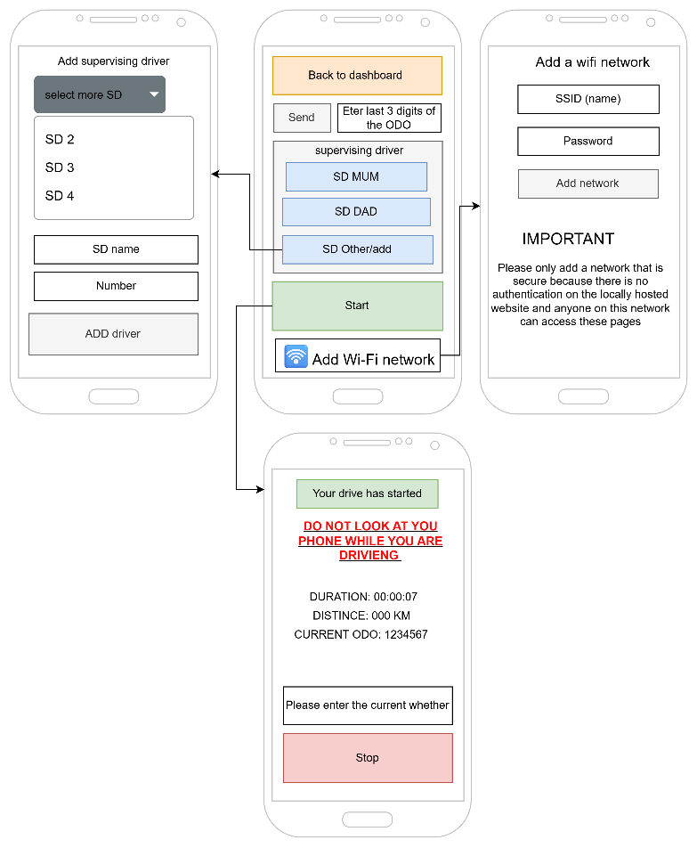
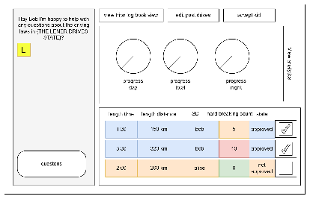
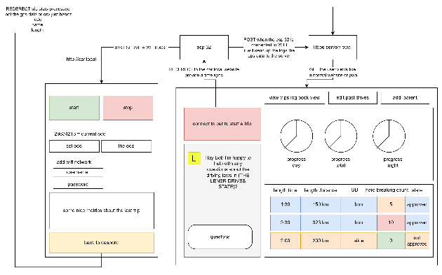

2.4 — Pseudocode (10 Marks)
Write five pseudocode algorithms for critical functions and algorithms in the web application's backend. These pseudocode algorithms should provide a clear foundation for coding the application. Include detailed explanations and comments for each algorithm.

Algorithm 1 ☑️
LET time_last_log_gps = 0
LET time_last_log_acell = 0
LET log = True

WHILE log:
If time + 1 >= time_last_log_gps:
time_last_log_gps = time.time()
db.connection.write_gps(current_gps)
If time.time + 0.2 >= time_last_log_acell:
time_last_log_acell = time.time()
db.connection.write_acell(
ave_acell_over_last_log_time)
db.connection.write_parant(parant_form_post_req)
ENDWHILE

WHILE true:
IF send_over_4G = True:
let_4g_connection = True
for drive in all_drives:
last_back_off_time = 1
WHILE True:
IF send_to_cloud_4g(jsonifi.drive):
remove(drive)
BREAK
ELSE:
back_off_time *= 5
sleep(back_off_time)
IF back_off_time > 100:
4g_connection = False
break
IF NOT 4g_connection:
break

ELSE:
let wifi_connection = True
for drive in all_drives:
last_back_off_time = 1
WHILE True:
IF send_to_cloud_wifi(jsonifi.drive):
remove(drive)
BREAK
ELSE:
back_off_time *= 5
sleep(back_off_time)
IF back_off_time > 100:
wifi_connection = False
break
IF NOT wifi_connection:
break
sleep(60)
END WHILE

BEGIN send_to_cloud_4g(drive) -> bool:
IF not connect_to_4g():
RETURN False
IF send_json_to_cloud(drive):
RETURN True
ELSE: RETURN False
END

BEGIN send_to_cloud_wifi(drive) -> bool:
IF not connect_to_wifi():
RETURN False
IF send_json_to_cloud(drive):
RETURN True
ELSE: RETURN False
END

BEGIN connect_to_wifi:
start_time = time.time
WHILE start_time + 10 < time.time():
all_ssid = scan_for_wifi()
IF knowen_ssid in all_ssid:
IF connect_to_ssid(ssid): Return True
END WHILE
RETURN False

This is a piece of code with lets the esp to connect to the intent and also make end send logs

Algorithm 2 ☑️
This is how the user will interact with the app and also the logger.
BEGIN
# the user will start in the pwa I will not show the js sirvis worker logic
IF pwa.click_start_tip
pwa.rederect_to_esp(the_car_from_drop_down)
esp.show_start_trip_dasbord()
IF esp.click_start_loging THEN
esp.move_L_plate_open_with_servo()
esp.fsm.start_logging()
ENDIF
ENDIF

IF esp.click_stop_loging THEN
esp.move_L_plate_shut_with_servo()
esp.fsm.stop_logging()
ENDIF

IFesp.conected_to_wan THEN
FOR log_file = esp.SD.get_first_log_file TO esp.SD.get_last_log_file STEP esp.SD.get_next_log_file
WHILE var:
IF NOT esp.conected_to_wan THEN
BREAK
ENDIF
esp.WIFI.send_file_to_cloud(log_file)
IF esp.send_file_to_cloud.receved() THEN
var = esp.SD.deleat_file(log_file)
ENDIF
ENDWHILE
ENDIF

IF esp.click_go_to_dasbord() THEN
LET latest_trip = get_latest_trip_summiry()
esp.rederect_to_pwa(latest_trip)
ENDIF

pwa.get_add_trip_summiry(latest_trip)
pwa.render_latest_trip()
pwa.update_db_with_trip_summiry()
pwa.refreash_dashbord()
pwa.add_prompt_to_remind_user_to_refreash()

IF pwa.get_wan THEN
pwa.uplod_trip_sumeriys()
END

Algorithm 3

Milestone 2: This should be completed by term 1, week 6.

