­­

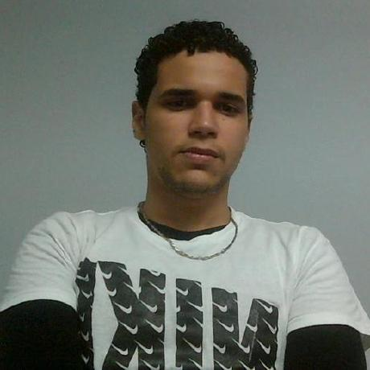

***EDUCATION***

**2012 IT Essentials 1:**

Technological Institute of the America (ITLA)

**2014 Software Technologist:**

Technological Institute of the America (ITLA)

**2015 Immersion English:**

Dominican American Institute

**2016 Software Engineering:**

APEC University(coursing)

***OTHER***

**2015 Advance Data Base Course**

***AngularJS Course***

***Git y GitHub Course***

***Building Applications with ASP.NET MVC 4***

***Introduction to the ASP.NET Web API***

***Node.js for .NET Developers***

[Platzi](https://platzi.com/), [PluralSight](https://www.pluralsight.com/)

***SKILLS***

*Proficient in:*

* Python 3 years
* Flask/Falcon 2 years
* Django 2 years
* MySQL 3 years
* PostgreSQL 1 year
* NodeJS 1 year
* ReactJS 6 months

*Familiar with*

* MongoDb
* Celery
* Object Oriented Development
* Clean Code
* Web Scraping
* GNU/Linux

(Elementary OS; Ubuntu 12, 14)

* Version Management (Git)

*"Do what you love and you’ll never work a day in your life"*

**Spanish :** Native

**English :** Intermediate

***WORK REFERENCES***

* **José Ernesto Rodríguez (Technology Manager)(Tecnocom) Cel.:849-815-0377**
* **Richard Brailer Nova (Technology Manager)(Ole SuperMarket) Cel.:809-334-1717**
* **Luis Alfredo Dilone (Senior Auditor/Developer)(BanReservas) Cel.: 829-918-4326**

***Freddy García Abreu***

*** 402-0061597-5***

*** +1-849-409-8890***

*** freddie-wpy@outlook.es***

*** https://github.com/freddygarcia***

*** c/ 3ra #10 Ralma Villa Faro, Santo Domingo Este, Sto. Dgo. Rep. Dom.***

***Software Developer***

***PROFESSIONAL EXPERIENCE***

**2014 (3 months)**

**Tecnocom**, Junior *Developer*

* Application Development reports to the Superintendence of Banks (***JSF***).

**2015 (1 year 3 months)**

**Olé Supermarket** *Developer*

* Primary responsibilities include design, develop and maintenance of an ERP to complement Dynamics AX features. This was accomplished by using Asp .Net MVC4, SQL Server and front-end kit (AngularJS, JQuery, Bootstrap) in addition to web services development.
* Develop and maintenance of **Dynamics AX** modules **X++** to addnew custom features.
* Inventory Application Development **MVC4**. Frameworks and technologies including Asp .Net MVC4, SQL Server, AJAX, JSON, AngularJs, CCS3.
* Develop and maintenance of stores procedures SQL **Server**.
* Responsible for maintaining and debugging an inventory Windows Mobile Application (2002) which included its deployment and configuration on Pocket PC.

**2016 (Actually)**

**BanReservas** Auditor

* I work in a financial area doing audit testing data to satisfy the company politics and avoiding risks.
* My role is designing **ACL** (**Audit Command Language**) scripts for testing data. Sometimes we develop tests using **Python** and **PHP** as alternatives for **ACL.**
* I participated as collaborator in a task manager application(**PHP, Phalcon, Mysql**) designing and developing modules and new features; collaborator in an ERP Project**(NodeJs, Mysql)**

***PERSONAL PROJECTS***

* Collaborator in the Intellisys Challenge, a competition developing an ERP Software using **DJango**, **PostgreSQL**, **Bootstrap**.
* Some of my personal projects:

|  |
| --- |
|  |
|  |
|  |
|  |
|  |

* + *Django rest* (api rest), *django*(back-end), *native react* (mobile), *html, css*(font-end) and mysql (notes taker | freelance)
  + *flask*(web services), codeigniter(back-end), json(consumed web service), *html, css*(font-end) and mysql (ticket manager | freelance)
  + *flask*(back-end), *html, angular, css*(font-end) and *MSSQL* (task manager | internal area project).