LetsDoThis!

Attempt #1:
- Analyzed 10K data only; the limiting factor from a data perspective is the lack of GPX files for other race types. Additionally, it is not obvious how the model will respond by adding in other race types as new features.
- Used logistic regression where the target variable y takes a binary value, either 0 (below the median time for that course where the median is calculated without age/gender considerations) or 1 (above). In other words, 0 = faster than the median, 1 = slower.
- Extract the weights, otherwise known as beta:

- Calculate the dot product X.dot(beta) for all runners and plot, the result is the left distribution. Integrate in a special way in order to get the S-curve. Slow runners show up on the right-hand side, and I examined some of these times and it appears that these runners were basically walking; this is not a measure of difficulty! I may need to rethink this approach, but this is our main assumption so far.
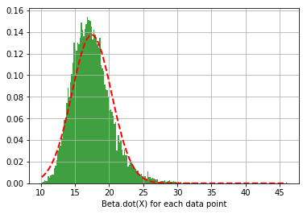
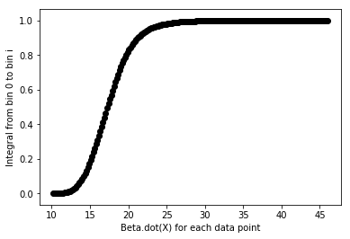

Attempt #2:
- Use linear regression where now the target variable is the runners time minus the median time for that course. Again, slow runners show up on the right-hand side, i.e. the large finish time minus the median time is a large positive quantity. We may need to introduce a cut here.
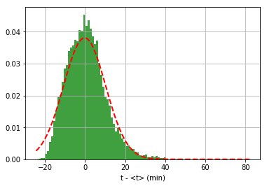

- For 10K, I have implemented a dt cut of dt < 23 minutes, which roughly excludes people who took 75 minutes or longer to complete a 10K=6.2mi race, e.g. these people were moving at 5mph or less. Average walking speeds are roughly 3.1 mph, so these people are only moving 60% faster than walking pace. I’m excluding fast walkers. Here is the plot, using a cut of 20 minutes:
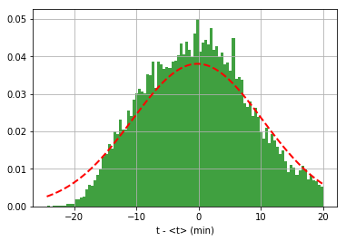

- Doing the same procedure as logistic regression, extract the weights:

- And get the distributions:
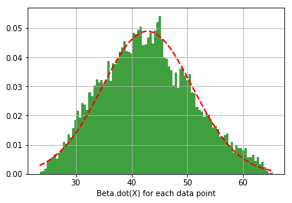

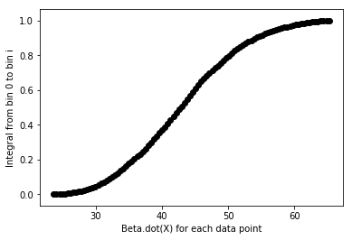

which seems to have solved the extremely finicky behavior in the S-curve. The far-right of the S-curve corresponds to slower runners, which we are assuming is a contributor to our difficulty index.

