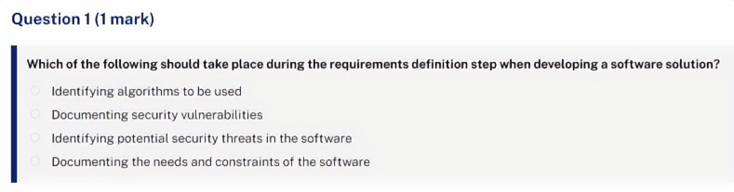
Answer:
Documenting the needs and constraints of the software
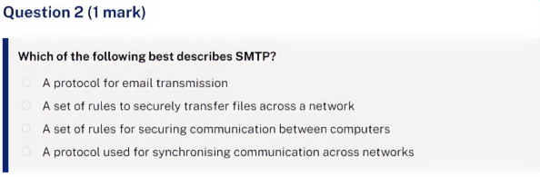
Answer:
A protocol for email transmission
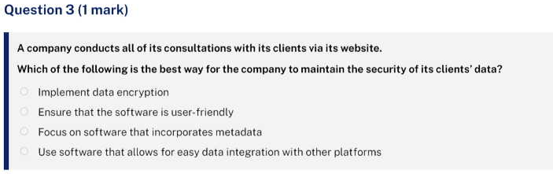
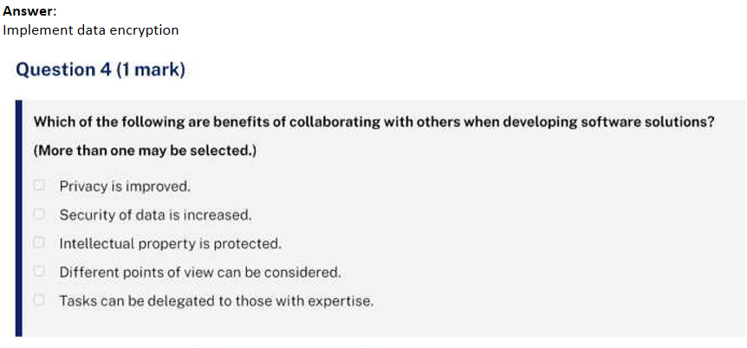
Answer:
Different points of view can be considered.
Tasks can be delegated to those with expertise.
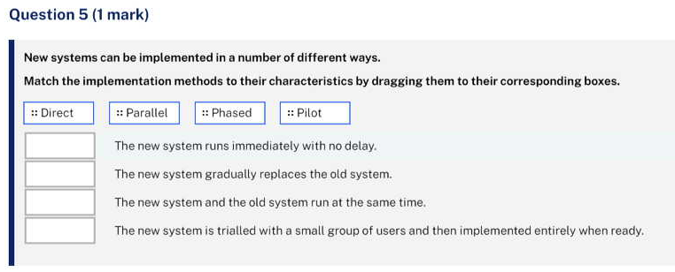
Answer:
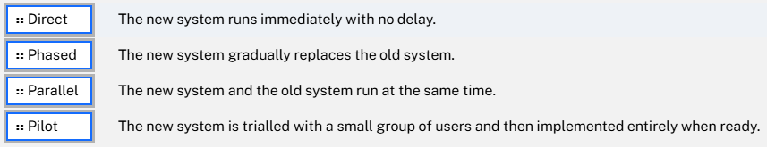
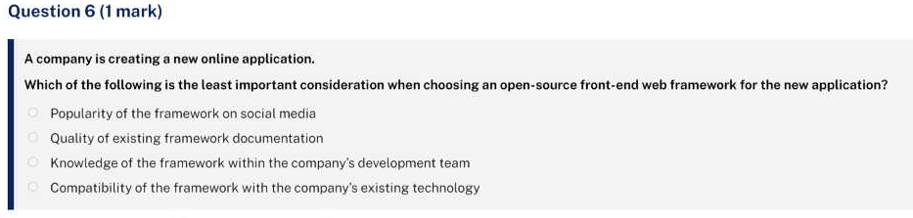
Answer:
Popularity of the framework on social media
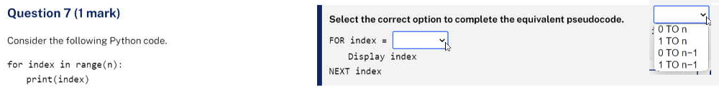
Answer:

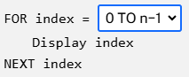

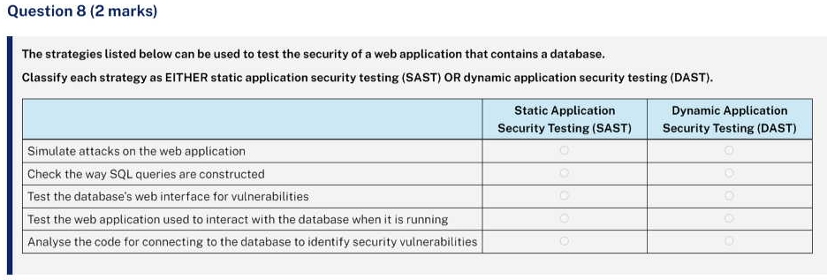
Answer:
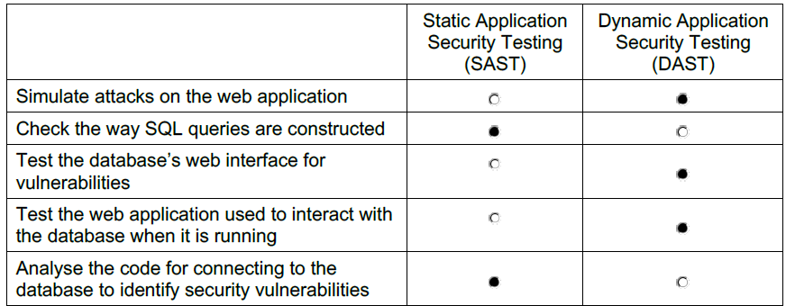
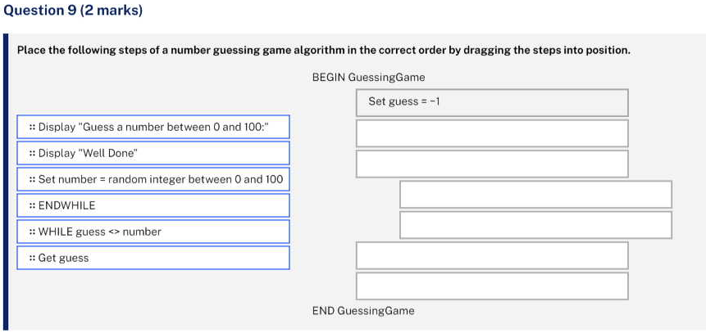
Answer:
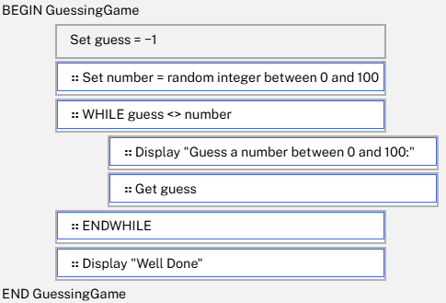
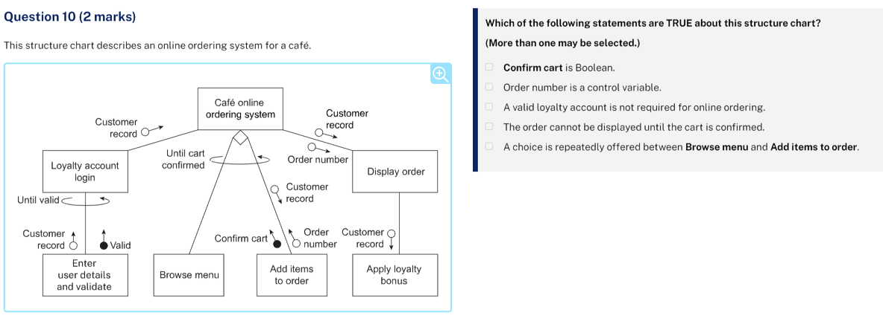
Answer:
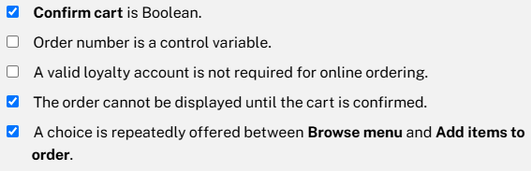

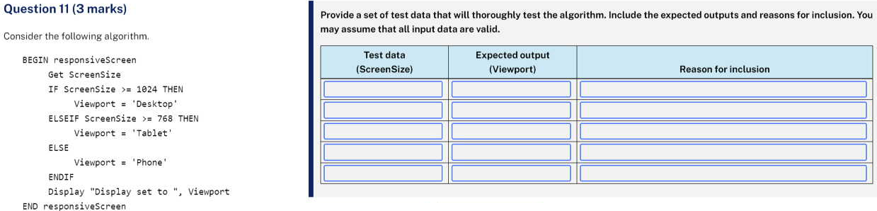
Sample answer:
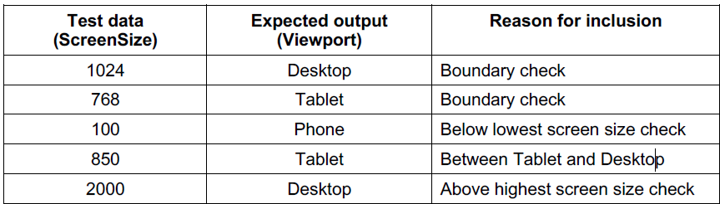
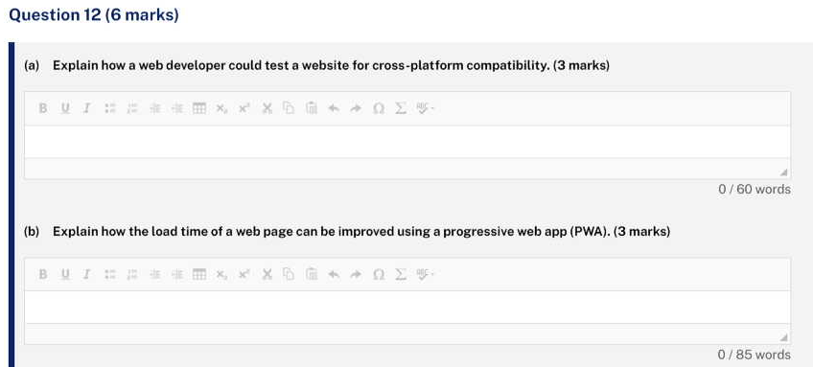
(a) Sample answer:
A web developer can use browser developer tools. These tools, built into most modern browsers, allow developers to simulate how their website looks and behaves on different devices and screen sizes. By using these tools, developers can identify and fix any issues related to cross-platform compatibility, ensuring that the website works well across a variety of devices and browsers.

(b) Sample answer:
A progressive web app (PWA) can optimise assets by compressing files and pre-caching important resources, allowing files such as image-gallery.js and video-gallery.js to be loaded into memory or cache while the rest of the page loads. PWAs also use service workers to cache resources, ensuring faster load times on repeat visits and offline functionality. They also use lazy loading, where only the necessary content is loaded initially, improving load speed, while other non-essential resources are loaded as needed.
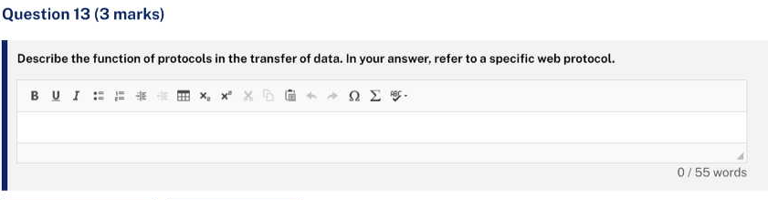
Sample answer:
Protocols are important in data transfer as they establish rules for communication between devices connected to a network, such as the internet. HTTP (Hypertext Transfer Protocol) enables browsers to request web content from servers, which respond with the requested data. The protocol defines the structure of requests and the response so that data transfer can occur. Answers could also include TCP/IP, DNS, FTP, SFTP, SSL, TLS, SMTP, POP3, IMAP and Data packets.
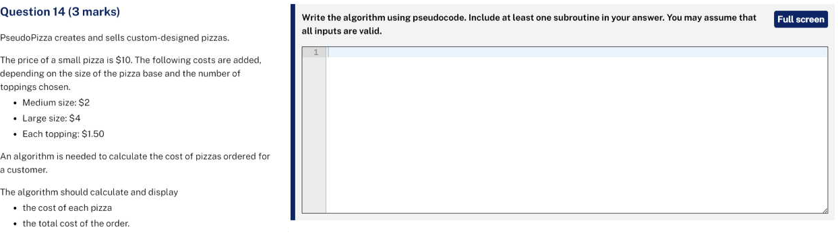

Sample answer:
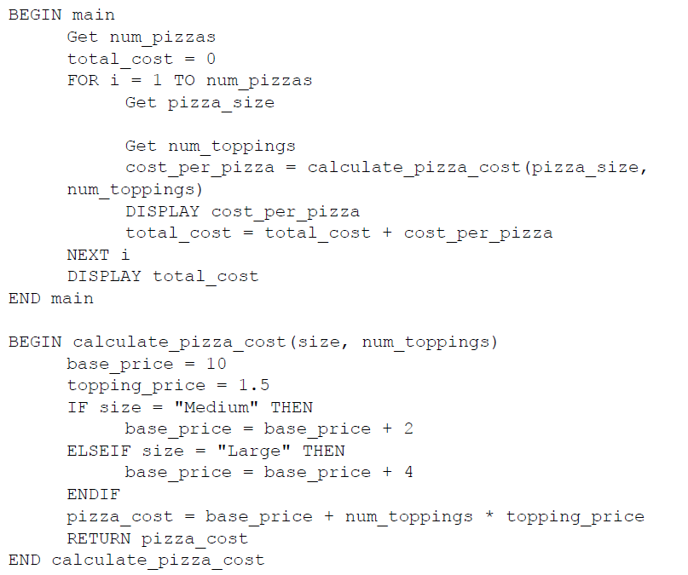

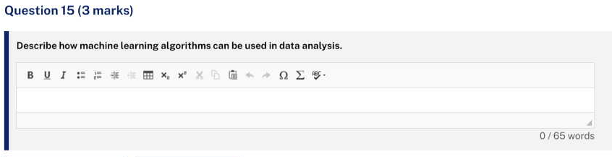
Sample answer:
Machine learning algorithms can be trained with a subset of the data to automatically identify patterns and trends within large datasets. The algorithms can handle complex relationships and nonlinearities present in the data allowing for efficient and comprehensive analysis. Machine learning can also be used for predictions and forecasting. These models can learn from new data over time, continuously improving their analysis and predictive accuracy and performance.
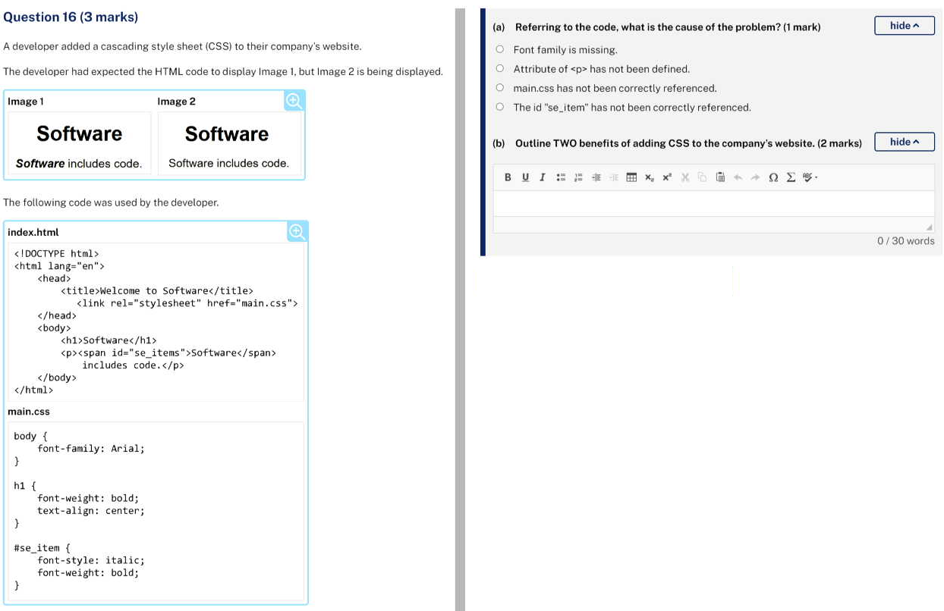
(a) Answer:
The id "se_item" has not been correctly referenced.

(b) Sample answer:
It can provide the same look and feel across the company’s websites for consistency and ease of use. Separate html and CSS code can allow developers to work independently on files.
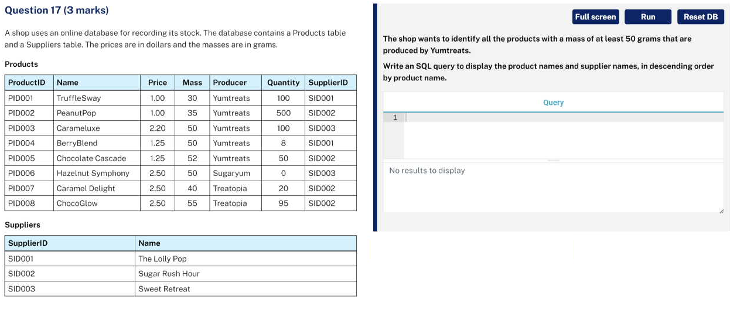
Sample answer:
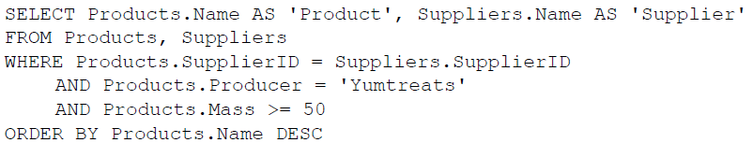

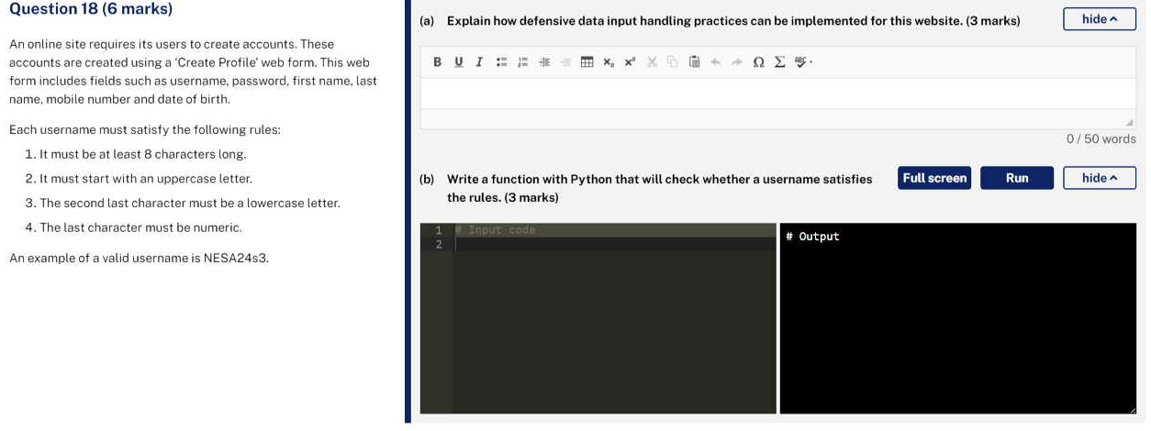
(a) Sample answer:
Data sanitisation using client-side scripting can clean the data and remove dangerous input. Input validation on the client-side can check that entered data meets all of the requirements before getting processed by the server. Errors generated by data not meeting rules can be shown to the user.

(b) Sample answer:
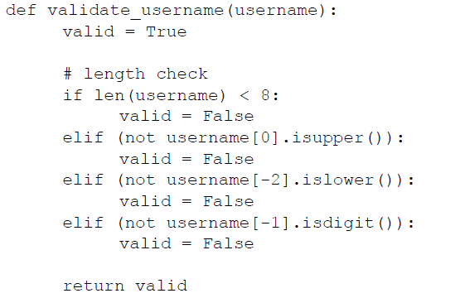
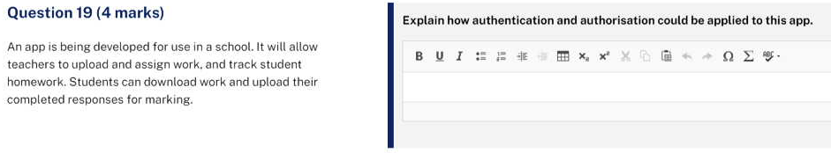
Sample answer:
Authentication ensures that only staff and students with valid usernames and passwords, which should be encrypted in storage (eg using hashing), can access the app. Authorisation controls access to specific features of the app based on user roles or groups. Teachers may have permissions to upload, assign and track homework, while students can only download tasks and upload completed work. By organising users into specific roles or groups, the app restricts access to appropriate functionality, ensuring that each user can only perform actions relevant to their role or group.
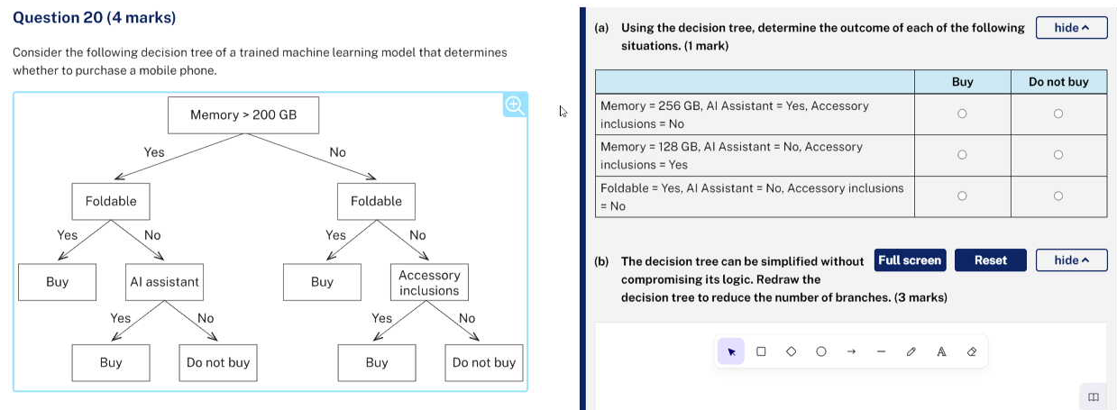
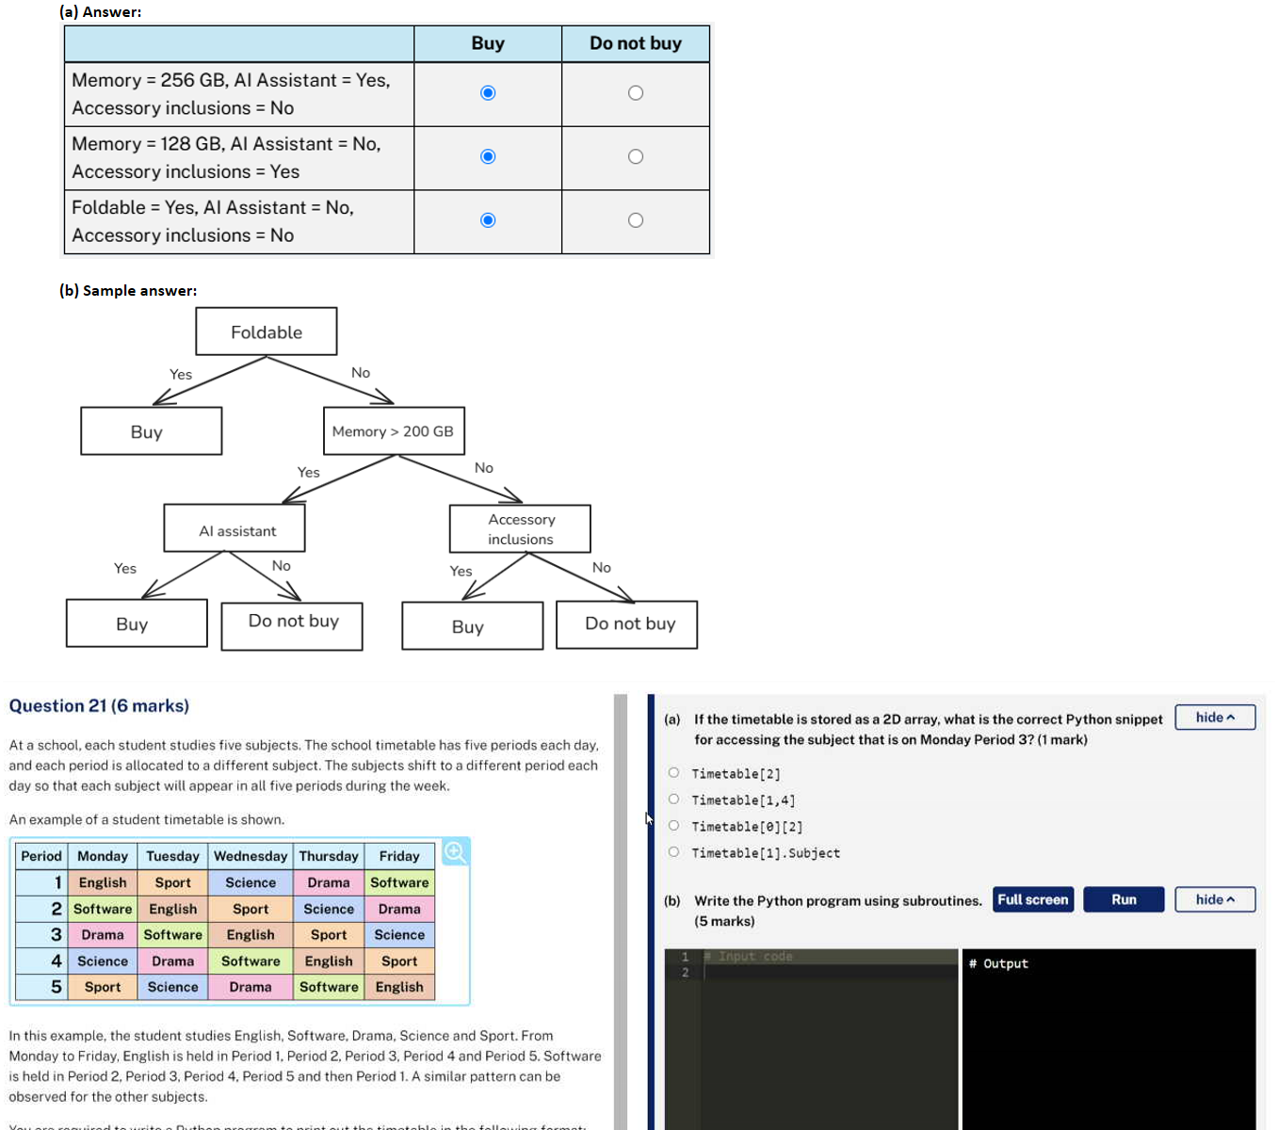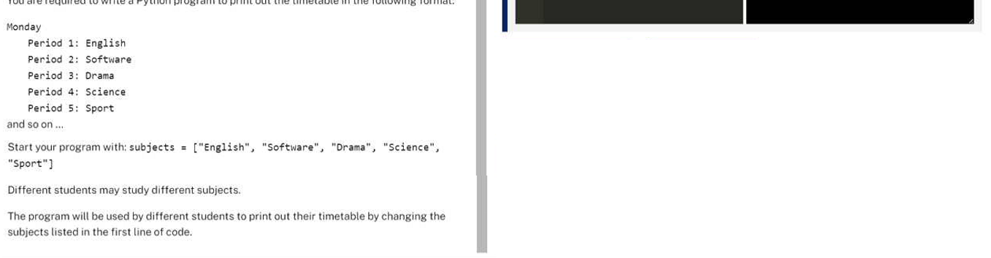
(a) Answer:
Timetable[0][2]

(b) Sample answer:
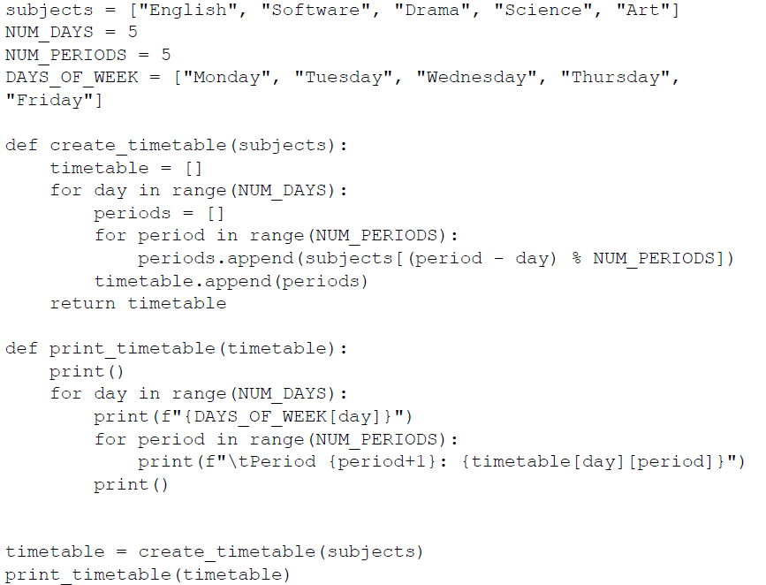

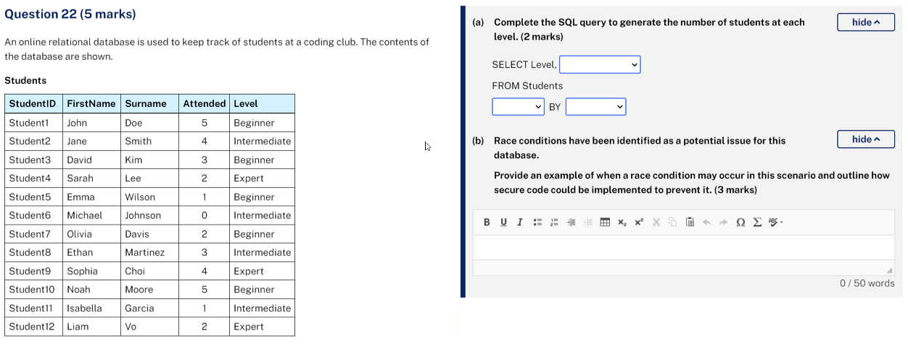
(a) Answer:
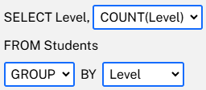

(b) Sample answer:
With multiple teachers potentially accessing the database at the same time, race conditions can allow malicious users to gain unauthorised access. Authentication could be used to restrict access to the database, and code can be written to use atomic transactions and database locks to time the reading and writing of data.
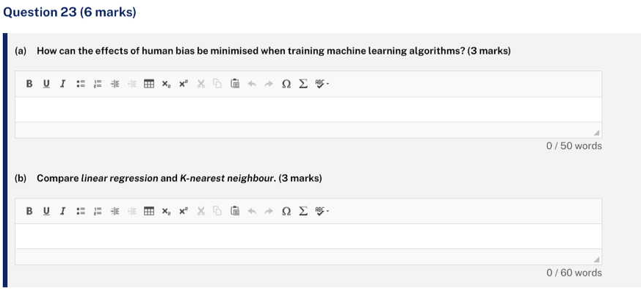
(a) Sample answer:
Training data is initially selected by humans, who may unintentionally introduce their own biases. To minimise this, ensure that training data is representative of the problem the ML model will address. Reviewing data by individuals from diverse backgrounds could identify and reduce potential biases, ensuring fairer and accurate model performance.

(b) Sample answer:
Linear regression and K-nearest neighbours (KNN) are both supervised learning algorithms that make predictions from labelled data. The key difference is how they handle data: linear regression assumes a linear relationship between input features and the target variable, while KNN makes predictions based on the closest ‘K’ training examples, allowing it to handle more complex, non-linear patterns. However, KNN can be more computationally expensive than linear regression and is usually slower.

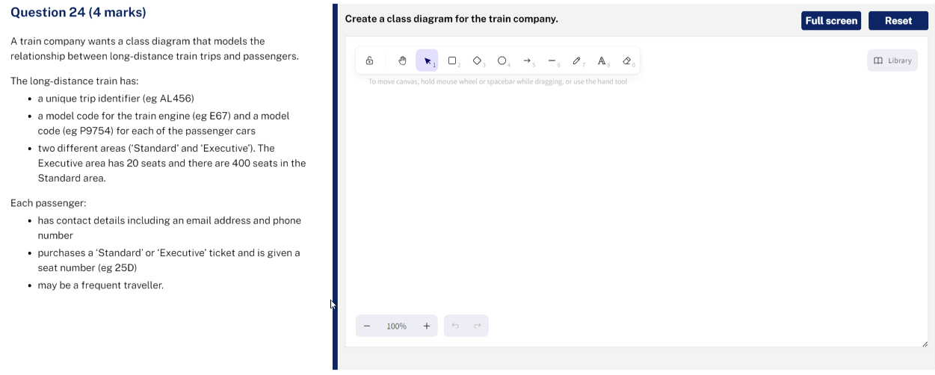
Sample answer:

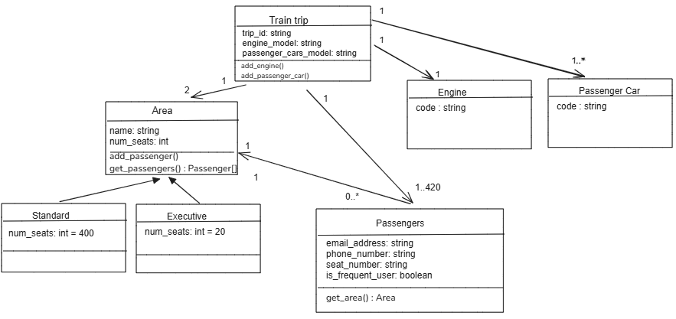
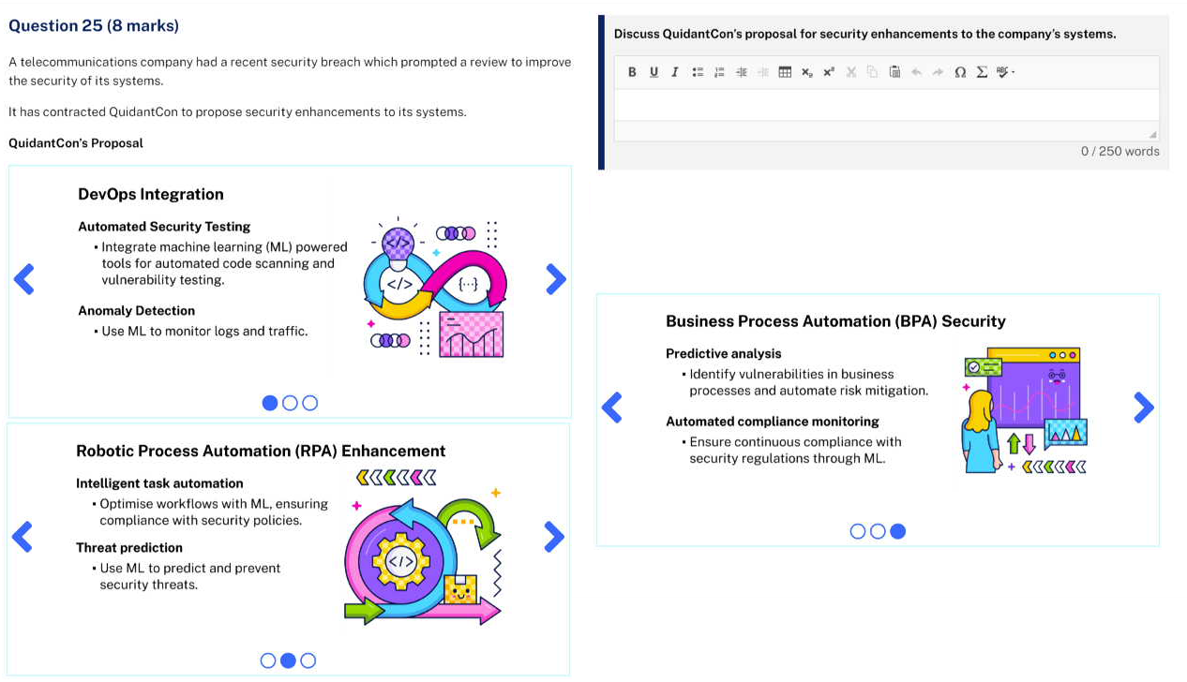
Sample answer:
QuidantCon's proposal for the company suggests leveraging machine learning (ML) and automation to bolster security measures. One key benefit is the automation of security testing and vulnerability scanning, facilitated by integrating ML-powered tools into the DevOps pipeline. This approach ensures continuous security testing and provides rapid feedback to developers, allowing for early detection of security issues and reducing the risk of vulnerabilities being exploited. The frequent and automated testing improves the overall security position and enhances compliance with industry standards. Additionally, ML algorithms can analyse vast amounts of data to detect patterns and anomalies, which is crucial for proactive threat identification. This capability enables the company to identify security risks proactively, learn from past incidents, and predict future attacks, thereby enhancing their overall security measures.

QuidantCon's proposal for the company also raises some concerns. One key issue is the need for high-quality data for ML algorithms to work effectively. If the data is inconsistent or incomplete, the ML models may not perform well, leading to false positives or missed threats. Another concern is the complexity of implementing ML solutions, which can be challenging and may require specialised skills and training. This complexity could result in integration challenges, higher costs, and delays. Additionally, ML systems can be biased, potentially affecting security decisions. Security and privacy are also critical, as handling sensitive data requires protection against unauthorised access and breaches. These concerns emphasise the need for a careful and balanced approach when considering ML and automation in security practices.

