MICRO HACK 1 · SETUP & PREREQUISITES
Setup & Prerequisites
Business Apps with Fabric & Rayfin — get ready before 09:00
Helios Mobility (fictional client) · prepare the data foundation

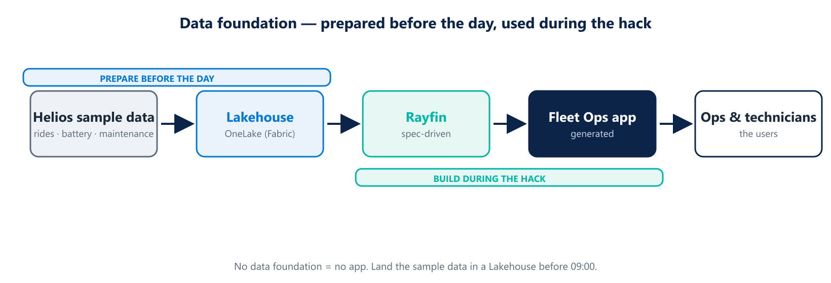
The app is generated from data that already lives in Fabric — the data foundation is your real prerequisite.

Before you start
In this Micro Hack you generate a Business App with Rayfin from data that already lives in Microsoft Fabric. So the single most important thing to prepare is the data foundation: a Lakehouse in OneLake loaded with the Helios sample datasets. Everything below gets you there before 09:00.
THE ONE RULE
No data foundation, no app. If the Helios data is not in a Lakehouse before the day starts, teams cannot build.

1 · Provision the environment
☐ A Microsoft Fabric tenant with capacity (an F-SKU or a Fabric trial).
☐ A dedicated workspace named “Helios-MicroHack”.
☐ Entra ID accounts for every participant, added to the workspace.
☐ Rayfin (Business Apps) access enabled for the tenant / workspace.
☐ A modern browser and access to *.fabric.microsoft.com (no blocking proxy).

2 · Load the Helios sample data
Create one Lakehouse and load four datasets. Keep names simple and consistent — the spec will refer to them.
Dataset | File | What it holds
scooters | scooters.csv | Each scooter: id, city, model, status
rides | rides.csv | Trips: scooter id, start/end, distance
battery | battery.csv | Battery level history per scooter
maintenance | maintenance.csv | Open / past maintenance jobs
Steps:
- Create a Lakehouse called “HeliosLake” in the workspace.
- Upload the four files, then load each as a table.
- Preview one table (e.g. scooters) to confirm rows and column types.

3 · Roles & access
Role | Who | Why
Workspace Admin | Facilitator | Manage capacity, settings, sharing
Member | Coaches | Build and edit alongside teams
Contributor | Participants | Create the app and edit content

4 · Definition of ready (before 09:00)
☐ HeliosLake Lakehouse exists with the four tables loaded and previewed.
☐ Every participant can sign in and open the workspace.
☐ Rayfin can be launched from the workspace.
☐ A facilitator has run the end-to-end demo once on this environment.

Troubleshooting
Symptom | Likely cause | Fix
Can't open workspace | Account not added | Add the user as Contributor
Tables empty | Files not loaded to tables | Re-run “load to tables”
Rayfin not visible | Preview not enabled | Enable in tenant/workspace settings

