MICRO HACK 1 · PARTICIPANT WORKBOOK
Participant Workbook
Design & build your Fleet Operations app
Helios Mobility (fictional client) · think first, then let Rayfin build

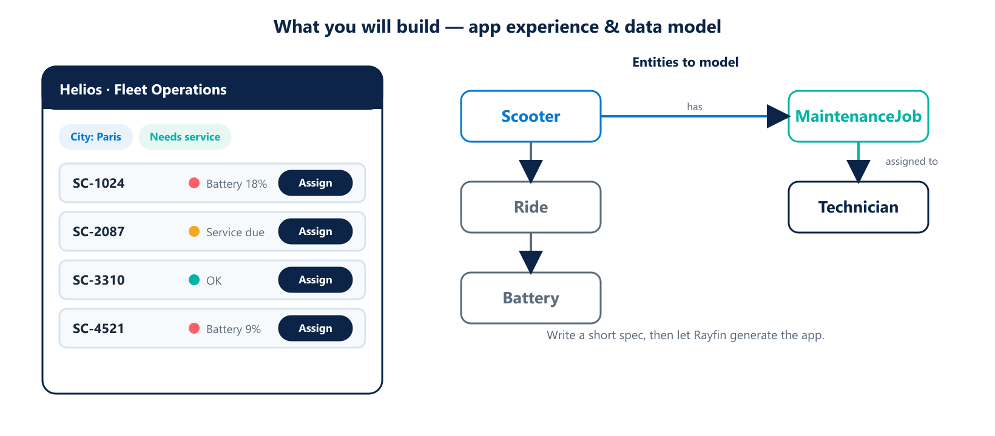
What you will build: an operations app on one side, the data model behind it on the other.

Your challenge
Helios Mobility's city operations managers lose time chasing scooter problems across spreadsheets and email. Your team will write a short spec and let Rayfin generate a Fleet Operations app on Fabric — one place to see every scooter, spot the ones that need attention, and assign jobs to technicians.
MEET YOUR USER · Camille, city operations manager
“Every morning I need to know which scooters are down, where they are, and who can fix them — without opening five tools.”

Reflect before you build
Spend 15 minutes as a team on these questions before touching the tool. A clear spec beats a fast start.
- What decisions does Camille make each day? What does she need to see to make them?
- What belongs on the first screen — and what does not?
- Which actions must the app support (assign, mark fixed, flag)?
- Who else uses it, and what should they NOT be able to do?

Worksheet · Data model
List the entities your app needs and the few fields that matter. Use the diagram above as a starting point.
Entity | Key fields | Notes
Scooter | id, city, status, battery | The core object

Worksheet · Write your spec
Fill this in, then describe it to Rayfin in plain language.
Spec item | Your answer
App name | e.g. Helios Fleet Ops
Primary users | e.g. City operations managers
Main screens
Key actions
Rules / permissions
Data sources (tables) | scooters, rides, battery, maintenance

Sprint 1 · Build the core (13:30 – 15:30)
☐ Generate the app from your spec with Rayfin.
☐ Show a list of scooters with a live status indicator.
☐ Filter by city and by “needs attention”.
☐ Open a scooter to see its detail (battery, last ride, open jobs).

Sprint 2 · Extend (15:45 – 16:45)
☐ Add an “Assign to technician” action on a scooter.
☐ Add role-based views: manager sees all, technician sees their jobs.
☐ Add a summary tile: how many scooters need attention per city.

Stretch goals
- A simple status workflow (open → in progress → done).
- A map or chart tile for at-a-glance health.

Demo checklist (5 minutes)
☐ Show the problem, then the app solving it.
☐ Walk one real task end-to-end (spot → assign → done).
☐ Say what you would add next for a real rollout.

