MICRO HACK 2 · SETUP & PREREQUISITES
Setup & Prerequisites
ISV Workloads with the Extensibility Kit — get ready before 09:00
GreenGrid Analytics (fictional ISV) · stand up your SaaS, then the dev environment

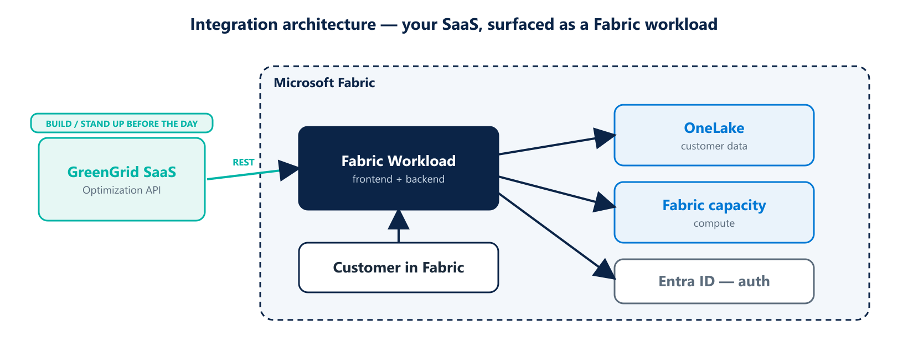
The workload is a thin, Fabric-native layer over your existing SaaS — so the SaaS must exist first.

Before you start
In this Micro Hack you turn an existing product into a native Microsoft Fabric workload using the Fabric Extensibility Kit. The workload is mostly a thin layer that surfaces your SaaS inside Fabric. That means there are two things to prepare: your SaaS service, and your Fabric dev environment.
KEY PREREQUISITE
You must develop and stand up a SaaS service first (here, the GreenGrid Optimization API). The workload integrates it — it does not replace it. No reachable SaaS, no working workload.

Part A · Your SaaS service (stand up before the day)
A small REST service is enough for the hack. It stands in for your real product.
Endpoint | Method | Returns
/optimize | POST | Starts an optimization run, returns a run id
/status/{id} | GET | Run status and, when ready, the result
/health | GET | Simple liveness check
Checklist:
☐ The SaaS runs and is reachable over HTTPS (local tunnel, App Service or container).
☐ It accepts an API key or bearer token, and allows CORS from Fabric.
☐ Sample input and a sample result are available to demo.

Part B · Fabric & developer environment
☐ A Fabric tenant with workload development / developer mode enabled.
☐ A workspace with capacity assigned.
☐ Node.js LTS, git, and the Fabric Extensibility Kit SDK installed.
☐ The starter workload repository cloned locally.
☐ An Entra ID app registration (client id, redirect URI, API scopes).

Connectivity check
Check | How to verify
Dev machine → SaaS | Call /health and get 200 OK
Workload loads locally | Run the dev server and open it in Fabric
Auth works | Acquire a token with your app registration

Definition of ready (before 09:00)
☐ The GreenGrid SaaS responds to /health from the open internet.
☐ Each team can run the starter workload locally inside Fabric.
☐ Tokens / app registration are in place and tested.
☐ A coach has completed the scaffold-run-publish loop once on this setup.

Troubleshooting
Symptom | Likely cause | Fix
Workload won't load | Dev mode off | Enable workload dev in settings
CORS error to SaaS | Origin not allowed | Allow the Fabric origin on the API
401 from SaaS | Missing / wrong token | Check API key or bearer token

