MICRO HACK 2 · PARTICIPANT WORKBOOK
Participant Workbook
Design & build your Fabric workload
GreenGrid Analytics (fictional ISV) · map your product onto Fabric

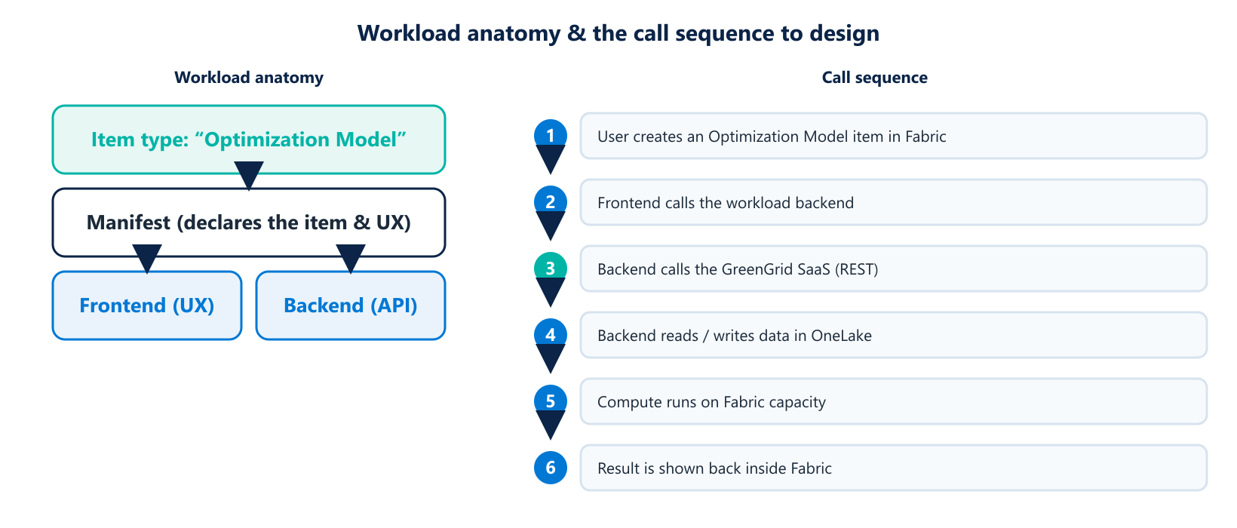
The anatomy of the workload, and the call sequence you need to design.

Your challenge
GreenGrid Analytics sells energy-optimization software, but today customers shuttle data in and out of Fabric to use it. Your team will use the Fabric Extensibility Kit to ship GreenGrid as a native Fabric workload, so customers create and manage “Optimization Models” directly inside Fabric, on their OneLake data.
THE MINDSET
Don't rebuild your product. Wrap it. The workload gives your existing SaaS a native home in Fabric — UX, data access, identity and billing all come from the platform.

Reflect before you build
- What is the unit of value your customers create? (Here: an “Optimization Model”.)
- What should it look like inside Fabric — what does the user see and do?
- Which of your SaaS endpoints does each user action call?
- What data does it read from, or write back to, OneLake?

Worksheet · Design your item type
Question | Your answer
Item type name | e.g. Optimization Model
What it represents
Key properties
Main user actions

Worksheet · Map actions to your SaaS
This is the heart of the integration. For each user action, name the calls behind it.
User action | Backend → SaaS | OneLake / capacity
Run optimization | POST /optimize | Read inputs from OneLake
Check result | GET /status/{id} | Write result to OneLake

Sprint 1 · Scaffold & run (13:30 – 15:30)
☐ Scaffold the workload and declare the “Optimization Model” item type.
☐ Run the workload locally inside Fabric.
☐ Read sample input data from OneLake.
☐ Call your SaaS /optimize from the backend and show a run id.

Sprint 2 · Integrate & package (15:45 – 16:45)
☐ Wire up authentication (Entra ID) end-to-end.
☐ Tie compute to Fabric capacity; write the result back to OneLake.
☐ Package the workload for publishing to the workload hub.

Stretch goals
- A status/progress experience while the optimization runs.
- A second item action (e.g. compare two model runs).

Demo checklist & path to publish
☐ Show a customer creating and running an Optimization Model inside Fabric.
☐ Show where your SaaS is called and where data flows in OneLake.
☐ State your path to publishing the workload for real customers.

