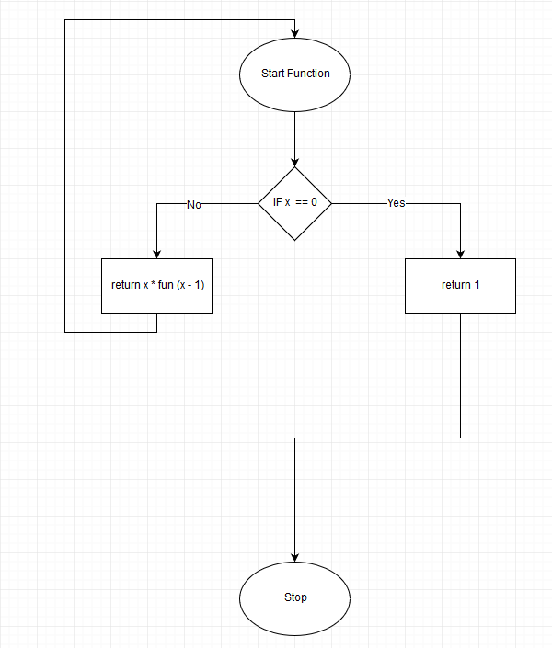

1

Start

X = 5

1

Let’s analyze how does program works:  
For example, x = 5;

Start program (1)   
Step 1: If 🡪 return 5 \* (fun(5-1))  
Step 2: x = 4 If 🡪 return 4 \* (fun(4-1))  
Step 3: x = 3 If 🡪 return 3 \* (fun(3-1))  
Step 4: x = 2 If 🡪 return 2 \* (fun(2-1))  
Step 5: x = 1 If 🡪 return 1

In every step program storage, the formulas in cash memory so informally this look like:

5 \* (fun(5-1)) \* (fun(4-1)) \* (fun(3-1)) \* (fun(2-1))

And in the last step program knows how match is equal to fun(2-1).   
If you look to schematic block you see as fun(2-1) = fun(1) = 1.

In every step program has new information:

S1: 5 \* (fun(5-1))  
S2: 5 \* 4 \* (fun(4-1))  
S3: 5 \* 4 \* 3 \* (fun(3-1))  
S4: 5 \* 4 \* 3 \* 2 \* (fun(2-1))  
S5: 5 \* 4 \* 3 \* 2 \* 1

Solution: 120