PARTIAL KERFUFFLE
Rev 3
Table of Contents
1 Overview 3
2 Materials 3
3 Definitions 3
4 Set up 5
4.1 Overview 5
4.2 Faction customization 5
4.3 Strategic Map 5
4.4 Win Condition Cards 5
5 Turn Phases 6
5.1 Overview 6
5.2 Monetary Phase 6
5.3 Army Management Phase 6
5.4 Strategic Map Phase 7
5.5 Battle Phase 7
6 End Conditions 8
6.1 Win Conditions 8
6.2 Loss Procedure 8
7 Clause of Randomness 9
8 Variations 9
9 Flow Charts 10
9.1 Turn Flow Chart 10
9.2 Battle Flow Chart 10

1 Overview
Partial Kerfuffle is intended to be a game that combines the strategic plotting that comes with being a strategic / political leader and the tactical tension that comes with being a battlefield commander. Players take on the role of the leaders of a map appropriate faction (kingdoms are to kings as cities are to gang leaders) and take turns making moves on any map, be it a city divided into districts or a country divided into provinces. If players clash, they take the battle to the dice game. Who will accomplish their objectives? All will try. The rest is chaos, also known as history.

2 Materials
To play a game of Partial Kerfuffle, you will need
- 3 - 6 players
- A printed map of a region divided into provinces
- Reference and Battle Mats
- Lots of chits for army composition markers on the strategic map (footmen, knights, kings, queens, and generals)
- Chits for special province markers (Fortresses and Capitals)
- At least 3 dice
- Pens (of varying colors, if desired)
- Scratch paper for banners
- A small deck of win conditions

3 Definitions
First, the lingo.
- Strategic Map
  - Map of the world where the strategic game takes place.
  - Holds provinces, capitals, territories, fortresses, and armies.
- Province
  - A division of space on the strategic map.
- Capital
  - A player's primary province.
  - Capitals both generate money and serve as a spawn point for army recruitment.
  - Chosen at the beginning of the game and always under the player's control.
  - Represented on the strategic map with a faction insignia annotated with a C.
- Army Camp
  - A province that is occupied by a player's army.
  - Army camps generate money for the army's owner.
- Territory
  - A province that is adjacent to a player's Army Camp.
  - Territories generate money for players with adjacent armies.
- Fortress
  - A province that serves as a spawn point for army recruitment.
  - Chosen at the beginning of the game and persists throughout.
  - Fortresses can be occupied by any player.
  - Represented on the strategic map with a fortress insignia.
- King
  - A faction's head of state.
  - Placed on the strategic map, a king may also join an army, gaining the ability to lead troops around the strategic map and participate in battles.
  - Represented on the strategic map with a faction insignia annotated with a K.
  - If a king is killed, it is permanently removed from the game.
- Queen
  - A faction's secondary head of state.
  - Placed on the strategic map, a queen may also join an army, gaining the ability to lead troops around the strategic map and participate in battles.
  - Represented on the strategic map with a faction insignia annotated with a Q.
  - If a queen is killed, it is permanently removed from the game.
- Army
  - Any collection of military units, including and limited to knights and pawns.
  - Must be led by at least one king, queen, or general.
  - At most, a single army may contain 4 pawns, 2 knights, a general, a king, and a queen.
- General
  - Military commander that, when attached to an army, allows that army to move around the strategic map.
  - Represented on the strategic map with a faction insignia.
  - The general does not participate in any battles (stays behind in the camp).
  - At most, a player may control 3 generals.
- Knight
  - Traditional knight in the western chess sense.
  - Represented on the strategic map with a dime.
- Footman
  - Traditional pawn in the western chess sense.
  - Represented on the strategic map with a penny.
- Prisoner
  - A military unit that has fallen under control of a player other than its original owner.
  - See Article 5.5 for how to obtain and what to do with prisoners.
- Conquer
  - To remove both the king and queen of a player from the strategic map.
  - By extension, to remove a player from the game.
- Win Condition Card
  - A card drawn at the beginning of the game representing one of the game's win conditions.

4 Set up

4.1 Overview
Before a game of Partial Kerfuffle begins, each player must set up three things:
- Customize their faction banner or select a default insignia
- Choose a starting location, fortress location, and be allocated starting armies
- Draw a Win Condition card

4.2 Faction customization
Each player draws or selects a small insignia to identify their faction's armies as they move around the map.

Note: Creativity is encouraged, but insignias may be as simple as a single color or shape.
Note: This must be done for each army under the players control (at the beginning or along the way).
Hint: good for passing time during other people's turns.

4.3 Strategic Map
Starting locations
Each player must
- select and mark a province to use as his or her faction's capital with a faction insignia.
- select a neighboring province as their starting army camps. Starting army camps must be connected to that player's capital directly.

Starting armies
Each player is allocated
- A king and queen in his or her capital
- A general, two pawns, and a knight in their starting province

Fortresses
Each player selects one (1) province anywhere on the map to place a fortress.

4.4 Win Condition Cards
Draw cards from the Win Condition Deck to define the game's win conditions.
  - Each player draws a Win Condition Card
  - Only the player who draws the card may fulfill this win condition to win
  - Each player can reveal his or her win condition at any time or keep it hidden
  - Players must reveal their win condition in order to claim it

See Article 6.1: Win Conditions for more details.
Win Conditions may include
- Hoard a treasury of 100 gold
- Conquer the player to your left / right / across from you
- Hold half of the fortresses on the strategic map
- Hold three enemy generals from all opponents prisoner in your capital
- Be owed 15 gold by all players

5 Turn Phases

5.1 Overview
After set up, each turn will compose of the following phases until the win conditions are met (see Article 6: Win Conditions).
- Money Phase
- Army Management Phase
- Strategic Map Phase
- Battle Phase (if declared)

5.2 Monetary Phase
This phase handles the monetary gains of each player. Calculated from revenue and expenditures. Each player must
- Collect Revenue money from the following map conditions.
  - Add 1 gold for each Territory
  - Add 1 gold for each Army Camp
  - Add 2 gold for each occupied Capital
  - Fortresses never generate gold
  - Coin markers may be used to assist tallying
- Deduct Upkeep money is based on the following map conditions.
  - Deduct 2 gold for each king or queen outside the capital
  - Deduct 1 gold for each general outside the capital
  - Deduct 3 gold for each occupied fortress

5.3 Army Management Phase
This phase handles the growth of each player's armies. Each player must either
  - purchase troops with available treasury
    - Prices are deducted from treasury according to purchase. Prices are as follows.
      - Pawn - 1 gold
      - Knight - 2 gold
      - General - 10 gold
    - The player collects the strategic map representations of new troops (off-map)
    - Purchased troops may be placed on the next Army Management Phase
  - distribute collected troops among the player's capital and occupied fortress(es).

5.4 Strategic Map Phase
In the strategic map phase, players move around armies and interact with other players.
- Armies led by a king, queen, or general may be moved within a range of 1 province.
- Adjacent armies may transfer units
- Battles are declared
  - When a player's army enters a province occupied by a hostile player's army, a battle challenge is issued
  - The defending player may accept or decline
    - Accept
See Article 5.5: Battle Phase
    - Decline
Defending player must move to an adjacent friendly or neutral province
- Deals with other players may be discussed at this time
  - Common deals include
    - Alliances
    - Money lending
    - Declarations of war
    - Betrayals

5.5 Battle Phase
After a battle challenge is issued in the Strategic Map Phase, the conflict must be resolved in the Battle Phase. The outcome of the battle is determined by a probabilistic betting mechanic. At the end of a battle, the victorious army may take prisoners. The procedures and rules for battle and prisoner resolution are detailed below.
- Set Up
  - Each player needs
    - The coinage representation of their participating army
    - Three dice
- Battle
  - The battle is composed of a series of “clashes” between individual soldiers
  - Battle procedure
    - Players choose a soldier to “bet”
    - Players roll a number of dice, depending on which soldier was selected to bet
      - Footman – 1 die
      - Knight – 2 dice
      - King or Queen – 3 dice
    - The soldier of the player who rolled the lower value dies
    - This procedure continues until an army is either destroyed or a player declares a retreat
  - Retreat procedure
    - Each player selects a soldier to participate in one final clash
    - If the retreating army's soldier
      - succeeds
        - the opposing player takes the retreating army's soldier prisoner
        - the rest of the retreating army escapes
      - fails
        - the opposing player takes the entire retreating army prisoner
- Aftermath
  - Prisoners
    - Prisoners are kept to be used during the Strategic Map phase
    - Prisoner ideas include
      - Ransom – Return troops to owner for money or favors
      - Trade – Exchange prisoners
      - Recruitment – Select half of the prisoners to keep as your own
      - Execute – Remove all prisoners from game as though they were killed in battle
  - Post battle army positions
    - General rule is that the victorious army's movement dominates
    - Attacker victory
      - Attacking army occupies battle province
      - Defending army must move to a province adjacent to the battle province
    - Defender victory
      - Attacking army and defending army remain in starting positions

6 End Conditions

6.1 Win Conditions
At the end of the day, when the dust settles, someone(s) must come out on top. The “when” is tied closely to the Win Condition cards in the Set Up phase.
- The wars and power plays continue until any number of players claim exactly half of the game's win conditions cards (see Article 4: Set Up)
  - Round down for odd numbers of win conditions
- To declare accomplishment of a win condition, the corresponding win condition card must be revealed
- Only win conditions that are fulfilled at the time of completion are counted

6.2 Loss Procedure
So you're kingdom's been conquered. Here's what the Partial Kerfuffle afterlife looks like. Upon being conquered,
- The player is removed from the game
- The game continues until victory conditions are met (see Article 6.1 – Win Conditions)
- If the conquered player yet fields troops at the time of being conquered, a coin is tossed
  - Heads
    - Half of the conquered player's remaining troops belong to the conquering player
    - The rest are removed from the strategic map as though they were killed in battle
    - The conquering player selects
    - The surviving troops are distributed in the conquering player's Army Management Phase
  - Tails
    - All the conquered player's remaining troops remain in their last positions until they are
      - bought during the strategic map phase - Standard rates apply
      - killed in the battle phase - Their previous owner commands them during these battles

7 Clause of Randomness
All other actions of play are left purposefully unaddressed. The players are encouraged to get creative: make deals, strategies, tactics and plots. Anything short of violent, illegal, and morally destructive activities are encouraged to add spice to game play.

8 Variations
By default, this game was envisioned with a simple, one player one kingdom sort of format. However, others (or a combination of others) may also be interesting. For example,
- Teams
  - Two or more players may be assigned to a kingdom. They must decide amongst themselves which strategies to execute and how to execute them. They must also collaborate to make the tough decisions as they arise...
- Ogre / Empire
  - Faction and castle set up proceeds normally
  - One player is randomly selected as “The Ogre” or “The Empire”
  - The Ogre / Empire is allocated
    - a treasury of 50 gold
    - an army in half of the fortresses (of the Ogre / Empire's choice) on the map. Each army has
      - One general
      - Two Footmen
      - Two Knights
  - All other players
    - are allocated the usual starting resources
    - are limited to 1 general

9 Flow Charts

9.1 Turn Flow Chart
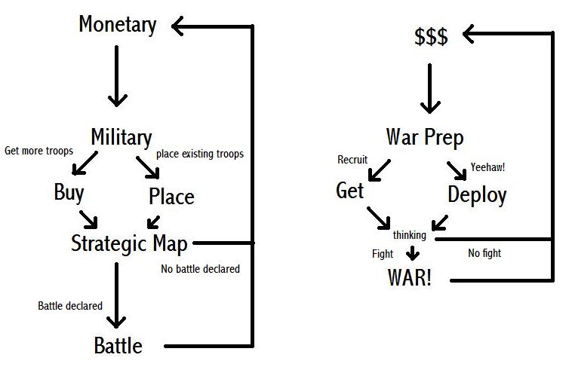

9.2 Battle Flow Chart
