**Supplementary information/ index**

**Table S1.** Detailed significant drought years, affected Countries and regions, and impacts

|  |  |  |
| --- | --- | --- |
| Reference | Drought year or period within the years 2001 to 2020 | Remarks on drought occurrences by region/ country/ basin |
| Meteorological Drought |  |  |
| North Africa |  |  |
| Babaousmail et al. (2021) | 2001-2020 | 70% desert with less than 50mm of r/f. 150mm of r/f in arid areas. Recurrent drought in the Sahel, Sahara, and its environs. |
| Touchan et al. (2008), Touchan et al. (2011), Mohamed et al. (2023) | 2001-2002 | Drought in Northern Africa, notably Morocco, Algeria, and Tunisia, with Tunisia experiencing extreme conditions. |
| Elagib & Elhag. (2011) | 2002-2008 | El Niño driving droughts in Sudan. |
| Thi et al. (2023) | 2001,2005, 2015-2017, 2019-2020 | Droughts in Northeast Africa as detected through the Standardized Precipitation Index (SPI). |
| West Africa |  |  |
| Kasei et al. (2010) | 2001 | Mali, Burkina Faso, Ghana, Togo, and the Volta Basin suffer droughts per SPI assessments. |
| Ogunrinde et al. (2023) | 2001 to 2005 and 2012 | Drought in Nigeria, particularly severe in 2002 and 2012. |
| East Africa |  |  |
| Nicholson. (2014), Ayugi et al. (2022) | 2005/2006, 2007, 2008, 2009, 2011, 2017/2018 | Below normal rainfall in the greater horn of Africa in regions of Kenya, Tanzania, Somalia, and Ethiopia. |
| Uhe et al. (2018) | 2010/2011, 2016 | Kenyan drought |
| Dutra et al. (2013), Tierney et al. (2013) | 2010-2011 | Severe drought in the Horn of Africa, especially in Somalia and Ethiopia, is among the worst in six decades, influenced by the Indian Ocean. |
| Hastenrath et al. (2007) | 2005 | Equatorial East Africa, Kenya |
| [15] | 2001-2002 | Horn of Africa drought and monitoring using gridded precipitation data. |
| Southern Africa |  |  |
| Mishra & Singh. (2010), Bhaga et al. (2020), Rouault & Richard. (2005), Chivangulula et al. (2023),Chikoore & Jury. (2021) | 2002-2004 and 2015-2019 | Droughts in Southern Africa, including El Niño impact, with extreme meteorological droughts in 2015, 2016, and 2019. |
| Central Africa |  |  |
| Alber et al. (2021),Chen et al. (2022) | 2001-2020 | Drying trend in Congo linked to gradually decreasing precipitation and SPEI study findings |
| Ntali et al. (2023) | 2002, 2004, 2009, 2011, 2012, 2015, 2016, 2017, 2018, and 2019 | Frequent droughts in northern Cameroon, as determined by SPI analysis." |
| Carvalho et al. (2017) | 2013 | Severe drought in Angola |
| Pinto et al. (2023) | 2012-2020 | Southern Angola experienced droughts |
| Agricultural Drought |  |  |
| North Africa |  |  |
| Amri et al. (2011) | 2001 | Drought in North Africa as assessed through NDVI analysis |
| Henchiri et al. (2020) | 2002 | Analysis of agricultural drought in Tunisia, North Africa, with a focus on the exceptionally dry year of 2002. |
| Thi et al. (2023) | 2016-2017 and 2019-2020 | Precise observation of severe drought in Morocco and Algeria within Northeast Africa, utilizing NDVI time series data. |
| West Africa |  |  |
| Bhaga et al. (2023) | 2018 | In 2018, drought-induced crop failure in Senegal resulted in food insecurity for 245,000 people. |
| Brown et al. (2017) | 2011 | Agricultural drought in Ghana. Monitored with a satellite based agricultural drought early warning system. |
| Eastern Africa |  |  |
| Rulinda et al. (2012) | 2005-2006 | Drought across Burundi, Kenya, Rwanda, Tanzania, and Uganda, with agricultural drought spreading spatially from September 2005 to its peak in January 2006. |
| Southern Africa |  |  |
| Ndlovu & Mjimba. (2021) | 2019 | In 2019, Zimbabwe saw a roughly 70% drop in maize production due to drought. |
| Archer et al. (2022),Theron et al. (2021), Theron et al. (2022) | 2015-2019 | Multiyear agricultural drought in South Africa from 2015 to 2019, impacting Western and Eastern Cape. |
| Central Africa |  |  |
| Chen et al. (2022) | 2001-2020 | Congo rainforest productivity declining with increasing drought frequency, severity, and duration trends, though not yet severe. |
| Luetkemeier et al. (2017) | 2006 | Angolan study using various drought indices indicates limited trend variation from 2001 to 2011, with only one severe drought in 2006. |
| Hydrological Drought |  |  |
| North Africa |  |  |
| Henchiri et al. (2021) | 2001-2003, 2008-2010 | Morocco and Algeria in North Africa experiencing hydrological drought. |
| Achite et al. (2023) | 2014-2016 | Algeria's Wadi basin facing severe to extreme drought. |
| West Africa |  |  |
| Oloruntade et al. (2017) | 2006 | In Nigeria, the Niger-South Basin experienced drought in 2006, as evidenced by the findings derived from the Standardized Runoff Index (SRI). |
| Henchiri et al. (2021) | 200-2003, 2008-2010 | Mali, Guinea, Ghana, Sierra Leone, Cote d’Ivoire, Niger, Burkina Faso, Nigeria experienced hydrological drought conditions. |
| Ogunrinde et al. (2023) | 2003-2004 | Extreme hydrological drought in Nigeria |
| East Africa |  |  |
| Anderson et al. (2012) | 2010-2011 | Drought in Ethiopia, Somalia, and Kenya indicated by hydrological modeling results. |
| Calow et al. (2010) | 2002-2003, 2004-2005, 2005-2006 | Droughts in Ethiopia studied through groundwater research. |
| Tareke & Awoke. (2022) | 2001,2002,2003,2004,2005,2010,20112012 | Severe and extreme hydrological drought years in six Ethiopian river basins, determined through Streamflow Drought Index (SDI) results. |
| Southern Africa |  |  |
| Mussá et al. (2015) | 2003-2004 | Hydrological droughts in South Africa's Crocodile catchment area identified via groundwater analysis employing the SRI hydrological index. |
| Siderius et al. (2018) | 2015/2016 | Southern Africa experienced hydrological droughts due to a severe El Niño event, leading to low lake levels in Botswana and Zambia. |
| Bhaga et al. (2020) | 2015-2018 | Severe drought in South Africa's Western Cape, resulting in a 20% decrease in dam levels. |
| Cenral Africa |  |  |
| Ndehedehe et al. (2019), Sorí et al. (2023),Alber et al. (2021),Sorí et al. (2017),Alber et al. (2021) | 2001-2020 | Trend shows the Congo River Basin has become drier. |
| Pinto et al. (2023) | 2012-2020 | Drying trend in Angola. |

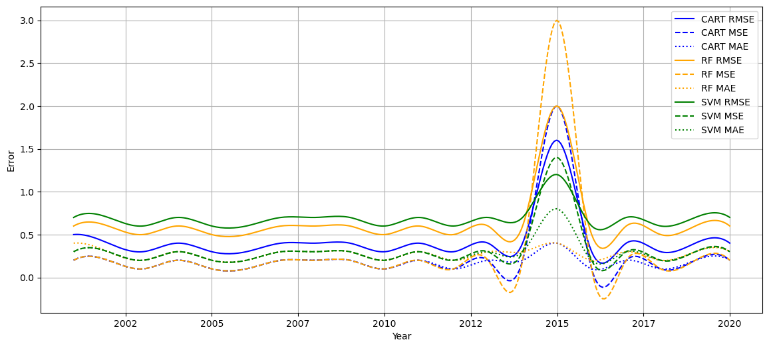

**Figure S1.** Meteorological drought-training errors

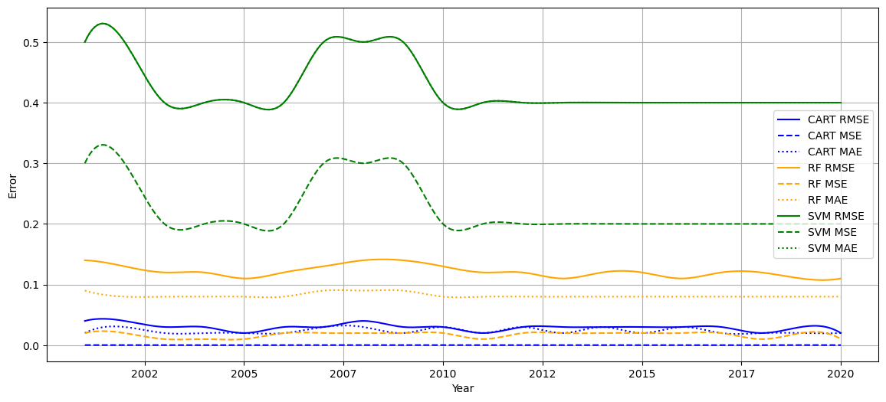

**Figure S2.** Agricultural drought-training errors

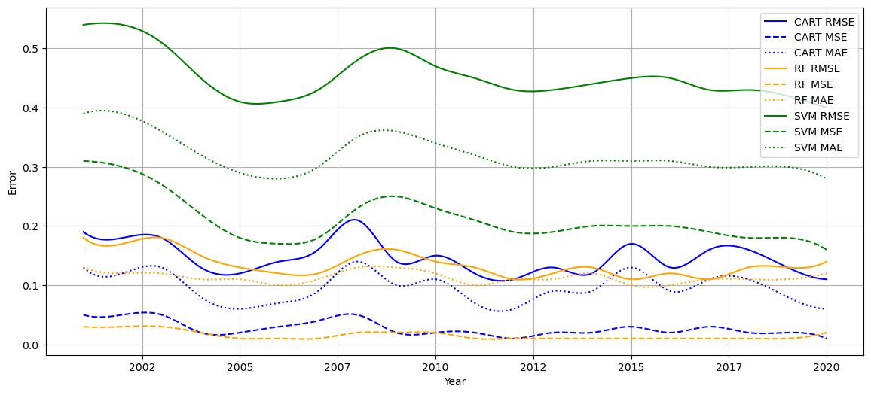

**Figure S3.** Hydrological drought-training errors.

1. Babaousmail, H.; Hou, R.; Ayugi, B.; Ojara, M.; Ngoma, H.; Karim, R.; Rajasekar, A.; Ongoma, V. Evaluation of the Performance of Cmip6 Models in Reproducing Rainfall Patterns over North Africa. *Atmosphere (Basel)* 2021, *12*, doi:10.3390/atmos12040475.

2. Touchan, R.; Anchukaitis, K.J.; Meko, D.M.; Attalah, S.; Baisan, C.; Aloui, A. Long Term Context for Recent Drought in Northwestern Africa. *Geophys Res Lett* 2008, *35*, doi:10.1029/2008GL034264.

3. Touchan, R.; Anchukaitis, K.J.; Meko, D.M.; Sabir, M.; Attalah, S.; Aloui, A. Spatiotemporal Drought Variability in Northwestern Africa over the Last Nine Centuries. *Clim Dyn* 2011, *37*, 237–252, doi:10.1007/s00382-010-0804-4.

4. Mohamed, M.A.E.-H.; Moursy, F.I.; Darrag, M.H.; El-Mahdy, M.E.-S. Assessment of Long-Term Trends and Mapping of Drought Events in Tunisia. *Sci Afr* 2023, e01766, doi:10.1016/j.sciaf.2023.e01766.

5. Elagib, N.A.; Elhag, M.M. Major Climate Indicators of Ongoing Drought in Sudan. *J Hydrol (Amst)* 2011, *409*, 612–625, doi:10.1016/j.jhydrol.2011.08.047.

6. Thi, N.Q.; Govind, A.; Le, M.-H.; Linh, N.T.; Anh, T.T.M.; Hai, N.K.; Ha, T. V. Spatiotemporal Characterization of Droughts and Vegetation Response in Northwest Africa from 1981 to 2020. *The Egyptian Journal of Remote Sensing and Space Science* 2023, *26*, 393–401, doi:10.1016/j.ejrs.2023.05.006.

7. Kasei, R.; Diekkrüger, B.; Leemhuis, C. Drought Frequency in the Volta Basin of West Africa. *Sustain Sci* 2010, *5*, 89–97, doi:10.1007/s11625-009-0101-5.

8. Ogunrinde, A.T.; Oguntunde, P.G.; Akinwumiju, A.S.; Fasinmirin, J.T.; Adawa, I.S.; Ajayi, T.A. Effects of Climate Change and Drought Attributes in Nigeria Based on RCP 8.5 Climate Scenario. *Physics and Chemistry of the Earth* 2023, *129*, doi:10.1016/j.pce.2022.103339.

9. Nicholson, S.E. A Detailed Look at the Recent Drought Situation in the Greater Horn of Africa. *J Arid Environ* 2014, *103*, 71–79, doi:10.1016/j.jaridenv.2013.12.003.

10. Ayugi, B.; Eresanya, E.O.; Onyango, A.O.; Ogou, F.K.; Okoro, E.C.; Okoye, C.O.; Anoruo, C.M.; Dike, V.N.; Ashiru, O.R.; Daramola, M.T.; et al. Review of Meteorological Drought in Africa: Historical Trends, Impacts, Mitigation Measures, and Prospects. *Pure Appl Geophys* 2022, *179*, 1365–1386, doi:10.1007/s00024-022-02988-z.

11. Uhe, P.; Philip, S.; Kew, S.; Shah, K.; Kimutai, J.; Mwangi, E.; van Oldenborgh, G.J.; Singh, R.; Arrighi, J.; Jjemba, E.; et al. Attributing Drivers of the 2016 Kenyan Drought. *International Journal of Climatology* 2018, *38*, e554–e568, doi:10.1002/joc.5389.

12. Dutra, E.; Magnusson, L.; Wetterhall, F.; Cloke, H.L.; Balsamo, G.; Boussetta, S.; Pappenberger, F. The 2010-2011 Drought in the Horn of Africa in ECMWF Reanalysis and Seasonal Forecast Products. *International Journal of Climatology* 2013, *33*, 1720–1729, doi:10.1002/joc.3545.

13. Tierney, J.E.; Smerdon, J.E.; Anchukaitis, K.J.; Seager, R. Multidecadal Variability in East African Hydroclimate Controlled by the Indian Ocean. *Nature* 2013, *493*, 389–392, doi:10.1038/nature11785.

14. Hastenrath, S.; Polzin, D.; Mutai, C. Diagnosing the 2005 Drought in Equatorial East Africa. *J Clim* 2007, *20*, 4628–4637, doi:10.1175/JCLI4238.1.

15. Tadesse, T.; Haile, M.; Senay, G.; Wardlow, B.D.; Knutson, C.L. The Need for Integration of Drought Monitoring Tools for Proactive Food Security Management in Sub-Saharan Africa. *Nat Resour Forum* 2008, *32*, 265–279, doi:10.1111/j.1477-8947.2008.00211.x.

16. Mishra, A.K.; Singh, V.P. A Review of Drought Concepts. *J Hydrol (Amst)* 2010, *391*, 202–216.

17. Bhaga, T.D.; Dube, T.; Shekede, M.D.; Shoko, C. Impacts of Climate Variability and Drought on Surface Water Resources in Sub-Saharan Africa Using Remote Sensing: A Review. *Remote Sens (Basel)* 2020, *12*, 1–34.

18. Rouault, M.; Richard, Y. Intensity and Spatial Extent of Droughts in Southern Africa. *Geophys Res Lett* 2005, *32*, doi:10.1029/2005GL022436.

19. Chivangulula, F.M.; Amraoui, M.; Pereira, M.G. The Drought Regime in Southern Africa: A Systematic Review. *Climate* 2023, *11*.

20. Chikoore, H.; Jury, M.R. South African Drought, Deconstructed. *Weather Clim Extrem* 2021, *33*, doi:10.1016/j.wace.2021.100334.

21. Alber, K.; Zhou, L.; Raghavendra, A. A Shift in the Diurnal Timing and Intensity of Deep Convection over the Congo Basin during the Past 40 Years. *Atmos Res* 2021, *264*, doi:10.1016/j.atmosres.2021.105869.

22. Chen, J.; Shao, Z.; Huang, X.; Zhuang, Q.; Dang, C.; Cai, B.; Zheng, X.; Ding, Q. Assessing the Impact of Drought-Land Cover Change on Global Vegetation Greenness and Productivity. *Science of the Total Environment* 2022, *852*, doi:10.1016/j.scitotenv.2022.158499.

23. Ntali, Y.M.; Lyimo, J.G.; Dakyaga, F. Trends, Impacts, and Local Responses to Drought Stress in Diamare Division, Northern Cameroon. *World Development Sustainability* 2023, *2*, 100040, doi:10.1016/j.wds.2022.100040.

24. Carvalho, S.C.P.; Santos, F.D.; Pulquério, M. Climate Change Scenarios for Angola: An Analysis of Precipitation and Temperature Projections Using Four RCMs. *International Journal of Climatology* 2017, *37*, 3398–3412, doi:10.1002/joc.4925.

25. Pinto, I.; Coughlan de Perez, E.; Jaime, C.; Wolski, P.; van Aardenne, L.; Jjemba, E.W.; Suidman, J.; Capdevila-Serrat, A.; Tall, A. Climate Change Projections from a Multi-Model Ensemble of CORDEX and CMIPs over Angola. *Environmental Research: Climate* 2023, doi:10.1088/2752-5295/ace210.

26. Amri, R.; Zribi, M.; Lili-Chabaane, Z.; Duchemin, B.; Gruhier, C.; Chehbouni, A. Analysis of Vegetation Behavior in a North African Semi-Arid Region, Using SPOT-VEGETATION NDVI Data. *Remote Sens (Basel)* 2011, *3*, 2568–2590, doi:10.3390/rs3122568.

27. Henchiri, M.; Liu, Q.; Essifi, B.; Javed, T.; Zhang, S.; Bai, Y.; Zhang, J. Spatio-Temporal Patterns of Drought and Impact on Vegetation in North and West Africa Based on Multi-Satellite Data. *Remote Sens (Basel)* 2020, *12*, 1–26, doi:10.3390/rs12233869.

28. Bhaga, T.D.; Dube, T.; Shekede, M.D.; Shoko, C. Investigating the Effectiveness of Landsat-8 OLI and Sentinel-2 MSI Satellite Data in Monitoring the Effects of Drought on Surface Water Resources in the Western Cape Province, South Africa. *Remote Sens Appl* 2023, *32*, doi:10.1016/j.rsase.2023.101037.

29. Brown, M.; Black, E.; Asfaw, D.; Otu-Larbi, F. Monitoring Drought in Ghana Using TAMSAT-ALERT: A New Decision Support System. *Weather* 2017, *72*, 201–205, doi:10.1002/wea.3033.

30. Rulinda, C.M.; Dilo, A.; Bijker, W.; Stein, A. Characterising and Quantifying Vegetative Drought in East Africa Using Fuzzy Modelling and NDVI Data. *J Arid Environ* 2012, *78*, 169–178, doi:10.1016/j.jaridenv.2011.11.016.

31. Ndlovu, T.; Mjimba, V. Drought Risk-Reduction and Gender Dynamics in Communal Cattle Farming in Southern Zimbabwe. *International Journal of Disaster Risk Reduction* 2021, *58*.

32. Archer, E.; du Toit, J.; Engelbrecht, C.; Hoffman, M.T.; Landman, W.; Malherbe, J.; Stern, M. The 2015-19 Multi Year Drought in the Eastern Cape, South Africa: It’s Evolution and Impacts on Agriculture. *J Arid Environ* 2022, *196*, doi:10.1016/j.jaridenv.2021.104630.

33. Theron, S.N.; Archer, E.; Midgley, S.J.E.; Walker, S. Agricultural Perspectives on the 2015-2018 Western Cape Drought, South Africa: Characteristics and Spatial Variability in the Core Wheat Growing Regions. *Agric For Meteorol* 2021, *304–305*, doi:10.1016/j.agrformet.2021.108405.

34. Theron, S.N.; Archer, E.R.M.; Midgley, S.J.E.; Walker, S. Exploring Farmers’ Perceptions and Lessons Learned from the 2015–2018 Drought in the Western Cape, South Africa. *J Rural Stud* 2022, *95*, 208–222, doi:10.1016/j.jrurstud.2022.09.002.

35. Luetkemeier, R.; Stein, L.; Drees, L.; Liehr, S. Blended Drought Index: Integrated Drought Hazard Assessment in the Cuvelai-Basin. *Climate* 2017, *5*, doi:10.3390/cli5030051.

36. Henchiri, M.; Igbawua, T.; Javed, T.; Bai, Y.; Zhang, S.; Essifi, B.; Ujoh, F.; Zhang, J. Meteorological Drought Analysis and Return Periods over North and West Africa and Linkage with El Niño–Southern Oscillation (Enso). *Remote Sens (Basel)* 2021, *13*, doi:10.3390/rs13234730.

37. Achite, M.; Simsek, O.; Adarsh, S.; Hartani, T.; Caloiero, T. Assessment and Monitoring of Meteorological and Hydrological Drought in Semiarid Regions: The Wadi Ouahrane Basin Case Study (Algeria). *Physics and Chemistry of the Earth* 2023, *130*, doi:10.1016/j.pce.2023.103386.

38. Oloruntade, A.J.; Mohammad, T.A.; Ghazali, A.H.; Wayayok, A. Analysis of Meteorological and Hydrological Droughts in the Niger-South Basin, Nigeria. *Glob Planet Change* 2017, *155*, 225–233, doi:10.1016/j.gloplacha.2017.05.002.

39. Anderson, W.B.; Zaitchik, B.F.; Hain, C.R.; Anderson, M.C.; Yilmaz, M.T.; Mecikalski, J.; Schultz, L. Towards an Integrated Soil Moisture Drought Monitor for East Africa. *Hydrol Earth Syst Sci* 2012, *16*, 2893–2913, doi:10.5194/hess-16-2893-2012.

40. Calow, R.C.; MacDonald, A.M.; Nicol, A.L.; Robins, N.S. Ground Water Security and Drought in Africa: Linking Availability, Access, and Demand. *Ground Water* 2010, *48*, 246–256, doi:10.1111/j.1745-6584.2009.00558.x.

41. Tareke, K.A.; Awoke, A.G. Comparing Surface Water Supply Index and Streamflow Drought Index for Hydrological Drought Analysis in Ethiopia. *Heliyon* 2022, *8*, doi:10.1016/j.heliyon.2022.e12000.

42. Mussá, F.E.F.; Zhou, Y.; Maskey, S.; Masih, I.; Uhlenbrook, S. Groundwater as an Emergency Source for Drought Mitigation in the Crocodile River Catchment, South Africa. *Hydrol Earth Syst Sci* 2015, *19*, 1093–1106, doi:10.5194/hess-19-1093-2015.

43. Siderius, C.; Gannon, K.E.; Ndiyoi, M.; Opere, A.; Batisani, N.; Olago, D.; Pardoe, J.; Conway, D. Hydrological Response and Complex Impact Pathways of the 2015/2016 El Niño in Eastern and Southern Africa. *Earths Future* 2018, *6*, 2–22, doi:10.1002/2017EF000680.

44. Ndehedehe, C.E.; Anyah, R.O.; Alsdorf, D.; Agutu, N.O.; Ferreira, V.G. Modelling the Impacts of Global Multi-Scale Climatic Drivers on Hydro-Climatic Extremes (1901–2014) over the Congo Basin. *Science of the Total Environment* 2019, *651*, 1569–1587, doi:10.1016/j.scitotenv.2018.09.203.

45. Sorí, R.; Gimeno-Sotelo, L.; Nieto, R.; Liberato, M.L.R.; Stojanovic, M.; Pérez-Alarcón, A.; Fernández-Alvarez, J.C.; Gimeno, L. Oceanic and Terrestrial Origin of Precipitation over 50 Major World River Basins: Implications for the Occurrence of Drought. *Science of the Total Environment* 2023, *859*, doi:10.1016/j.scitotenv.2022.160288.

46. Sorí, R.; Nieto, R.; Vicente-Serrano, S.M.; Drumond, A.; Gimeno, L. A Lagrangian Perspective of the Hydrological Cycle in the Congo River Basin. *Earth System Dynamics* 2017, *8*, 653–675, doi:10.5194/esd-8-653-2017.