**LAVINGTON GIRLS SECONDARY SCHOOL**

**FORM 4 AUGUST HOLIDAY ASSIGNMENTS 2025**

**MATHEMATICS**

**NAME................................................................CLASS..........ADMNO.........**

1. (a) A straight line L, whose equation is 3y - 2x = -2 meets the x-axis at R.

Determine the co-ordinates of R. (2 mks)

b) A second line L2 is perpendicular to L1 at R. Find the equation of L2 in

the form *y = mx + c*, where m and c are constants. (3 mks)

(c) A third line L3 passes through (-4,1) and is parallel to L2 Find:

(i) the equation of L3 in the form y = mx + c, where m and c are constants

(2 mks)

(ii) the co-ordinates of point S, at which L intersects L (3 mks)

2. The diagram below represents a solid conical frustrum. Given that the height of the frustrum is 4cm, the radius of the base is 4.9cm and slant height of the frustrum is 2.1 cm.

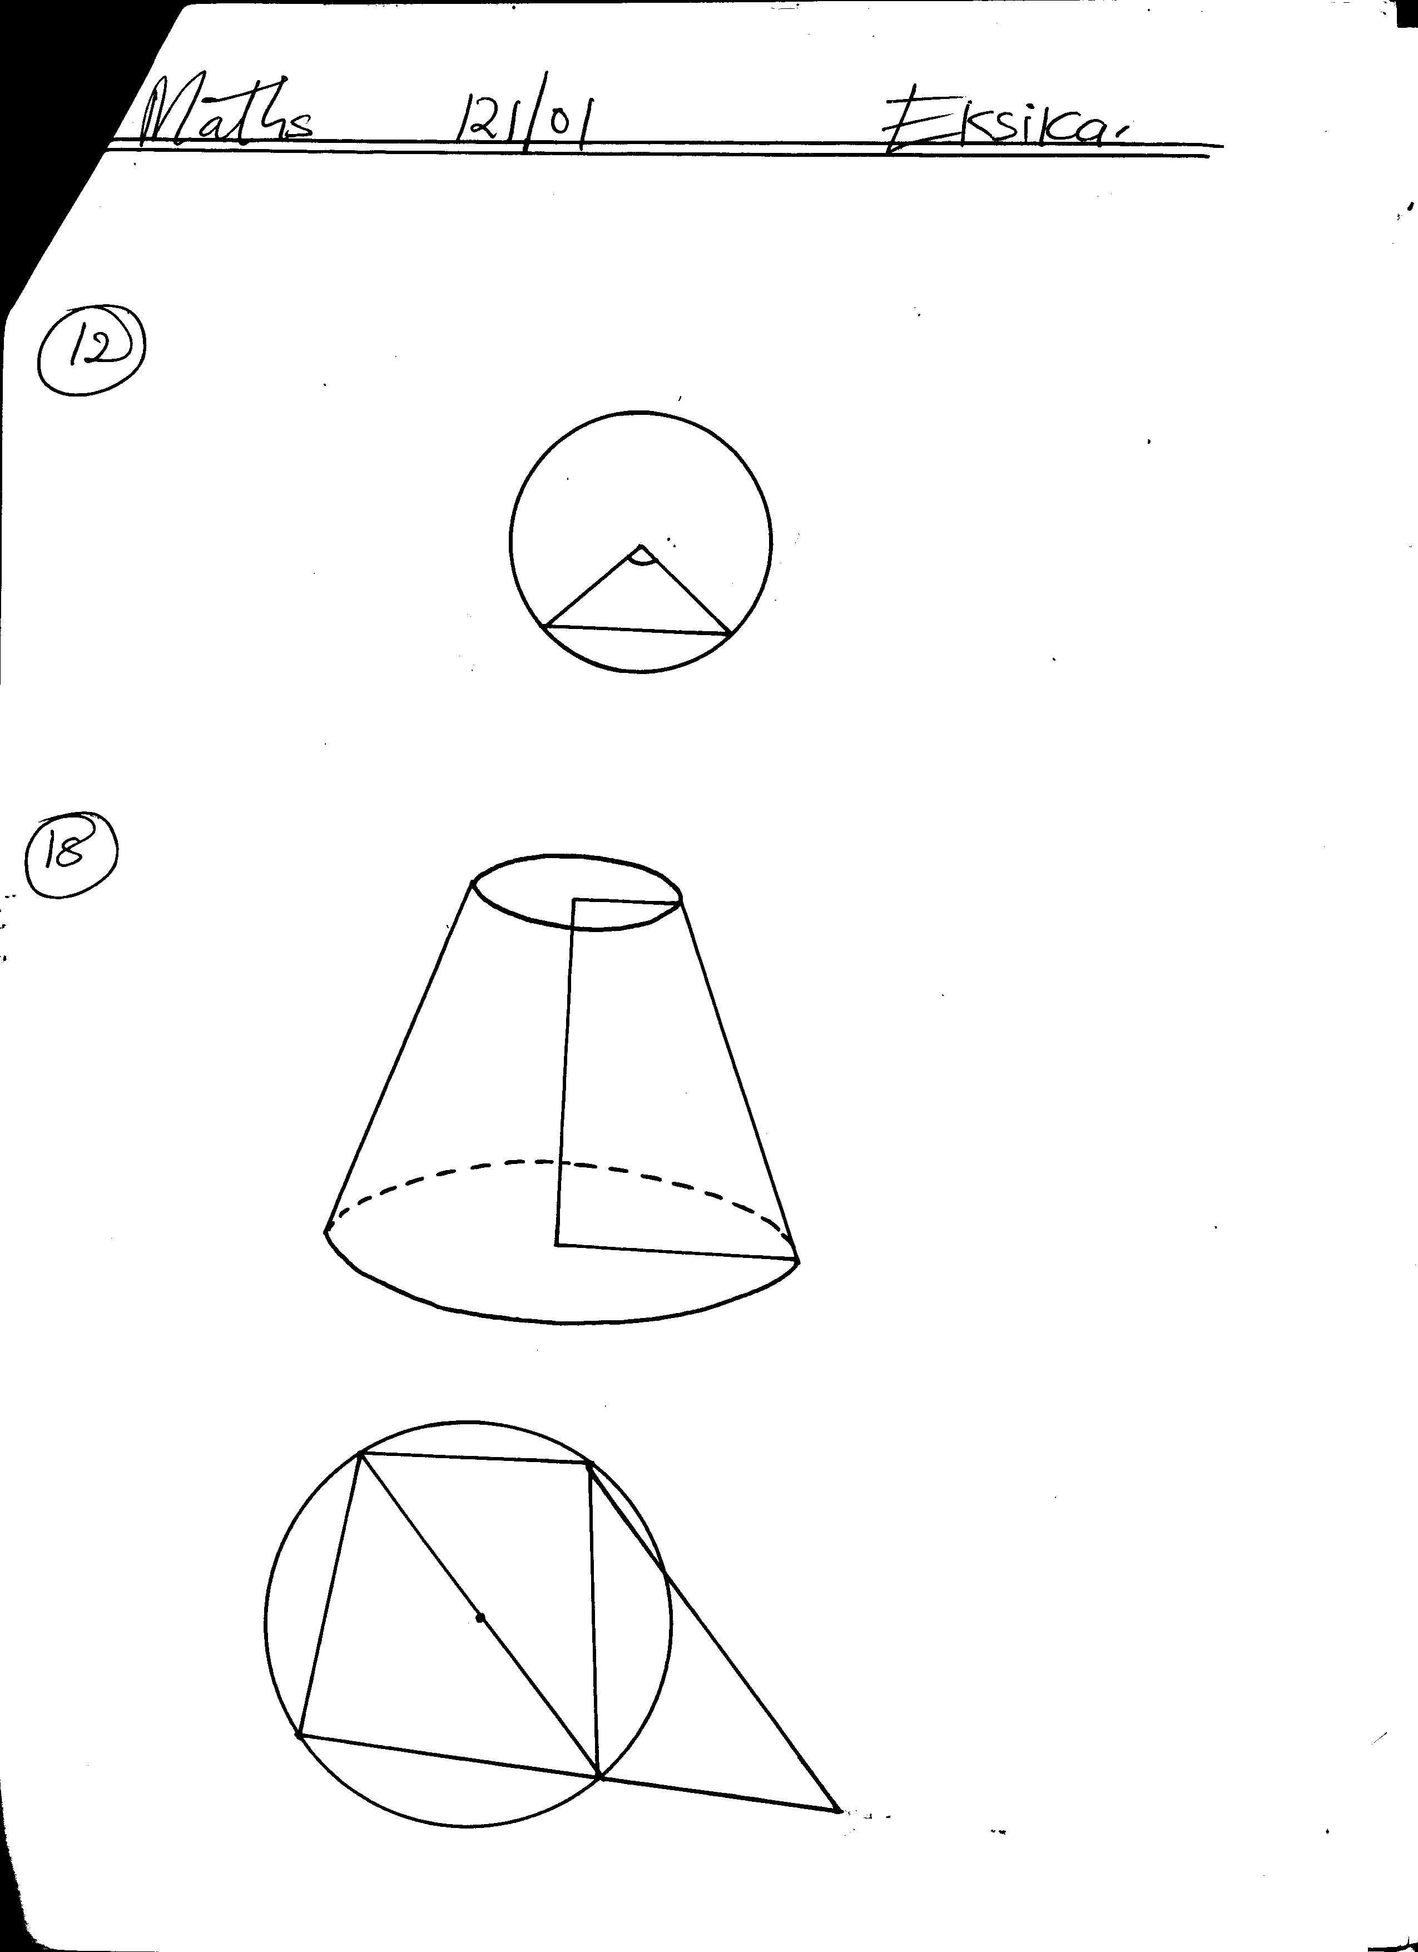

**B**

a) Determine the height of the chopped off cone and hence the height of the bigger cone. (2mks)

b) Calculate the surface area of the solid. (4mks)

c) Calculate the volume of the solid. (4mks)

3. A matatu left Ravine for Torongo 51km away at an average speed of 48km/h at 7.00am. At 7.30am a Boda boda left Torongo for Ravine travelling along the same route at an average speed of 60km/h. Find:

(a) The time when Boda boda meet the matatu (3mks)

(b) How far from Ravine did the Boda boda meet the matatu (3mks)

(c) After meeting the Boda boda the matatu stopped for fifteen minutes before resuming the journey. At what speed should it travel then to reach Torongo at the same time when the Boda boda reached Ravine (4mks)

4.The table shows the marks obtained by 40 candidates in an examination

|  |  |  |  |  |  |
| --- | --- | --- | --- | --- | --- |
| Marks | 5-14 | 15-29 | 30-34 | 35-44 | 45-49 |
| Frequency | 2 | 12 | 7 | 15 | x |

(a) Find the value of x (2mks)

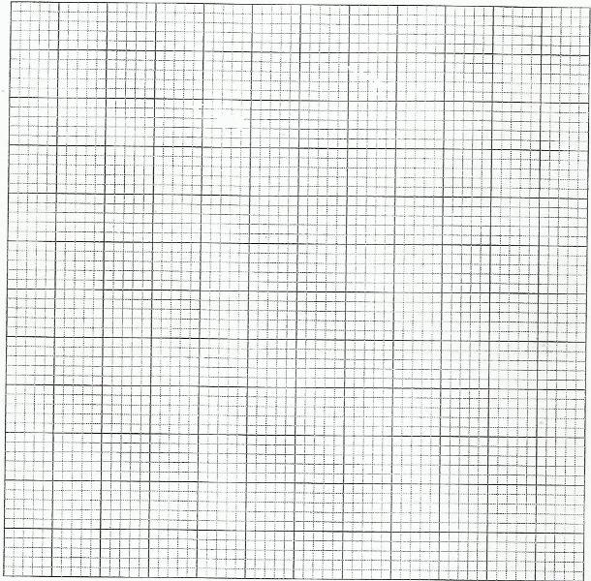 (b) On the grid provided below draw a histogram to represent the data (5mks)

(c) By drawing a straight line on the graph above determine the median mark(3mks)

5. A certain number of people agreed to contribute equally to buy a book worth sh. 1,200 for a school library. Five people pulled out so the others agreed to contribute an extra sh. 10 each. Their contribution enabled them to buy a book worth sh. 200 more than they originally expected.

1. If the original number of people was x, write an expression of how much each was originally to contribute. (1mk)

1. Write down two expressions of how much each contributed after the people pulled out. (2mks)
2. Calculate how many people made the contribution. (5mks)
3. Calculate how much each contributed. (2mks)

6. Three planes P,Q and R left Jomo Kenyatta International Airport at 8.10a.m, 8:40a.m and 9.20a.m respectively. Plane P travelled at 300km/h along N700W, plane Q travelled at 240km/h along N67.50E and R travelled at 400km/h along 2100.

a) Using a scale of 1cm to represent 100km, locate the position of the planes at 10.50a.m. (6mks)

b) Find the distance of plane Q and R at 10.50a.m. (2mks)

c) Find the bearing of plane Q from plane P (1mk)

d) Find the bearing of plane R from plane Q. (1mk**)**

1. The figure below represents a cuboid EFGHJKLM in which EF =40cm, FG=9cm and GM=30cm. N is the midpoint of LM.

M

J

N

L

K

30cm

H

G

9cm

F

E

40cm

Calculate correct to 4 significant figures:

1. the length of GL; (1mk)
2. the length of FJ; (2mks)
3. the angle between EM and the plane EFGH; (3mks)
4. the angle between the planes EFGH and ENH. (2mks)
5. the angle between the lines EH and GL. (2mks)
6. A triangle ABC with vertices A (-4,2), B(-6,6) and C(-6,2) is enlarged by scale factor -1 and centre (-2,6) to produce triangle A1B1C1. Triangle A1B1C1 is then reflected in line y=x to give triangle A11 B11C11.

 a) Draw triangle ABC and its successive images on the grid provided. State the co-ordinates of A1B1C1 and A11B11C11. (6mks)

(b) If triangle A11B11C11 is mapped onto a triangle whose co-ordinates are A111(0,-2), B111(4,-4) and C111(0,-4) by a rotation, find the centre and the angle of rotation. (4mks)

**END**

9.(a)Fill the table below for the curves given by y = 3 sin (2χ + 30°) and y = Cos 2χ for χ

values in the range O ≤ χ ≤ 180°. (2mks)

|  |  |  |  |  |  |  |  |  |  |  |
| --- | --- | --- | --- | --- | --- | --- | --- | --- | --- | --- |
| χ | 0° | 15° | 30° | 45° | 60 | 75° | 90° | 120° | 150° | 180° |
| y = 3 Sin (2χ + 30°) |  |  |  |  |  |  |  |  |  |  |
| y = Cos 2χ |  |  |  |  |  |  |  |  |  |  |

(b) Draw the graphs of y = 3 Sin (2χ + 30°) = Cos 2χ on same axes. (2mks)



(c) Use your graph to solve the equation y = 3 Sin (2χ + 30°) and y = Cos 2χ. (2mks)

1. Determine the following from your graph:

(i) Amplitude of y = 3 Sin (2χ + 30°). (1mk)

(ii) Period of y = 3 Sin (2χ + 30°) . (2mks)

(iii) Phase angle for y = 3 Sin (2χ + 30°). (1mk)

10. OAB is a triangle in which  M is a point on OA such that OM: MA = 2: 3

~

~

~

~

and N is another point on AB such that AN: NB = 1: 2. Lines ON and MB intersect at X.

1. Express the following vectors in terms of 

~

~

(i) AB (1mk)

~

(ii) ON (1mk)

~

(iii) BM (1mk)

~

1. If OX = KON and BX = hBM express OX in two different ways. Hence or otherwise

~

~

~

~

~

find the values of h and K. (6mks)

(c) Determine the ratio OX: XN. (1mk)

11. A trader bought 8 cows and 12 goats for a total of Ksh.294,000. If he had bought 1 more cows and 3 more goats he would have spend Ksh.337,500.

(a)Form two equations to represent the above information. (2 marks)

(b).Use matrix method to determine the cost of a cow and that of a goat. (4marks)

1. The trader sold the animals he had bought making a profit of 40% per cow and 45% per goat.

(i) Calculate the total amount of money he received. (2 marks)

(ii) Determine his profit in Kenya shillings. (2 marks)

12.Income tax is charged on annual income at the rate shown below

|  |  |
| --- | --- |
| **Taxable income (K£)** | **Rate (shs per K£)** |
| 1 – 1500  1501 – 3000  3001 – 4500  4501 - 6000  6001 – 7500  Over 7500 | 2  3  5  7  9  10 |

A civil servant earns a monthly basic salary of Ksh.8570. He is housed by the government and as a result, his taxable income is 15% more than his salary. He is entitled to a tax relief of Ksh. 150 per month.

a) How much tax does he pay in a year? (6mks)

b) From his salary, the following deductions are also made every month.

WCPS 2% basic salary

NHIF Ksh 20

Calculate the civil servants net salary per month. (4mks)

13. A plane takes off from airport P at (0°, 40°W) and flies 1800 nautical miles due East to Q then

1800 nautical rules due South to R and finally 1800 nautical rules due West before landing at S.

(a) Find to the nearest degree the latitudes and longitudes of Q, R and S.(4mks)

1. If the total flight time is 16 hours, find the average speed in knots for the whole journey. (3mks)
2. Find the time taken to fly from R to S, given that this was two hours shorter than the time

taken from P to Q to R. (2mks)

1. The 2nd and 5th terms of an arithmetic progression are 8 and 17 respectively. The 2nd, 10th and

42nd terms of the A.P. form the first three terms of a geometric progression. Find

(a) the 1st term and the common difference. (3mks)

(b) the first three terms of the G.P and the 10th term of the G.P. (4mks)

(c) The sum of the first 10 terms of the G.P. (3mks)

15. (a) The acceleration of a particle t seconds after passing a fixed point P is given by a = 3t – 3.

Given that the velocity of the particle when t = 2 is 5m/s, find

(i) its velocity when t = 4 seconds. (3mks)

(ii) its displacement at this time. (3mks)

(b) Find the exact area bounded by the graph χ = 9y - y³ and the Y-axis.(4mks)

16). Two baskets X and Y contain identical balls except for the colours.Basket X contains 6 red balls

and 3 black balls. Basket Y contains 2 red balls and 3 black balls.

(a) If a ball is drawn at random from each basket, find the probability that both balls

are of the same colour. ( 4 marks )

(b) If two balls are drawn at random from each basket, one ball at a time without replacement,

find the probability that:-

(i) The two balls drawn from basket X or basket Y are red. (4 marks )

(ii) All the four balls drawn are red. (2marks )