# Development of a file sharing by invitation service based on AWS S3

*Project 17*

**Mathieu Devaud** (*mathieu.devaud@master.hes-so.ch)*

**Frederic Montet** *(frederic.montet@master.hes-so.ch)*

## Context

This project is about using the power of cloud to create a file sharing system based on invitation with AWS S3. A main user with an AWS account can use his credentials to create URLs to give to secondary users. These URLs can be used by the secondary users to upload any file on the S3 of the main user. The main user can then monitor the links he created and download files secondary users uploaded.

## Work we did

All the system is web based and give to the users an elegant interface hosted on an Amazon EC2 instance. The instance is launch from a python script using the API boto. The interface is based on the Python framework Django.

From the main user perspective, an admin interface permit him to generate link via a simple button. The link is generated via the javascript API of S3 and create a temporary presigned URL containing all the permissions needed to upload a file. When a link is created, it is stored in a local database sqllite3. The main user can watch all the links and interact with them via new buttons for deleting the links, download the file uploaded by secondary user and watch get the presigned url from alert box.

From the secondary user’s perspective, he can navigate to the link received from the main user and get to a simple formulary to choose any file on his system to upload it to the S3 without amazon account. The file is uploaded with a PUT method in an AJAX request to the pre signed URL.

## Where it is

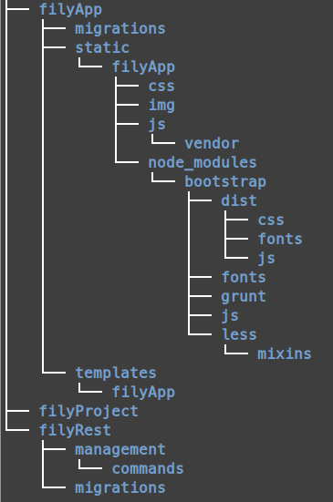

The project is separated in three main directories. The first one is **filyApp**, it contains all the client side code. The second one is **filyProject**, it contains all the Django project files. The last one is **filyRest**, it contains all the server side code.

Figure : Architecture

The majors file to understand the way the application works is the ***main.js*** file in: *filyApp->static->filyApp->js*.

To run the application just apply this command:

*# python manage.py runserver*