

**UNIVERSITY**

**CHUKA**

**SYSTEM DESIGN SPECIFICATION (SDS) FOR NYASOFT ONLINE MOVIE STORE SYSEM (NYOMSS)**

**SUBMITTED TO**

**FACULTY OF SCIENCE, ENGINEERING AND TECHNOLOGY**

**DEPARTMENT OF COMPUTER SCIENCE AND ICT**

**BY**

**NAME: NYAKUNDI HESBON ELIJAH**

**REG NO: EB1/05686/11**

**SUPERVISOR NAME: MR D.G.MWATHI**

Table of Contents

CHAPTER ONE: 3

1.0 INTRODUCTION 3

1.2.0 PROJECT SCOPE 4

1.2.1 Hardware Interfaces 4

1.2.2 Software Interfaces 4

CHAPTER TWO 6

2.0 SYSTEM DESIGN /ARCHITECTURE OF NYASOFT ONLINE MOVIE STORE (NYOMSS) 6

2.1 HARDWARE ARCHITECTURE 7

CHAPTER THREE 8

3.0 COMPONENT AND PROCESS DESIGN 8

3.1 USE CASE DIAGRAM 8

3.2 Flowcharts 8

3.2.1 General System Design Flowchart 9

3.3.2 Administrator flowchart 10

3.3.3 Client flowchart 10

CHAPTER FOUR 11

4.1.0DATABASE DESIGN 11

4.1.1 Ordered items table 12

4.1.2 Our movie store table 13

4.1.3 Administrator Login table 13

4.1.4 Client Login table 13

4.1.5 User Login table 13

CHAPTER FIVE: 14

5.0USER DISPLAYS AND OUTPUT REPORTS 14

5.1.0 User interfaces 14

5.1.1Homepage interface 14

5.1.2 Client Register and Login interfaces 14

5.1.3 Administrator interface 16

3.1.4 Movies store interface 17

6.0 REFERENCENCES AND APPENDICES 18

6.1 REFERENCES 18

6.2 APPENDICES 18

APPENDIX A: LIST OF ACRONYMS AND ABBREVIATIONS 18

APPENDIX B: LIST OF FIGURES 19

APPENDIX B: LIST OF TABLES 19

# CHAPTER ONE:

## 1.0 INTRODUCTION

This is an introduction part of system design specification document that will provide an overview of the system, including a brief description of each of the major functions or operations to be provided by this system (NYOMSS).

Nyasoft Online Movie Store System (NYOMSS) is a system suitable for both large movie stores and small-sized movie stores. It is used by three users; first ,the store attendant to view the ordered movies online, post the current movies on the website and even help the admin to give a view previews of the movies. Secondly, the store admin to keep records of the movies in demand and all the management activities in the store. Third user as the client can access the website make an order and be able to view various lists of movies in the store and can leave a comment. The system shall allow the clients to register before doing all other operations of login in, previewing movies and making an order. As well as other staff members must login to the system for them to access full management rights. The system is designed and developed to cope with the current information age and curb the demand for movies through an online order system. The system is seen to relieve both the client and the store attendant, the rush/congestion when one is in the movie store making an order, but to allow his/her make an order in earlier date and to pick it in a later date.

The system is cost effective because all the softwares are readily available. That is WAMP and Dreamweaver. I also have adequate knowledge on PHP and MySQL and there are a lot of online tutorial that help me in case I stack. Also almost all other development tools that I will use will be mostly open source tools.

This document will provide details on the scope, system design, database design, user displays and output display and References and Appendices.

.

## 1.2.0 PROJECT SCOPE

The objectives of this project will be as follows:

1. To come up with a working online movie store system.
2. To create a database where all movies will be stored for easier retrieval.
3. To create a database of clients’ ordered movies and the time to pick them to ease jam in the movie shop.
4. To provide consolidated information since all data concerning registered clients and movies will be stored in the database.
5. To provide faster retrieval and access of movies and Client’s’ information such as movies ordered by clients, new clients etc.

Also this system will require the stated below hardware and software interfaces as well as tools and equipment to come up with a fully operational system that without them everything is going to mess that is:

### 1.2.1 Hardware Interfaces

Since the application must run over the internet, all the hardware that require to connect internet will be hardware interface for the system. As for e.g. Modem, WAN – LAN, Ethernet Cross-Cable. But for testing purposes will use local host.

### 1.2.2 Software Interfaces

The NYOMSS system shall communicate with the DBMS to verify authentications of users.

The NYOMMS system shall also communicate with DBMS to check update and view movies in the store.

## 1.3 CONSTRAINTS

The constraints of the system to be developed are:

* User can log in only with his assigned username and password.
* There is availability guest facility that is guest book.
* User interfaces is only in English that is no other language option is available
* Only registered users will be authorized to use the system

Also the following developmental tools and equipment shall be mandatory for the NYOMSS system:

* **Apache Web-server:** To upload developed webpages on the server and integrating them with PHP.
* **PHP:** PHP will be used as scripting language in basic HTML pages.
* **Mozilla Firefox**: Will be used in wamp server to run and test our HTML and PHP script.
* **MySQL**: Will be used in creating and managing Database.
* **Adobe Dreamweaver** (or any other simple text editor): To write HTML pages and PHP scripts.
* **Adobe Photoshop, PhotoScape, flash banner** maker and photo slide show maker Platinum: For image editing.
* **Adobe flash player**: For playing and showing movie previews.

All the above interfaces are explained more on the next subsections.

# CHAPTER TWO

## 2.0 SYSTEM DESIGN /ARCHITECTURE OF NYASOFT ONLINE MOVIE STORE (NYOMSS)

In the system, Web browser will be used as client, PHP, HTML and MYSQL as business logic tier to achieve its function, and database system as the data layer.

* **Client**

Client side will be Web Browser, which will be implemented through system's display logic. The function was to send request to Web Server through the Web browser by users (store administrators, clients).

* **Business Logic Tier**

Business logic tier will be achieved mainly by PHP and HTML running in the WAMP. It will respond to client requests to achieve the business logic with the Web Server. Apache, open source software, will be used as the Web Server.

* **Data Tier**

Data tier will be realized with database system, used to store the business data such as ordered movies and movies in store and control data such as user data. MYSQL was used to achieve the data tier.

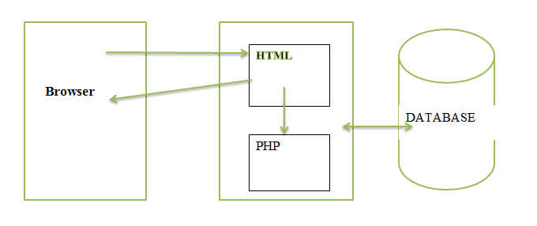

**DATA TIER**

**BUSINESS LOGIC TIER**

**CLIENT TIER**

Figure 2.1: System Structural Diagram

## 2.1 HARDWARE ARCHITECTURE

This is the hardware structure of the system showing how it’s deployed and used:

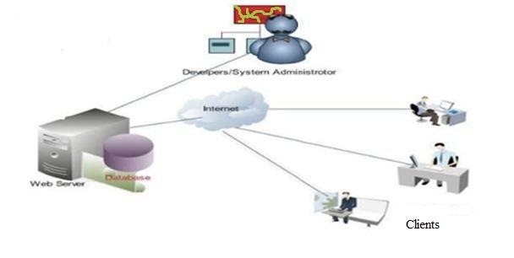

Figure 2.2: Hardware Architecture Diagram

# CHAPTER THREE

# 3.0 COMPONENT AND PROCESS DESIGN

## 3.1 USE CASE DIAGRAM

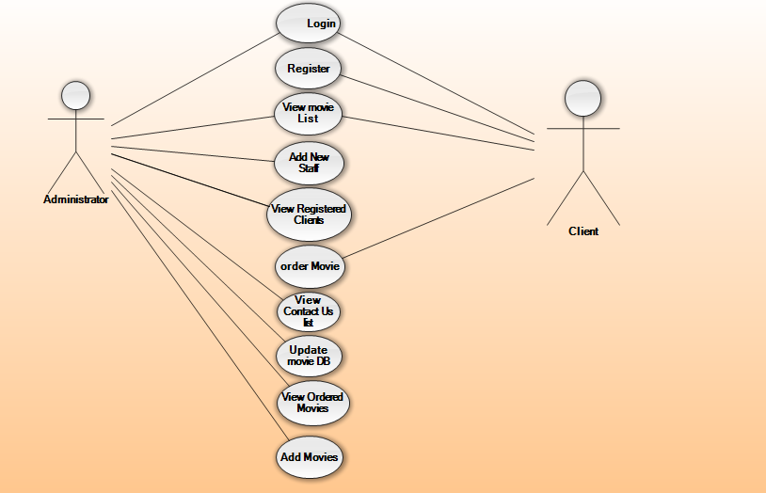Figure 3.1: use case diagram

## 3.2 Flowcharts

Flowcharts show the flow of data from external entities into the system, and from one process to another within the system. There are four symbols for drawing a flowchart:

1. Rectangles representing *external entities*, which are sources or destinations of data.
2. Arrows representing the *data flows*, which can either, be electronic data or physical items.
3. Cylinders representing *data stores* such as databases or XML files.

The databases and user interfaces were interconnected for easier communication and data flows.

The admin is able to access all sites within the system unlike the client who is restricted to some parts of the system. This interconnection enables easier, faster and efficient communications within the system.

Different flowcharts were designed for the system which included;

1. General system design flowchart
2. Administrator flowchart design
3. Client flowchart design

### 3.2.1 General System Design Flowchart

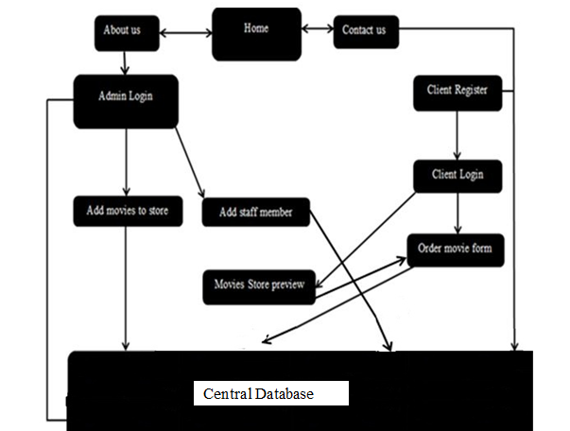

Figure 3.2 A flowchart of general system design of NYOMSS.

### 3.3.2 Administrator flowchart

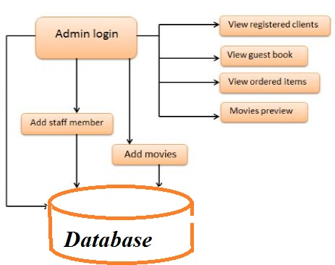

Figure 3.3 NYOMSS Admin flowchart design

### 3.3.3 Client flowchart

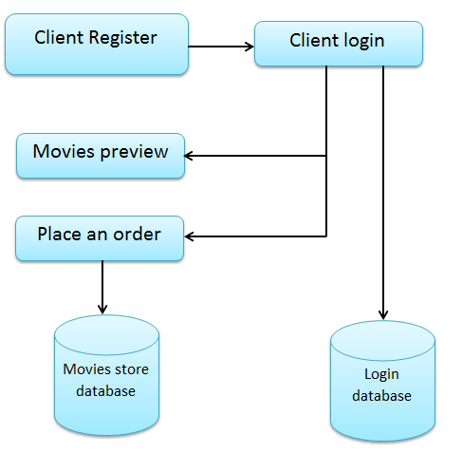

Figure 3.4 NYOMSS Client flowchart design

# CHAPTER FOUR

## 4.1.0DATABASE DESIGN

In order to design NYOMSS, the relational database was designed first. Conceptual design was divided into two parts: The **data model** and the **process** **model**. The data model focused on what data was to be stored in the database while the process model dealt with how the data was to be processed. To put this in the context of the relational database, the data model was used to design the relational tables. The process model was used to design queries that were to access and perform operations on those tables.

Different tables were used to design the database. An example of tables is the movie store table and ordered items table. The movies store table stores all movies that have been added by the administrator for the client to view from the movies database. The ordered items table also shows the kind of items that have been ordered by the client. The movies store table stores and sorts movies according to the movie type as the ordered items table saves items by sorting them in the date of picking. The client who extends time of picking is displaced by the one who is in urgency of picking. Another table is the guests table which stores the information of the guests who have contacted the shop through the system. Other tables include the user login table for storage of client registration details. The admin login table also stores staff registration details as the password reset table stores the details of clients whose login details are forgotten. The system was designed with two databases and six tables as shown below.

|  |  |
| --- | --- |
| **DATABASE** | **TABLES** |
| Login | * Admin login * User login * Contact us * Password reset |
| Movies store db | * Ordered items tb * Our store |

Figure 4.1 NYOMSS Databases and tables design

The relational approach is firmly grounded in the mathematical theory of relational algebra (Ulman 1982). This has important implications for the design of database tables. Firstly, a set, as mathematically defined, cannot have duplicate values. Since each table or relation represents a set, it cannot, therefore, have any rows whose entire contents are duplicated. Secondly, as each row must be different to every other, it follows that a value in a single column, can be used to define a primary key for the table, which allows each row to be uniquely identified. Irrespective of whether the primary key is restricted to one column or spans several, no column that forms part of a key can be null, that is can contain a row location without a value, because this would be a potential for permitting duplicate rows to be stored. The uniqueness property allows the primary key to serve as the sole row level addressing mechanism in the relational database model (date 1986). Below is a sample of design tables.

### 4.1.1 Ordered items table

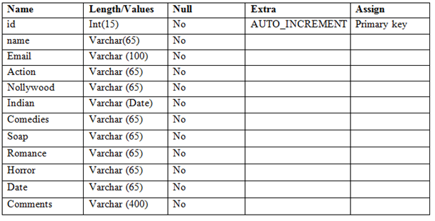

Table 4.1 NYOMSS Ordered items table design

### 4.1.2 Our movie store table

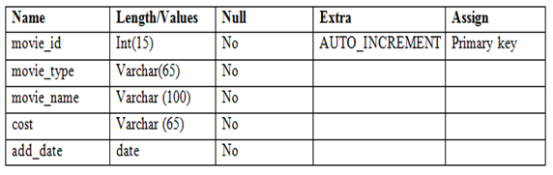

Table 4.2 NYOMSS Our store table design

### 4.1.3 Administrator Login table

|  |  |  |  |  |
| --- | --- | --- | --- | --- |
| Name | Length/Values | Null | Extra | Assign |
| Admin_id | Int(20) | No | AUTO_INCREMENT | Primary key |
| Username | VarChar(35) | No |  |  |
| Password | VarChar(30) | No |  |  |

Table 4.3 NYOMSS Administrator Login table design

### 4.1.4 Client Login table

|  |  |  |  |  |
| --- | --- | --- | --- | --- |
| Name | Length/Values | Null | Extra | Assign |
| Client_id | Int(15) | No | AUTO_INCREMENT | Primary key |
| username | Varchar(30) | No |  |  |
| email | Varchar(35) | No |  |  |
| password | Varchar(35) | No |  |  |

Table 4.4 NYOMSS Client Login table design

### 4.1.5 User Login table

|  |  |  |  |  |
| --- | --- | --- | --- | --- |
| Name | Length/Values | Null | Extra | Assign |
| User_id | Int(10) | No | AUTO_INCREMENT | Primary key |
| name | Varchar(30) | No |  |  |
| email | Varchar(35) | No |  |  |
| password | Varchar(35) | No |  |  |

Table 4.5 NYOMSS User Login table design

The MyISAM and InnoDB database engines will be used inter-changeably. Also B-Tree/ISAM will be used as a type of accessing system files from the database.

## CHAPTER FIVE:

# 5.0USER DISPLAYS AND OUTPUT REPORTS

## 5.1.0 User interfaces

Before implementing the actual design of NYOMSS System, a few user interface designs were constructed to visualize the user interaction with the system as they browse to preview movies in store, create an account and place an order.

### 5.1.1Homepage interface

The figure below show the initial design of the system homepage tabs.

The user is only able to view the movies in the store only after a successful login. A user is required to register first then login to the system to access the store. Both the administrator and the client are able to view the movies in the store but only the administrator has privileges to adjust the database. The client is only able to login to the system, view the movies in the store and their respective costs, type and year re-leased. He or she is then able to place an order of his or her movie(s) from the store. Different tabs were designed in the homepage to allow easier navigation to other pages as shown below;

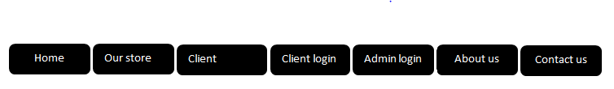

Figure 5.1: NYOMSS Homepage interface design tabs.

### 5.1.2 Client Register and Login interfaces

The interface was designed to allow the client register to the system. After a successful registration he/she is able to login to the system to perform and perform an action of his/her choice. The client is able to login to the system with the details used during registration. Upon forgotten login details he/she is redirected to Forget Login Details to reset password or create a new account.

The client is then able to perform the following upon a successful login

* Preview movies in store
* Select movies of choice
* Submit order online

Designs of the client registration and login interfaces before implementation are shown below.

Client registration form design

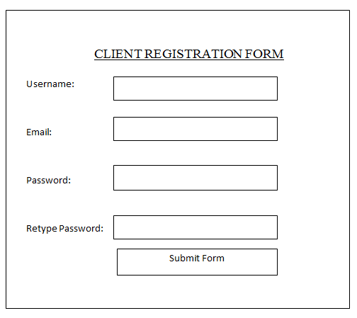

Figure 5.2 NYOMSS Client Registration Form design

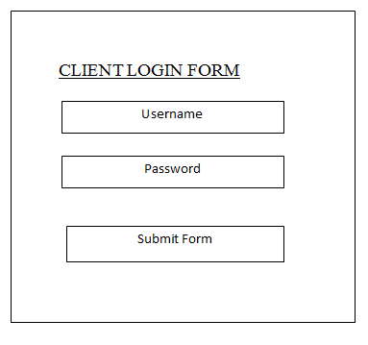Client login form design

Figure 5.3 NYOMSS Client Login Form design

### 5.1.3 Administrator interface

The administrator interface enables an administrator to perform multiple functions on logging in successfully. He/she has privileges to perform different activities unlike the client. The following are some of the activities he/she is supposed to perform;

* Add movies to store
* View movies list in the store database
* Update movies database
* View Registered Clients
* View ordered items
* Add new staff member through registration
* View Contact us guests

The form below represents an admin adding movies to store.

Adding movies to store interface design

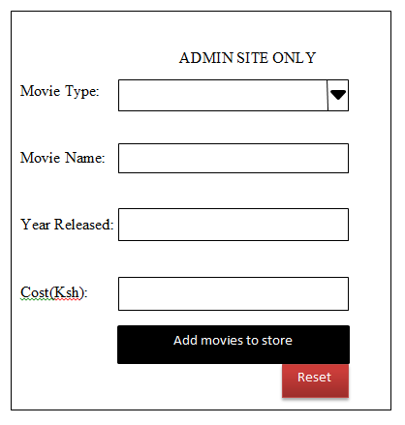

Figure 5.4 NYOMSS admin adding movies design

### 3.1.4 Movies store interface

The movies store interface is able to display a list of movies within the store and the ones added by the administrator. The page is only accessible after a successful login of a client. The figure below is a sample of the NYOMSS movies database interface.

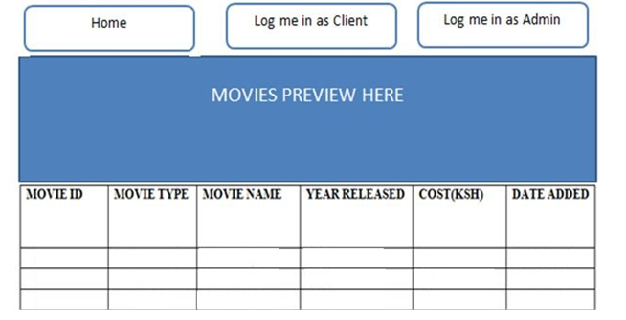

Figure 5.5 NYOMSS movies store interface design

The store was designed in such a way that the movies are sorted according to the movie type for easier identification of the kind of movie a client wants. A client is able to view the type of movie he/she wants easily before making an order. He/ she is also able to view and compare the prices and year released. The client is thus able to know the latest movies in the market.

## 

# 6.0 REFERENCENCES AND APPENDICES

## 6.1 REFERENCES

Somerville, lan (2011) Software Engineering, USA, Boston; Pearson Education-9th Edition.

Chris Gane and Trish Sarson. *Structured Systems Analysis: Tools and Techniques.* McDonnell Douglas Systems Integration Company, 1977

Abel D J (1988) Relational data management facilities for the special information systems.

<http://nipprojects.com/about-nip>

## 6.2 APPENDICES

### APPENDIX A: LIST OF ACRONYMS AND ABBREVIATIONS

NYOMSS - Nyasoft Online Movie Store System

HTML- Hyper Text Markup Language

CSS – Cascading Style Sheets

PHP – PHP Hyper Text Preprocessor

SQL – Structured Query Language

DBMS – Database Management Systems

CPU – Central Processing Unit

OS – Operating System

RAM – Random Access Memory

CD – Compact Disk

MyISAM – it’s a storage database engine

ISAM-indexed sequential access memory

### APPENDIX B: LIST OF FIGURES

Figure 2.1: System Structural diagram…………………………………………………....Page 6

Figure 2.2: Hardware Architecture Diagram.…………………………………………......Page 6

Figure 3.1: Use Case Diagram.……………………………….………………………......Page 8

Figure 3.2 Flowchart of general system design of NYOMSS………………………. ……Page 9

Figure 3.3 NYOMSS Admin flowchart design…………………………………………….Page10

Figure 3.4 NYOMSS Client flowchart design …………………………………………... Page10

Figure 4.1 NYOMSS Databases and tables design ……………………………………….Page11

Figure 5.1: NYOMSS Homepage interface design tabs………………………………… Page 14

Figure 5.2 NYOMSS Client Registration Form design…………………………………..Page 15

Figure 5.3 NYOMSS Client Login Form design………………………………………… Page 15

Figure 5.4 NYOMSS admin adding movies design Form…………………………..…… Page 16

Figure 5.5 NYOMSS movies store interface design Form………………………............. Page 17

### APPENDIX B: LIST OF TABLES

Table 4.1 NYOMSS Ordered items table design………………………………………….. Page12

Table 4.2 NYOMSS our store table design……………………………………..…………. Page13

Table 4.3 NYOMSS Administrator Login table design………………………………...…… Page13

Table 4.4 NYOMSS Client Login table design……………………………………………... Page13

Table 4.5 NYOMSS User Login table design………………………………………………Page13