Customer Orders

Online Orders

True website or apps

Login system

They can search product name

Product can be search by

Product discription or product nr.

Prudct nr – Product discription - how many - price – totaal price

Orders From Mail and phone.

Custumers send mail or call the sales person.

Sales Person can choose client.

Product can be search by

Product discription or product nr.

This information will show on the system – Price can be change and some custumers have some product seiseon price.

Prudct nr – Product discription - how many - price – totaal price

This is how we put know in system.

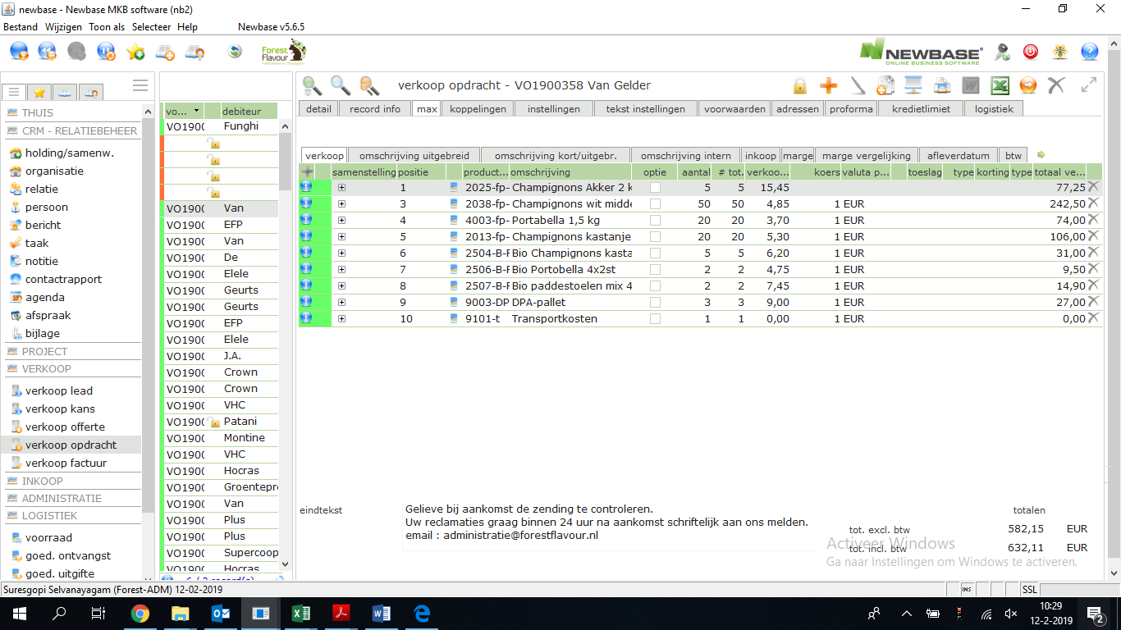

**Order Pick**

This is how it looks now on the papers when we print..

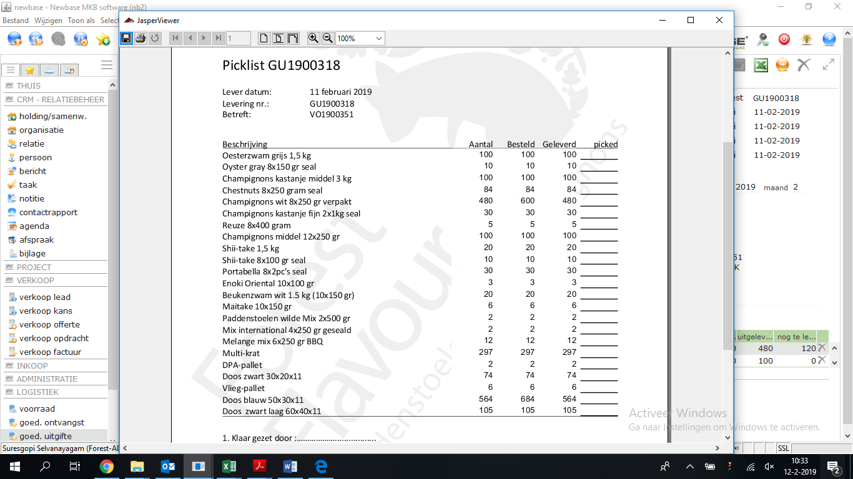

Must be same – the person who make the order on the pallet.

The person can put on how monay backet or box he picked how much and he put on the pallet – enter

Besteld – order custumers

Geleverd – dilvered by custumer end when we don’t have on stock maybe i twill different.

We need make one more

On pallet – this will give how much the order picker put on the pallet.

When Custumers add the product online or offline

When custumers add extra product or same product extra amount on the list.

Sales person need check and go to order picking app that the picker can put the

We need Print CMR for truck driver.

CMR Paper for truck driver.

All so some product what is coming in side.

Check what we buy from other company.

From who is comming – send details in system.

How much come inside

How was the quality score - by size and how it looks maybe if quality is bad we can put picture or make ticket for our supplier.

We need al lso make system for bio mushroom.  
What come in,  
What goes out.  
What we slice  
what we mix.  
etcc.