II. Conceptual Meditation of the Sutra Path Stage

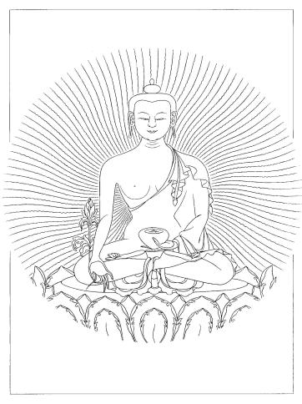

A. Words of Truth

Visualizing the luminous body of Buddha,
think with certainty, “Buddha truly dwells there.”
At that very instant, wherever you have visualized Buddha,
the Buddha is actually present.
The wisdom body of Buddha
is beyond birth and death,
dimensions and time, proximity and distance.
In the Samadhiraja Sutra, the Buddha said:
“Whoever remembers the moon-like Buddha
while walking, sitting, standing, or sleeping,
the Buddha remains constantly in front of them.
And they will attain complete enlightenment.”
In this Sutra, the Buddha also said:
“Having a wisdom body like golden light,
the Protector of the Universe is extremely beautiful.
Whoever focuses their mind upon the Buddha,
thos Bodhisattvas practice absolute meditation.”

In another Sutra, the Buddha taught:

“Whoever visualizes the Buddha,
the Buddha dwells in front of them.

The Buddha constantly bestows blessings
and liberates completely from all defects.”

By visualizing the Victorious Buddha,
you not only accumulate merit,
but create an inexhaustible root of merit
that will never be lost.

In the Avatamsaka Sutra, the Buddha said:

“By seeing, hearing, and making offerings
to the Victorious Buddha,
an immeasurable amount of merit develops.

Until all disturbing emotions
and the sufferings of Samsara are overcome,
this accumulated merit will never be lost.”

Whatever beneficial aspirations you make
in front of the Buddha will truly be fulfilled.

In the Manjushri Ksetayuha, the Buddha taught:

“All phenomena arise according to conditions
and are totally dependent upon one's intentions.

Whatever appropriate aspirations you make,
the corresponding results will be achieved.”

While recognizing the fact that phenomena appear,
yet are without self-nature, engage in the practice
that commemorates our Incomparable Teacher,
the Buddha.

(All of these Sutra quotations are from the original Sutra Pitaka of the Mahayana.)

B. Meditations on Buddha Shakyamuni:
Visualization of Luminosity
Ah! The union of unborn emptiness
and unceasing interdependent appearances
manifests like a miraculous display.

In the vast, transparent sky before me,
amidst and ocean of pure offering clouds,
on a disk of the moon on a disk of the sun,
on a lotus blossom, on the jeweled lion-throne,
sits the Lord of the Shakayas, the incomparable Buddha.

Your wisdom-body of golden color is endowed
with the major marks and minor signs.
You wear the three Dharma robes
and sit in the Vajra posture.
Your gracefully outstretched right hand
is the Earth-Touching Mudra
holding a begging bowl filled with nectar.

You are like a golden mountain,
blazing with majesty and splendor.
You radiate shining light rays of wisdom
throughout the infinite space of all universes
You manifest as enlightened beings,
the embodiments of all refuge.
You are surrounded by the Eight Great Bodhisattvas
and Sixteen Arhant Elders.

The mere thought of you liberates beings
from the extremes of Samsara and Nirvana
and bestows the blessings of the supreme splendor
of wisdom bliss.

I offer to you my body, speech, and mind,
all enjoyments, all merit, and all universes.
Please transform my body, speech, and mind
into your compassionate wisdom.

(Maintain the visualization of Buddha Shakiness throughout the
following practices in this section until reaching the Completion Stage.)

