30-Day Extension

If an applicant is unable to find a unit in their first 60 days, then they are eligible for a one-time 30-day extension.

1. The applicant can use the extension request form that was included in their issuance packets. They may also submit a request by email or write their own if they lose the form.
2. Look-up the applicant then check the “Waitlist History” tile. If the action reads “ON THE CLOCK ACTION”, proceed with processing the extension request: 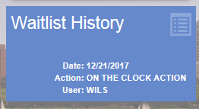
3. On the “Action” drop-down menu, select “Perform Action”: 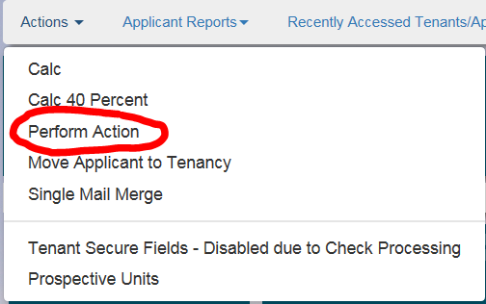
4. On the “Select Wait List to Perform Action” box, select the appropriate program. The “Perform Action” box will appear once a program is selected: 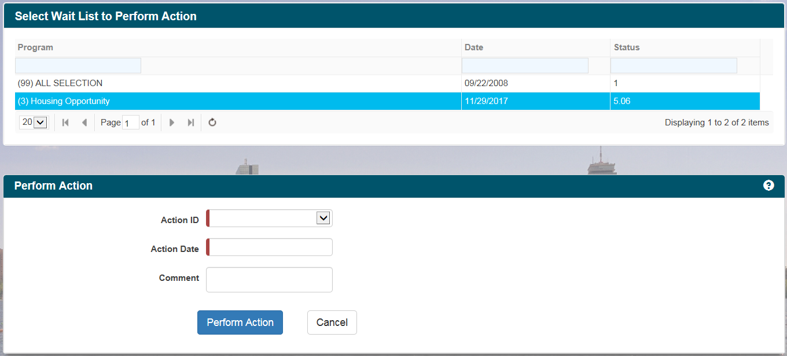
5. On the “Action ID” drop-down menu, select “(6.0100) 1ST 30 DAY EXT”. The “Action Date” field will be the date the voucher initially expires. Click on the “Perform Action” button when ready: 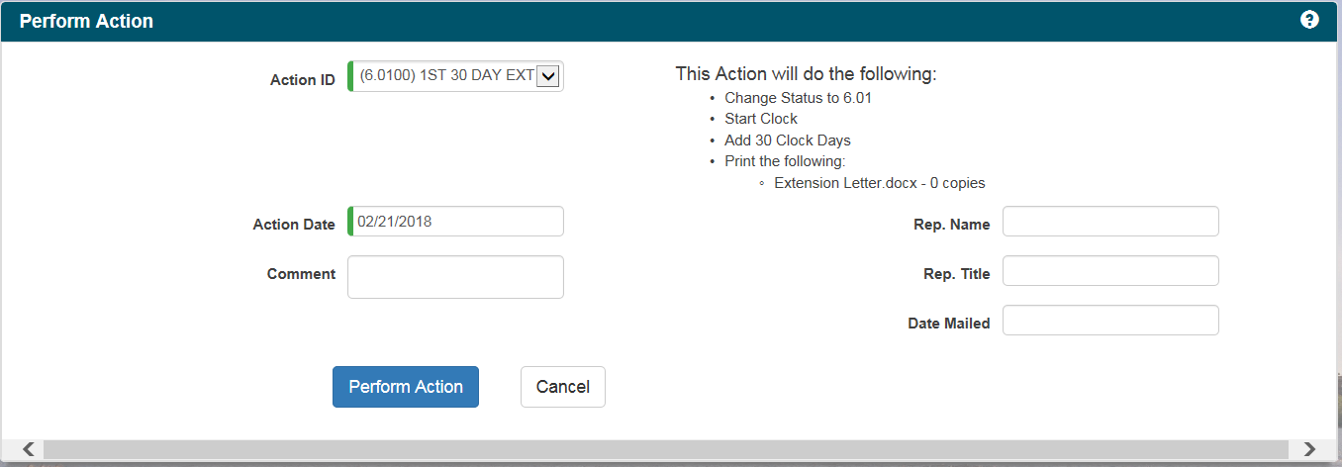
   1. **\*\*\*\*\* AS OF 2/16/2018 THE EXTENSION LETTER WILL NOT BE GENERATED AUTOMATICALLY. YOU MUST USE THE EXTENSION LETTER THAT’S LOCATED IN THE RELOCATION FOLDER UNTIL THIS IS RESOLVED. \*\*\*\*\***
6. Click back to the applicant’s main page. The OTC tile will be updated with the new expiration date to be noted on their voucher: 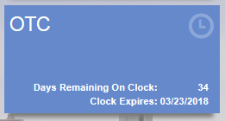
7. Create a new voucher that reflects the information noted on the voucher the applicant signed when they were issued. On the “Date Extension Expired” box on the re-issued voucher, note the new expiration date noted in the OTC tile.
8. Use the voucher extension approved letter located in the relocation folder in the G drive. Be sure to update the letter with the applicant’s information as well as the date their voucher will expire again.
9. Make a copy of the re-issued voucher and letter to leave in the file. The re-issued voucher, letter, and a blank RFTA need to be mailed to the applicant.
10. Contact the client by phone or email to inform them the re-issued voucher is on its way. Once completed the file can go back in the appropriate box in the file room.