Submitting an RFTA (Intake)

1. **All RFTAs must be date stamped for the date that it was submitted.** This will be the action date when processing.
2. The following items must be checked prior to processing. **DO NOT MOVE FORWARD WITH PROCESSING UNLESS THESE ITEMS ARE COMPLETED.** If any items are missing or incomplete, contact the property owner/manager and applicant:
   1. RFTA completed and signed by both applicant and prospective property owner/manager. **If the unit is located in a city Metro Housing| Boston does not cover, then the file will need to be transferred to the office that does cover it. The RFTA and applicant’s file can be passed to the intake coordinator to transfer out.**
   2. W9 tax form completed, social security or EIN number noted clearly, and signed by the prospective property owner/manager. **All RFTAs must be accompanied by the completed W9 tax form regardless of how many clients an owner has with us.**
   3. Direct deposit form completed and accompanied by either a voided check or deposit slip. **If an owner already has an account set up, they do not need to submit this again.**
   4. De-leading documentation in the form of either the letter of compliance if the unit was built prior to 1978 or a copy of the building permit if built on or after 1978. **This applies only to a family with a child under the age of 6.** If there is no one in the family composition this applies to, then de-leading documentation is not needed.
   5. Certificate of fitness. This only applies for units located in:
      1. Chelsea
      2. Revere
      3. Everett
      4. Lexington
      5. Malden
      6. Stoneham
3. The W9 tax form and completed property owner cover sheet will need to be submitted to the leased housing data coordinator. He/she will then return it after it’s been verified by noting the completed date as well as the Tracker owner number. If the W9 was rejected, then the owner must be contacted in order to correct it. **The W9 must be verified and approved in order to process the RFTA.**
4. Look up the applicant when ready to process.
5. On the “Actions” drop-down menu, select “Perform Action”: 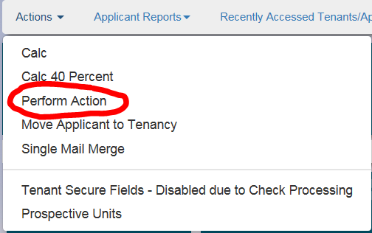
6. Select the appropriate program: 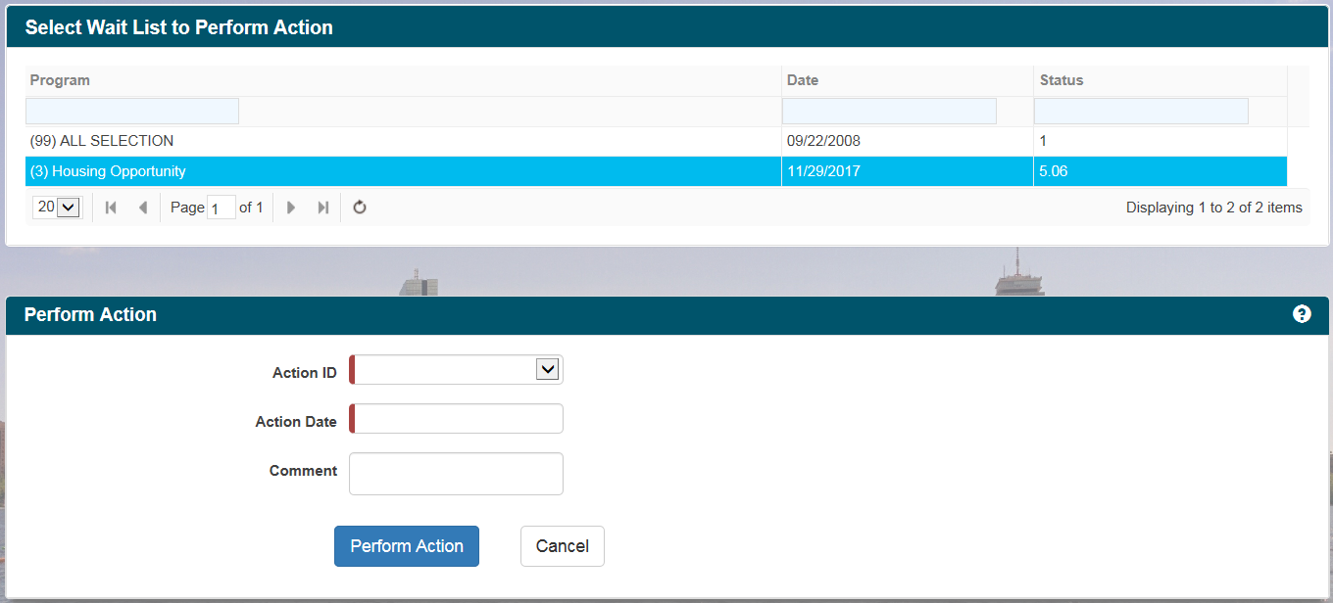
7. In the “Perform Action” area, select “6.1000 RFTA Submitted” in the “Action ID” drop-down menu. The “Action Date” will be the date the RFTA was submitted to us. **DO NOT USE THE DATE THE RFTA IS BEING PROCESSED ON.** Disregard the area on the right that pops up when noting the action on the right hand side: 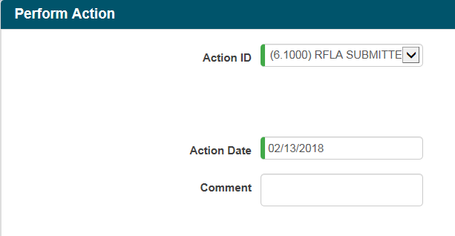
8. Click on “Perform Action” when ready. This will stop the applicant’s voucher time. The “OTC” tile will be blank.
9. On the “Actions” drop-down menu, click on “Prospective Units”.
10. In the “Add Prospective Unit” box, the “Move In Date” is the date noted on box 3 of the RFTA. Tracker Web will default to “Use Existing Unit”. Type in the unit address in the “Prospective Unit Address” and compare it to box 2 of the RFTA. If they match, click on “Save”: 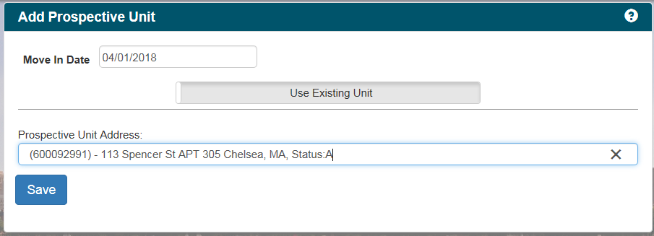
11. If the unit does not exist in Tracker, then it will need to be entered in as a new unit. Click on “Use Existing Unit” to turn this into “Create New Unit”. Enter all unit information consistent with the RFTA: 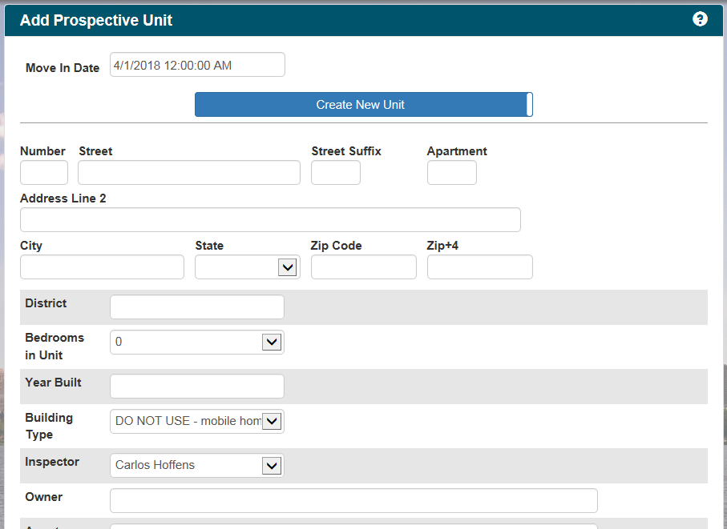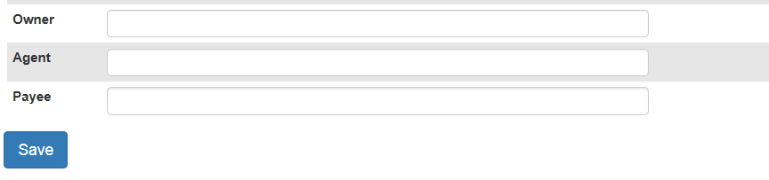
    1. District is 1.
    2. Do not use any of the “Building Type” options where “DO NOT USE…” is noted.
    3. Cross reference the most recent caseload distribution sheet for the inspector.
    4. “Owner”, “Agent”, and “Payee” are where the p.o. number noted on the return W9 needs to be entered.
    5. Click “Save” when ready.
12. Once saved, go to the “Actions” drop-down menu and select “Calc 40 Percent”: 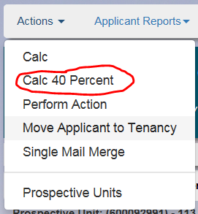
13. Click on the “Utilities” tile on the right hand side of the screen.
14. In the “Utilities Info” box, select “55” on the “Utilty Chart” drop-down menu. **Tracker Web can only generate the correct utility allowance with this chart number.**: 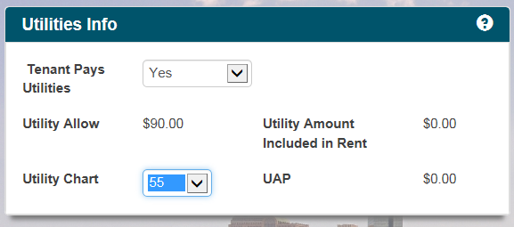
15. In the “Utilities Tenant Pays” box, leave the “Effective Date” field as is. Cross reference box 11 of the RFTA to enter in utilities that the applicant is responsible for: 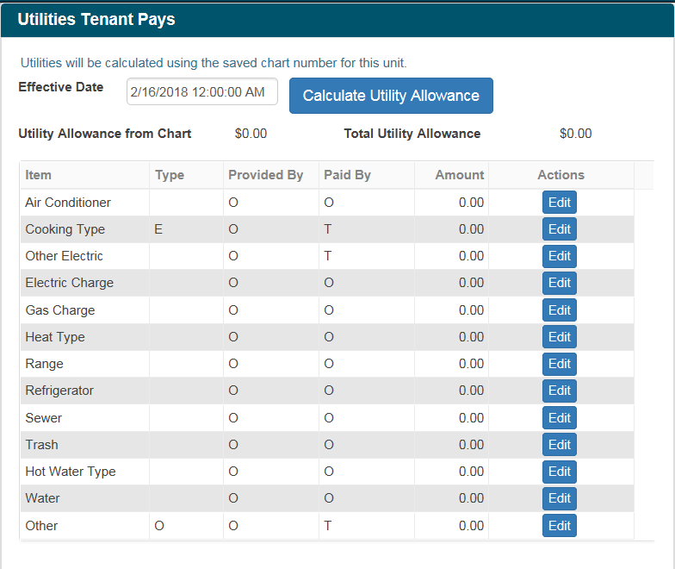
16. If there are any utilities that need to be updated to reflect the applicant being responsible for it, click on “Edit” on the appropriate utility and update that utility’s “Paid By” column. Click “Save” to update: 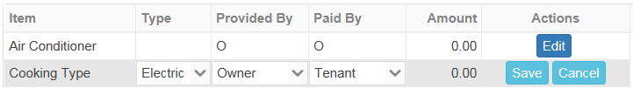
17. Once the utilities section is completed, click on “Save” under the “Utilities Info” box.
18. Click on the “Calculate Utility Allowance” button. Tracker will generate the utility allowance: 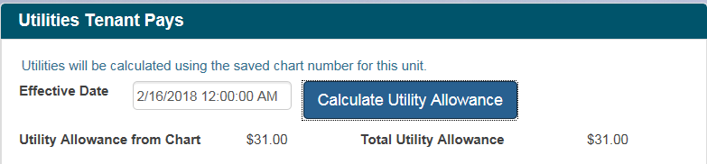
19. Once you “Save and Close” it’ll be redirected to the “Calc 40 Percent” screen. Enter rent information here consistent with the RFTA. The “Payment Standard for Family” will have to be entered manually: 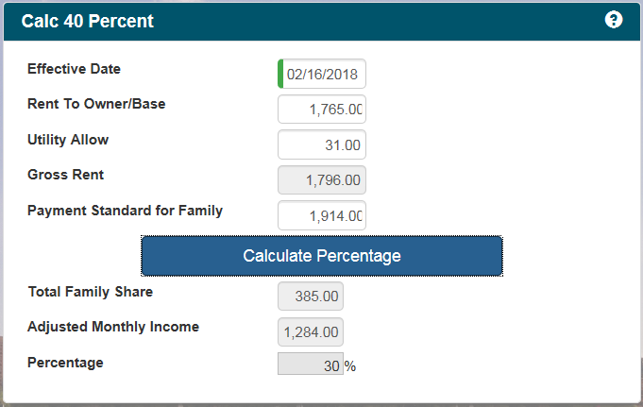
20. Calculate the maximum housing cost by adding ten percent of the monthly net income to the payment standard. If this amount is higher than the gross rent, continue processing. **If the gross rent of the unit exceeds the maximum housing cost, do not continue processing and inform the intake coordinator.** This will need to be followed-up with the property owner/manager to re-negotiate the rent amount.
21. Go back to “Prospective Units”.
22. In the “Saved Prospective Unit” box, double check the unit address. If it’s correct then click on the “Print Reqeust Inspection- RFTA Form” button: 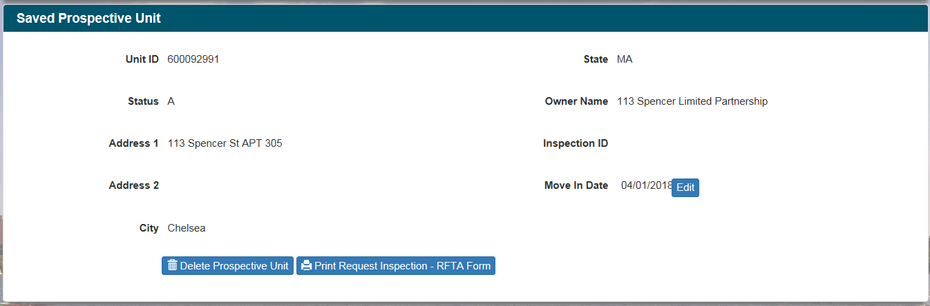
23. In the “Request For Inspection – RFTA Form” box, the “Lease Up Date” will be the date noted on box 3 of the RFTA. When ready, click “Run Report”: 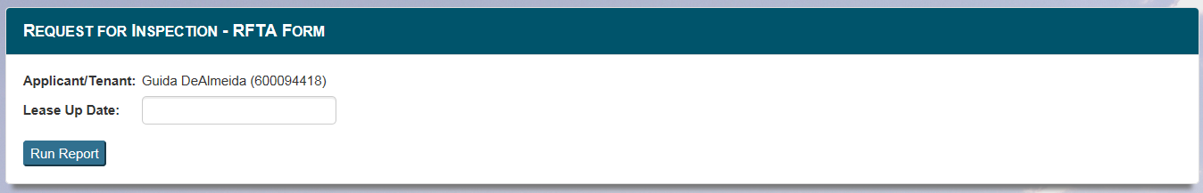
24. Tracker will generate the report that needs to be submitted to inspections. Print this form out. **As of 2/16/18 there is not a way to update the voucher size. Cross of the “0” noted in the bedroom size and replace with the appropriate voucher size.**
25. Make a copy of the original RFTA and the printed RFTA to leave in the file. Both the original RFTA and the printed RFTA need to be submitted to the inspection coordinator for new units. The printed RFTA also needs to note the maximum housing. **If an applicant is using their voucher to lease in place, this needs to be noted on the printed RFTA.** 
    1. **\*\*\*\*\* IF THE RFTA INCLUDES DE-LEADING DOCUMENTATION, THEN IT NEEDS TO BE SUBMITTED TO THE PROPERTY OWNER SERVICES MANAGER TO VERIFY. \*\*\*\*\***
26. Once completed, the file can be left in the intake coordinator’s file drawer.