**ASHESI UNIVERSITY COLLEGE**

CENTRALIZED HOSPITAL AND PHARMACY MANAGEMENT

SYSTEM

**FREDRICK OHENEBA ABAYIE**

**2016**

**APPLIED PROJECT**

ASHESI UNIVERSITY COLLEGE

CENTRALIZED HOSPITAL AND PHARMACY MANAGEMENT

SYSTEM

By

FREDRICK OHENEBA ABAYIE

Dissertation submitted to the Department of Computer Science,

Ashesi University College

In partial fulfillment of the requirements for the award of

Bachelor of Science degree in Computer Science

APRIL, 2016

Declaration

I hereby declare that this dissertation is the result of my own original work and that no part of it has been presented for another degree in this University or elsewhere.

Candidate’s Signature: ……………………………………………………………

Candidate’s Name: ……………………………………………………………

Date: ……..…./……………./………….

I hereby declare that the preparation and presentation of the dissertation were supervised in accordance with the guidelines on supervision of dissertation laid down by Ashesi University College.

Supervisor’s Signature: ………………………………………………………….

Supervisor’s Name: ……………………………………………………………

Date: ……..…./……………./………….

Acknowledgements

I would like to express my sincerest gratitude to my project supervisor Mr. Aelaf Dafla, for his guidance and support throughout this project.

Abstract

This project aims to provide a centralized system where hospitals and pharmacies interact and share information to improve services and the health of patients. The application is developed in order to address the issue of hospitals and pharmacies not having updated records of patients. The system seeks to help mostly patients keep track of medications that were prescribed to them by the hospital and given to them by the pharmacy. The application will also allow the patient to check the times medications must be taken on the application.

Moreover, hospitals and pharmacies through a centralized system can access patient information and details. Both hospital and pharmacy will have an updated version of a patient’s information when ever an update is made.

Table of Contents

Chapter 1: Introduction 1

1.1 Introduction and Background 1

1.1.1 Problem Statement 1

1.1.2 Motivation 2

1.2 Objectives 3

1.3 Research & Existing Solutions 4

1.3.1 Central~HealthMS 4

1.3.2 GNUmed 5

Chapter 2: Requirement Engineering 6

2.1 Feasibility 6

2.2 Requirement Discovery 7

2.2.1 Requirement Gathering 7

2.3 Functional Requirement 8

2.3.1 System Administrator 8

2.3.2 Doctors 9

2.3.3 Nurses 10

2.3.4 Pharmacist 10

2.3.5 Laboratory Technicians 11

2.4 Non-Functional Requirement 11

2.4.1 Product Requirement 11

2.4.2 Organizational Requirement 12

2.4.3 External Requirement 12

2.5 Requirement Elicitation and Analysis 12

2.5.1 Scenarios 12

2.5.2 Use Cases 13

2.5.4 Activity Diagram 15

2.6 System Architecture 17

2.7 Architectural Pattern 18

Chapter 3: Implementation 20

3.1 Process Model 20

3.2 Tools and Technology 20

3.3 Challenges 22

3.4 Platform 22

3.4.1 Web Version 22

3.4.2 Mobile Version 23

3.5 Web Interface 23

3.6 Mobile Interface 25

Chapter 4: Testing and Results 27

4.1 Development Testing 27

4.1.1 Unit Testing 27

4.2 Release Testing 28

4.2.1 Requirement Based Testing 28

4.3 User Testing 28

4.3.1 Beta Testing 29

4.4 Other Testing 29

Chapter 5: Conclusion and Recommendation 30

References 31

Centralized Hospital and Pharmacy Management System

# Chapter 1: Introduction

## 1.1 Introduction and Background

This project is aimed at developing a software for hospitals and pharmacies in Ghana to help minimize self-medication and also to assist health personnel in keeping accurate records of patients. Most hospitals in Ghana do not have proper record keeping systems in place to record patient’s details (including name, age, disease, prescriptions etc.) and manage them properly (Nyonmorworko, 2015). Also, patients do not get a formal report after visiting hospitals. This software will not only allow health personnel to enter details of patients but also the hospital management will be able to use the software to generate statistical reports and also to process health insurance claims. The software will allow pharmacies know more information about the drugs prescribed to a patient by a doctor. Examples of such information will be the name of the patient, age, the hospital he/she visited and the patient’s doctor.

### 1.1.1 Problem Statement

Hospitals store patient information on pieces of paper and stored in folders which is also made of paper. In a scenario where there is a fire outbreak or flooding in the hospitals, all the necessary documents of patients could be lost. This is a crucial problem because if the health of a patient is not tracked properly, it could lead to more complications or even the patient losing his/her life (Poissant, Pereira, Tamblyn, & Kwawasumi, 2005). Also the time it takes for an OPD staff to search for the folder of a particular patient has an impact on quality of health services delivered. Furthermore, service delivery, waiting time and reimbursement are affected due to the format in which the national health insurance is submitted for processing (Sakyi, Atinga, & Adzei, 2012). The software will help in transitioning from paper passed record keeping to electronic record keeping, generate statistical reports and help health personnel to send health insurance claims.

### 1.1.2 Motivation

The urgent concern discovered in most hospitals is the time that patients wait for their files to be found before they get to see a doctor. It takes longer in cases where the patient has lost his hospital card or does not remember the last time he visited that hospital. This could be a difficult job for the nurses who are to search for a particular file amongst thousands of other files. In certain cases, the file of a patient could not be found or if found could be badly damaged. The time it takes a nurse to search for a particular patient’s file could be reduced drastically when proper record keeping systems such as Central~HealthMS are put in place and the outmoded paper methods are discarded (Poissant, Pereira, Tamblyn, & Kwawasumi, 2005).

Normally when a patient goes to a hospital, after waiting minutes or even hours for his files to be found, the doctors write drug prescriptions on a piece of paper for patients to buy them from a pharmacy. There are scenarios where the pharmacist mistakenly gives a patient the wrong drug or dose due to the poor visibility of the doctor’s handwriting (Institute for Safe Medication Practices, 2009). However, the software will enable doctors send prescriptions of patients to pharmacists at ease. Also the details of patients will be stored using the software in a secured database. A database will serve as the folder for keeping records of patients who visit the hospital. It will also be highly effective in searching for a patient’s health information because it is faster when searching from a database.

Moreover, the availability of the management software will help the hospital management keep proper records of important data. The management will be able to generate statistical reports (including number of patients that visited the hospital in a month, the number of malaria cases treated within a week etc.) which will in the long run help to minimize certain diseases or improve the services of the hospitals.

## 1.2 Objectives

* Develop a software that will allow effective record keeping systems and structures for most hospitals in Ghana.
* Develop a software that will allow better communication between hospitals and pharmacies in Ghana to provide patients with the best of services.
* Develop a software to provide statistical report for hospital management to effectively manage the daily activities in hospitals
* Develop a software to allow health personnel submit an electronic health insurance claim with ease.
* Develop a software to reduce the time it takes a nurse to search for a patient’s file or update the details of a patient.

## 1.3 Research & Existing Solutions

A research conducted showed that most hospitals in Ghana encounter the problem of bad record keeping of patients’ information. Through the research, several applications were discovered which were purposely developed to tackle these persisting challenges. The few hospitals that used software in managing patient information were mostly open-sourced software. Some of these software was developed by foreign developers hence does not meet the demand of the hospitals in Ghana (Poikonen, 2009).

Some of the existing software found had difficult user interface that made users confused as to what to do next. The installation process of some of the software was hectic because it demanded other requirement before it can be up and running. Also, the computers in some of the hospitals were not powerful enough to support some of the software because few demanded more memory to be able to work efficiently.

After the research, it was concluded that most of the applications were developed without considering the platform or computer it will be operated on or the users of the software. The results and observations derived of the research prove the necessity of this project. Below are related works that are already in use;

### 1.3.1 Central~HealthMS

This application was developed by graduate student in Ashesi University to help hospitals effectively keep records of patients that visit the hospital. The application allows system users to add patients and edit their details. It is also a platform that contains information of patients such as their medical records, visits to the hospital and the various hospitals visited.

The application accomplished its user requirement but the system requirement for the application was at risk. The application used old versions of programming languages and frameworks that had numerous security issues making the application not secured and prone to attacks. Some of the forms in the application also does not check for unaccepted input which is also another security issue.

### 1.3.2 GNUmed

This medical software aims to providing documentation, understanding and management of patient’s health records. The software is accessible on both Linux and Windows Operating Systems.

After installation of the software to test, and know how the software tackles the problems in the health sector, the instructions for installation was not straight forward. Hence for a user who has no programming background, the user will have difficulties in installing and running the software.

# Chapter 2: Requirement Engineering

This chapter describes what the system is set out to do and the constrains on its implementation and operation. Thus explaining the user and system functional requirement as well as the systems non-functional requirement.

Also Unified Modeling Language (UML) will be used to represent the system at different perspectives. UML will be used to describe the interaction and structural models to illustrate how the components of the system communicates with one another.

## 2.1 Feasibility

Central~HealthMS is a realistic software that will help hospitals and pharmacies manage the records of patients efficiently. The project is feasible to implement because it targets to solve existing problem such as record keeping and management of patients in hospitals and pharmacies in Ghana’s. These are the challenged in the health sector that the project seeks to tackle. Also there are available technologies (libraries, frameworks etc.) that will make the implementation of the project possible.

The most vital of these resources is time which is limited for the implementation of the project. This is because the project comprises of complex systems hence more time will be needed to think through the project critically on how to secure records and integrate with other complex existing systems. Due to the time limit, the project does not need a huge budget to succeed. The time associated has also affected the cost to be incurred in commencing with the project. The project does not need a huge budget to succeed.

Moreover, the necessary skilled developer for the implementation of the project is also available. The skills required for a successful implementation of the project are knowledge in PHP programming, android mobile development, Java, MySQLi, Apache Server and the use of Adobe Illustrator.

## 2.2 Requirement Discovery

Before the system’s design and architecture can be modelled, the user and system requirements must be gathered. Also information about required system and existing systems will be gathered to help achieve the requirements. The process that will be used in gathering of requirement from the system stakeholders will be interviews. The users will be presented with scenarios and paper prototypes to guide them understand some of the functions of the system. Discussed below are the resources that will be utilized to gain the requirement to implement the system.

### 2.2.1 Requirement Gathering

The hospital personnel were a major factor in gathering the requirement for the system. Nurses, doctors, pharmacist and laboratory technicians were interviewed about the challenges they face when it comes to managing the records of patients. Also observations were made on how the hospital personnel conducted their various activities related to their services to patients. The processes they go through in registering a new patient, how records are managed and the challenges they face were all recorded.

To get a glimpse of how some of these problems were tackled, a related project implemented by a graduate was analyzed. The analysis of the project included how the systems architecture was designed, the listed user and system requirements and the challenges that was encountered during the implementation of the project.

Moreover, other requirements were gathered from the project supervisor through several interviews during the project implementation. With his experience in implementing and deploying health sector systems, he provided certain factors in the sector that needed more attention and analysis.

## 2.3 Functional Requirement

The functional requirement of the Health Management System describes what the users of the system can do. Thus the tasks each user of the system can perform and their constraints to those tasks.

### 2.3.1 System Administrator

The system administrator of the Health Management System has the rights that the other users of the system do not have. But the system administrator can not perform all the functions of the system. The administrator also has certain constraints. Listed below are the tasks the system administrator can perform in the system.

1. **Management of Doctors**: The administrator of the Health Management System will have access to the registration of a new doctor in the hospital. The administrator will also be able to view details, edit and search for registered doctors on the HMS. The administrator can also grant or deny a doctor’s access to the system.
2. **Management of Nurses**: The administrator can also add new nurses, update their details and search for a particular nurse in the system. The administrator can also grant or invoke a doctor’s access to the system. The administrator can also grant or deny a nurse’s access to the system.
3. **Management of Laboratory Technicians**: Adding of laboratory technicians to the system can also be accomplished by the system administrator. The details of technicians can also be updated and searched. The administrator can also grant or deny a laboratory technician access to the system.
4. **Management of Patient**: The system administrator can not add new patients to the system, prescribe drugs to a patient and edit the details of a patient in the system. The system administrator does not have access to delete a patient from the system.

### 2.3.2 Doctors

The system doctors also have their own tasks that they can perform on the system. Their functionalities are not related to the other users of the system. The doctors are also constraint on some functionalities and therefore can not perform all the functions of the system.

1. **Management of Patients Medical Records**: The doctor has access to viewing of a patient’s medical records. The doctor can search for a patient’s record, can update or edit a patient’s record and can also add a new medical record for a patient.
2. **Management of Patient**: The doctor can search for a patient and view the patient’s information but cannot add a new patient to the system, edit or update the patient’s information.

### 2.3.3 Nurses

The nurses also have their unique functionalities on the system. They are also bound by constraints and can only perform tasks that they are allowed access to by the system administrator.

1. **Management of Patients Information**: The nurses can add a new patient, edit or update a patient’s information but cannot prescribe a drug to a patient.
2. **Management of Profile**: A nurse does not have the access to edit individual profiles of themselves. That task is allowed by only the system administration.

### 2.3.4 Pharmacist

The pharmacist in the hospital is also restricted on the system hence can perform only limited actions on the system.

1. **Updating of Patient Medication**: The pharmacist will be able to update a patient’s medication. Thus indicating that the drugs have been given to the patient.
2. **Management of Drugs**: Another task of the pharmacist is the management of drugs in the inventory. The pharmacist will be able to add new drugs, update drug details in the inventory.

### 2.3.5 Laboratory Technicians

The laboratory technicians are the users of the system with the least priority. They are also constraint by the action and functionality of the system.

1. **Management of Patient Labs**: The major task of the pharmacist on the system will be to manage and add the labs done by patients.

## 2.4 Non-Functional Requirement

The non-functional requirements of the system are the services that the Health Management System does not provide to the users of the system but are relevant for the operation of the system. These services include the security of the system, its performance, availability, how reliable the system will be, privacy, usability and the environment in which it will be used.

### 2.4.1 Product Requirement

The Health Management System shall be available any time an authorized user access the system. Thus it will be available all working hours and can be accessed by all users at any given time.

### 2.4.2 Organizational Requirement

Users of the Health Management System will have to login to the system by providing details given to them by the system administrator. Cross site scripting will be checked each time a user performs a task to prevent unauthorized data manipulation in the system.

### 2.4.3 External Requirement

The Health Management System shall implement security measures to make sure that the privacy of patients is not breached in case the system is attached by a hacker. The problem cross-site scripting and request forgeries will be prevented in the implementation stages to make the application secure.

## 2.5 Requirement Elicitation and Analysis

For this system, requirement elicitation and analysis is needed to determine the domain of the application. Also it is important to highlight the services that the system will provide to its end-users.

### 2.5.1 Scenarios

A. Mr. Kwame, a 45 years old business man, visits a hospital at Kwabenya due to a recent pain he has developed in in waist. Upon arrival to the hospital he goes to the Nurses to check his temperature, weight and height for update his health information on the system. In case Mr. Kwame was not already on the system, he will then be registered onto the system. After his health details have been updated, he is then assigned to Dr. Obaapa. The doctor then accesses Mr. Kwame’s health information to view his track of illness and also adds the new symptoms the patient is witnessing. The doctor then refers him to the laboratory to undertake prescribed tests.

At the laboratory, the technician can see the list of patients coming for test. Mr. Kwame’s name appears on the list and is called by the technician. After the test, the results of the test are recorded against his health information.

Mr. Kwame then goes back to the doctor. This time the doctor will have the updated lab results. Based on that the doctor then prescribes drugs to the patient.

B. When Mr. Kwame leaves the hospital; he then goes to the nearest pharmacy to get the drugs that the doctor prescribed to him. He then presents his system identification to the pharmacist, the pharmacist then searches the system for the patient. When the patient is found, the pharmacist can then see the drugs that were prescribed, the hospital the patient visited, the name of the doctor that gave the prescription and other relevant information.

The pharmacist, Dr. Pharm then gives the prescriptions to the patient and indicates it on the system as delivered. When this is done Mr. Kwame can view his drugs on the mobile application. It will also display the time and quantity of the drugs he has to take. Mr. Kwame can pay for the drugs the pharmacist is giving to him by using MTN mobile money.

### 2.5.2 Use Cases

Below is a use case diagram for the system. The diagram shows the system actors and how they interact with the system. The type of interactions that take place and the actor that is involved are illustrated in the diagram. The system has numerous actors and they all interact with the system differently.

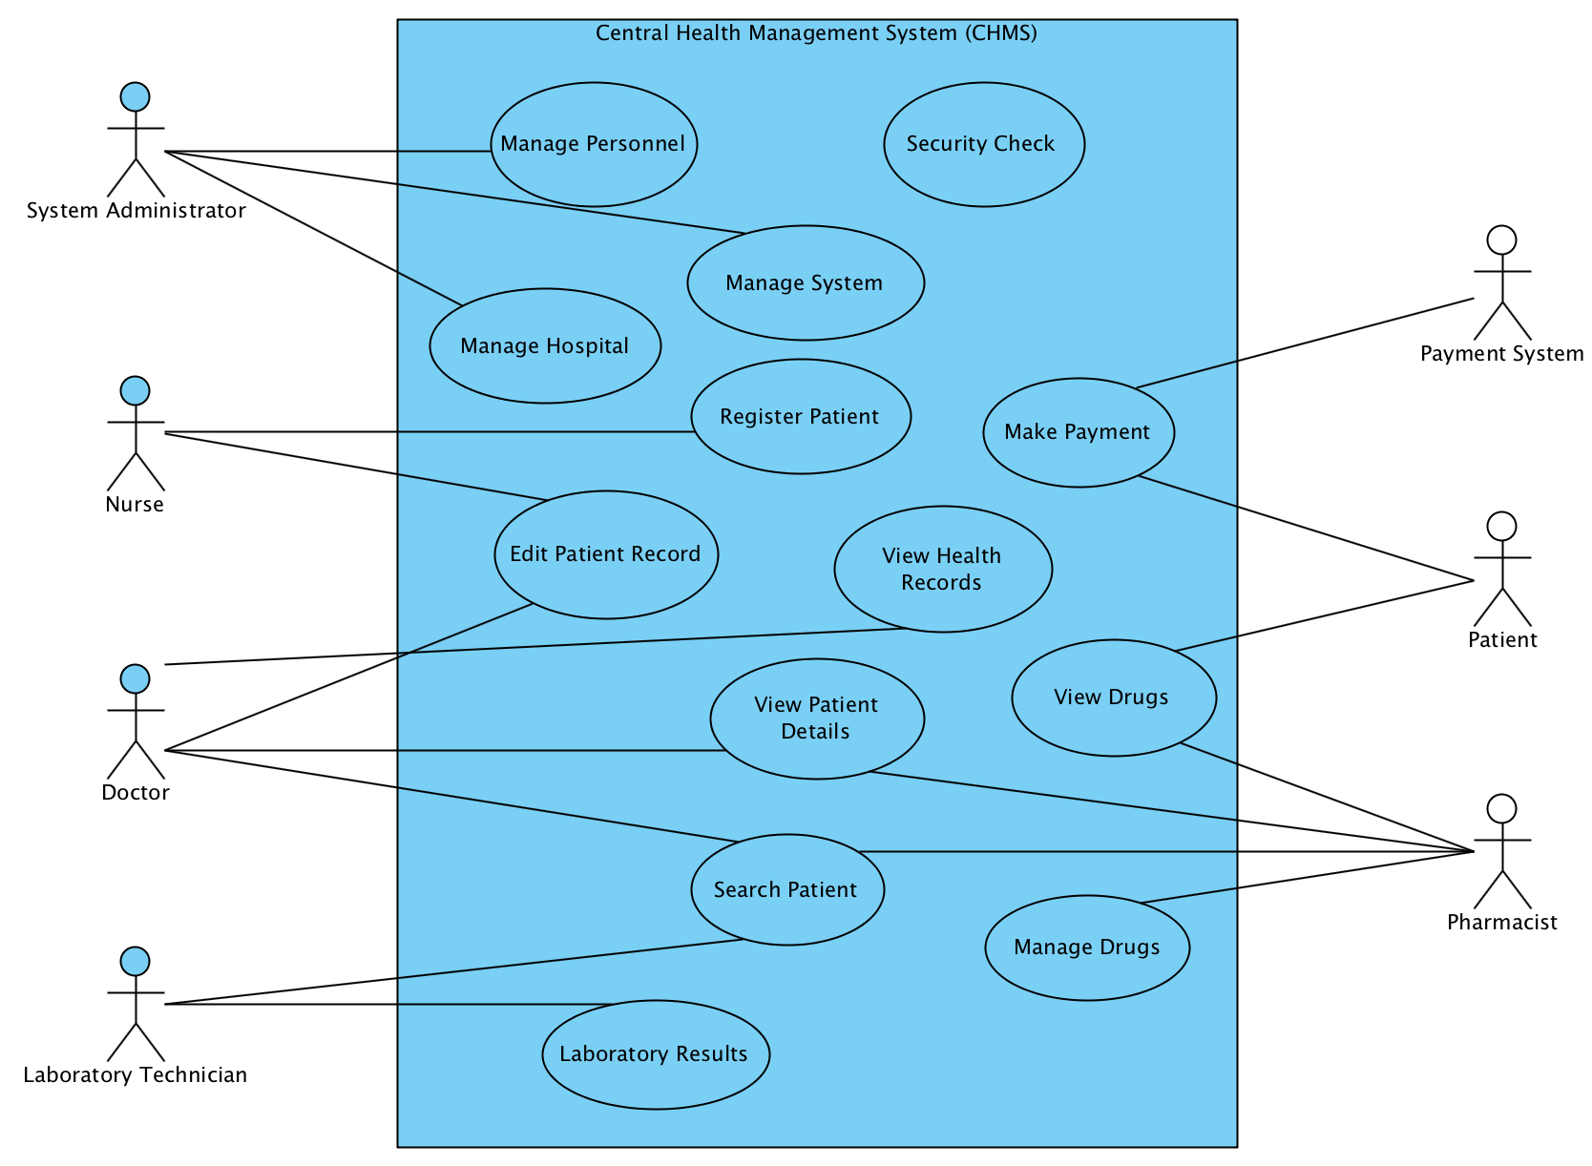

**Figure 2.3.2 – System Use Case Diagram**

System Users

* Security Check

All the system users must pass through a security check before they can get access to the system to perform their tasks. The security check involves a login page where users will be required to provide system username and password to be allowed access to the system.

System Administrator

* Manage Personnel, System and Hospitals

The role of the system administrator is to manage other users of the system. These users are the health officials that use the system to perform their tasks. The management of personnel involves adding new users, editing their profile, granting and denying users access to the system.

The administrator is also responsible for managing the system. This will be done by adding users to different roles and each role has its own rights and privileges on the system.

The management of hospitals and pharmacies is also another task for the system administrator. The admin can add, edit and disable new hospital and pharmacy on the system.

### 2.5.4 Activity Diagram

In displaying the processes in the scenario presented, an activity diagram will be used to visualize the activities involved in data processing. The diagram show case the activities that happen when a user interacts with Central~HealthMS.

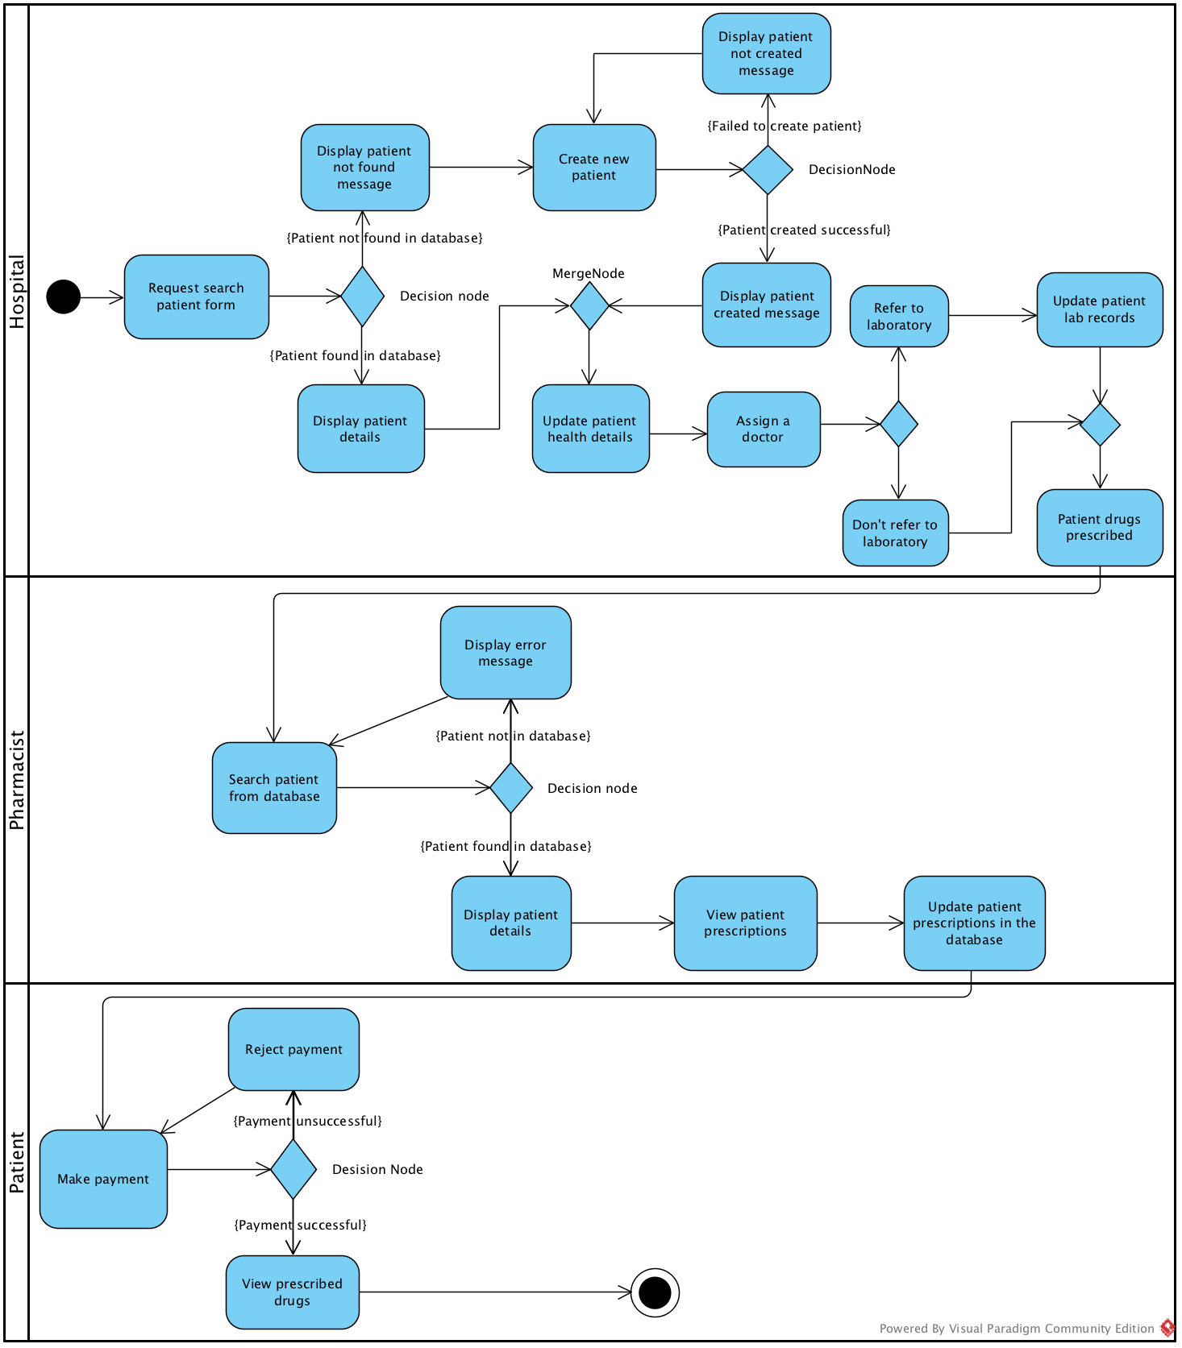

**Figure 2.3.4 Activity Diagram**

## 2.6 System Architecture

Central~HealthMS is a web application that should be accessed by all the users at any given time. The system however follows the generic client-server architecture to be able to allow all the users to access the application.

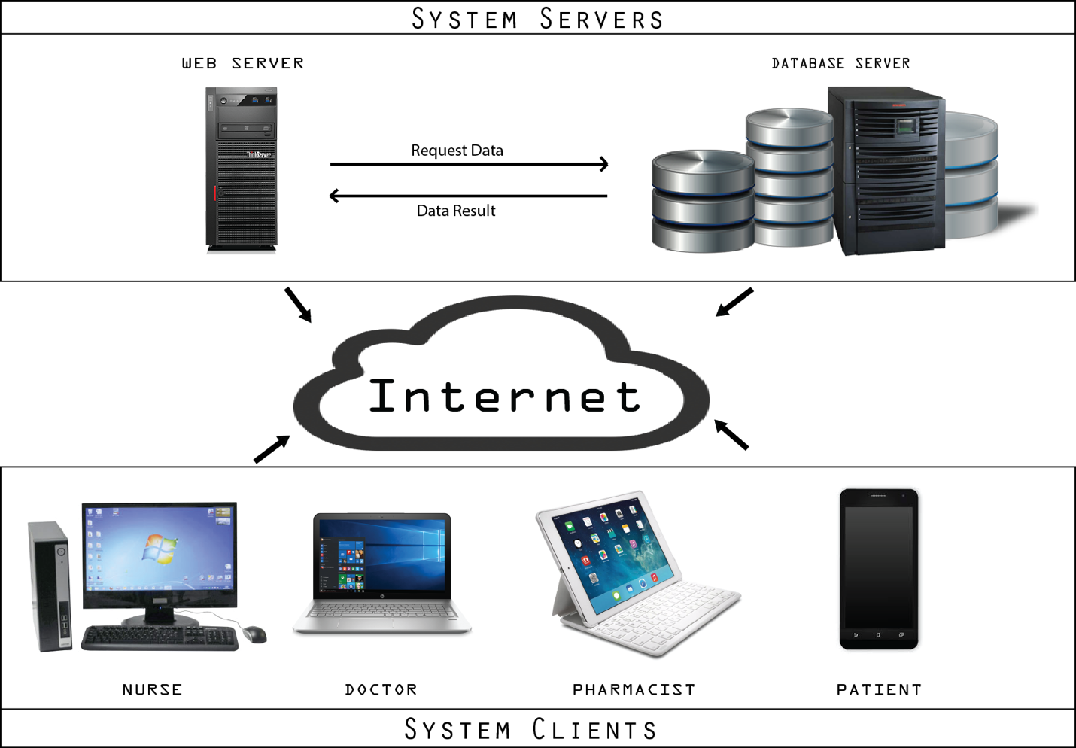

**Figure 2.4.1 Client-Server Architecture**

For a client to access the application, there must be a stable Internet connection to be able to make an HTTPS request to the server hosting Central~HealthMS application. When the client request for a page from the server, the client waits until it receives a reply in the form of content requested for from the server. This architecture is preferred because users can then access the application no matter their location all they need is access to the internet.

## 2.7 Architectural Pattern

The Central~HealthMS will be developed based on the the Model-View-Controller pattern. The structure of the system is based on three components that interact with each other. The model structure is a representation of the database. The model consists of the database architecture that the user interacts with indirectly. The model encompasses the data entities involved with the system. The views represent the interface which serves as an interpreter for the data in the model for the users of the system. The controller component serves as a channel connecting the model and the views. The controller updates the users view when there are changes in the model and updates the model when the user sends a command.

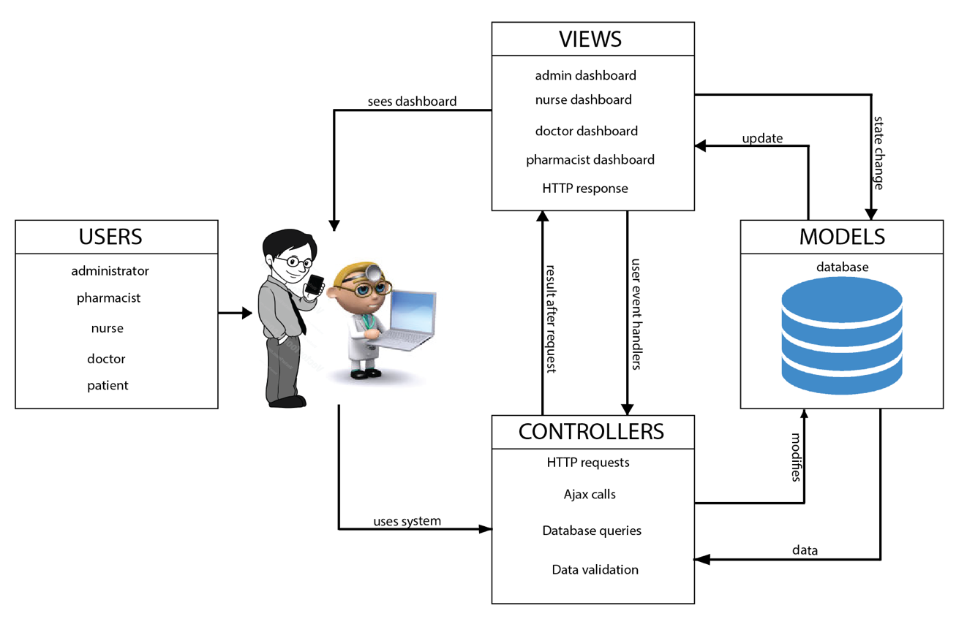

**Figure 2.5.1 – System Architecture**

The reason why MVC was chosen as the architectural design pattern for the Central~HealthMS system was due to its numerous advantages over other pattern. The pattern will help to represent the data in the model in multiple ways. Central~HealthMS system is a complicated system hence MVC will make updating the system easy. This is because when changes are made to the data entities in the model, these changes do not have any effect on how the views are displayed to the system users. This makes the components in the Central~HealthMS system independent from each other. The use of this pattern for the design of the software is also due to scalability of the system. Since it is advisable for future updates and addition of new functionalities at minimum cost. Since Central~HealthMS system consists of various components, the design pattern will help in faster development and also dividing the components into smaller modules to work on. This will make each component in the system to be easily debugged.

# Chapter 3: Implementation

This chapter focuses on the tools, components and libraries used for the implementation of Central~HealthMS. The chapter also provides screenshots of the various user interfaces of the system in different states.

## 3.1 Process Model

Before implementation of the software, it was necessary to know the user requirement and the design of the system. The waterfall software process model made it possible to be able to design the system before implementation. By following this model, the requirement of the system users was gathered and validated to know the implementable ones from the others. This was a major step towards the implementation of Central~HealthMS. After both functional and non-functional requirement of the target users were developed the system was then designed to suit the requirement.

## 3.2 Tools and Technology

This section elaborates the tools, languages and libraries that were used during the implementation of the Central~HealthMS.

|  |  |
| --- | --- |
| Tools | Description |
| PHP 7.0.4 | Hypertext Pre-processor (PHP) is a server-side scripting language. Since Central~HealthMS will be hosted on the server PHP makes it possible for clients to communicate with the application over the internet. In communicating with the server, MySQLi was used which is a more secured. |
| MySQL | MySQL is a relational database server that was used to model the database of the system. |
| HTML5 | For the client to be able to use the application, HyperText MarkUp Language (HTML5) was used to design the Graphical User Interface for the system so that users of the systems will be able to use the system with ease. |
| CSS3 | Cascading Style Sheets (CSS3) was used to design the user interfaces for the application. It was used to manipulate the HTML5 to produce better looking Graphical User Interface. |
| JavaScript | JavaScript was used for animations and transitions in the application. |
| Twig 1.24 | This is a PHP library template engine that was used with HTML5 to provide flexible templates for the application. |
| Android | This is the Operating System and language that the mobile version of the system was built with. It makes it possible to run the application on all android devices. |
| PhpStorm | This is the IDE that was used to develop the application. This IDE was used because it makes development easy and fast. |
| GitHub | This is a versioning control repository where the project was stored and used to track development progress during implementation. |
| PHPUnit | This is a testing framework for PHP. The framework was used to carry out test cases for methods and objects for the software. |

## 3.3 Challenges

During the implementation of the project, certain difficulties were encountered that led to a twist in the development of the project. The initial framework used to start the development of the project was Laravel 5.2. Even though the framework makes development of web applications easy,

## 3.4 Platform

This section of the chapter highlights the platform that Central~HealthMS will be able to operate in without challenges. The constraints of the application on various platforms are also discussed for the users to have an idea of the applications operating platforms.

### 3.4.1 Web Version

The web version of the application can be accessed by users through Google Chrome, Safari and Mozilla Firefox browsers. The browsers that the application run on are not operating system specific. Hence, the application will run on all browsers on any operating system it being Linux, Windows and Mac OS. There are also few constraints for the web application. It is not advisable to run it on Windows Internet Explorer because it has not been tested for that particular browser. Hence when run using internet explorer, it will not give the user the best of performance needed.

### 3.4.2 Mobile Version

The mobile version of the application will run on native Android Operating System. Hence any smart phone running the Android OS will be able to install the application and use with ease. The only thing needed after installation of the application is to provide login details and after that all required access will be granted. There is also constraint on the mobile version of the application as there is for the web. The application however does not support android versions below Android 4.1 Jelly Bean. Hence users using any version of android below Jelly Bean will not be able to install the application.

## 3.5 Web Interface

This section of the chapter illustrates the numerous user interfaces for the application. A detailed description of each interface is provided.

* **Login Interface:** This is the first page that is used for security clearance for the application. When a user accesses the application, the user is provided with the login page in order to provide the necessary authentication details to be allowed access.

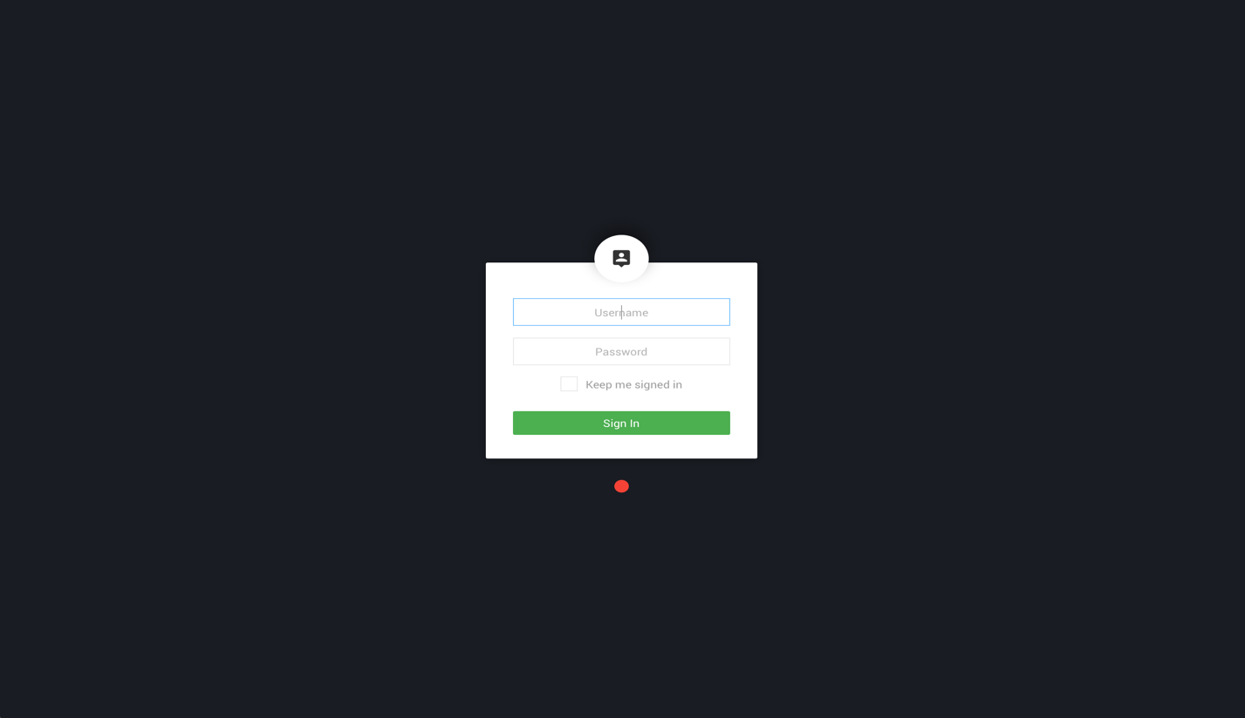

**Figure 3.4.1 Login Interface**

* **Dashboard Interface:** This is the landing page for the user after login is successful. Statistics of the drugs and patients in the system database are displayed for the user to easily make meaning of them. It also has the time of the day displayed on the header of the page. Statistics such as the number of patients that have been served and the total amount of money earned.

**Figure 3.4.2 Dashboard Interface**

## 3.6 Mobile Interface

Below is the user interface available for the mobile version of the application. The mobile version is mostly for the patients only.

* **Login Page:** For the mobile application, the patient will also have to provide login details to be allowed access through the application. The patient login will be a one-time authentication in order to improve efficiency of the application.

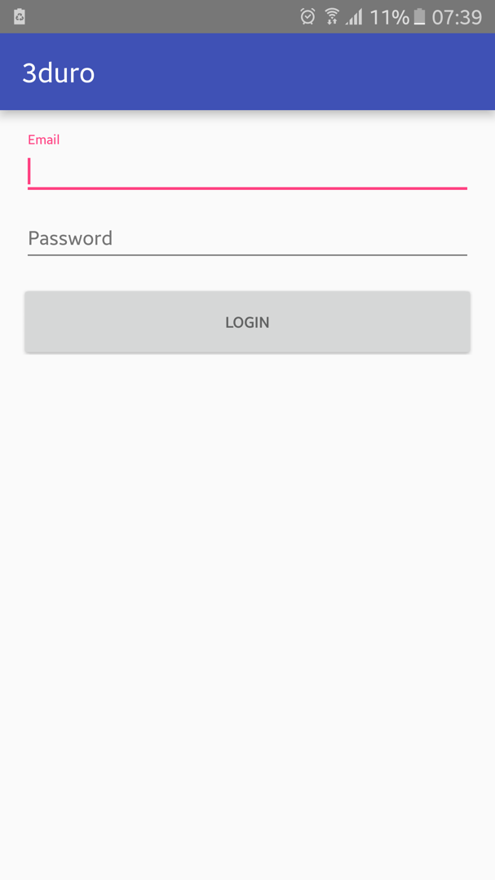 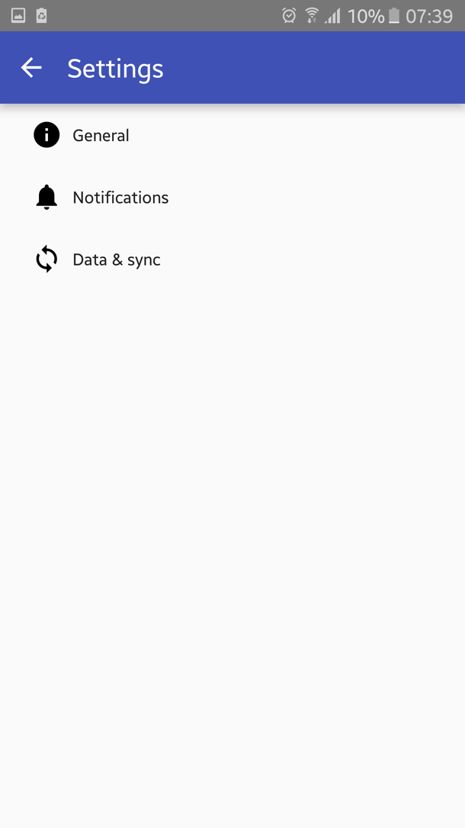

**Figure 4.5.1 Mobile Login Interface Figure 4.5.2 Mobile Settings Interface**

* **Settings Page:** The patient can also access the settings of the mobile application to tweak how the application should behave. The user can turn off notifications and and change the display name. Above is Figure 4.5.2 the interface for the settings page.

# Chapter 4: Testing and Results

This section of the document highlights the techniques used for testing Central~HealthMS and the results that were obtained from each independent test. Since the software has stakeholders, and is intended to be used by them, it is necessary to go through various test cases both during and after development to make sure the software meets its requirements. Below are the various tests and results that was used on the system:

## 4.1 Development Testing

During the development phase of the software, several objects and components were tested to make sure that they function as they were supposed to. This testing was primarily to detect bugs in the software during development and fix them before deployment. To carry out the development testing successfully PHPUnit testing framework was used.

### 4.1.1 Unit Testing

In testing the numerous objects and methods in the software, unit testing was conducted sequentially. This was used to verify that all the operations associated with the particular objects accepted and produced the required output.

However, the various objects and methods in the software passed all the unit test that was conducted during development. The methods produced the expected outputs and rejected inputs that will lead to an error.

## 4.2 Release Testing

Since Central~HealthMS was developed in releases it was essential to conduct a release test for each version that was intended for users. Explained in this section is the technique used for the release testing of the software.

### 4.2.1 Requirement Based Testing

For the release testing of the software, it was necessary to make a requirement based testing to verify that the defined requirements of the system have been met. This was done by having the various requirements and deriving set of tests for it.

After all the requirement based test was conducted on the software, it resulted that the software passed all the test cases. However, this indicates that the software has been properly implemented to satisfy the defined requirements.

## 4.3 User Testing

The user testing was the most important part of the software testing. Since the software has stakeholders, it was necessary to make the software available to the target customers for general feedback on the use of the software.

### 4.3.1 Beta Testing

Central~HealthMS users were provided a release of the software for evaluation. The purpose of this test was to learn the challenges that may arise when the software is exposed to the working environment and the interaction problems.

Several feedbacks came through from the software users which helped to improve the features and functionality of the software. However, the testing proved to be a success, by helping improve the usability of the software.

## 4.4 Other Testing

Since Central~HealthMS is a web application, it tested on four popular browsers. They are Google Chrome, Mozilla Firefox, Safari and Internet Explorer. Even though the application worked well on the latest versions of the browsers, it was also tested on previous versions. After running several tests, it was realized that the application has issues rendering on previous versions of Internet Explorer and some versions of Safari.

This discovery led to optimizing the source code to allow the application to function well on these previous versions of browsers. Due to the tests, improvements have been made to allow the application render well on some previous versions of browsers.

# Chapter 5: Conclusion and Recommendation

# References

Healthcare, O. (2013, January). *Omron, Company Info*. Retrieved from Omron: http://www.omron-healthcare.com/eu/en/company-info

Institute for Safe Medication Practices. (2009). *Improving Medication Safety In Community Pharmacy.* Retrieved from Assessing risk and opportunities for change: https://www.ismp.org/communityRx/aroc/files/ISMP_AROC.pdf

Nyonmorworko, N. D. (2015, April 15). *Reflections in the mirror; Records keeping in Ghana's Health Sector*. Retrieved October 22, 2015, from graphic.com.gh: http://graphic.com.gh/features/opinion/41676-reflections-in-the-mirror-records-keeping-in-ghana-s-health-sector.html

Ohene-Bonsu, K. G. (2015). *Centralized Hospital Management System For Health Centers In Ghana.* Ashesi University College, Computer Science, Berekuso.

OpenMRS. (2013). *About OpenMRS*. Retrieved from OpenMRS: http://openmrs.org/about/

Poikonen, J. (2009, March 16). *50 Successful Open Source Projects That Are Changing Medicine*. Retrieved October 22, 2015, from pharmacyinformatics.blogspot.com: http://pharmacyinformatics.blogspot.com/2009/03/50-successful-open-source-projects-that.html

Poissant, L., Pereira, J., Tamblyn, R., & Kwawasumi, Y. (2005, September 1). The impact of electronic health records on time efficiency of physicians and nurses. *a systematic review. Journal of the American Medical Informatics Association, 12*(5), 505-516.

Sakyi, K. E., Atinga, A. R., & Adzei, A. F. (2012). Managerial problems of hospitals under Ghana's National Health Insurance Scheme. *Clinical Governance: An International Journal, 17*(3), 178-190.

Sommerville, I. (2011). *Software Engineering* (9th Edition ed.). United States of America: Addison-Wesley.

Team, G. (2013, January 20). *About GNUmed*. Retrieved from GNUmed: http://wiki.gnumed.de/bin/view/Gnumed/AboutGNUmed

Technologies, I. (2015). *Software Informer*. Retrieved from Omron Health Management Software: http://omron-health-management-software.software.informer.com/

Wallen, J. (2009, October 20). *Let your medical practice go open source with Gnumed*. (gHacks Technology News) Retrieved April 14, 2015, from http://www.ghacks.net/2009/10/20/let-your-medical-practice-go-open-source-with-gnumed/

Appendix

Class to handle Auoth for a patient

