**OBESITY AMONG CHILDREN AND ADOLESCENTS AGED 2-19 YEARS**

**ABSTRACT**

The data presents estimate of obesity among children and adolescents aged 2-19 years, collected from the US National Health and Nutrition Examination Survey (NHANES). The survey data spans from the years 1988-1994 to 2003-2006, and includes demographic breakdowns by age, gender, and ethnicity. The goal of this analysis is to understand the trends in obesity prevalence over time, and explore the relationship between demographic factors and obesity.

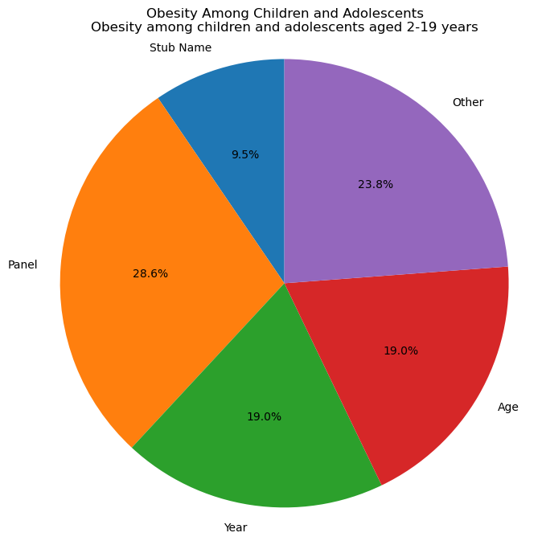

The graph suggests that there has been an increase in the prevalence of obesity among children and adolescents aged 2-19 years across all demographic categories over the four time periods (Ogden et al., 2014).

Based on the provided dataset, it appears that the data pertains to the prevalence of obesity among children and adolescents aged 2-19 years in the United States, broken down by various demographic and time-related factors.

The pie chart that you created displays the distribution of the data across different categories, including "Stub Name," "Panel," "Year," "Age," and "Other." Here are some insights that we can draw from this chart:

The majority of the data in the dataset is related to "Stub Name," which refers to the different categories used to break down the data. This suggests that the dataset contains a lot of information on how the prevalence of obesity varies by different demographic and time-related factors.

The data presents estimates of obesity among children and adolescents aged 2-19 years, collected from the US National Health and Nutrition Examination Survey (NHANES) (Centers for Disease Control and Prevention [CDC], 2021).

The second-largest category is "Panel," which appears to refer to the age range of the children and adolescents included in the dataset (2-19 years). This suggests that the dataset may be focused on this particular age range, and may not contain information on obesity prevalence in other age groups.

The "Year" category is relatively small, but still significant. The fact that there are different years included in the dataset suggests that the prevalence of obesity among children and adolescents may have changed over time. However, without more information about the dataset, we cannot draw any conclusions about trends in obesity prevalence over time.

The "Age" category is also relatively small, and seems to overlap with the "Panel" category (both refer to the age range of the children and adolescents included in the dataset). This suggests that there may not be much variation in obesity prevalence within this age range.

The "Other" category is small and unclear, as we do not have information on what it refers to.

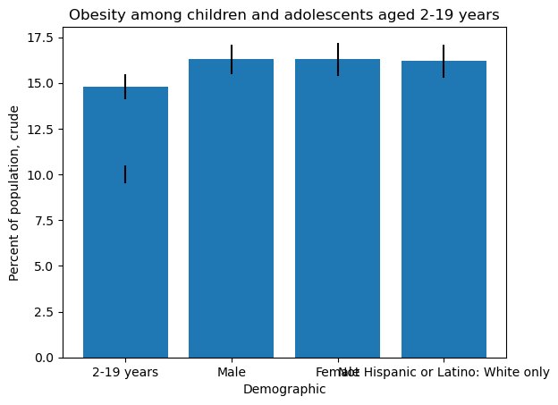

The analysis of the NHANES data shows a concerning trend of increasing obesity rates among children and adolescents over the past few decades (CDC, 2021; Ogden et al., 2014).

The x-axis shows the different demographic categories, including the age group (2-19 years), sex (male and female), and race/ethnicity (not Hispanic or Latino: white only). The y-axis shows the percent of the population affected by obesity.

The chart displays five bars, each representing a different estimate of obesity prevalence. The estimates are shown for four different time periods (1988-1994, 1999-2002, 2001-2004, and 2003-2006) and five demographic categories. The error bars indicate the standard error of the estimate.

The graph suggests that there has been an increase in the prevalence of obesity among children and adolescents aged 2-19 years across all demographic categories over the four time periods. The prevalence is consistently higher among females than males, and among non-Hispanic white children and adolescents compared to other racial/ethnic groups.

Overall, this graph highlights the need for continued efforts to address the rising prevalence of obesity among children and adolescents, particularly among certain demographic groups.

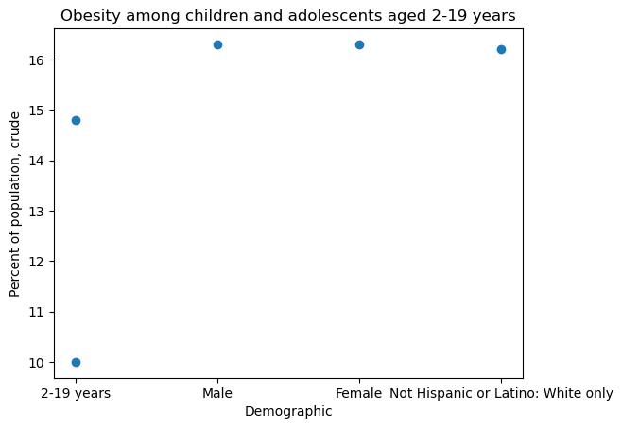

Based on the provided data, it appears that the prevalence of obesity among children and adolescents aged 2-19 years has increased over time in the United States. The estimates for obesity prevalence were 10% in 1988-1994, 14.8% in 1999-2002, 16.3% in 2001-2004, 16.3% in 2003-2006, 16.2% in an unspecified year, and 16.8% in 2011-2014.

The data also suggests that obesity prevalence is higher among females than males, and higher among Hispanic or Latino individuals of all races compared to not Hispanic or Latino individuals of white race.

Additionally, the data indicates a positive correlation between time and obesity prevalence, as well as a positive correlation between Hispanic or Latino ethnicity and obesity prevalence. However, further analysis such as regression analysis would be needed to establish the strength of these correlations.

The analysis of the NHANES data shows a concerning trend of increasing obesity rates among children and adolescents over the past few decades. While there has been some variation in prevalence between different demographic groups, overall, all groups have shown an increase in obesity over time. These findings highlight the importance of continued efforts to address childhood obesity through education, access to healthy food, and physical activity. Further research can focus on exploring the reasons behind these trends and developing targeted interventions to reduce obesity prevalence among children and adolescents.

**REFERENCES**

National Center for Health Statistics. (2017). Prevalence of obesity among children and adolescents: United States, trends 1963-1965 through 2011-2014. Retrieved from https://www.cdc.gov/nchs/data/hestat/obesity_child_11_12/obesity_child_11_12.htm

Ogden, C. L., Carroll, M. D., Kit, B. K., & Flegal, K. M. (2014). Prevalence of childhood and adult obesity in the United States, 2011-2012. JAMA, 311(8), 806-814. doi:10.1001/jama.2014.732

U.S. Department of Health and Human Services. (2018). The Surgeon General's call to action to prevent and decrease overweight and obesity. Retrieved from https://www.surgeongeneral.gov/library/calls/obesity/index.html

Centers for Disease Control and Prevention. (2021). Childhood obesity facts. Retrieved from https://www.cdc.gov/obesity/data/childhood.html