**Mistake in requirements**

The following two function were changed to achieve the random origin in level 5.

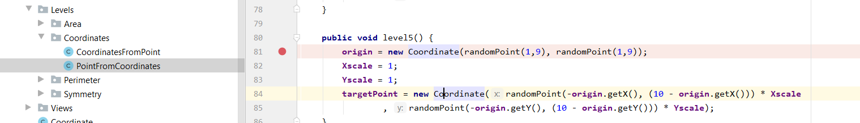

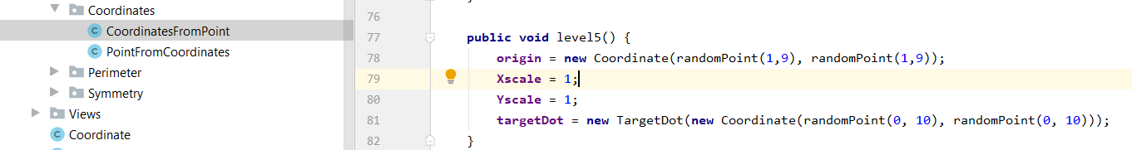

*Test for activity 1:5*

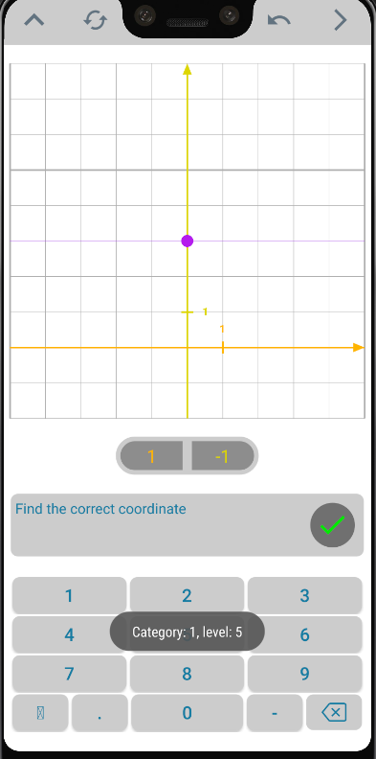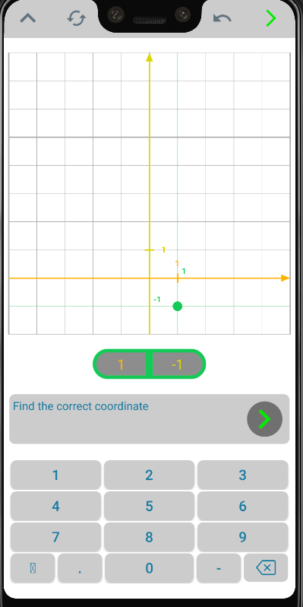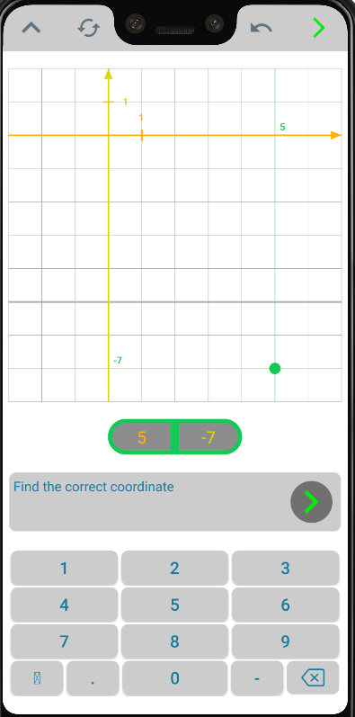

*Test for activity 2:5*

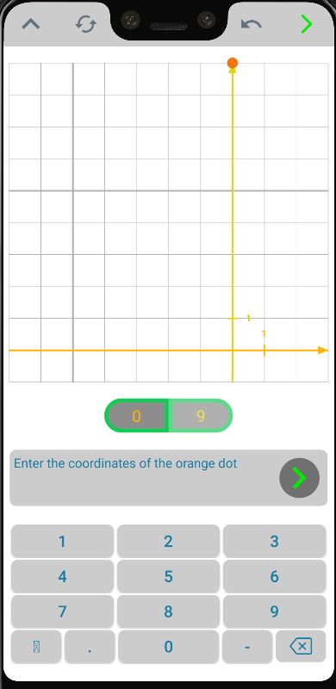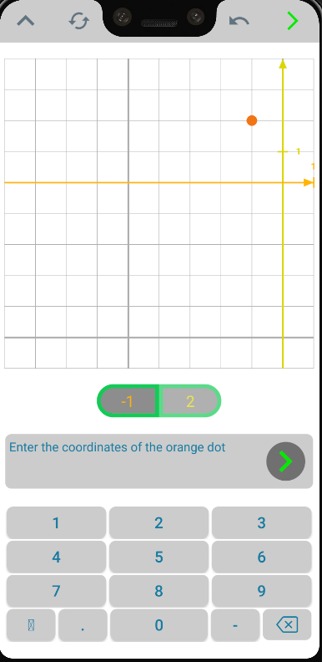

**Random X/Y scales**

*Activity 1:6 / 1:7*: A new level was created to divide level 6 into an easy and advanced/difficult level as shown below:

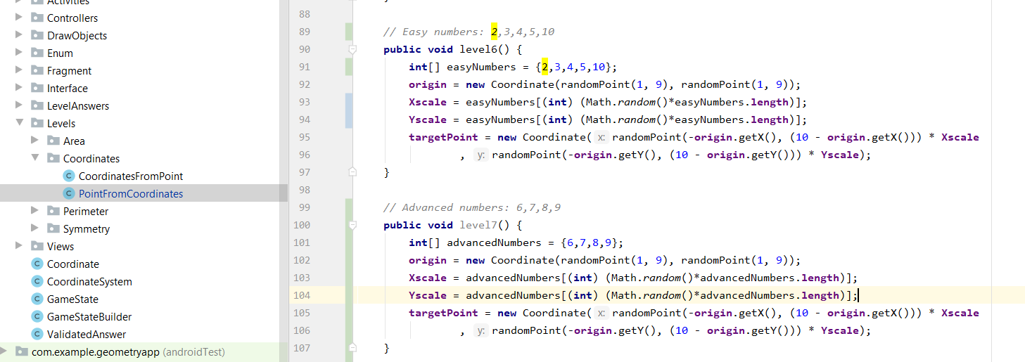

Test of easy level 1:6 with numbers 2,3,4,5,10.

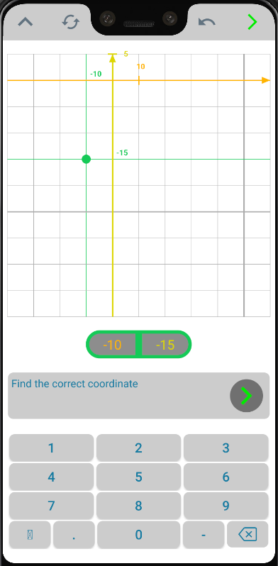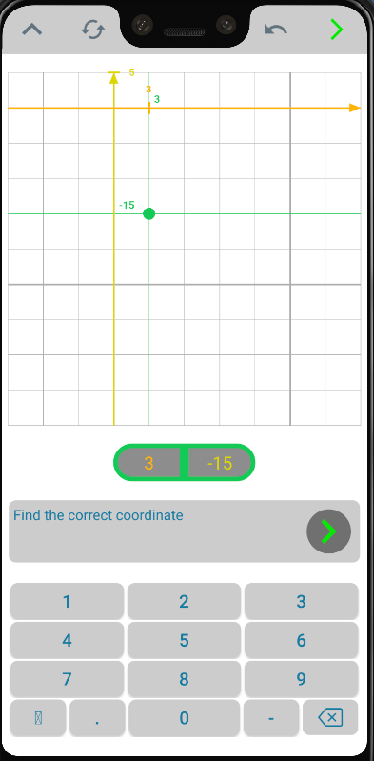

Test of advanced level 1:7 with numbers 6,7,8,9. The test images below shows that a 7th level has been added.

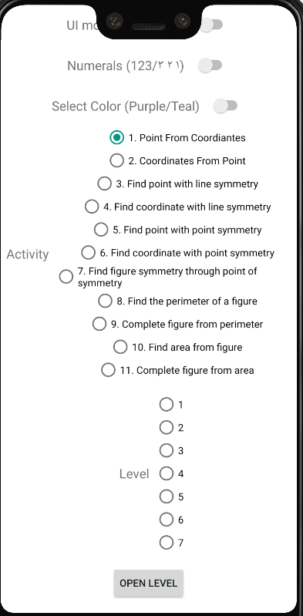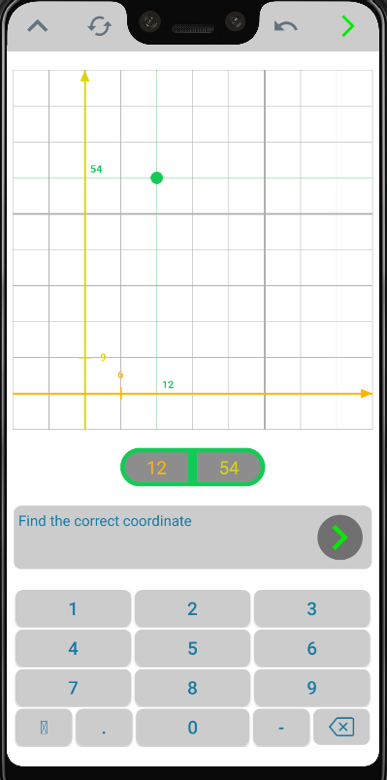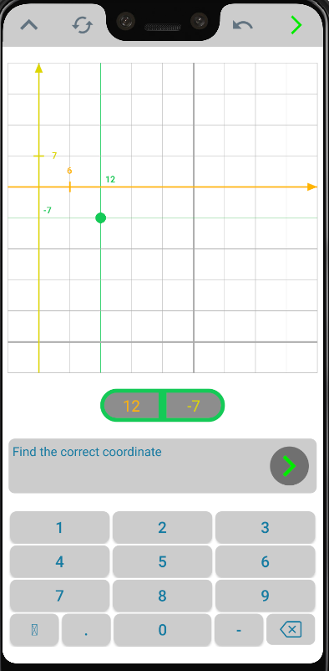

The initial four levels were divided into eight levels switching between easy and advanced/difficult numbers. Hence, eight levels are now available:

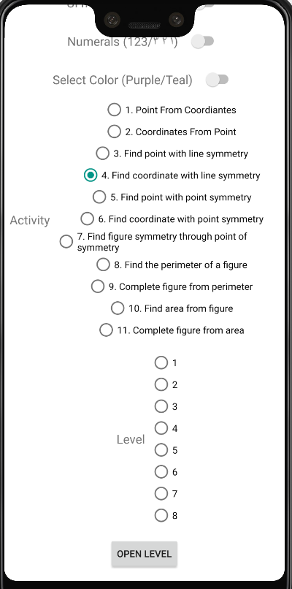

*Activity 4:1 / 4:2*

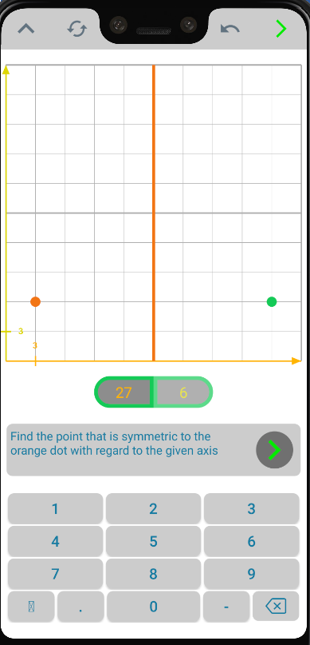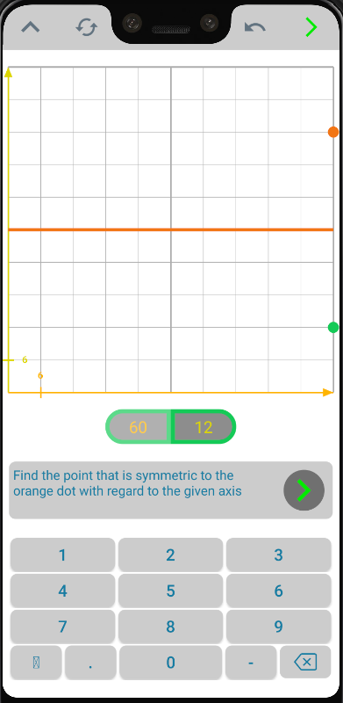

*Activity 4:3 / 4:4*

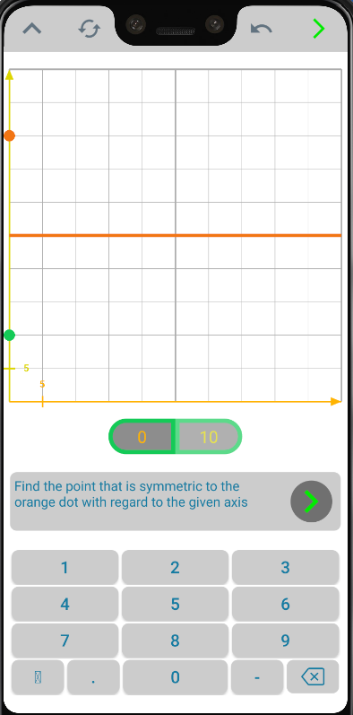 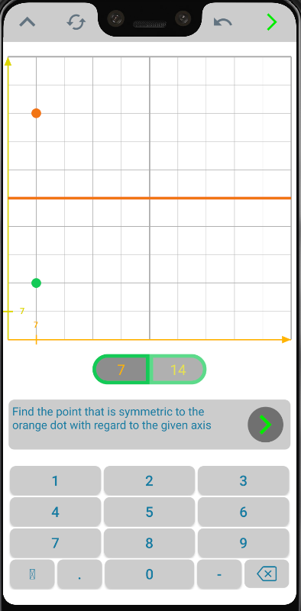

Activity 4:5 to 4:8 has not been documented.

To make activity 6:4 with easy and advanced numbers, a fifth level was added

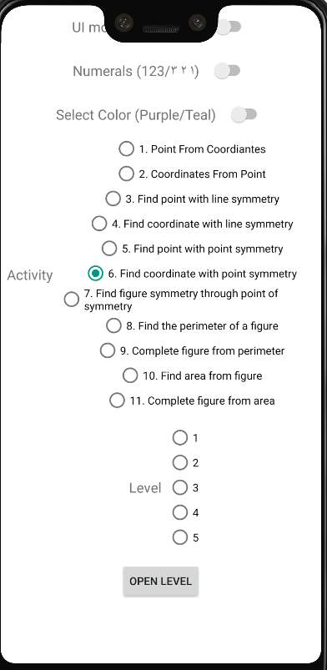

*Activity 6:4 / 6:5*

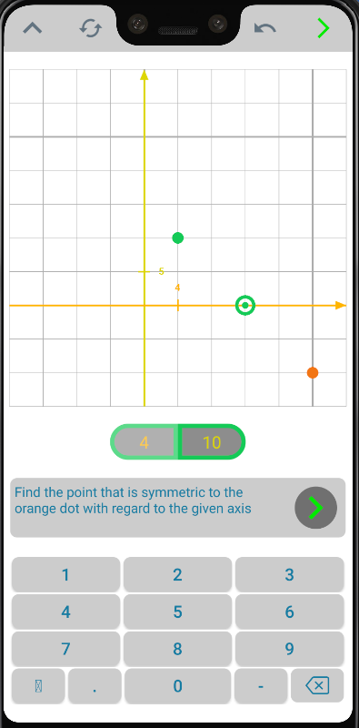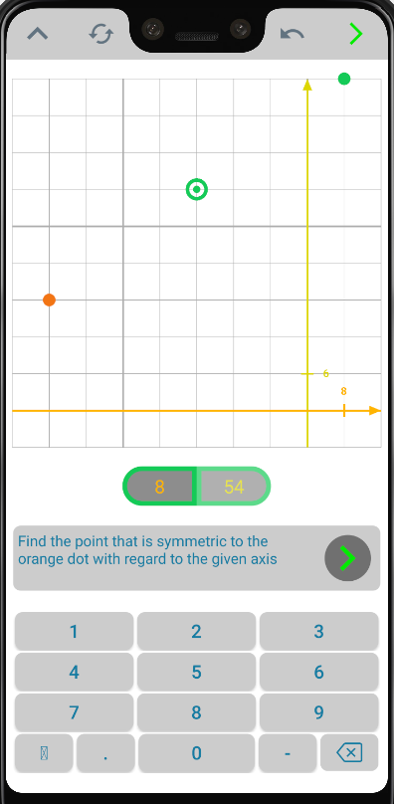

**Remove coordinates on axis when user choses a new point**