Movile Development

**Module Title:**  Mobile Development / Professional Practice

**Assignment Type:**  Individual Submission

**Project Title:** Travel Pal

**Date: 12th**  May 2019

**Name:** Freddy Joaquin Basilio Rojas

**Student Number:**  2018460

**Pic Application**

**Take Picture**

**Tools :**

* PhoneGap
* Cordova
* Framewrok7 v4.
* Plugins:
  + Cordova-plugin-camera.
  + Cordova-plugin-file
  + Cordova-plugin-save-image

**Screenshots during process of develop.**

1. **Structure of my project PicApp**

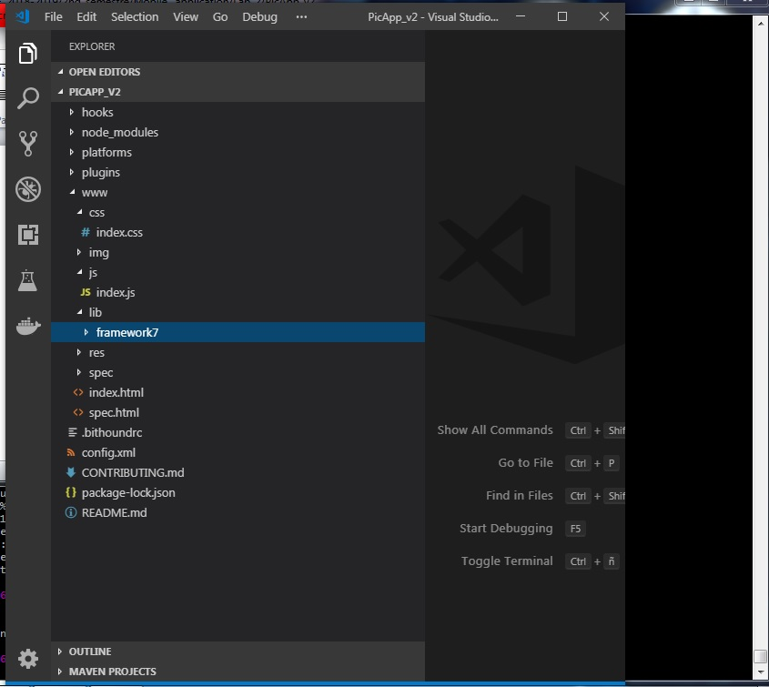

1. **Upload the last version to a repository.**

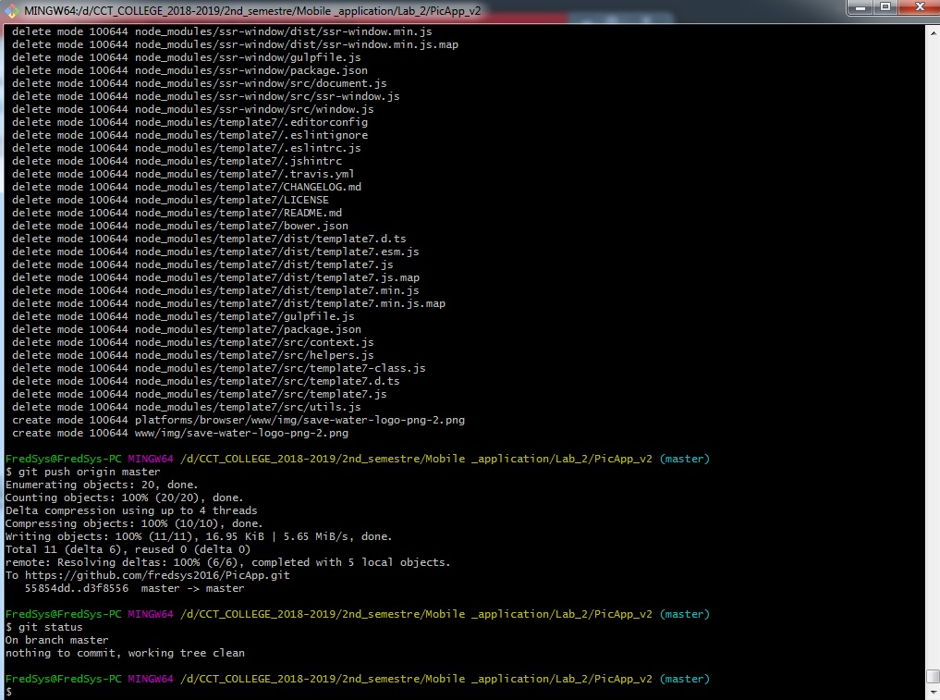

1. **Content of the repository.**

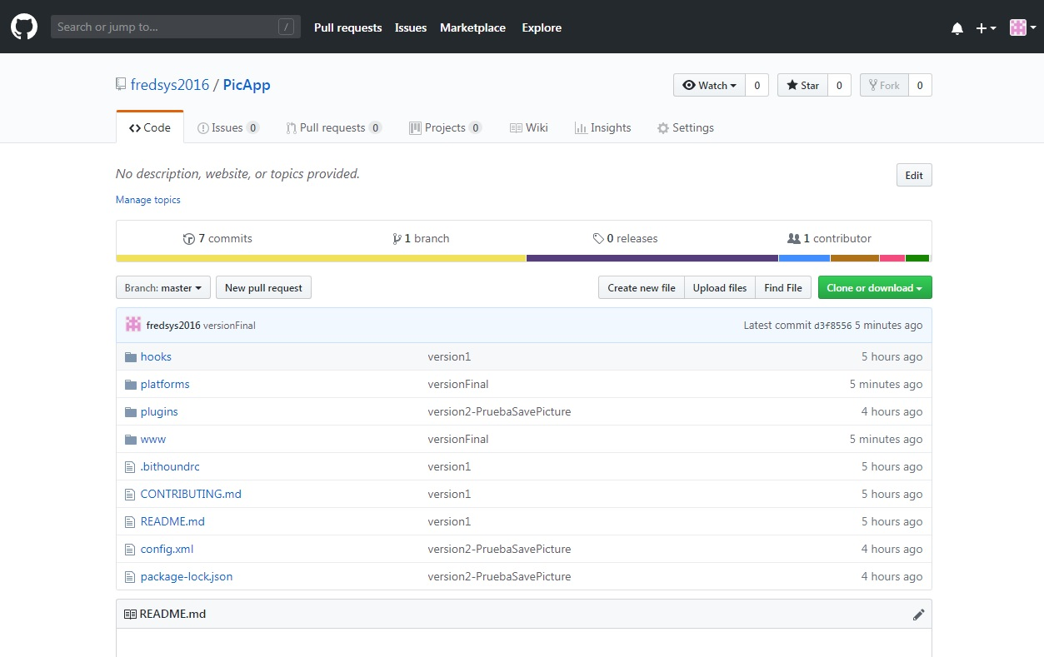

1. **Pulling from my repository to Build APK**

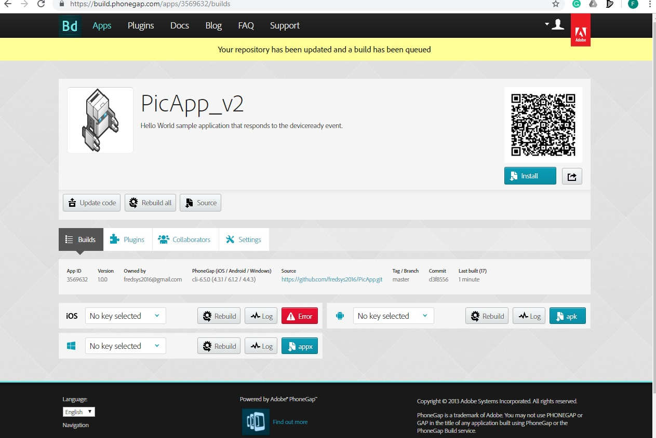

1. **Web Browser**

