1: Analysis

1.1: Company background

Ilford County High School (Figure 1.1) is a medium-sized selective grammar school, sixth form and science college for boys aged 11-18, situated in Barkingside, Redbridge, and Essex. The school admits about 200 students each year. Its sister school, also in Redbridge, is Woodford County High School in Woodford Green.

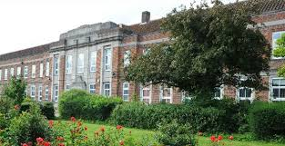Established in 1901 as Park High Grade School, it started off mixed but the girls’ section broke off in 1929. The school is frequently rated as “Outstanding” in Ofsted inspections. Notable former pupils include footballer Sir Trevor Brooking and Kenneth Allen, a Professor of Nuclear Physics at the University of Oxford.

Figure 1.1: Ilford County High School

Most subjects are taught at the school, and teaching is divided into departments for each subject taught. The school’s chemistry department has a particularly high intake due to the majority of students wishing to study medicine. The head of department, Mrs Wardrope, oversees four other teachers and two laboratory assistants. Classes number approximately thirty students each.

1.2: Current system

The chemistry department’s methods of teaching the topic of chemical equilibrium reactions are quite traditional – they have been described by the head of department as ‘chalk and talk’, with information from slideshows produced by the department or textbooks as a teaching aid. Some teachers supplement their lessons with additional media that they have found or produced, such as worksheets or animations.

Because of the nature of the current system, it is essential to observe it first-hand. It was observed that the two main things teachers teach in this topic are how chemical reactions typically work, and the effect of changing conditions such as concentration on a given reaction. These are demonstrated via four main methods:

* Using a specific, real-life example helps students to visualise a reaction and understand it more clearly, as well as engaging them and broadening their knowledge
* 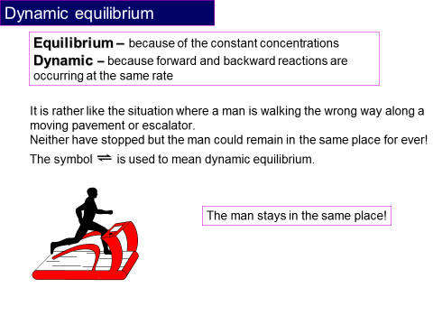Explaining the general principles of equilibrium reactions gives students the basic knowledge that they need to work with any given reaction
* Analogies(see figure 1.2) help to clarify the chemical principles by likening them to things that the students find easier to understand
* Practical exercises allow students to experience what happens during an equilibrium reaction first-hand. The school provide the necessary equipment and chemicals, and give students instructions to follow. For key stage 5 students, practical exercises are devised based on those listed in the ILPAC (Independent Learning Project for Advanced Chemistry) textbook, such as the experiments printed in item 1 of the Appendix. Sometimes they are adjusted to use cheaper chemicals, or ones which react more quickly in the case of experiment 6.2. The experiment is often followed by questions like those shown, to test students’ understanding. Practical exercises are rarely performed because it is difficult to obtain the required conditions (for example, an airtight reaction vessel is ideal).

Figure 1.2: An example of an analogy, used in slideshows produced by the department

The focus of this analysis is on the first two methods, with an aim to improve them. For students studying at A2 level, it is necessary to teach how to calculate the equilibrium constant of a reaction.

In the first case, the inputs are the reactants, products and sometimes the catalyst of an actual reaction. These can be an example from the textbook, or a reaction that the teacher is familiar with. The teacher goes through these processes:

* Finding the formulae of the input chemicals. If the input is given as a formula, the teacher can write the formula without any extra processing. If the input is given as a systematic chemical name (e.g. phenylethene), the teacher uses this information to deduce the formula and write it. If the input is given as a trivial name (e.g. styrene), the teacher finds out the systematic name, if it is not already known, and then deduces the formula.
* Writing the equilibrium equation and reaction data on the board, for the class to see. Equilibrium equations are always written in the form

Reactants ** **Products

where a + separates the formulae of each reactant or product in the equation. When a catalyst is involved, its formula is generally written above or below the double arrow. In general, the teacher will use their knowledge to check that the equation is valid before moving on, but it is sometimes more necessary to know what happens in the reaction rather than its equation. The teacher will often ‘balance’ the equation by adding numbers to the beginning of certain formulae according to their stoichiometric ratio, so that both sides of the equation have the same number of each type of atom. This is necessary when the reaction’s equilibrium constant (Kc) will be calculated.

* Using their knowledge of this topic to deduce what happens during the reaction – reactants react and become products; simultaneously, products react and become reactants. As reactants react, their concentration decreases, and the product concentration increases. However, the decline in concentration is slowed by the conversion of products into more reactants. Later in the reaction, the reactant concentration becomes low enough, and the product concentration becomes high enough, for the concentrations on both sides of the equation to become constant because they are being converted into each other at the same rate. This is what is meant when the reaction is said to be ‘at equilibrium’.
* Calculation of Kc, for higher-level students. This is most often worked through with the students, rather than calculated by the teacher or already known. This and related mathematical calculations are performed using calculators. The calculation of Kc is explained in detail in section 2.5.

In the second case, the input is a change in conditions in an existing reaction. This input comes from the teacher when introducing the topic, but could be suggested by a student in a later lesson. The teacher uses their knowledge to deduce how a reaction with this change compares to the original – the main principle is that the equilibrium position shifts to counteract a change, which increases the rate of one of the reactions.

* When increasing temperature, the rate of the reaction which lowers the temperature is increased. Depending on which reaction lowers the temperature, the concentration of reactants will increase and that of the products will decrease, or vice versa. The opposite will happen if the temperature is decreased. Temperature is the only condition which affects Kc, and it is proportionate to Kc.
* Increasing the concentration (for non-gases) or pressure (for gases) of the reactants causes an increase in the rate of production of products (and vice versa) until the original concentrations or pressures are restored, so that the value of Kc does not change. The opposite happens if one of these conditions is decreased.
* Adding a catalyst allows particles to react which normally would not have enough energy. As a result, concentrations increase and decrease more quickly, so equilibrium is reached more quickly. Increasing the concentration of the catalyst increases the effect.

The output in both cases is verbal information relayed by the teacher to the students, explaining what is happening and why. This tends to be illustrated by diagrams providing an abstraction of the reaction, and/or graphs of concentration of the reactants and products. In the case of changing conditions, diagrams and graphs of a reaction with the change may be compared with those of the same reaction without that change. There may also be questions asked (such as ‘Why did this happen?’, or ‘What would be different if this condition changed?’) to consolidate students’ understanding. Students are encouraged to copy what they have learnt into their exercise books, so that they can be referred to in future lessons or during revision.

The head of department has explained that teachers can demonstrate the basic concept of equilibrium reactions effectively, but the problem is that they find it difficult to get students to visualise the equation process and the effect of changing conditions. The supplementary media mentioned above is found by other teachers to have little scope for customization, to demonstrate different real-life examples.

1.3: Prospective end user(s)

The main end users of this project will be the teachers and students in this school.

I will mainly be working with Mrs Wardrope, as well as the other teachers in the department. Each teacher is in charge of five classes, and there are eight classes in years 11 to 13, where reversible reactions are included in the curriculum. In the classroom, their role is to teach the students the information in the curriculum and help them with points that they don’t understand. A solution should help the teachers to do this in some way.

I will also be distributing questionnaires to the students, as a solution would be used for the teachers to help the students. The role of the students is to do the class work and homework set by the teacher, as well as take in information delivered by the teacher, generally by taking notes. They also need to revise for upcoming tests and exams, and a solution may be useful as revision material.

A solution to the problem could be used by teachers and students in other institutions as well.

1.4: User needs and limitations

The information in this section was compiled from questionnaires distributed to teachers and students. Copies of all received questionnaires can be seen in the appendix (items 2 to 9).

1.4.1: Analysis of questionnaire for teachers

This questionnaire was distributed to all five teachers in the Chemistry department and returned by three of them.

Question 1: Most difficult area(s) of the topic to teach

The most common answers to this question were that students had difficulty visualising the concepts and distinguishing between rate and equilibrium. These answers suggest the usefulness of a simulation in aiding teachers and students. It was also stated that students have difficulty using the chemical equations to solve related problems – it may help to add functionality for solving basic problems using input data.

Question 2: IT usage

All teachers answered that they were able to use computers and judged themselves to have an above average IT ability. Most teachers stated that they were used to educational programs, slideshow software and the most popular Internet browsers.

Question 3: Features of educational software

Frequently suggested features were animation, pictures, reaction graphs, simulation and adjustable conditions. This makes it clear to me that the department is particularly interested in a simulation.

Question 4: Factors which make teaching difficult

One of the factors mentioned was students’ “inability to visualise or understand what is taking place in the reaction”.

1.4.2: Analysis of questionnaire for students

This questionnaire was distributed to seven randomly-selected students in the school, in years 11-13. Five students returned the questionnaire.

Question 1: Key stage

The questionnaire was answered by more students in key stage 5 than 4, so the information provided by the key stage 4 students should hold slightly more weight.

Question 2: Understanding of areas of the subject

Students tended to strongly agree that they already had a solid understanding of the concept of reversible reactions and what happens to them when they reach equilibrium, in a slight contrast with the teachers’ answers. This means that there can be less focus on explaining these topics.

A modal answer could not be determined from the range of answers given on the subject of calculation. When also taking into account the teachers’ opinions on students’ ability to solve related problems, it is clear that the project should be able to perform calculations and output each step of the calculation as well as the results.

Students tended to claim strong understanding of the effects of changes in conditions on an existing reaction, which conflicts with the teachers’ interest in adjustable reaction conditions. It is possible that students outside the sample are less able to understand this point and so this feature should be included.

Figure 1.3: The range of understanding of graphs in the sample

Constructing graphs based on reaction data appears to be the area students find most difficult.

Question 3: IT usage

All students answered that they were able to use computers. When asked to judge their level of ability there was a range of answers, but no one answered “Poor”. All students said they were most used to using the slideshow and word processing software installed on the school computers, and most teachers felt the same way, so software which has a similar user interface to the software they use already would make the project much easier to use.

Figure 1.4: The range of IT ability in the sample

Question 4: Features of educational software

The majority of students mentioned reaction graphs as features they would like to see. Teachers also expressed an interest in the project displaying graphs of reactions. The gathered data makes it very clear that reaction graphs should be a major feature in the project.

Question 5: Factors which impede learning

A significant amount of factors were mentioned by the students in the sample, but none which would prevent them from using a solution. One student mentioned their class’ ‘limited’ amount of practical lessons due to room changes, suggesting that students would benefit from software which mimics a practical exercise.

1.4.3: Summary of needs and limitations

From the information given, the end users’ needs are a system which helps students to understand and visualize the concept and process of reversible reactions, and use equation data to solve problems related to them. The end users also need a low-level user interface. Teachers evidently want this to be done primarily through visuals, which tends to engage students, and students seem like they would benefit from understandable graphs and animations.

The teachers have some limitations. In general teachers did not describe their IT ability as ‘excellent’, so a complex or higher-level interface would not be advisable. Teachers are also slightly limited by the reduction of lesson time by fifteen minutes to one hour, making for less teaching time per week. This makes it difficult to convey enough information in the time frame.

As for the students’ limitations, a variety of IT ability was reported, meaning that a complex or high-level interface is definitely not viable. Furthermore, the room changes for some classes mean that the solution should be easily accessible for use in whichever room the class is in. This is best achieved by being able to run the program on the interactive whiteboards that each room has.

1.5: Data flow

1.5.1: Current system

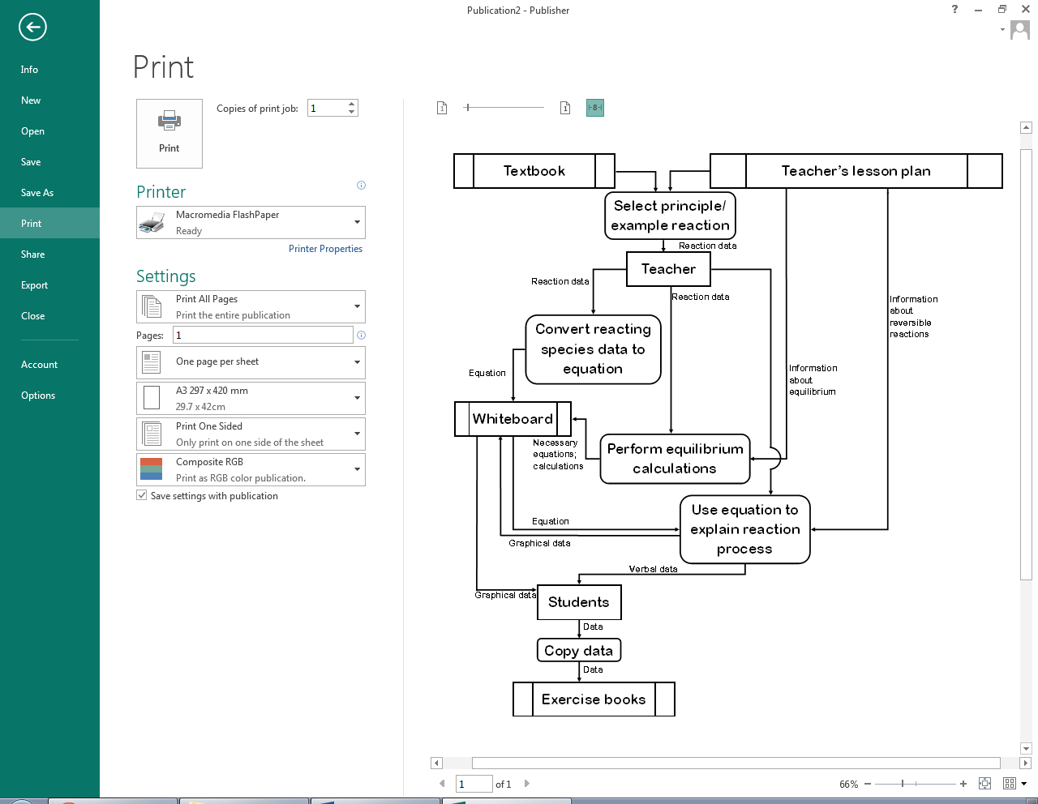

Figure 1.5: Current data flow when demonstrating equilibrium reactions and/or calculations

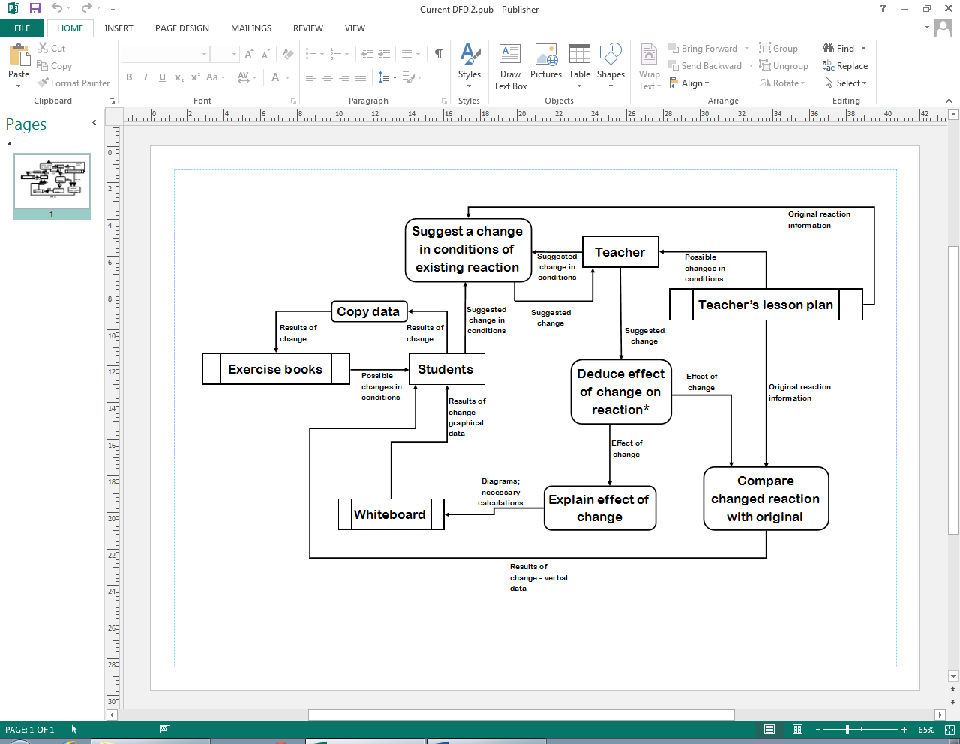

Figure 1.6: Current data flow when demonstrating changes in conditions of an equilibrium reaction.

*See figure 1.7

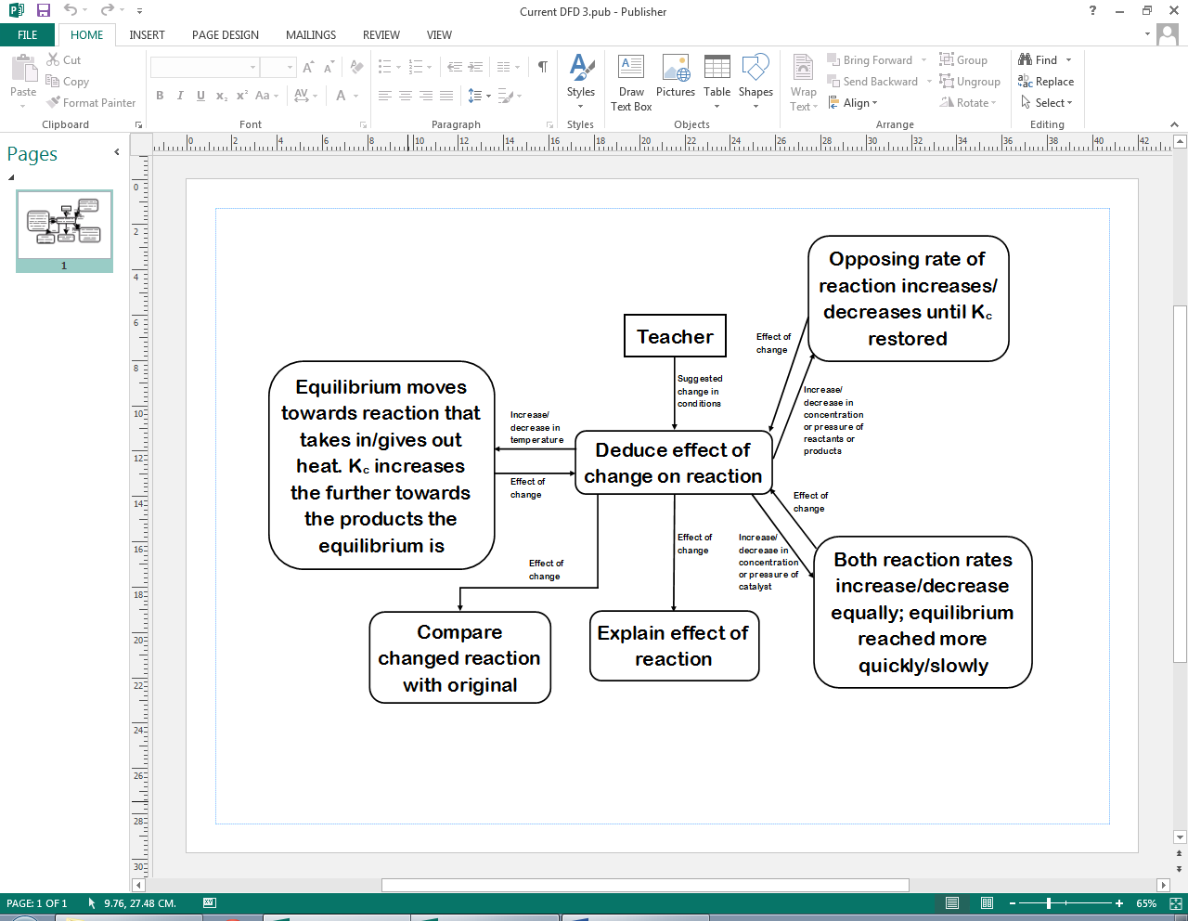

Figure 1.7: In-depth view of the “Deduce effect of change” process in Figure 1.6.

1.5.2: Proposed System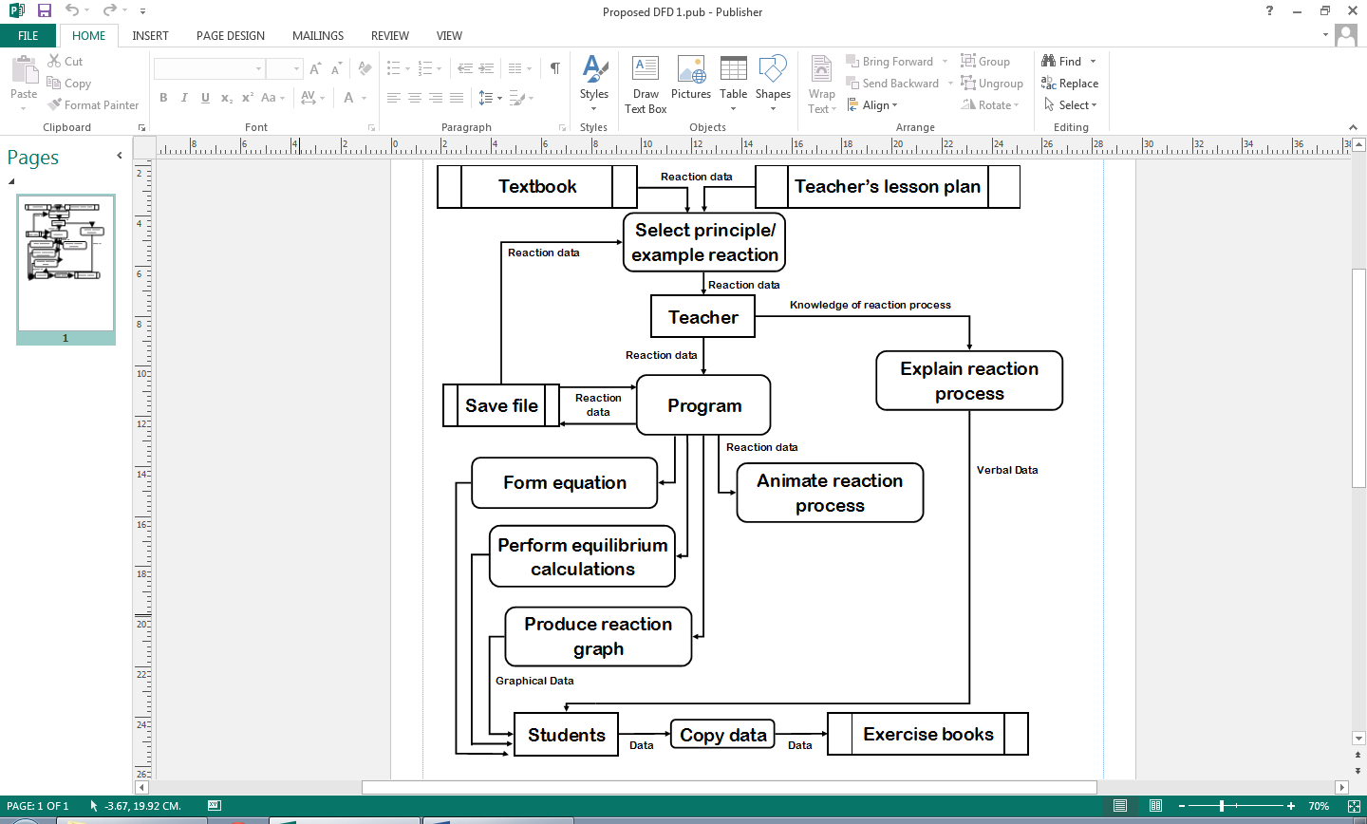

Figure 1.8: Proposed data flow when demonstrating equilibrium reactions and/or calculations.

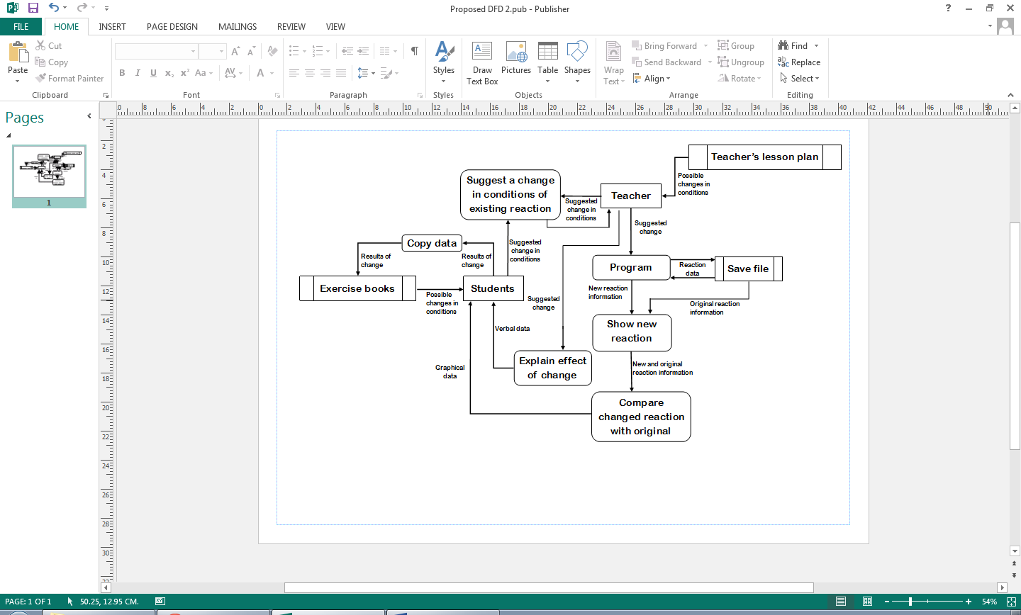

Figure 1.9: Proposed data flow when demonstrating changes in conditions of an equilibrium reaction.

1.5.3: Process Details

This section is a more detailed explanation of the processes involved in the preceding diagrams.

* Select principle/example reaction: if the teacher wishes to teach in general terms then they will teach in terms of reactants A and B and products C and D. They could instead teach using a real-life example, which can be recalled from the teacher’s memory or suggested by a student. The teacher needs to make sure that the reaction is suitable – a reversible reaction, which has no exceptions to the rules that the teacher is teaching.
* Convert reacting species data to equation: the specific data required to form an equation is the formula and stoichiometric ratio of each reacting species. More information on how an equation is formed can be found in section 1.2.
* Perform equilibrium calculations: the value of Kc is calculated using the system described in section 2.4. Concentration is measured in moles per cubic decimetre (mol dm-3) so if, for example, there are 3 reactants and 1 product, the units are mol3 dm-9/mol dm-3 = mol2dm-6.
* Use equation to explain reaction process: the equation is not strictly needed to explain the process as all the information comes from the teacher’s knowledge, but it is helpful for students if the teacher makes reference to the equation when explaining.
* Copy data: students manually copy down the information on the whiteboard or delivered by the teacher into their exercise books. GCSE students most often are expected to copy all information, but as teaching is more in-depth at A-Level and sometimes goes beyond the syllabus, A-Level students often only copy the information which is part of the syllabus.
* Suggest a change in conditions of existing reaction: a change is suggested in one of the following conditions - concentration/pressure, catalyst presence/quantity or temperature. This would be suggested by a teacher if they are teaching or a student if they have a question.
* Compare changed reaction with original: generally by writing reaction data side-by-side, the teacher can compare the old and new reaction and point out any differences to the students.
* Explain effect of change: using their knowledge of reversible reactions, the teacher explains to the students the implication of a change in conditions. A summary of what they would say for a particular change is provided in figure 1.5. Effect on Kc is only discussed at A-Level.
* Program: the software application which is the proposed system, used in conjunction with teaching.
* Form equation: Converts the formulae and stoichiometric ratios of each reacting species into a formula that summarises the reaction.
* Animate reaction process: produces a short animation representing the current reaction.
* Show new reaction: this consists of producing the animation and graph of the new reaction.
* Compare changed reaction with original: the new and original reaction data is shown together on the same screen, possibly by superimposition or side-by-side comparison.

1.6: Data dictionary of current system

Teaching and learning about equilibrium reactions involves processing a significant amount of qualitative and quantitative data. Limits on certain items of data are in accordance with the limits used in lessons; for example, students only work with values to two decimal places. A solution would need to make use of all this data.

|  |  |  |  |  |  |
| --- | --- | --- | --- | --- | --- |
| Field Name | Field Purpose | Field Type | Maximum Field Size | Example Data | Validation |
| Formula | Identifies a reactant, catalyst or product by the number of atoms of each element | String | 25 characters | “H2O2” | Teacher checks if a formula makes chemical sense, but this is a complicated process if they have not heard of the formula |
| Amount | The amount of a substance, measured in moles | Unsigned Float | 3 digits, including 2 decimal places | 3.25 | Must be more than 0.00 |
| Volume | The amount of space the system takes up, measured in cubic decimetres (dm3). One mole of gas occupies 24 dm3. | Unsigned Float | 4 digits, including 2 decimal places | 18.50 | Must be more than 00.00 |
| Concentration (non-gases); pressure (gases) | The amount of a reactant, product or catalyst per unit volume, measured in moles per dm3 | Unsigned Float | 4 digits, including 2 decimal places | 10.04 | Calculated from amount and volume |
| Kc | Equilibrium constant of a reversible reaction at a constant temperature | Signed Float | Between 1010 and 10-10 | 0.24 | Calculated from concentrations of products and reactants |
| Temperature | The average kinetic energy of the particles in the system, measured in Kelvin | Unsigned Integer | 3 digits | 273 | Must be more than 000 and less than 1000 |
| Position of equilibrium | Describes whether reactants, products or neither are being produced at a higher rate than the other | String | 6 charact-ers | “Middle” | Determined by concentrations, Kc and whether the reaction is endothermic |
| Endothermic | Describes whether, during production of products, energy is taken in overall | Boolean | - | True | - |
| Stoichiometric Ratio | The ratio of a molecule to other molecules required for them to react | Integer | 1 digit | 3 | Must be between 1 and 9 inclusive |

1.6.1: Data sources and destinations

|  |  |  |
| --- | --- | --- |
| Field Name | Source | Destination |
| Formula | Lesson plan/textbook | Equation |
| Amount | Lesson plan/textbook | Textbook/ Concentration calculation |
| Volume | Lesson plan/textbook | Textbook/ Concentration calculation |
| Concentration/Pressure | Volume and Amount | Textbook/Kc change deduction |
| Kc | Concentration; Stoichiometric Ratio | Textbook |
| Temperature | Lesson plan/textbook | Textbook/Kc change deduction |
| Position of Equilibrium | Conditions | Textbook |
| Endothermic | Lesson plan/textbook | Kc change deduction |
| Stoichiometric Ratio | Formula | Equation; Kc calculation |

1.7: Possible solutions

One possible solution to this problem is to use more practical exercises, so that students can experience first-hand how reversible reactions behave. However, it is very difficult in a school laboratory to create the necessary conditions for an equilibrium reaction. Furthermore, acquiring the chemicals and equipment for such a high proportion of students to each perform an experiment may take too much time and would be extremely costly. There is also a high chance of experimental errors made by the students, which may cause them to misunderstand how these reactions behave. In addition, some chemicals present a health and safety risk – see the “HAZARD WARNING” section in item 1 of the Appendix.

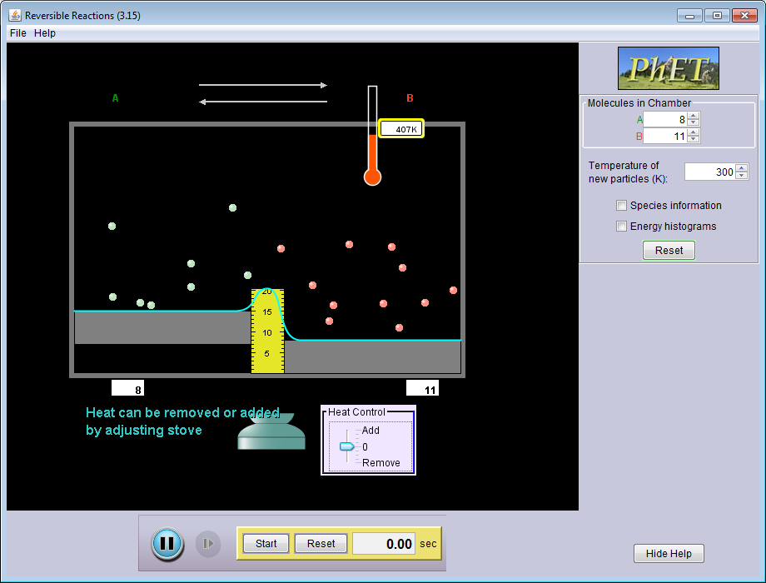Another possible solution is to use this simulation application (see figure 1.10), produced by the University of Colorado, which is downloadable for free and immediately available. It presents information concisely, including information that is not measurable via school equipment. It provides an understandable model of reactions and the effects of changes in conditions. On the other hand, it has a number of flaws, most notably the severely limited help function and lack of user guide. Very little is explained and the user is left to their own devices. This means that an inexperienced student using the application would have to rely on a lot of explanation from the teacher, so while useful as a teaching aid it is inappropriate as revision software. It also provides features such as histograms and average particle speed, but this is not necessary for students at the school. Furthermore it does not appear to take concentration, multiple reactants/products or the equilibrium constant into account, so it is not useful for key stage 5 students.

Figure 1.10: A simulation of reversible reactions

The third possible solution is the development of special-purpose software for simulating reversible reactions. The main disadvantage is that it would not be immediately available as, due to only one person working on the program, it would take a significant amount of time to produce. In addition, many bugs may be present. As the solution is a simulation it will not be a perfect representation of this type of reaction, but a major advantage is that it can be run with any conditions, any number of times. There is a bespoke element to this solution in that features are based on the opinions, needs and limitations of the department and its students (see section 1.4), and the end users can be worked closely with throughout development, making it not too simplistic or detailed. This would enable the software to be closely based on the curriculum and therefore very useful. Programs are installed on the school’s application server, allowing them to be used from any computer connected to the network (at least one computer in each classroom would in effect be able to use this solution, addressing the issue of not always being able to use the lab rooms). The caveat of this is that the program will not be usable should the server become unavailable, but this very rarely occurs.

The third solution is the one which will be implemented, because it is free and safe, unlike using the chemicals and equipment. It also fits what the department requires better than software produced without the school’s involvement. A user guide will also come with the software, so that users will know how to use it. These benefits outweigh the drawbacks mentioned above.

1.8: Data volumes

1.8.1: Current system

The current system does not store any data outside of the lesson, except for slideshows and other media. A significant amount of data is processed during the lesson, but not as much as in the proposed system. Formulae/chemical names, concentrations and volume, temperature and stoichiometric ratios are all processed during the lesson. Data is not processed for graph construction because graphs are always sketched.

1.8.2: Proposed system

Being a simulation, the software would not need to store a lot of data – at most, some reaction data entered by the user so that they do not have to enter it every time they want to run a simulation, and possibly the data of some previous simulations so that they can be compared with one another. However, it would have to process a lot of data to produce the simulation, including calculation of Kc, concentrations/pressures of the reacting species and the positions of objects on-screen for animations. The department’s computers are not very powerful and the calculations are more important, so graphics must be clear but not resource-intensive.

1.9: Proposed system objectives

The proposed system’s objectives must be met by the 23rd of February, 2015, in time for the topic to be taught to the current year 11 students.

1. The program must be able to save and load files that it has created one at a time, within two seconds for each file. The program files must consist of a maximum of five separate reactions.
2. The program must be compatible with and run smoothly on the school’s computer systems. It must also have a similar-looking interface to the general-purpose software the school uses.
3. The program must be able to produce a simple 30-second animation, using a grid of coloured squares to represent a given reversible reaction, in colours selected by the user.
4. The program must be able to produce a graph of concentration of reactants and products against time for a given reversible reaction, which displays in colours selected by the user, progresses alongside the animation and is plotted at the same rate.
5. The program must be able to correctly calculate Kc for a given chemical reaction and output the steps involved in its calculation, as well as displaying whether Kc has increased, decreased or not changed when a condition is changed.
6. The user must be able to compare two reactions side-by-side in the same window.
7. The user must be able to select colours from a colour palette to represent the reactants and products in a particular reaction.
8. The user must be able to print all data related to the reactions being compared, in colour or black and white, on A4 paper.

Following a meeting to discuss the prototype, the following objectives were added:

1. The program must have options to toggle the visibility of descriptive labels in reaction windows at runtime. The labels must be hidden by default and are shown or hidden immediately by pressing a toggle button.
2. Users must be able to enter chemical formulae using normal, superscript and subscript text.
3. The program must allow users to attempt to balance the reaction equation for themselves, by entering stoichiometric ratios for each reacting species.
4. The program must be able to calculate the stoichiometric ratios of a given reversible reaction.
5. The program must be able to compare its calculated ratios against those the user entered, and immediately display whether or not the user is correct.
6. The program must be able to produce a graph of rate of the forward and backward reactions against time for a given reversible reaction, which displays in colours selected by the user, progresses alongside the animation and is plotted at the same rate.

Agreement of the proposed system objectives can be found in the Appendix, item 10.